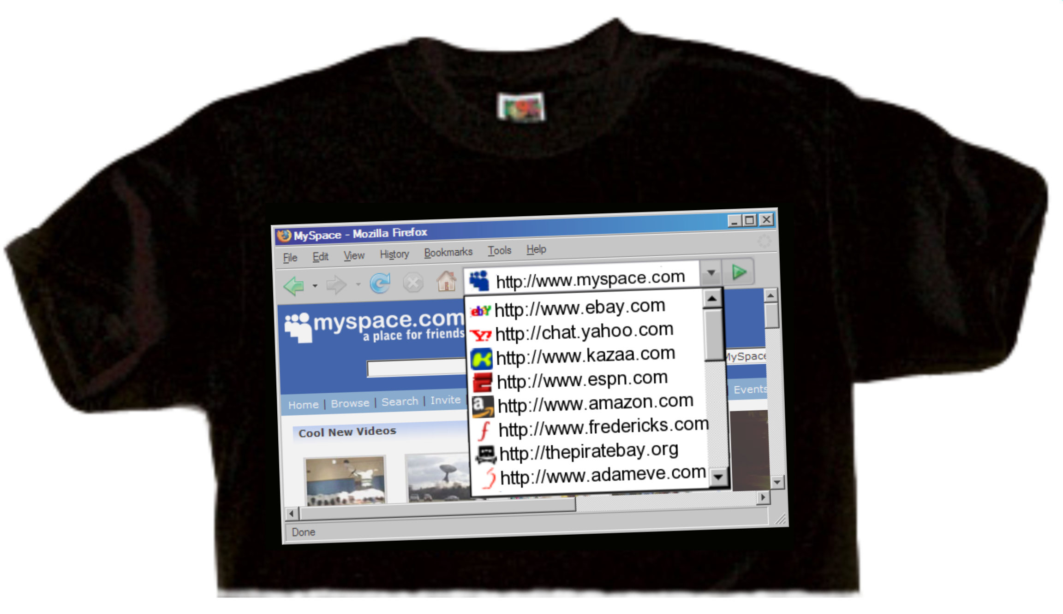
Would you be proud to wear your browser history?
Would you be embarrassed if your boss
or your peers saw where you’ve been going?

Our company allows reasonable personal use of the Internet, however there are a
Harassment
Viewing inappropriate content, such as pornography, hate or violence, can create an environment that is hostile and offensive for your co-workers, and can damage our reputation.
lot of bad things that can happen if you use the Internet irresponsibly here at work.
Viruses
Visiting less than reputable websites can lead to viruses, spyware, or other malicious software getting into our network.
Service Interruptions
Large downloads and streaming audio and video can suck up network resources that other employees need to do work and service customers.
Productivity
Frequent online browsing, shopping, and chatting can get in the way of getting your work done, and often leads to resentment from your coworkers.

