

Pawel Gburzynski

The SHOCK praxis

Version 0.1 (CC1350)



March 1, 2021

© Copyright 2013-2021, Olsonet Communications Corporation.
All Rights Reserved.

Preamble
The role of this praxis is to demonstrate the set of sensors onboard the CC1350STK (aka CC1350S SensorTag) and provide a generic tool for collecting sensor data from the device without having to connect it over a wire to ta PC. It is intended for experiments where possibly large (relatively speaking) sets of data have to be collected and stored for off-line analysis and interpretation.
After we have set up the first decent version of GUI, I am going to upgrade the praxis to provide for high-speed data acquisition from the IMU (accelerometer) possibly involving compression and some sort of acknowledgments. The idea is to be able to collect IMU data with high reliability and at as high a rate as possible.

The devices
The setup involves two devices: a CC1350STK (see Figure 1) called the Tag in the sequel, and a LAUNCHXL-CC1350 (Figure 2) called the Peg and acting as the wireless interface of the Tag to the PC. The Tag is powered from a battery and can be freely moved around within the Tag-Peg transmission range which is of order 100 m in open space. The wireless communication channel is not BT: it is built around the so-called proprietary mode of CC1350 and operates within the 916 MHz ISM band.

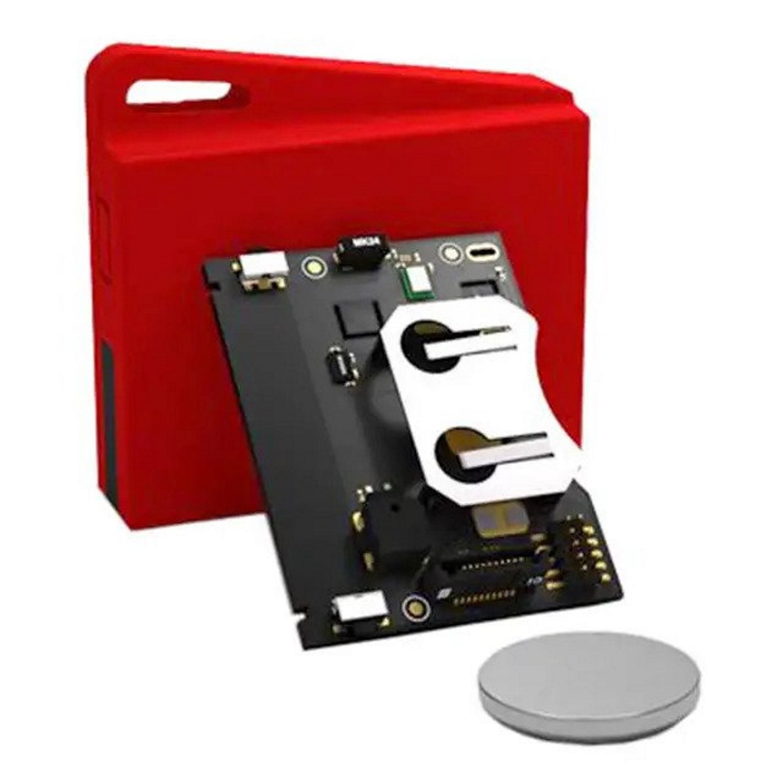
Figure 1: CC1350STK

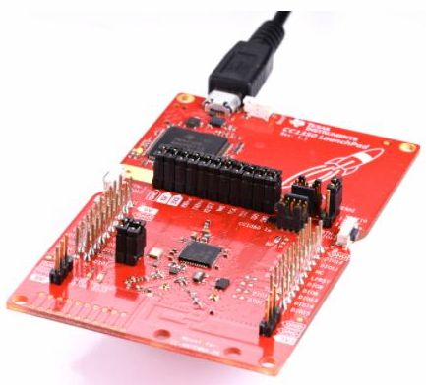
Figure 2: LAUNCHXL-CC1350

Controlling the Tag
The Tag is stored in a dormant state in which it practically uses no battery power. Strictly speaking, there is no OFF switch on the device; however, the deepest sleep mode of the microcontroller effectively amounts to an OFF state because the battery drain is then negligible. To wake up the device from the dormant state, Switch 1 (see Figure 3) should be pressed once. If the device was actually dormant, the LED will blink once and the microcontroller will reset (the device will effectively start in its initial power-up state). When the device starts, its radio receiver is turned on in “full mode” (as opposed to the WOR mode, see below). Note that in this state, the battery will only last for about 13 hours.
When the device is active (non-dormant), Switch 1 can be used to control the radio (and thus the power drain). A normal (short) push of the switch cycles through these modes: off, WOR, full on. Following the push, the LED will blink quickly 2 times (when the assumed state is “radio off”), 4 times for WOR, and 6 times for “full on”.

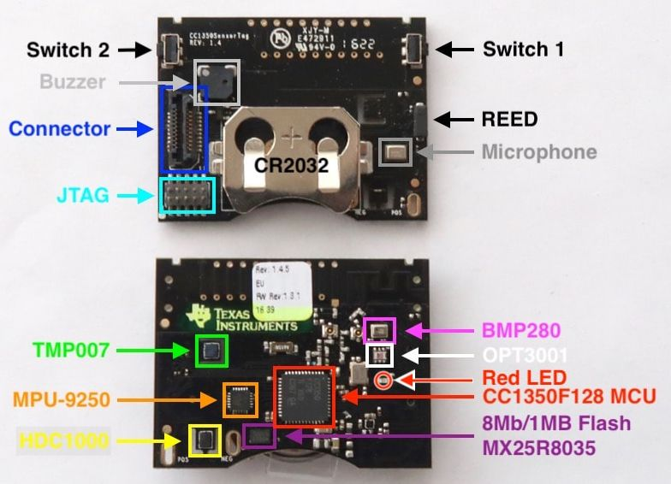
Figure 3: Tag layout
When Switch 1 is pressed continuously for more than 5 seconds, the LED will start to blink (it will blink very quickly 64 times) and the device will hibernate, i.e., go to the dormant state. You should release the switch when the LED starts blinking. Otherwise, if the switch is still pressed when the LED is done blinking, the device will reset.
Switch 2 is not used at present. Switch 1 is the only means to control the device manually (without connecting to it from the Peg over the RF link). Note that the receiver can be turned off remotely from the Peg, and the device can also be put into the dormant state this way. The device responds to this request in a manner slightly different from its response to Switch 1. The actual action is postponed for 1 second, so the device can respond to (acknowledge) the request. Then, if the receiver is being switched off, the LED will blink 16 times (at a rate ½ of that for the device going dormant). If the device is requested to go dormant, the LED will then blink 64 times, exactly as for a long push of Switch 1.

Power requirements
At present, the device exhibits three modes of operation. In the dormant state, the device is basically switched off (and it [basically] uses no power), but the operation of turning it on is implemented in a “modern” sort of way ;-). In a nutshell, the microcontroller goes down and freezes having tuned itself to a pin state change of Switch 1 so the device will reset when the button is pressed.
Having reset (started), the device starts listening on the radio channel so it can receive commands from the Peg. In its present version, the device cannot do much without receiving a command from the Peg

The Tag uses most power when sending data over the RF channel. With the transmitter turned on, the battery will last for about 10 hours.

With the RF module turned off, the device operates in a low-power state (even if it is not formally dormant) using very little battery. At present, the state is not significantly different from dormant, especially that the device can do practically nothing without receiving (over the radio) a command from the Peg (it will also respond to Switch 1 cycling). However, there is a significant conceptual difference between that state and the dormant state that can be exploited in a future version of the praxis. In the dormant state, the device is completely inactive: it is only tuned to a push of Switch 1, to reset when the switch is pressed. In the idle state, the device can respond to events (like sensor events), so (in principle) it can be set to react (and send a radio pawake up on a motion event.

With the receiver on (full on),

The watch

The device can operate standalone and it can also communicate over RF with the OSS script in this directory. Here is the generic functionality of the buttons (we only use four of them labeled LT – left top, LB – left bottom, RT – right top, RB – right bottom):

LB | cycles through the displayable items which are: watch, radio status, acceleration statistics, pressure/temperature; when pressed for more then 3 sec, the button switches off the display; press it again for 3 sec to turn the display back on
RT | switches through the options (if any) of the currently displayed item
RB | as RT, but in the reverse direction
LT | when pressed for more than 3 sec, enters the setting mode for the currently displayed item, if such a mode is available for the item

In the setting mode, the buttons act as follows:

LB | cycles through the things to set (if there are multiple possibilities)
RT | Cycles through the possible values for the thing being currently set
RB | as RT, but in the reverse direction
LT | exits the setting mode (assuming the selected setting)

The watch display offers the best illustration of the the buttons' functions (because it uses most options). The remaining items may be extended in the future to accommodate more options. New items can also be added.

For example, in the normal (non-setting) mode of the watch, RB and RT will switch between seconds (displayed in the bottom row) and the calendar (month/day/year). This is what we mean by options of the currently displayed items.

To set the watch manually (as opposed to over the radio), press LT for at least three seconds. The bottom row will show seconds and the number will be flashing. By pressing RB/RT you will increment or decrement the number of seconds. LB will cycle through seconds, minutes, AM/PM/24hrs, hours, day, month, year. For each case, using RB/RT, you can cycle through the possible values. When done, press LT to finalize the setting.

By pressing LB once (in normal mode, starting from the watch display), you will get to the radio status. Press LT for at least three seconds to make the status line flash. Then, use RB or RT to turn the radio ON (or OFF). Push LT to activate the change.

When on, the radio operates in WOR mode, so you shouldn't worry about its extravagant power consumption when idle. Needless to say, you have to turn the radio on, if you want the device to communicate with the OSS.

The third item (next to the radio status), which you can select by pressing LB, is the acceleration statistics. The upper line displays the number of events, and the lower line offers three options (selectable with RB/RT): the last acceleration measurement, the average over all events so far, or the maximum over all events.

When running, the accelerometer thread responds to events signaled by the sensor and, after each event, collects a sample. The sample is the sum of absolute values of acceleration along each of the three axes (expressed in g).

Note that the acceleration statistics are only available if the acceleration sensor/thread is running. Again, to start the sensor, you have to push LT for at least three seconds which will get you to three options (selectable with RB/RT): ON, OFF, and CLEAR. The last one means re-setting the statistics accumulated so far.

Note that the acceleration sensor can be configured from the OSS (see below). Its default configuration covers simple motion detection.

The last displayable item is pressure/temperature. This item has no options (yet) and is not settable. When selected, it will show the temperature (upper row) and pressure (lower row) updated every 5 seconds. The pressure is in decaPascals, i.e., the last decimal digit of the Pascal value is removed and rounded into the second digit.

The OSS

For OSS communication, you need an access point, i.e., a WARSAW node flashed with the “ap” Image.

Connect the AP to the PC, switch on the radio on the watch, and run the OSS script by executing oss in the praxis directory. Note that the command runs oss from your BIN directory (put there when PICOS was deployed), and that script, in turn, reads oss.tcl from the praxis directory. Press Connect and wait until the script connects to the AP. Here are the commands (note that they, as well as all the keywords, can be abbreviated to the minimum unique prefix):

ap [-node n] [-retries r] [-wake w] [-preamble p]

This command sets up some parameters of the AP. Without arguments, it will poll for and report the current settings used by the AP.

The first argument sets the watch's Host ID. The default Host ID assumed by the AP is 1.

The second argument gives the number of retransmissions of every packet sent by the AP to the watch. Note: I do not mean retries while waiting for ACK. There are no packet ACKs at the AP-to-watch level, only command ACKs to the OSS. If this value is greater than 1, it simply means that every single packet will be transmitted that many times back-to-back. As commands carry reference numbers, there is no worry that the same command will be executed multiple times.

The third argument gives the number of wake packets (ones with long preambles) beginning every transmission to the watch. Normally, this number should be 1. You can set it to zero, e.g., when you have made sure that the receiver at the watch is open for a long time after the previous waking reception. That might speed up communication by eliminating the (unnecessary) long preambles.

Note that by default every transmission to the watch consists of two (identical) packets (the setting is 1, 1), the first one being preceded by a long preamble and the second transmitted normally.

Finally, the fourth argument specifies the length of a waking preamble in PicOS milliseconds. Note that it should not be shorter than 2048 (two seconds), which also happens to be the default, as this roughly corresponds to the length of the WOR cycle (+ some small margin).

status

This command polls the watch for status. The response contains:

- the uptime of the node split into hours, minutes, and seconds
- the time at the node (shown as calendar date/time)
- the accelerometer thread status (ON, OFF)
- the display status (ON, OFF)
- the ON interval for the RF receiver
- the battery voltage

Note that there is no indication of the radio status: it cannot be OFF, if you are seeing the message, can it?

The ON interval of the receiver is the number of milliseconds for which the receiver stays open after the last activity of the radio (before going to WOR sleep). By default, that interval is 3072, i.e., 3 seconds.

time [set] [date/time]

This command sets the device's clock. The set keyword is optional and has no meaning. Without arguments, the command sets the clock to current time (as known by the PC running the OSS script). By providing a specific date/time (in any of the numerous and natural formats acceptable by Tcl) you can set the clock to anything.

radio [on | off] [delay]

The command turns the radio OFF (with the off) parameter, or changes the RX ON interval (with on followed by a delay – in that case, on is optional). Of course, you cannot use this command to turn ON the radio which has been OFF.

display [on | off]

The command turns the LCD ON (with on or no argument), or OFF (with off).

pressure [read]

The read keyword is optional and meaningless. The command requests a reading of the pressure/temperature sensor.

accelerometer configure ...

The command configures the acceleration sensor without starting it. If the sensor is active, the command will reconfigure it on the fly. Otherwise, the configuration will be loaded into the sensor the next time the accelerometer thread is started.

Following configure, you may put explicit register assignments in the form:

-reg regnum val … val -reg regnum val … val …

where regnum is a register number and val is a value (possibly an expression) evaluating to a number between 0 and 255. Multiple values specified for a single register number will be assigned to consecutive registers.

A more convenient option is to use shortcuts (macros) for typical configurations. Those configurations are identified by the selectors: -parameters, -motion, -doubletap, -singletap, -orientation, -flat, -fall, -shock, corresponding (more or less) to the options described in (my) document of the sensor's driver with -parameters corresponding to the arguments of the on operation (selecting the range and bandwidth). Those macros accept the same arguments as described in the document, e.g.,

accel config -par 0 6 -motion 2 73

configures the sensor for 2G range with bandwidth 6 (500Hz) for motion detection with 2 samples and the threshold of 73.

accelerometer on [-from date/time]
[-to date/time]
[-erase]
[-report interval pack]

The command turns the accelerometer thread on. The action can be scheduled for a specific time interval in the future. If no interval is specified, the measurement starts immediately and continues indefinitely, i.e., until terminated explicitly. It is legal to specify one end of the interval with obvious consequences. With -erase, any previous measurement (event count, average, maximum) is reset.

The -report argument indicates that the device should be sending periodic reports of acceleration values along the three axes. The interval argument, defaulting to 1024, is the interval in PicOS milliseconds between two consecutive samples, and pack, defaulting to 1, tells how many samples should be packed into one RF packet (the maximum is 10). Note that this may cause heavy RF traffic draining the battery.

If the thread is on at the time, and the parameters of the operation indicate that it should be started in the future, the thread is terminated. Unless -erase is specified, the results of the previous measurements are retained, so the new action will be adding to the previous activities if the thread.

accelerometer collect

This is a shorthand for the following command sequence executed in a single go:

time set
accelerometer configure …
accelerometer on -report 4 10

whose purpose is to set the device into a fast raw data collection mode. The configuration arguments implicitly used by the second command reset the device to default settings with 2g range and 1000 Hz bandwidth (corresponding to -par 0 7).

accelerometer [off | erase | read | events ]

With off, the running accelerometer thread is stopped, the sensor switched off. With erase, the statistics are reset (without affecting the thread in progress). With read (which is equivalent to no argument) you request a reading of the sensor's current data (regardless of any events). With events, you ask for the current statistics: the number of events, the average, the maximum, and the last sample.

That's it for now.

It in fact drains a small fraction of 1 μA.

