TracEd (0.2 – October 2012)

Perhaps these notes will acquire a decent form; at present, they're for internal use only.

The Trace praxis is meant to morph into an 'illustrating blueprint', to help us present PANDA, illustrate PICOS concepts and good practices, libraries, OSSIs, UIs, etc. Needless to say, as is, it does little of the above but, I believe, it will either inspire something better on the theme, or be improved to do the intended.

This document will follow the development; refinements of the CHRONOS UI and UIs / OSSIs in general, are planned as immediate continuation. Also, the sensor module is totally missing, represented just by 'embedded' battery reading.

'dupa' tags in the code point at immediate doubts. Hopefully, their list by the end of this document will shrink along our works on TracEd. (* the list is not compiled yet *)

The praxis is meant for WARSAW and CHRONOS boards (at the moment), all examples here use the site_mob_types.xml model, also used for presentations. The CHRONOS board's presence as a separate application type is due to the fact that this seems to be the only way to have radically different UIs within the same model. These twins clearly have the same code:

app_war.cc:
#include "_app.cc"

app_chr.cc:
#include "_app.cc"

Exercise (typless application):

mv _app.cc app.cc
mv app_war.cc _app_war.cc
mv app_chr.cc _app_chr.cc

Reconfigure BOARD for WARSAW, associate VUEE with mhop.xml, build, run and enjoy a setup excellent for mono-type application's various experiments and extensions. The only UI present is the classic UART (ser_*).

Remember to go back with file names and PANDA configs before following this document with a VUEE run.

Quick start:

Configure for CHRONOS, WARSAW, idiosyncratic VUEE with udaemon and direct udaemon data, associate site_mob_types.xml, build and run VUEE.

Several windows appear, handy for demonstrations:
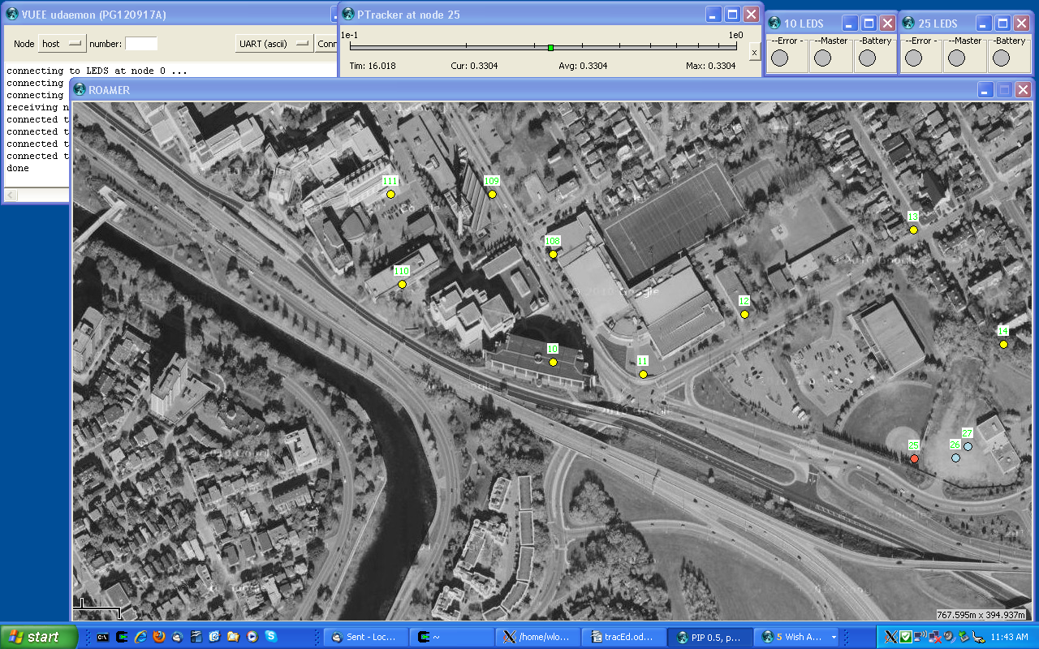

Connect node 0's ASCII UART:

0: Anybody? (Y)
63: Anybody? (Y)
127: Anybody? (Y)

Time-stamped, attempts to find an operator appear. This 'inactive oss' mode is new as a general suggestion. I don't know whether the idea is bad altogether, should be recommended as an option, or as a good practice. In any case, input from an OSS is not expected until a 'Y' appears:

Y
TracEd commands:
t [ dst [ dir [ hops ]]]
s(tatus) [ dst ]
a(ny) dst hops len <str>
d(isp) len <str>
<str>
m(aster) [1/0]
b(eacon) [ freq ]
r(x) [1/0]
h(elp)
O(ff UI)
q(uit)

Only now 'OSS-in' resources are allocated. (After O command, TracEd releases input buffers and reverts to the inactive oss mode.) BTW, permanently present and active 'OSS-out' is a yet another matter for a thoughtful discussion.

t
Trace to dst, with hops max. distance. Dir denotes the direction, coded as 0 – backwards, 1 – seeded forward, 2 – forward, 3 – both directions. Note that the trace is quite expensive network-wise and can play important roles on any application's functional level, main or supporting, therefore these distinctions are not frivolous, especially when one thinks about the packet length constraint. To illustrate:

t 0 3 0
full flooding, packets growing both ways: as expensive as it gets

t 14
tr(14) 11 3 4:
14 100*
13 101
12 98
108 96
10 105

t 14 1
at node #4 (local_host 14) this appears (I call it 'seeded trace' for now, hoping for a better name):
tr(10) 6 117 4:
11 109
12 105
13 98
14 102

t 14 2
tr(14) 9 4 3:
11 109
12 105
13 98
14 100
*10 97

t 14 3
tr(14) 7 3 4:
12 97
13 99
14 101
13 100
12 97
108 97
10 107

In the 'tr(14) 7 3 4:' above, 14 is the destination, 7 is the message type (to be converted to meaningful strings by an illustrative piter's plugin), 3 is forward, and 4 backward hop counter.

Each of the follow-up lines shows node id and rssi on the packet's road. The counters are correct for all the requests but 'seeded trace', where the packet's sequence number and forward counter are displayed. Similarly, the lines with '*' denote data that is available but not directly requested (it may be out of sequence).

There is an important deficiency: on the packet's traverse, node ids are trimmed to 1 byte. Otherwise, the number of reported entries would have to be limited to half of the present maximum of 25, which covers well all practical networks.

s
Statistics / status. Its intended use goes well beyond its name and current functionality in other praxes. Note that the dst is where the stats are output; they're always collected at the source node, where the command is issued. Note that the 'classical' functionality can be achieved by 'a <dst> <hops> 1 s'. For example:

s
Stats 10 fl 0260 t 1196 M 0 m 4254.4052 s 256 b 2600

s0
The same line will appear on all nodes within 1-hop radius. This implicit radius circumcision is useful in some applications, especially when broadcast shouldn't be allowed.

s 14
Stats 10 fl 0260 t 2330 M 0 m 4254.4052 s 256 b 2600
(displayed at node #4 (id 14))

a 14 0 1s
a 14 0 1 s
Stats 14 fl 0240 t 2419 M 0 m 4228.4134 s 256 b 2600

Two last lines show the 14's statistics on the 10 (where the command was issued).

The actual statistics will vary with the applications. In TracEd, we show hex flags (fl) that include node type and 'buttons' (alarms, events), uptime (t), master (M), memory (m) current.minimum, stack (s) and battery (b). In VUEE, stack is fixed at 256, and battery comes from the model.

Commands that don't produce explicit output to the UI issue an implicit 's' after associated actions.

a
'Any' command invokes the embedded command on dst within hops range. Len tail bytes are parsed at the source node, converted into an OSSI-independent structure and sent to dst for execution. Note that this makes the command UI-agnostic at execution time. Nested 'any' or 'any' to local host are not allowed, for no formal reason. I can't think of a practical use for them, but both can be accommodated, the former within the packet length limit.

'd', ' '
Display their str, d last len characters:

dupa jas
dupa jas

d 3 dupa jas
jas

Used with 'a', they are meant for event notifications on remote nodes, even with different UIs. Note that this way the (UI-independent) command interpreters substitute for distinct message types, which is quite desirable, I think. Of course, the UI-specific translator at the source node must do its job.

m
Starts or stops the Master's beacon:

m 1
Stats 10 fl 0260 t 3395 M 10 m 4260.4052 s 256 b 2600
m0
Stats 10 fl 0260 t 3420 M 0 m 4260.4052 s 256 b 2600

I'm not sure what should be recommended as a default master-related functionality. It is clear that many if not all praxes should have this built-in. Likely, all associated resources, save the master_host placeholder should be dynamic. However, I can't see a general prescription how masters should abdicate or be crowned. In TracEd, the usual racing between commands and beacons may happen. One can think about this novelty: nodes should become master-less after missing a prescribed number of master beacons, and TracEd implements that in a simplistic way. Whether this trigger should be a parameter, a number embedded in the beacon, a multiplier of expected beacon freq. or an absolute number... I don't know. TracEd has it all opened (dangling would be a better word), waiting for more elaborate CHRONOS implementation, where I am planning a tag & peg -like implicit functionality when a node with RX ON receives messages, constrained by types, range or dst, from nodes with limited capacity, and acts differently, depending whether itself it is master-less or not. We'll see.

b
Beacon. A utility present in most applications, e.g. for heartbeats, retries, environment sensing, etc. Here, apart from the optional master beacon (mbeacon), we implement message beacon (msgbeac) to carry a stats, trace or any command.

b (beacon's status not set)
Beac 0 0 0

b 15 (set beacon's frequency to 15s)
Beac 15 0 0

s0
b
Beac 15 24 4 (msg_stats (msg_type 4) 24B long is on the beacon)

b 0
Beac 0 0 0 (off, unset)

The b-responses show frequency, size, msg_type. A note is due here: as implemented, the beacon's payload is set for the 1st message and not mutable. Clearly, this can be easily changed, but the mutations in consecutive messages can be accommodated in a few application-specific ways (in-buffer cheap replacement or full scale reallocation and reassembly come to mind).

r
RX ON /OFF. With no argument, it works as (embedded) s.

r 0
Stats 10 fl 0220 t 2927 M 0 m 4260.4052 s 256 b 2600

r77
Stats 10 fl 0260 t 2965 M 0 m 4260.4052 s 256 b 2600

switch RX off /on, visible through the flags. BTW, good practices for the rx status monitoring and on / off empty operations should be clearly stated. I don't really know what makes a significant difference to the RF driver. Same goes with not exactly defunct TX switch; it is safer and convenient without it, but we may want to illustrate the (subtle?) impact of explicit TX ON/OFF in practical scenarios.

h
Shows available commands

O
Stats 10 fl 0240 t 110 M 0 m 4260.4150 s 256 b 2600
110: Anybody? (Y)

Switches off UI, frees its resources and goes back to the 'inactive oss' mode.

CHRONOS

Although practical in some direct applications of TracEd, Chronos appears here mainly for its distinct UI, which should help structure the praxis and define modules that can be turn into HW-dependent or functional libraries. The OSS / OSSI structures proved to be difficult to define in a decent and somewhat abstract way. We hope that this praxis and reminiscences of binary i/f in Genesis and VersaMesh will produce a good trade-off between efficiency and generalization. This is just a start.

The UI estate used in this praxis:
out:
LCD
4 hex character upper line
5 hex character lower line
LED iconic replacements (in the driver)
buzzer

in:
5 buttons (upper left (UL) #0, LL #1, UR #2, LR #3, mid right #4

We'll extend this 'estate' if a direct application of this particular praxis requires it. (SIMPLE or location experiments come to mind.)

In the VUEE models, the ossi-out i/f is handled via EMUL, ossi-in via ASCII UART. Clearly, a lot can be improved here, albeit any nontrivial improvement should be triggered by a practical need; as is, the i/f is more than sufficient for testing and development (less so for presentations).

We continue to use sim_mob_types.xml; the nodes 25-27 are of CHRONOS (_chr) type. For the output presented here, drag the mobile node 25 in between nodes 10, 11, and open its EMUL and ASCII UART windows. The 0-4 digits entered at the UART denote button pushes.

In EMUL:
<0> (0) Init
<0> (0) buzzer_init
<0> (0) ON
<0> (0) hi: 25
<0> (0) lo: UIOFF
<0> (4) OFF
<0> (68) ON
<0> (68) hi: 25
<0> (68) lo: UIOFF
<0> (73) OFF

Every minute or so, node id (25) and UIOFF appear on LCD: application is running (with UI OFF).

CHRONOS has a serious design flaw: its weak (200-250mAh) battery is not rechargeable and difficult to replace. Therefor button #4 is designated to work as ON / OFF switch. From any active state it goes into deep sleep (LPM3, all OFF) with all buttons but #4 disabled:

4
<0> (86) ON
<0> (86) lo: SLEEP
<0> (86) buzzer_off
<0> (89) OFF
In EMUL, we see: LCD ON, SLEEP displayed low, buzzer off (regardless if it was ON), and 3s later LCD goes OFF. In this state, the battery will last years. Next #4 push:

4
<0> (16668) ON
<0> (16668) lo: RESET
<0> (0) Init
<0> (0) buzzer_init
<0> (0) ON
<0> (0) hi: 25
<0> (0) lo: UIOFF
<0> (5) OFF
The praxis resets to UIOFF mode.

Button #3 toggles between active UI and UIOFF mode:

3
<0> (43) buzzer_off
<0> (43) ON
<0> (43) lo: TRACE
<0> (43) hi: 25

3
<0> (169) hi: s025
<0> (169) lo: 00
<0> (169) Init
<0> (169) buzzer_init
<0> (169) ON
<0> (169) hi: 25
<0> (169) lo: UIOFF
<0> (173) OFF
Note that the stats (s025, 00) will be hardly visible, overwritten by (25, UIOFF). Not that it matters...

Button #2 toggles RX OFF / ON:

2 (ON)
<0> (808) hi: s125
<0> (808) lo: 00

2 (OFF)
<0> (819) hi: s025
<0> (819) lo: 00

Button #1 sends out a seeded trace message. If the master host is set (only via a master beacon from external host, which in turn requires RX ON), is is equivalent to the 't <master> 1' command. If no master is set, 't 0 1' goes out.

1
tr(25) 6 233 1: // this will appear on node 10 and on quite a few others
10 117
Similarly, button #0 sends out either 's <master>' or 's 0' (the latter with implicit limit to immediate neighbourhood):

0
Stats 25 fl 0130 t 3040 M 0 m 4270.4244 s 256 b 2600

There are two CHRONOS-specific quirks we applied to make the praxis a bit more practical. Since there is no 'button echo' and buttons #1 and #0 don't produce local output, we're echoing the content of the UI-agnostic structure that drives all UI types. Command code ('t' for #1 and 's' for #1 and number of arguments is shown on high line, and 1st argument (the destination) on low line. So, on a masterless node:

1
<0> (44) hi: t3
<0> (44) lo: 0

0
<0> (61) hi: s1
<0> (61) lo: 65535
Note that the neighbourhood broadcast is coded via 0xffff here.

With the master set, the same buttons will echo:

1
<0> (460) hi: t3
<0> (460) lo: 10

0
<0> (463) hi: s1
<0> (463) lo: 10

Aside from local UI-out triggered by local UI-in (buttons), CHRONOS acts exactly like other node types, with UI-out carved for its resources. If there is a text output to show, first 4 characters are shown in high line, up to 5 next in low line. A 300ms buzz sounds as well. The EMUL strings don't cut strings, as the LCD display would, so there is no visible difference:

a 25 1 11 room 12345 // on node 10

on node 25:
<0> (1176) buzzer_on
<0> (1176) hi: room 12345
<0> (1176) lo: 12345
<0> (1176) buzzer_off
On real LCD, it'll be 'room' and ' 1234'

a 25 1 10 room12345 // on node 10

on node 25:
<0> (1211) buzzer_on
<0> (1211) hi: room12345
<0> (1211) lo: 12345
<0> (1211) buzzer_off
Real LCD: 'room', '12345'

Implementation: code, internals
(* this section will be filled in very soon*)

I split module headers into mname.h and mname_dcl.h. I thought it was a good idea, I don't think that now, but I left it for better eyes.

Mysteries

VUEE (udaemon?) occasionally hang-ups with no apparent reason or trace. It was a tell-tale sign of the UART confusion with binary commands (the pointer to '\0' was interpreted as a binary command, with truly unpredictable outcome), so it may be a yet another bug's syndrome.

Demonstration

This is just a proposal for a setup and storyboards; the actual demo should follow the audience interests,with more / less emphasis on VUEE, HW (flashing), code, routing (TARP_RTR may be added), other areas.

Run pip, open tracEd.

Configuration->
CPU+Board -> MSP430, Multiple, CHRONOS, WARSAW
VUEE -> idiosyncratic, with udaemon, direct data, data file site_mob_types.xml
Loaders->Elprotonic for Cygwin, msp430-gdb for Ubuntu

Have Build->All prepared, it takes a while.
Build -> VUEE (could be prepared, too – later on we'll be building it anyway).

Execute -> Run VUEE
Explain the windows, start with ROAMER's “<x,y> type# / id” bar.
Open and browse over xml files: site_mob_types, channel, tag. Explain a few elements, attributes, content.

Drag 25 back around of 26, 27, Open UART, EMUL on 25, open RX on 25 (via 3, 2 on UART), show the diff on PTracker. Underline Ptracker's usefulness.

Close 25 UART, EMUL windows, open UART 10, do Y, m1. Explain.

Explain highlighting on ROAMER. In PIP, File -> Search for highlight_ (_ is important). Double-click on msg.cc:145, change 13 to 12, save, abort VUEE, close udaemon, rebuild. Explain that PICOMP needs to translate stuff, so VUEE compiles all praxis files, no matter what was updated. Run Build All, to show that make will only go after touched files.

Run VUEE, anchor 25 when it starts moving (you can open site...xml and show mobility data in roamer), open UART 10, do Y and m1. Explain the diff (label stays on node 12).

Open UART 25, do 3, 2 (you'll see battery up at PTracker). Do m1 on 10 until green LED 25 is ON.

Keep only (narrower) UART 10 visible over ROAMER. Play with 't 0 3' and 't 25 3'.Explain that both flooding and many-hops trace are taxing the net, purposefully set suboptimal (slack, no fuzzy acks).

Abort, kill udaemon, run VUEE again. Open UART 10, do Y, m1. Minimize UART 10. Open EMUL and UART 25, do 3, 2 (you'll see battery up at PTracker). Wait until green LED 25 is ON (you can help with m1's on restored UART 10. On UART 25, do 0,0,1, check in EMUL that beacon is on. Kill UART, EMUL 25. Narrow UART 10, enjoy traces from 25 on 10s beacon, it nicely shows how this can be used for tracking or surveys. Observe, how difficult it would be to reliably verify such scenarios without VUEE. Not to mention the actual development.

Optionally, go into the tracEd functionality as a light general blueprint (mainly, about 'a' as rpc). I wouldn't do it unless asked to extend on tracEd or otherwise invited by reactions to shown fragments.

Customize war image for BACA0010, flash, connect the node via FTDI USB and run piter. Have CHRONOS ready, flashed with BACA0025, sleeping. Wake it up (#4, #3), put stats on beacon (0, 0, pause, 0). On 10, Y, m1. Watch the 25'stats on 10, on real hardware. On 10, 'a 25 1 10 room12345' will display 'room/12345' on 25. Switch off CHRONOS RX (2), underline thrifty power budget. Put CHRONOS to sleep (4).

