

A setup to sniff packets for Alphanet V1.0

PG



January 24, 2015
Flash the provided image into one of the “Warsaw” boxes. For that, the best way is to connect the box to a PC via the standard FTDI (UART-USB) dongle (so the node is conveniently powered from USB). The green wire of the dongle's flat plug should face the switch (i.e., away from the antenna). The switch should be pointing towards the plug (USB power).
Unscrew the box and connect the MSP-FET430UIF programmer to the J-TAG connector inside the box. The red wire of the connecting cable should be pointing to the right (with the connector facing up), i.e., towards the side with the USB plug.
Invoke the Flash Programmer (Lite FET-Pro430 by Elprotronic). Open the image file. Make sure to select MSP430F1611 from the MSP430F1xx group as the Microcontroller Type). Program the image, i.e., erase + write. Remove the J-TAG cable and re-power the node by flipping the switch back and forth. The LED on the box should go solid green.
Just in case: make sure that you don't have a file named .sapicrc in your user folder on Windows, i.e., C:\Users\yourname. Of course, you don't, unless you have been running our Spectrum Analyzer before. If something goes wrong in the future, make sure to remove that file before restarting SA. Then it will start with the default settings that I have configured it with. Those settings are crafted for your network and for automatic packet logging.
Double click on sa.exe to start the SA. Needless to say, the Warsaw box should be connected to the computer via the USB dongle.
After a while, the SA should find the box and you should see two windows, one like this:

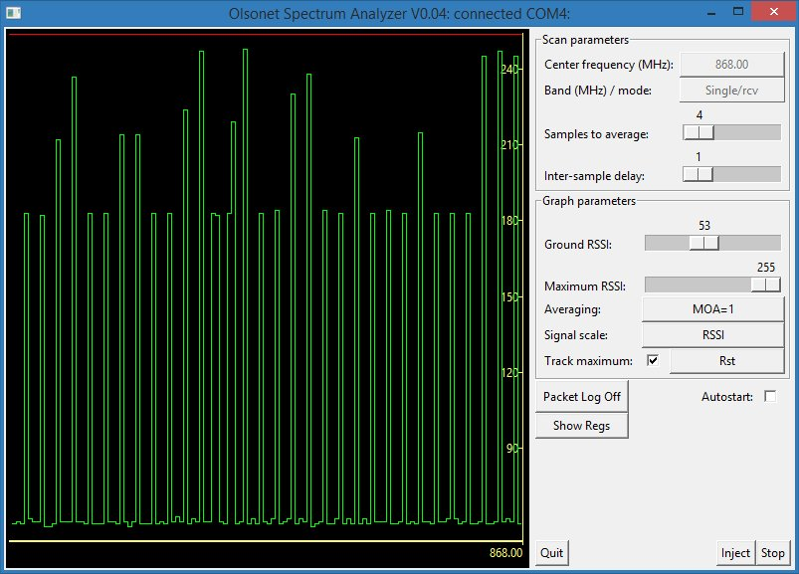
and the other like this:

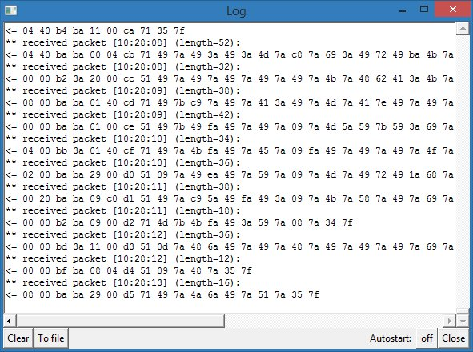
They may be empty if there's no network activity in the neighborhood. The “Autostart” box in the main window will be checked (this is how it should be) and the “Autostart” selection in the log window will be “on”. From now on, whenever the box receives a packet, it will display a message in the log window.
Just one more step: we need to point the SA to a file where it will be storing packet data. Click “To file” at the bottom of the log window and select the file to write the packet log to. Then change the “Autostart” selection in the log window to “on + file”. This way, when you close the program and start it again it will autostart logging to the same file (appending new packet data to it).
I am enclosing the full manual of the SA (just in case). No need to touch it for now.

