Intro

The intention of this writeup is to raise interest from AT about the tools presented here. We (at Olsonet) believe that this may be a much better way to develop and verify the whole system(s) based on Olsonet's networking (AlphaNets at AT). By much better we mean: more convenient, quicker and as reliable as the real HW / firmware. If we decide to use the tools, the virtual setups under their control will go far beyond what's practical in pilots or trials. We may fully depict intended deployments, even before they're feasible, and tweak & verify the system for their optimization.

A lot is left out of this writeup, including decent “applied to AlphaNet” documentation. As it is needed only at AT, we don't plan to do it until we see a clear interest.

We present a praxis named spot in its virtual implementation. Note that we can (could) do exactly the same exercise with real nodes. The virtual implementation mimics the real praxis at the network level and runs the same source code that the real devices would.

A few points:

A very simple UI is intended for humans (machines hate illustrations, I guess) – which means unnecessary descriptions and talkative attitude. If AT decides to use this tool, the binary i/f will replace it, for RENESAS devices connected to COM ports, or with a translator for human eyes. Note that any node in the model can be connected to a COM port for external devices or for a pipe to another COM port for software running on the host. This means, e.g., that software intended to talk to real nodes can talk to virtual ones instead (and be completely fooled). BTW, we pick Windows for supposed user convenience, but models running on a Linux server, communicating over TCP sockets, are as good or better.

The simple model is the minimal setup to illustrate many details we want to highlight; it is the only model we refer to in this document, even if other models are accessible in the VUEEPACK package.

Quick Start:

- Double click on runmodel.exe, Select simple.xml as data file, Run model:

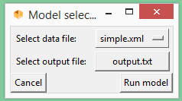

- In VUEE udaemon, from the drop down resource list select ROAMER and Connect, select PANEL and Connect:

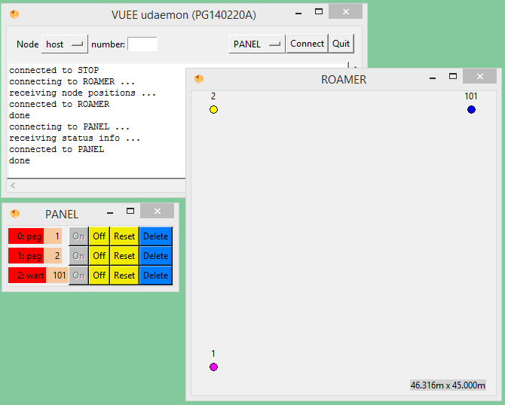

- Right-click on node 101, choose UART (Ascii), same with node 2:

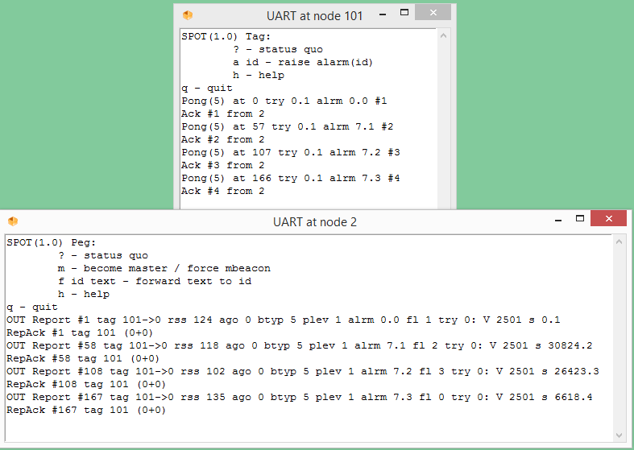

... and so on. Quick Start ends here, as we need to plunge into details.

The functionalities outlined below purposefully differ from the AlphaNet specs. The main reason is to underline details that are needed for ad-hoc networking and to clarify exceptional scenarios. However, the functional conformance to the AlphaNet spec is almost trivial to achieve. In other words, AlphaNet specs define a proper subset of what's outlined below. We don't claim that the extensions are mandatory or even needed. However, we do believe that experimenting with the model described here clarify details and allow investigation of exceptions that would be difficult to trigger or even rigorously define, without it.

Tag functionality

In the simple illustration, tags are WARSAW nodes (wart – warsaw tag) with ASCII UART interface. CHRONOS is available (in another, more involved model), AP319, AP320 with binary UART will be supported very soon, if so desired also in the model available to AlphaNet works at AT. Buttons, LCDs, LEDs, buzzers are present where necessary, but omitted in this introductory writeup.

When Tag is switched on, it sends out a pong packet with board-specific sensor info, status quo, etc. Also, a random alarm generator is started. This generator issues alarm #7 with probability 1/2 every 50 – 59 seconds, regardless of the node status. [This is purely for scenario verifications, useful in some and annoying in other scenarios. Obviously, this functionality doesn't belong to the end-user i/f, but for system testing it may prove to be very convenient. If so, we should have the alarm frequency and randomization configurable on the UI.]

Pong's freq. (tag's heartbeat) should be configurable in the final solution, or even self-controlled, described by the specs (e.g., it may increase for location tracking near areas of special interest). For now, the pongs go out at start and 60s after last pong or alarm was initiated. Tag sends out the packets with 3 retries spaced 5s apart, with variable power output. [This is in clear disobedience to the AlphaNet specs, but is necessary to trigger and verify some important scenarios. We simply don't click fast enough.] After each TX, RX is open for up to 2s, to be closed on the ack arrival.

If an alarm is issued (with the a command), it resets the heartbeat and is queued for TX immediately. If an alarm is issued during previous packet (pong or alarm) processing, it is queued to immediate TX after the current packet is processed (retried and dropped, or acked). Two last alarms are queued; i.e., if more are issued during a single packet processing, only last two are transmitted. (The 2 is just the size of a circ. buffer with overwrites, trivial to change if needed.)

All packets addressed to and sourced at tags are proxy messages (not to be forwarded). Tags don't forward at all. Parameters:
5s – span between retries (should be shortened and randomized 1-3s in target application)
2s – time RX opened for acks (may be shorten to 1 but note that in regular cases RX is off earlier, after ack arrives). I don't know what percentage of “late acks” arrive in the 2nd second, and am not concerned enough to verify that in the deployment's environment. I'd vote for 2 but 1 is as good. If this makes any difference, likely we have other RF problems with node density or EM noise.
0x7531 – vector of output power levels (encoded as subsequent hex digits, 7 is max). (Variable power is not needed unless we go for location-based features.)

From our experience, although these parameters should be thoughtfully chosen for a given application or even the deployment site, none of them should be user-configurable.

UI:

SPOT(1.0) Tag:
? - status quo
a id - raise alarm(id)
h - help
q – quit

Oversimplified menu. ? (in fact, any unrecognized character returns the node status, also simplified (for now):

x
Node 101 uptime 0.0:6:33 mem 4256 4168
Attached is node 101, up for 0 days, 0 hours, 6 minutes and 33 seconds. Current free memory is 4256 words (8512B), ever low so far has been 4168.

This is a typical flow if the model is left alone:

Pong(5) at 61 try 0.1 alrm 0.0 #2
Ack #2 from 2
Pong(5) at 121 try 0.1 alrm 0.0 #3
Ack #3 from 2
Pong(5) at 167 try 0.1 alrm 7.1 #4
Ack #4 from 2
Pong(5) at 227 try 0.1 alrm 0.1 #5
Ack #5 from 2
Pong(5) at 281 try 0.1 alrm 7.2 #6
Ack #6 from 2

Last pong (board type 5) sent 281 seconds after boot, try 0 at power level 1 is in fact alarm #7 with “alarm seq. number” 2. The tag's private reference # was 6. It was acked (#6 matches) from node 2.

A few comments:

Alarm #7 was generated by randal, a process generating randomized alarms mentioned above.

“alarm seq. number” is a static counter (mod 16) increased every time an alarm is raised. It is carried also in alarm-less heartbeat pongs and goes all the way to the master. It is a convenient tool to assess completeness of data at the OSS, or out-of-sequence reports.

Device type is clearly redundant here, even if it is needed at the master or OSS to decode the payload.

Notably missing is the local / global selector from AlphaNet. If the models are accepted as our tool of choice, we'll implement switches & jumpers as convenient separate objects. Same goes with dials on AP319.

LEDs are not functional in this model, for clarity.

Peg functionality

At boot, the peg (e.g. AP321) opens the receiver, sets output power level to 7 (max) and master_host to 1. It also starts a process to monitor and retry unconfirmed reports. Networking (TARP) parameters are set:
- full packet trimming (DD, SPD caches),
- static topology (route recovery will be slow, but practically it is not needed at all),
- no slack for suboptimal routing (in target deployment slack is likely be 1 unless node density generates natural redundancy),
- forwarding ON,
- no hop-by-bop implicit acks (They may be needed if the “hop radius” of the deployment is high or the density is low. They should be used also if there are no explicit end-to-end acks for multihopping reports.)

Node 1 (master by default) switches forwarding OFF and starts the master beacon, instead of the report monitor. Also, it blocks the pegs. This “peg blocking” is a flag that makes the node deaf for pongs. This way, we may designate selected nodes in dense deployments to be pure forwarders, standby nodes, etc. Here, we use it to make at least one meaningful intermediary between the master and tags. So, the master does not hear tags at all.

After a pong (alarm or not) reception, the peg sends back the ack, constructs a report message and sends it multihopping to master, and “interprets the report” to the UART. This interpretation depends on the UI i/f, and is very similar to what a tag does with pong messages. Let's see:

tag:
Pong(5) at 1234 try 0.1 alrm 7.13 #15
Ack #15 from 2
results in on the peg's UART in this:
OUT Report #5153 tag 101->0 rss 107 ago 0 btyp 5 plev 1 alrm 7.13 fl 3 try 0: V 2501 s 61399.95
RepAck #5153 tag 101 (0+0)

So, the Report went OUT (we'll see very similar data on the master, with IN) with ref #5153 (we use uptime, but it may be a static counter if alarms from the same tag should be distinguished with a subsecond granularity. Source tag is 101 (->0 is meaningless, just to maintain common format with the master's OSS i/f). RSSI 107 is measured on this node. Ago 0 denotes the original event's time (note that we ignore potential tag retries that can add up to a few seconds). If the peg doesn't receive the ack from the master, the report will be resent with 'ago' set accordingly. [I understand that AlphaNet doesn't require these report retries, but I would suggest to reconsider this, unless wired connectivity is always present and reliable.] To continue: the alarm came from board type 5, sent with power level 1. Alarm is #7 sequenced as 13th. 'fl 3' is meaningless here, the alarm came in at 'try 0' (first). Board-specific payload follows. For board type 5 it is the voltage 2501 and two 2B integers – first a random value generated for each alarm, the second is a ++index (61399.95). All these are illustrative placeholders for various sensors.

Report Ack copies the ref# and the tag id, removes the report from “watched reports list” and shows that the list has 0 alarms + 0 non-alarm outstanding entries to resend to the master.

On the master (node 1), the same event triggered by tag 101 is reported as:
IN Report #5153 tag 101->2 rss 107 ago 0 btyp 5 plev 1 alrm 7.13 fl 3 try 0: V 2501 s 61399.95

The only difference beside IN direction is the 101->2 indicating node 2 as the forwarder.

We are going over very simple scenarios, where some of the attributes seem to make little sense. In a real setup, they gain on weight, especially at the sink node and the OSS handling many nodes.

Any node can become the master upon the m command from UART. Note that some racing may occur if the timing is unfortunate. However, the m command issuer can check local effect at any time, redo m command, or rely on master beacons. m on the master triggers a single beacon broadcast. Regular beacon goes out every 10x randomized 58-62 seconds. [It is tempting to change the master id on each node via UART, especially if wired connectivity is available. It doesn't seem right in any but exceptional scenarios: either the RF network (only there the master has a meaning) can do it, or there is little sense in the very notion of the master. So, such a functionality may be implemented for exceptions but not used routinely. Also, note that the “natural” way of master id propagation sets the privileged caches on its way – this cannot be done from command line.]

Master change is a relatively complex operation on a deceivingly easy trigger. Abdication, coronation, flooding broadcasts, network-wide updates, all together are not a light operation. It definitely should not be part of routine procedures, even if it seems to be working flawlessly. Of course, in the simple model it has no network-related complexity and can be examined in quite a few interesting scenarios. (Note that ROAMER paints the master node in magenta (purple, if you ask a man... well, a normal man), just for fun. Try m on node 2.

Command f implements an approximation of relays from the AlphaNet specs. Nearly whole command line is sent (multihopped) to a destination or broadcast. No multicast. [Again, in a large network, this is a complex operation on a trivial trigger. If justified as a routine operation, it may have a max hop count as a parameter, so packets potentially “against the natural flow” don't bounce around until their TTL expire. Sporadic triggers are OK without it, and we can verify their impact in any network & scenario, with the tool we're introducing here.]

UI

SPOT(1.0) Peg:
? - status quo
m - become master / force mbeacon
f id text - forward text to id
h - help
q – quit

As for tags, any unrecognized character returns the node status:

y
Node 1 uptime 0.0:25:20 master 1 mem 4260 4134

m
Sent mbeacon
(this was on the master)

m
I am M
(this elevated node 2)

from node 1:
f 2 #2 where are you
OUT FWD #4473 2 [.]

will cause
IN FWD #4473 1 [ 2 #2 where are you]
on node 2.

The whole buffer, less the f, goes out, just for illustration. If you do this (and other things) a few times, you're bound to have thoughts alike “hey, I'd like to see hop distance from the sender, as part of the output.” The hop count and a lot of other things are available for the price of cluttering the OSS.

Conclusions, thoughts

What is presented here, barely introduces the “applied VUEE” introduction, not to mention VUEE proper. We refrain from lingering on more involved scenarios; they're more fruitful when discovered in experiments...

Can't resist: please design a test case for queueing alarms at tags, with real HW and RENESAS i/f. Design it and execute the test case.

Here:
- In the PANEL, switch off node 2.
- Issue a1, a2, a3, a4 commands to 101, quickly.
- Switch on 2. Enjoy dynamics of a1, a3, a4... or inserted a7 if randal sneaks in.

The same source code drives the model and is turned into MSP firmware. Additional work goes into model and scenario creation.

There are other resources to examine, see the snapshots below:

Want to see power budget on heuristically accurate operations over 2 years? Look at the PTRACKER.
Buttons, pins, dials, jumpers? - PINS.
Sensors? - SENSORS
LEDs? - LEDS

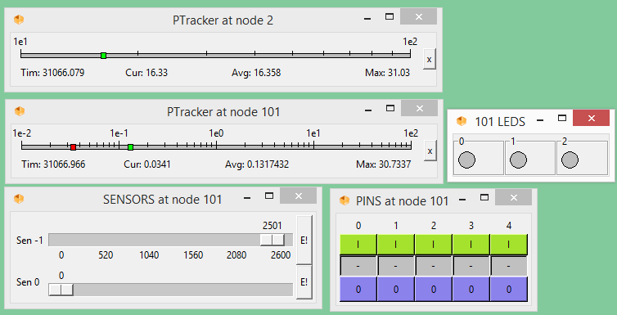

Business angle: Obviously, we're at Olsonet are best suited as users of our modelling tools, in the middle of development cycle: detailed design, implementation and verification. However, the very same tools can be used for marketing, pilots, prototypes and, on the other end, for support and maintenance (e.g., analysis of intended upgrades). It would require personal and monetary efforts to transfer the knowledge and maintain the tools, but it may be a worth the effort.

