

ExperiNetting



Version 0.1
February 2013

Proprietary and confidential, for internal use only

Introduction
It happened that Netting, especially its ODR, is convenient for diverse experiments within Combat's R&D projects. Here, I'm trying to illustrate its application to a few aspects of RSSI-based location engine. Although many times we attempted at gathering data, its analysis, some conclusions, etc., we've never produced satisfactory results and were not able to preserve an interesting partial outcome for continuations.

This is a living document. Experiments and data are recorded elsewhere, but (hopefully) will be referenced here.

Ingredients

LOCATION engine
Designed a while ago, scarcely used since. It is this project's main tool, and the main subject at the same time. The goal is to evolve its algorithms and interfaces into a combo-tool for surveys and tracking, used by dedicated praxes, but also by optional side-functionality available for PicOS praxes.
PICOS\Linux\LOCATION
doc_120103.odt

VUEE / SEDATIVE
Although all, in this initial version, is produced in VUEE, its role is not nearly as exposed, as it should be. Server-based VUEE or its mirroring cousins are envisioned to be central for location-aware applications run in PicOS. All pertinent hardware setups will be modelled in VUEE, with its channel models derived from real readings.

Netting
We (ExperiNetting.odt) are in the exp sub-directory, with all data files referenced here:
PICOS\Apps\PROPRIETARY\inProgress\netting
Netting.odt describes the praxis, but it is addressed to a different audience and interests, However, novice experimenters may find it useful.

Root experiment (VUEE)

In this experiment, we use the combat10.xml data set that consists of 10 (peg) nodes mimicking nodes to be deployed at Combat's HQ (CHQ) and one (tag) “querying node”:

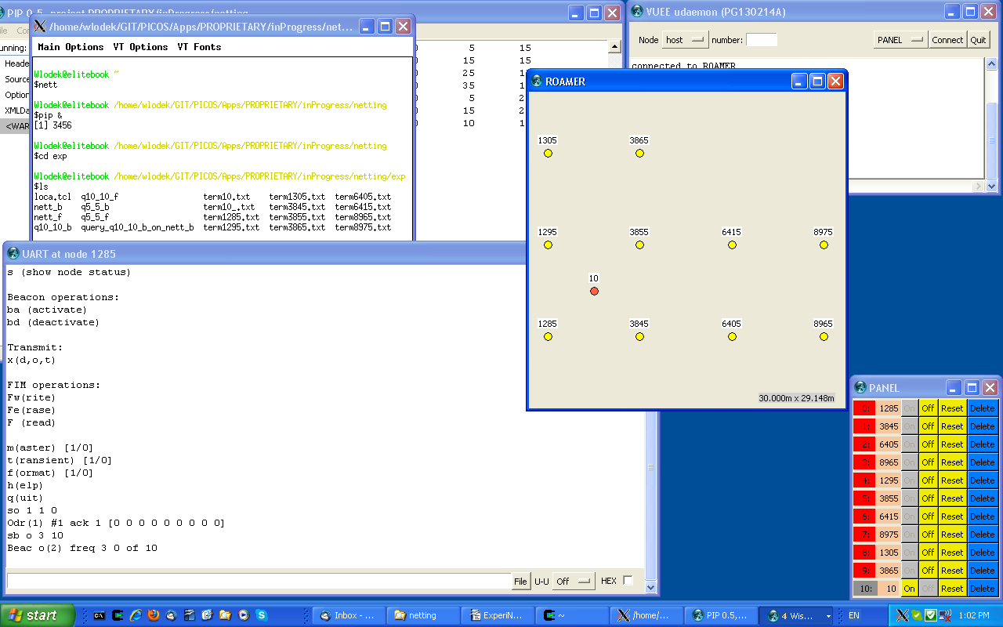
All run at defaults from git. For each node but #10, open UART and log it to term*txt. Issue:
so 1 1 0
sb o 3 10
ba
and observe a session of 1-hop ODRs. They're nicely visible in ROAMER, via the highlight feature. Close (Stop) the log at the end.
After logging the consecutive ODR sessions for the 10 nodes, we get 10 term*.txt files.
mkdir my_exp
cp term* loca.tcl my_exp
cd my_exp
./loca.tcl term* nett
Resulting nett_b and nett_f are directly employable as points.db in LOCATION/TEST.
cd ..

Switch ON node 10 (via PANEL), connect UART, open log. As before:
so 1 1 0
sb o 3 10
ba

Stop logging, move the node over node 1285, repeat the session, this time logging to term10_.txt (previous one so in term10.txt).
./loca.tcl term10.txt q_10_10
./loca.tcl term10_.txt q_5_5
will produce files q_10_10* and 1_5_5* suitable to feed LOCATION's queries, query_10_10_on_nett_b shows the results. The only update, in reference to git, was done in param.xml, where tag in <dis> was set to more realistic -230.

Start here

Obviously, the partial results presented here are unsatisfactory, but we just want to invite to a methodic process to:

- Capture real rssi data and shape survey tools. Very shortly, we'll have the CHQ mapped and mirrored in a channel model.

- Verify LOCATION algorithms. They were never trustfully tested and have great potential in their flexible design. However, only experimental data can drive the changes and verify results.

- After the location engine works “by hand” on experimental data, channel modelling in VUEE should follow the findingsand allow realistic, even if somewhat idelistic, runs of loaction-aware praxis.

- VUEE / SEDATIVE interfaces should be defined to offer location angine as its add-ons (not necessarily integrated with the rest of resources).

