

Seawolfie

demonstration

Technical Note

Version 0.5
April 2011

© Copyright 2008-2011, Olsonet Communications Corporation.
All Rights Reserved.

TOC

Seawolfie 1
Introduction 3
Requirements 3
Functionality 4
Demonstration 7
Equipment 7
Matchmaking 8
Networking 11
A simple VUEE model 11
Noombuzz provisioning 14
Comments and thoughts 18

Introduction

This technical note outlines the Seawolfie demonstration prepared as a 'variation on the theme' of the requirements from Combat Networks. The requirements and the software sketch that implements them should be viewed only as a rough articulation of relevant fragments of the Seawolf project. Hopefully, a posteriori they'll be seen as seminal works leading to a successful application. Therefore, this note is intended only at audience active within the Seawolf project.

Although we're scratching the overlapping areas of ad-hoc communities, mobile groups and anonymous security enforcement, we refrain from digressions from our focus. Appearance of the noombuzz site anchors the functionality to the specific setup and should help to envision crucial details and inspire additional functionality. That's the main goal of the Seawolfie demonstration: aid in articulation and implementation of hardware and software details of the first version of the functional seawolfie device in particular and the Seawolf application in general.

The Requirements section has come from Combat Networks.

The Functionality section is a dry outline, likely difficult to read prior to the actual demonstration.

The Demonstration section studies a functional demonstration. As a side effect, we present our Virtual Underlay Emulation Engine (VUEE) in action, touching on its tremendous potential as a development and maintenance tool.

The Comments & thoughts section has a good title; since nothing is firm yet, we share a few points that may be not that evident at first sight.

This document is evolving and its form is somewhat inconsistent; chronological rather than based on merits. Noombuzz is a case in point: this pivotal functionality is a mere add-on in this document.

Fast-forward to 2011. The path concerned with a dedicated device (Seawolfie) was explored within the YEP project; we have verified that the required functionality is feasible, although pushes tiny resources available on the EMSPCC11 to the device's limits. A dedicated device has unique business virtues, by definition absent from general-purpose devices, even if they're accompanied by “Seawolf adaptors”. However, the upfront production cost of such device is not justified without a hard business case for demand of thousands of nodes, which is not likely to materialize without these thousands readily available.

We intend to break this circular dependency with real-life pilot deployments of functional tandem: a general-purpose device (Android-based smartphone) as the “Seawolf personal presentation device” (SPPD) and “Seawolfie dongle” (SED) that enables ad-hoc networking. A Bluetooth (BT) link binds the devices.

The very first design (Matchmaker or Mm) defined what accounts for blueprints for specific social networking later dubbed Seawolf. In YEP, it was trimmed down and equipped with a specific UI (LCD, buttons, joystick). For the works on Seawolf tandem device (let's call it Seatan), we use Mm as the springboard; it is very convenient to replace serial interface with BT, much easier than a functional conversion from YEP.

This increment (v. 0.5) describes a simple initial adaptation for the BT link, just enough to shape the SPDD. A separate document will describe the SPDD itself. Expected but minimal functional adjustments beyond the interface Seatan will need, will be presented here in the next iteration, if this experiment yields expected results.

Requirements

- Identify other devices in the area (30-50 ft)
- Read other devices memory to determine commonalities in each other’s databases
- Database information (database includes First name, picture (in future versions), and 3-5 user selectable “passions”)
- Signal both hardware devices (vibrate, light, sound) that a commonality has been found
- Allow users to accept or reject the offer to share information
- Upon Acceptance allow users to view some database information (first name, picture, area of commonality)
- Upon Rejection, send sorry I’m busy message
- Allow users to grant other information in the database to be transmitted (future version)
- Indicate direction and approximate distance between devices and display as a compass or directional arrow on screen (future version)

Functionality

Although implemented functionality approximates the requirements, it truly is a variation on the theme. We don't strictly follow the requirements for these important reasons:

- Somewhat reversed approach highlights the process of forming ad-hoc communities, where members remain anonymous until they decide to reveal their identities and lift privacy to a selectable degree, within a selected group. Note that noombuzz-based provisioning moves part of this functionality elsewhere, but the ultimate choice is still in the user's hands.
- Although the main functionality requires only proximity communication, we do believe multi-hopping networking sooner or later will stand out as an attractive differentiator.

The setup: a large multi-threaded conference. At the registration, participants receive badge-like devices, in shape and weight comparable to secure ids... This would be ideal, but likely not that feasible. The devices have a rustic user interface (UI): 2-3 -line LCD, RGB LED, a couple of buttons. The device has a mini-USB interface. All public PCs at the conference run an applet that is able to communicate with the badge via USB, temporarily extending the UI. Also, USB Bluetooth dongles are available for rent. They enable the extended UI not only on the PCs, but also on PDAs, cell handsets, mobile tablets, etc. Free applets are available for popular mobile platforms.

Graphical LCD became a hard requirement for the envisioned functionality. It is not clear yet if it'll be the only LCD, not if it can be accommodated on devices derived from our experimental hardware (the EMSPCC11 node).

Each device has a unique and constant identifier. The devices are flashed with data provided by participants prior to the conference, directly on the noombuzz site, or indirectly via the conference organizers. All is settable through the extended interface at any time, but the organizers may want to set desired defaults. This is important, as clever and unobtrusive advertising of local businesses may be a good incentive to install and maintain such a system.

The attributes involved in matchmaking:

- Nickname: a brief and mnemonic identifier (e.g. first name).
- Description: Ideally, it depicts appearance, a prominent feature, etc.
- Business description: Business card content, main research interest, employer's profile.
- Private description: Hobby, spontaneous desire, private contact data.
- Alarm description: Unlikely to be set a priori, it enables multi-hopping communication within already established communities.
- Profile: List of several well defined interests, features, topics, local venues. For the demo the attributes are binary (interested / applicable, or not).
- Include: A match is attempted between the receiver's Include and sender's Profile, so at any time Include should describe current preferences for follow-up interactions.
- Exclude: All incoming Profiles are discarded if matched against Exclude.
- Noombuzz list: The list of ids, dispositions, and additional information downloaded from the noombuzz site. The ids on the list are handled according to the associated disposition without further consultations.
- Monitor list: The list of ids the user wants to communicate with, not necessarily when in the range. In other words, this is the list of members of established communities the user is a part of. Note that these are ad hoc communities formed at the event, not necessarily related to noombuzz communities.
- Ignore list: The list of ids to be ignored as senders.

The demonstration will make all the details more palatable, here we can offer only dry descriptions. For the demo we use an ASCII terminal, pretending to be the extended user interface. For the rustic i/f on a final device, display likely will be scrolling on LCD, triggered by a user request. Event notifications will be signaled via LEDs, buzzers, etc.

Let's assume that the matchmaking data is seawolfies reflect users' preferences.

When switched on, the device sends periodic messages with its identifier, the owner's nickname and profile. The receiver and beacon are ON, unless switched off on the user's request.

- Received 'profile msg' is checked against the 'Noombuzz list'. If the sender is on the list, the message is handled as prescribed in the associated disposition. Otherwise:

- Received 'profile msg' is checked against the Ignore list. If the sender is on the list, the message is dropped. Otherwise:

- Incoming Profile is checked against Exclude properties. If any matches, the message is dropped. Otherwise:

- Incoming Profile is checked against Include properties. If none matches, the message is dropped. Otherwise:

- Sender is checked against the 'tag list'. This is a highly dynamic list with all current potential contacts, and with all persons the owner is interacting with. If the sender is not on the list, it is added there. Otherwise, some of the attributes are updated. (More is happening behind the scenes, as this list's maintenance is pivotal for a healthy application. De-bouncing of nodes flickering at the reception range is a good example of an important but not that obvious feature.)

There are commands to maintain all the lists, to display pertinent info, and to handle the intended flow of interactions. Let's go with a common chain of events:

The user displays the 'tag list', and picks an entry. The 'Y' command accepts the sender, and replies
with the user's Description. The 'N' command moves the sender to the Ignore list.

After the 'profile msg' is accepted, at least one side should be able to physically locate the other, and start conversation. Private or business data exchange may follow. The actual flow of events and exchanged information will vary, as all depends on spontaneous user decisions.

Alarms, although they may be used within any established community or for multi-hopping point to point communication, are primarily meant to organize conference participants into groups according to the conference threads, workshops, social events, etc. -- they provide efficient (group-targeted) event notifications. Incoming alarms are checked against the Ignore and Monitor lists first. If the sender is not there, the usual profile matching occurs.

The noombuzz site is designated as the main (possibly: exclusive) interface for the Seawolfie provisioning. Rich web-based functionality, abundance of relevant data and flexible selection methods make it the ideal tool to prepare most of the configuration data loadable via a PC-USB interface. However, in this version we keep the 'event data' and 'noombuzz data' complementary, in hope to uncover still hidden but attractive functionality. We'll consolidate into a consistent approach in the next iteration. Let's take a look at the demonstration and more details:

Demonstration

This section is not meant to be a comprehensive guide to the implemented functionality. Instead, we aim at giving the reader an orientation tour only.

Screen snapshots were taken from the demo running under VUEE, but the functionality and her implementing code are identical on the network of the EMSPCC11 nodes. The actual demonstration should include this presentation within VUEE, followed by a similar setup with physical nodes. We will deal with four nodes only, but larger configurations are likely to be studied before good requirements and competent hardware design decisions can be articulated.

Equipment

Four Olsonet's general experimental board EMSPCC11 and their hand-assembled variants are used for the demonstration:

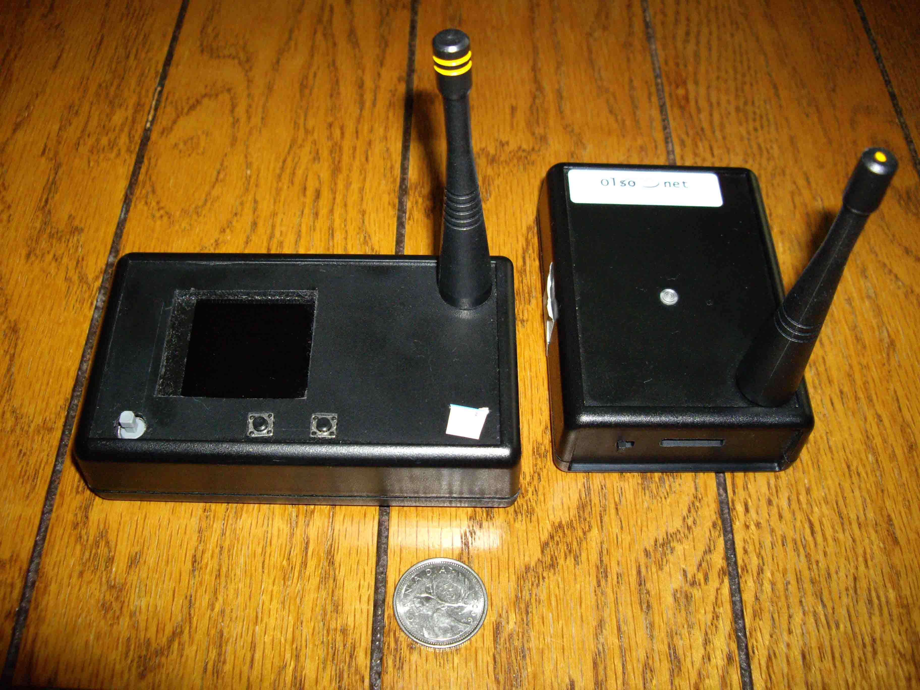

Essential components of the EMSPCC11:

- MSP430F1611 microcontroller: <http://focus.ti.com/docs/prod/folders/print/msp430f1611.html>
- CC1100 RF module: <http://focus.ti.com/docs/prod/folders/print/cc1100.html>
- On board data storage: <http://www.atmel.com/dyn/resources/prod_documents/doc3443.pdf>

Hand-assembled variants with two buttons, joystick, graphical LCD and buzzer are used to build skeleton PicOS drivers and verify the resource requirements. The pilot version of the application is likely to run on those boards, possibly after some further modifications.

Matchmaking

The designers will be surprised how much innovative thoughts may be implemented for organizing this seemingly trivial functionality. True profiles will be much more elaborate, and the matching likely will employ fuzzy algorithms. For the demo, we deal with simple bitmaps and bitwise AND operations.

It is yet unclear how much of the selection and profiling can be performed on the noombuzz site, either prior or during the event the Seawolfie devices are deployed for. If this is the only required provisioning interface, most of the structures described below disappear, delegated to the noombuzz site. The 'Noombuzz list' is prepared and downloaded to the device, and the matching is reduced to id comparisons. However, we keep the functionality independent from noombuzz for now, calling this part of the setup 'event data' as opposed to 'noombuzz data' from the 'Noombuzz list'. One can easily nullify 'event data' by clearing Include vector or setting Exclude to 0xFFFF. Similarly, empty (not downloaded) 'Noombuzz list' leaves only 'event data' operational.

Even if Noombuzz is the only provisioning interface, the functionality below should be contemplated, as that way or another id classification via profile matching or other criteria must be performed somewhere.

Let's study 'event data' first:
Each Profile (same goes for Include and Exclude lists) is a 16-bit map of binary choices. We arbitrary divide them into four categories four choices each, as depicted below:

visiting local female male
Personal

personal professional volatile solid
Profile

thread 1 thread 2 workshop A workshop B
Professional

squash bridge pm trip bar
Volatile

cinema outdoors piano music
Solid

Let's look at the data pretending to come from questionnaires, set for the experiment in the simm.xml configuration file (simm stands for simple matchmaker):

<node number="0">
<location>5.0 5.0</location>
<preinit tag="HID" type="lword">0xBACA000A</preinit>
<preinit tag="NICK" type "string">Alice</preinit>
<preinit tag="DESC" type "string">white blouse</preinit>
<preinit tag="DBIZ" type "string">Ala Inc.</preinit>
<preinit tag="DPRIV" type "string">613-111-2222</preinit>
<preinit tag="PROFI" type="word">0xAF26</preinit>
<preinit tag="PINC" type="word">0xFFFF</preinit>
<preinit tag="PEXC" type="word">0</preinit>
</node>

This node is visible in the simulator as 'Node 0', located at (5, 5) on the Cartesian plane. Its hardware id is 0xBACA000A, of which two least significant bytes form the logical identifier 10 used for all communications. The user nicknamed Alice chose “white blouse” as her initial description, “Ala Inc.” as business data, and “613-111-2222” as her bold private cue. She describes herself as a visiting female, professionally interested in all choices,. She is interested in the afternoon trip organized for the conference participants, and if she wants to talk about her true interests, she'll talk about piano music or Himalayan trekking (outdoors). She want to talk to all, and excludes nobody.

Now one should be able to decode Bob's (11), Cat's (102) and Dog's (103) settings as well.

<node number="1">
<location>15.0 5.0</location>
<preinit tag="HID" type="lword">0xBACA000B</preinit>
<preinit tag="NICK" type "string">Bob</preinit>
<preinit tag="DESC" type "string">tall, red tie</preinit>
<preinit tag="DBIZ" type "string">Bombardier</preinit>
<preinit tag="DPRIV" type "string">room 666</preinit>
<preinit tag="PROFI" type="word">0x55F0</preinit>
<preinit tag="PINC" type="word">0xFFFF</preinit>
<preinit tag="PEXC" type="word">0</preinit>
</node>

<node number="2" start="off">
<location>5.0 15.0</location>
<preinit tag="HID" type="lword">0xBACA0066</preinit>
<preinit tag="NICK" type "string">Cat</preinit>
<preinit tag="DESC" type "string">nice paws</preinit>
<preinit tag="DBIZ" type "string">Mice Exterme</preinit>
<preinit tag="DPRIV" type "string">on March break</preinit>
<preinit tag="PROFI" type="word">0xE0FF</preinit>
<preinit tag="PINC" type="word">0xFFFF</preinit>
<preinit tag="PEXC" type="word">0x2000</preinit>
</node>

<node number="3" start="off">
<location>15.0 8.0</location>
<preinit tag="HID" type="lword">0xBACA0067</preinit>
<preinit tag="NICK" type "string">Dog</preinit>
<preinit tag="DESC" type "string">big jaws</preinit>
<preinit tag="DBIZ" type "string">Hunt Extreme</preinit>
<preinit tag="DPRIV" type "string">whistle high C</preinit>
<preinit tag="PROFI" type="word">0xF014</preinit>
<preinit tag="PINC" type="word">0xFFFF</preinit>
<preinit tag="PEXC" type="word">0</preinit>
</node>

All this is arbitrary and for illustration only. As already said, a good general frame for the matchmaking profiles won't be that obvious to forge.

Networking

We employ four nodes. When switched on, they broadcast 'profi msg' messages with frequencies spread between 2 and 4 seconds. All other messages are triggered by users. The messages are relatively long, as they contain strings of characters. However, most of them don't multi-hop.

The typical setup will have a high density of nodes, so 'listen before transmit' (LBT) is essential. Also, transmitters should operate on minimum power levels, to cut down the range and interference. For the demo, we set the data rate to 200K bps, to shorten the range to 5-6 meters.

We believe that multi-hopping functionality (here it is just alarms, but much more attractive features can be borrowed from our other blueprints) eventually will become popular, so for a large gathering it may be prudent to switch off forwarding on the user nodes, and set up a quasi-infrastructure with dedicated forwarders, appropriately placed to cover the venue with good and redundant data paths.

The infrastructure-backed setups are discussed in a separate document within the Seawolf project.

A simple VUEE model

The following snapshot comes from the VUEE emulation of the network:

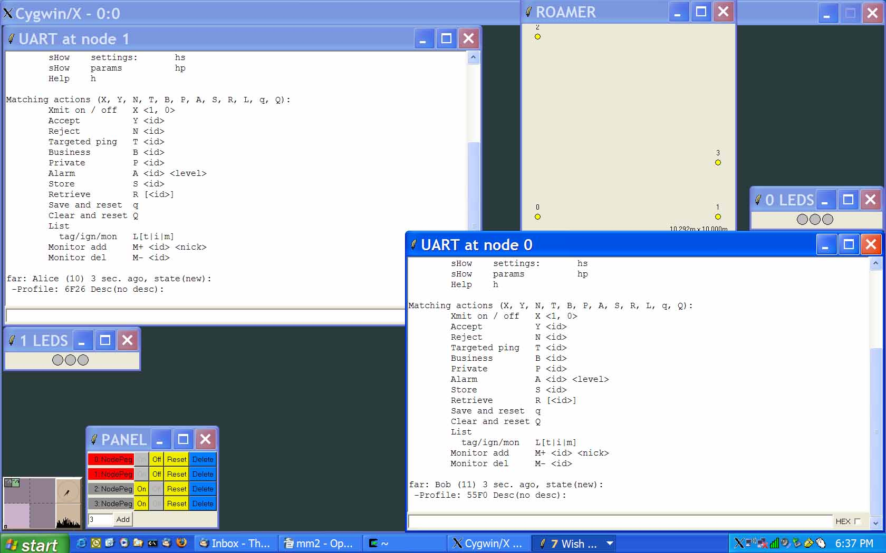
The four nodes are visible in the ROAMER window, the PANEL shows that only Alice's and Bob's are ON, and their extended UIs are in UART windows. LEDS are shown as well. We outline basic operations and their results using this setup.

At startup, the menu is displayed (no noombuzz here, for clarity):

Set / show matching (s, p):
nickname: sn <nickname 7>
desc: sd <description 15>
priv: sp <priv desc 15>
biz: sb <biz desc 15>
alrm: sa <alrm desc 15>
profile: pp <ABCD hex>
exclude: pe <ABCD hex>
include: pi <ABCD hex>

Help / bulk shows:
sHow settings: hs
sHow params hp
Help h

Matching actions (U, X, Y, N, T, B, P, A, S, R, L, q, Q):
AUto on / off U [1|0]
Xmit on / off X [1|0]
Accept Y <id>
Reject N <id>
Targeted ping T <id>
Business B <id>
Private P <id>
Alarm A <id> <level>
Store S <id>
Retrieve R [<id>]
Save and reset q
Clear and reset Q
List
tag/ign/mon L[t|i|m]
Monitor add M+ <id> <nick>
Monitor del M- <id>

The first section sets the attributes we've already discussed. If a command appears without an argument, it is interpreted as a show request, e.g. sn is 'show nickname'.

The next menu section is about bulk shows, divided into two parts. The actual output is the best introduction:

hs
Nick: Alice, Desc: white blouse
Biz: Ala Inc., Priv: 613-111-2222, Alrm:
Profile: 6F26, Exc: 0000, Inc: FFFF

hp
Stats for hostId - localHost (BACA000A - 10):
Freq audit (4) events (4) PLev (1) Time (898)
Mem free (788, 788) min (0, 0)

In the hs output we should recognize the data used for matchmaking, hp shows a few of the basic node's parameters we'll ignore for now.

Since Bob and Alice are in the range, they immediately see each other's pings. Alice sees Bob's data:

far: Bob (11) 3 sec. ago, state(new):
-Profile: 55F0 Desc(no desc):

Bob (id 11) is 'far' (2.5 – 5 meters away), he appeared about 3 seconds ago with the 0x55F0 profile, and no description. Should Bob switch off the beacon (or the badge), or walk away, after a short while Alice would see:

far: Bob (11) 0 sec. ago, state(gone):
-Profile: 55F0 Desc(no desc):

Two of the features not announced yet have become visible: rough distance estimation, and maintenance of the nodes in the immediate neighborhood reflected in the 'tag list'.

As already mentioned, we set the nodes to have the RF range of about 5 meters. Rough but useful distance estimations based on the RSSI, are far (2.5 – 5), near (1.2 – 2.5), and proxy (0 – 1.2). How good this can be on the final hardware and how it may be extended to show directions, remain open issues.

More complex algorithms are applied for a reasonable maintenance of the neighborhoods. Several states are introduced (new, reported, confirmed, matched, gone), separated by corresponding 'fading' states, all for a balance between two extremes: incessant reporting of all events, and a silence broken only on explicit user requests. The former is not practical in majority of realistic setups, the latter can't maintain the context achievable with automatic periodic messages. We believe that the functionality enabled via periodic pings makes a significant difference, therefore this more complex approach is justified.

We've already seen the new and gone states. If Alice replies with 'Y 11', Bob will see:

far: Alice (10) 4750 sec. ago, state(reported):
-Profile: 6F26 Desc(intro): white blouse

Now, if Bob sends back 'B 10', Alice's terminal will show:

far: Bob (11) 0 sec. ago, state(matched):
-Profile: 55F0 Desc(business): Bombardier

Alice would see 'confirmed' state between her 'Y' and Bob's 'B'. Note that the transition to the matched state is considered important enough to reset the clock of the Bob's state. Of course, all these arbitrary choices can be adjusted for a given application.

The autoack feature helps with a meaningful demo with just one terminal. If set, automatic replies are sent for acceptable matchmaking messages. The reply is of the same type as the incoming message and mimics the user responding with the Y, B, or P command. In general, autoacs are useful for end to end reliable messaging.

If we switch Cat and Dog ON and start playing with the nodes in the ROAMER window, we'll see the results, imagine variety of scenarios at a real conference, and be able to check how the system deals with them. There is a wide gap between what is implemented for this demonstration and what will be needed for a real system. However, VUEE enables a comfortable environment for these activities.

The notion of 'targeted ping' is introduced, to signal an explicit desire to communicate. If the user issues the 'T <id>' command, an extra beacon message is sent addressed to the target id. This explicit interest is signaled to the recipient with the “intim” (intimate) label, as below on the Dog's interface:

near: Cat (102) 664 sec. ago, *intim* state(matched):
-Profile: E0FF Desc(private): on March break

As mentioned, alarms signal multi-hopping extensions, and in the demo their output looks like that:

Alrm from Cat(102) profile(E0FF) lev(7) hops(2) for 0:
happy hours at 5

Note the number of hops (2), and 0 as the receiver id (the latter means broadcast).

LEDs may be one of the very few ways to signal events on the actual wearable badge. For the demo, we have the following 'protocol' implemented:

Solid green is on when the node is switched on. If there is at least one entry matched, the green led blinks. If the beacon is switched off, it sets the blue mode, blinking if there is a match on the 'tag list'. Red replaces blue or green for about 4 seconds after an alarm is received and displayed. As so many other details, this is an arbitrary functionality.

Save and Restore move data to and from non-volatile memory, enabling post-collection processing, data archives, or event logs.

Noombuzz provisioning

As said, this is not just an add-on. It may easily replace the Include and Exclude vectors, and the Ignore list. All other data may be downloaded from Noombuzz, obsoleting most of the functionality above, or rather moving data manipulation to the Noombuzz site. Let's look at the current implementation again, this time with the Noombuzz hooks in bold. The startup screen:

***Seawolfie 0.4***
Set / show matching (s, p):
nickname: sn <nickname 7>
desc: sd <description 15>
priv: sp <priv desc 15>
biz: sb <biz desc 15>
alrm: sa <alrm desc 15>
profile: pp <ABCD hex>
exclude: pe <ABCD hex>
include: pi <ABCD hex>

Help / bulk shows:
sHow settings: hs
sHow params hp
sHow event desc he [ABCD hex [ABCD hex]]
sHow nbuZZ desc hz [AB hex {AB hex]]
Help h

Matching actions (U, X, Y, N, T, B, P, A, S, R, E, L, q, Q):
AUto on / off U [1|0]
Xmit on / off X [1|0]
Accept Y <id>
Reject N <id>
Targeted ping T <id>
Business B <id>
Private P <id>
Alarm A <id> <level>
Store S <id>
Retrieve R [<id>]
Erase E <id>
Save and reset q
Clear and reset Q
List
nbuzz/tag/ign/mon L[z|t|i|m]
nbuZZ add Z+ <id> <what: 0|1> <why: AB hex> <dhook> <memo>
nbuZZ del Z- <id>
Monitor add M+ <id> <nick>
Monitor del M- <id>

'Show event desc' is not really noombuzz-related, but added for the event symmetry. One may recall the arbitrary demo settings:

he
event 15 visiting
event 14 local
event 13 female
event 12 male
event 11 thread 1
event 10 thread 2
event 9 workshop A
event 8 workshop B
event 7 squash
event 6 bridge
event 5 pm trip
event 4 bar
event 3 cinema
event 2 outdoors
event 1 piano
event 0 music

Bob's profile is 0x55F0. What it means decoded? Alice can check easily:

he 55f0
event 14 local
event 12 male
event 10 thread 2
event 8 workshop B
event 7 squash
event 6 bridge
event 5 pm trip
event 4 bar

She can also see the match that brought Bob to her device. We recall that Alice's Include is a generous 0xFFFF, but say she is pickier with 0x5010. If she does:

he 55f0 5010
event 14 local
event 12 male
event 4 bar

she'll see maybe not that impressive but true (selected from provisioned data) bonding with Bob.

Similarly with the noombuzz data:

hz
noombuzz 7 night life
noombuzz 6 career
noombuzz 5 blogs
noombuzz 4 looks great
noombuzz 3 last year
noombuzz 2 latin
noombuzz 1 combat
noombuzz 0 olsonet

The data pretend to be downloaded from the noombuzz site. Note the freedom in user's selection, or rather in the classification moved to the web site. We've made the vector 8-bit only, but we expect this width to be good enough for any comfortable setup. Note that an attempt at rigorous and general classification with the 16-bit vector for 'event data' is far from satisfactory. The superiority of the private selection on the noombuzz site over the classification uniform for all participants is clearly visible.

Z+ fakes a single entry download from noombuzz. Let Alice do:

Z+ 11 0 8 0 $50
NBuzz add 11

She says: Bob (id 11) should be ignored (0) because of the noombuzz category 3 (8 = 2^3) 'last year', with memo '$50' attached. If Bob was in the neighborhood, he'll be gone soon despite matching profile, as noombuzz takes priority over everything else:

far: Bob (11) 399 sec. ago, state(gone):
-Profile: 55F0 Desc(no desc):

Let's see the noombuzz list:

Lz
NBuzz imports:
- 11 dh(0) ....|... $50

Note the '|' and '.' showing encoded criteria. This convention is likely more readable than hex numbers for most users, and seems suitable for LCD.

If Alice didn't borrow from, Bob but lent him $50, her noombuzz entry would need this minute correction:

Z+ 11 1 8 0 $50
NBuzz upd 11

that would bring Bob back to Alice's seawolfie:

far: Bob (11) 6 sec. ago, state(new):
-Profile: 55F0 Desc(no desc noombuzz):

Note the noombuzz reference, as easy to cross-check as before:

Lz
NBuzz imports:
+ 11 dh(0) ....|... $50

'+' and '-' are the only dispositions now. 'dh' stands for 'data hook' and represents associated data of possibly large volume, including downloaded or RF-transmitted pictures.

Voluminous data will be the main addition in version 0.5 of this document. If we're lucky, it'll be the Seawolfie 1.0, on well-defined hardware.

Seatan update

As said in the Introduction, we purposefully stay away from changes beyond the BT link's accommodation. Even the BT-related updates are add-ons rather than changes, as it should help us concentrate on the SPPD, wrap the works into an independent unit, and verify the interface's functionality with any serial device and within VUEE.

Input (command, data) remains unchanged. The SPDD will translate its state and user actions into text strings and send them to SED via BT link. Clearly, this is suboptimal, especially for relatively large amounts of preset / downloaded data. However, since it accommodates our current needs, we intend to keep it this simple way. (Note that we have tools like OEPto improve it, should the needs appear.)

Output is modified as follows:

All string templates are gathered in a single file (globals_peg.h) and clearly divided into two groups:
- non-mutable (e.g. welcome screen);
- format-driven, i.e. versioned via conditional compilation.

The versions of format-driven strings are easy to manipulate; also, it is easy to move the templated between the two group. Although it is not enforced, the intended nomenclature calls for the output string
<line1> “\r\n”...<lineN> “\r\n”
to be delivered to the SPPD as
PD_MARK <nn> <line1> “, “ … <lineN> “\r\n”

PD_MARK is #defined in the same global_peg.h and arbitrary nn will switch to corresponding SPPD processing.

For example:

#ifdef PD_FMT

static const char profi_ascii_def[] =
FMT_MARK "05 %s: %s (%u) %lu sec. ago,"
"%sstate(%s), Profile: %x, Desc(%s%s: %s\r\n";

#else

static const char profi_ascii_def[] =
"\r\n%s: %s (%u) %lu sec. ago,"
"%sstate(%s):\r\n -Profile: %x Desc(%s%s: %s\r\n";

#endif

may show the familiar

Lt
Current tags:
far: Alice (10) 30 sec. ago, state(matched):
-Profile: 6F26, Desc(intro): white blouse

or SPPD-directed

Lt
!PD12 Current tags:
!PD05 far: Alice (10) 30 sec. ago, state(matched), Profile: 6F26, Desc(intro): white blouse

if PD_FMT is #defined in options.sys.

Note that the versions are independent of the interfaces and devices in use; e.g. an ASCII terminal can be used on an Android device paired into Seatan with our standard EMSPCC11.

Presence of the appropriate driver is requested via mkmk <target>. WARSAW compiles in the UART, WARSAW_BLUE deals with BT. A single ser_select() does that, driven by compile-time constant set in mkmk.

Comments and thoughts

No particular order in these thoughts and reflections.

It may be that the requested functionality can be achieved with a simpler approach. However, we believe that the presented design has the advantage of being applicable to truly diverse application spaces. Also, we find most of the ad hoc networking applications deceivingly simple to sketch, and disappointingly complex in crucial but initially hidden details.

The actual 'leading customer' or 'target application' must be firmly established very early in the development cycle, as the device's physical characteristics and networking aspects will impact or even dictate fundamental decisions.

Special care must be taken to articulate Seawolfie interactions with existing devices and classical networking. It may be that the best approach is a software add-on to an existing device (Android, Blackberry). Consumer electronics space may be a good candidate to such extensions.

Unless there is a need for interoperability with a priori unknown systems, standards like ZigBee may be harmful. If interoperability seems important, the previous point should be considered.

As physical proximity is an important functional constraint, RF links should be rather short. For the demo, we set transmitters' power level and data rate such that good communication breaks at about 5 meters. Only slightly wider range is advisable for the true application, as short links also help with high density of the nodes.

RSSI is good only for rough distance estimations. Directional antennas or sensors may be used to both distance and directional approximations. However, this is pure and difficult R&D, with unpredictable outcome.

GUI is very important, and novel approaches may be needed. For large gatherings, works on a good OSS, distributed processing, or swarm intelligence may bring forward functionality that will eclipse the original goals.

The device should be designed in a way that signaling within the communities is very convenient through the embedded 'rustic interface', but all verbose info, configuration parameters, and functional links to post-collection data processing should use the 'extended interface'.

Non-volatile memory (NVM) plays an important functional role of the repository of data selected for further processing off the node. Diverse technologies can be employed, each with intricate constraints. Therefore, the NVM should be carefully researched and designed for the target application.

Noombuzz role (e.g. as the exclusive provisioning interface) should be decided as soon as possible, but not hastily; retractions may be expensive.

The RF traffic as well as UI 'load' may be significant in dense deployments. We may want to experiment with large number of nodes with matching profiles, to keep UI functional under the stress. To illustrate:

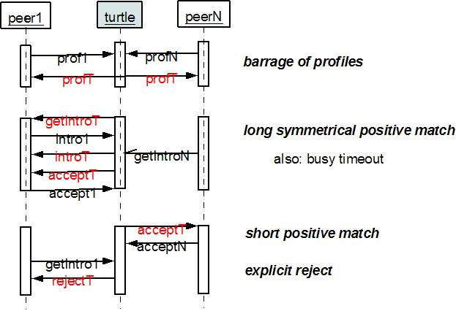

Note that the 'barrage of profiles' is incessant. Network engineering for a given deployment should partition RF channels for picture exchange, site surveys may be needed to optimize (mostly: shorten) the RF range and set pertinent parameters (e.g. LBT). Of course, these considerations are valid for mass deployments, not for pilot runs.

Version (v. 0.3) of this note was titled “Matchmaker demonstration”.

