

E-RTags: Operations



November 2009

This document contains confidential information, which is proprietary to Olsonet Communications Corporation. No part of its contents may be used, copied, disclosed or conveyed to any party in any manner whatsoever without prior written permission from Olsonet Communications Corporation.

© Copyright 2009, Olsonet Communications Corporation.
All Rights Reserved.

Preamble

This document focuses on the operational view of the Extended Routing Tags blueprint and should be read together with “E-RTags: Interface Specification.”

This document is intended for a technical audience familiar with the application space in general and with the informal principles of operations of the target (large) application. It does not provide all the details of E-RTags focusing instead on the most essential (representative) aspects of functionality and occasionally hinting at other (less critical, but possibly interesting) aspects. Although the blueprint itself, in its implementation on the experimental (demo) hardware (EMSPCC11), can be treated as a completely functional application, it is not intended as a production system. In particular, some of the performance characteristics exhibited by the blueprint (being necessarily a rough and generic approximation of the target system) should be viewed as incidental and tunable.

Glossary:

Asset Table The list of ESNs representing the assets currently being assigned for tracking by a Sensor Node.

Beacon Freq Refers to the frequency with which the Master sends beacon messages. This (configurable) frequency also applies to the periodic “new” messages sent by an unbound node before it joins the network.

Binding The procedure of joining the network by a new (so far unbound) node.

ESN Equipment serial number, i.e., a unique and constant 4-byte identifier. All nodes within the network and all assets attached are identifiable by ESN.

Local Host Current node identifier: a 2-byte number unique within the network.

Master The single selected RTag connected to the OSS computer via UART. The OSS computer is called the OSS host or host.

Master Host The Local Host attribute of the Master Node. This 2-byte value is known to every node bound to the network.

Network Id The 2-byte numerical identifier of the network. Can be used to logically separate different networks operating in the neighborhood. A.k.a. Net Id.

Node Id The 2-byte numerical identifier of a (any) node. Local Host is the Node Id of the current node.

NVM Nonvolatile memory (which can be a dedicated EEPROM chip or Flash Information Memory of the MSP430).

OSS Operational Support System. Denotes external software (typically run on infrastructure computers) controlling the wireless network and receiving reports from it. OSSI refers to the interface (protocol) between the wireless network and the OSS. OSS host refers to the OSS computer connected to the Master.

PicOS Olsonet's operating system for wireless nodes.

Praxis The complete functionality (specification) of a networked wireless application. The application constitutes an incarnation of the praxis for the particular hardware; a network of such devices is the application.

Sensor Node A node interfaced to sensors monitoring the status of some equipment. Internally, e.g. in message type mnemonics, 'sensor node' is called 'bridge').

TARP Olsonet's Tiny Ad-hoc Routing Protocol. This is a meta-protocol (driven by an extensible chain of rules) for organizing information exchange in Olsonet's mesh networks.

An overview

The demonstrated praxis implements a sample generic system for asset (equipment) tracking and monitoring. It consists of three dynamically configurable types of nodes (roles): RTags (Routing Tags), Sensor Nodes, and the Master. All nodes are based on the same hardware and execute the same program (i.e., are flashed with the same firmware). Intentionally, there is a single Master node connected (via a UART) to the OSS host. The role of the Master node can be assumed/transferred/taken over dynamically by another node, if required.

The RTag (Routing Tag) role is the default role of an active network node. The remaining two roles can be viewed as special cases of RTags. A Routing Tag participates in the collective action of forwarding packets within the mesh network, i.e., is responsible for maintaining connectivity. With TARP, this responsibility is naturally scalable to the node's opportunities and abilities to help other nodes in this task. The reliability and overall operability of our mesh network does not hinge on the well-being of any single node.

A Sensor Node is responsible for keeping track of some equipment. A single trackable asset is identified via a unique ESN (Equipment Serial Number). In the present network, a Sensor Node receives equipment status via its UART from “asset sensors”. Such sensors can be emulated for the demo by terminals attached to the Sensor Node's UART. A single Sensor Node can be responsible for monitoring an arbitrary number of separately identifiable assets.

The responsibility for monitoring specific assets (tagged with specific ESN values) is assigned to Sensor Nodes by the OSS host. A Sensor Node detecting an unassigned asset will report this event to the OSS host, which may subsequently decide that the asset should be now tracked by the reporting Sensor Node.

Sensor Nodes can be configured to periodically report on the status of the tracked items and generate alarms in certain conditions, e.g., when a registered item does not confirm its “normal” condition within a predefined interval.

In addition to monitoring its assigned assets, a Sensor Node can also report on the status of its ten I/O pins. Two of those pins can be connected to two switches interpreted as a Counter (a debounced counter of pulses) and a Notifier (an event trigger). The remaining 8 pins are ADC-capable and they can be used (optionally and selectively) for sensing analog data.
Operations and functions

- Power-up
- Reset button
- Becoming the Master
- Binding
- Becoming a Sensor Node
- Acquiring or changing the Master status
- Asset registration
- Alarms
- Reliable reporting
- Acknowledgments
- Connectivity
- Encryption
- Duty cycles

Power-up

At power-up, the node reads from the NVM the predefined (default) values of Network Id, Local Host, Master Host, Asset Table, as well as the length of the duty cycle and the I/O reporting date. If the Reset Button is pressed during the power-up, the NVM is erased. A node without an identity (e.g., whose NVM has been erased) starts in an unbound state (see below).

Here is the list of node parameters (not mentioned above) affecting the node's operation along with their default settings. Those parameters can be changed by commands (see “E_RTags: Interface Specification”) from the Master:

- the number of retries for asset status and I/O reporting [3]
- the timeout for report acknowledgment [10s]
- connectivity warning threshold, i.e., the number of missed beacons from the Master after which the connectivity LED starts blinking [3]
- bad connectivity threshold (the LED goes solid off) [additional 4 missed beacons]
- OK status reporting frequency (no alarm) [1h]
- negative status reporting mode [registered ESNs with missed heartbeats]

Defaults are set:
- number of retries for node and sensor status, and IO reporting: 3
- status reporting acknowledgment timeout: 10s
- connectivity warning (number of missed heartbeats from the Master after which the connectivity LED starts blinking): 3
- bad connectivity (the LED is OFF): additional 4 beats
- status reporting frequency: 64 (1h is 64 of 'PicOS seconds')
- negative status reporting (registered ESNs for which status heartbeats have NOT shown up are reported)

Depending on data read from NVM (or lack of it):

Network-less node
If the net id is not set (all 1’s in NVM translate to net id 0), the node sets its node id to LSWord of its ESN, and sends out periodic messages to advertise its presence. The frequency is fixed to 31 seconds, and the message type is msg_new (5). Until the node is bound, it doesn’t participate in any of the network activities other than the binding process. The connectivity LED is blinking fast.

Bound node
With its net id set, the node waits for a msg_master (1) to become a fully functional router / sensor node, but it performs limited routing, and responds to commands from the start. The connectivity LED blinks slow, until the 1st message from the Master that, among other parameters, will set the connectivity data. Note that the node is not aware about the pertinent frequency before the message arrives, so the LED doesn’t turn off.

Master
Connectivity LED is ON, connectivity frequency and the beacon are set to 29s. Note that the Host must send CMD_MASTER to initiate the usual routine.

Reset button
When the button is pressed, after up to 1s the LEDs (all of them) will blink once. If the button is released in less than 4 sec after the blink, the board will reset itself (as after power up). If the button is held for longer, the LEDs will go on, an the board will erase NVM. Then the LEDs will blink 7 times and the board will reset.
CMD_RESET allows various levels of application reset triggered remotely or via UART, the details can be found in the “E-RTags: Interface Specifications” document.

Becoming the Master

Network-less node
The node must receive CMD_SET for PAR_NID, through the UART interface. Optionally, the Host may configure pertinent parameters, i.e. node id, connectivity data, and beacon frequency. CMD_MASTER, usually with broadcast target (0), concludes the operation. Connectivity LED turns solid on.

Bound node
A node becomes the network’s Master upon the CMD_MASTER reception via its UART, with consequences both local (e.g. “FE” messages are blocked), and network wide (routing data change). Upon becoming the Master, forwarding is shut off, but may be explicitly switched on by appropriate CMD_SET.

Notes
This potentially disruptive operation can be made more restricted; however, it also allows flexibility in changing the Master’s physical location, ad hoc arrangements for exceptional conditions, etc.

Binding
If the net id is zeroed, at NVM reset or via CMD_SET, the node sets its node id to ESN’s LSWord, and sends msg_new (5) proximity messages every 31 seconds. All bound nodes in range construct msg_bindReq (6) messages, and send them to their Masters (note that more than 1 network may be operational, and that a master-less node does nothing upon hearing msg_new). The Master outputs the message content to the Host. The Host issues a CMD_BIND that travels back to the indicated node (or is executed on the Master, if it received the msg_new directly). Execution of CMD_BIND sends out msg_bind (7) with indicated range (usually, 1 hop), carrying all information needed for binding. After processing it, the previously network-less host becomes a fully functional member of the network, temporarily without routing data. It immediately stops broadcasting msg_new, and starts status monitoring, i.e. starts sending msg_br.

Becoming a Sensor Node
Since all bound nodes except the Master send msg_br, they all may be seen as (potential) sensor nodes ready to register sensors and report alarms. Unbound or master-less nodes echo back “FE” messages with the “0xFE” replaced with appropriate error code (RC_ENET, RC_EMAS).

Acquiring or changing Masters
This looks deceitfully simple, but has a profound impact on the routing efficiency, until the caches on the forwarding nodes adjust to the new focus. On the application level, any source of an incoming msg_master becomes the Master. When a Master gets msg_master from another node, it abdicates peacefully with no visible side effects.

Note
It is extremely flexible, but also dangerous in a chaotic setup, if multiple Master Hosts try to compete within the same network.

Sensor (ESN) registration
When a node receives CMD_SENS command with Write action, it adds the ESN from the payload to its sensor table in NVM.

Alarms
An “FE” message with any ESN and a non-zero status received via UART is immediately forwarded in the msg_alrm (9) message to the Master, by any qualified node. Qualified here means bound, with a master.

Heartbeat (status) SensorRx messages
If the ESN table is empty, i.e. there is no registered ESNs, all “FE” messages are treated as alarms (see above).

Reliable reporting
Every bound node runs a status reporting process. Every so often (with the frequency defaulted to 1 hour), it starts the reporting activities: Firstly, a msg_br (8) is sent, indicating number of registered ESNs and number of statuses that were reported in the current period. When acknowledged, it is followed by msg_st (10) messages, carrying up to 5 registered ESNs that haven’t seen a status or alarm message since the last status report. Configurable parameters define number of retries and response timeouts. Bad (with a wrong ESN) acknowledgments are ignored; negative ack cuts the current reporting, and starts the timer for a new one.

If an interrupt driven IO is enabled, the same message delivery mechanism is employed for msg_io. The reporting process is distinct, but it shares configurable parameters with the status reporting process. Since IO reporting is 1 message long, there is no need for negative acks for it.

Acknowledgments

Auto acks
When on (they’re on by default) on the Master, positive acks are automatically generated for msg_br, msg_st, and msg_io messages, for a steady flow of reliable reporting.

Explicit acks
All negative acks must be generated explicitly, by CMD_SNACK. If positive acks are Host-generated as well, they must provide the last ESN reported by the msg_st being acknowledged, or 0 for msg_br.

CMD_IOACK must have payload to the msg_io it is acknowledging.

Connectivity
Each msg_master by default carries connectivity data to be valid on all nodes in the network. This rule may be overridden when all three relevant parameters: frequency, missed to warn, and missed to bad are set to 0. In that case, the parameters may be set on individual nodes by CMD_SET. On any node, if missed to warn expected msg_master messages are not received, a dedicated LED starts blinking. If “missed to warn” + “missed to bad” were missed, the LED is switched off. Any msg_master received puts the LED back on.

Encryption
TEA (Tiny Encryption Algorithm) with three selectable 128-bit keys is used to en- and de-crypt the messages’ payloads. The three “secret keys” are flashed in with the firmware. The keys used within a given network must be the same for the sender and recipient(s) of any encrypted message.

Two parameters control the encryption:
- PAR_ENCR_M: Encryption mode. If “free” (0), the node uses the key indicated in an incoming message (or doesn’t decrypt). If “strict” (1), the node decrypts incoming messages with the key indicated by its PAR_ENCR_K. Messages encrypted with other keys are dropped (but forwarded if hey are broadcast). PAR_ENCR_M defaults to “free” (0).
- PAR_ENCR_K: Encryption key # (0..3). Zero means “no encryption”. Packets originating on a node with PAR_ENCR_K set are encrypted with this key #. PAR_ENCR_K defaults to “no encryption” (0).
- PAR_ENCR_D: Encryption data. Combines the mode and key, forming a shortcut convenient in some operations.

Tracing and a part of the binding process are never encrypted:
Tracing (msg_trace, msg_traceAck) mutates packets on every hop, and the overhead of en- and decrypting them is not justified for this diagnostic / maintenance - oriented functionality.
Binding: The messages originating and terminating on an unbound node are note encrypted. The newly bond node inherits PAR_ENCR_D from the binding node.

Duty cycles

PicOS embeds power saving mechanism all applications enjoy automatically. On the MSP430, idle time is spent in LPM0 (see TI’s document SLAU049E p. 2-14), waiting for external or internal stimuli.

Set command (PAR_RF) can switch the transceiver off, which puts the RF chip into a power saving mode. However, this is of limited use on remote nodes without UART interface. Also, a manual coordination of any sizable network may not be feasible.

E-RTags, via PicOS, make use of the EMSPCC11's and MSP430’s ultra low power capabilities, and provides users with mechanisms to maintain the network integrity, i.e. to cycle through the deep sleep and active periods in unison.

Master controls the “net duty cycle” via regular messages, much like it controls the connectivity feature. Let’s examine modes and states pertinent to duty cycles:

state  mode | dis | ena / prep | sleep
net | ACT ⬄ LPM0  RF On | ACT ⬄ LPM0  RF On | LPM3  RF Off
priv_net | ACT ⬄ LPM0  RF On | ACT ⬄ LPM0  RF On | ACT ⬄ LPM0  RF Off, delays
priv_on | ACT ⬄ LPM0  RF On | N/A | N/A
priv_off | ACT ⬄ LPM0  RF Off  (On if needed) | N/A | N/A

Modes:

- net – Node is configured for maximum power savings. In the sleep mode, processor runs with minimum power consumption, and RF is switched off.
- priv_net – In the sleep mode, functionality not available in LPM3 is active, but RF is switched off, and messages originating on the node are delayed or aborted. This is designed for continuous functionality, e.g. pulse counting.
- priv_on – Extra duty cycling is ignored. Useful for nodes with plentiful power supply, reachable from the Master by routes via such nodes.
- priv_off – Keeps Rx Off all time, Tx goes on only when needed. May be useful for well-configured leaf nodes with continuous functionality, reachable via nodes in the priv_on mode.

As an example, on the newest EMSPCC11, the power budget's outline: sleep - 17uA, ACT RF off - 300uA, ACT RF on - 18mA.

States:

- dis – Duty cycles are disabled.
- ena – Enabled.
- prep – Preparing to sleep. Depending on the network size and maximum route length, this period allows Master to communicate the duty cycle to remote nodes.
- sleep – The whole point of this exercise.

This state machine shows a typical node’s states, transitions, and their triggers:

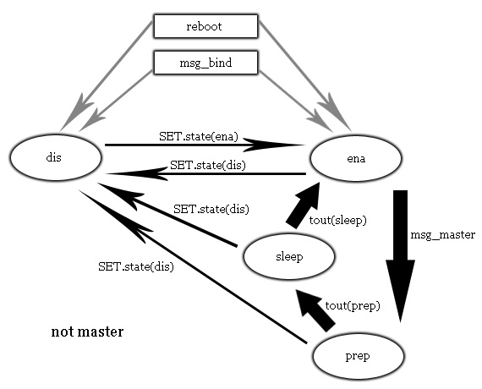

Master’s state machine is simpler:

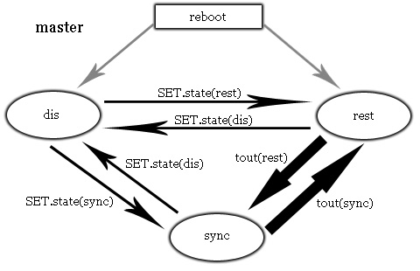

Master never sleeps, the sync state helps calculate information inserted into msg_master that all other nodes use to control their duty cycles (i.e. to sleep at the same time).

Defaults values should be carefully devised, so the network runs “out of the box” for main or most users. For testing and illustration, we’re planning to use a 50% duty cycle: 90 s. sleeping, 60 s. prep/sync and 30 s. ena time. With these parameters, the master will stay in rest for 90 + 30 s.

Consider this scenario on test defaults:

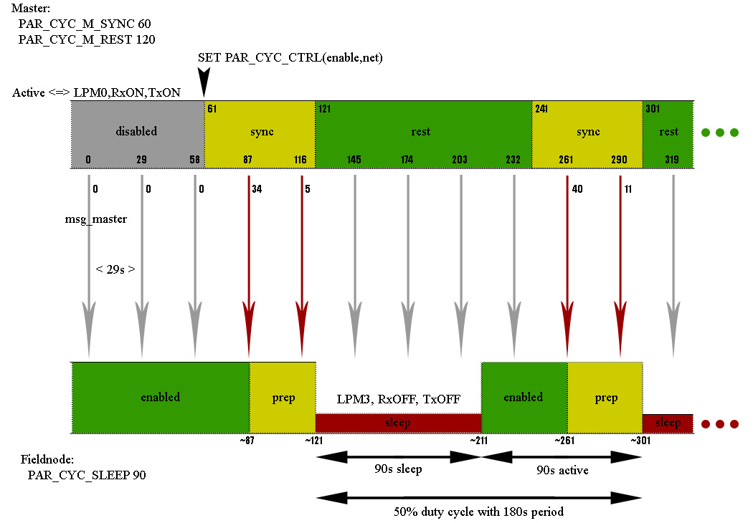

By default, a field node runs in the “enabled” state, with a preconfigured “sleep period” of 90 s. When a node becomes the master, it is placed in the “disable” state, with “sync period” defaulted to 60, and “rest period” set to 120. (Customized parameters are written to NVM, and restored at power up.)

In this scenario, “SET PAR_CYC_CTRL (enable, net)” is issued at time 61. It starts a monitoring process that transitions the node between sync ⬄ rest states, according to the settings (in this case, for 60 and 120 s., respectively). The node’s RF is always on, and the processor goes to LPM0 if there is no task to handle, ready to go Active as soon as there is a need.

Periodic msg_master messages (by default sent every 29 s.) contain “synchronization information” the master calculates in its sync state. It is simply the remaining time in the sync state, on the other nodes interpreted as the distance (in seconds) from the beginning of expected “sleep period”. We step through this particular scenario here, but one may want to explore flexibility of this design: self healing on resets, auto-embracing newly bound nodes, immunity to occasional message loss, configurability to various network conditions, compensating for average network latency, etc.

A field node, when it receives the sync info in its enabled state, starts a process to stay active (in prep state) until when the sleep period is expected, and to put the node in the sleep state for locally configured sleep time (PAR_CYC_SLEEP = 90). After the sleep, the monitor process terminates, leaving the node in the enable state as the sleep never happened. The cycle repeats, under total control of the master.

We show a field node in the net mode, comatose in LPM3. In the priv_net mode, it would switch RF off, keeping the last message to send after moving to enable state and turning RF on.

Hands on
PLEASE BE DILIGENT WITH UNFORGIVING UART. NO SPACES, NO EXTRA $, COUNT CHARACTERS TWICE AND WELL.

In this storyboard, we use “Terminal v1.9b”, and its notation. In any kind of serious use, it must be replaced with more humane OSSI – we provide simple Tcl/Tk wrappers for custom projects.

Part I

- Flash 2 nodes. They’ll have the same ESNs (0xBACA0001), but for this exercise it doesn’t matter. Attach (19.2, 8, 1) terminals to them. Connect, set HEX mode. Note that every time the node is flashed, NVM is cleared as well on boards without EEPROM.

- If nodes are not “fresh”, power up holding the reset button down, or press the button for 4 seconds, to clear NVM. Debug strings:
00 04 FD 01 12 00 04 00 04 FD 01 03 A6 04
show the app. / sys. version (2.00) and free RAM (934B). Clear the terminal receive panels.

- Connectivity LEDs are fast blinking, Tx, Rx LEDs blink every 31 seconds for msg_new broadcasts, but nothing happens, as there is nobody qualified to act on the messages. Let’s assume Terminal 1 as the Host with attached Base Station, Terminal 2 as SensorRx attached to the Sensor Node.

- Host to Base Station:
CMD_LOCALE: $00$04$0A$01$00$00$04
(bot (00), length (04), opcode (0A), opref (01), irrelevant target (00 00), eot (04)
Response:
00 0B 0A 01 00 01 00 01 00 CA BA 00 00 04
(bot (00), length (0B), opcode (0A), opref (01), oprc (00), node id (0x0001), ESN (0xBACA0001), master id (0x0000), eot (04)

- Host to Base Station:
CMD_SET, PAR_LH: $00$07$02$8B$01$00$01$02$00$04
Response (forced by high bit set in opref 8B):
00 08 02 8B 00 01 00 01 02 00 04
(RC_OK, local host (node id) is set from 0x0001 to to 0x0002)

- Host to Base Station:
CMD_SET, PAR_CON: $00$07$02$8D$02$00$0A$1D$34$04
Response:
00 08 02 8D 00 02 00 0A 1D 34 04
(audit freq. (1D); warn at 3 beats, bad at next 4, 0 missed beats (0x0034)

- Host to Base Station:
CMD_SET, PAR_NID: $00$07$02$8E$02$00$04$07$00$04
Response:
00 08 02 8E 00 02 00 04 07 00 04
(I’m in net 7 now)

- Host to Base Station:
CMD_SET, PAR_BEAC: $00$06$02$80$02$00$09$1D$04
Response:
00 07 02 80 00 02 00 09 1D 04

- Host to Base Station:
CMD_MASTER: $00$04$03$01$00$00$04
Becoming the Master, connectivity LED solid ON.
Response:
00 05 03 01 00 00 00 04

- The msg_new message outputs start to occur: the Sensor Node attached to Terminal 2 has been sending them every 31 seconds:
00 0A FF 06 01 00 CA BA 01 00 02 00 04
Please note 0x0002 as the sender, it helps understand the design intention. Msg_new is a proximity message, not allowed to pollute established networks in the neighborhood. In a larger network, this message would originate msg_bindReq (that’s the 06 after FF), and “made nodes” would send this message to their Masters. Here, we deal with a shortcut, where the Master sees msg_new directly. In the binding below, the same logic applies, and the master itself is the command’s target, i.e. the node sending msg_bind with limited range, to the orphan node.

- Host to Base Station:
CMD_BIND: $00$0B$05$80$02$00$01$00$CA$BA$55$00$01$04
Myself as the target (0x0002), bind 0xBACA0001 to my network, with new node id 85 (0x0055). This message is allowed to go 1 hop only. The RC_OK response comes back.
Newly bound node sends the msg_br, with output to th Host:
00 0B FF 08 55 00 00 34 00 00 00 00 01 04
connectivity data (34), no ESNs, no status, auto-ack on (auto-ack is local to the Master, it tells the Host that te acks are not necessary).
The next Master message will turn the connectivity LED solid ON, on the Sensor node.

- SensorRx to Sensor Node (Terminal 2):
$00$09$FE$01$02$AA$BB$CC$DD$00$99$04
echoed: 00 09 FE 01 02 AA BB CC DD 00 99 04
Msg output to the Host (Terminal 1):
00 0C FF 09 55 00 01 02 AA BB CC DD 00 99 04
Sensor type 01 revision 02, with ESN 0xDDCCBBAA reported status msg with rssi 0x99. The sensor (ESN) table is empty (no status aggregation), so the status message is treated as an alarm, i.e. is forwarded to the Master.

- Host to Base Station:
CMD_SENS action Write: $00$09$08$F1$55$00$AA$BB$CC$00$05$04
With forced (via opref F1) response:
00 0A 08 F1 00 55 00 AA BB CC 00 05 04
Note that we’ve registered 0x00CCBBAA, not 0xDDCCBBAA, to explore impact of the content of the ESN table.

- SensorRx to Sensor Node:
$00$09$FE$01$02$AA$BB$CC$DD$00$99$04
echoed: 00 09 09 01 02 AA BB CC DD 00 99 04
and nothing on the Host.
This time FE was replaced with RC_EADDR (09), to show that, with non-empty ESN table, the status message is dropped because it relates to an unregistered ESN. Note that an alarm would go through regardless of its ESN.

[One can explore status and alarm reporting in many ways; to see the status reporting with frequency more suitable for testing, the sensor node’s data can be adjusted from the host, e.g.:
$00$08$02$F1$55$00$0D$01$00$00$04
will set the frequency to 1 “minute” (64 seconds), yielding forced confirmation
00 09 02 F1 00 55 00 0D 01 00 00 04
and the sensor node data
00 0B FF 08 55 00 01 34 01 00 01 00 01 04]

- Power off both nodes. Attach a button to pull GPIO_1 high on the Host (attached to Terminal 1), and GPIO_2 on the Sensor Node. Pressing the buttons sets their pins low. Power nodes up.

- Master’s connectivity LED is solid, Sensor Node’s is blinking. Sending CMD_MASTER as in Step 9. establishes the connectivity, again. The fact that data are restored from NVM can be checked in many ways, e.g. CMD_LOCALE shows local settings.

- Host to Base Station:
CMD_IO action IO_READ (bulk) locally: $00$08$0B$00$02$00$00$FF$FF$FF$04
Response:
00 09 0B 00 01 02 00 01 00 20 09 04
Same CMD_IO action IO_READ (bulk) to the Sensor Node: $00$08$0B$00$55$00$00$FF$FF$FF$04
Response:
00 09 0B 00 01 55 00 08 00 20 09 04
This is quite difficult to read, as the 4 bytes are treated as 30 bit long bitmap encoding all 10 readable pins, 3 bits per pin. The IF document has details; this output shows pins CFG0-2 high, and high GPIO_1 on Host, and GPIO_2 on Sensor Node.

- Double checking with easy output:
Host to Base Station:
CMD_IO action IO_READ (pin 1) locally: $00$08$0B$00$02$00$00$01$FF$FF$04
Response:
00 09 0B 00 01 02 00 00 01 01 FF 04
Same CMD_IO action IO_READ (pin 2) to the Sensor Node: $00$08$0B$00$55$00$00$02$FF$FF$04
Response:
00 09 0B 00 01 55 00 00 02 01 FF 04
- Host to Base Station:
CMD_IO action IO_CNT_START locally: $00$08$0B$00$02$00$03$0A$00$00$04
starts counting from 10 on falling edges (rising would be $13 instead of $03). Dull response:
00 09 0B 00 01 02 00 03 0A 00 00 04
CMD_IO action IO_NOT_START to the Sensor Node: $00$08$0B$00$55$00$05$01$00$00$04
starts event notifications on rising (thanks to $01) edges. Responses:
00 09 0B 00 01 55 00 05 01 00 00 04
00 09 FF 0D 55 00 07 00 00 00 01 04
The first one is dull OK (to be precise, RC_OKRET), but the second is interesting: since GPIO_2 is high and the notifications were requested on rising edge, the msg_io is sent immediately, producing this message output. 07 is IO_STATE showing the notifier on, on rising edge, with pending event (see _IF document for the IO_STATE bitmap). 01 means autoack on, so there is no need for explicit CMD_IOACK. 3 bytes of zeroes in between are the counter. Press the button on Sensor Node (nothing happens), and release it to see the same functionality in action, on rising GPIO_2 edge.

- Host to Base Station:
CMD_IO action IO_CNT_GET locally: $00$08$0B$00$02$00$07$FF$FF$FF$04
Response:
00 09 0B 00 01 02 00 17 0A 00 00 04
Shows active (inactive would be 07 instead of 17) counter with value 10.
Press the button, resend, it’ll be 11 (0B). Release the button, it’ll stay on 11. Only falling edges count.

That seems sufficient to start experimenting with both local and remote IO operations.

Part II
(Master and sensor nodes are assumed, e.g. as after step 11. We keep the step counter, but the demonstration is not dependent on the flow.)

- Host to Base Station:
CMD_GET, PAR_CYC_CTRL:
$00$05$01$00$02$00$1C$04
Response:
00 08 01 00 01 02 00 1C 00 00 04
(On the master, default state: disabled (00); mode: net (00))

Same, to the remote node:
$00$05$01$00$55$00$1C$04
Response:
00 08 01 00 01 55 00 1C 01 00 04
(state: enabled (01); mode: net (00))

- Host to Base Station:
CMD_GET, PAR_CYC_SLEEP:
$00$05$01$00$55$00$1D$04
Response:
00 0A 01 00 01 55 00 1D 5A 00 00 00 04
(Default (for tests) deep sleep period: 90 seconds)

Attempt to query the master:
$00$05$01$00$02$00$1D$04
Response:
00 06 01 00 04 02 00 1D 04
returns RC_EMAS, as sleep period does not apply here.

- Let’s check remaining duty cycle parameters on the master:
Host to Base Station:
CMD_GET, PAR_CYC_M_SYNC:
$00$05$01$00$55$00$1E$04
Response:
00 08 01 00 01 02 00 1E 3C 00 04
(Default (for tests) sync’ing period: 60 seconds)
Host to Base Station:
CMD_GET, PAR_CYC_M_REST:
$00$05$01$00$55$00$1F$04
Response:
00 0A 01 00 01 02 00 1F 78 00 00 00 04
(Default (for tests) rest period: 90 + 30 seconds)

- Start network wide duty cycles:
Host to Base Station:
CMD_SET, PAR_CYC_CTRL:
$00$07$02$F0$02$00$1C$02$00$04
Response:
00 08 02 F0 00 02 00 1C 02 00 04
(Move to sync state: in 60 seconds 0x0055 should start sleeping in a 50% duty cycle with 180 s. period)

In various moments:
Host to Base Station:
CMD_GET, PAR_CYC_M_REST:
00$05$01$00$02$00$20$04
or
00$05$01$00$55$00$20$04
show the time progression within current states.

Theory and practice

We present a high level view on vital parts of the E_RTags operations, with emphasis on RF and routing. TARP is described elsewhere in details; here we concentrate on the “timeless” flavor of it implemented in E_RTags, and give specifics on illustrative examples.

A few acronyms:
TTL (time to live) – maximum number of hops a packet is allowed in the network. Constant, set to 10.
DD – duplicate discard (cache).
SPD – sub-optimal path discard (cache)

TARP settable parameters:
Tarp level:
0: Full flooding, only packets that reach destination or TTL are removed. It is never practical in any network, but is helpful in staging offensive setups for testing.
1: DD on, SPD off. If a node is always on an optimal path (e.g. if a segment is static and “in line”), this is a good option. Only duplicates or packets at TTL are dropped.
2: Full TARP. Only packets on “satisfactory paths” are forwarded. Default value.

Tarp slack: A path can be worse than optimal by that many hops, and still be satisfactory. This parameter is particularly useful for asymmetrical RF links or overshooting RF signals. In other words, it mitigates bad (too optimistic) SPD cache entries. Defaults to 1.

Tarp route recovery/repair (rte_rec): SPD cache maintains a mechanism to enable a sub-optimal path a while after optimal paths disappear. The rte_rec controls speed of this recovery; “satisfactory path” increases by 1 hop for 2^(rte_rec) dropped messages (to a given destination). Maximum is 3, defaults to 2.

Tarp forwarding: Only nodes with no business in forwarding (e.g. leaf nodes) should have it Off (0). Defaults to On (1).

Let’s assume a chain of nodes S -> A -> B -> THIS -> C -> D. In this paragraph, we consider node THIS and a packet traveling from S to D.
This is the header:

hoc: Forward hop count. Starts with 0 at snd, and is incremented on every hop.

hco: Estimated distance to rcv, or TTL if the distance is unknown. It may be adjusted on transient hops.

This is what THIS is:

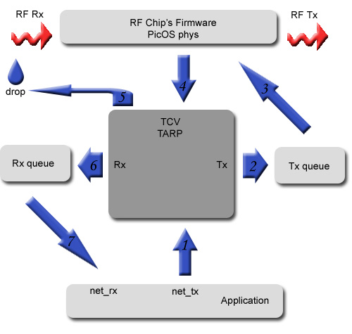
Transmission

Application sets type, rcv, and occasionally hco, attaches the payload, and passes the message to Tarp (1).

Tarp requests TCV’s buffer space (adding space for net id and entropy), copies the message to the buffer, fills in seq, snd, hoc = 0, hco, and entropy, optionally encrypts the payload with entropy, and queues the packet at Tx queue (2). It should be noted that SPD cache is consulted to set hco.

(3) RF driver adds net id and checksum, and transmits the packet.

Reception

RF driver receives packets from the air, verifies checksum and net id, and asks Tarp for disposition for complete and verified packets (bad packets are dropped) (4).

“Tarp decides” (expanded below) if the incoming packet should be dropped (5), queued for the application (6), forwarded (2), or cloned to be queued and forwarded. Packets to be queued for the application are optionally decrypted.

An application’s process dequeues and process the message (7).

“Tarp decides”

msg_new is queued for the application; all other messages from unbound nodes are dropped.

Echoes of THIS own messages are dropped.

On unbound nodes, msg_bind is queued for the application (this is the final stage of binding procedure). Everything else is dropped. Note that the RF driver discards packets with set but unmatched net id.

Forward hop counter hoc is incremented.

To shorten the walk-through, Tarp level 2 is assumed from now on.

DD cache is checked and updated if necessary. If the message has already been seen, it is dropped.

SPD cache is updated. On THIS, the entry S is set: 3 hops, 0 drops.

If rcv == THIS, the message is queued for the application.

If the message is a broadcast and Tarp forwarding is Off, the message is queued for the application.

If the message is a broadcast (and Tarp forwarding is On), the packet is cloned, original is queued for the application, and the copy is queued for transmission (2). Trace messages (msg_trace, msg_traceAck) mutate, to include visited hosts’ ids.

At this point, only unicasts to other hosts are left to process.

If TTL is reached, the packet is dropped.

“SPD decides” (expanded below): drop or forward.

“SPD decides”

No entry for rcv: forward.

If the packet is on “satisfactory path”, forward. Otherwise drop.

When dropping, increment a counter of routing attempts.
(SPD entry D: drops++.)

Let’s have SPD cache entry as {hops, drops}. THIS is on optimal path for a packet traveling to D if:

p.hoc + c.hops <= p.hco
(p for packet, c for cache, to underline the source of information)

Satisfactory path is more relaxed:

p.hoc + c.hops <= p.hco + slack + (c.drops >> rte_rec)
with added slack and route recovery at a desired speed.

Tarp code located in PicOS/LibComms tells the stories with unmatched accuracy, and is more comprehensive than this sketch.

