

Seawolfie

YEP demonstration

Technical Note

Version 1.0
July 2009

© Copyright 2009, Olsonet Communications Corporation.
All Rights Reserved.

TOC

Seawolfie 1
Introduction 3
Demonstration 3
Comments and extensions 12

Introduction

This technical note descends from the “Seawolfie: demonstration” (mm.odt) written in July 2008 for initial requirements of the project. Key aspects of the “year end project” (YEP) are described here; however, we don't touch on the noombuzz interface, nor we discuss plans leading to functionally complete setups.

We concentrate on simple but functionally complete demonstration scenarios, within the VUEE environment. For intrinsic details, see Seawolf.odt and the PicOS suite of documents. Now semi-dormant criteria matching is described in the original mm.odt.

We assume adequate environment, including Tcl wraps and port emulation, as described in RTAGS:R090519A.

The screen snapshots are readable in details when zoomed; they serve only as step-by-step illustrations. The demonstrations should be prepared within the actual VUEE model (sixnodes.xml or its derivative), and rehearsed within the actual demo setup (overhead projector, right resolution, extended desktops, etc.). This document does not contain details on these preparations.

Demonstration

Screen snapshots were taken from the sixnodes.xml model running under VUEE, but the functionality and the implementing code are identical on the network of the wolfies and EMSPCC11 nodes. The actual demonstration should include a VUEE presentation followed by a similar setup with physical nodes.

We deal with four wolfie nodes, plus a mock-up of two advertiser / organizer stations.

Four wolfies and two modified EMSPCC11:
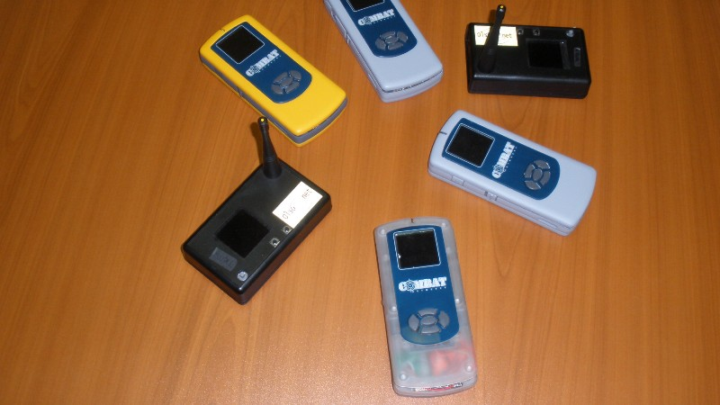

Execute buid.sh in YEP, start side sixnodes.xml. Start udaemon.exe in VUEE/UDAEMON. The sixnodes.xml model:

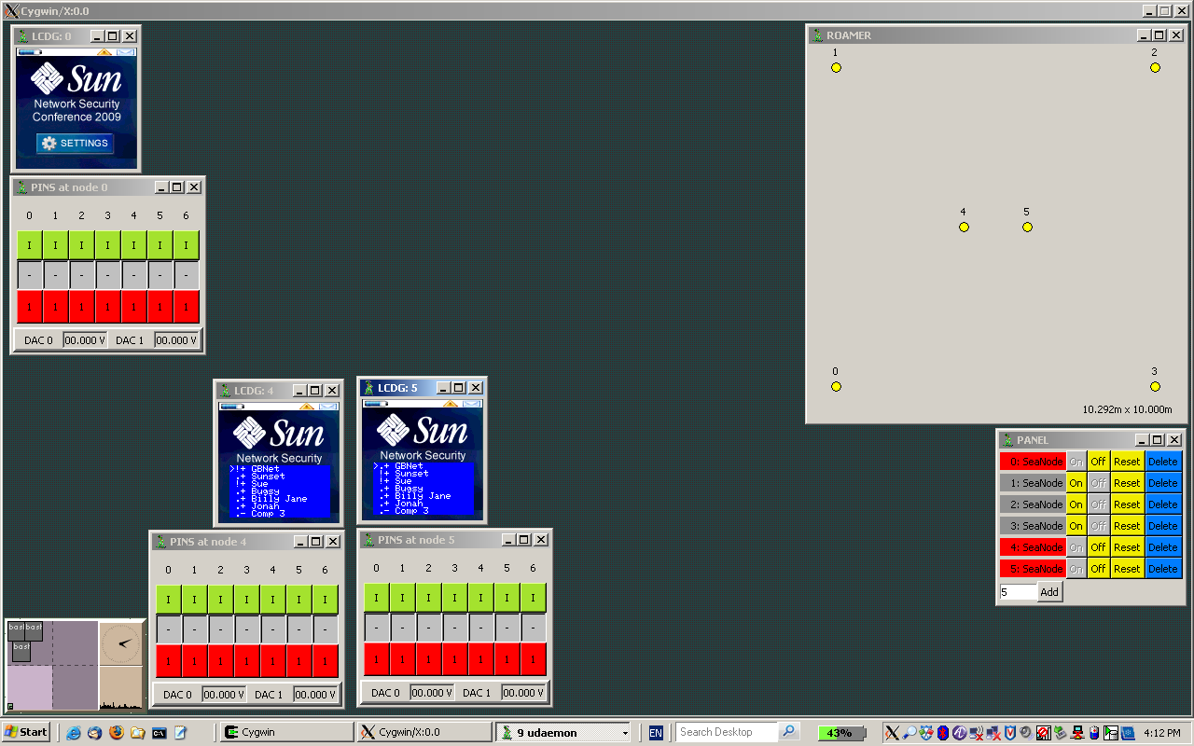
Snapshot 1

Note that parts of the EEPROM content described in noombuzz?.xml files include items designed for richer functionality of flexible personalized matchmaking, dormant during most of the presentation. However, they can be used to extend the presentation for a curious audience.

The ROAMER window shows the wolfie nodes (WON) 0-3, and organizers / advertisers stations (OAS) 4-5. PANEL shows that the nodes 1-3 are OFF.

PINS represent buttons (right click on a red square is a PUSH). Buttons 0, 1 (B0, B1) are side buttons on WON, buttons 2-5 are joystick buttons N, E, S, W (JN, JE, JS, JW), and B5 is the joystick centre / push (JP).

General button-triggered functionality:

B0: switches between the neighborhood view (NBV) and list view (LIV). (Not allowed on OAS.)
B1: left unused (contrast, buzzer, other future add-ons).
JN, JS: scrolling / cursor movements.
JW: triggers yes / ok / accept messages.
JE: triggers no / not now / deny messages.
JP: drills down for more details.

NBV shows 0 to 3 (preselected) users within the range, with their statuses. The 1/1, 1/2, and 1/3 screen parts (user representations) are scrollable and addressable. On Snapshot 1, the LCDG0 window shows an empty NBV (the conference's wall paper).

LIV shows the content downloaded from noombuzz, with the neighborhood and statuses marked with symbols as in the 'matchmaker' earlier version (!, m, M, etc.) In the demonstration, it is intended to show the OAS point of view, in real deployments enhanced by additional functionality, GUI, links to classical networks, databases, etc. LCDG4 depicts an organizer node, LCDG5 is an advertiser.

Let's run a few scenarios, and comment on the views and user actions. Using PANEL, switch nodes 1-3 ON. Then, bring up LCDG and PINS windows of all the users. Scrolling down (or up) cursors on nodes 1, 2 and 4,5 we get Snapshot 2:

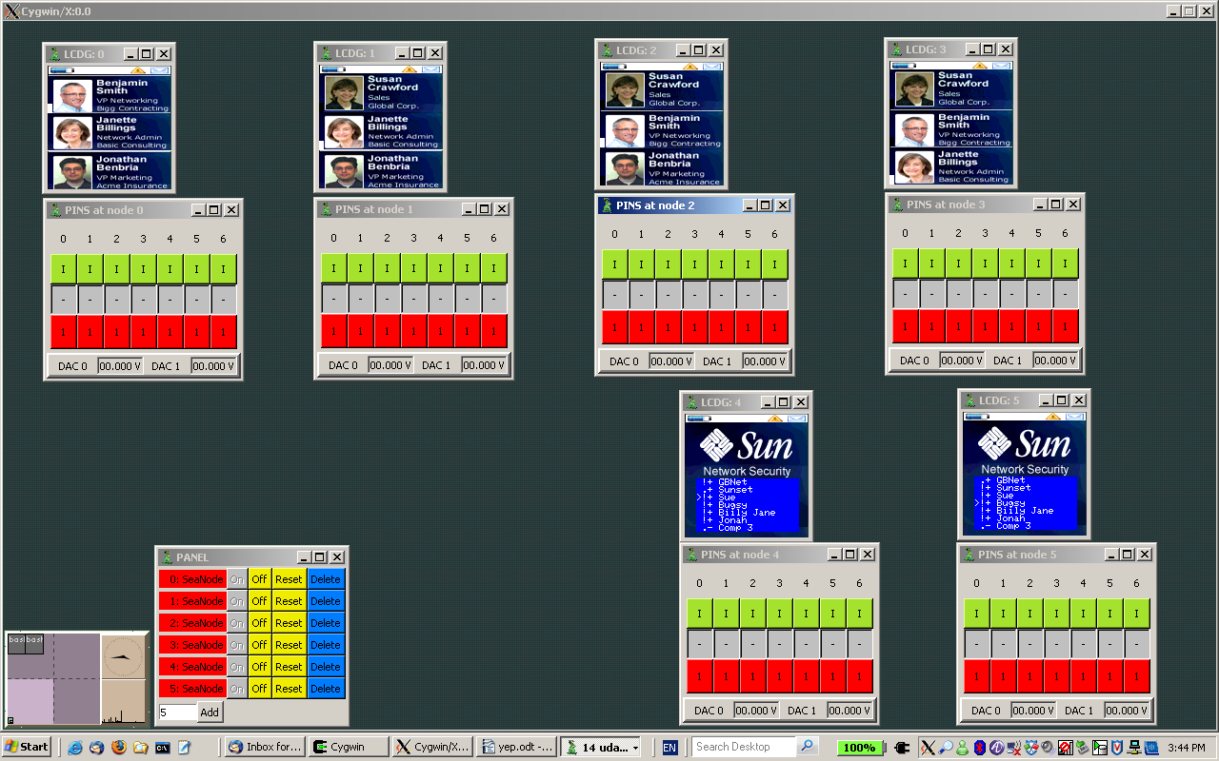
Snapshot 2

Play around with the LIV scrolling (no wrapping, more entries) and NBV (wrapping, only preselected nodes in the neighborhood are visible). Switch between LIV and NBV (B0) on nodes 0-3. On nodes 4, 5 NBV is purposefully blocked (this is driven by content downloaded from noombuzz).

It should be apparent that node 0 (id: 1) belongs to Susan Crawford (nickname: Sue), node 1 (id: 2) to Benjamin Smith (Bugsy), node 2 (id: 4) to Janette Billings (Billy Jane), and node 3 (id: 8) to Jonathan Benbria (Jonah). Sheer presence of the nodes in NBV guarantees them within the range of each other.

Node 4 (id: 77) belongs to Organizers (nickname: Sunset), and node 5 (id: 88) to Global Business Networking (GBNet) who depict advertisers. Their LCDGs show LIV, with neighborhoods marked with !s on scrollable lists.

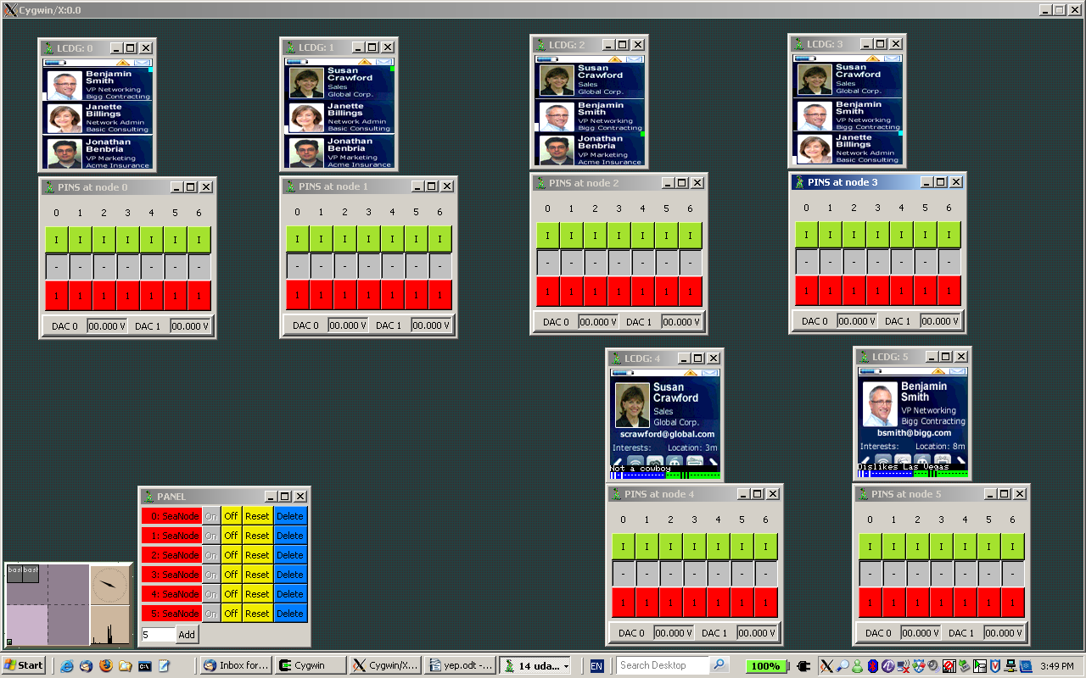
Snapshot 3

Node 0 (Sue) sent 'hello' to node 1 (Bugsy), i.e. Sue pressed JW with cursor on Bugsy. Since Sue is on Bugsy's list, node 1 auto-responded with 'matching criteria'. The exchange caused cyan square on node 0's Bugsy part (matched, but no user action yet), and green one on node 1's Sue (initiated and matched). Note that the cyan square is equivalent to '2' and green square to 'm' on the LIV (matchmaking protocol details are described in mm.odt). Similarly, Jonah invited Billy Jane.

On nodes 4, 5 operators pressed JP, 'drilling down', i.e. displaying Sue's and Bugsy's 'official' information overlaid with the operators' private comments and classifications (created on noombuzz and downloaded to the devices).

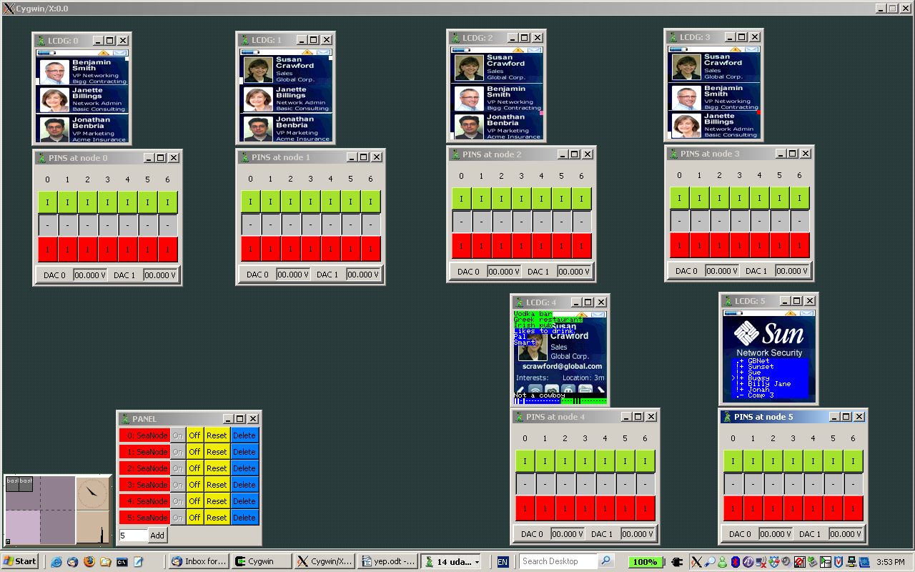
Snapshot 4

In here, Bugsy accepted (JW) Sue's 'hello', resulting in white squares (equivalent to 'M' on LIV).

Billy Jane responded 'not now' (JE) to Jonah. Her pink square differs from red on Jonah's LCDG, as it signalizes her option to say 'yes' until Jonah disappears from the neighborhood. The pink and red are quivalent to '~' and '-' in LIV.

Sunset drilled down (JP) on Sue to show explicit categories encoded in bar codes on the bottom of the LCDG, while GBNet returned to the list (JN).

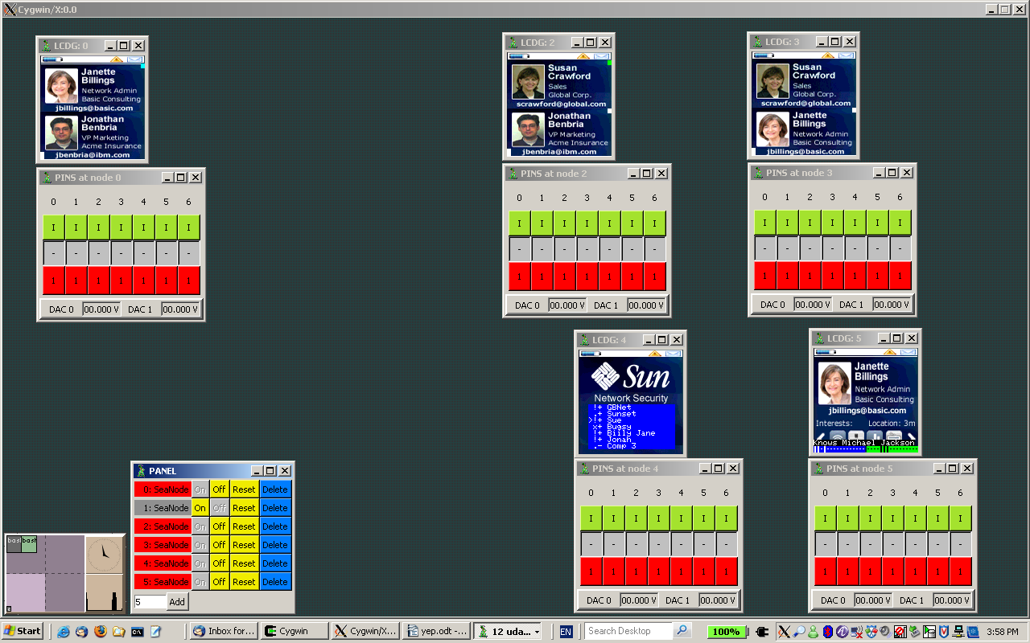
Snapshot 5

Bugsy switched off.

Billy Jane said 'ok' to Jonah.

Sues said 'hello' to Billy Jane.

Sunset returned to the LIV.

GBNet drilled down on Billy Jane.

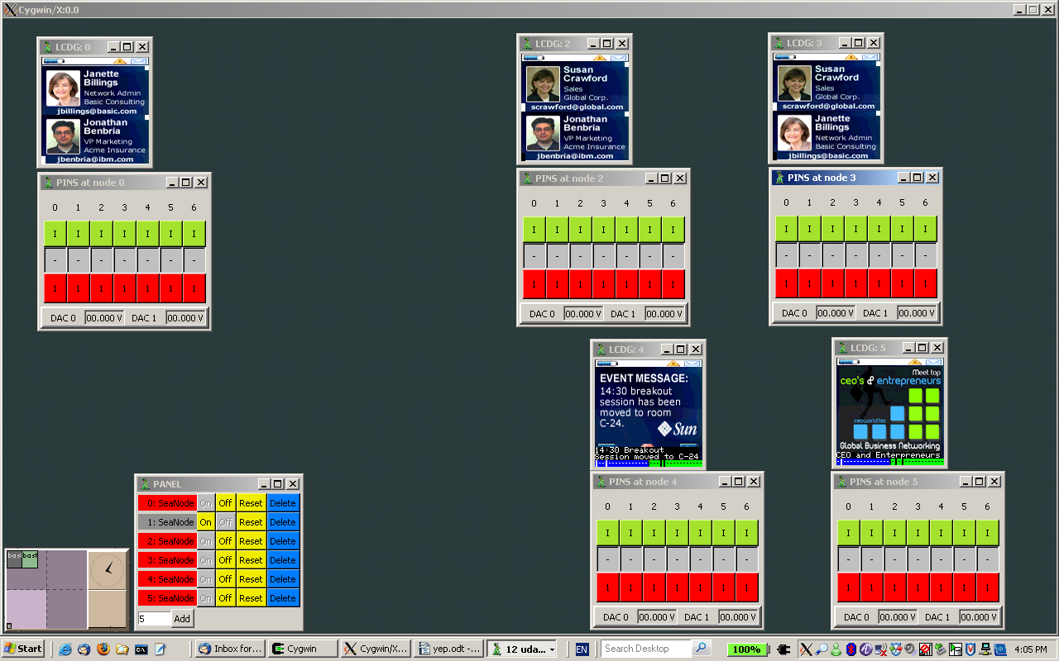
Snapshot 6

Billy Jane responded 'ok' to Sue.

Sue and Jonah matched (sent 'hello', 'ok').

Sunset and GBNet scrolled down to their own info, and drilled (JP). This is a cue to event notifications and advertising.

For the OAS i/f, we use fragments of much richer VUEE functionality (VUEE.pdf), with oss.tcl (Seawolf.pdt). For the demonstration, it should be enough to rehears the specific scenarios.

Udaemon: Connect UART(hex) to node 4, enable U-U CNCB0.
YEP: issue ./oss.tcl CNCA0 115200

The connectivity can be verified via 'mem' or 'li' commands. Any response is good.
Issue:

ns 3 1 1 1 1 12 pls confirm_

ns 3 4 2 2 2 9 in 5 min!

Kill UART(hex) to node 4, connect in the same way to node 5. Issue:

ns 3 8 3 3 3 8 14:30!!

Snapshot 7 shows the results:

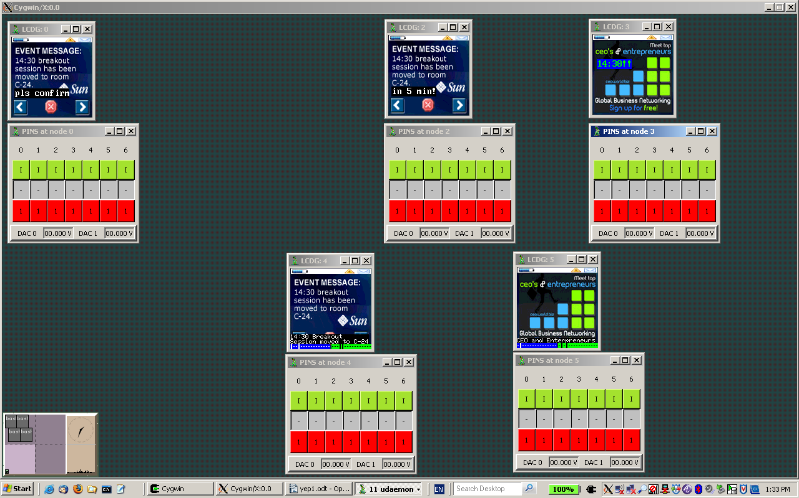
Snapshot 7

The first ns (neighborhood send) command sends the 12-char string to node 1, with ref. 1. The next addresses node 4, and the last goes to node 8, this time from node 5.

After a WON receives the message, it displays graphics associated with the sender, and superimposes the message content (text) anchored and formatted in predetermined ways, presumably according to the sender's intentions. Also, an immediate response is generated, which shows:

Ad Ack:6 from <node id> ref <#>

on reception of which the OAS is assured the notification or advertisement appeared on the target's screen.

The graphics stay on the LCDG until the user presses a button. As usual, JW generates 'yes', JE 'no', and anything else clears the graphics from the LCDG, returning to the previous screen. That way, we achieve 2-way communication, as the sender gets

Ad Ack:1 from <node id> ref <#>
Ad Ack:0 from <node id> ref <#>

or nothing, depending of the user's choice. Note that if the LCDG is blocked by another graphics waiting for the user's action, the sender gets

Ad Ack:7 from <node id> ref <#>

that can be interpreted as 'busy'. In general, we have a simple protocol with flexibility well beyond practical needs.

Comments and extensions

This section is waiting for impressions and suggestions from demonstrators. To start with, the LED and BUZZER signaling should be defined and implemented.

Note that several important points and many details are omitted here; this is a yet another attempt on a living document that follows the Seawolf project's evolution.

