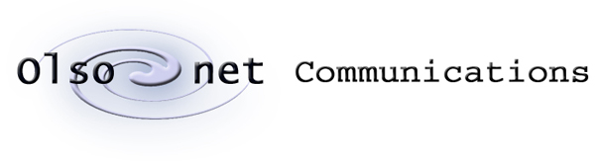


Tags & Pegs

Technical Note

Version 0.2
September 24, 2007

Tracked changes to ver. 0.1.

This document contains confidential information, which is proprietary to Olsonet Communications Corporation. No part of its contents may be used, copied, disclosed or conveyed to any party in any manner whatsoever without prior written permission from Olsonet Communication Corporation.

© Copyright 2007, Olsonet Communications Corportation.
All Rights Reserved.

Tags & Pegs 1
Introduction 2
Vocabulary 2
Demonstration 3
Deeper Look 13
Tags & Pegs: the blueprint 15

Introduction

This technical note introduces Olsonet’s‘Tags and Pegs’ (TNP) blueprint, shown from several different angles, with varying detail levels.

The Vocabulary section outlines used terminology.

The Demonstration section records a functional demonstration with several scenarios. As a side effect, we present Virtual Underlay Emulation Engine (VUEE) in action, touching on its tremendous potential as a software development and maintenance tool.

The Deeper Look section discusses main differences between the demo version and any industrial TNP's incarnation. In this section we also point at hidden and deceiving gap between the lightness and clarity of the visible functionality, and challenges intrinsic to any robust and scalable deployment of ad-hoc networking. This gap is not advertised by vendors offering functional fragments, e.g. ‘standard’ protocol stacks, and in our views is one of the key reasons for scarce industrial acceptance of ad-hoc networking. Hardware variants are discussed as well, hinting on ways praxes based on the TNP blueprint morph into practical application / solution.

The Tags and Pegs section is a high level view on several praxes based on the TNP blueprint, as well as at the blueprint itself.

Vocabulary

- Peg: A stationary (or low mobility) node, forwarding packets from other pegs, and gathering information about tags in vicinity. If position tracking is part of the functionality, pegs form a grid of reference points with known locations.

- Tag: A mobile node periodically transmitting information about its physical environment. It is capable of receiving packets, but in sporadic and restricted ways. Usually, tags don’t route packets.

- Network Id: A logical network identifier. Several networks with different network identifiers may operate in the same physical neighborhood.

- Local Host: A (settable) logical node identifier, unique within a given network id.

- Host Id: Hardware Id, Equipment Serial Number, etc. A constant and unique identifier flashed in or obtained from a dedicated hardware resource.

- Master Id: Logical identifier of a master (sink, tributary, gateway, etc.) node (Peg), where most of the packets originate or terminate. Used in routing optimization and network synchronization.

- OSS(I): Operations Support System (Interface).

- RSS(I): Received Signal Strength (Indicator)

Demonstration

We don’t present flashy façade, but true behavior of key functionality. The screen snapshots are taken from the demo praxis running under VUEE, but the functionality is similar and the code identical on the network of real nodes built around MSP430 and CC1100. For brevity, we highlight only main functions. Complete demonstration should include this presentation within VUEE, followed by demonstration of physical nodes running the very same software.

Let's have a grid of Pegs, placed in known positions. They listen to periodic messages broadcast by Tags roaming in the neighborhood. Pegs maintain inventory of all Tags in vicinity, and send messages about local event notifications and alarms to the Master.

The Master is one of the Pegs that happen to be connected to an OSS; an entity controlling the network.

The Tag is a mobile node that periodically broadcasts information from its sensors.

The demonstration focuses on location discovery, ignoring Tags' interfaces to physical world. The content of messages Tags send is limited to the Tag's node id, and its transmitter's power levels. For clarity, we use only one power level (1). Pegs receive messages from Tags, correlate the Tag's node id, power level the message was sent with, and RSSI it was received with, to build images of their neighborhoods. They send messages to the Master, about any interesting event. For the demonstration, matters are simplified by mapping the pair (level, RSSI) into laconic distance estimations of “proxy”, "near" and "far".

The Master interfaces an OSS (text terminal here) via OSSI (RS232), and communicates events from all Pegs. Also, it accepts commands meant for the network maintenance, queries about status quo, etc.

Let's consider this screen:

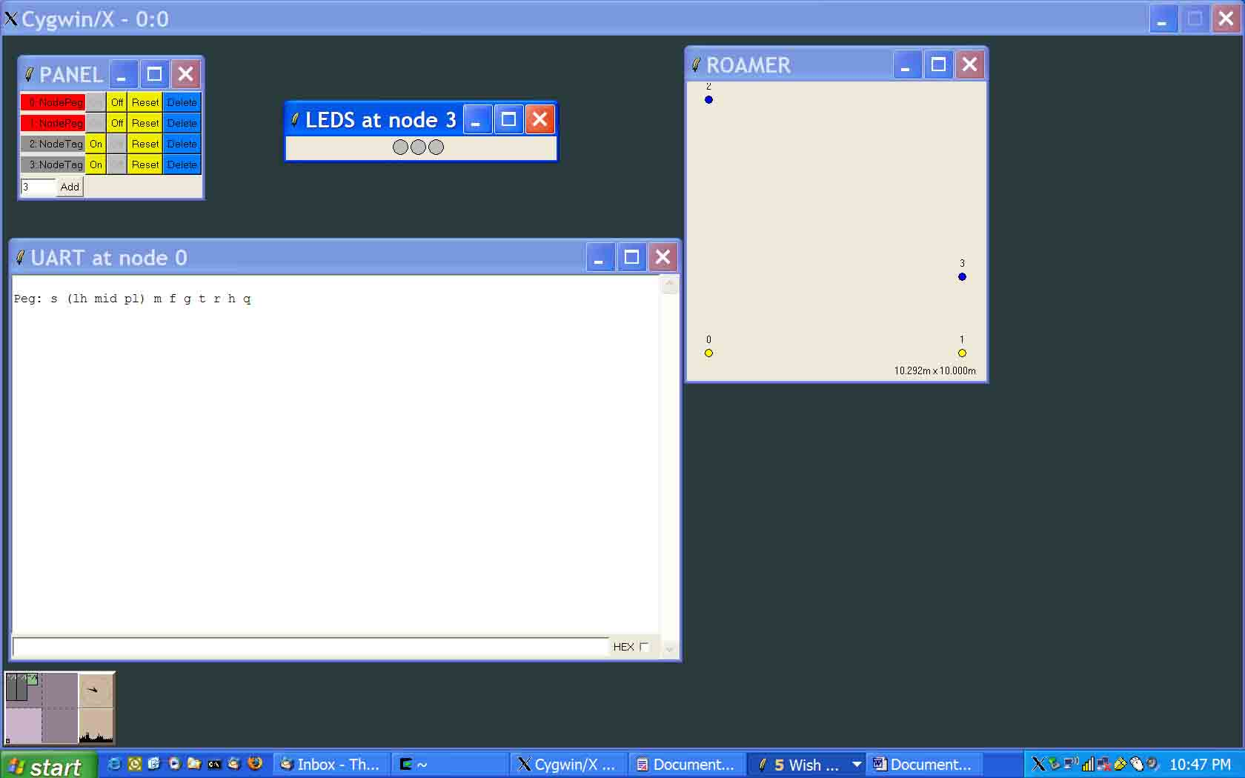

VUEE is running the sisec_demo.xml configuration. Two Pegs: Node0 located at (5, 5) and Node1 (15, 5), as well as the Tags: Node2 (5, 15) and Node3 (15, 8), are visible in the Roamer window. The Panel shows that both Tags are switched off. UART window to Node0 is the OSSI, is showing laconic help with available commands. Also, LEDs on Node3 (one of the Tags) are shown, to demonstrate optional functionality aimed at particulars of a Tag implementation (presence of LCD, LED, buzzer, etc.).

In this scenario, Pegs know the Master from the start, so as soon as we switch the Tags ON via the Panel buttons, the Master's UART shows:

Peg: s (lh mid pl) m f g t r h q

T102(0101) at P10 at 21: far #1

T103(0101) at P10 at 22: far #1

T103(0201) at P11 at 22: near #1

P10 is the Node0 (Master itself), P11 is Node1. T102 is the Node2, T103 is the Node3. Note that the nodes in the emulator must have consecutive numbers starting at zero, while node ids of Tags and Pegs are freely settable. Here, they're 10 and 11 for Pegs, and 102, 103 for Tags.

So, the Master P10 sees both tags T102 and T103 as being 'far', and P11 sees only T103 as 'near'. If we wait several minutes, or we move T102 slightly towards P11, we will see occasional output like this:

Peg: s (lh mid pl) m f g t r h q
T102(0101) at P10 at 21: far #1
T103(0101) at P10 at 22: far #1
T103(0201) at P11 at 22: near #1

T102(0101) at P11 at 162: far #1

T102(0101) at P11 at 172: gone far #1

which shows that P11 reports T102 as briefly being 'far'. It is so because the RF signal rarely may make it from T102 to P11 with consistency good enough for P11 to report T102 in its vicinity. The algorithms to accept a tag, or consider it 'gone' are highly parameterized, so they can be adjusted to granularity appropriate for given praxis and RF environment.

In this emulation, the radio channel is handcrafted to have a good connectivity at 10m, fading quickly to very poor at 15m. At the distance between P11 and T102 slightly over 14m, the fading causes occasional 'tag blinking'. This is a real phenomenon that must be assuaged by proper parameterization, likely with help from OSS functionality.

The RSSI is mapped to the distance (at the power level 1), so that 'near' boundary is roughly at 4.5m, i.e. less than half the distance between Pegs. ‘Proxy’ starts at about 1 meter.

The numbers in brackets, e.g. (0201) show mapped RSSI and power levels; 03 – proxy, 02 - near, 01 - power level 1. The other number is the reported event's timestamp, in seconds from the last Master's reset. This is an important detail that lets OSS map events to real time, based just on the Master's uptime.

So, let's drag the Tags to their new positions, in the Roamer window:
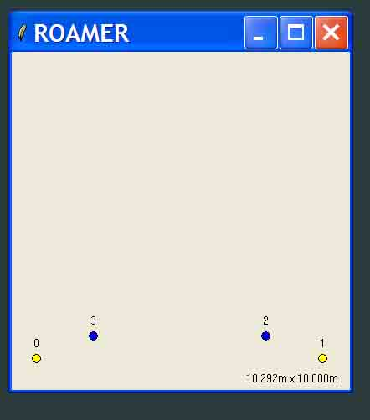

With a slight delay (again, a parameterized tradeoff between swiftness and bandwidth usage), we see the reported events:

Peg: s (lh mid pl) m f g t r h q
T102(0101) at P10 at 21: far #1
T103(0101) at P10 at 22: far #1
T103(0201) at P11 at 22: near #1
T102(0101) at P11 at 162: far #1
T102(0101) at P11 at 172: gone far #1

T102(0101) at P11 at 343: far #1

T103(0201) at P10 at 358: near #1

T103(0101) at P11 at 358: far #1

T102(0201) at P11 at 361: near #1

They speak for themselves. Now, through the Panel, switch off T102, to observe:

Peg: s (lh mid pl) m f g t r h q
T102(0101) at P10 at 21: far #1
T103(0101) at P10 at 22: far #1
T103(0201) at P11 at 22: near #1
T102(0101) at P11 at 162: far #1
T102(0101) at P11 at 172: gone far #1
T102(0101) at P11 at 343: far #1
T103(0201) at P10 at 358: near #1
T103(0101) at P11 at 358: far #1
T102(0201) at P11 at 361: near #1

T102(0201) at P11 at 510: gone near #1

T102(0101) at P10 at 510: gone far #1

That's how the Tags that have disappeared are reported. Switch the T102 on again:

Peg: s (lh mid pl) m f g t r h q
T102(0101) at P10 at 21: far #1
T103(0101) at P10 at 22: far #1
T103(0201) at P11 at 22: near #1
T102(0101) at P11 at 162: far #1
T102(0101) at P11 at 172: gone far #1
T102(0101) at P11 at 343: far #1
T103(0201) at P10 at 358: near #1
T103(0101) at P11 at 358: far #1
T102(0201) at P11 at 361: near #1
T102(0201) at P11 at 510: gone near #1
T102(0101) at P10 at 510: gone far #1

T102(0101) at P10 at 639: far #1

T102(0201) at P11 at 639: near #1

It is easy to notice that the OFFs are reported with a delay greater than ONs, which is yet another result of parameterization used to tune up the system to a desired behavior within given environment. For example, rapid off/on blinking will not produce interesting events that could trigger excessive network traffic, which frequently is a desirable feature.

Let's look at the LEDs of T103 now. The green LED is attached to the transmitter, yellow to the receiver, and red left for special events, signaled from the Master. Green and yellow LEDs blinking show frequent pings the two Tags send. One can switch T102 on / off to see the effect on the T103's yellow LED.

Let's issue the command

t 103 11 5

on the Master's UART. Whether we get a confirmation

T 103 at P 11 Set ack 2 ack seq 23

is immaterial now, but we should notice that the red LED on T103 blinks for ca. 5 seconds. This command translates to "Notify Tag 103 through Peg 11 about payload 5", and illustrates the functionality in which the Master can order any Peg to store information for a roaming Tag, and forward it to this Tag when it is passing by. Many flavors of event notifications, alarms, and security related functionality in general can be built on this mechanism. In this demonstration, only Tags in the Peg’s vicinity at the moment of the message arrival are notified about the Master’s wish.

We're assuming all nodes ON, as on the last screenshot. Let's issue a few commands:

f 103 0 0 (find T103 anywhere, anyhow) returns:

T103(0201) at P10 at 358: near #3

T103(0101) at P11 at 358: far #3

f 103 0 2 (find T103 anywhere where it is 'near'):

T103(0201) at P10 at 358: near #5

f 0 11 0 (count all Tags on P11):

T0(0000) at P11 at 0: total #2

f 0 0 2 (count all near Tags, everywhere):

T0(0000) at P10 at 0: total #1

T0(0000) at P11 at 0: total #1

This concludes basic demonstration. We warned that we would show true mechanisms and interactions, so let's consider another setup, configured in sec_demo.xml:

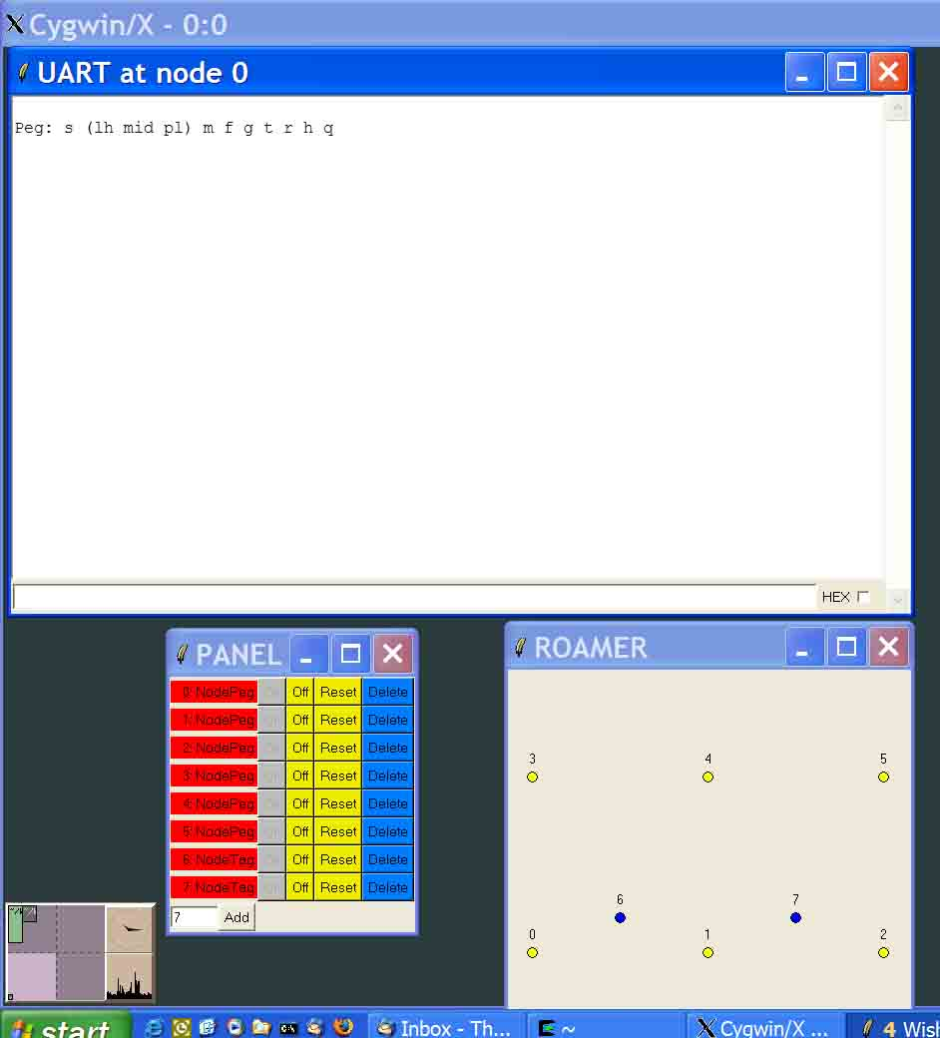

The Pegs’ positions, RF channel, and routing parameters are set to generate unwanted effects (notorious hidden terminals on every hop, no auto route recovery, no routing slack).

The main goal of this setup is to show ad hoc networking in action. Only the Pegs 10m apart see each other well. Rarely, a diagonal packet goes through, to corrupt routing information. Route refreshment is done only by slow (every ~30s) master beacons. This scenario also shows what kind of interface the OSS deals with in a real setup.

This time, the Tags are ON by default, but the nodes don't know the Master, so they maintain their neighborhoods, waiting for the Master. Let's reset Node0, and issue the command

m 0

on its UART. The result:

Peg: s (lh mid pl) m f g t r h q
// reset
Peg: s (lh mid pl) m f g t r h q
m 0
T107(0101) at P14 at -27: far #1
T107(0101) at P11 at -27: far #1
T106(0101) at P14 at -27: far #1
T106(0101) at P10 at 2: far #1
T107(0101) at P11 at -27: far #2
T107(0101) at P15 at -27: far #3
T106(0101) at P13 at -26: far #4
T106(0101) at P11 at -27: far #4
T107(0101) at P12 at -26: far #5
T107(0101) at P12 at -26: far #7
T106(0101) at P13 at -26: far #7
T106(0101) at P11 at -27: far #7

Firstly, we note negative timestamps on the events reported from remote nodes. After the reset, when P10 (Node0) became the master, its local uptime was included in the message sent to all other nodes, to let them all calculate a local value (called master_delta) that would be used for time adjustments in all reporting. That way, the OSS can attach real timestamps to all events, no matter when and where they happen, when Pegs reset, etc.

Let's take a look at #n output. It reveals yet another important feature of the system: end to end confirmations aka reliable delivery. All messages deemed important (here, all messages about tag locations), are resent until a proper confirmation reaches the source of the original message. On this particular example, let's extract and investigate messages from P11, reporting on T106 and T107:

T107(0101) at P11 at -27: far #1
T107(0101) at P11 at -27: far #2
T106(0101) at P11 at -27: far #4
T106(0101) at P11 at -27: far #7

After receiving the broadcast (‘m 0’) that P10 became the Master, P11 reports its inventory, i.e. sends messages about T106 and T107 being ‘far’ since 27s before the Master’s reset. The #1 message about T107 reaches P10, is reported through OSSI, and acknowledged to P11. The ack gets corrupted by interference from all other nodes sending messages at the very same moment. On the next inventory check, P11 sees T107 unconfirmed, and resends the message (#2). This time, the ack is successful, and the Tag marked as confirmed. Similarly, T106’s reports #1, 2, 3, 5, 6 are lost, ack to #4 is lost, and finally handshaking #7 makes P11 happy. Although these details are hardly visible, they help understand and appreciate pertinent mechanisms. Note that these vicious scenarios are rarely the case in real setups, however, the point we’re making is about the built-in reliability of message delivery.

Any query or command coming in via OSSI is not reliable (because OSS can reissue it if the response doesn't come back). This is clearly visible in broadcast queries like this one:

f 0 0 0 (all Pegs: count all your Tags) may return

f 0 0 0
T0(0000) at P10 at 0: total #1
T0(0000) at P13 at -29: total #1
T0(0000) at P11 at -29: total #2
T0(0000) at P15 at -29: total #1
T0(0000) at P12 at -29: total #1

but a query refinement shows that some reports went missing:

f 0 14 0
T0(0000) at P14 at -28: total #2

All this signals elaborate functionality that must be implemented to reliably fulfill requirements that can be outlined in deceivingly simple terms.

Last scenario, configured to have a Tag indefinitely roaming through a grid of Pegs, is designed to let the user observe the setup, without many interactions. The Tag should be switched ON to see the events, but later on everything is left for the user’s imagination. As configured in rosec_demo.xml:

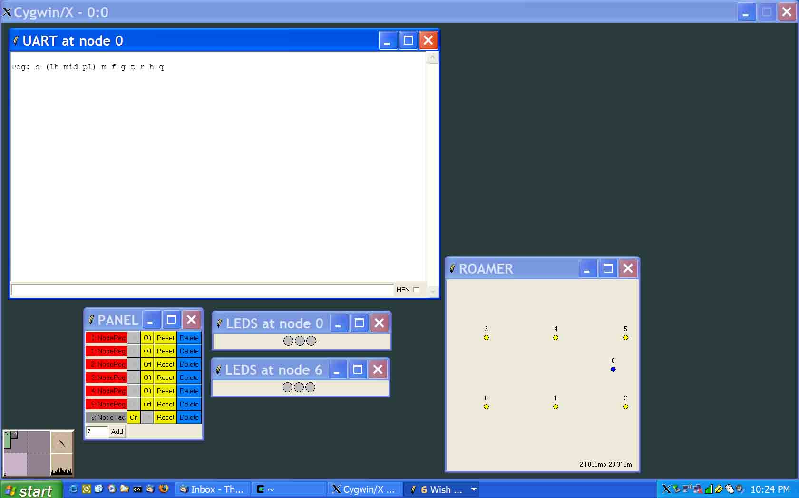

Full set of available commands, with short explanations is given here only for curiosity quenching experiments:

Pegs

s [ local_host [ master_id [ power_level ] ] ]
Set the variables for which non-zero values are passed. Without arguments, it displays various statistics.

m [ peg ]
Set sender’s id as master id on the targeted peg. Usually issued as ‘m 0’ or ‘m’, also sets “I’m the master” on the local host.

f [ tag [ peg [ rssi [ power_level ] ] ] ]
Find or count Tag(s) on the Peg(s). Zeroes are treated as wildcards or broadcast.

g tag peg
Get tag from the peg. Displays tag’s various parameters. The peg acts as the forwarder (Tags are not part of the network). Zeroes are not allowed.

t tag peg [ passwd [ local_host [ major_freq [ minor_freq [ power_levels [ span [new_passwd]]]]]
Set tag’s parameters, through the peg. Zeroed tag or peg are not allowed. (Note that for the demo, ‘passwd’ is treated as duration for the blinking red LED, up to 10s. If the number is > 10 and < 20, the LED stays solid ON for ‘passwd – 10’ seconds.)

r [ peg [ npeg [ pwr [ str ]]]]
Set peg’s id (its local host) to npeg, set its transmitter’s power level to pwr, and display str. The last option is there to show potentially useful functionality of triggering events on any peg in the network (e.g. they can display scrolling messages on their LCDs; security, marketing, etc.)

o[{r|t| }{+|-}]
RF options: {both, rx, tx} {on, off}

h
‘Help’: list of commands

q
Quit (reset)

Tags

s [local_host [major_freq [ minor_freq [ power_levels [ span ]]]]]
major_freq – every so many milliseconds, all (up to 4) ‘pongs’ are repeated.
minor_freq – in milliseconds, timeslot for each of ‘pongs’.
power levels – 0xdcba: in hex, up to 4 power levels ‘pongs’ are broadcast on.
span – at highest power level, the Tag’s receiver id turned on for so many milliseconds. If span == 1, the receiver is switched ON. If span == 2, the receiver is switched OFF.
h
q

Deeper Look

We hint at several details that should be considered during design and implementation of a real application (within our framework, application is synonymous to solution). Although we don’t recognize layers, it is handy to classify matters as pertinent to applications, praxes, routing, OSSI, etc.

Application

Likely, the Tag’s hardware is different from the Peg’s. Depending on interfaces to the physical world, the praxis functionality may be quite different. Number of LEDs, presence of an LCD, number of sensors, and presence of sensors directly supporting the main functionality (e.g. accelerometers for ‘location engines’), have profound impact on the way the praxis is derived from the blueprint.

It may be that the hardware of the Pegs designated to have OSSI capabilities is different from other Pegs. If the OSSI is simple and the needed hardware ubiquitous, e.g. as in the RS232 case, this distinction is not worth too much attention. However, if the OSSI consists of sophisticated and expensive equipment, e.g. data modems, Bluetooth, Ethernet, it makes sense to divide Tags into subsets with different functionality. If the nodes with OSSI are not supposed to act as Pegs at all (i.e. they’re not supposed to collect information on Tags, don’t route, etc.), it may be beneficial to borrow from another blueprints, and introduce a third application, let’s call it Custodian. Logistics for maintenance, distribution, customer support, etc. must be considered before making this decision, as it would be difficult and expensive to change mind after design.

Data logging capabilities and parameters that must survive power failures will dictate presence of EEPROM, SRAM, etc.

Praxis

Tag’s power budget considerations are designed in. Peg’s are not. If a network-wide duty cycles are needed, they have to be borrowed from the Routing Tags blueprint. For example, TNP is the right blueprint for automated meter reading (AMR) with heavy sub-metering, and there a 20-30% duty cycle should be sufficient. For an industrial control setup with instant alarm delivery, duty cycles are out. Since it doesn’t make sense to pollute the blueprint with functionality irrelevant in many applications, Pegs don’t have this capability by default.

Similar reasoning is applied to message encryption and user authentication. Note that encryption / authentication is trivial to add, while network-wide duty cycles are not.

Demonstration praxis lacks several important diagnostic and troubleshooting functions, e.g. route trace, and remote command execution. They’re always needed in real deployments.

OSSI

Text based interface is impractical, for several reasons. Compact commands in binary formats are more efficient. For demonstrations without a proper GUI, text commands are maintained, but the TNP blueprint assumes binary OSSI, with clearly defined command set.

Data integrity should be verified on the OSS side, since it has more resources to use for this non-core but expensive and important functionality. Embedded software should shield itself only from disastrous input.

If the OSSI can be reliable (i.e. checksums, flow control, etc.) it should be made so. Usually this is easy for new systems, and close to impossible if the praxis interfaces an established infrastructure.

Routing

TARP parameters (route recovery, slack, cache sizes) should be carefully adjusted. VUEE should play a vital role in emulations verifying resources that can be used for caching, as well as the system stress testing, vicious scenarios, etc.

Novelties alike soft acks, parallel route elimination, or RSSI thresholds for cache updates may be considered, but because of assumed liberty in engineering the network of Pegs and their immobility, the routing should be robust with ‘classical’ TARP functionality.

Network engineering

Site surveys and RF channel modeling is crucial for a successful deployment. Deployment rules should set desirable distance ranges and power levels. Note that this is not about creating a rigid infrastructure of Pegs, but rather about rules that make the network flexible and expandable without unwanted side effects. This is a complex task, usually starting with the deployment site RF survey, followed by the RF channel model, followed by VUEE runs.

TO BE CONTINUED

Tags & Pegs: the blueprint

TBD

