

Matchmaker

demonstration

Technical Note

Version 0.2
March 2008

© Copyright 2008, Olsonet Communications Corporation.
All Rights Reserved.

TOC

Matchmaker 1
Introduction 3
Requirements 3
Functionality 4
Demonstration 6
Equipment 6
Matchmaking 7
Networking 9
A simple VUEE model 9
Comments and thoughts 13

Introduction

This technical note outlines the ‘Match Maker’ demonstration prepared as a 'variation on the theme' of the requirements from Combat Networks. The requirements and the application that implements them should be viewed only as a rough articulation and a quick adaptation. Hopefully, a posteriori they'll be seen as seminal works leading to a successful cooperation. Therefore, this note is intended at audiences at Combat Networks and Olsonet Communications only.

Although we're scratching the overlapping areas of ad-hoc communities, mobile groups, and anonymous security enforcement, we refrain from digressions from our narrow focus. The same is true about exciting potential business synergies between Combat Networks and Olsonet -- they're out of scope here.

The Requirements section has come from Combat Networks.

The Functionality section is a dry outline, likely difficult to read prior to the actual demonstration.

The Demonstration section studies a functional demonstration. As a side effect, we present our Virtual Underlay Emulation Engine (VUEE) in action, touching on its tremendous potential as a development and maintenance tool.

The Comments & thoughts section has a good title; since little is known and nothing is firm now, we share a few points that may be not that evident at first sight.

This document follows our agreement for a quick but useful job, and we hope the latter is achieved. Obvious shortcomings will be ironed out after a 'go ahead' for a larger project.

Requirements

- Identify other devices in the area (30-50 ft)
- Read other devices memory to determine commonalities in each other’s databases
- Database information (database includes First name, picture (in future versions), and 3-5 user selectable “passions”)
- Signal both hardware devices (vibrate, light, sound) that a commonality has been found
- Allow users to accept or reject the offer to share information
- Upon Acceptance allow users to view some database information (first name, picture, area of commonality)
- Upon Rejection, send sorry I’m busy message
- Allow users to grant other information in the database to be transmitted (future version)
- Indicate direction and approximate distance between devices and display as a compass or directional arrow on screen (future version)

Functionality

Although implemented functionality approximates the requirements, it truly is a variation on the theme. We don't strictly follow the requirements for these important reasons:

- This is a quick (ca. 30 hours), hack-like modification of an existing prototype.
- Available hardware does not have a suitable user interface.
- Somewhat reversed approach highlights the process of forming ad-hoc communities, where members remain anonymous until they decide to reveal their identities and lift privacy to a selectable degree, within a selected group.
- Although the main functionality requires only proximity communication, we do believe multi-hopping networking sooner or later will stand out as an attractive differentiator.

The setup: a large multi-threaded conference. At registration, participants receive badge-like devices, in shape and weight comparable to secure ids. They have a rustic user interface (UI): 2-line LCD, RGB LED, a couple of buttons. The device has a mini-USB interface. All public PCs at the conference run an applet that is able to communicate with the badge via USB, temporarily extending the UI. Also, USB Bluetooth dongles are available for rent. They allow to move the extended UI from scarce PCs to PDAs, cell handsets, mobile tablets, etc. Free applets are available for popular mobile platforms.

Each device has a unique and constant identifier. The devices are flashed with data provided by participants prior to the conference. All is settable through the extended interface at any time, but the organizers may want to set desired defaults. This is important, as clever and unobtrusive advertising of local providers may be a good incentive to install and maintain such a system.

The attributes involved in matchmaking:

- Nickname: a brief and mnemonic identifier (e.g. first name).
- Description: Ideally, it depicts appearance, a prominent feature, etc.
- Business description: Business card content, main research interest, employer's profile.
- Private description: Hobby, spontaneous desire, private contact data.
- Alarm description: Unlikely to be set a priori, it enables multi-hopping communication within already established communities.
- Profile: List of several well defined interests, features, topics, local venues. For the demo the attributes are binary (interested / applicable, or not).
- Include: A match is made between the receiver's Include and sender's Profile, so at any time Include should describe current preferences for follow-up interactions.
- Exclude: All incoming Profiles are discarded if matched against Exclude.
- Monitor: A list of ids the user wants to communicate with, not necessarily when in the range. In other words, this is the list of members of established communities the user is a part of.
- Ignore: A list of ids to be ignored as senders.

The demonstration will make all the details more palatable, now we can offer only dry descriptions. For the demo we use an ASCII terminal, pretending to be the extended user interface. For the rustic i/f on a final device, display likely will be scrolling on LCD, triggered by a user request. Event notifications must be signaled via LEDs, buzzers, etc.

Let's assume that the matchmaking data reflects the users' preferences.

When switched on, the device sends periodic messages with its identifier, the owner's nickname and profile. The receiver and beacon are ON, unless switched off on the user's request.

Received 'profile msg' is checked against the Ignore list. If the sender is on the list, the message is dropped.

Incoming Profile is checked against Exclude properties. If any matches, the message is dropped.

Incoming Profile is checked against Include properties. If none matches, the message is dropped.

Sender is checked against the 'tag list'. This is a highly dynamic list with all current potential contacts, and with all persons we're interacting with. If the sender is not on the list, it is added there. Otherwise, some of the attributes are updated. (More is happening behind the scenes, as this list's maintenance is pivotal for a healthy application. De-bouncing of nodes flickering at the reception radius is a good example of an important but not that obvious feature.)

There are commands to maintain all the lists, to display pertinent info, and to handle the intended flow of interactions. Let's go with a common chain of events:

The user displays the 'tag list', and picks an entry. The 'Y' command accepts the sender, and replies
with the user's Description. The 'N' command moves the sender to the Ignore list.

After the 'profile msg' was accepted, at least one side should be able to physically locate the other, and start conversation. Private or business data exchange may follow. The actual flow of events and exchanged information will vary, as all depends solely on spontaneous user decisions.

Alarms, although they may be used within any established community or for multi-hopping point to point communication, are primarily meant to organize conference participants into groups according to the conference threads, workshops, social events, etc. They provide efficient (group-targeted) event notifications. Incoming alarms are checked against the Ignore and Monitor lists first. If the sender is not there, the usual profile matching occurs.

Let's take a look at the demonstration for more details:

Demonstration

This section is not meant to be a comprehensive guide to the skeleton functionality implemented for the Matchmaker demo. We aim at giving the reader an orientation tour only, and hope to play a somewhat inspirational role should the project continue in any form.

Screen snapshots were taken from the demo running under VUEE, but the functionality and her implementing code are identical on the network of the EMSPCC11 nodes. The actual demonstration should include this presentation within VUEE, followed by the same setup with physical nodes.

As requested, we deal with a four node setup. Much larger configurations are likely to be studied before good requirements and competent hardware design decision can be articulated.

Equipment

Olsonet's general experimental board EMSPCC11 used for the demonstration:

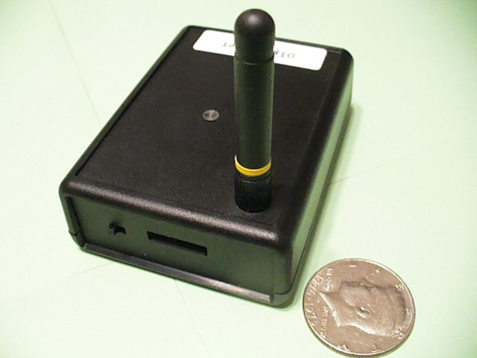

The essential components of the EMSPCC11:

- MSP430F1611 microcontroller: <http://focus.ti.com/docs/prod/folders/print/msp430f1611.html>
- CC1100 RF module: <http://focus.ti.com/docs/prod/folders/print/cc1100.html>
- On board data storage: <http://www.atmel.com/dyn/resources/prod_documents/doc3443.pdf>

Matchmaking

The designers will be surprised how much innovative thoughts will be implemented for organizing this seemingly trivial functionality. True profiles will be much more elaborate, and the matching likely will employ fuzzy algorithms. For the demo, we deal with simple bitmaps and bitwise AND operations.

Each Profile (same goes for Include and Exclude lists) is a 16-bit map of binary choices. We arbitrary divide them into four categories four choices each, as depicted below:

visiting local female male
Personal

personal professional volatile solid
Profile

thread 1 thread 2 workshop A workshop B
Professional

squash bridge pm trip bar
Volatile

cinema outdoors piano music
Solid

Let's look at the data pretending to come from questionnaires, set for the experiment in the simm.xml configuration file:

<node number="0">
<location>5.0 5.0</location>
<preinit tag="HID" type="lword">0xBACA000A</preinit>
<preinit tag="NICK" type "string">Alice</preinit>
<preinit tag="DESC" type "string">white blouse</preinit>
<preinit tag="DBIZ" type "string">Ala Inc.</preinit>
<preinit tag="DPRIV" type "string">613-111-2222</preinit>
<preinit tag="PROFI" type="word">0xAF26</preinit>
<preinit tag="PINC" type="word">0xFFFF</preinit>
<preinit tag="PEXC" type="word">0</preinit>
</node>

This node is visible in the simulator as 'Node 0', located at (5, 5) on the Cartesian plane. Its hardware id is 0xBACA000A, of which last 2 bytes form the logical identifier 10 used for all communications. The user nicknamed Alice chose “white blouse” as her initial description, “Ala Inc.” as business data, and “613-111-2222” as her bold private cue. She describes herself as a visiting female, professionally interested in all choices,. She is interested in the afternoon trip organized for the conference participants, and if she wants to talk about her true interests, she'll talk about piano music or Himalayan trekking (outdoors). She want to talk to all, and excludes nobody.

Now we should be able to decode Bob's (11), Cat's (102) and Dog's (103) setting as well.

<node number="1">
<location>15.0 5.0</location>
<preinit tag="HID" type="lword">0xBACA000B</preinit>
<preinit tag="NICK" type "string">Bob</preinit>
<preinit tag="DESC" type "string">tall, red tie</preinit>
<preinit tag="DBIZ" type "string">Bombardier</preinit>
<preinit tag="DPRIV" type "string">room 666</preinit>
<preinit tag="PROFI" type="word">0x55F0</preinit>
<preinit tag="PINC" type="word">0xFFFF</preinit>
<preinit tag="PEXC" type="word">0</preinit>
</node>

<node number="2" start="off">
<location>5.0 15.0</location>
<preinit tag="HID" type="lword">0xBACA0066</preinit>
<preinit tag="NICK" type "string">Cat</preinit>
<preinit tag="DESC" type "string">nice paws</preinit>
<preinit tag="DBIZ" type "string">Mice Exterme</preinit>
<preinit tag="DPRIV" type "string">on March break</preinit>
<preinit tag="PROFI" type="word">0xE0FF</preinit>
<preinit tag="PINC" type="word">0xFFFF</preinit>
<preinit tag="PEXC" type="word">0x2000</preinit>
</node>

<node number="3" start="off">
<location>15.0 8.0</location>
<preinit tag="HID" type="lword">0xBACA0067</preinit>
<preinit tag="NICK" type "string">Dog</preinit>
<preinit tag="DESC" type "string">big jaws</preinit>
<preinit tag="DBIZ" type "string">Hunt Extreme</preinit>
<preinit tag="DPRIV" type "string">whistle high C</preinit>
<preinit tag="PROFI" type="word">0xF014</preinit>
<preinit tag="PINC" type="word">0xFFFF</preinit>
<preinit tag="PEXC" type="word">0</preinit>
</node>

All this is arbitrary and for illustration only. As already said, a good general frame for the matchmaking profiles won't be that obvious to forge.

Networking

We employ four nodes. When switched on, they broadcast 'profi msg' messages with frequencies spread between 2 and 4 seconds. All other messages are triggered by users. The messages are relatively long, as they contain strings of characters. However, most of them don't multi-hop.

The typical setup will have a high density of nodes, so 'listen before transmit' (LBT) is essential. Also, transmitters should operate on minimum power levels, to cut down the range and interference. For the demo, we set the data rate to 200K bps, to shorten the range to 5-6 meters.

We believe that multi-hopping functionality (here it is just alarms, but much more attractive features can be borrowed from our other blueprints) eventually will become popular, so for large gathering it may be prudent to switch off forwarding on the user nodes, and set up a quasi-infrastructure with dedicated forwarders, appropriately placed to cover the venue with good and redundant data paths.

A simple VUEE model

In the following snapshot of VUEE emulation of the network, the OSS is represented as ASCII terminals (UART).

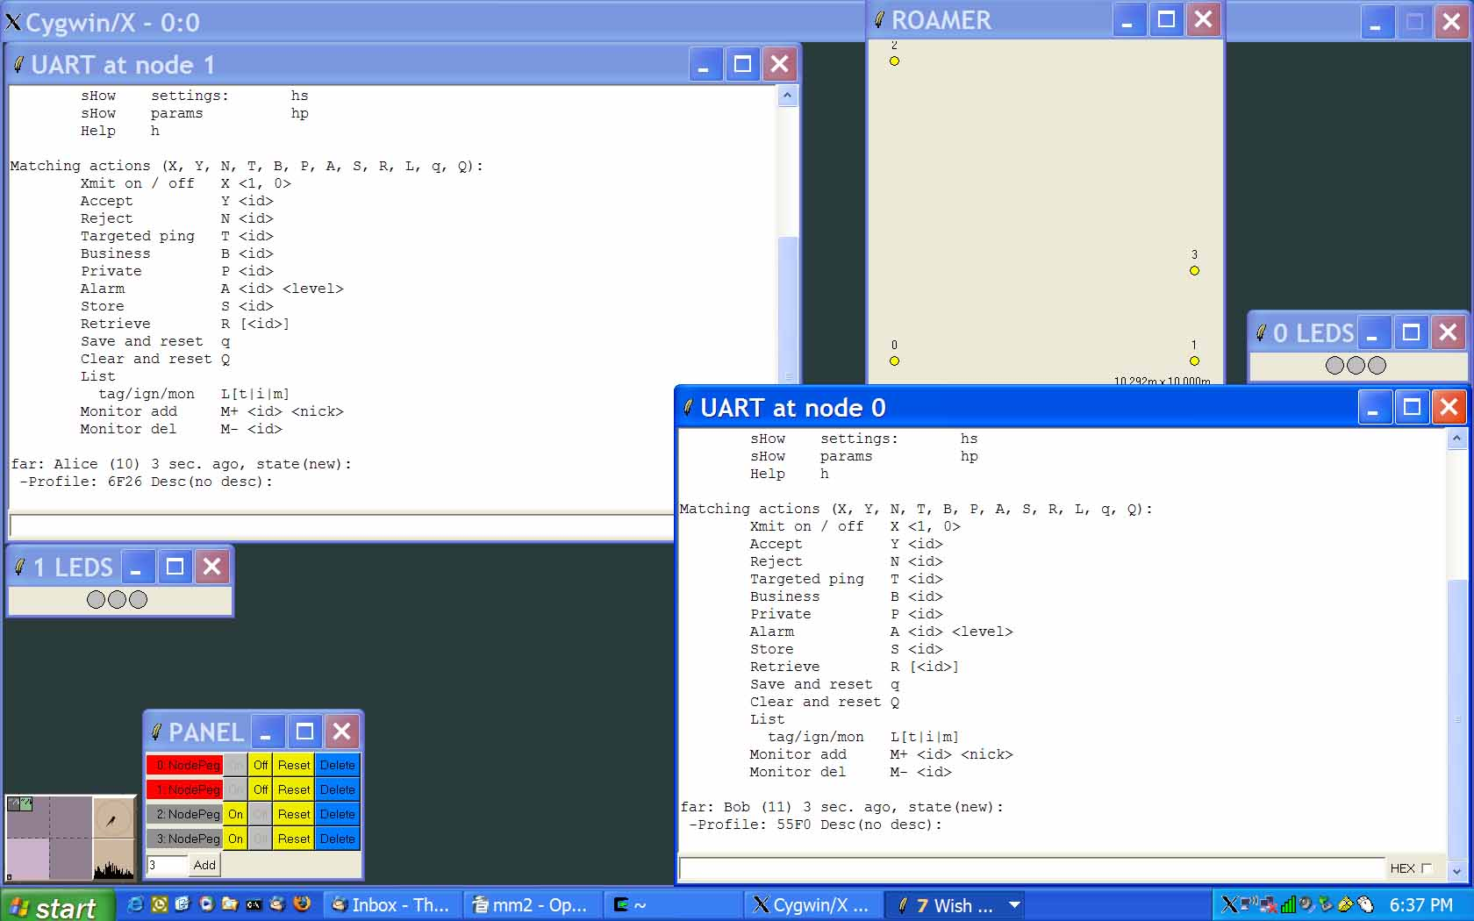
The four nodes are visible in the ROAMER window, the PANEL shows that only Alice's and Bob's are ON, and their extended UIs are in UART windows. LEDS are shown as well. We'll outline basic operations and their results using this setup.

At startup, the menu is shown:

Set / show matching (s, p):
nickname: sn <nickname 7>
desc: sd <description 15>
priv: sp <priv desc 15>
biz: sb <biz desc 15>
alrm: sa <alrm desc 15>
profile: pp 0xABCD
exclude: pe 0xABCD
include: pi 0xABCD

Help / bulk shows:
sHow settings: hs
sHow params hp
Help h

Matching actions (X, Y, N, T, B, P, A, S, R, L, q, Q):
Xmit on / off X <1, 0>
Accept Y <id>
Reject N <id>
Targeted ping T <id>
Business B <id>
Private P <id>
Alarm A <id> <level>
Store S <id>
Retrieve R [<id>]
Save and reset q
Clear and reset Q
List
tag/ign/mon L[t|i|m]
Monitor add M+ <id> <nick>
Monitor del M- <id>

The first section sets the attributes we've already discussed. If a command appears without an argument, it is interpreted as a show request, e.g. sn is 'show nickname'.

The next menu section is about bulk shows, divided into two parts. The actual output is best introduction:

hs
Nick: Alice, Desc: white blouse
Biz: Ala Inc., Priv: 613-111-2222, Alrm:
Profile: 6F26, Exc: 0000, Inc: FFFF

hp
Stats for hostId - localHost (BACA000A - 10):
Freq audit (4) events (4) PLev (1) Time (898)
Mem free (788, 788) min (0, 0)

In the hs output we should recognize the data used for matchmaking, hp shows a few basic node parameters we'll ignore for now.

Since Bob and Alice are in the range, they immediately see each other's pings. Alice sees Bob's data:

far: Bob (11) 3 sec. ago, state(new):
-Profile: 55F0 Desc(no desc):

Bob (id 11) is 'far' (2.5 – 5 meters away), he appeared about 3 seconds ago with the 0x55F0 profile, and no description. Should Bob switch off the beacon (or the badge), or walk away, after a short while Alice would see:

far: Bob (11) 0 sec. ago, state(gone):
-Profile: 55F0 Desc(no desc):

Two of the features not announced yet have become visible: rough distance estimation, and maintenance of the nodes in the immediate neighborhood reflected in the 'tag list'.

As already mentioned, we set the nodes to have the RF range of about 5 meters. Rough but useful distance estimations based on the RSSI, are far (2.5 – 5), near (1.2 – 2.5), and proxy (0 – 1.2). How good this can be on final hardware and how it may be extended to show directions, remain open issues.

More complex algorithms are applied for a reasonable maintenance of the neighborhood's image. Several states are introduced (new, reported, confirmed, matched, gone), separated by corresponding 'fading' states, all for a balance between two extremes: incessant reporting of all events, and a silence broken only on explicit user requests. The former is not practical in most realistic setups, the latter can't maintain the context achievable with automatic periodic messages. We believe that the functionality enabled via periodic pings makes a significant difference, therefore this more complex approach is justified.

We've already seen the new and gone states. If Alice replies with 'Y 11', Bob will see:

far: Alice (10) 4750 sec. ago, state(reported):
-Profile: 6F26 Desc(intro): white blouse

Now, if Bob sends back 'B 10', Alice's terminal will show:

far: Bob (11) 0 sec. ago, state(matched):
-Profile: 55F0 Desc(business): Bombardier

Alice would see 'confirmed' state between her 'Y' and Bob's 'B'. Note that the transition to the matched state is considered important enough to reset the clock of the Bob's state. Of course, all these arbitrary choices can be adjusted for a given application.

If we switch Cat and Dog ON and start playing with the nodes in the ROAMER window, we'll see the results, imagine variety of scenarios at a real conference, and be able to check how the system deals with them. There is a wide gap between what is implemented for this demonstration and what will be needed for a real system. However, VUEE enables a comfortable environment for these activities.

The notion of 'targeted ping' is introduce, to signal an explicit desire to communicate. If the user issues the 'T <id>' command, an extra beacon message is sent addressed to the target id. This explicit interest is signaled to the recipient with the “intim” label, as below on the Dog's interface:

near: Cat (102) 664 sec. ago, *intim* state(matched):
-Profile: E0FF Desc(private): on March break

As mentioned, alarms signal multi-hopping extensions, and in the demo the output looks like that:

Alrm from Cat(102) profile(E0FF) lev(7) hops(2) for 0:
happy hours at 5

Note the number of hops (2), and 0 as the receiver id, which means broadcast.

LEDs will be one of the very few ways to signal events on the actual wearable badge. For the demo, we have the following 'protocol' implemented:

Solid green is on when the node is switched on. If there is at least one entry matched, the green led blinks. If the beacon is switched off, it is treated as a blue mode, blinking if there is a match. Red replaces blue or green for about 4 seconds ofter an alarm is received and displayed. As so many other details, this is an arbitrary functionality without claims to usefulness.

Save and Restore move data to and from non-volatile memory, enabling post-collection processing, data archives, or event logs.

We believe that the only way to really appreciate the application is to try it, so we rest here.

Comments and thoughts

No particular order in these thoughts and reflections.

It may be that the requested functionality can be achieved with a simpler approach. However, we believe that the presented design has the advantage of being applicable to truly diverse application spaces. Also, we find most of the ad hoc networking applications deceivingly simple to sketch, and disappointingly complex in crucial but initially hidden details.

The actual 'leading customer' or 'target application' must be firmly established very early in the development cycle, as the device's physical characteristics and networking aspects will impact or even dictate fundamental decisions.

Special care must be taken to articulate Matchmaker's interactions with existing devices and classical networking. It may be that the best approach to a successful application is a software add-on to an existing device (e.g. Blackberry). Consumer electronics may be a good candidate to such extensions.

Unless there is a need for interoperability with a priori unknown systems, standards like ZigBee may be harmful. If interoperability seems important, the previous point should be considered.

As physical proximity is an important functional constraint, RF links should be rather short. For the demo, we set transmitters' power level and data rate such that good communication breaks at about 5 meters. Only slightly wider range is advisable for a true application, as short links also help with high density of the nodes.

RSSI is good only for a very rough distance estimations. Directional antennas or sensors may be used to both distance and directional approximations. However, this is pure and difficult R&D, with unpredictable outcome.

GUI is very important, and novel approaches may be needed. For large gathering, works on a good OSS, distributed processing, or swarm intelligence may bring forward functionality that will eclipse the original goals.

The device should be designed in a way that signaling within the communities is very convenient through the embedded 'rustic interface', but all verbose info, configuration parameters, and functional links to post-collection data processing should use the 'extended interface'.

