The main concept: any command may be issued anywhere in the network (source node), be executed on any node (proxy node), and target any node (target node). What “to target” means, depends on the command. That way or another, all commands return information about their execution result.

You’ve received all the sources on the “applet level”. If you have Cygwin and msp430-gcc tools installed, we’ll send you Makefile, system headers, and object libraries, so you can play with code changes and rebuilds… if you’d ever like to do it.

Image and Image.a43 play the same role as before. If you want to change local_host (equivalent to node id), you can use lh.exe the same way as before, but for RTag it is not necessary. Image has local_host set to 99, and the node is master-less (master_host is 0).

This “quick start” shows how to start with the extremely unfriendly “binary interface”, and describes a simple scenario of setting up 2 nodes, to run basic operations on them. Deeper explorations must follow CommandSet.doc, 1st draft of which is included.

Be warned: the interface is sensitive to erroneous input, and a reset may be needed if the input was vicious. We’re working on a friendlier PC applet.

Diagnostic messages are still ASCII strings, so if you see garbage, it may be a good idea so switch the Terminal to ASCII and repeat the operation. During normal operation, Terminals should be in hex mode, and that is presented here.

qs.tmf can be loaded into the Terminals, to avoid typing. (The Terminal is the freeware we sent you with AMR demo, capable of communicating with binary commands.) For reference, qs.tmf content (the lines are macra M1 – M7):

$00$09$80$00$00$80$00$00$01$AA$01$04
$00$0B$80$00$00$80$00$00$02$BB$01$58$00$04
$00$08$80$00$00$00$00$00$05$CC$04
$00$08$00$63$00$00$00$00$05$CC$04
$00$08$80$00$00$00$00$00$03$CC$04
$00$0A$80$00$00$80$00$00$02$DD$08$0E$04
$00$0B$00$00$00$40$00$00$01$AA$05$02$0A$04

- Run 2 Terminals, connect on separate ports 9600-N-8-1. All commands presented here are in qs.tmf, so you can load it up instead typing. You may want to clear Receive panel after each step, to clearly see the incoming responses.
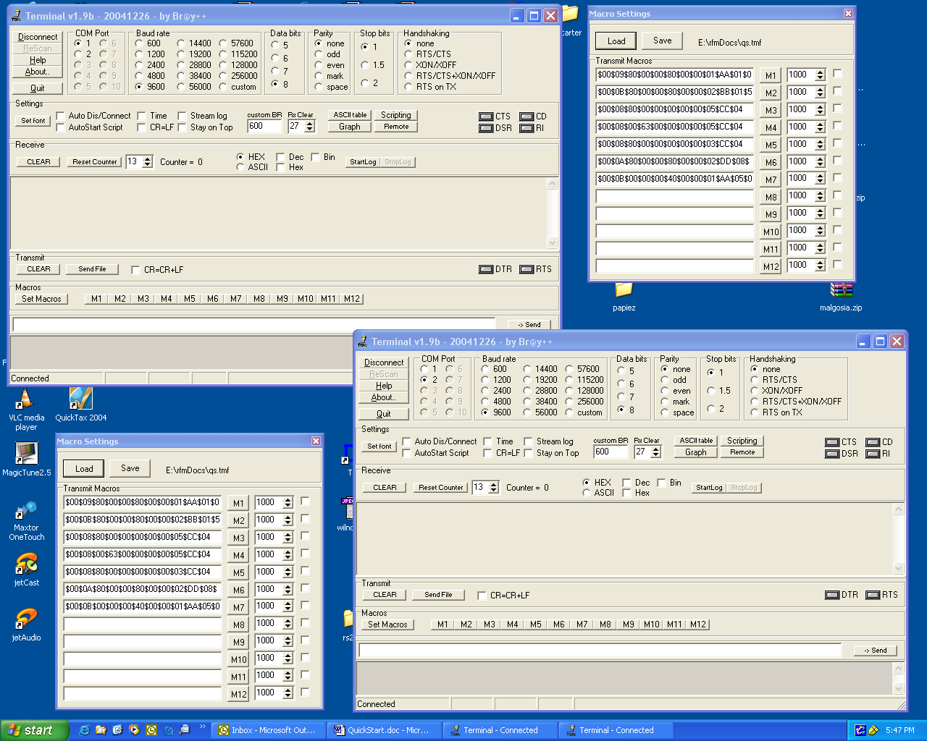
- Flash 2 DM2100s. Power up one of them.
- If you set the Terminal in ASCII mode, on power up you’ll see:

PicOS v1.15, Copyright (C) Olsonet Communications, 2002-2005
Leftover RAM: 1020 bytes
DM2100 initialized: 700, 1400, 2100 / 1050, 1750, 2450 (3150)

or hex codes if you have the terminal in hex mode. Ignore and clear. Keep Terminal in hex mode.

- Enter $00$09$80$00$00$80$00$00$01$AA$01$04 or click M1.
It means CMD_INFO for INFO_SYS group, issued for the local node.
The response 00 1F 20 63 00 80 63 00 80 63 00 01 AA 00 CA BA 00 00 63 00 07 00 04 00 00 00 00 00 00 00 00 00 00 04 shows:
- successful completion (oprc 00 after opref AA);
- host_id (hardware id) 0x0000BACA, shown little endian
- local host 99 (63 00 hex little endian);
- network id (07 00);
- time since power up (04 00 00 00);
- master_host (00 00);
- master_delta (time delta between the node’s and its master’s clocks) (00 00 00 00);
- beacon frequency in seconds (00).

- Modify M1 or enter $00$09$40$00$00$80$00$00$01$AA$01$04 (the proxy node now is the Master, not local_host). The response comes: 00 0D 20 63 00 40 00 00 80 00 00 01 AA 03 01 04. The 03 after AA is an error RC_EMAS, showing why the operation can’t be completed: the host is a ronin. (If you modified M1, change it back from ADQ_MASTER to ADQ_LOCAL.)
- Use macro M2 or $00$0B$80$00$00$80$00$00$02$BB$01$58$00$04 to set local host to 88 (0x58). You’ll get the “success” response (00 after opref BB). Modify M2 or issue $00$0B$80$00$00$80$00$00$02$BB$03$58$00$04 to set master_host the same. (The only change: PAR_LH -> PAR_MID.)
- Now, do M1 again (as in 4.) The response 00 1F 20 58 00 80 58 00 80 58 00 01 AA 00 CA BA 00 00 58 00 07 00 B7 07 00 00 58 00 00 00 00 00 00 04 reflects the changes. (You may also see here how many seconds it took me to write these things down.) Our local_host is now 88, and is its own master.
- Power up the other node (connected to another Terminal). You may recall that the default local_host is 99. Let’s check what’s around our node 88 (the first one), issuing a global trace (not that good idea in a large network). M3 or $00$08$80$00$00$00$00$00$05$CC$04 does it. This is the first time we see a command’s result not as a response, but a message output: 00 06 FF 03 01 01 63 00 04. See the document with many more pages for details (1 hop each way, to the node 99 (0x63)). Let’s explore it a bit more:
- M4 or $00$08$00$63$00$00$00$00$05$CC$04 is M3’s modification. Keep both Terminal visible, and after sending it, you’ll see 00 0C 20 58 00 00 63 00 00 00 00 05 CC 00 04 on node 88, and 00 06 FF 03 01 01 58 00 04 on 99. The 88 got the result: you successfully issued a global trace command to be executed on 99. The 99 got the message output to learn that the only host around in 88, 1 hop away both ways. Just for illustration:
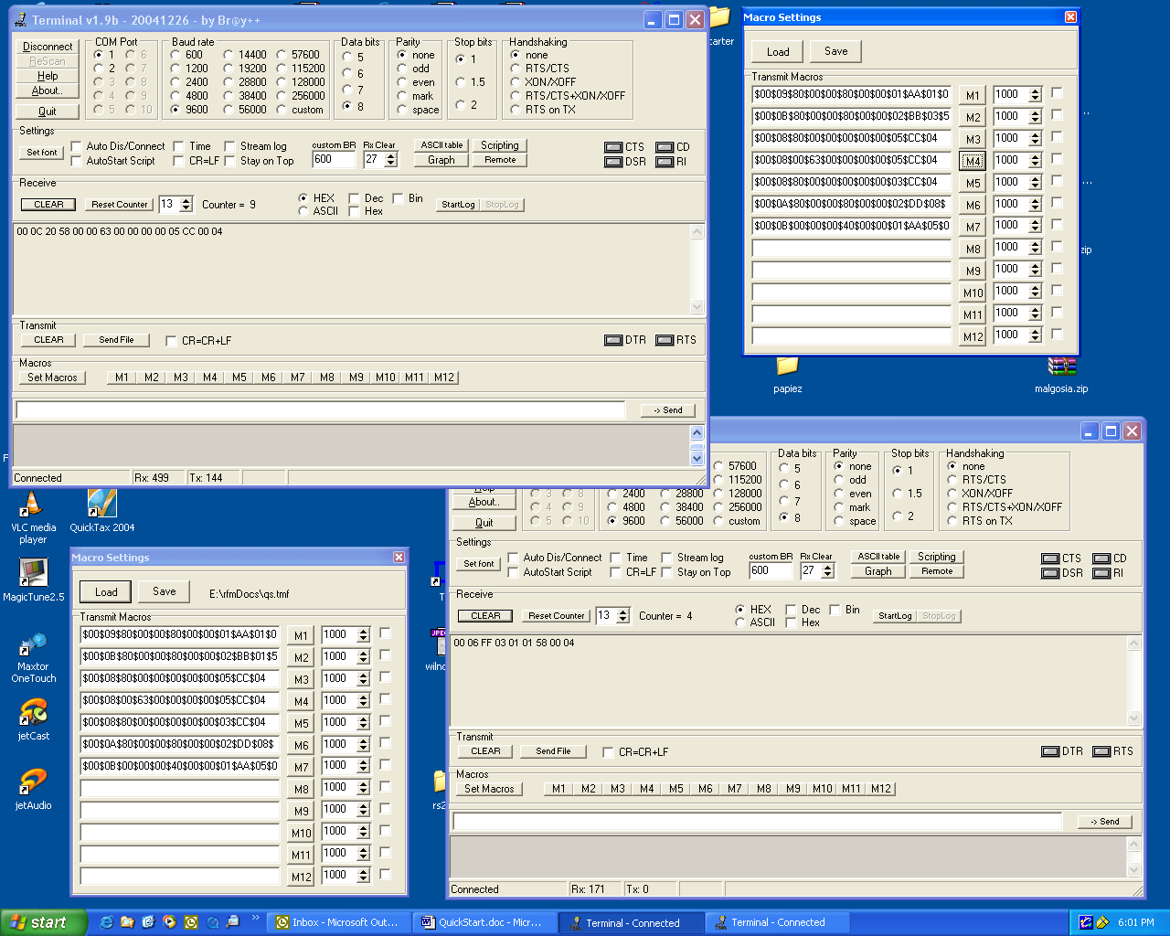
- Let’s make 88 a global Master. M5 or $00$08$80$00$00$00$00$00$03$CC$04. Another success: 00 0C 20 58 00 80 58 00 00 00 00 03 CC 00 04 (RC_OK after CC).
- Let’s set up a Master beacon on 15 s. First, set the beacon: M6 or $00$0A$80$00$00$80$00$00$02$DD$08$0E$04. RC_OK, again. Now, send M5 again (as in 10.) and enjoy the LEDs blinking, as the Master messages are silent otherwise.
- Master’s voice: Everybody in the network, give your Master ADC-converted voltage on pin 2 (of P6) with reference to 1.5V, sampled for 10 ms. M7 or $00$0B$00$00$00$40$00$00$01$AA$05$02$0A$04 would return (in our case just from the 99, but this is a good example why broadcast proxy, i.e. the whole network as a proxy, makes sense) 00 0F 20 58 00 00 00 00 40 00 00 01 AA 00 05 02 0A 04 (successful command forwarding) followed by 00 0F C0 58 00 C0 00 00 C0 00 00 01 AA 00 7F 02 0A 04 (7F is the reading; if you see FF it means the ADC was busy receiving, but it is not that important now). Note that the address qualifier “ADQ_MASTER” is resolved at the proxy, not at source. The response on node 99 says “success” about executing the command, but the result (the reading) was requested to be forwarded to the Master

That should be enough pretty much for anybody, including the author. Please note that we deal with networking only a tiny bit. Mostly, we deal with the application that happened to be a network, also.

When a decent interface is built, this somehow ironic “quick start” should be shredded. It was written because the binary interface was requested (rightly so, for resource utilization), and a proper interface is a time consuming matter.

(Text interface is still operational, so the RTag_RFM may become “AMR demo plus plus” in no time.)

