alphaEQfrac:
alphaEQradical:
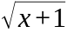
alphaEQcuberoot:
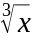
alphaEQsup:
alphaEQsub:
alphaEQsubsup:
alphaEQsin: 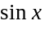
alphaEQcosub: 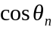
alphaEQcossub2: 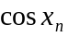
alphaEQlog: 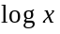
alphaEQlogbase: 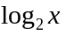
alphaEQsum:
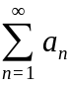
alphaEQint:
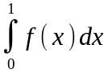
alphaEQintnolimits: 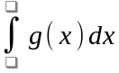
alphaEQparen: 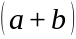
alphaEQbracket: 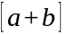
alphaEQbrace: 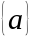
alphaEQabs: 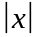
alphaEQstretchy:
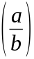
alphaEQsepdelim: 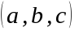
alphaEQmatrix:
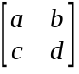
alphaEQhat:
alphaEQvec:
alphaEQbar:
alphaEQlimit:
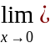
alphaEQeqarr:
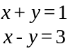
alphaEQquadratic:
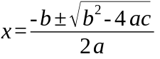
alphaEQtext: 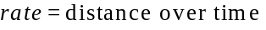
alphaEQgreek: 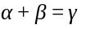
alphaEQchem: 