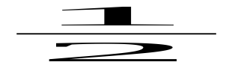Fraction:
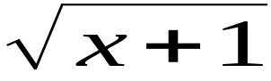Root:
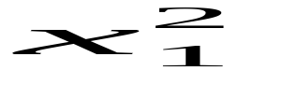SubSup:
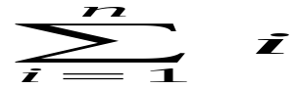Sum:
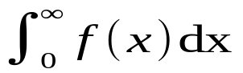Integral:
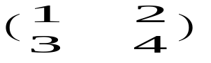Matrix:
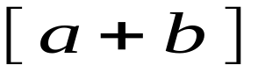Brackets:
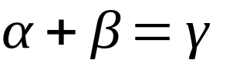Greek:
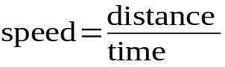TextInFormula:

