Fraction:
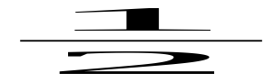
Root:
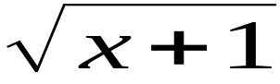
SubSup:
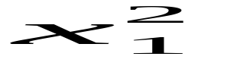
Sum:
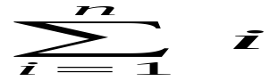
Integral:
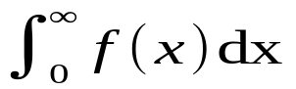
Matrix:
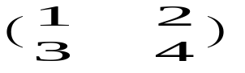
Brackets:
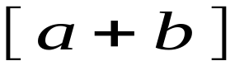
Greek:
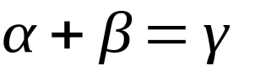
TextInFormula:
