Fraction: 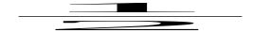
Root: 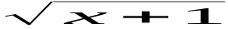
SubSup: 
Sum: 
Integral: 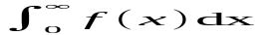
Matrix: 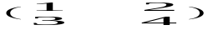
Brackets: 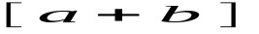
Greek: 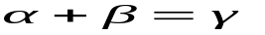
TextInFormula: 