**REQUIREMENTS IN PLAYERS:**

**Website used:** https://www.espncricinfo.com/records/tournament/team-match-results/icc-men-s-t20-world-cup-2022-23-14450

"WE NEED THE BEST 11"

1. The team should be able to score at least 180 runs on an average.
2. They should be to defend 150 runs on an average

**OPENERS**

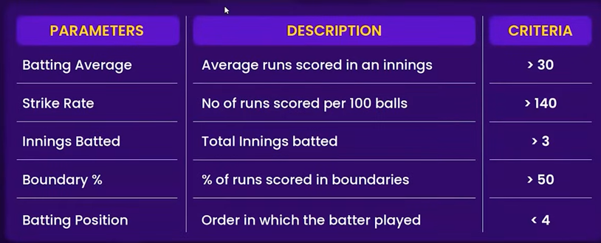

**ANCHORS/ MIDDLE ORDER BATTSMAN**

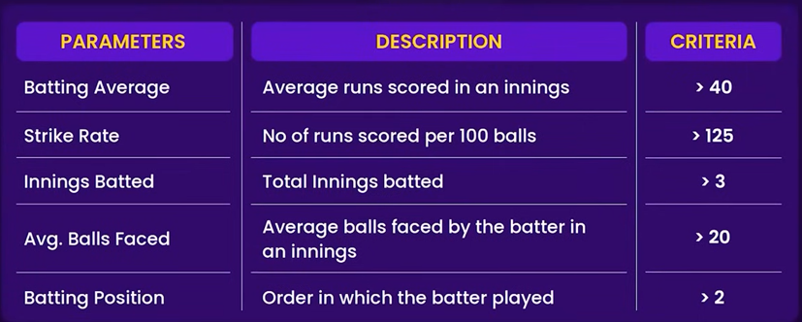

**FINISHERS/ LOWER ORDER ANCHOR**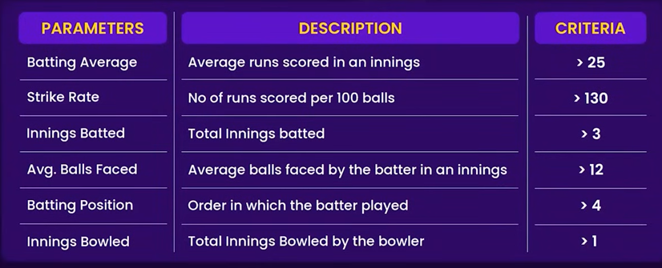

**ALL ROUNDERS**

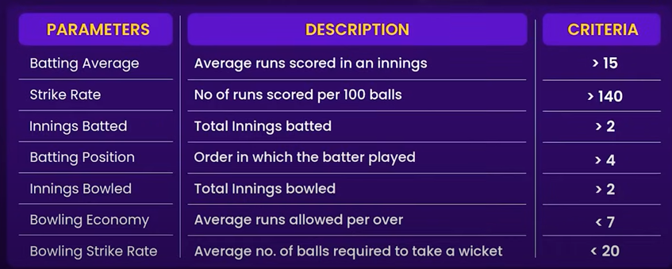

**SPECIALIST FAST BOWLERS**

