* Python: server – located in ***ClientServer\Server***
* .NET: client – located in ***ClientServer\Client***

**How to run the program:**

First you need to run the server.

**Server**

1. Run Command Prompt as administrator
2. Change current directory to directory where the project folder is located

* Type cd {project path}
* In the end of the path should be …\ClientServer\Server>

1. Run command “py server.py”
2. After these steps the server should work, and you will get the next output



1. Leave the server running (don’t close the cmd window)

**Client**

***Setting up the Environment for C# Compiler***

Open another Command Prompt as administrator.

To check if the path of the C# compiler is set as Environment Variable, type ***csc*** and press Enter. You should get something as shown below.

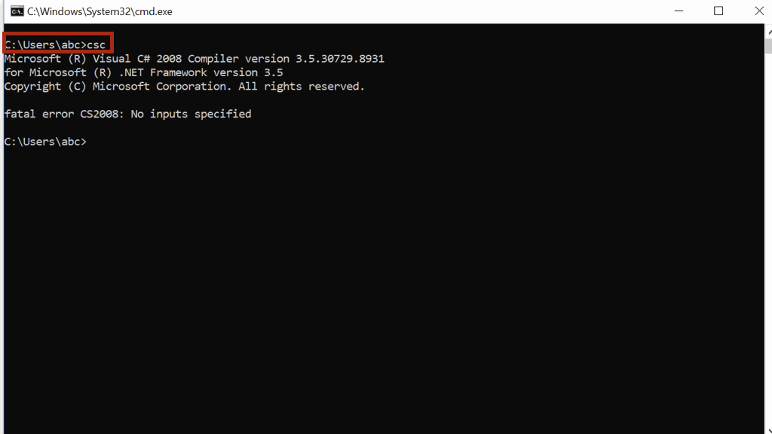

If you are getting this message - *'csc' is not recognized as an internal or external command, operable program or batch file*, then you need to the path of the C# compiler as Environment Variable.

***To set the path as Environment Variable***

**Step 1:** Go to **Control Panel -> System**. Under **Advanced System Setting** option click on **Environment Variables** as shown below:

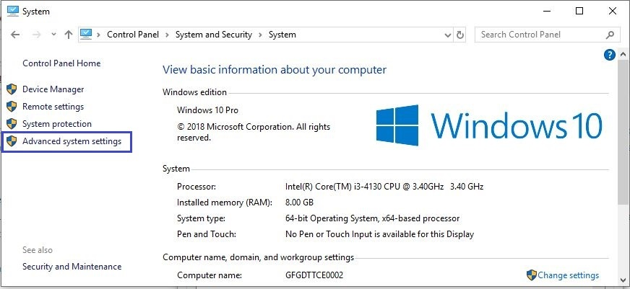

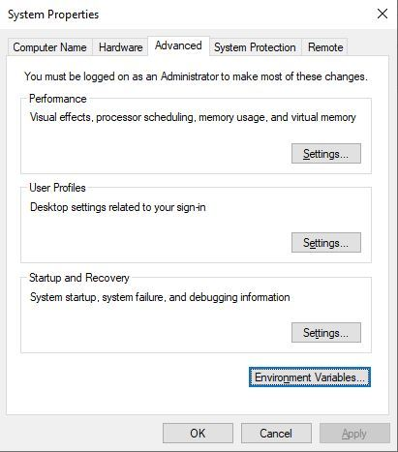

**Step 2:** Now, you have to alter the **“Path”** variable under System variables so that it also contains the path to the **.NET Framework** environment. Select the **“Path”** variable and click on the **Edit** button as shown below:

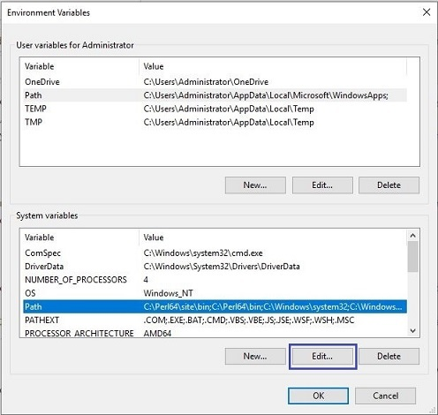

**Step 3:**

An Edit Environment variable window will appear. Let's assume that **csc.exe** is located in ***C:\Windows\Microsoft.NET\Framework\v4.0.30319*** directory. This directory is the path to the compiler.

Click on the **New** button and add the compiler path in the text box created as shown below. Then click on **Ok**.

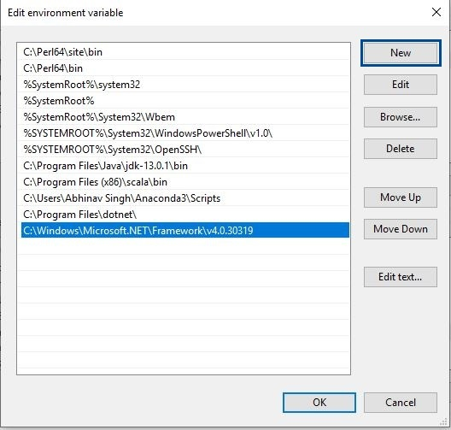

**Step 4:** Click on **OK**, Save the settings and it is done.

Now to check whether the environment setup is done correctly, open command prompt and type **csc**.

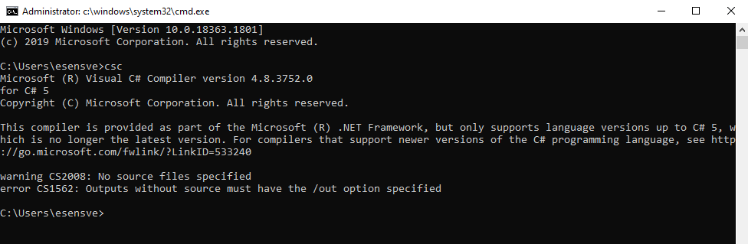

***Steps to Execute C# Program on cmd***

1. Change current directory to directory where the project folder is located

* Type cd {project path}
* In the end of the path should be …\ClientServer\Client>

1. Once you are in the correct directory in which you have your program, then you can compile and run your program.
2. To compile, type ***csc program.cs***

You will get the next output:

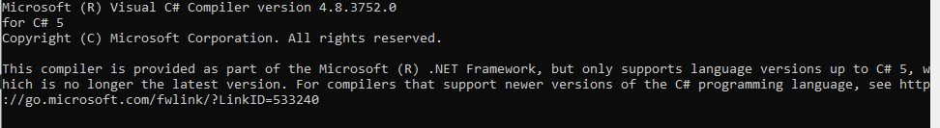

1. Once the program is compiled, run the program by typing filename (***program*** in our case) and then pressing Enter. You will get the output as shown below:

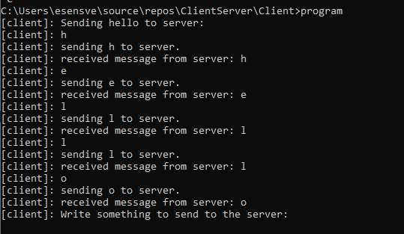

1. If you type something, you will get the following output 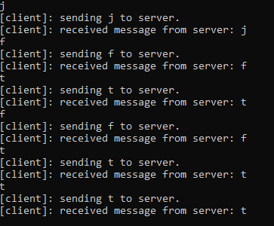

If you look at the server cmd window, you will see all characters that you have typed in client window

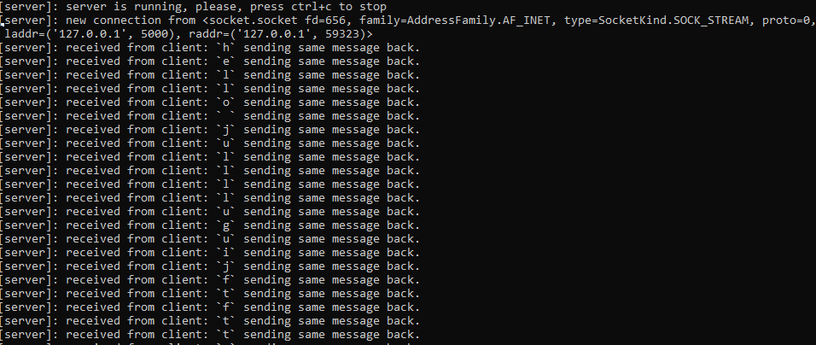

**How to run the program with Docker:**

1. Install the Docker
2. Run Command Prompt as administrator
3. Change current directory to directory where the project folder is located

* Type cd {project path}
* In the end of the path should be …\ClientServer

1. Open additionally Docker

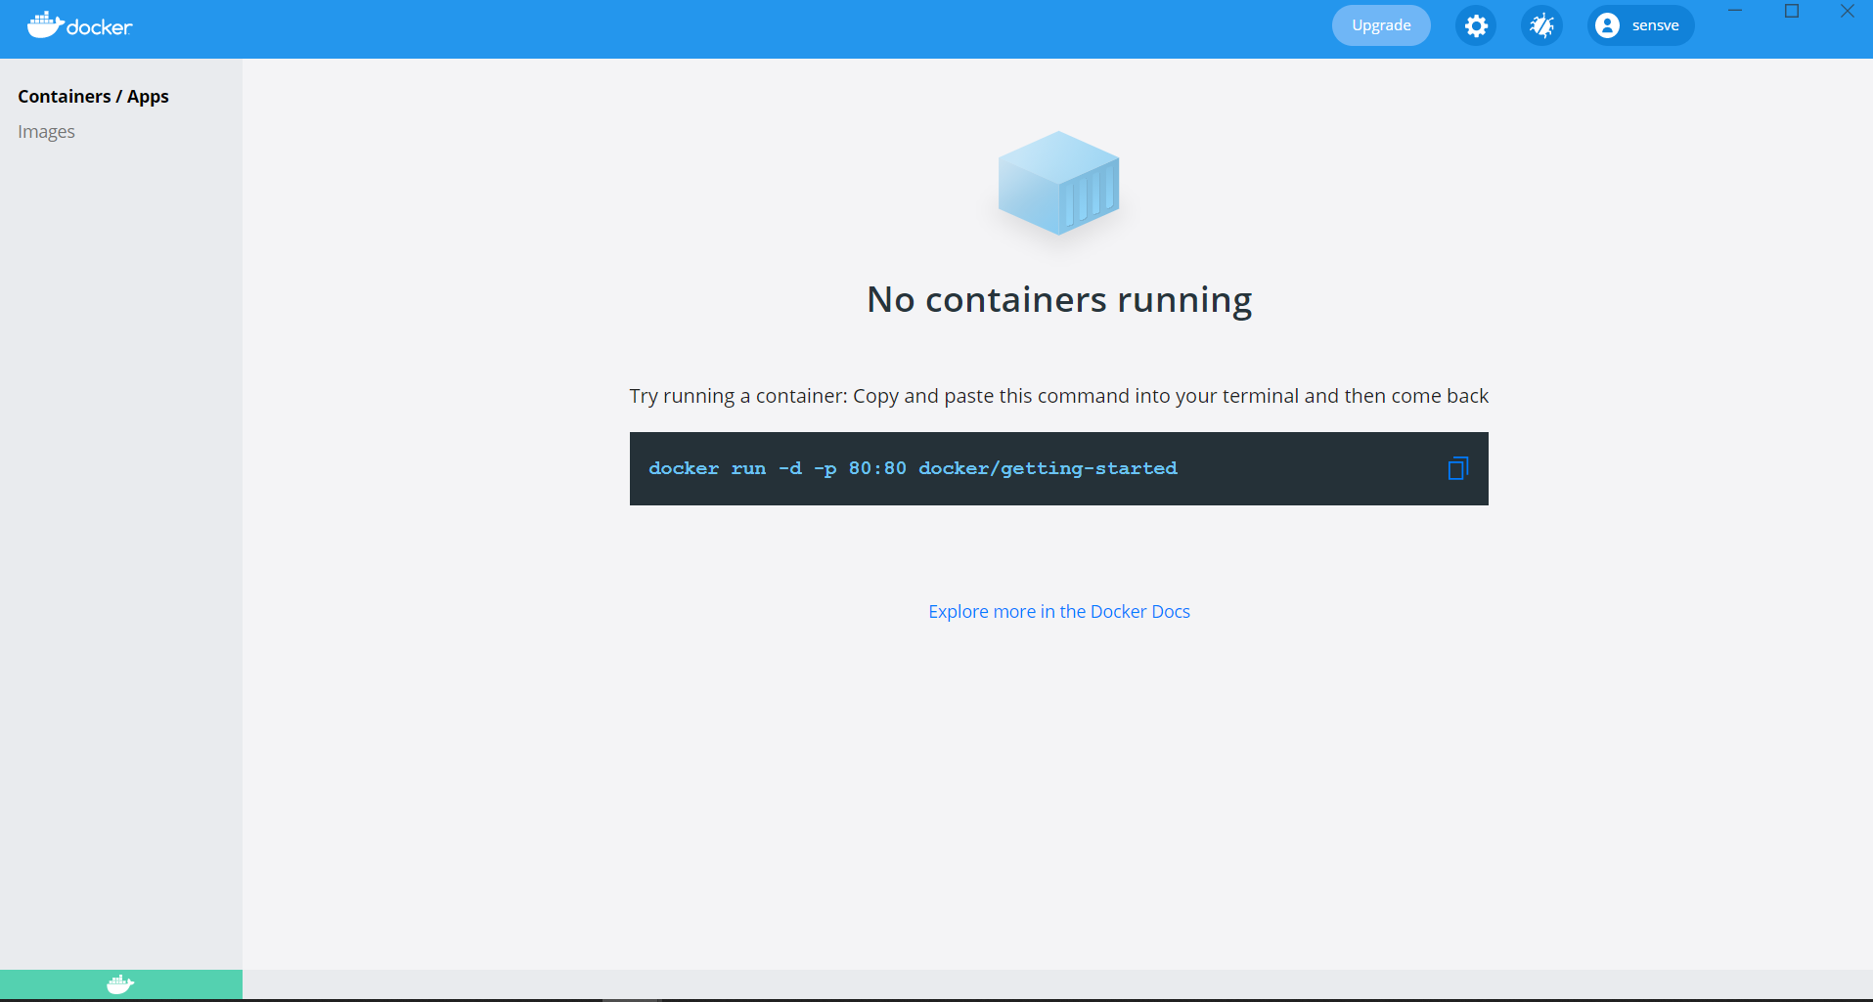

1. In cmd window run the following command

***docker-compose up -d && docker attach clientserver_client_1 && docker attach clientserver_server_1***

1. You will get the next output

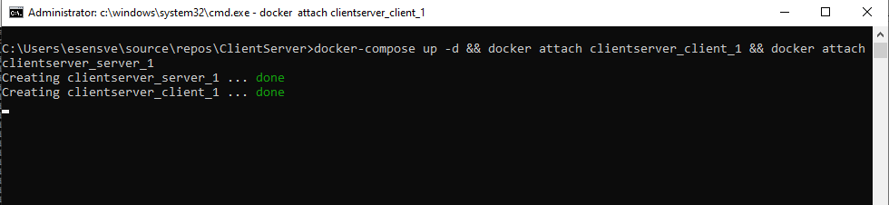

In the Docker window you will see that containers have been created

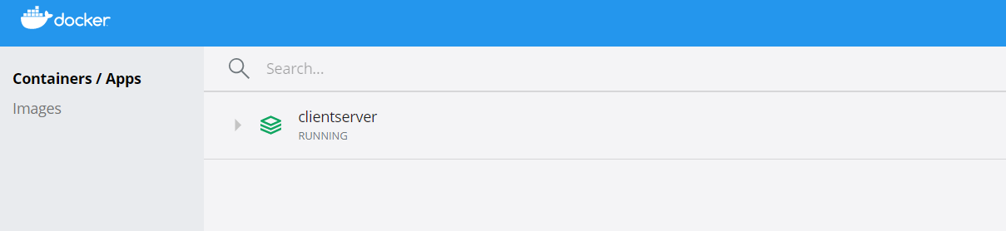

If you open clientserver, you will see

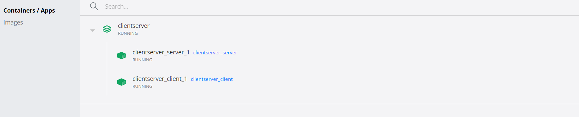

1. Click to clientserver_server_1 to make sure that server works

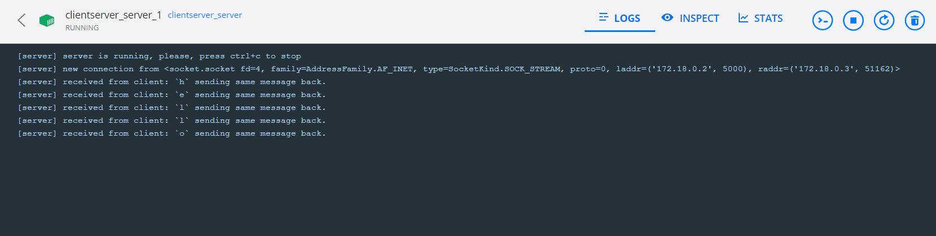

1. Click clientserver_client_1 to make sure that client works

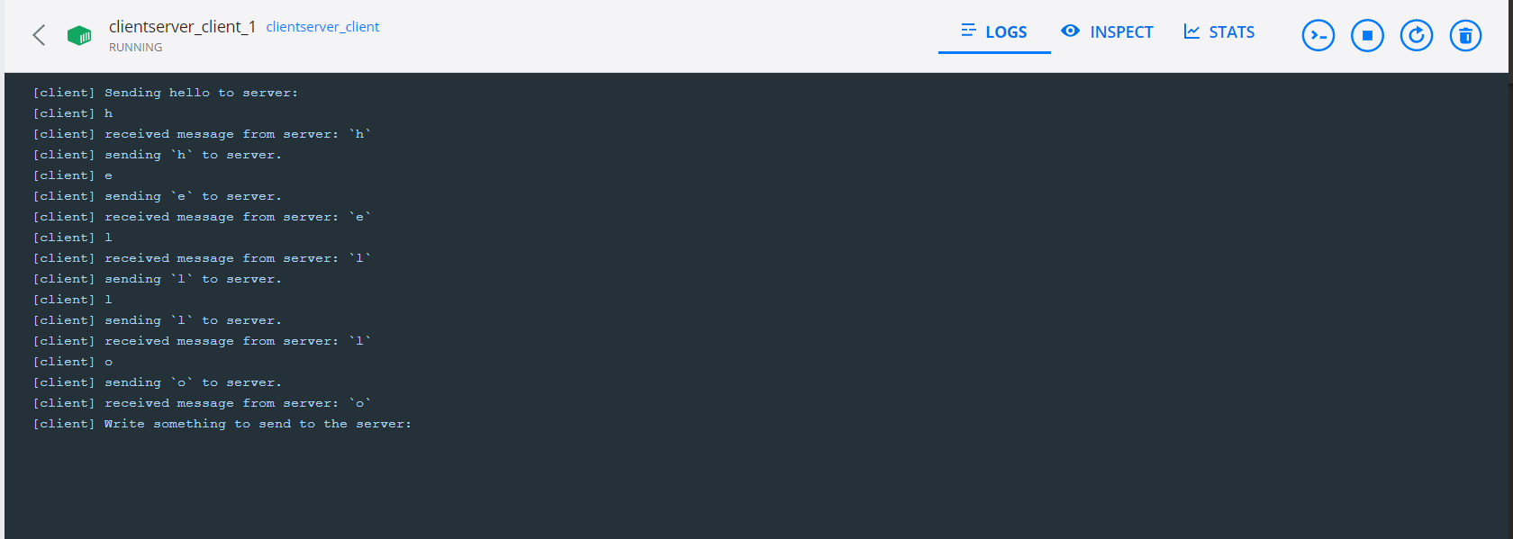

1. By printing something to cmd window, you will get the following results:

* In cmd window 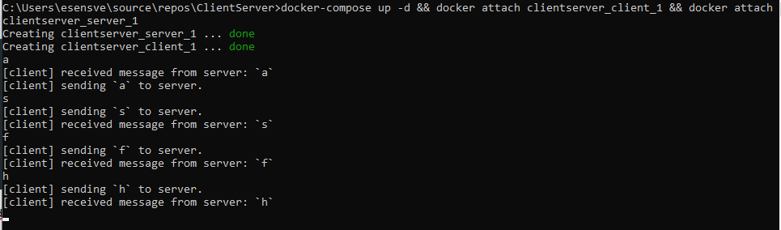
* In Docker clientserver_client_1

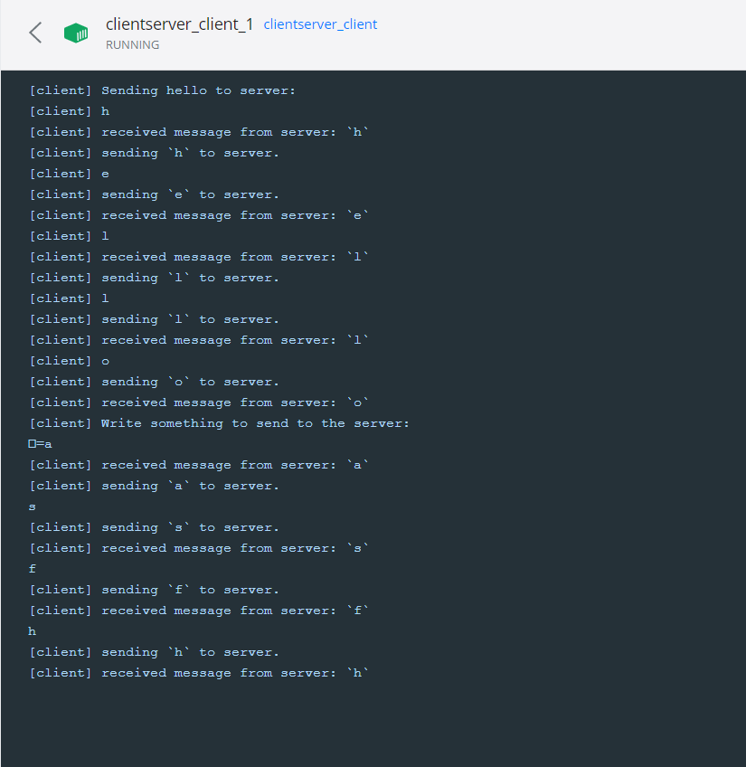

* In Docker clientserver_server_1

