**Darec McDaniel D424 Capstone - Employee Management System - User Guide**

**System Access**

The Employee Management System provides secure access through role-based authentication. Users must log in with their assigned credentials to access system features appropriate to their role.

**Test accounts: (Recommend admin to see all features)**

* [admin@ourcompany.com](mailto:admin@ourcompany.com) -> admin123
* [manager@ourcompany.com](mailto:manager@ourcompany.com) -> manager123
* [employee@ourcompany.com](mailto:employee@ourcompany.com) -> employee123

Navigation: The system features a responsive design with sidebar navigation on desktop devices and a collapsible menu accessible via the hamburger icon on mobile devices.

**Core Functionality**

**Employee Records Management**

The system maintains comprehensive employee records accessible through the Employees section. Users can view employee listings, search records using the integrated search functionality, and access detailed employee profiles by selecting individual entries.

Adding new employees requires completing mandatory fields including first name, last name, department assignment, role designation, and contact information. The system automatically generates usernames and email addresses based on the provided information.

Employee record modifications can be performed through the edit function, accessible via the pencil icon in the employee listing. Changes are saved immediately upon confirmation.

**Project Management**

The Projects section provides comprehensive project oversight capabilities. Users can view all projects with current status indicators and team member assignments.

Project creation involves specifying project parameters including name, description, timeline, and initial status. Team members are assigned through the dropdown selection interface during project setup or through subsequent project management actions.

**Performance Review System**

The performance review module enables systematic evaluation of employee performance. Reviews are created by selecting the target employee and review period, then completing performance ratings on a five-point scale with accompanying commentary.

Historical performance reviews are accessible through the Reports section with filtering capabilities by employee or date range.

**Reporting and Analytics**

The system generates three primary report types:

* Employee Roster: Complete organizational directory
* Salary Analysis: Compensation data overview
* Performance Summary: Aggregated review analytics

All reports support PDF export functionality and can be filtered according to specific criteria.

**User Role Permissions**

Administrator Access: Full system privileges including employee management, department administration, project creation, comprehensive reporting, and performance review capabilities.

Manager Access: Team member management within assigned departments, project management for supervised initiatives, team performance reviews, and department-specific reporting.

Employee Access: Personal profile viewing and editing, project assignment visibility, performance review access, and contact information updates.

**System Requirements**

Authentication: Passwords must contain a minimum of eight characters with uppercase letters, lowercase letters, numbers, and special characters.

Device Compatibility: The system supports desktop, tablet, and mobile device access with responsive interface adaptation.

Data Management: All modifications require explicit save confirmation. Users can cancel operations without data persistence using the cancel function.

**Step-by-Step Instructions**

**Employee Management System**

**Login Process**

1. Go to the application website
2. Enter your username and password
3. Click "Login"

**Navigation**

Desktop:

* Use the menu on the left side

Mobile:

* Tap the menu button (☰) at the top

**Dashboard Usage**

1. View system overview with employee counts, project status, and charts
2. Click on cards to navigate to detailed sections

**Employee Management**

View Employees

1. Click "Employees" in the menu
2. Browse the list or use the search bar
3. Click on an employee name to see their details

Add New Employee

1. Go to "Employees" → Click "Add Employee"
2. Fill in: First Name, Last Name, Department, Role, Position, Phone, Password
3. Click "Create" (username and email are auto-generated)

Edit Employee

1. Find the employee in the list
2. Click the edit button (pencil icon)
3. Make changes and click "Update"
4. Alternatively, access the edit pane from the employee detail screen by clicking the view button (eye icon)

**Project Management**

View Projects

1. Click "Projects" in the menu
2. See all projects with their status and team members

Create New Project

1. Go to "Projects" → Click "Add Project"
2. Enter project name, description, dates, and status
3. Assign team members from the dropdown
4. Click "Create Project"

Manage Project

1. Click on a project name to open it
2. Update status, add/remove team members
3. Edit project details as needed
4. Alternatively, click on the edit button (pencil icon) in the list to open the edit pane.

**Departments**

Click "Departments" in the left sidebar to:

* View all departments
* Click on department name to view details and employees
* Click number of employees to go back to Employees pane.

**Reports**

Generate Reports

1. Click "Reports" in the menu
2. Choose report type:

* Employee : Complete employee list
* Department: Compensation department list
* Project Summary: Complete project list

1. Click “Generate Report” to populate the report below.
2. Download functionality coming in future releases

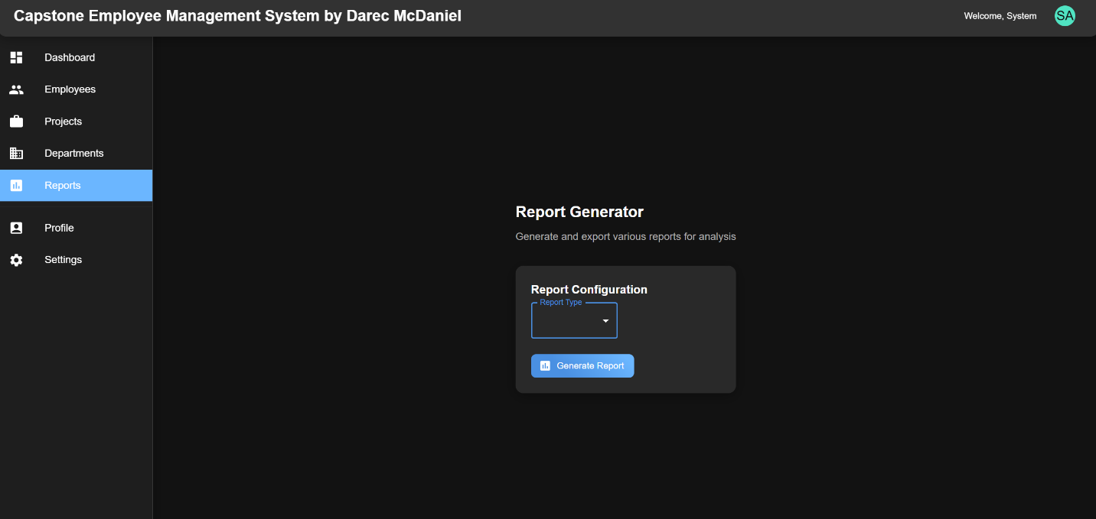

**Profile**

Click your avatar in the top right or click Profile in the menu to:

* View profile information
* Update personal details
* Change password

**Settings (Admin only in menu)**

* Click "Settings" in sidebar to access system configuration options.
* Change mode Light/Dark
* Save Changes to apply.
* Further functionality coming in future releases