Prompt:

User: Read the Entire workspace and understand how I implemented the selenium Java

I want to add the playwright typescript

Please tell me the impacted files.

Response:
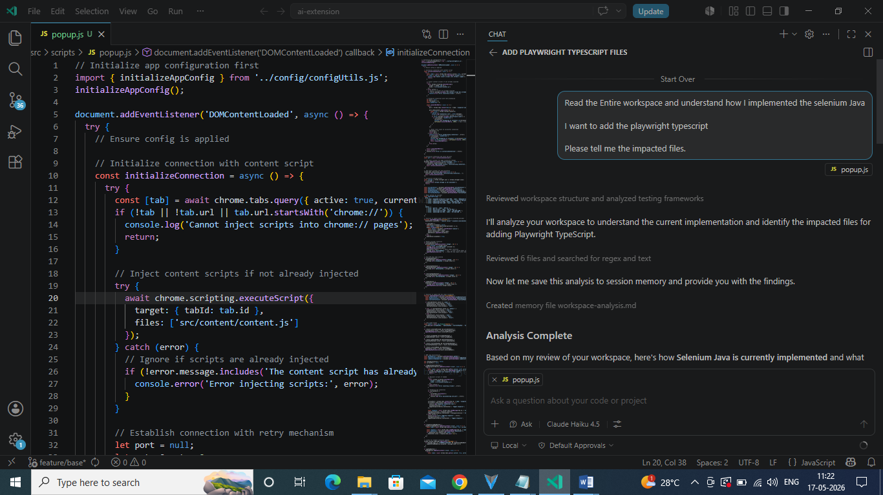

GitHub Copilot: I'll analyze your workspace to understand the current implementation and identify the impacted files for adding Playwright TypeScript.
Now let me save this analysis to session memory and provide you with the findings.

## Analysis Complete

Based on my review of your workspace, here's how **Selenium Java is currently implemented** and what files will be **impacted when adding Playwright TypeScript**:

### Current Selenium Java Implementation

Your extension generates Selenium Java code through:

1. **UI Options** (panel.html): Language dropdown includes Java, and engine dropdown includes Selenium
2. **Prompt Templates** (prompts.js): Two prompts handle Selenium Java:
- `SELENIUM_JAVA_PAGE_ONLY` - generates Page Object classes
- `CUCUMBER_WITH_SELENIUM_JAVA_STEPS` - generates Cucumber feature files + Java step definitions
3. **Code Generation Logic** (chat.js):
- `isJavaSelenium()` method checks if combination is Java + Selenium
- `getPromptKeys()` determines which prompts to use based on selections
- Supports checkbox selection for Feature File and Page Class generation

---

## **Impacted Files for Adding Playwright TypeScript**

### 1. **prompts.js** - ADD 2-3 new prompts
- `PLAYWRIGHT_TS_PAGE_ONLY` - TypeScript page object model for Playwright
- `PLAYWRIGHT_TS_WITH_CUCUMBER` - Cucumber feature file + Playwright TS step definitions
- (Optional) `PLAYWRIGHT_ONLY` - Standalone Playwright tests

### 2. **chat.js** - MODIFY code generation logic
- Add `isPlaywrightTypeScript()` helper method (similar to `isJavaSelenium`)
- Update `getPromptKeys()` method to handle Playwright + TypeScript combinations
- Update the unsupported language message handler ([line 593](src/scripts/chat.js#L593))
- Update loading indicator text generation ([line 458](src/scripts/chat.js#L458)) to recognize Playwright

### 3. **panel.html** - CHECK/MODIFY UI
- Language dropdown: Already has "ts" option ✓
- Engine dropdown: Already has "playwright" option ✓
- May need to update checkbox labels/visibility for TypeScript generation modes

### 4. **prism-typescript.js** - Already included ✓
- Syntax highlighting for TypeScript already available
- No changes needed (already referenced in panel.html)

### 5. **manifest.json** - VERIFY
- Check permissions are adequate for new code generation
- Likely no changes needed

---

## Summary

**3 main files need modification:**
1. prompts.js - Add Playwright TypeScript prompt templates
2. chat.js - Add Playwright TypeScript logic to code generation flow
3. panel.html - Verify/update UI labels (options already exist)

The UI already supports the language and engine combinations—you mainly need to add the prompt templates and logic to route TypeScript + Playwright selections to the right prompts.

Implementation:

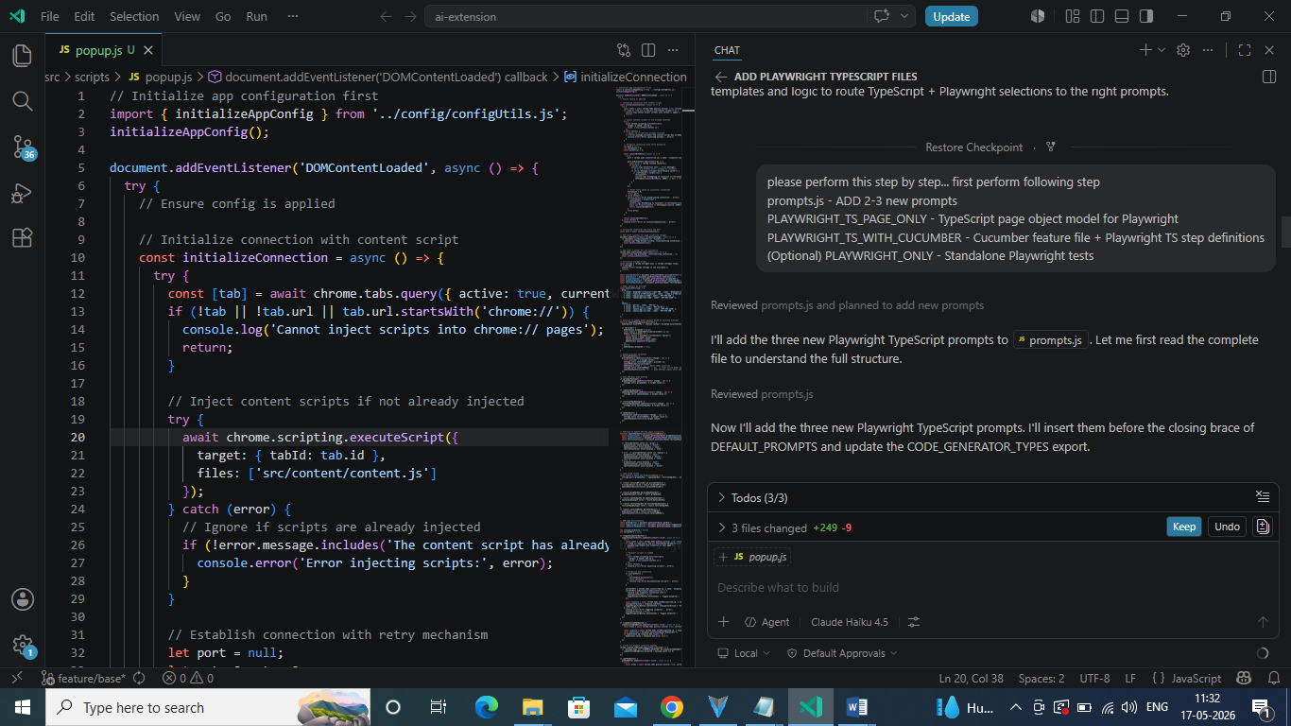

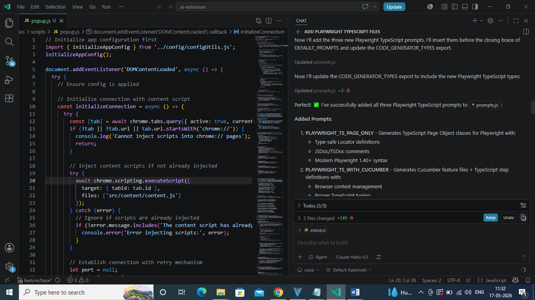

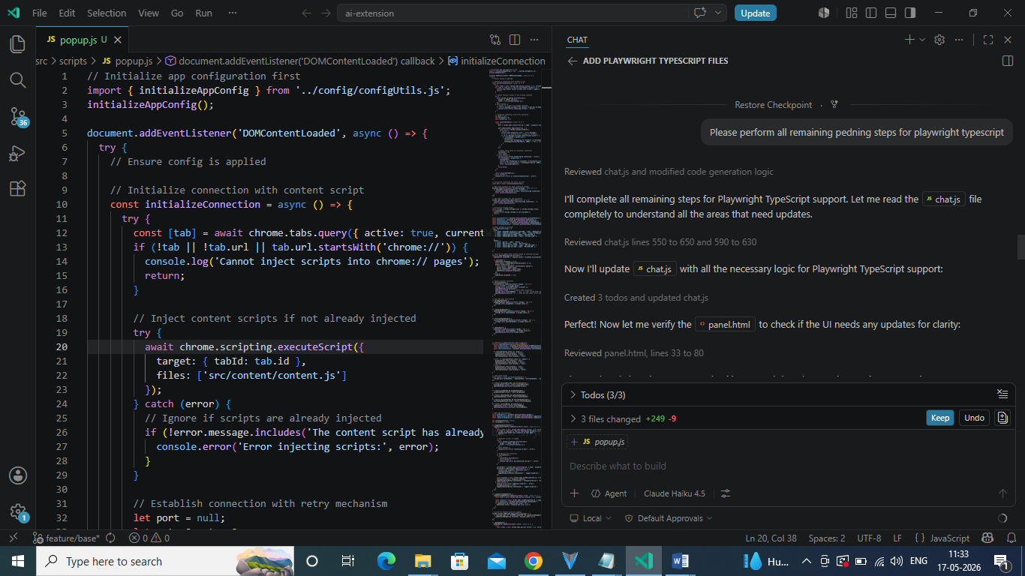

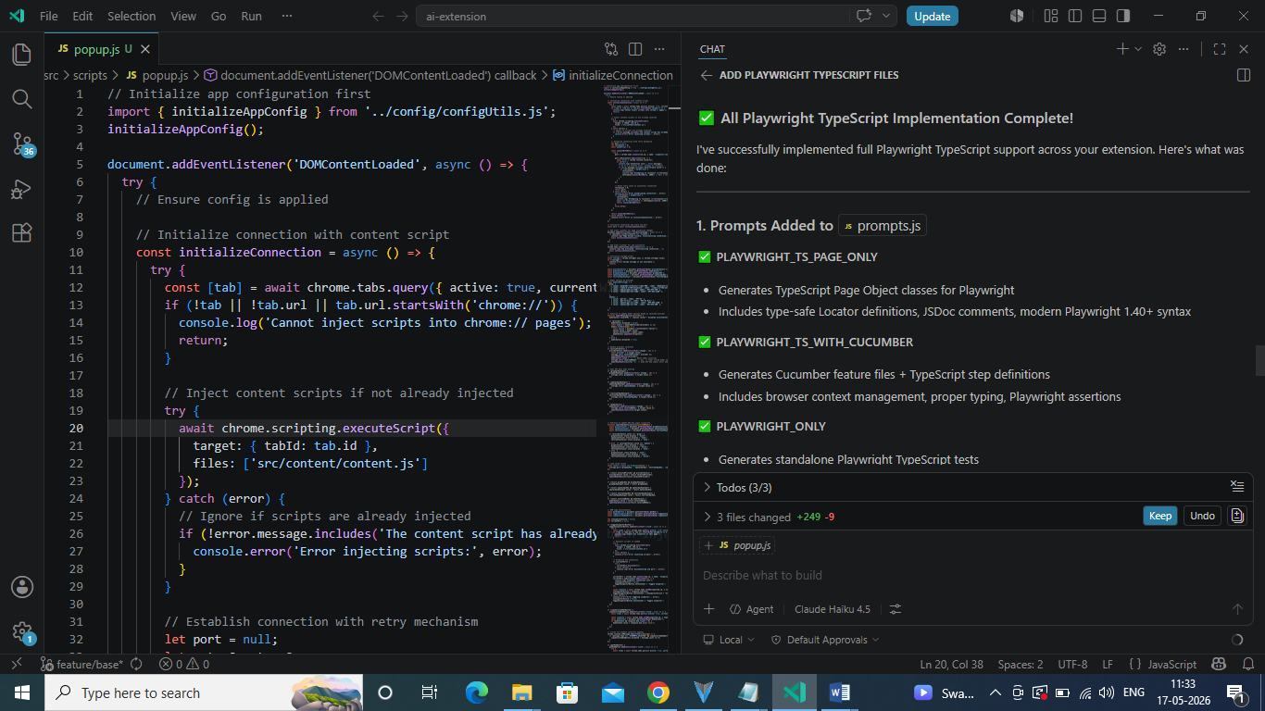

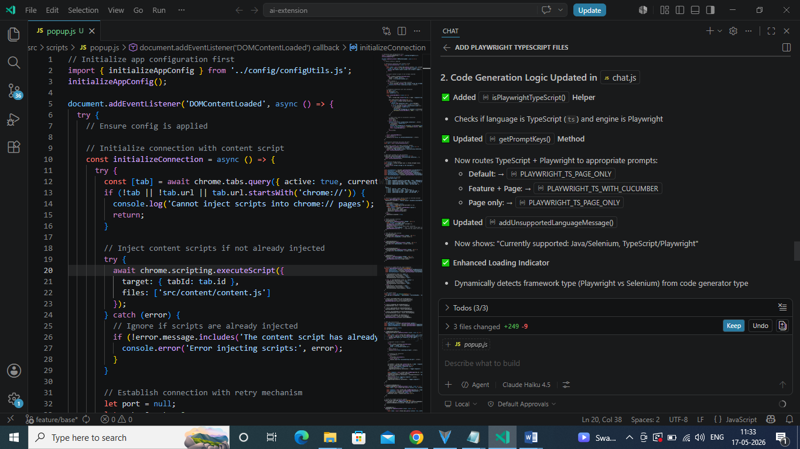

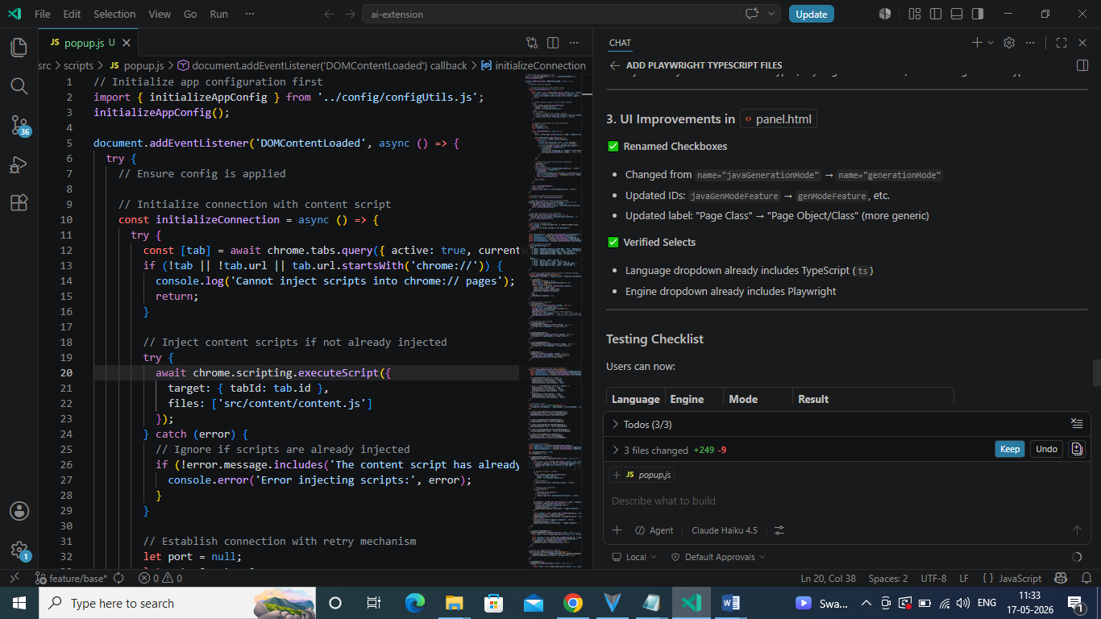

Result:

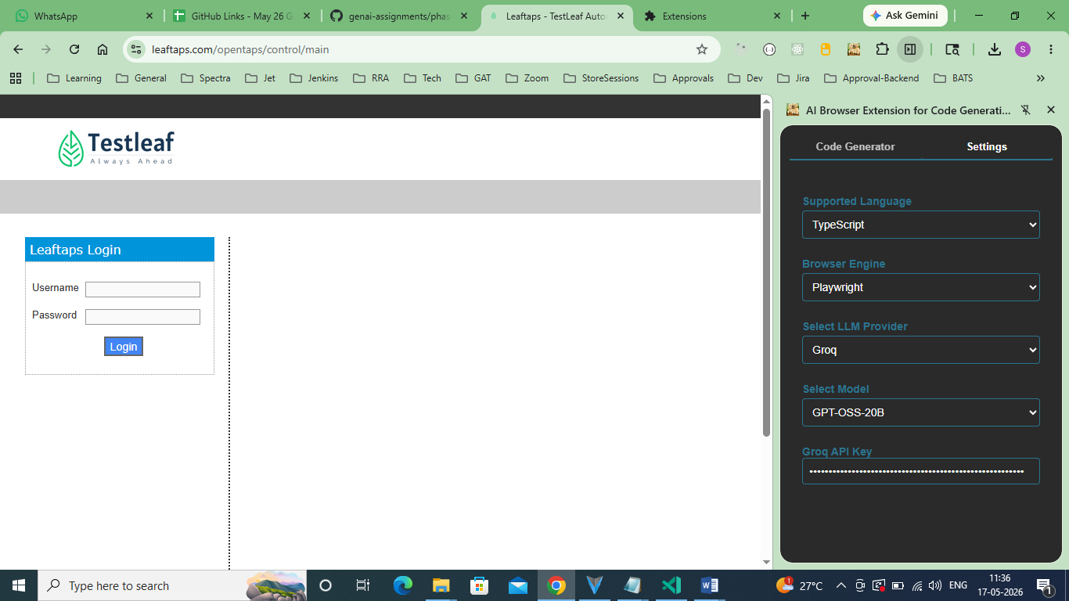

Feature file:

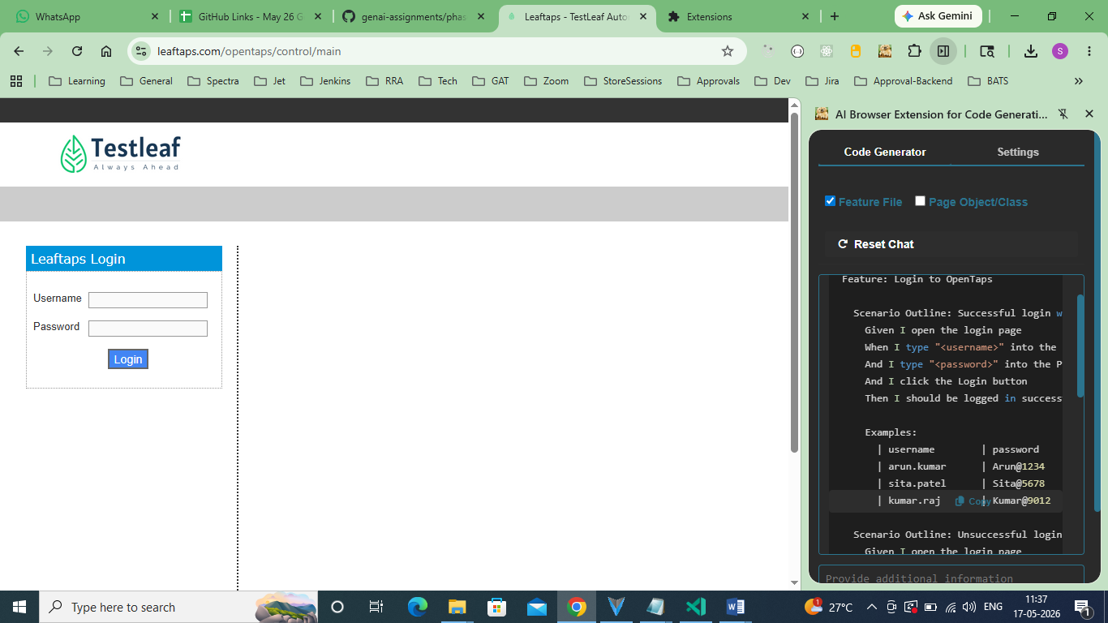

Type script page object:

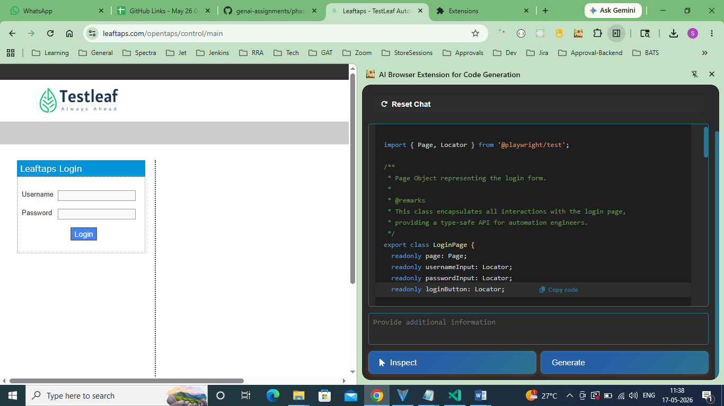

import { Page, Locator } from '@playwright/test';

/**
* Page Object representing the login form.
*
* @remarks
* This class encapsulates all interactions with the login page,
* providing a type-safe API for automation engineers.
*/
export class LoginPage {
readonly page: Page;
readonly usernameInput: Locator;
readonly passwordInput: Locator;
readonly loginButton: Locator;

/**
* Creates an instance of LoginPage.
*
* @param page - The Playwright Page instance.
*/
constructor(page: Page) {
this.page = page;
this.usernameInput = page.locator('#username');
this.passwordInput = page.locator('#password');
this.loginButton = page.locator('input[type="submit"][value="Login"]');
}

/**
* Navigates to the login page.
*
* @param url - Optional URL to navigate to; defaults to the root.
* @returns A promise that resolves when navigation completes.
*/
async goto(url: string = '/'): Promise<void> {
await this.page.goto(url);
}

/**
* Fills the username field.
*
* @param username - The username to enter.
* @returns A promise that resolves when the field is filled.
*/
async fillUsername(username: string): Promise<void> {
await this.usernameInput.fill(username);
}

/**
* Fills the password field.
*
* @param password - The password to enter.
* @returns A promise that resolves when the field is filled.
*/
async fillPassword(password: string): Promise<void> {
await this.passwordInput.fill(password);
}

/**
* Submits the login form by clicking the login button.
*
* @returns A promise that resolves when the click action completes.
*/
async submitLogin(): Promise<void> {
await this.loginButton.click();
}

/**
* Checks if the login button is visible on the page.
*
* @returns A promise that resolves to true if visible, otherwise false.
*/
async isLoginButtonVisible(): Promise<boolean> {
return this.loginButton.isVisible();
}

/**
* Retrieves the current value of the username input.
*
* @returns A promise that resolves to the username string.
*/
async getUsernameValue(): Promise<string> {
return this.usernameInput.inputValue();
}

/**
* Retrieves the current value of the password input.
*
* @returns A promise that resolves to the password string.
*/
async getPasswordValue(): Promise<string> {
return this.passwordInput.inputValue();
}
}

