A Novel Map Switching Algorithm and Generation Pipeline for Autonomous Mobile Robots in Eccentric Scenarios

Tejas M K, Lalithesh K, Preetham M, Dr. R. Senthilnathan
Department of Mechatronics Engineering
SRM Institute of Science and Technology, Kattankulathur, Tamil Nadu, India
[Corresponding author email — placeholder]

1. Introduction
Autonomous mobile robots operating in indoor environments depend fundamentally on accurate and computationally efficient map representations. The map serves as the primary spatial reference for localization, path planning, and obstacle avoidance, making its quality and management strategy central to the overall performance of the navigation system. As deployment environments expand from small rooms to building-scale spaces such as hospitals, warehouses, and university facilities, the demands placed on map representations have grown substantially, creating challenges that existing approaches address only partially.
The dominant paradigm for indoor robot navigation is the two-dimensional occupancy grid map [1, 2, 3], in which the environment is discretized into a uniform grid of cells, each assigned a probability of occupancy. Occupancy grids are intuitive, compatible with standard range sensors, and directly supported by widely used navigation frameworks such as ROS2 and Nav2 [6]. However, their memory and computational cost scale with the square of the environment's linear dimension at a fixed resolution. For a building-scale indoor environment spanning 60 m × 45 m at a navigation-grade resolution of 0.04 m per cell, a single monolithic occupancy grid requires over 1.46 million cells. Allocating, updating, and planning over this costmap imposes a significant burden on resource-constrained embedded platforms such as the NVIDIA Jetson Nano, which must simultaneously execute sensor processing, localization, and real-time path planning.
Three-dimensional map representations, including OctoMap [2] and ColMap [1], address vertical dimensionality through hierarchical octree and run-length encoding schemes, achieving order-of-magnitude memory reductions compared to full 3D grids. However, these methods still maintain a single global map whose memory footprint scales with environment size. For planar indoor navigation, where the navigable space is constrained to corridors, maintaining a global 3D representation introduces unnecessary overhead. Even with compression, the planner's data structures remain proportional to the active map extent, causing path planning latency to grow with environment scale.
Alternative representations address these challenges through abstraction or sparsification. Landmark-based maps [5] represent the environment as sparse feature sets. Topological and semantic maps [4, 9] encode spatial relationships between regions for efficient long-range planning. Rectangle-based maps (RC-Map) [8] partition free space into rectangular regions, reducing path planning computation to 1.5% of the grid-based cost while using only 3% of the memory. Despite these advances, most approaches assume a single global map structure built and maintained in its entirety, limiting applicability to embedded systems with strict memory budgets.
A more targeted strategy is partitioning the environment into spatial submaps loaded and unloaded at runtime based on the robot's current location. Semantic zone-based map management [9] implements this for 3D maps in hospital environments, dynamically loading only task-relevant zones while offloading inactive regions. Submap joining approaches [10] optimize global map consistency from local submaps, reducing pose optimization complexity to be independent of global map size. The long-term SLAM survey by Sousa et al. [4] identifies runtime map swapping as an emerging technique for large-scale environments. However, these methods either target 3D maps, require specialized SLAM frameworks, or focus on map building rather than real-time navigation on pre-built maps.
The present work addresses this gap by proposing a tile-based map switching system for 2D occupancy grid navigation using the ROS2 and Nav2 stack. The environment map is decomposed offline into spatially overlapping tiles, each covering one navigable zone of the floor. At runtime, only the tile corresponding to the robot's current location is loaded into the map server. A custom Behavior Tree action node monitors the robot's pose and heading at each navigation cycle and initiates an asynchronous tile switch when the robot enters a predefined overlap region between adjacent tiles. This approach reduces the active costmap size from 1,466,724 cells (monolithic) to a mean of 91,594 cells, a 93.8% reduction while enabling the navigation stack to operate continuously without interruption during tile transitions.
The proposed system is validated on a differential drive mobile robot platform deployed on the second floor of the Hi-Tech Block at SRMIST KTR, a corridor environment spanning approximately 60 m × 45 m containing laboratories, classrooms, and staff rooms. The robot is tasked with autonomous material transfer between rooms, representing a practical service robotics application where embedded compute constraints demand efficient map management.
The key contributions of this work are: (1) a tile-based map decomposition strategy for 2D occupancy grid environments that constrains active costmap size to a per-tile constant regardless of total environment scale; (2) a heading-aware trigger zone mechanism that correctly disambiguates bidirectional tile transitions within overlap regions; (3) a non-blocking asynchronous state machine for tile switching that maintains continuous Nav2 operation throughout the transition; and (4) a quantitative benchmark comparing the monolithic and tessellated approaches across costmap size, planner memory, and CPU utilization.
The remainder of this paper is organized as follows. Section 2 describes the experimental platform and software stack. Section 3 presents the map data generation pipeline. Section 4 details the map switching algorithm. Section 5 presents benchmark results. Section 6 concludes.

1.1 Maps for Indoor Robot Localization

1.1.1 Types of Map Representations
The most widely adopted representation is the two-dimensional occupancy grid [2, 3], which divides the floor plane into a uniform lattice of cells and assigns each cell a log-odds probability of occupancy. Occupancy grids integrate directly with standard navigation planners but scale as O(n²) with environment size. Three-dimensional extensions address environments with vertical structure: OctoMap [2] uses an octree achieving up to 97% memory reduction versus full 3D grids through pruning; ColMap [1] combines a 2D N²-tree with run-length encoding along the vertical axis, achieving 12–15× lower memory than OctoMap at equivalent resolution. Both retain probabilistic occupancy semantics while compressing storage, but memory still grows with environment size.
Topological maps represent the environment as a graph of nodes connected by traversable edges [4], scaling gracefully to large environments but ill-suited for metric obstacle avoidance. Semantic maps extend this by associating regions with functional labels [9], enabling task-aware navigation. Yun and Yoo [9] demonstrate semantic zone partitioning within RTAB-Map, dynamically loading only task-relevant zones for a hospital navigation robot. Landmark maps [5] represent the environment as sparse distinguishable features, achieving mean localization accuracy of 0.284 m on the NCLT urban dataset while reducing memory by orders of magnitude versus dense grids. RC-Map [8] partitions free space into rectangles, requiring only 1.5% of grid-based planning computation and 3% of grid memory for a 300×300 environment.

1.1.2 State of the Art and Key Challenges
The long-term SLAM survey by Sousa et al. [4] synthesizes 142 works, identifying map sparsification and transparent disk-swapping as key strategies for large-scale environments. Wang et al. [10] achieve path joining of environments up to 250 m × 200 m in 2–6 seconds with translation errors 3–12× smaller than Cartographer. Vega-Torres et al. [7] propose SLAM2REF for aligning LiDAR-inertial session data with reference maps, converging to a global pose in 11–21 seconds versus 42–80 seconds for standard AMCL. Horelican [6] evaluates Nav2 on a custom platform in dynamic environments, identifying that high-resolution maps cause bandwidth overload regardless of other navigation parameters — directly motivating map coverage management.
A fundamental tension in occupancy grid mapping is the resolution-memory tradeoff. ColMap [1] quantifies this: a 100 m × 100 m × 30 m environment at 5 cm resolution requires 9.6 GB as a full 3D grid. OctoMap [2] reports exponential memory growth with tree resolution. Gonzalez-Arjona et al. [3] adopt binary rather than probabilistic occupancy specifically to satisfy FPGA memory constraints. The long-term SLAM review [4] identifies map sparsification and runtime memory swapping as the two principal strategies to address this tradeoff without sacrificing localization quality.

1.1.3 Comparison of Available Approaches
Table 1 summarizes the key characteristics of surveyed map representations and management strategies across five criteria: memory scaling, runtime partial loading, 2D Nav2 compatibility, and embedded platform suitability.

Method | Representation | Memory Scaling | Runtime Partial Load | 2D Nav2 Compatible | Embedded
OctoMap [2] | 3D Octree | O(n³) compressed | No | No | Partial
ColMap [1] | 2D N²-tree + RLE | Sub-linear | No | No | Partial
Simplified OGM [3] | Binary 2D Grid | O(n²) | No | Yes | Yes (FPGA)
RC-Map [8] | Rectangle Graph | ~3% of grid | No | Yes (custom) | Yes
Landmark Map [5] | Sparse features | O(landmarks) | No | No | Yes
Semantic Zone [9] | 3D RTAB-Map+zones | Bounded (zone) | Yes (zone) | No | Partial
Submap Joining [10] | Grid submaps | O(submaps) | No (build-time) | Partial | Partial
SLAM2REF [7] | Pose graph+BIM | O(session) | No | Partial | No
Proposed | 2D OGM tiles | O(1) active tile | Yes (tile) | Yes (Nav2) | Yes

Table 1. Comparison of map representation and management approaches for indoor robot navigation.
The proposed tile-based approach is the only method in the surveyed literature that simultaneously satisfies all five criteria. The closest related work is Yun and Yoo [9], which achieves runtime partial loading but relies on RTAB-Map with manually defined 3D semantic zones, making it inapplicable to resource-constrained 2D navigation scenarios.

2. Experimental Setup and Software Tools
This section describes the robotic platform, sensor configuration, target deployment environment, and software infrastructure used to develop and evaluate the proposed tile-based map switching system.

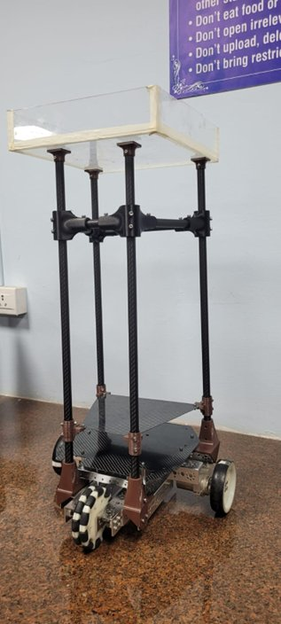
2.1 Robot Platform
The experimental platform is based on the NI Dani mobile robot chassis configured for differential drive operation. The chassis was extended with a custom superstructure for the material transfer application: four vertical carbon fiber tubes are mounted on the base plate, supporting an elevated acrylic payload tray at a total height of 750 mm from ground to tray surface. A front-mounted omnidirectional castor wheel provides passive lateral compliance, and a rear support wheel ensures structural stability. The tray configuration is intended for transporting documents, small packages, and other lightweight materials between rooms and offices within a floor.
The onboard computing unit is an NVIDIA Jetson Nano (4 GB RAM, ARM64) running Ubuntu 22.04 with ROS 2 Humble. The motor driver is a Cytron SmartDuo30 dual-channel brushed DC motor controller interfacing with the drive motors over serial. The entire software stack is containerized using Docker, enabling development and benchmarking on an AMD64 laptop before deployment on the Jetson Nano, ensuring consistent software behaviour across both platforms.
Fig. 1. Material transfer robot platform: carbon fiber chassis, differential drive, front castor wheel, carbon fiber vertical supports, and elevated acrylic payload tray.

2.2 Sensors and Localization
The robot is equipped with a single ZED Mini stereo camera (Stereolabs, SDK v4.2.5) as the sole exteroceptive sensor, providing synchronized stereo RGB imagery, depth estimation, and inertial measurement via its onboard IMU. The camera is mounted at 800 mm from the ground on the front face of the robot, tilted 30 degrees downward toward the floor to maximize depth coverage of the navigable corridor ahead. A custom 3D-printed mount with an adjustable tilt bracket holds the camera at the specified angle.
Localization is performed entirely by the ZED ROS 2 wrapper using visual-inertial odometry (VIO), with IMU fusion enabled in the ZED SDK configuration combining accelerometer and gyroscope data with stereo visual odometry to produce a robust pose estimate. The resulting odometry is consumed by the Nav2 stack as the primary localization source. No external LiDAR, GPS, or additional range sensors are used.

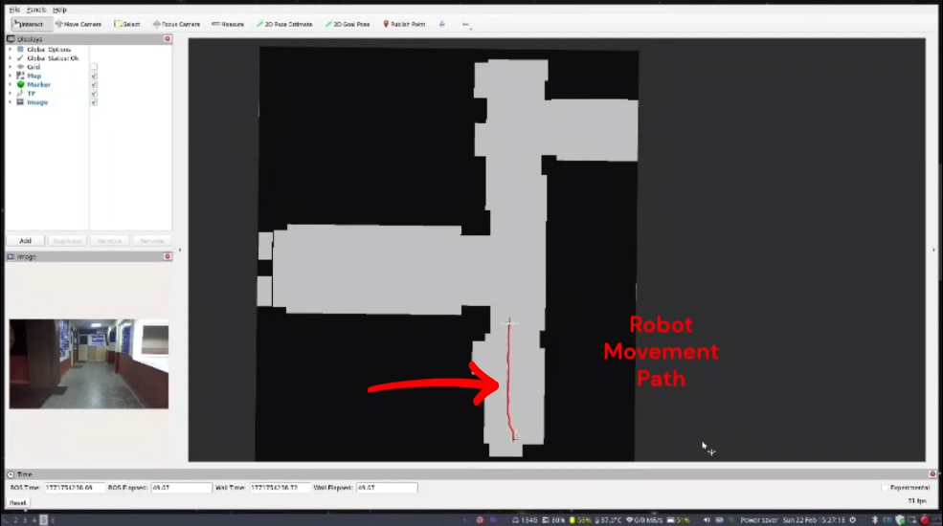

Fig. 2. RViz visualization of a tessellated tile loaded during live navigation. The active costmap covers only the current tile region; the remainder of the floor is not represented in memory. Camera feed (bottom-left) shows the corridor view from the ZED Mini.

2.3 Application and Deployment Environment
The target deployment environment is the second floor of the Hi-Tech Block at SRMIST KTR, comprising a network of corridors connecting laboratories, classrooms, and staff rooms spanning approximately 60 m × 45 m. The navigable space consists exclusively of corridor pathways; all room interiors, walls, and structural elements are treated as occupied space. The robot is tasked with material transfer between various classrooms, staff rooms, and laboratories within in the floor.
A key observation motivating the tile-based approach is that when represented as a single occupancy grid at 0.04 m/cell, the monolithic map spans 1,466,724 cells, of which only 11.7% are navigable. The remaining 88.3% corresponds to structurally unnavigable regions, walls and room interiors, for which the Nav2 costmap allocates memory and the planner builds data structures that contribute nothing to navigation.

2.4 System Requirements
The following quantified requirements guided the design and evaluation of the system: map resolution 0.04 m/cell; tile switch latency < 500 ms (including map load, costmap clear, and rebuild delay); switch cooldown 500 ms minimum inter-switch interval; post-switch costmap rebuild delay 300 ms; platform memory budget constrained by Jetson Nano 4 GB RAM under full ROS 2 stack load.

2.5 Software Libraries and Tools

Library / Tool | Version | Role
ROS 2 Humble | Humble Hawksbill | Middleware and navigation framework
Nav2 | 1.1.20 | Autonomous navigation stack
BehaviorTree.CPP | 3.8.7 | Behavior Tree execution engine
ZED SDK | 4.2.5 | Stereo camera driver, VIO, IMU fusion
CycloneDDS | 1.3.4 | DDS middleware
yaml-cpp | 8.0.2 | Tile configuration file parsing
tf2 | 0.25.16 | Robot pose lookup
Docker | 29.3.0 (AMD64) / 23.x (Jetson Nano ARM64) | Containerized deployment (ARM64 + AMD64)
OpenCV | 3.2.1 | Image processing (map pipeline)

Table 2. Software libraries and tools used in the system.

2.6 Nomenclature

Term | Definition
Monolithic map | Single occupancy grid covering the entire environment, loaded in full into the map server
Tessellated map | Set of partial occupancy grid maps (tiles) covering the environment, with only one active at any time
Tile | Individual occupancy grid segment (PGM + YAML) representing one navigable zone
Trigger zone | Rectangular overlap region where two adjacent tiles share coverage; robot entry initiates switch evaluation
Switch point | Specific (x, y) coordinate within a trigger zone used for cross-tile navigation
Tile switch | Process of loading a new tile via /map_server/load_map, followed by costmap clear and rebuild
Heading | +x/−x/+y/−y cardinal direction derived from robot yaw, used to determine switch direction
Switch cooldown | Minimum time enforced between consecutive tile switches to prevent oscillatory switching

Table 3. Nomenclature used throughout this paper.

3. Map Data Generation Pipeline
This section describes the end-to-end pipeline for generating the tessellated occupancy grid maps used by the navigation system. The pipeline proceeds through five stages: physical measurement, CAD drawing in SolidWorks, export and conversion to a raster image, resolution calibration and occupancy annotation, and tessellation into overlapping tiles with ROS 2 metadata. The pipeline is executed entirely offline; the resulting tile files are static assets loaded at runtime.

3.1 Physical Measurement
All corridor widths, room doorway positions, wall offsets, and junction dimensions were measured manually using a surveyor's measuring tape at floor level along the principal corridor axes of the Hi-Tech Block 2nd floor. This manual approach was adopted because no pre-existing architectural drawings with sufficient metric accuracy were available for the specific floor layout.

3.2 CAD Drawing and DXF Export
Using the recorded measurements, a 2D sketch was constructed in SolidWorks capturing the outline of all navigable corridor regions, wall boundaries, and doorway positions. Room interiors are excluded as they fall outside the robot's operational domain. The sketch was then converted to a SolidWorks Drawing sheet, which establishes the 2D sheet layout with proper scale and projection. Two exports were produced from this drawing: a DXF (Drawing Exchange Format) file for documentation and archival purposes, and a PNG raster image used as the direct input to the map generation pipeline.
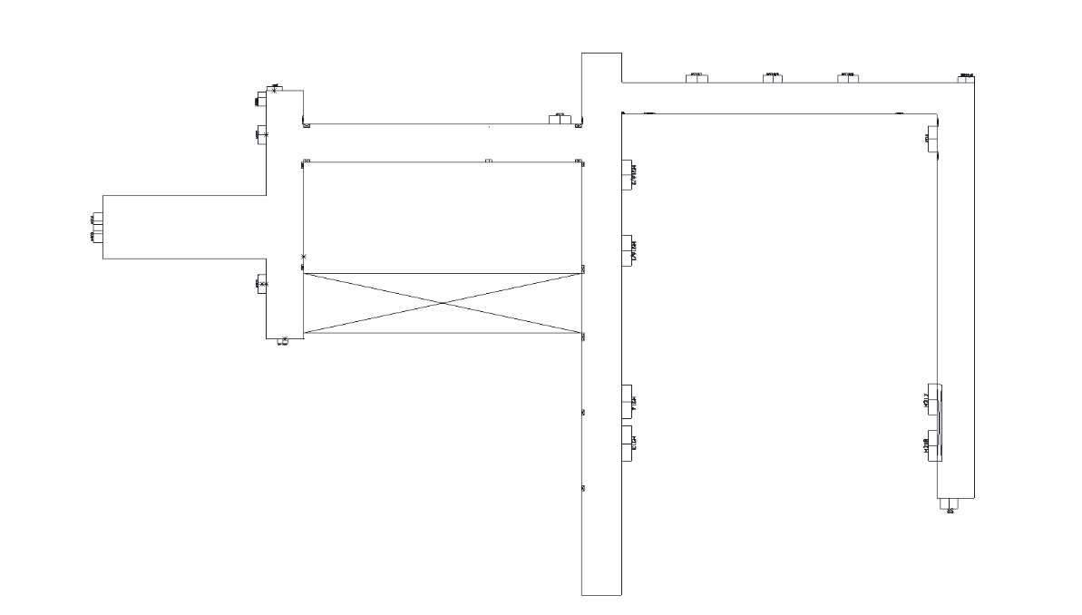

Fig. 3. SolidWorks CAD sketch of the Hi-Tech Block 2nd floor (DXF export). Corridor outlines, wall boundaries, and room positions (H201–H219) are annotated.

3.3 DXF to PNG Conversion

The PNG was exported directly from the SolidWorks Drawing via File → Export → Portable Network Graphics at 1:1 scale. Exporting at 1:1 scale from the drawing sheet ensures the pixel grid corresponds directly to the metric dimensions of the sketch, preserving the aspect ratio without any post-export rescaling. The exported PNG was subsequently converted to grayscale using a Python script, producing a single-channel image suitable for occupancy annotation in the following step.

3.4 Resolution Calibration

The map resolution, defined as the physical distance represented by each pixel, was determined using the following relation:

Resolution (m/px) = Physical Distance (m) / Pixel Distance (px)

This approach, known as pixel-to-metric calibration, establishes a direct correspondence between the pixel coordinate system of the raster image and the metric coordinate system of the real environment. A reference corridor segment of known physical length 2.3 m was identified in the environment, and its corresponding pixel span was measured as 55 pixels in the exported PNG, yielding:

Resolution = 2.3 m / 55 px ≈ 0.04 m/px

This value was adopted uniformly across all five tiles rather than calibrating each tile independently. Uniform resolution ensures that the coordinate systems of adjacent tiles are metrically compatible, a prerequisite for accurate tile origin alignment in the ROS 2 map server and for seamless localization continuity during tile transitions. The value of 0.04 m/px (40 mm per cell) is also consistent with standard Nav2 map server and costmap configurations reported in the literature for indoor corridor navigation [6].

3.5 Occupancy Annotation
The grayscale PNG was annotated as a binary occupancy map: navigable regions (corridors) painted white (pixel value 255, free space) and all non-navigable regions (walls, room interiors) painted black (pixel value 0, occupied). Annotation was performed manually using a raster image editor (Microsoft Paint), with corridor boundaries traced from the underlying CAD geometry. Since the CAD sketch serves as the geometric reference, the accuracy of annotation is bounded by the precision of the original measurements rather than the choice of editing tool.
A critical observation from this step is that only 11.7% of the 1,466,724 total cells in the monolithic whole-floor map are navigable. The remaining 88.3% represent walls and room interiors, occupied space that the robot will never traverse, yet a monolithic approach allocates full costmap resources for all of it. This spatial inefficiency directly motivates the tessellation strategy described in Section 3.6.
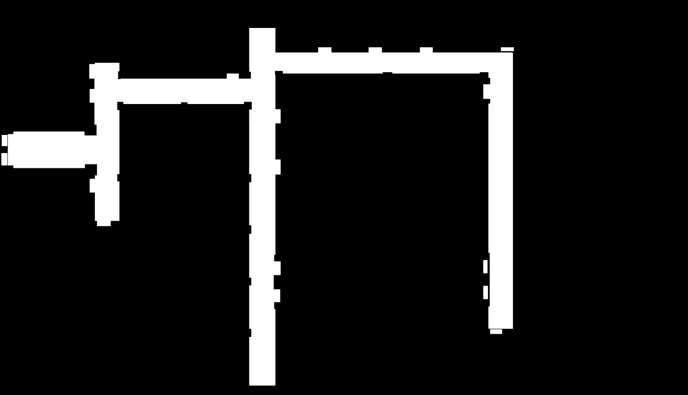

Fig. 4. Full floor occupancy map after annotation (63.8 m × 36.8 m at 0.04 m/px, 1,596 × 919 px). White = navigable corridor; black = occupied/wall. Only 11.7% of cells are navigable, motivating tessellation.

3.6 Map Tessellation

3.6.1 Turning Point Detection
The floor layout contains multiple direction changes, T-junctions and L-junctions where corridor axes change. These turning points serve as natural tile boundaries. They were detected by analyzing the distribution of navigable pixels along horizontal and vertical scan lines across the floor plan image. At straight segments, scan lines perpendicular to the corridor axis return a consistent navigable width; at junctions, the navigable cross-section changes significantly, producing a local peak in the spatial frequency of direction changes. These peaks identified candidate split locations, verified against the physical layout.

3.6.2 Overlap Offset and Tile Boundaries
At each identified turning point, the cut line is duplicated at a fixed offset of 40 pixels (1.6 m at 0.04 m/px) ahead of the original, creating two boundary lines per junction. The region between these two lines forms the overlap zone shared by the two adjacent tiles — Tile A extends to the far boundary and Tile B begins at the near boundary, such that both tiles include the overlap region in their coverage. This symmetric duplication ensures that the overlap zone is spatially embedded within both tiles rather than belonging exclusively to either one. The overlap serves two purposes: it defines the trigger zone within which the tile switch is evaluated (Section 4.3), and it provides sufficient spatial margin to absorb the navigation artifacts arising from the asynchronous switch window described in Section 4.5. The resulting five tiles cover the full navigable floor with pairwise overlapping regions at each tile boundary.
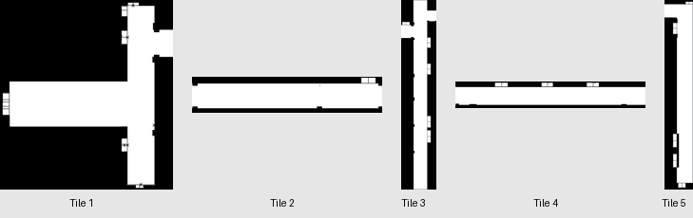

Fig. 5. Individual tessellated tile maps (Tile 1–5). Each tile covers one navigable zone of the floor. White = free space, black = occupied. Tiles vary in shape to match corridor topology.

Tile | Dimensions (px) | Physical Size (m) | Total Cells | Navigable Cells | Navigable % | Covers
Tile 1 | 360×399 | 14.4×16.0 | 143,640 | 44,542 | 31.0% | Main lab corridor (H201–H208)
Tile 2 | 291×90 | 11.6×3.6 | 26,190 | 17,390 | 66.4% | East connector corridor
Tile 3 | 212×831 | 8.5×33.2 | 176,172 | 59,848 | 34.0% | Central corridor (H212–H215)
Tile 4 | 476×96 | 19.0×3.8 | 45,696 | 24,837 | 54.4% | North connector (SR1–SR3)
Tile 5 | 171×686 | 6.8×27.4 | 117,306 | 43,275 | 36.9% | East corridor (H216–H219)
Whole Map | 1596×919 | 63.8×36.8 | 1,466,724 | 171,826 | 11.7% | Full floor (monolithic)

Table 4. Tile dimensions, physical coverage, and navigable cell statistics at 0.04 m/px resolution.

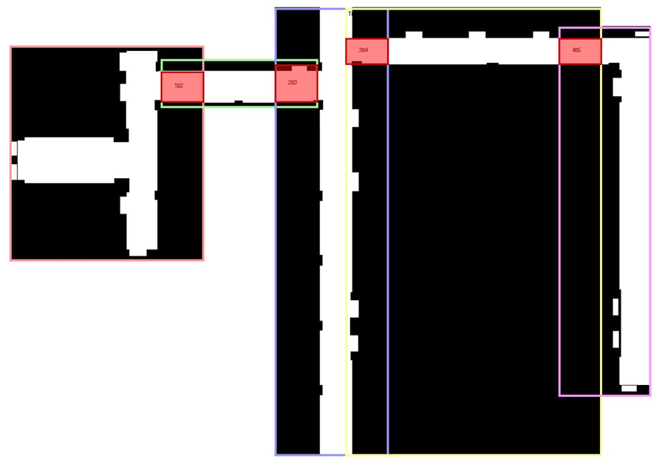

Fig. 6. Tessellated map tile layout with overlap regions. Colored bounding boxes indicate tile extents; red rectangles mark trigger zones where tile switches are initiated between adjacent tile pairs (1↔2, 2↔3, 3↔4, 4↔5).

3.7 PGM Conversion and YAML Metadata
Each annotated tile PNG was converted to PGM format required by the ROS 2 map server. For each tile, a YAML metadata file specifies the map image path, resolution (0.04 m/px), and origin, the position of the tile's bottom-left corner in the global world coordinate frame expressed as [x, y, θ]. Tile origins were determined by measuring the physical offset of each tile's bottom-left corner from a common reference point and verified by overlaying each tile in RViz to confirm alignment of corridor features across tile boundaries.
Table 5. YAML metadata parameters for each tile map.

Tile | Map File | Resolution (m/px) | Origin [x, y] (m) | Occ. Thresh | Free Thresh
Tile 1 | tile1.pgm | 0.04 | [−9.8, −1.0] | 0.65 | 0.196
Tile 2 | tile2.pgm | 0.04 | [0.98, 10.36] | 0.65 | 0.196
Tile 3 | tile3.pgm | 0.04 | [9.03, −15.44] | 0.65 | 0.196
Tile 4 | tile4.pgm | 0.04 | [14.31, 12.6] | 0.65 | 0.196
Tile 5 | tile5.pgm | 0.04 | [33.3, −11.02] | 0.65 | 0.196

4. Map Switching Algorithm
The map switching algorithm is the primary contribution of this work. It enables a Nav2-based robot to navigate across a tessellated environment by dynamically loading and unloading map tiles at runtime without interrupting the navigation stack. The algorithm is implemented as a custom Behavior Tree action node, TileCheckAction, integrated into the Nav2 BT Navigator as a plugin.

4.1 Integration with the Nav2 Behavior Tree
Nav2 uses a Behavior Tree to orchestrate high-level navigation logic. TileCheckAction is inserted into the standard Nav2 ReactiveSequence and ticked on every BT cycle alongside FollowPath. It is implemented as a BT::SyncActionNode (BehaviorTree.CPP v3), always returning SUCCESS to ensure the ReactiveSequence continues ticking FollowPath uninterrupted. Internally, a four-state asynchronous state machine handles the switch process across multiple ticks without blocking. Tile state is persisted to a file (/tmp/current_tile.txt) ensuring correct tile restoration if the BT is reloaded mid-session.

4.2 Tile Configuration
All tile definitions, spatial bounds, neighbour relationships, and trigger zone coordinates are specified in a centralized YAML configuration file (tiles_config.yaml) with three sections: settings (global parameters), tiles (individual tile metadata), and connections (overlap regions and switch geometry between adjacent tile pairs). At initialization, the algorithm parses this configuration and constructs a list of Trigger Zone objects one per direction per connection used for per-tick zone lookup.

Parameter | Value | Description
Resolution | 0.04 m/cell | Map grid resolution, consistent across all tiles
Number of tiles | 5 | Total tessellated tiles covering the floor
Switch cooldown | 0.5 s | Minimum interval between consecutive tile switches
Post-switch delay | 0.3 s | Wait for Nav2 costmap rebuild after clear
LoadMap timeout | 5.0 s | Maximum wait for /map_server/load_map response
ClearCostmap timeout | 8.0 s | Maximum wait for costmap clear response
Tile persistence | File (/tmp/current_tile.txt) | Tile ID persisted across BT reloads

Table 6. Tile switching algorithm configuration parameters.

4.3 Switching Cues: Position and Heading

4.3.1 Spatial Containment
The robot's current position (x, y) is obtained by looking up the map → base_link transform via tf2. A trigger zone is an axis-aligned bounding box [x_min, x_max, y_min, y_max] in world coordinates. The robot is within a trigger zone if and only if: x_min ≤ x ≤ x_max and y_min ≤ y ≤ y_max.

4.3.2 Heading-Based Directional Disambiguation
Spatial containment alone is insufficient to determine switch direction. An overlap region is shared by exactly two tiles; without heading information the algorithm cannot distinguish a robot transitioning from Tile A→B versus B→A. The robot's yaw angle is mapped to one of four cardinal headings (+x, −x, +y, −y) using 45-degree angular thresholds. Each TriggerZone carries a required heading. A switch from Tile A→B is triggered only when the robot is inside the overlap box AND travelling in the heading associated with the A→B direction, correctly handling robots reversing through overlap zones.

4.4 Asynchronous Switch State Machine
Once a valid trigger is detected, the algorithm initiates a tile switch through a four-state asynchronous state machine. Asynchronous (non-blocking) service calls are critical: a blocking call would stall the entire BT tick loop and halt navigation. Instead, ROS 2 service futures are dispatched and polled across successive ticks with zero-timeout checks, allowing FollowPath to continue executing throughout the switch process.

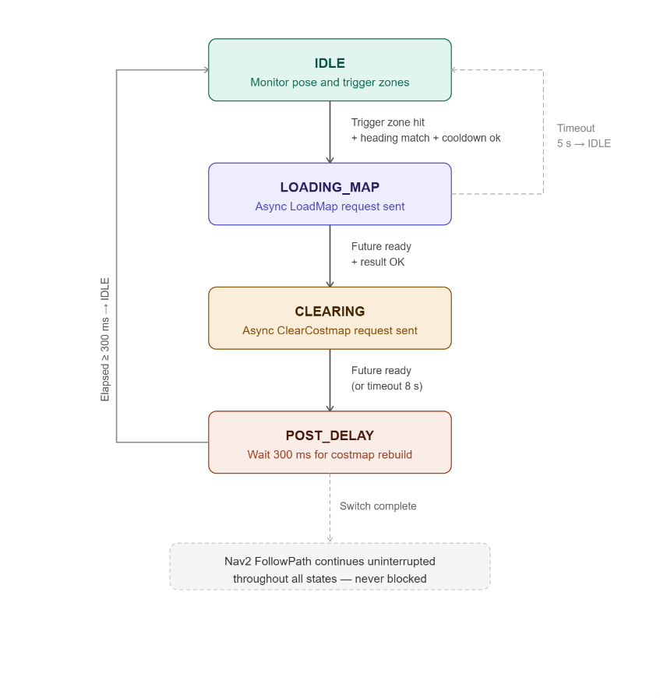

Fig. 8. Asynchronous tile switch state machine. States: IDLE (normal monitoring), LOADING_MAP (async LoadMap request), CLEARING (async costmap clear), POST_DELAY (timestamp-based wait for costmap rebuild). Navigation continues uninterrupted throughout all states.

State | Description | Transition Condition
IDLE | Monitor pose and trigger zones each tick | Trigger zone + heading + cooldown → LOADING_MAP
LOADING_MAP | Async LoadMap request sent; future polled each tick | Future ready + result OK → CLEARING; Timeout 5s → IDLE
CLEARING | Async ClearCostmap request sent; future polled | Future ready → POST_DELAY; Timeout 8s → POST_DELAY
POST_DELAY | Timestamp-based wait for costmap rebuild | Elapsed ≥ 300 ms → IDLE (switch complete)

Table 7. States of the asynchronous tile switch state machine.

4.5 Switching Artifacts and Mitigation
A known artifact of this design is that the robot operates briefly on a stale costmap during the switch window (~100–300 ms), as TileCheckAction always returns SUCCESS and FollowPath continues executing. This is mitigated by the overlap zone design: both tiles share the overlap region by definition, so the outgoing tile's costmap remains geometrically valid within the overlap for the entire switch duration. The 300 ms POST_DELAY ensures the new costmap is fully populated before the next planning cycle. The 500 ms cooldown prevents oscillatory switching when the robot decelerates near a trigger zone boundary.

4.6 Demonstration
A video demonstration of the tile switching system operating in the live corridor environment at SRMIST KTR is available as supplementary material. The video shows the robot traversing across three tile boundaries with the map server updating the active tile in real time. [Supplementary Video: https://youtu.be/2qS1voOvwqg]

5. Results and Discussion
This section presents a quantitative comparison of the monolithic and tessellated approaches across costmap size, Nav2 process memory, and CPU utilization. Benchmarks were conducted over a 120-second navigation run with identical waypoints on an AMD64 laptop running the containerized ROS 2 stack. The tile-based run completed three tile switches during the evaluation period.

5.1 Active Costmap Size
The most significant reduction is in active costmap cell count. The monolithic map maintains a fixed costmap of 1,466,724 cells throughout navigation. The tessellated approach reduces this to a mean of 91,594 cells across the 120-second run (peak 176,172 cells immediately following a tile switch during costmap rebuild) — a 93.8% mean reduction. Since path planning complexity scales with costmap size, this directly reduces the computational load on the Nav2 planner on every planning cycle.

5.2 Process-Level Memory Consumption

Nav2 Process | Monolithic (MB) | Tessellated (MB) | Reduction (MB) | Reduction (%)
Map Server | 29.3 | 22.0 | 7.3 | 24.9%
Planner Server | 154.5 | 34.6 | 119.9 | 77.6%
Controller Server | 26.4 | 25.5 | 0.9 | 3.4%
BT Navigator | 28.1 | 28.7 | −0.6 | −2.1%
Lifecycle Manager | 18.4 | 18.4 | 0.0 | 0.0%
Nav2 Total | 256.7 | 129.2 | 127.5 | 49.7%

Table 8. Per-process memory consumption: monolithic vs. tessellated map approach (AMD64 benchmark, 120 s run).

The dominant contributor is the Nav2 Planner Server, dropping from 154.5 MB to 34.6 MB, a 77.6% reduction. This is consistent with expected behaviour: the global planner (NavFn/Smac) allocates data structures proportional to costmap size, and with 93.8% fewer active cells, planner memory contracts substantially. The Map Server reduction (24.9%) reflects the smaller PGM image per tile versus the full floor map. Controller, BT Navigator, and Lifecycle Manager show negligible differences, as expected, they operate on velocity commands and BT logic rather than map data.

5.3 CPU Utilization
Mean CPU utilization was 32.8% (monolithic) versus 44.7% (tessellated), with peaks of 65.7% and 91.3% respectively. The higher CPU usage in the tessellated case is attributed to tile switch events, concurrent service calls, costmap clearing, and map loading, and increased replanning frequency following each costmap reset. Outside of switch events, CPU utilization is comparable between approaches. For the Jetson Nano target platform, memory is the more constrained resource, making this tradeoff favourable.

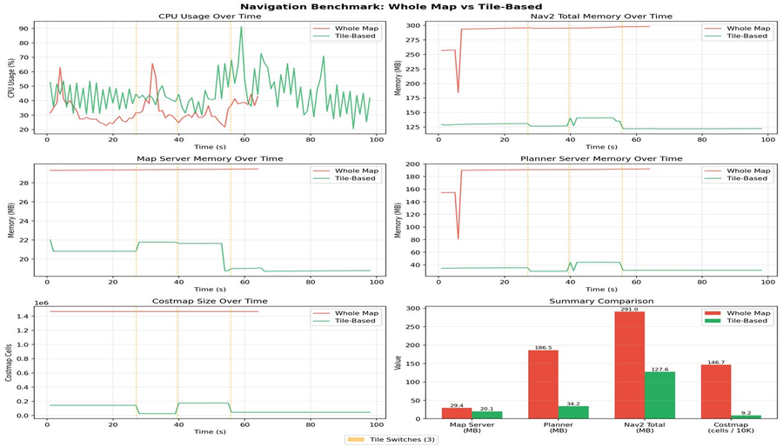

Fig. 9. Navigation benchmark: Whole Map vs. Tile-Based. Top row: CPU usage and Nav2 total memory over time. Middle row: Map Server and Planner Server memory over time. Bottom row: Costmap cell count over time and summary bar chart. Vertical yellow dashed lines indicate tile switch events.

5.4 Summary

Metric | Monolithic Map | Tessellated Map | Improvement
Active costmap cells | 1,466,724 | 91,594 (mean) | 93.8% reduction
Planner Server memory | 154.5 MB | 34.6 MB | 77.6% reduction
Map Server memory | 29.3 MB | 22.0 MB | 24.9% reduction
Nav2 total memory | 256.7 MB | 129.2 MB | 49.7% reduction
Mean CPU usage | 32.8% | 44.7% | +11.9% overhead
Peak CPU usage | 65.7% | 91.3% | +25.6% at switch events
Map scalability | Fixed (full floor) | Modular (per tile) | Qualitative improvement

Table 9. Summary comparison of monolithic and tessellated map approaches across all benchmark metrics.

The tessellated approach achieves substantial reductions in active costmap size and Nav2 planner memory, at the cost of moderate CPU overhead concentrated at tile switch events. The modular tile structure also provides a scalability advantage: extending the navigable environment requires only the addition of new tile files and connection entries in the configuration YAML, with no modification to existing tiles or the navigation stack configuration.

6. Conclusion
This paper presented a tile-based map switching system for autonomous mobile robot navigation in large indoor environments using the ROS2 and Nav2 stack. The proposed approach decomposes a pre-built 2D occupancy grid map into a set of spatially overlapping tiles and dynamically loads only the tile corresponding to the robot's current location, constraining the active costmap to a bounded size regardless of total environment extent.
The system was implemented as a custom Behavior Tree action node (TileCheckAction) integrated as a Nav2 plugin, using a heading-aware trigger zone mechanism for bidirectional transition disambiguation and a four-state asynchronous state machine to ensure continuous navigation throughout tile switch events. Applied to a 60 m × 45 m indoor corridor environment at SRMIST KTR, the approach reduced the active costmap from 1,466,724 cells to a mean of 91,594 cells (93.8% reduction), and the Nav2 Planner Server memory from 154.5 MB to 34.6 MB (77.6% reduction), at the cost of a moderate CPU overhead of +11.9% mean and +25.6% peak during switch events.
A key observation from the map analysis is that only 11.7% of the monolithic map's cells are navigable, confirming that the large majority of costmap resources in a corridor environment are spent on walls and room interiors that the robot will never traverse. Tessellation directly addresses this inefficiency by aligning tile boundaries with the navigable topology rather than the geometric bounding box of the entire floor.
The tile configuration is fully specified in a human-readable YAML file, making the system straightforward to extend: adding a new floor zone requires only a new tile PGM/YAML pair and a connection entry, no modification to the navigation stack configuration or existing tiles is required. This modularity is a practical advantage for real-world deployment where environments evolve over time.
Several directions remain for future work. First, the map generation pipeline currently requires manual measurement, annotation, and tile boundary placement. This could be automated by deriving tessellated tiles directly from an existing architectural floor plan, with corridor segmentation and turning point detection performed programmatically to produce deployment-ready PGM/YAML tile sets without human intervention. Second, the tile switching logic currently triggers purely on position and heading, without awareness of the robot's navigation goal. Integrating goal-awareness — such that a tile switch is initiated only when the navigation goal lies outside the current active tile — would eliminate unnecessary switches for short intra-tile trajectories that happen to pass through an overlap zone, reducing the associated CPU overhead and costmap disruption. Third, the current implementation operates as a Nav2 Behavior Tree plugin, which requires modification of the BT XML to deploy. Refactoring TileCheckAction as a native Nav2 lifecycle node or costmap layer plugin would make the system drop-in compatible with any standard Nav2 configuration, significantly lowering the integration barrier for adoption in other robotic platforms.

References
[1] A. Fisher, R. Cannizzaro, M. Cochrane, C. Nagahawatte, and J. L. Palmer, "ColMap: A memory-efficient occupancy grid mapping framework," Robotics and Autonomous Systems, vol. 142, p. 103755, 2021. doi: 10.1016/j.robot.2021.103755
[2] A. Hornung, K. M. Wurm, M. Bennewitz, C. Stachniss, and W. Burgard, "OctoMap: An efficient probabilistic 3D mapping framework based on octrees," Autonomous Robots, vol. 34, pp. 189–206, 2013. doi: 10.1007/s10514-012-9321-0
[3] D. Gonzalez-Arjona, A. Sanchez, F. López-Colino, A. de Castro, and J. Garrido, "Simplified occupancy grid indoor mapping optimized for low-cost robots," ISPRS International Journal of Geo-Information, vol. 2, pp. 959–977, 2013. doi: 10.3390/ijgi2040959
[4] R. B. Sousa, H. M. Sobreira, and A. P. Moreira, "A systematic literature review on long-term localization and mapping for mobile robots," Journal of Field Robotics, vol. 40, pp. 1245–1322, 2023. doi: 10.1002/rob.22170
[5] A. Schaefer, D. Büscher, J. Vertens, L. Luft, and W. Burgard, "Long-term vehicle localization in urban environments based on pole landmarks extracted from 3-D LiDAR scans," Robotics and Autonomous Systems, vol. 136, p. 103709, 2021. doi: 10.1016/j.robot.2020.103709
[6] T. Horelican, "Utilizability of Navigation2/ROS2 in highly automated and distributed multi-robotic systems for industrial facilities," IFAC PapersOnLine, vol. 55-4, pp. 109–114, 2022. doi: 10.1016/j.ifacol.2022.06.018
[7] M. A. Vega-Torres, A. Braun, and A. Borrmann, "SLAM2REF: Advancing long-term mapping with 3D LiDAR and reference map integration for precise 6-DoF trajectory estimation and map extension," Construction Robotics, vol. 8, p. 13, 2024. doi: 10.1007/s41693-024-00126-w
[8] Y. Baek and J. K. Park, "Fast path generation algorithm for mobile robot navigation using hybrid map," Applied Sciences, vol. 15, p. 2414, 2025. doi: 10.3390/app15052414
[9] H. Yun and S. Yoo, "Semantic zone based 3D map management for mobile robot," arXiv preprint arXiv:2512.12228, Dec. 2025. [Online]. Available: https://arxiv.org/abs/2512.12228
[10] Y. Wang, L. Zhao, and S. Huang, "Grid-based submap joining: An efficient algorithm for simultaneously optimizing global occupancy map and local submap frames," arXiv preprint arXiv:2501.12764, Jan. 2025. [Online]. Available: https://arxiv.org/abs/2501.12764

