**SMART WATER MANAGEMENT**

**Phase 2: Innovation - Transforming the Design into a Smart Water Management Solution**

In this phase, we will take the design developed in Phase 1 and put it into action to create a transformative solution for smart water management using IoT sensors. Here are the detailed steps we will take to turn our design into reality.

**Step 1: Project Planning and Team Formation**

Assemble a cross-functional team comprising IoT experts, water engineers, data analysts, and project managers. Develop a project plan with well-defined objectives, timelines, and resource allocation.

**Step 2: Sensor Deployment**

Select and procure the appropriate IoT sensors, including water quality sensors, flow meters, and leak detection sensors. Identify key water supply and distribution points for the pilot deployment. Install sensors in the selected locations, ensuring proper calibration and connectivity.

**Step 3: Data Acquisition and Sensor Network Setup**

Establish a secure network for sensor data transmission. Configure the sensors to send data to a central data hub in real-time. Implement data validation and error-checking mechanisms to ensure data accuracy.

**Step 4: Data Processing and Analysis**

Develop algorithms for real-time data processing and analysis, including anomaly detection for leak identification and water quality assessment. Define thresholds and triggers for alerts related to water quality and supply issues. Test and refine data processing algorithms to minimize false alarms and optimize accuracy.

**Step 5: Platform Development**

Design and develop a web-based platform and mobile application for monitoring and control. Integrate features such as real-time water quality monitoring, consumption tracking, and supply control. Ensure a user-friendly interface that works across various devices.

**Step 6: Integration and Connectivity**

Develop APIs and data pipelines to establish a connection between the sensor network and the platform. Implement secure authentication and authorization mechanisms to protect user data and maintain privacy. Integrate cloud-based infrastructure to host the platform and support scalability.

**Step 7: Testing and Optimization**

Conduct rigorous testing of the entire system to identify and address any bugs or issues. Optimize the platform for performance, responsiveness, and scalability. Gather user feedback and make improvements based on user suggestions and needs.

**Step 8: User Training and Awareness**

Develop user guides and training materials for both consumers and water utility personnel.

**Step 9: Pilot Deployment**

Deploy the smart water management system in a select number of locations to run a pilot program. Collect data and feedback from the pilot phase to fine-tune the system and validate its effectiveness.

**Step 10: Full-Scale Deployment**

Based on the success of the pilot program, roll out the system to a broader network of water supply and distribution points. Continuously monitor and maintain the system to ensure its reliability and accuracy.

**Step 11: Data Management and Reporting**

Implement data storage and backup solutions to securely store historical sensor data. Generate reports and insights based on historical data to support water utility management and decision-making.

**Step 12: Continuous Improvement**

Continuously gather user feedback and iterate on the system to address emerging needs and challenges. Explore opportunities for further innovation, such as predictive maintenance algorithms and expanding the sensor network to cover more areas.

By following these steps, the design for a smart water management system using IoT will be transformed into a practical and innovative solution that improves water quality, reduces water wastage, and enhances the overall efficiency of water distribution and management.

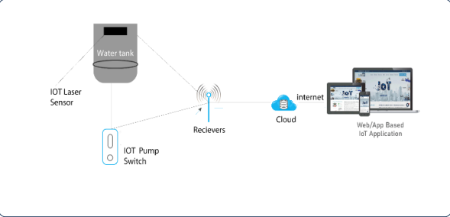

**BLOCK DIAGRAM FOR SMART WATER MANAGEMENT**