**INSTRUCTION FOR FRESHFIRE WORLDWIDE MINISTRIES**

**Content**

* + **Home**
  + **About**
  + **Message**
  + **Events**
  + **Gallery**
  + **Blog**

**Home Pages:**

* + Logo
  + Navigation Menu
  + Slider Options

Logo :

1.Go to FreshFire admin panel

2.Go to VamTam ---> General Setting.

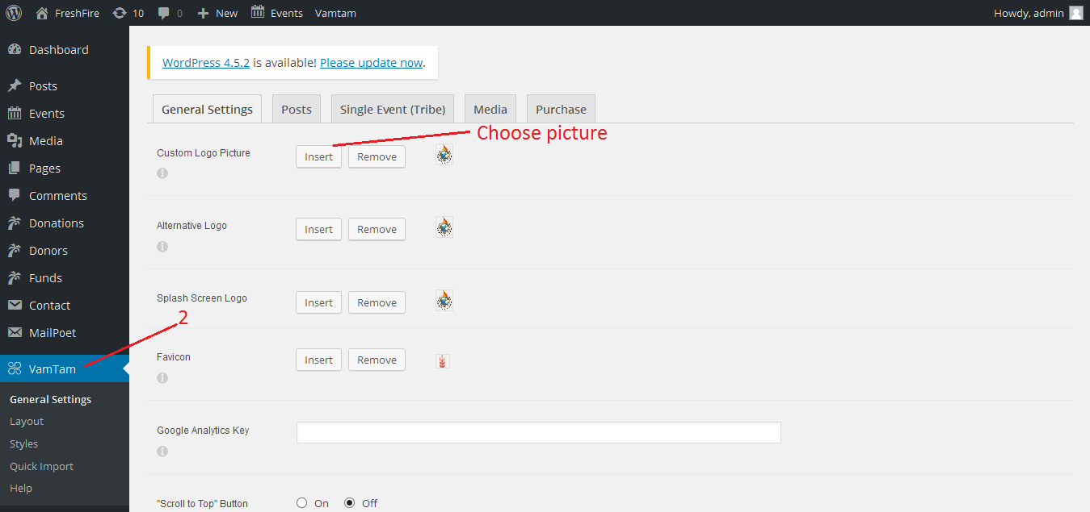

Navigation Menu

1. You can manage menu by going to Appearance Menu .
2. You can generated menu item from left side and drag the generated menu at the right side to sort it.
3. In Menu structure to Drag each item into the order you prefer.
4. Click the arrow on the right of the item to reveal additional configuration options.

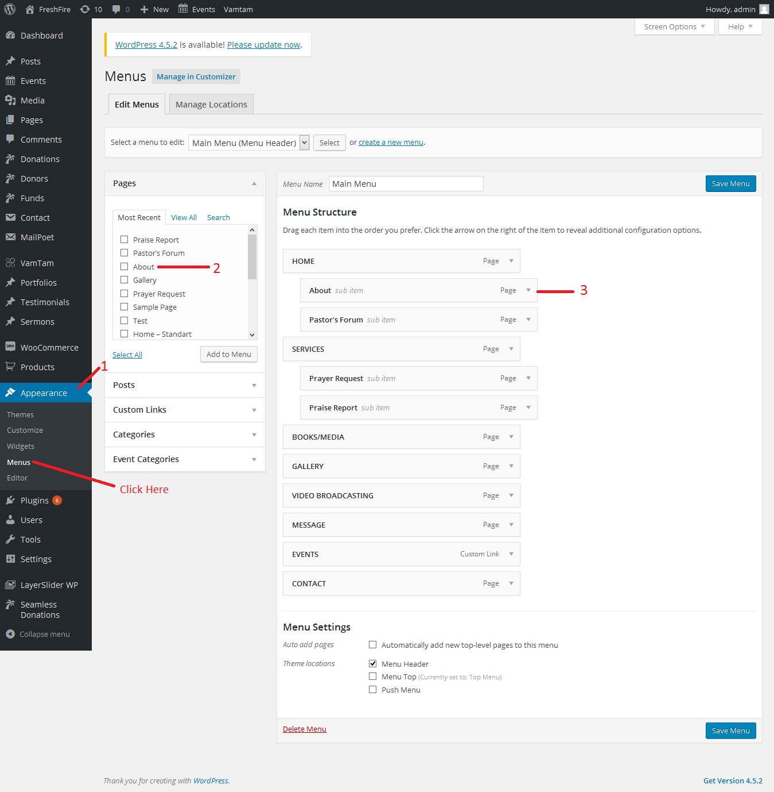

Slider Option :

1.You can manage Slider images by going to LayerSlider WP .

2. Click here to generate new slider

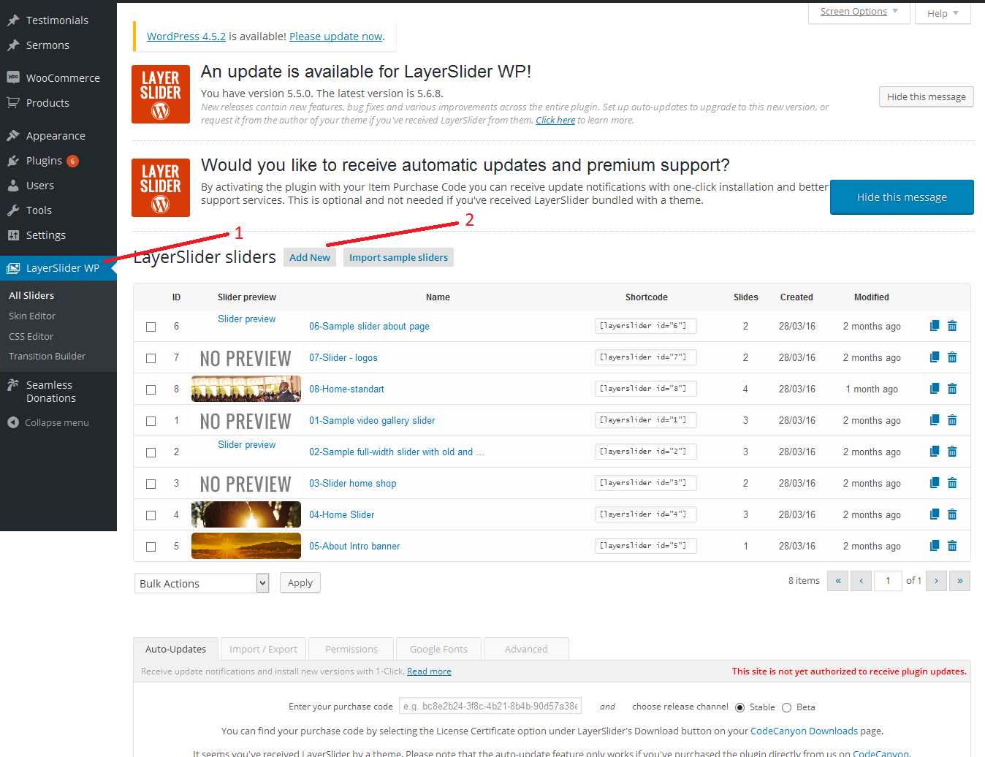

Page Item :

1. You can manage PageOptions by going to Pages .

2. Click here to add new pages

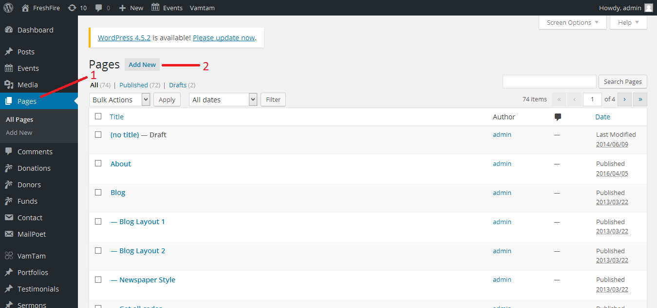

1. Add title for page.
2. You can add all these item to page by using drag and drop option.
3. You can drop here the selected item

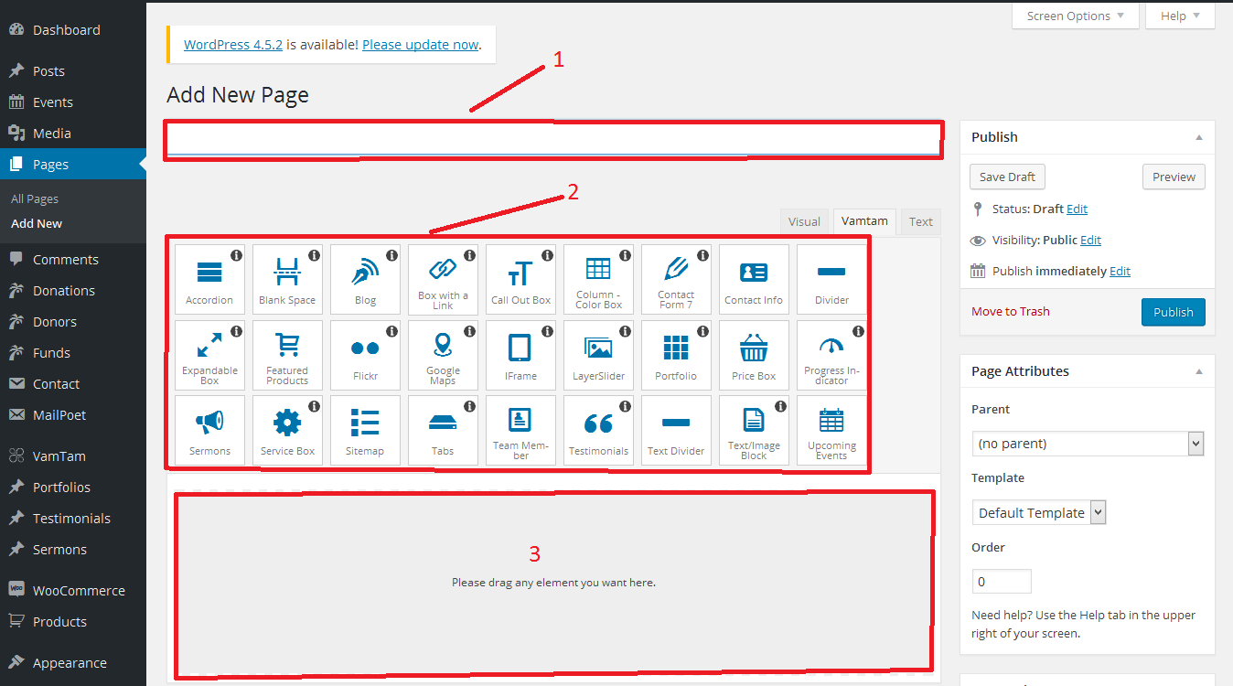

About Page :

1. In about page Content can be added at Edit Page.

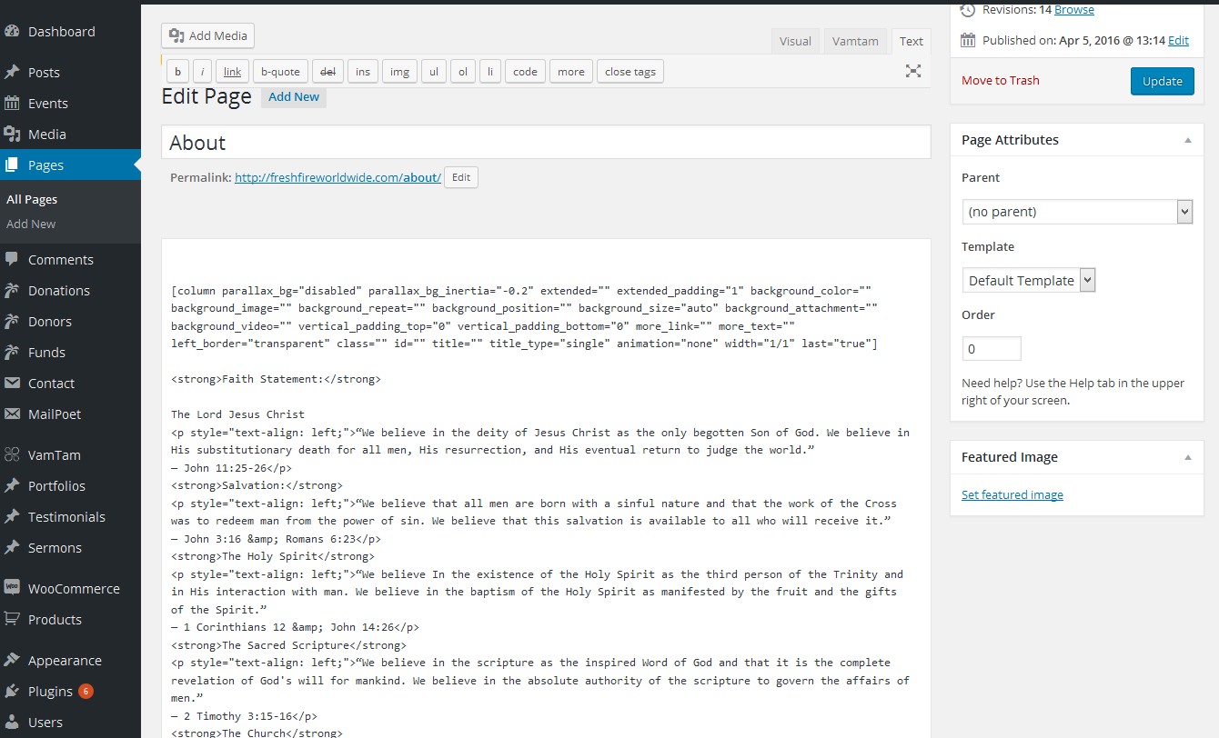

Gallery Page :

1. You can Select Portfolio option in menu.
2. Click this edit button.

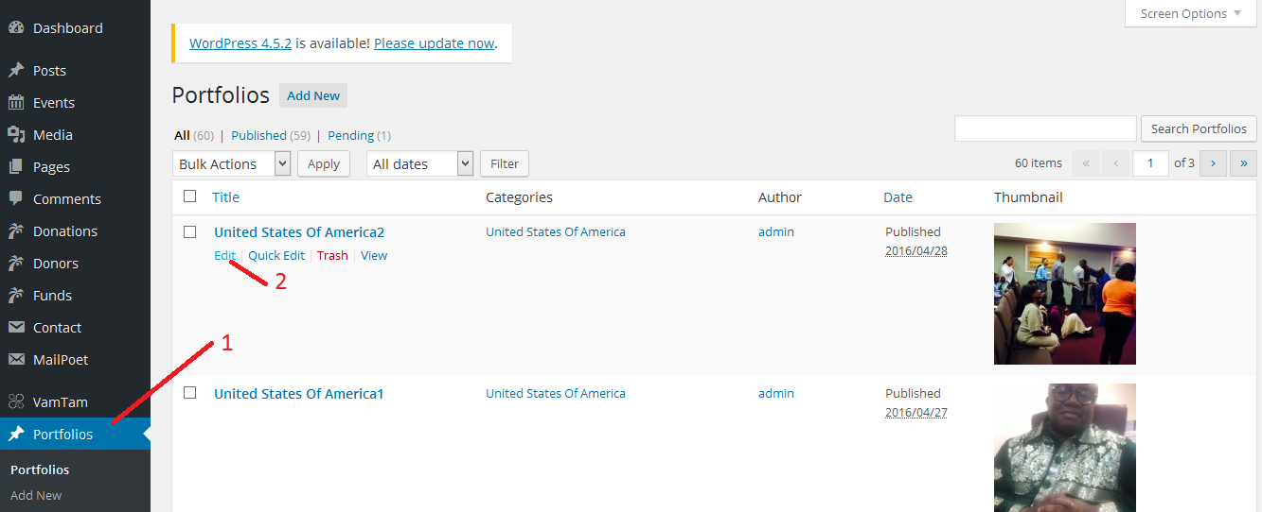

1. In page option this may be used for choose gallery image option.
2. You can choose the category.

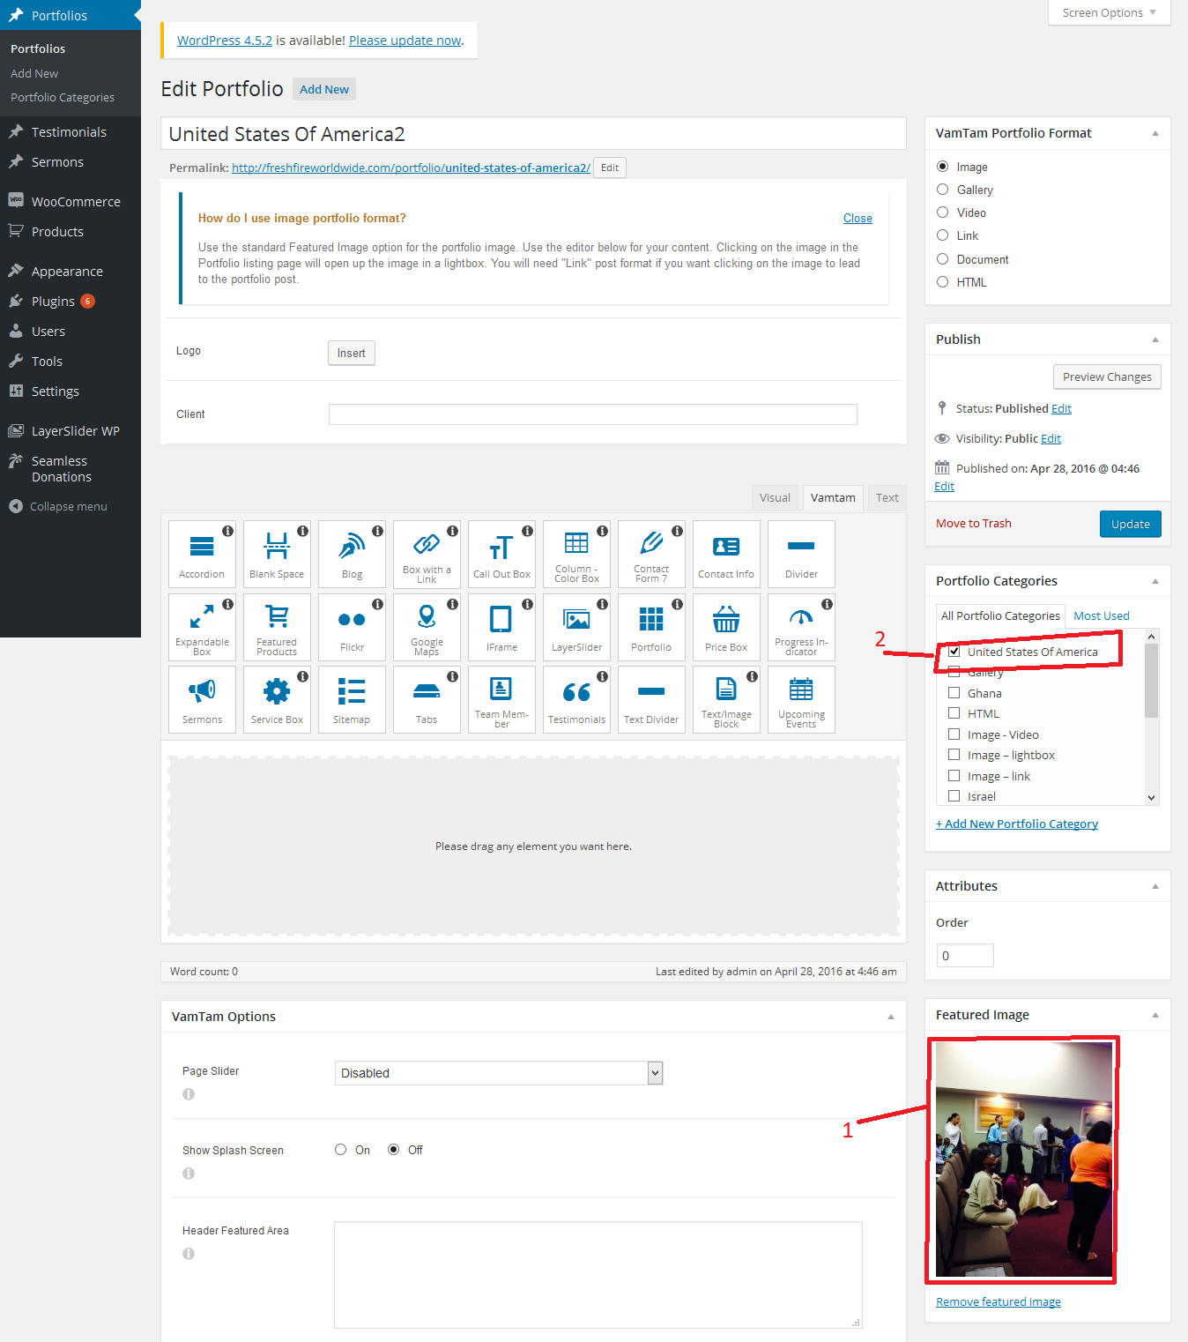

Message Post Page :

1.you can choose post option in menu.

2.Click this button to create the new post

3.Click this edit button you can edit the post.

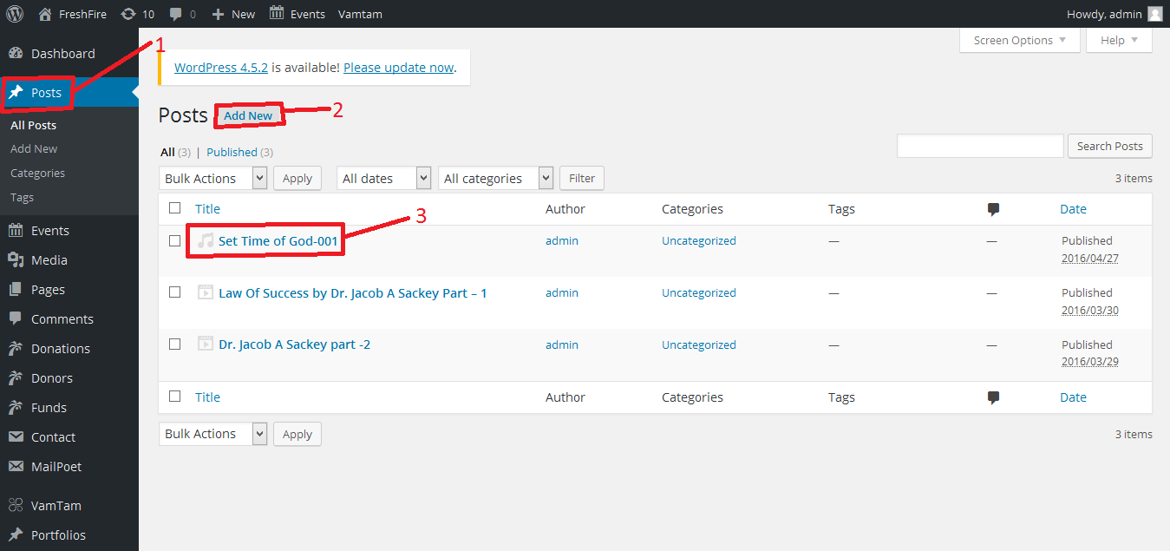

1. Here you paste your audio or video link
2. Choose the format of your post
3. You can also select message page and change the contents.

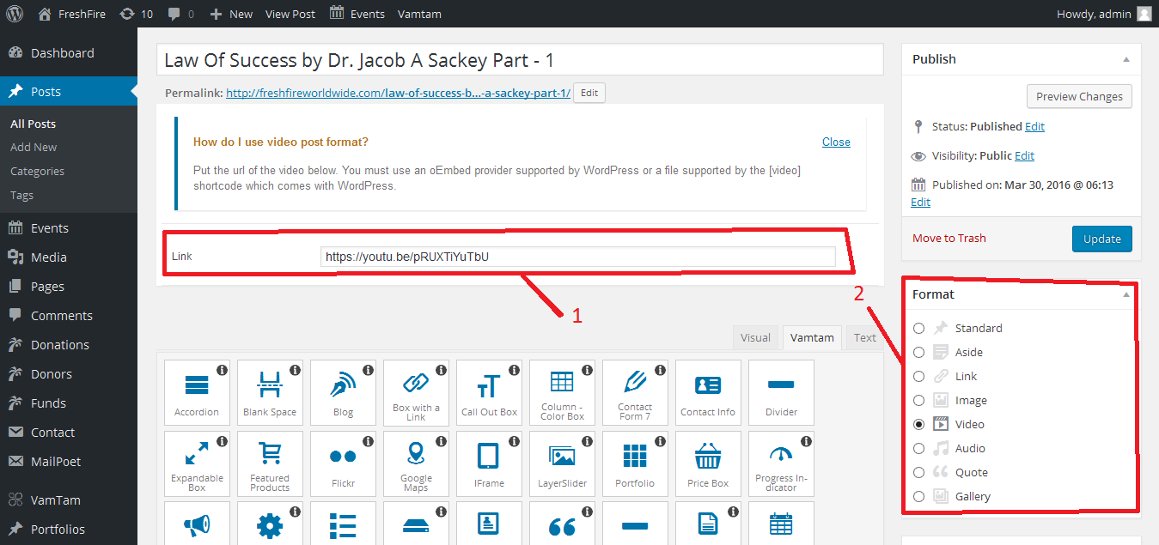

Event Option :

1. You can choose Event option in menu.

2.Click this button to create the new Event

3.Click this edit button you can edit the Event.

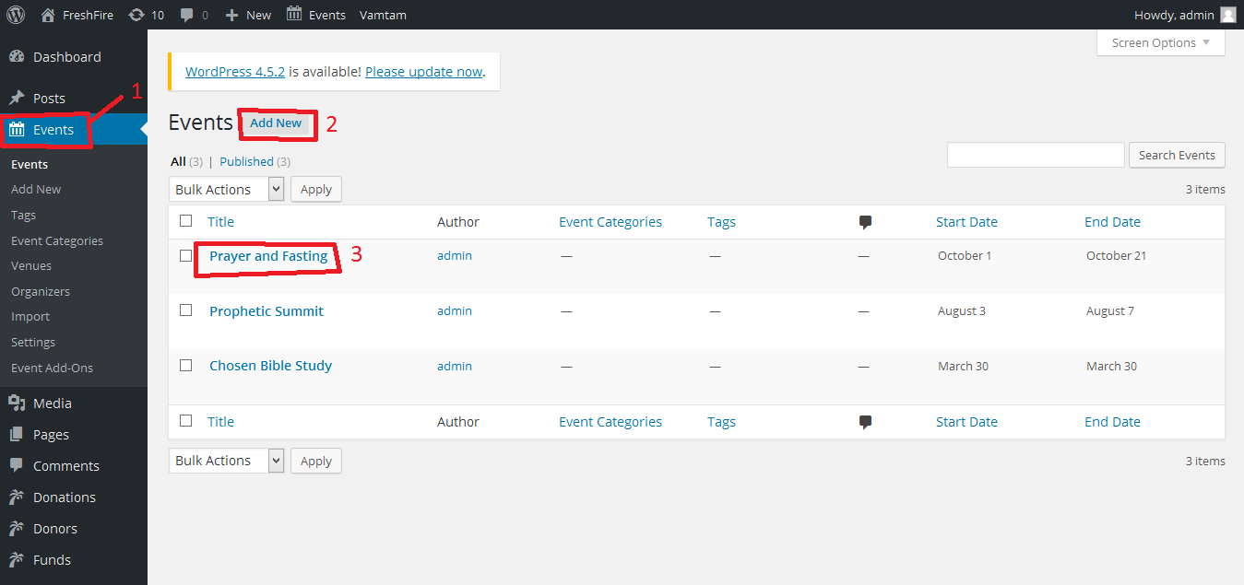

1.Enter the Event Start Date/Time

2.Enter the Event End Date/Time.

