**INSTRUCTION FOR CHRISTIAN OUTREACH CENTER INTERNATIONAL**

**Content**

* + **Home Pages**
  + **About Pages**
  + **Pastors Pages**
  + **Message Posts page**
  + **Announcements page**
  + **Contact page**
  + **Blog page**

**Home Pages :**

* + Logo
  + Navigation Menu
  + Slider Option

Logo :

1.Go to Real Church admin panel

2.Go to Overall Elements 🡪Logo.

3.You can set the logo margin size.

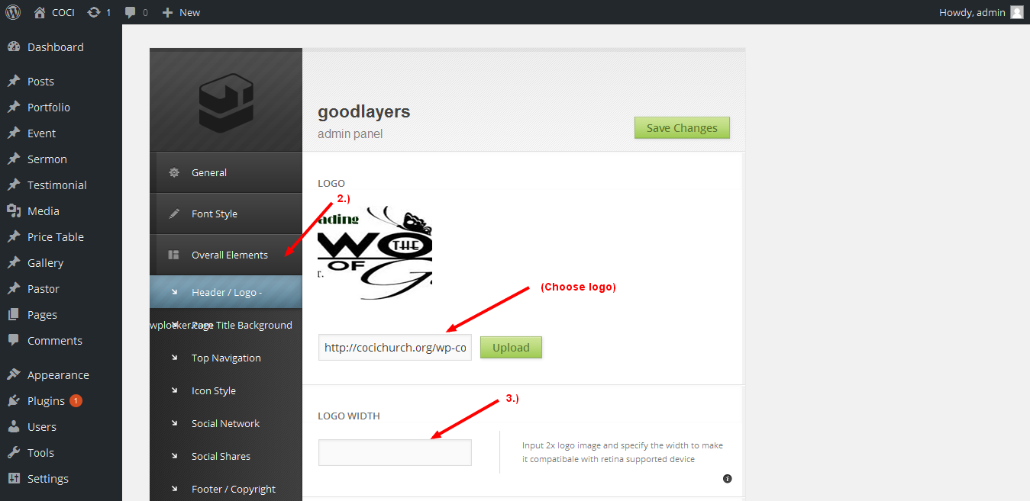

Navigation Menu :

1. You can manage menu by going to Appearance 🡪 Menu .
2. You can generated menu item from left side and drag the generated menu at the right side to sort it.
3. In Menu structure to Drag each item into the order you prefer.
4. Click the arrow on the right of the item to reveal additional configuration options.

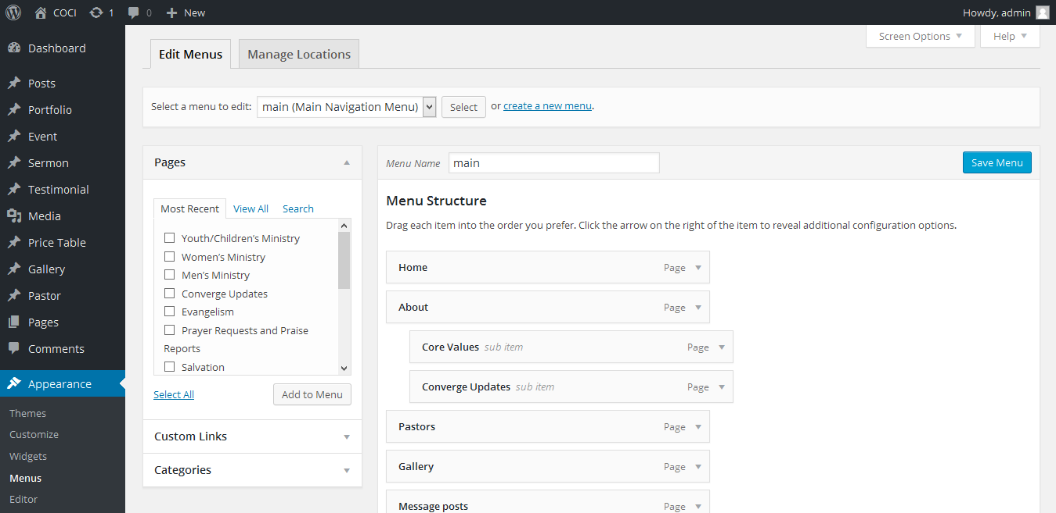

Slider Option :

1.Page Top Slider will show full width slider above the page content and page sidebar, so it'will always be full width. You can create it at the bottom of 'Page Option'.

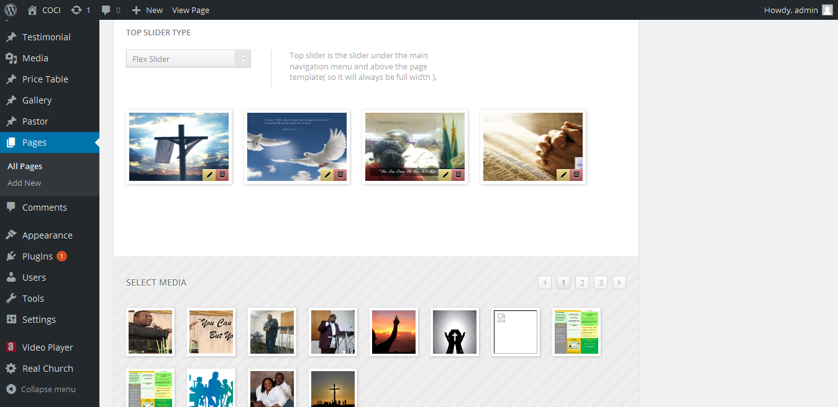

Page Item :

1. Page Item is a item that we provide for the page.
2. You can add all these item to page by use the Add Item section in "Page Options".
3. You can choose item at 'Item list'. When you add item, it will appear at the item container.
4. You can edit, delete, increase size and decrease size of each item by use these following button. ( each item has different size depends on its functional )

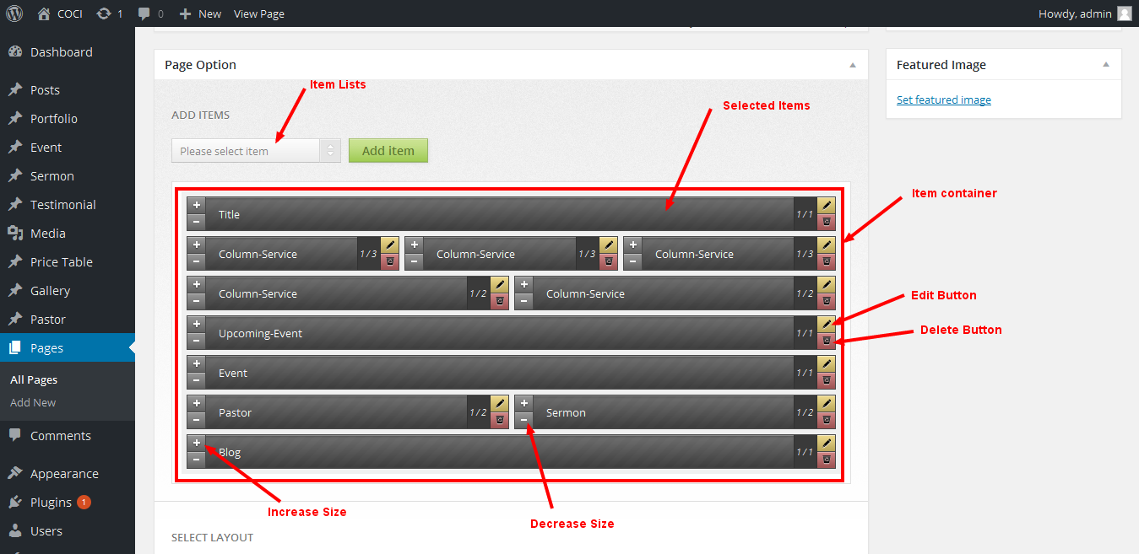

About Page :

1. In about page Content can be added at Edit Page.

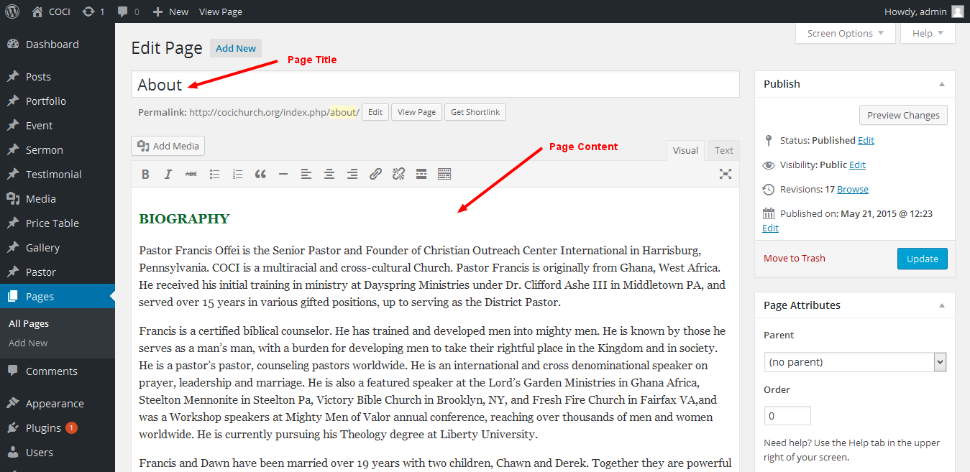

Pastors Page :

1. Create pastor page.
2. Select category for the pastors.
3. Add Thumbnail images for the pastors.
4. Add position

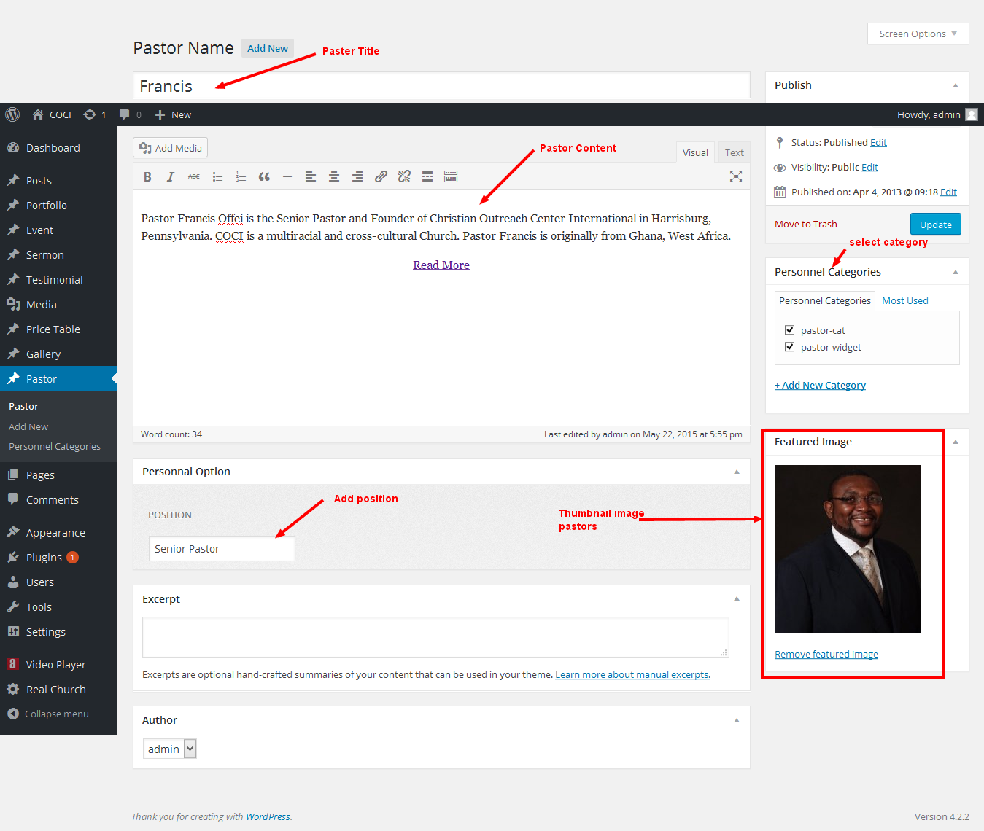

Gallery Page :

1. After create gallery item and click edit item
2. In page option Editor.
3. Choose Item size for display.
4. Choose the gallery page to display

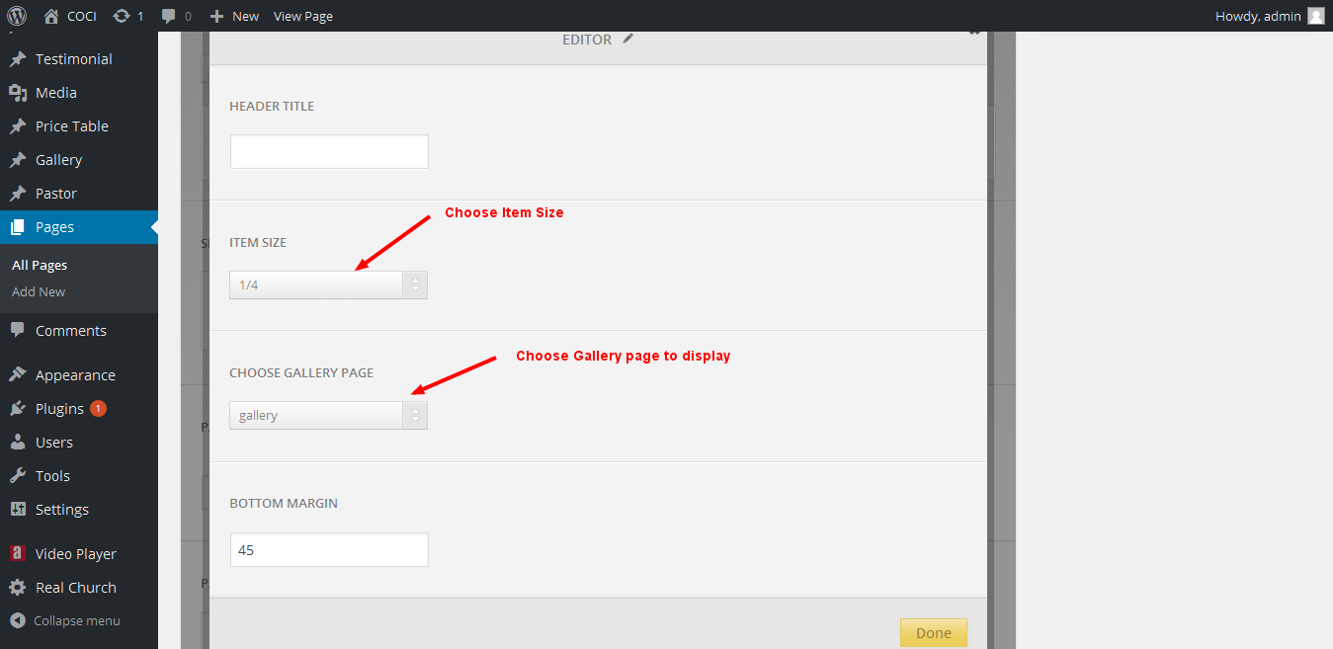

In Edit Gallery :

1.Edit and Delete the gallery images.

2.In select media to add image into the gallery.

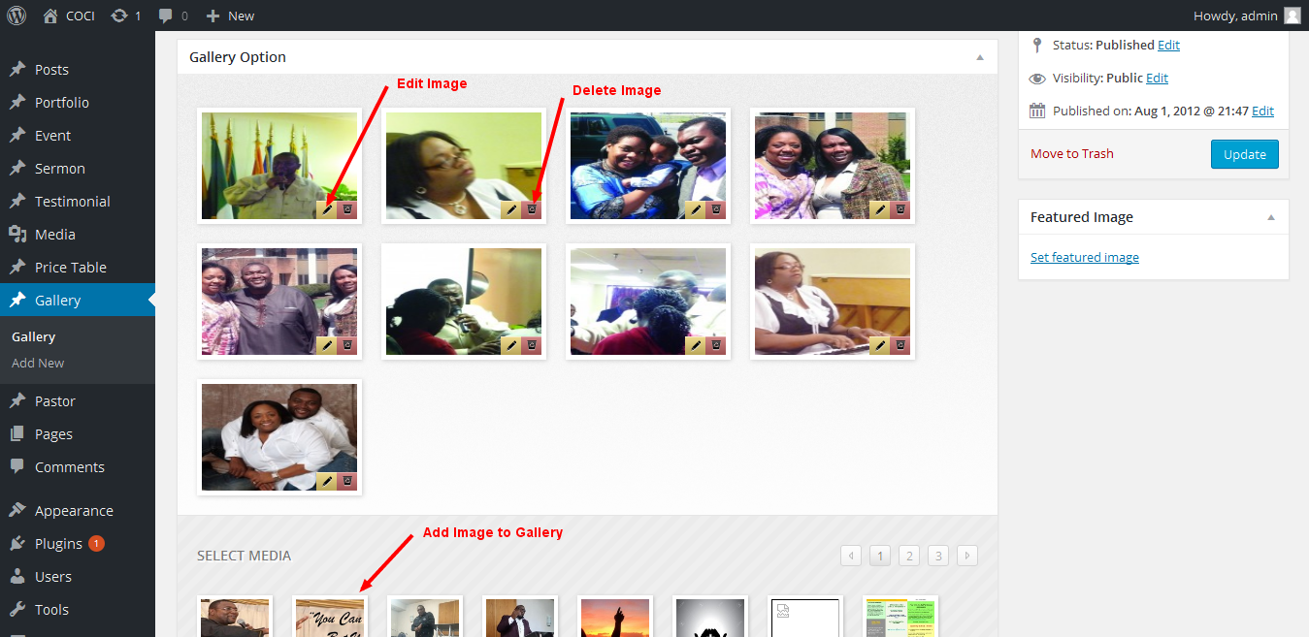

Message Post Page :

1.Create the Sermon item

2.Select the Category

3.Enter the pastor name

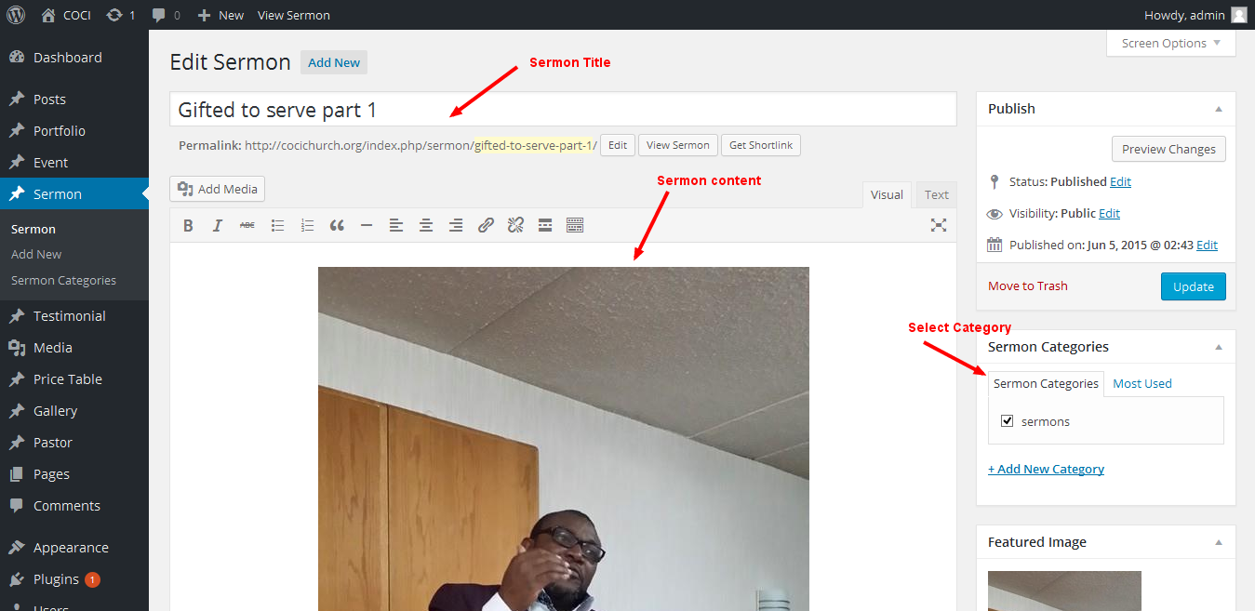

In sermon page Item :

1.Select sermon type

2.Choose category

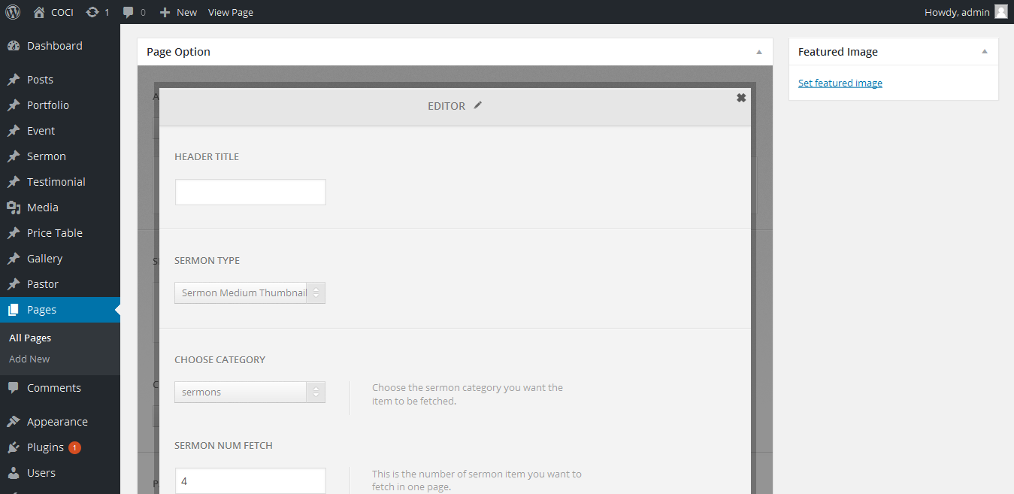

Announcements pages :

1.Create Announcement pages item.

2.Select the Category name.

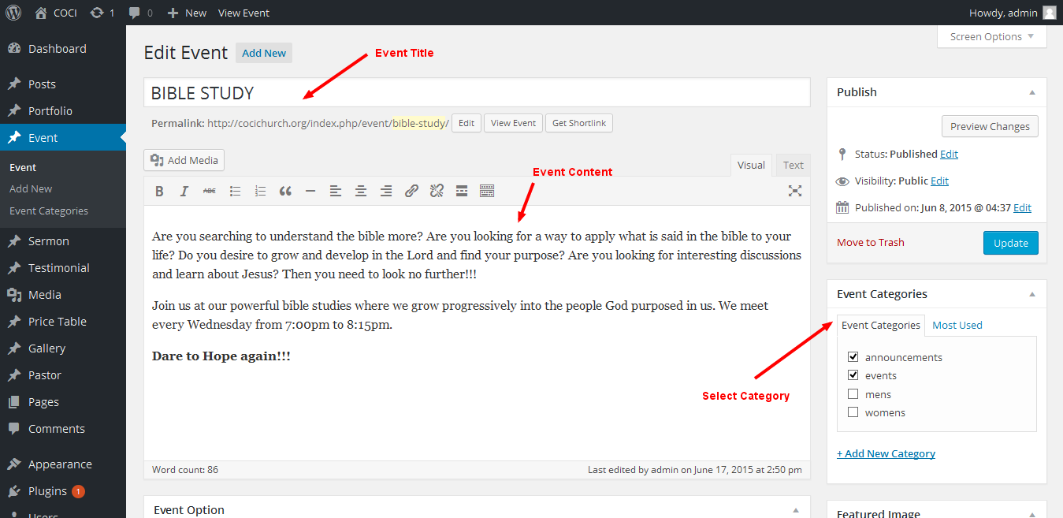

Event Option :

1.Enter the Event Start Date/Time

2.Enter the Event End Date/Time.

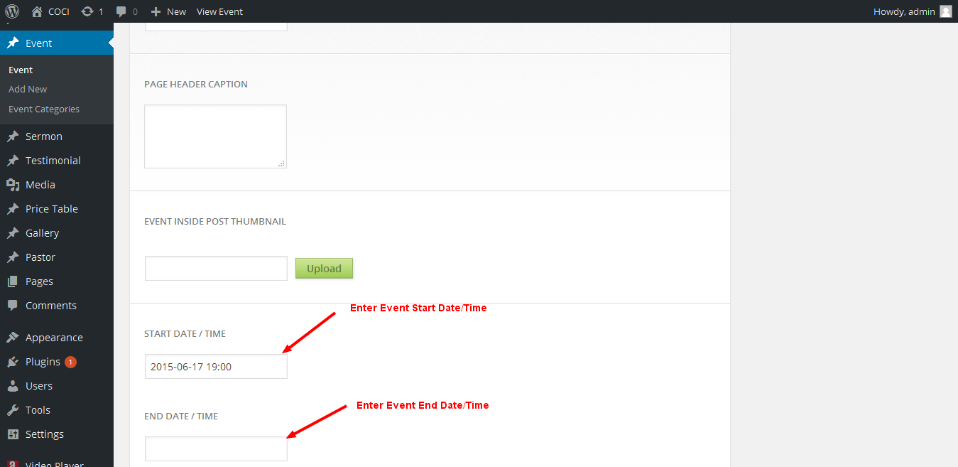

In announcements Pages are :

* + Men’s Ministry
  + Women’ Ministry
  + Youth/Children’s Ministry
  + Salvation
  + Prayer Requests and Praise Reports
  + Evangelism

Contact Page :

1.Create the new Contact page

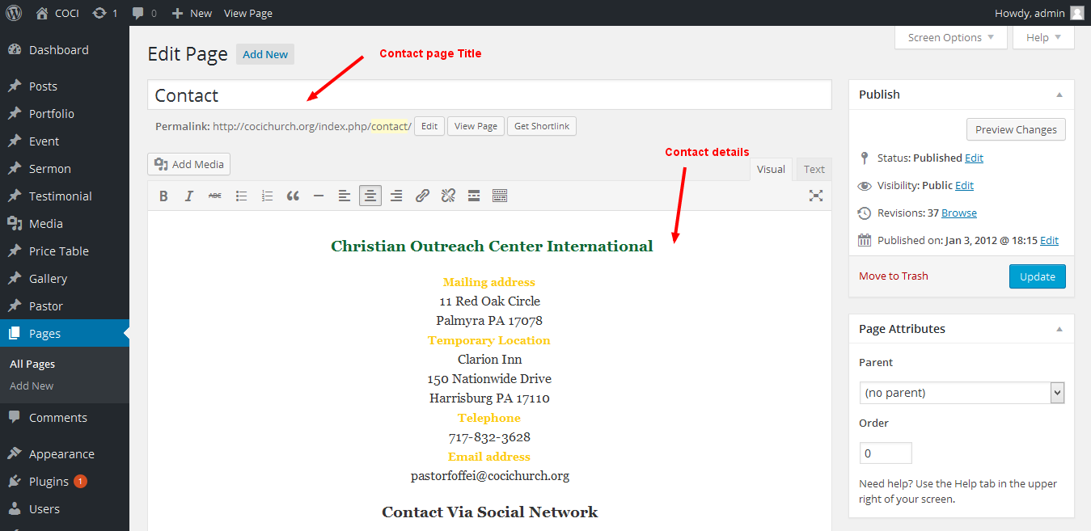

Contact page Item :

1. You can edit, delete, increase size and decrease size of each item by use these following button. ( each item has different size depends on its functional )

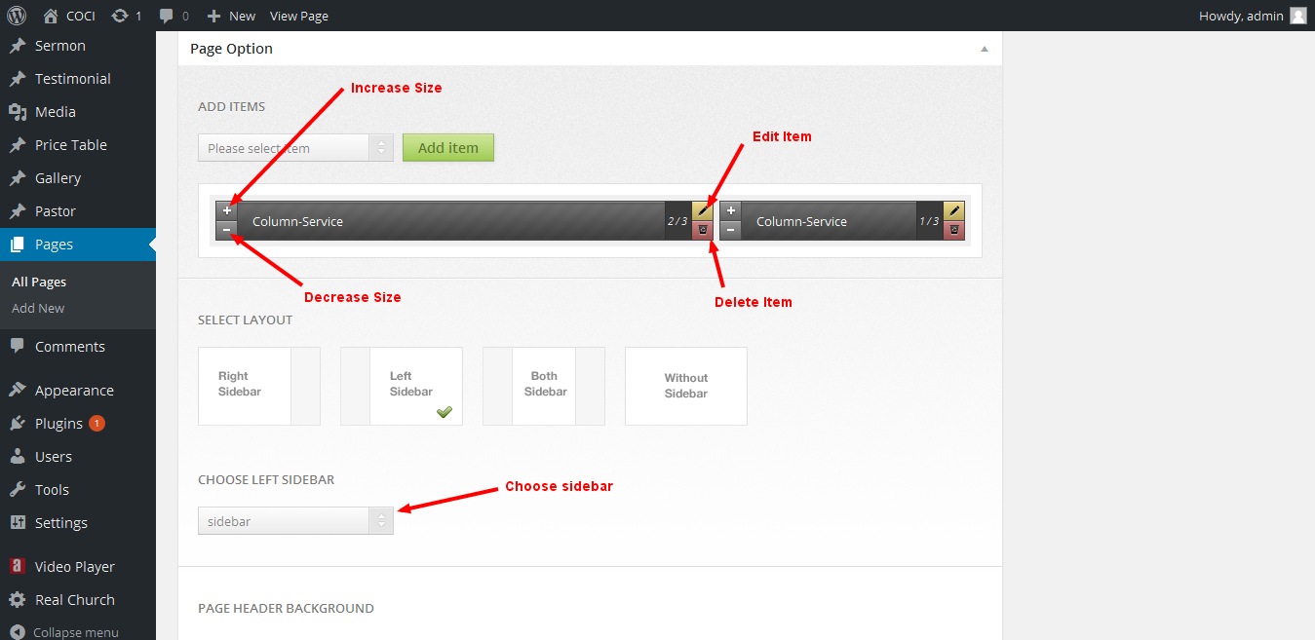

Blog pages:

1. To create blog, go to 'Posts > Add New' and fill your contents.

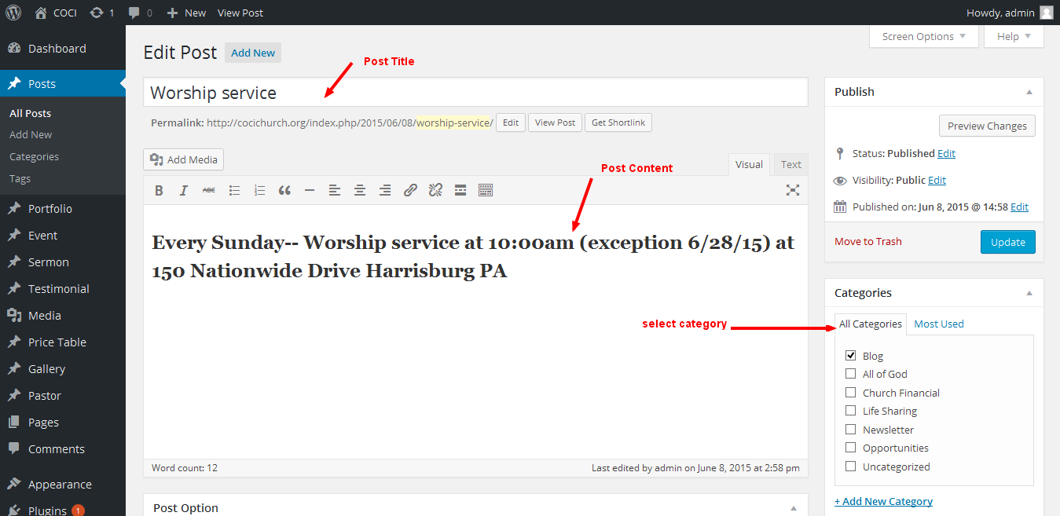

COCI Newsletter

1. To create blog, go to 'Posts > Add New' and fill your contents.

