Date | 30 September 2026
Team ID | SWTID-2026-7773
Project Name | Implement Client Script & UI Policy (Incident)
Team Leader | Senthil Kumar A
Team member | Sri Indhu Prasath A
Team member | Pothi raj S
Team member | Krithick S
Maximum mark | 5

Protecting Incident State: Preventing Direct List Editing

The fifth activity focuses on controlling changes to the State field when users edit Incident records directly from a list view. Direct list editing can allow users to modify important Incident information without opening the complete Incident form.

The idea was developed to prevent unauthorized or unintended State changes through list editing while still allowing legitimate State updates through the Incident form.

The project user story is: As an Incident Management administrator, I want to prevent users from changing the Incident State directly from the list view so that State updates are performed through the appropriate Incident form process.

The proposed solution uses an onCellEdit Client Script named “Prevent state change via list edit”. The script is configured for the Incident table and monitors the State field during direct list editing.

When a user attempts to modify the State field directly from the Incident list, the script displays an alert informing the user that State cannot be updated using list editing and requests that the Incident be opened instead. The callback is then returned as false, preventing the list-based change.

This approach provides an additional level of control over Incident updates, reduces unintended changes, and encourages users to make State modifications through the appropriate Incident form.

Screenshot:

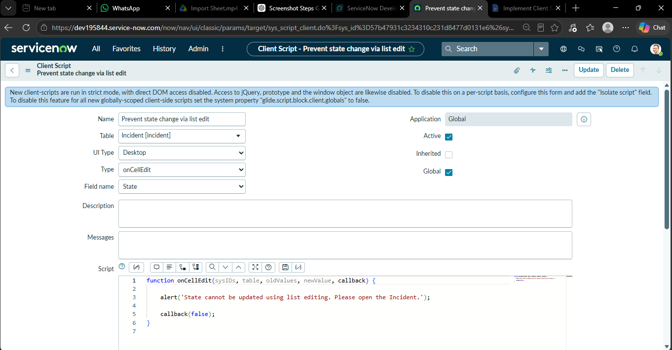

Configuration Details:

Configuration Item | Details
Table | Incident
Script Name | Prevent State Change via List Edit
Script Type | onCellEdit
Field | State
Trigger | State edited from List View
Action | Alert user and reject change
Result | State updated only through Incident Form

Flowchart – Prevent State Change via List Edit

┌──────────────────────────┐

│ Incident List View │

└────────────┬─────────────┘

│

▼

┌──────────────────────────┐

│ User edits the State │

│ field directly in list │

└────────────┬─────────────┘

│

▼

┌──────────────────────────┐

│ onCellEdit Client │

│ Script runs │

└────────────┬─────────────┘

│

▼

┌──────────────────────────┐

│ Is the edited field │

│ State? │

└────────────┬─────────────┘

│

┌────────┴────────┐

│ │

Yes No

│ │

▼ ▼

┌─────────────────────┐ ┌───────────────┐

│ Display alert: │ │ Allow normal │

│ State cannot be │ │ list editing│

│ changed from list │ └───────┬───────┘

│ view. Open Incident │

│ form instead. │ ▼

└──────────┬──────────┘ ┌────────────┐

│ │ Update │

▼ │ Allowed │

┌─────────────────────┐ └────────────┘

│ Callback = false │

│ │

│ Change is rejected │

└──────────┬──────────┘

│

▼

┌─────────────────────┐

│ Open Incident Form │

│ to update State │

└─────────────────────┘

