Date | 30 September 2026
Team ID | 6ab4005e6603573ccfb41be8
Project Name | Implement Client Script & UI Policy (Incident)
Team Leader | Senthil Kumar A
Team member | Sri Indhu Prasath A
Team member | Pothi raj S
Team member | Krithick S
Maximum mark | 5

Automating Urgency Updates: Implementing an onChange Client Script

Automatically Updating Urgency Based on Impact

1. Brainstorming & Ideation Phase
- The third activity focuses on automatically updating the Urgency field when the Impact of an Incident changes.
- Normally, users may need to manually update the Urgency field after changing the Impact value, which can lead to additional effort and inconsistent information.
- The idea was developed to automate this process using a ServiceNow onChange Client Script.
- The project user story is: “As an Incident Management user, I want the Urgency field to be automatically updated when Impact is changed to High so that related Incident information remains consistent without additional manual intervention.”

2. Proposed Solution
- A Client Script named “Auto set urgency for high impact” is created on the Incident table.
- The script is configured as an onChange Client Script on the Impact field.
- When the Impact value is changed to 1 – High, the script automatically sets the Urgency value to 1 – High.
- An informational message is displayed to notify the user about the automatic update.

3. Expected Outcome
- The Urgency field is updated automatically when High Impact is selected.
- Manual data entry is reduced and Incident information remains consistent.
- The activity demonstrates how Client Scripts can dynamically update form fields based on user actions.

Screenshot:

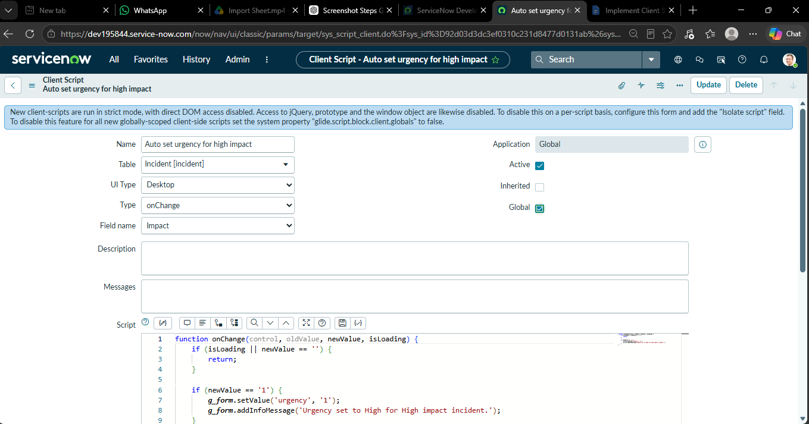

Flowchart for Automatically Updating Urgency Based on Impact

Start
↓
Incident Form Opened
↓
Impact Changed
↓
Is Impact = High?
↙ ↘
Yes No
↓ ↓
Set Urgency No Automatic
= High Update
↓ ↓
Display Info Continue
Message Process
↓ ↓
└────┬────┘
↓

End End

S.No | Configuration | Details
1 | Table | Incident
2 | Script Name | Auto set urgency for high impact
3 | Script Type | onChange
4 | Field | Impact
5 | Condition | Impact = 1 – High
6 | Action | Set Urgency = 1 – High

Client Script Configuration Details

