- About
- Forum
- Howtos & FAQs
- Low graphics
- Shell Scripts
- RSS/Feed
nixcraft - insight into linux admin work

20 Linux System Monitoring Tools Every SysAdmin Should Know
by Vivek Gite on June 27, 2009 · 293 comments· Last updated June 16, 2010

Need to monitor Linux server performance? Try these built-in command and a few add-on tools. Most Linux distributions are equipped with tons of monitoring. These tools provide metrics which can be used to get information about system activities. You can use these tools to find the possible causes of a performance problem. The commands discussed below are some of the most basic commands when it comes to system analysis and debugging server issues such as:
- Finding out bottlenecks.
- Disk (storage) bottlenecks.
- CPU and memory bottlenecks.
- Network bottlenecks.

#1: top - Process Activity Command
The top program provides a dynamic real-time view of a running system i.e. actual process activity. By default, it displays the most CPU-intensive tasks running on the server and updates the list every five seconds.
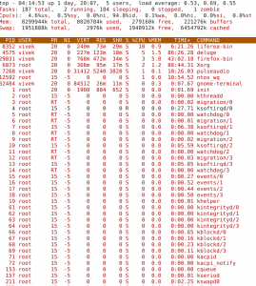
Fig.01: Linux top command

Commonly Used Hot Keys
The top command provides several useful hot keys:
Hot Key | Usage
t | Displays summary information off and on.
m | Displays memory information off and on.
A | Sorts the display by top consumers of various system resources. Useful for quick identification of performance-hungry tasks on a system.
f | Enters an interactive configuration screen for top. Helpful for setting up top for a specific task.
o | Enables you to interactively select the ordering within top.
r | Issues renice command.
k | Issues kill command.
z | Turn on or off color/mono
=> Related: How do I Find Out Linux CPU Utilization?

#2: vmstat - System Activity, Hardware and System Information
The command vmstat reports information about processes, memory, paging, block IO, traps, and cpu activity.
# vmstat 3
Sample Outputs:
procs -----------memory---------- ---swap-- -----io---- --system-- -----cpu------
r b swpd free buff cache si so bi bo in cs us sy id wa st
0 0 0 2540988 522188 5130400 0 0 2 32 4 2 4 1 96 0 0
1 0 0 2540988 522188 5130400 0 0 0 720 1199 665 1 0 99 0 0
0 0 0 2540956 522188 5130400 0 0 0 0 1151 1569 4 1 95 0 0
0 0 0 2540956 522188 5130500 0 0 0 6 1117 439 1 0 99 0 0
0 0 0 2540940 522188 5130512 0 0 0 536 1189 932 1 0 98 0 0
0 0 0 2538444 522188 5130588 0 0 0 0 1187 1417 4 1 96 0 0
0 0 0 2490060 522188 5130640 0 0 0 18 1253 1123 5 1 94 0 0

Display Memory Utilization Slabinfo
# vmstat -m

Get Information About Active / Inactive Memory Pages
# vmstat -a
=> Related: How do I find out Linux Resource utilization to detect system bottlenecks?

#3: w - Find Out Who Is Logged on And What They Are Doing
w command displays information about the users currently on the machine, and their processes.
# w username
# w vivek
Sample Outputs:
17:58:47 up 5 days, 20:28, 2 users, load average: 0.36, 0.26, 0.24
USER TTY FROM LOGIN@ IDLE JCPU PCPU WHAT
root pts/0 10.1.3.145 14:55 5.00s 0.04s 0.02s vim /etc/resolv.conf
root pts/1 10.1.3.145 17:43 0.00s 0.03s 0.00s w

#4: uptime - Tell How Long The System Has Been Running
The uptime command can be used to see how long the server has been running. The current time, how long the system has been running, how many users are currently logged on, and the system load averages for the past 1, 5, and 15 minutes.
# uptime
Output:
18:02:41 up 41 days, 23:42, 1 user, load average: 0.00, 0.00, 0.00
1 can be considered as optimal load value. The load can change from system to system. For a single CPU system 1 - 3 and SMP systems 6-10 load value might be acceptable.

#5: ps - Displays The Processes
ps command will report a snapshot of the current processes. To select all processes use the -A or -e option:
# ps -A
Sample Outputs:
PID TTY TIME CMD
1 ? 00:00:02 init
2 ? 00:00:02 migration/0
3 ? 00:00:01 ksoftirqd/0
4 ? 00:00:00 watchdog/0
5 ? 00:00:00 migration/1
6 ? 00:00:15 ksoftirqd/1
....
.....
4881 ? 00:53:28 java
4885 tty1 00:00:00 mingetty
4886 tty2 00:00:00 mingetty
4887 tty3 00:00:00 mingetty
4888 tty4 00:00:00 mingetty
4891 tty5 00:00:00 mingetty
4892 tty6 00:00:00 mingetty
4893 ttyS1 00:00:00 agetty
12853 ? 00:00:00 cifsoplockd
12854 ? 00:00:00 cifsdnotifyd
14231 ? 00:10:34 lighttpd
14232 ? 00:00:00 php-cgi
54981 pts/0 00:00:00 vim
55465 ? 00:00:00 php-cgi
55546 ? 00:00:00 bind9-snmp-stat
55704 pts/1 00:00:00 ps
ps is just like top but provides more information.

Show Long Format Output
# ps -Al
To turn on extra full mode (it will show command line arguments passed to process):
# ps -AlF

To See Threads ( LWP and NLWP)
# ps -AlFH

To See Threads After Processes
# ps -AlLm

Print All Process On The Server
# ps ax
# ps axu

Print A Process Tree
# ps -ejH
# ps axjf
# pstree

Print Security Information
# ps -eo euser,ruser,suser,fuser,f,comm,label
# ps axZ
# ps -eM

See Every Process Running As User Vivek
# ps -U vivek -u vivek u

Set Output In a User-Defined Format
# ps -eo pid,tid,class,rtprio,ni,pri,psr,pcpu,stat,wchan:14,comm
# ps axo stat,euid,ruid,tty,tpgid,sess,pgrp,ppid,pid,pcpu,comm
# ps -eopid,tt,user,fname,tmout,f,wchan

Display Only The Process IDs of Lighttpd
# ps -C lighttpd -o pid=
OR
# pgrep lighttpd
OR
# pgrep -u vivek php-cgi

Display The Name of PID 55977
# ps -p 55977 -o comm=

Find Out The Top 10 Memory Consuming Process
# ps -auxf | sort -nr -k 4 | head -10

Find Out top 10 CPU Consuming Process
# ps -auxf | sort -nr -k 3 | head -10

#6: free - Memory Usage
The command free displays the total amount of free and used physical and swap memory in the system, as well as the buffers used by the kernel.
# free
Sample Output:
total used free shared buffers cached
Mem: 12302896 9739664 2563232 0 523124 5154740
-/+ buffers/cache: 4061800 8241096
Swap: 1052248 0 1052248
=> Related: :
- Linux Find Out Virtual Memory PAGESIZE
- Linux Limit CPU Usage Per Process
- How much RAM does my Ubuntu / Fedora Linux desktop PC have?

#7: iostat - Average CPU Load, Disk Activity
The command iostat report Central Processing Unit (CPU) statistics and input/output statistics for devices, partitions and network filesystems (NFS).
# iostat
Sample Outputs:
Linux 2.6.18-128.1.14.el5 (www03.nixcraft.in) 06/26/2009
avg-cpu: %user %nice %system %iowait %steal %idle
3.50 0.09 0.51 0.03 0.00 95.86
Device: tps Blk_read/s Blk_wrtn/s Blk_read Blk_wrtn
sda 22.04 31.88 512.03 16193351 260102868
sda1 0.00 0.00 0.00 2166 180
sda2 22.04 31.87 512.03 16189010 260102688
sda3 0.00 0.00 0.00 1615 0
=> Related: : Linux Track NFS Directory / Disk I/O Stats

#8: sar - Collect and Report System Activity
The sar command is used to collect, report, and save system activity information. To see network counter, enter:
# sar -n DEV | more
To display the network counters from the 24th:
# sar -n DEV -f /var/log/sa/sa24 | more
You can also display real time usage using sar:
# sar 4 5
Sample Outputs:
Linux 2.6.18-128.1.14.el5 (www03.nixcraft.in) 06/26/2009
06:45:12 PM CPU %user %nice %system %iowait %steal %idle
06:45:16 PM all 2.00 0.00 0.22 0.00 0.00 97.78
06:45:20 PM all 2.07 0.00 0.38 0.03 0.00 97.52
06:45:24 PM all 0.94 0.00 0.28 0.00 0.00 98.78
06:45:28 PM all 1.56 0.00 0.22 0.00 0.00 98.22
06:45:32 PM all 3.53 0.00 0.25 0.03 0.00 96.19
Average: all 2.02 0.00 0.27 0.01 0.00 97.70
=> Related: : How to collect Linux system utilization data into a file

#9: mpstat - Multiprocessor Usage
The mpstat command displays activities for each available processor, processor 0 being the first one. mpstat -P ALL to display average CPU utilization per processor:
# mpstat -P ALL
Sample Output:
Linux 2.6.18-128.1.14.el5 (www03.nixcraft.in) 06/26/2009
06:48:11 PM CPU %user %nice %sys %iowait %irq %soft %steal %idle intr/s
06:48:11 PM all 3.50 0.09 0.34 0.03 0.01 0.17 0.00 95.86 1218.04
06:48:11 PM 0 3.44 0.08 0.31 0.02 0.00 0.12 0.00 96.04 1000.31
06:48:11 PM 1 3.10 0.08 0.32 0.09 0.02 0.11 0.00 96.28 34.93
06:48:11 PM 2 4.16 0.11 0.36 0.02 0.00 0.11 0.00 95.25 0.00
06:48:11 PM 3 3.77 0.11 0.38 0.03 0.01 0.24 0.00 95.46 44.80
06:48:11 PM 4 2.96 0.07 0.29 0.04 0.02 0.10 0.00 96.52 25.91
06:48:11 PM 5 3.26 0.08 0.28 0.03 0.01 0.10 0.00 96.23 14.98
06:48:11 PM 6 4.00 0.10 0.34 0.01 0.00 0.13 0.00 95.42 3.75
06:48:11 PM 7 3.30 0.11 0.39 0.03 0.01 0.46 0.00 95.69 76.89
=> Related: : Linux display each multiple SMP CPU processors utilization individually.

#10: pmap - Process Memory Usage
The command pmap report memory map of a process. Use this command to find out causes of memory bottlenecks.
# pmap -d PID
To display process memory information for pid # 47394, enter:
# pmap -d 47394
Sample Outputs:
47394: /usr/bin/php-cgi
Address Kbytes Mode Offset Device Mapping
0000000000400000 2584 r-x-- 0000000000000000 008:00002 php-cgi
0000000000886000 140 rw--- 0000000000286000 008:00002 php-cgi
00000000008a9000 52 rw--- 00000000008a9000 000:00000 [ anon ]
0000000000aa8000 76 rw--- 00000000002a8000 008:00002 php-cgi
000000000f678000 1980 rw--- 000000000f678000 000:00000 [ anon ]
000000314a600000 112 r-x-- 0000000000000000 008:00002 ld-2.5.so
000000314a81b000 4 r---- 000000000001b000 008:00002 ld-2.5.so
000000314a81c000 4 rw--- 000000000001c000 008:00002 ld-2.5.so
000000314aa00000 1328 r-x-- 0000000000000000 008:00002 libc-2.5.so
000000314ab4c000 2048 ----- 000000000014c000 008:00002 libc-2.5.so
.....
......
..
00002af8d48fd000 4 rw--- 0000000000006000 008:00002 xsl.so
00002af8d490c000 40 r-x-- 0000000000000000 008:00002 libnss_files-2.5.so
00002af8d4916000 2044 ----- 000000000000a000 008:00002 libnss_files-2.5.so
00002af8d4b15000 4 r---- 0000000000009000 008:00002 libnss_files-2.5.so
00002af8d4b16000 4 rw--- 000000000000a000 008:00002 libnss_files-2.5.so
00002af8d4b17000 768000 rw-s- 0000000000000000 000:00009 zero (deleted)
00007fffc95fe000 84 rw--- 00007ffffffea000 000:00000 [ stack ]
ffffffffff600000 8192 ----- 0000000000000000 000:00000 [ anon ]
mapped: 933712K writeable/private: 4304K shared: 768000K
The last line is very important:
- mapped: 933712K total amount of memory mapped to files
- writeable/private: 4304K the amount of private address space
- shared: 768000K the amount of address space this process is sharing with others
=> Related: : Linux find the memory used by a program / process using pmap command

#11 and #12: netstat and ss - Network Statistics
The command netstat displays network connections, routing tables, interface statistics, masquerade connections, and multicast memberships. ss command is used to dump socket statistics. It allows showing information similar to netstat. See the following resources about ss and netstat commands:
- ss: Display Linux TCP / UDP Network and Socket Information
- Get Detailed Information About Particular IP address Connections Using netstat Command

#13: iptraf - Real-time Network Statistics
The iptraf command is interactive colorful IP LAN monitor. It is an ncurses-based IP LAN monitor that generates various network statistics including TCP info, UDP counts, ICMP and OSPF information, Ethernet load info, node stats, IP checksum errors, and others. It can provide the following info in easy to read format:
- Network traffic statistics by TCP connection
- IP traffic statistics by network interface
- Network traffic statistics by protocol
- Network traffic statistics by TCP/UDP port and by packet size
- Network traffic statistics by Layer2 address
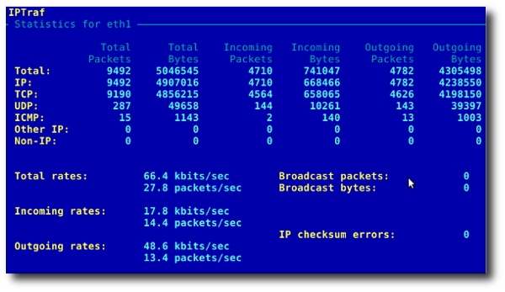
Fig.02: General interface statistics: IP traffic statistics by network interface
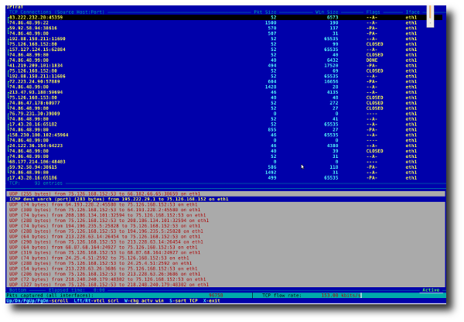
Fig.03 Network traffic statistics by TCP connection

#14: tcpdump - Detailed Network Traffic Analysis
The tcpdump is simple command that dump traffic on a network. However, you need good understanding of TCP/IP protocol to utilize this tool. For.e.g to display traffic info about DNS, enter:
# tcpdump -i eth1 'udp port 53'
To display all IPv4 HTTP packets to and from port 80, i.e. print only packets that contain data, not, for example, SYN and FIN packets and ACK-only packets, enter:
# tcpdump 'tcp port 80 and (((ip[2:2] - ((ip[0]&0xf)<<2)) - ((tcp[12]&0xf0)>>2)) != 0)'
To display all FTP session to 202.54.1.5, enter:
# tcpdump -i eth1 'dst 202.54.1.5 and (port 21 or 20'
To display all HTTP session to 192.168.1.5:
# tcpdump -ni eth0 'dst 192.168.1.5 and tcp and port http'
Use wireshark to view detailed information about files, enter:
# tcpdump -n -i eth1 -s 0 -w output.txt src or dst port 80

#15: strace - System Calls
Trace system calls and signals. This is useful for debugging webserver and other server problems. See how to use to trace the process and see What it is doing.

#16: /Proc file system - Various Kernel Statistics
/proc file system provides detailed information about various hardware devices and other Linux kernel information. See Linux kernel /proc documentations for further details. Common /proc examples:
# cat /proc/cpuinfo
# cat /proc/meminfo
# cat /proc/zoneinfo
# cat /proc/mounts

17#: Nagios - Server And Network Monitoring
Nagios is a popular open source computer system and network monitoring application software. You can easily monitor all your hosts, network equipment and services. It can send alert when things go wrong and again when they get better. FAN is "Fully Automated Nagios". FAN goals are to provide a Nagios installation including most tools provided by the Nagios Community. FAN provides a CDRom image in the standard ISO format, making it easy to easilly install a Nagios server. Added to this, a wide bunch of tools are including to the distribution, in order to improve the user experience around Nagios.

18#: Cacti - Web-based Monitoring Tool
Cacti is a complete network graphing solution designed to harness the power of RRDTool's data storage and graphing functionality. Cacti provides a fast poller, advanced graph templating, multiple data acquisition methods, and user management features out of the box. All of this is wrapped in an intuitive, easy to use interface that makes sense for LAN-sized installations up to complex networks with hundreds of devices. It can provide data about network, CPU, memory, logged in users, Apache, DNS servers and much more. See how to install and configure Cacti network graphing tool under CentOS / RHEL.

#19: KDE System Guard - Real-time Systems Reporting and Graphing
KSysguard is a network enabled task and system monitor application for KDE desktop. This tool can be run over ssh session. It provides lots of features such as a client/server architecture that enables monitoring of local and remote hosts. The graphical front end uses so-called sensors to retrieve the information it displays. A sensor can return simple values or more complex information like tables. For each type of information, one or more displays are provided. Displays are organized in worksheets that can be saved and loaded independently from each other. So, KSysguard is not only a simple task manager but also a very powerful tool to control large server farms.
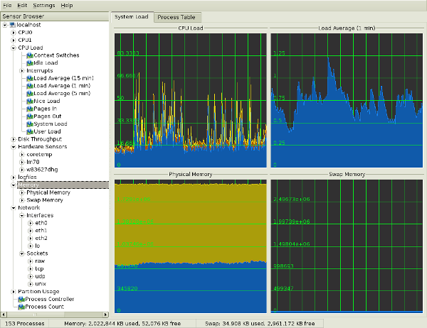
Fig.05 KDE System Guard {Image credit: Wikipedia}
See the KSysguard handbook for detailed usage.

#20: Gnome System Monitor - Real-time Systems Reporting and Graphing
The System Monitor application enables you to display basic system information and monitor system processes, usage of system resources, and file systems. You can also use System Monitor to modify the behavior of your system. Although not as powerful as the KDE System Guard, it provides the basic information which may be useful for new users:
- Displays various basic information about the computer's hardware and software.
- Linux Kernel version
- GNOME version
- Hardware
- Installed memory
- Processors and speeds
- System Status
- Currently available disk space
- Processes
- Memory and swap space
- Network usage
- File Systems
- Lists all mounted filesystems along with basic information about each.
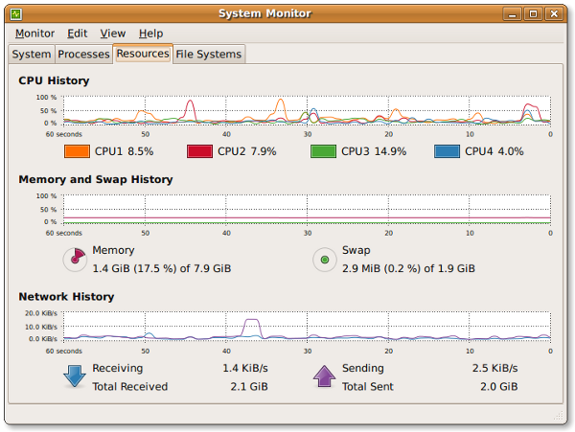
Fig.06 The Gnome System Monitor application

Bonus: Additional Tools
A few more tools:
- nmap - scan your server for open ports.
- lsof - list open files, network connections and much more.
- ntop web based tool - ntop is the best tool to see network usage in a way similar to what top command does for processes i.e. it is network traffic monitoring software. You can see network status, protocol wise distribution of traffic for UDP, TCP, DNS, HTTP and other protocols.
- Conky - Another good monitoring tool for the X Window System. It is highly configurable and is able to monitor many system variables including the status of the CPU, memory, swap space, disk storage, temperatures, processes, network interfaces, battery power, system messages, e-mail inboxes etc.
- GKrellM - It can be used to monitor the status of CPUs, main memory, hard disks, network interfaces, local and remote mailboxes, and many other things.
- vnstat - vnStat is a console-based network traffic monitor. It keeps a log of hourly, daily and monthly network traffic for the selected interface(s).
- htop - htop is an enhanced version of top, the interactive process viewer, which can display the list of processes in a tree form.
- mtr - mtr combines the functionality of the traceroute and ping programs in a single network diagnostic tool.
Did I miss something? Please add your favorite system motoring tool in the comments.

You should follow me on twitter here or grab rss feed to keep track of new changes.
{ 293 comments… read them below or add one }
← Previous Comments
balwant September 1, 2012 at 5:46 pm
very very nice..
Reply
← Previous Comments
Leave a Comment

Name *
E-mail *
Website

You can use these HTML tags and attributes for your code and commands: <strong> <em> <ol> <li> <u> <ul> <blockquote> <pre> <a href="" title="">
Notify me of followup comments via e-mail.
Security Question:
What is 15 + 15 ?
Solve the simple math so we know that you are a human and not a bot.

Tagged as: bandwidth monitoring tool linux, cpu monitoring linux, disk monitoring linux, htop command, load monitoring linux, monitoring linux servers, nagios monitoring linux, netstat command, network monitoring linux, pgrep command, process monitoring linux, ps command, ss command, top command

Previous post: My 10 UNIX Command Line Mistakes
Next post: Download Of the Day: Firefox 3.5 For Windows, Linux, Mac OS X
- Follow us @ Youtube | Twitter | Google +

Top of Form

- Sysadmin To Be Resources
  - 20 Linux system monitoring tools every sysAdmin should know
  - 20 Linux server hardening security tips
  - Linux: 20 Iptables examples for new sysAdmins
  - My 10 Unix command line mistakes
  - Top 25 PHP security best practices for Sys admins
  - The novice guide to buying a Linux laptop
  - Top 20 OpenSSH server best security practices
- Related Posts
  - Essential tools for monitoring and administrating MySQL Server
  - How To Track Changes in Your Linux Filesystem
  - Download of the day: AutoScan Network Monitoring – Management Tool
  - Nagios: System and Network Monitoring Book
  - Suse Linux: Nagios Basic Installation and Configuration
©2004-2012 nixCraft. All rights reserved. Cannot be reproduced without written permission.
Privacy Policy | Terms of Service | Questions or Comments | Copyright Info | Sitemap

