- With vibe coding implement the playwright/typescript or any other tool which you work say Selenium/Python
Below is Playwright typescript code
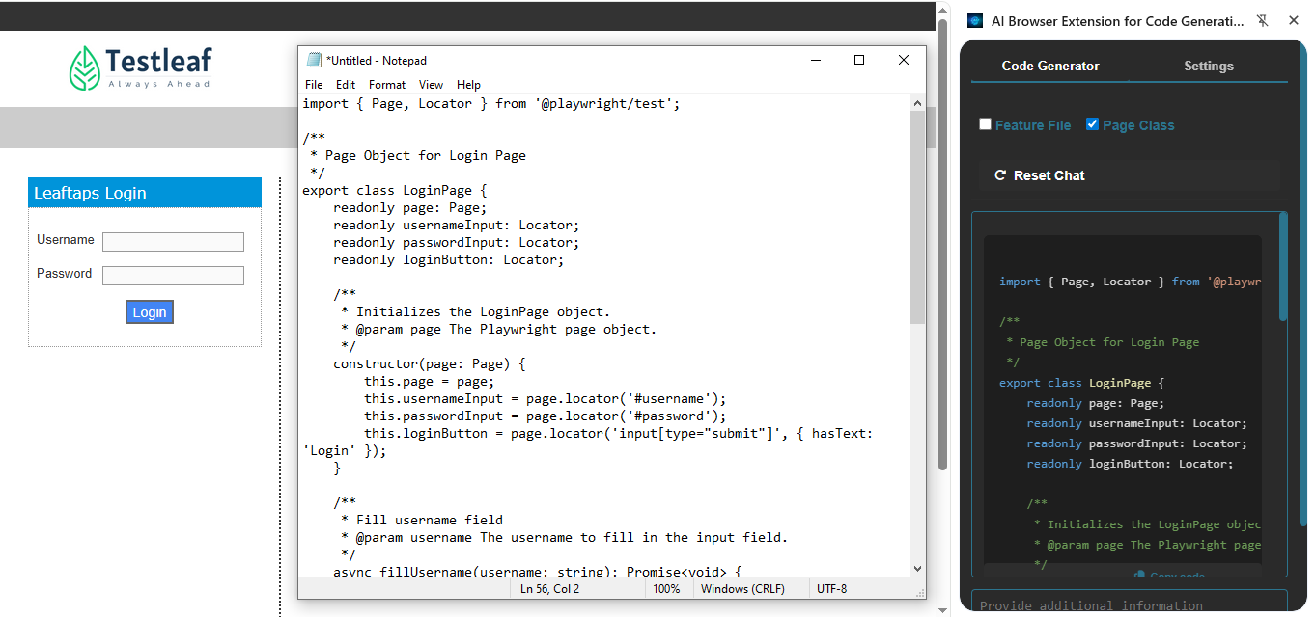

2) Use Bugmagnet extension for form filling
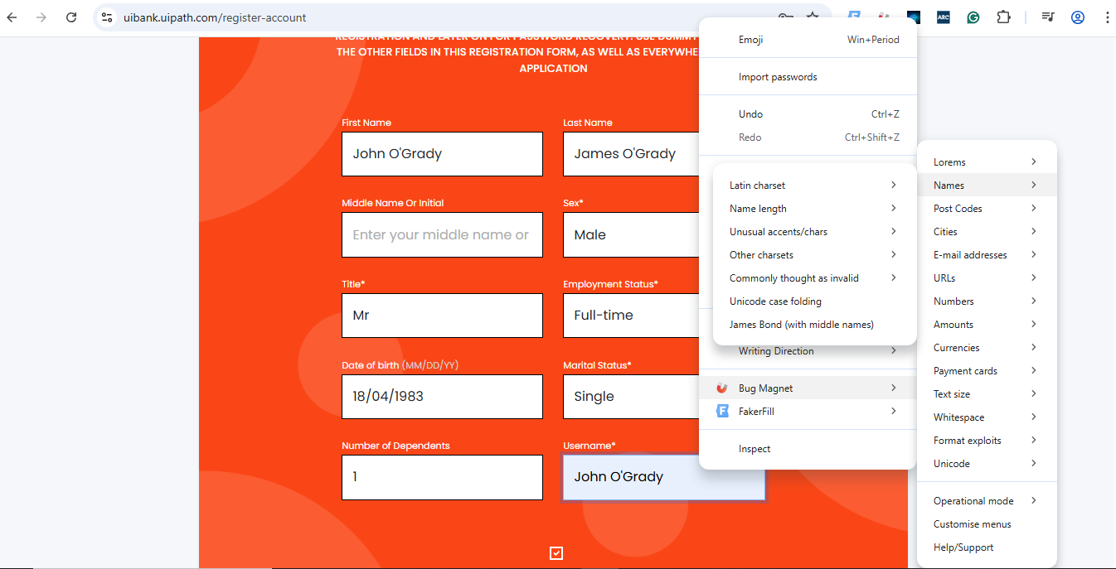

3)Use grammarly extension to correct the mistakes in your content
