REPORT
JAVA CONTROL STATEMENTS
I.BRANCHING STATEMENT:
1.Leap Year
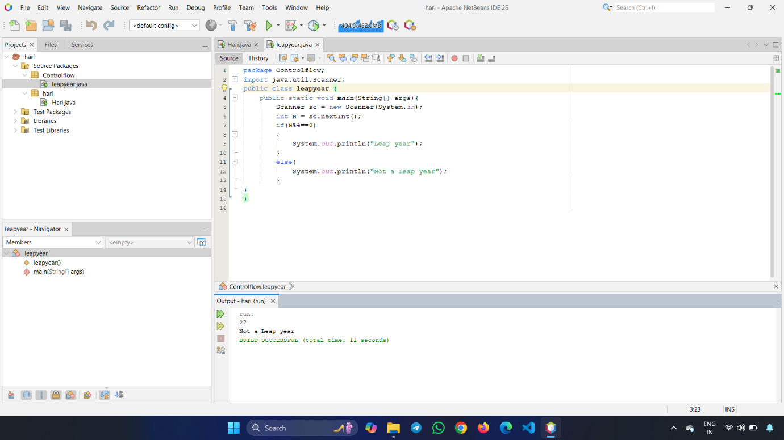2.Greatest of two Number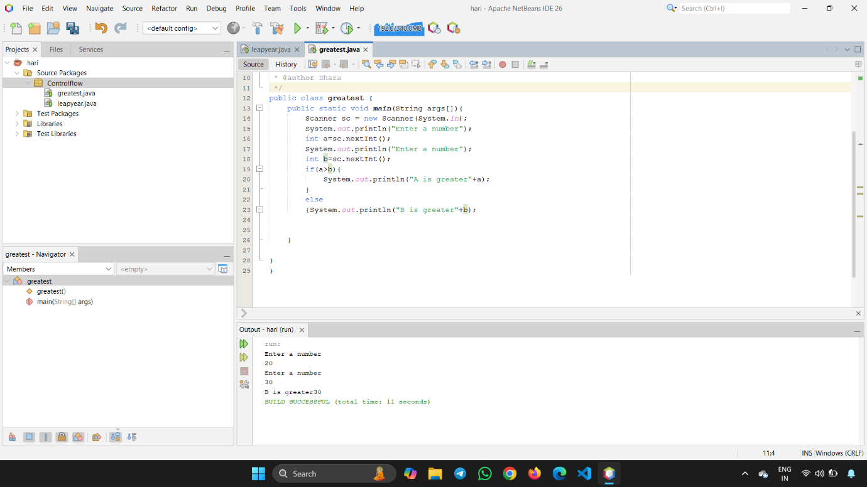
3.Movie review
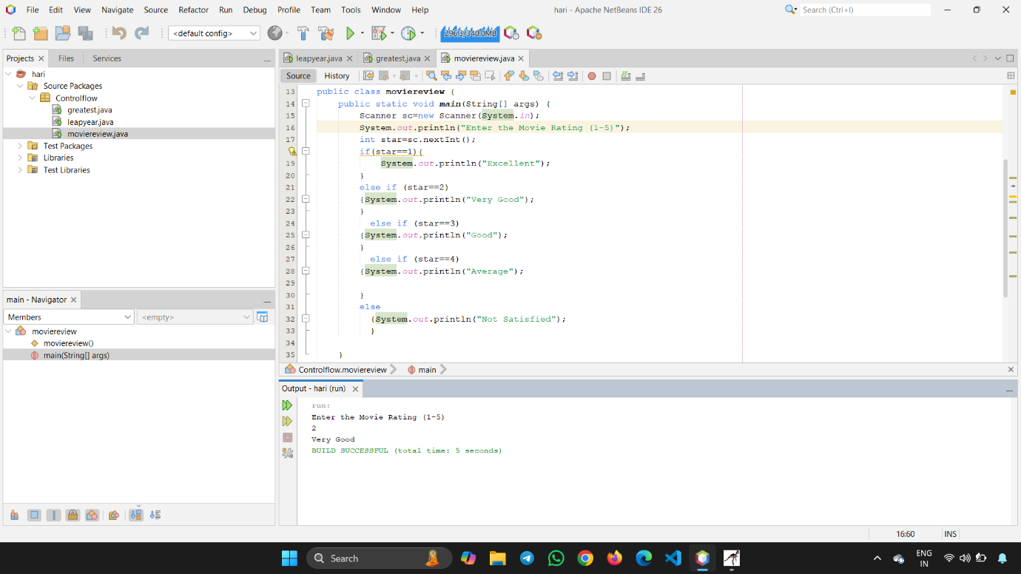

4.EB Calculation
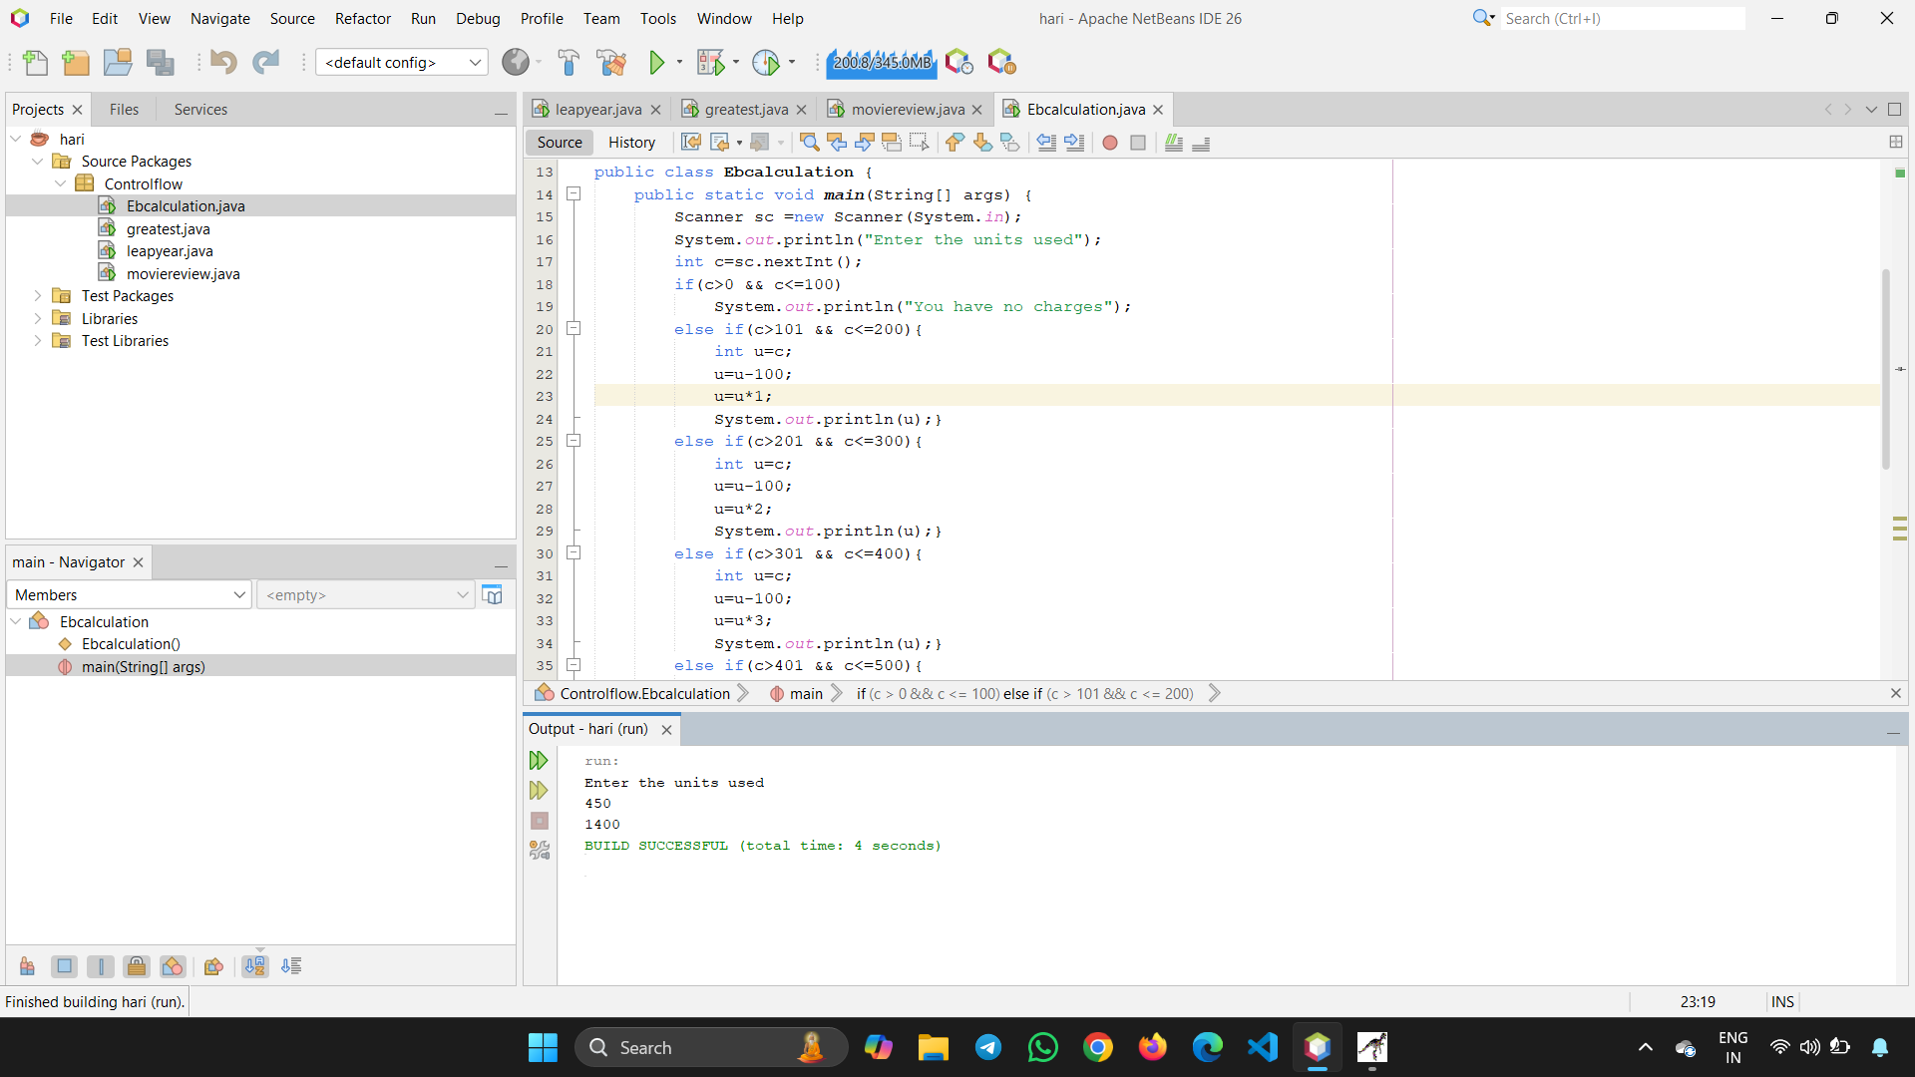
5.Display a Numbers in words
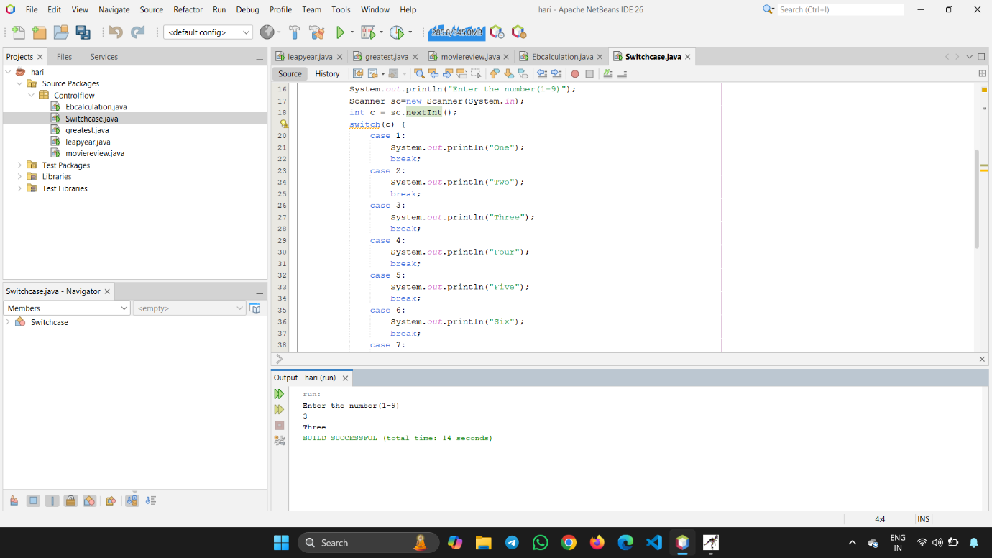

II.LOOPING STATEMENTS:
1.Display your Name in nth times
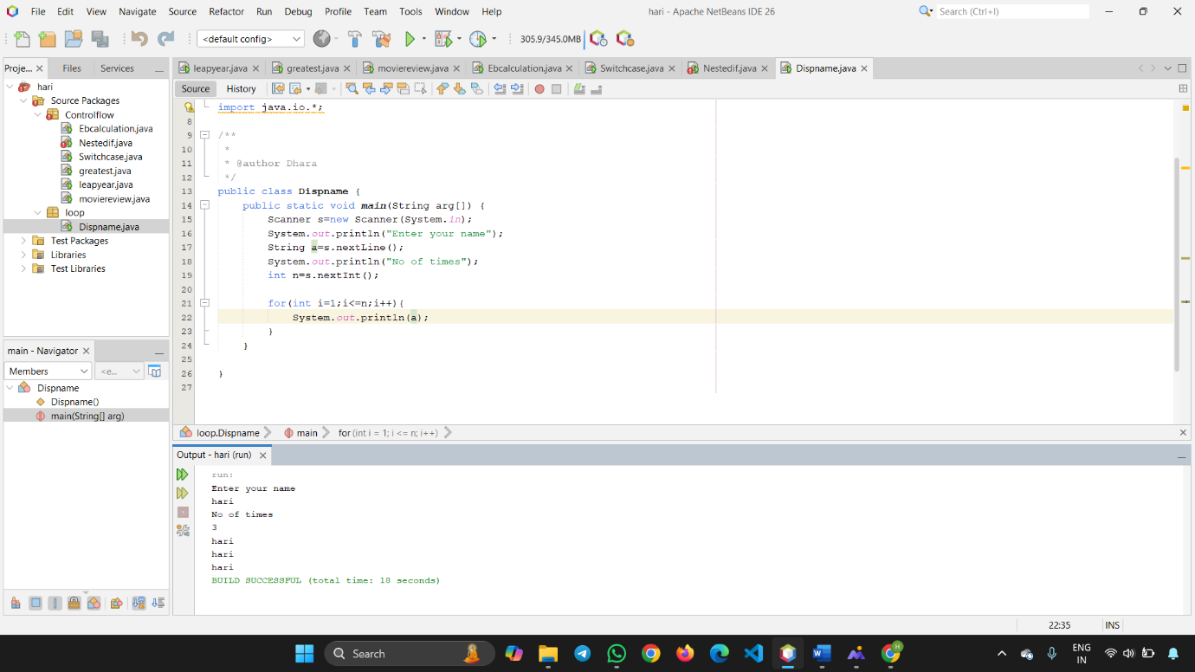

2.Reverse of a Number
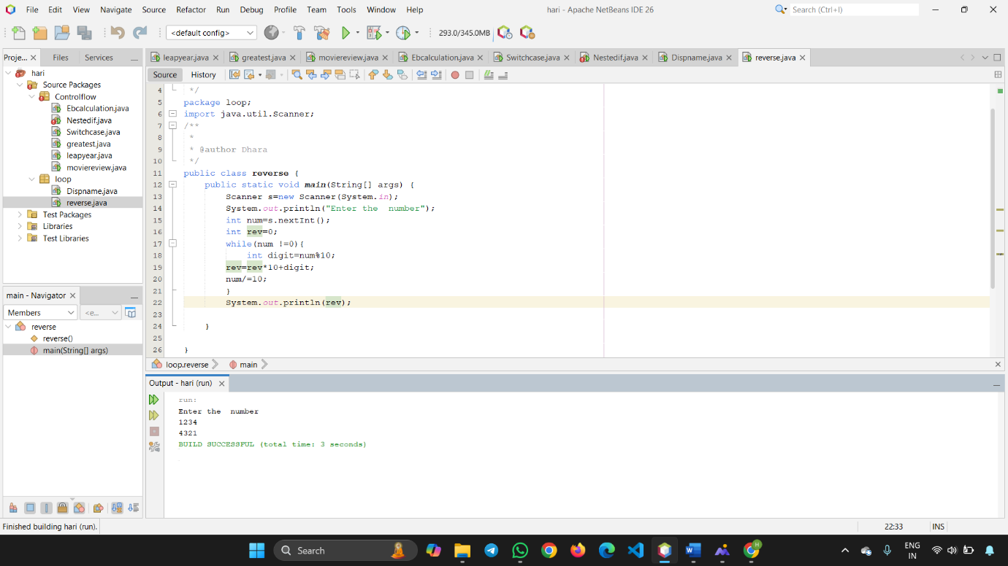

III.UNCONDITIONAL STATEMENTS:
1.Prime numbers:
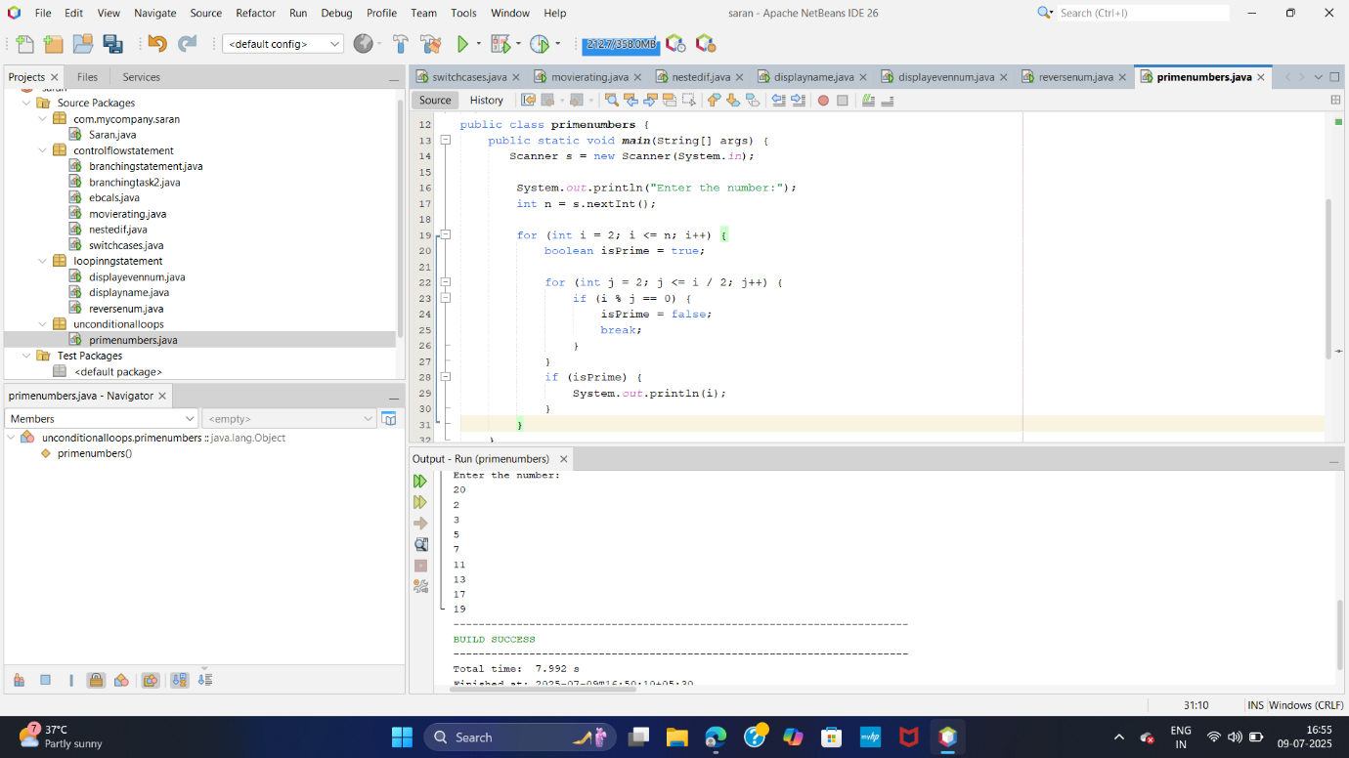
2.Factors of a Number
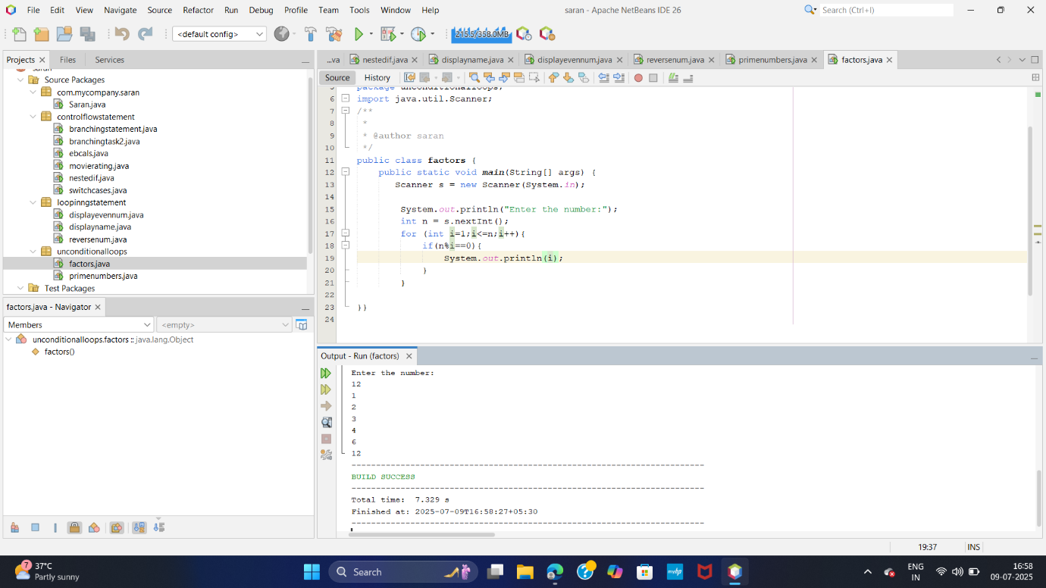

1.LARGEST NUMBER IN AN ARRAY:
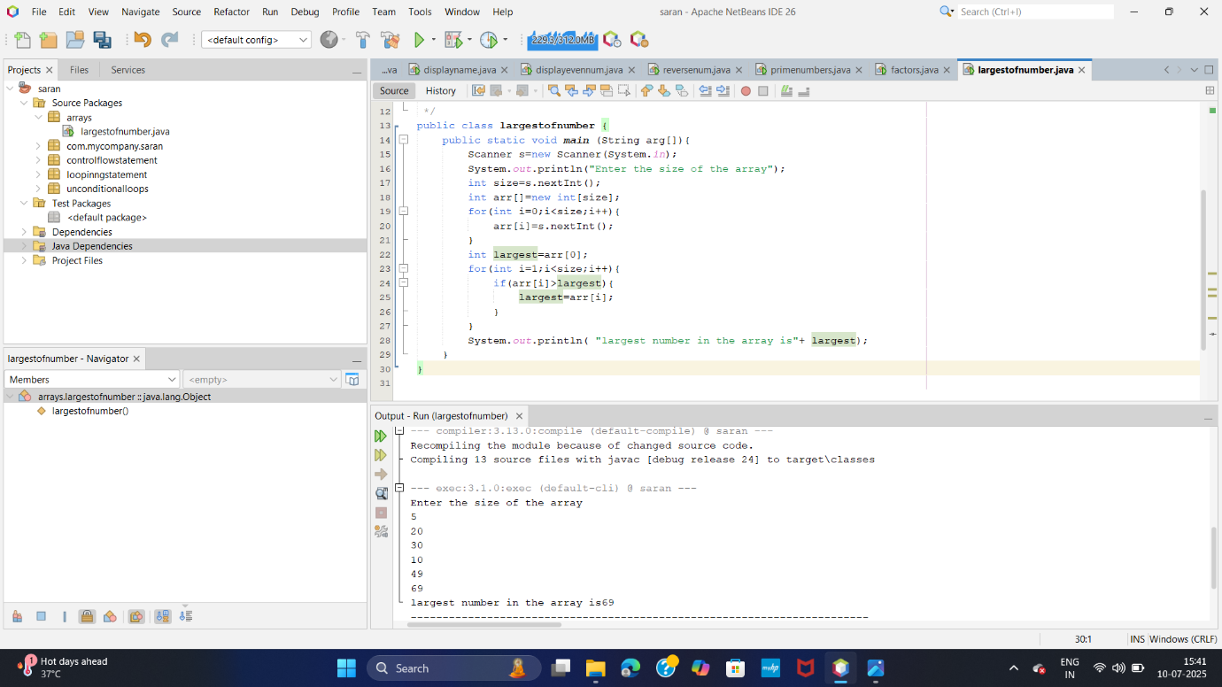

2.ADDITIONOF TWO ARRAY:
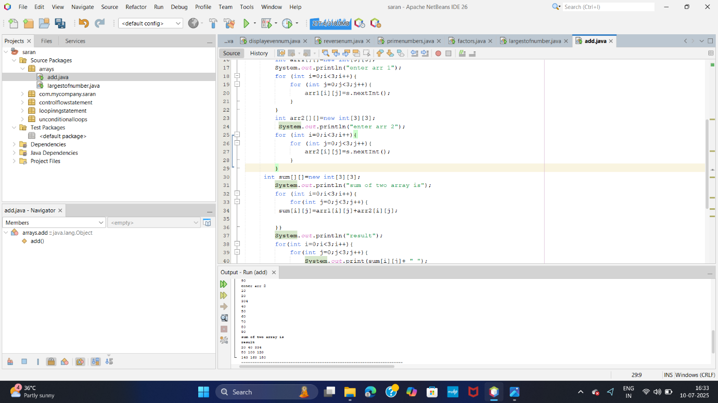

Patterns:
