# GitHub Commit and Push Process

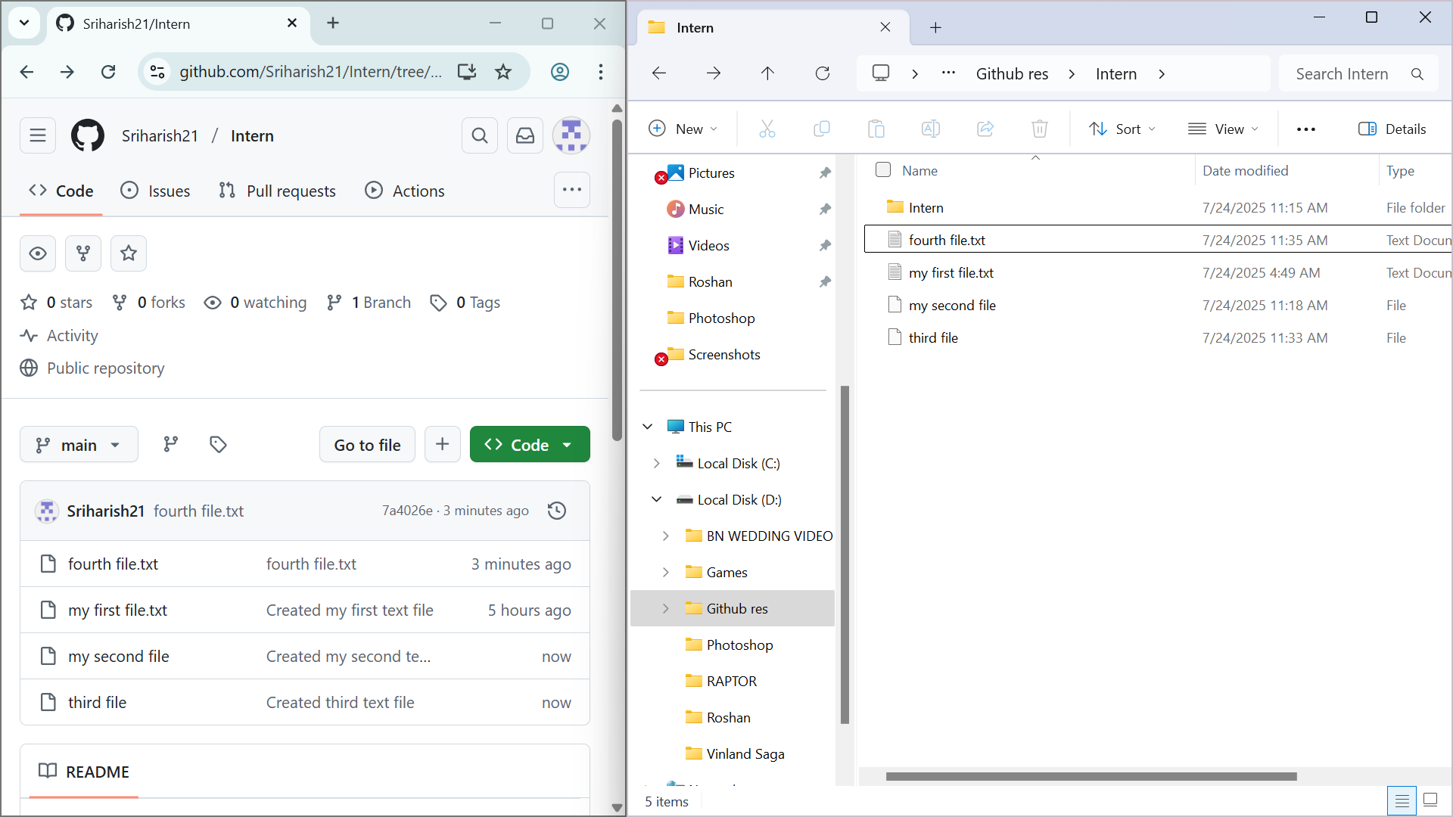

1. GitHub repository and local file explorer view

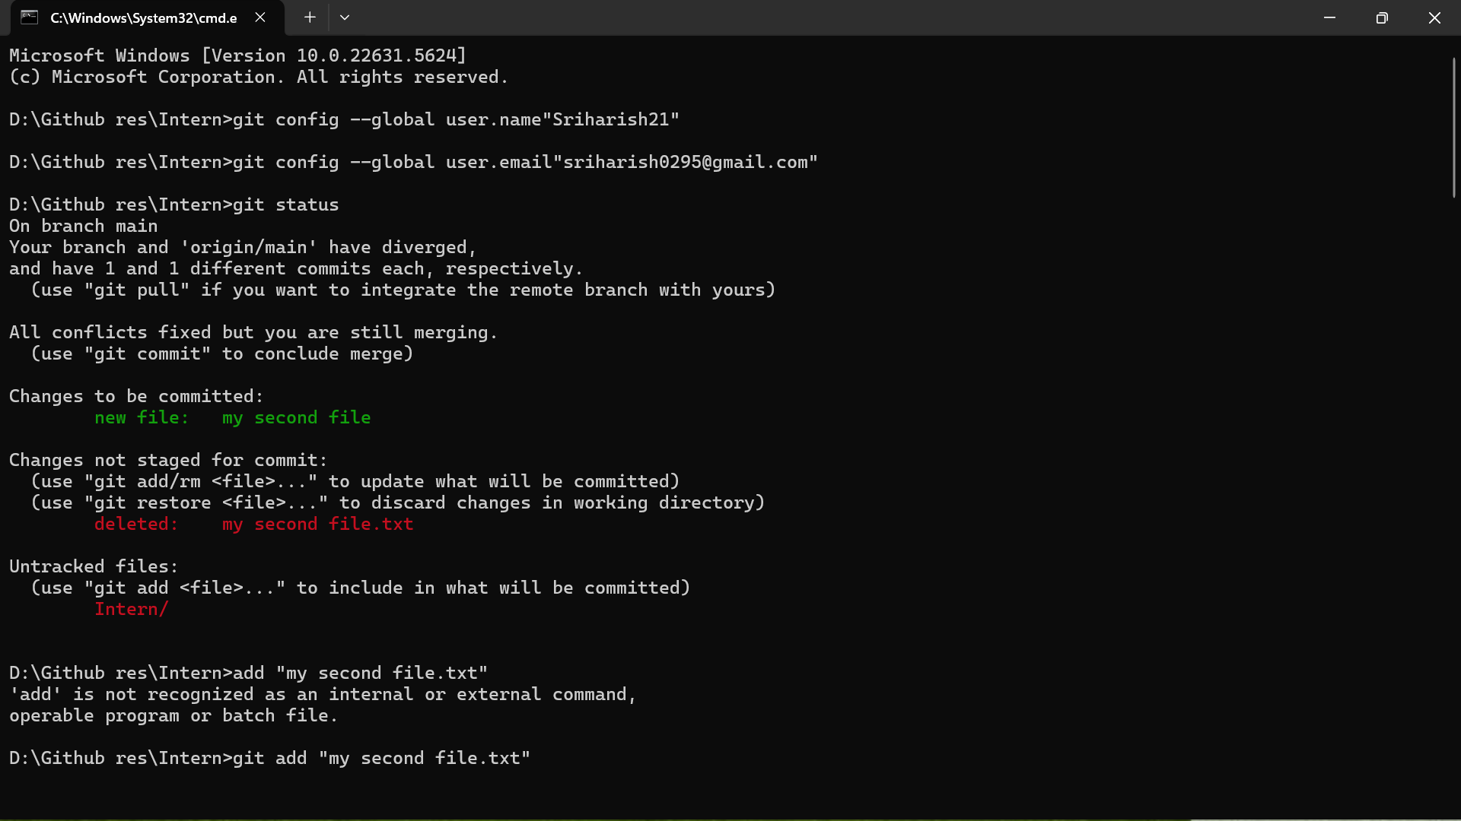

2. Git status showing file changes and initial add command

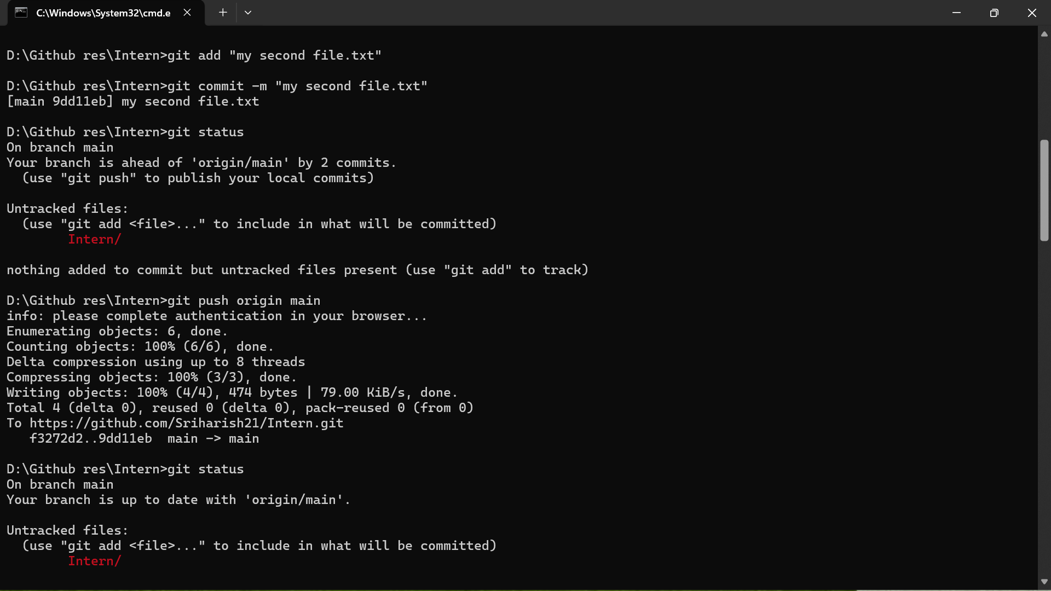

3. Commit and push process to GitHub

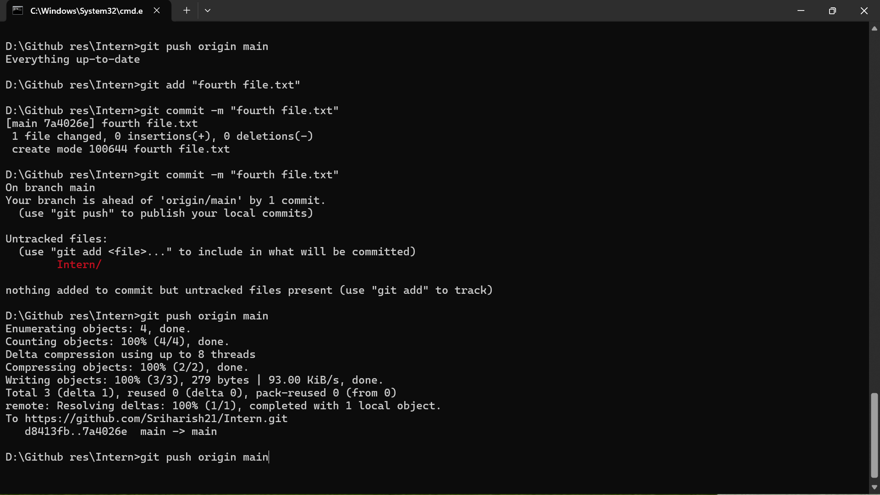

4. Final push and confirmation of update