Weather ForeCast API

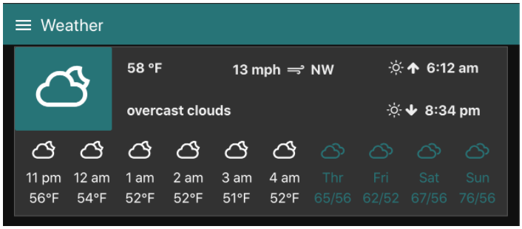

[GitLink](https://github.com/senthildsc/Weather-Forecast-from-OpenWeather.git)