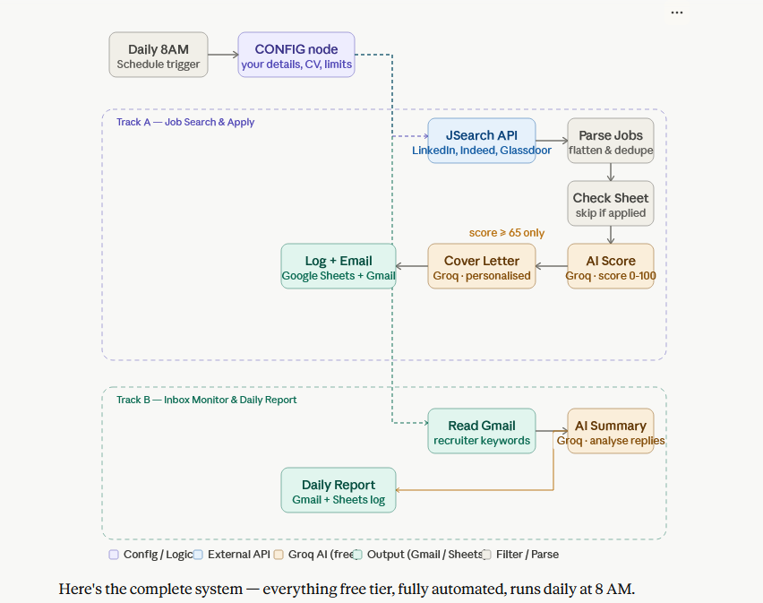

Now I have a clear picture of the best free stack. Let me build the complete, fully-documented workflow.Now I'll build the complete workflow JSON and a visual architecture diagram + setup guide.Now the visual architecture diagram and setup guide:Here's the complete system — everything free tier, fully automated, runs daily at 8 AM.

Free tools used
Tool | Purpose | Free tier
JSearch (RapidAPI) | Job search across LinkedIn, Indeed, Glassdoor, ZipRecruiter | 200 req/month — enough for daily runs
Groq | AI match scoring + cover letter + inbox analysis | Free, no card needed
Gmail | Read inbox + send all emails | Free OAuth
Google Sheets | Tracker database for all jobs + reports | Free
n8n | Self-hosted (Docker) | Always free

What it does every day at 8 AM
Track A — Job Search:
- Searches JSearch API with your title, location, experience level
- Parses and deduplicates results from LinkedIn/Indeed/Glassdoor simultaneously
- Checks Google Sheet — skips any company already applied to
- Groq AI scores each job 0–100 against your resume text
- Only applies (score ≥ 65) — generates a personalised cover letter per job
- Logs to Google Sheet + emails you the application package with a direct apply link
Track B — Inbox Monitor (runs in parallel):
- Reads Gmail for unread recruiter/interview/opportunity emails from last 7 days
- Matches emails to your tracked applications by company name
- Groq AI analyses each email — interview invite, rejection, follow-up, or spam
- Stars the email in Gmail, updates the sheet status to "Recruiter Contacted"
- Sends one daily HTML summary email with all actions, AI analysis, and priorities

Setup — 5 steps
Step 1 — Install & import
docker run -d -p 5678:5678 -v ~/.n8n:/home/node/.n8n docker.n8n.io/n8nio/n8n
Open localhost:5678 → Workflows → Import → paste the JSON file.
Step 2 — Get your free API keys
- JSearch: rapidapi.com/letscrape-6bRBa3QguO5/api/jsearch → Subscribe free → copy X-RapidAPI-Key
- Groq: console.groq.com → API Keys → Create
Step 3 — Connect credentials in n8n
- Gmail: Settings → Credentials → Gmail OAuth2 (Google Cloud Console)
- Google Sheets: same credentials or Service Account JSON
Step 4 — Create your Google Sheet Create a Google Sheet with two tabs named exactly: Applied Jobs and Daily Reports. Copy the Sheet ID from the URL.
Step 5 — Edit the CONFIG node (the purple node, first in the chain):
- JOB_TITLE, LOCATION, USER_EMAIL, USER_NAME, RESUME_TEXT — paste your full CV text
- SHEET_ID — your Google Sheet ID
- Replace YOUR_RAPIDAPI_KEY_HERE and YOUR_GROQ_API_KEY_HERE in the two HTTP Request nodes
Activate the workflow and it runs every morning automatically. You get two emails daily: one per qualifying job (with cover letter + apply link), and one consolidated summary of recruiter responses.

