Now I have everything needed. Let me build the complete solution — architecture diagram + full n8n JSON flow.Here's the complete guide — everything 100% free, self-hosted, no paid API.

Why WAHA + n8n (not Green API or Evolution API)
WAHA Core is always free with no limits on messages or time, runs in Docker on your own machine, and has a dedicated n8n community node (@devlikeapro/n8n-nodes-waha) built directly from the WAHA Swagger spec so all API calls are available in n8n. Green API's free "Developer" plan now limits webhooks to only 3 chats per month — not practical. Evolution API requires more DevOps. WAHA + n8n is the simplest fully-free stack.
For AI: Groq gives you a free tier with llama-3.3-70b — fast, generous, no credit card needed.
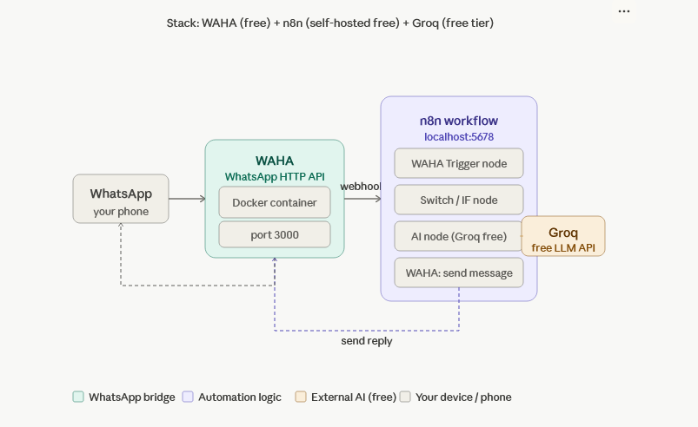

Step 1 — Setup (one-time)
docker-compose.yml — run both WAHA and n8n together:
services:
waha:
image: devlikeapro/waha
ports:
- "3000:3000"
environment:
- WHATSAPP_DEFAULT_ENGINE=NOWEB
- WHATSAPP_HOOK_EVENTS=message
- WHATSAPP_HOOK_URL=http://n8n:5678/webhook/whatsapp-inbox
volumes:
- ./waha_sessions:/app/.sessions
- ./waha_tmp:/tmp

n8n:
image: docker.n8n.io/n8nio/n8n
ports:
- "5678:5678"
environment:
- WEBHOOK_URL=http://localhost:5678
- GENERIC_TIMEZONE=Asia/Kolkata
volumes:
- ./n8n_data:/home/node/.n8n
docker compose up -d
Install WAHA community node in n8n: Go to n8n → Settings → Community Nodes → install: @devlikeapro/n8n-nodes-waha
Connect your WhatsApp: Open http://localhost:3000/dashboard → Start session → scan the QR code from your WhatsApp → Linked Devices.
Get Groq free API key: Sign up at console.groq.com → API Keys → Create key (free, no card needed).

Complete n8n Workflow JSON
Import this directly into n8n via Workflows → Import from JSON:
{
"name": "WhatsApp Inbox Reader & AI Replier",
"nodes": [
{
"parameters": {
"httpMethod": "POST",
"path": "whatsapp-inbox",
"responseMode": "onReceived",
"options": {}
},
"id": "node-webhook",
"name": "WhatsApp Webhook",
"type": "n8n-nodes-base.webhook",
"typeVersion": 1,
"position": [240, 300]
},
{
"parameters": {
"conditions": {
"options": { "caseSensitive": true },
"conditions": [
{
"id": "filter-fromme",
"leftValue": "={{ $json.body.payload.fromMe }}",
"rightValue": true,
"operator": { "type": "boolean", "operation": "notEquals" }
},
{
"id": "filter-type",
"leftValue": "={{ $json.body.event }}",
"rightValue": "message",
"operator": { "type": "string", "operation": "equals" }
}
],
"combinator": "and"
}
},
"id": "node-filter",
"name": "Only Incoming Messages",
"type": "n8n-nodes-base.filter",
"typeVersion": 2,
"position": [460, 300]
},
{
"parameters": {
"assignments": {
"assignments": [
{
"id": "a1",
"name": "sender",
"value": "={{ $json.body.payload.from }}",
"type": "string"
},
{
"id": "a2",
"name": "message",
"value": "={{ $json.body.payload.body }}",
"type": "string"
},
{
"id": "a3",
"name": "senderName",
"value": "={{ $json.body.payload.notifyName ?? $json.body.payload.from.replace('@c.us','') }}",
"type": "string"
},
{
"id": "a4",
"name": "timestamp",
"value": "={{ $json.body.payload.timestamp }}",
"type": "number"
},
{
"id": "a5",
"name": "session",
"value": "={{ $json.body.session }}",
"type": "string"
},
{
"id": "a6",
"name": "chatId",
"value": "={{ $json.body.payload.from }}",
"type": "string"
}
]
}
},
"id": "node-extract",
"name": "Extract Message Data",
"type": "n8n-nodes-base.set",
"typeVersion": 3,
"position": [680, 300]
},
{
"parameters": {
"rules": {
"values": [
{
"conditions": {
"options": { "caseSensitive": false },
"conditions": [
{
"leftValue": "={{ $json.message }}",
"rightValue": "reply:",
"operator": { "type": "string", "operation": "startsWith" }
}
]
},
"renameOutput": true,
"outputKey": "ai_reply"
},
{
"conditions": {
"options": { "caseSensitive": false },
"conditions": [
{
"leftValue": "={{ $json.message }}",
"rightValue": "summarize",
"operator": { "type": "string", "operation": "contains" }
}
]
},
"renameOutput": true,
"outputKey": "summarize"
}
]
},
"options": { "fallbackOutput": "log_only" }
},
"id": "node-switch",
"name": "Route by Intent",
"type": "n8n-nodes-base.switch",
"typeVersion": 3,
"position": [900, 300]
},
{
"parameters": {
"method": "POST",
"url": "https://api.groq.com/openai/v1/chat/completions",
"authentication": "genericCredentialType",
"genericAuthType": "httpHeaderAuth",
"sendHeaders": true,
"headerParameters": {
"parameters": [
{ "name": "Content-Type", "value": "application/json" }
]
},
"sendBody": true,
"contentType": "json",
"body": {
"model": "llama-3.3-70b-versatile",
"messages": [
{
"role": "system",
"content": "You are a helpful WhatsApp assistant. Be concise and friendly. The user wants you to reply to or help with their WhatsApp message. Reply in the same language as the incoming message."
},
{
"role": "user",
"content": "={{ $json.message.replace(/^reply:\\s*/i,'') }}\n\n(This message is from: {{ $json.senderName }})"
}
],
"temperature": 0.7,
"max_tokens": 500
},
"options": {}
},
"id": "node-groq-reply",
"name": "Groq AI Reply",
"type": "n8n-nodes-base.httpRequest",
"typeVersion": 4,
"position": [1120, 180],
"credentials": {
"httpHeaderAuth": { "id": "groq-cred", "name": "Groq API Key" }
}
},
{
"parameters": {
"method": "POST",
"url": "https://api.groq.com/openai/v1/chat/completions",
"authentication": "genericCredentialType",
"genericAuthType": "httpHeaderAuth",
"sendHeaders": true,
"headerParameters": {
"parameters": [
{ "name": "Content-Type", "value": "application/json" }
]
},
"sendBody": true,
"contentType": "json",
"body": {
"model": "llama-3.3-70b-versatile",
"messages": [
{
"role": "system",
"content": "Summarize the following WhatsApp message in 2-3 bullet points. Be brief."
},
{
"role": "user",
"content": "={{ $json.message }}"
}
],
"temperature": 0.3,
"max_tokens": 300
},
"options": {}
},
"id": "node-groq-summarize",
"name": "Groq AI Summarize",
"type": "n8n-nodes-base.httpRequest",
"typeVersion": 4,
"position": [1120, 380],
"credentials": {
"httpHeaderAuth": { "id": "groq-cred", "name": "Groq API Key" }
}
},
{
"parameters": {
"assignments": {
"assignments": [
{
"id": "b1",
"name": "aiResponse",
"value": "={{ $json.choices[0].message.content }}",
"type": "string"
}
]
}
},
"id": "node-extract-ai-reply",
"name": "Extract AI Reply",
"type": "n8n-nodes-base.set",
"typeVersion": 3,
"position": [1340, 180]
},
{
"parameters": {
"assignments": {
"assignments": [
{
"id": "c1",
"name": "aiResponse",
"value": "={{ '📋 Summary:\\n' + $json.choices[0].message.content }}",
"type": "string"
}
]
}
},
"id": "node-extract-ai-summary",
"name": "Extract AI Summary",
"type": "n8n-nodes-base.set",
"typeVersion": 3,
"position": [1340, 380]
},
{
"parameters": {
"method": "POST",
"url": "=http://waha:3000/api/sendText",
"sendBody": true,
"contentType": "json",
"body": {
"chatId": "={{ $('Extract Message Data').item.json.chatId }}",
"text": "={{ $json.aiResponse }}",
"session": "={{ $('Extract Message Data').item.json.session }}"
},
"options": {}
},
"id": "node-send-reply",
"name": "Send Reply via WAHA",
"type": "n8n-nodes-base.httpRequest",
"typeVersion": 4,
"position": [1560, 180]
},
{
"parameters": {
"method": "POST",
"url": "=http://waha:3000/api/sendText",
"sendBody": true,
"contentType": "json",
"body": {
"chatId": "={{ $('Extract Message Data').item.json.chatId }}",
"text": "={{ $json.aiResponse }}",
"session": "={{ $('Extract Message Data').item.json.session }}"
},
"options": {}
},
"id": "node-send-summary",
"name": "Send Summary via WAHA",
"type": "n8n-nodes-base.httpRequest",
"typeVersion": 4,
"position": [1560, 380]
},
{
"parameters": {
"values": {
"string": [
{
"name": "logged_message",
"value": "=📩 From: {{ $json.senderName }} ({{ $json.sender }})\n🕐 Time: {{ new Date($json.timestamp * 1000).toLocaleString() }}\n💬 Message: {{ $json.message }}"
}
]
},
"options": {}
},
"id": "node-log",
"name": "Log Message (no reply needed)",
"type": "n8n-nodes-base.set",
"typeVersion": 2,
"position": [1120, 560]
}
],
"connections": {
"WhatsApp Webhook": {
"main": [[{ "node": "Only Incoming Messages", "type": "main", "index": 0 }]]
},
"Only Incoming Messages": {
"main": [[{ "node": "Extract Message Data", "type": "main", "index": 0 }]]
},
"Extract Message Data": {
"main": [[{ "node": "Route by Intent", "type": "main", "index": 0 }]]
},
"Route by Intent": {
"ai_reply": [[ { "node": "Groq AI Reply", "type": "main", "index": 0 } ]],
"summarize": [[ { "node": "Groq AI Summarize", "type": "main", "index": 0 } ]],
"log_only": [[ { "node": "Log Message (no reply needed)", "type": "main", "index": 0 } ]]
},
"Groq AI Reply": { "main": [[{ "node": "Extract AI Reply", "type": "main", "index": 0 }]] },
"Groq AI Summarize": { "main": [[{ "node": "Extract AI Summary", "type": "main", "index": 0 }]] },
"Extract AI Reply": { "main": [[{ "node": "Send Reply via WAHA", "type": "main", "index": 0 }]] },
"Extract AI Summary": { "main": [[{ "node": "Send Summary via WAHA", "type": "main", "index": 0 }]] }
},
"settings": {
"executionOrder": "v1"
}
}

How the flow works
You send on WhatsApp | What happens
Any message starting with reply: | Groq AI drafts a reply and sends it back to the same chat
Any message containing summarize | Groq summarises it into bullet points and sends back
Any other message | Logged silently in n8n execution history — readable, no reply

Step 2 — Add the Groq credential in n8n
- Go to n8n → Credentials → New → HTTP Header Auth
- Name: Groq API Key
- Header name: Authorization
- Header value: Bearer YOUR_GROQ_KEY_HERE

Step 3 — Activate
- Activate the workflow in n8n (toggle top-right)
- Send yourself a WhatsApp message starting with reply: — e.g. reply: what should I say to reschedule a meeting?
- The AI reply appears in your WhatsApp within seconds

Extending it further
You can add more branches to the Switch node for other intents — translate:, draft:, todo:, etc. — each routing to a different Groq prompt. The Log Message branch is also useful as a notification trigger (connect it to a Gmail or Telegram node to get alerts when new messages arrive).

