**Title –** **PhonePe Pulse**

**Description –**

Welcome to the Phone Pe Pulse, a simple tool designed to help you efficiently collect and analyse data from Phone Pe. This tool provides the functionalities you need to gain valuable insights from Phone Pe Transactions, Users and Insurance details in State level, District Level and for whole India as well.

The Phone Pe Pulse tool is a comprehensive application built to extract various types of data from Phone Pe and build a visualization using various python plot.

**Table of Contents**

1. [**Aim**](https://github.com/PhonePe/pulse?tab=readme-ov-file#goal)
2. [**Guide**](https://github.com/PhonePe/pulse?tab=readme-ov-file#guide)
3. [**Code Details**](https://github.com/PhonePe/pulse?tab=readme-ov-file#documentation)
4. **Usage**
5. **Features**
6. **FAQs**
7. **License**
8. **AIM**

To create a Streamlit application that allows users to access and analyse data from multiple Phone Pe.

1. **Guide**

Prerequisite - you need the below file and software be downloaded / installed in your system.



Please follow the below steps

1. Open Visual studio code to execute the above python file.
2. Install the blow 2 packages in the terminal before executing the python file
   1. pip install google-api-python-client
   2. pip install isodate
3. Execute the SQL script in MYSQL to create all the 6 tables
4. Execute the Load program (python file) in the visual studio code to insert data into the database
5. You will be prompted to run stream lit in the terminal - **streamlit run Phonepe_pulse.py**
6. Once you execute the command the Phonepe Pulse app will be launched in the browser
7. Like below

**Selection 1 – Aggregated State Transactions**

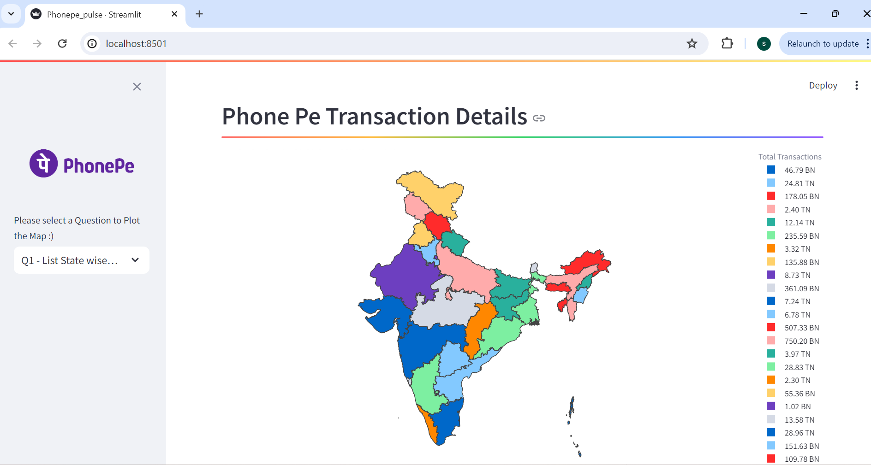

**Selection 1 – Sub selection – Quarter – Year wise Transactions Details**

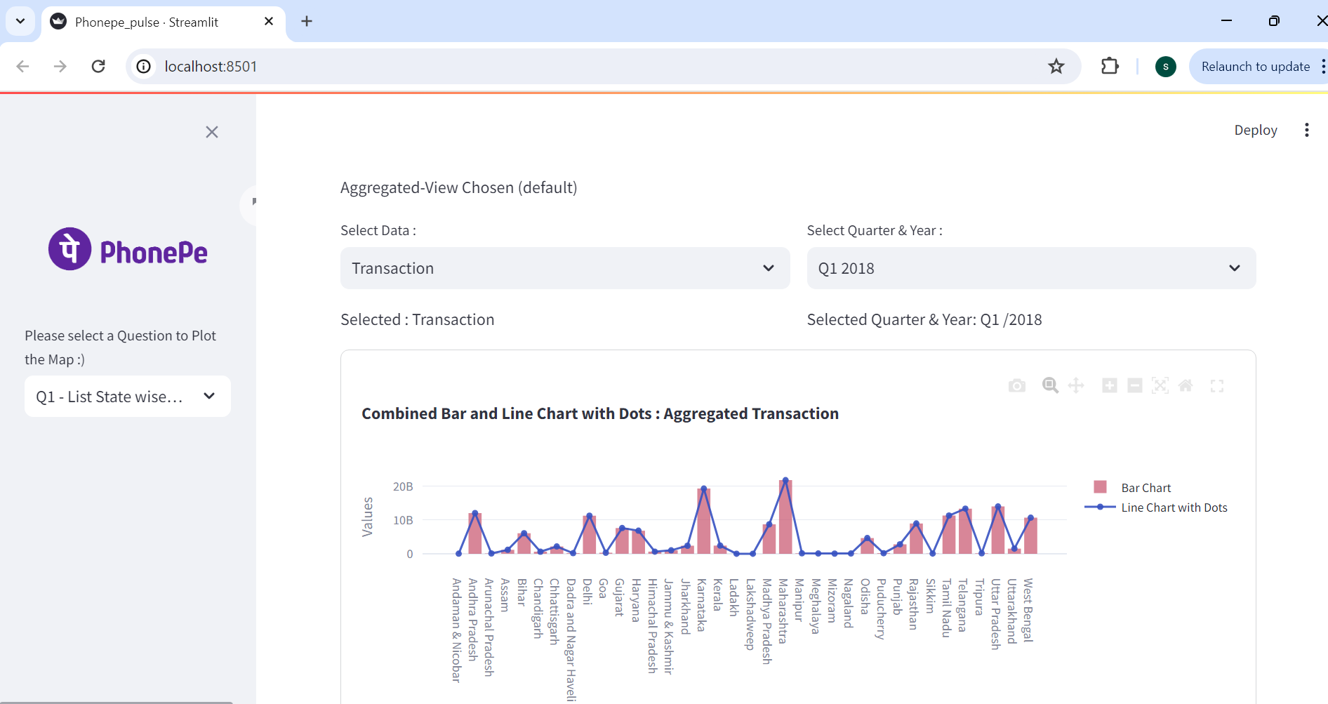

**Selection 2 – Aggregated State Users**

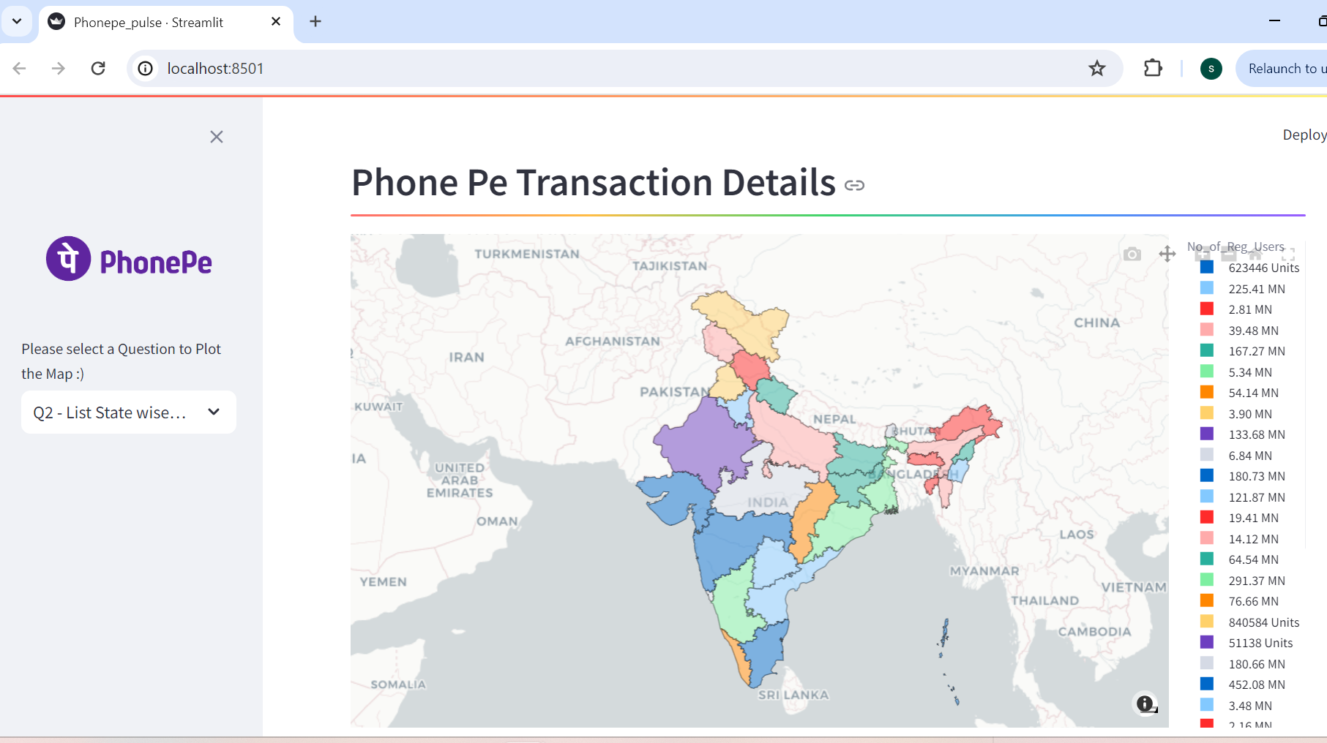

**Selection 3 – District Wise Transactions for a State**

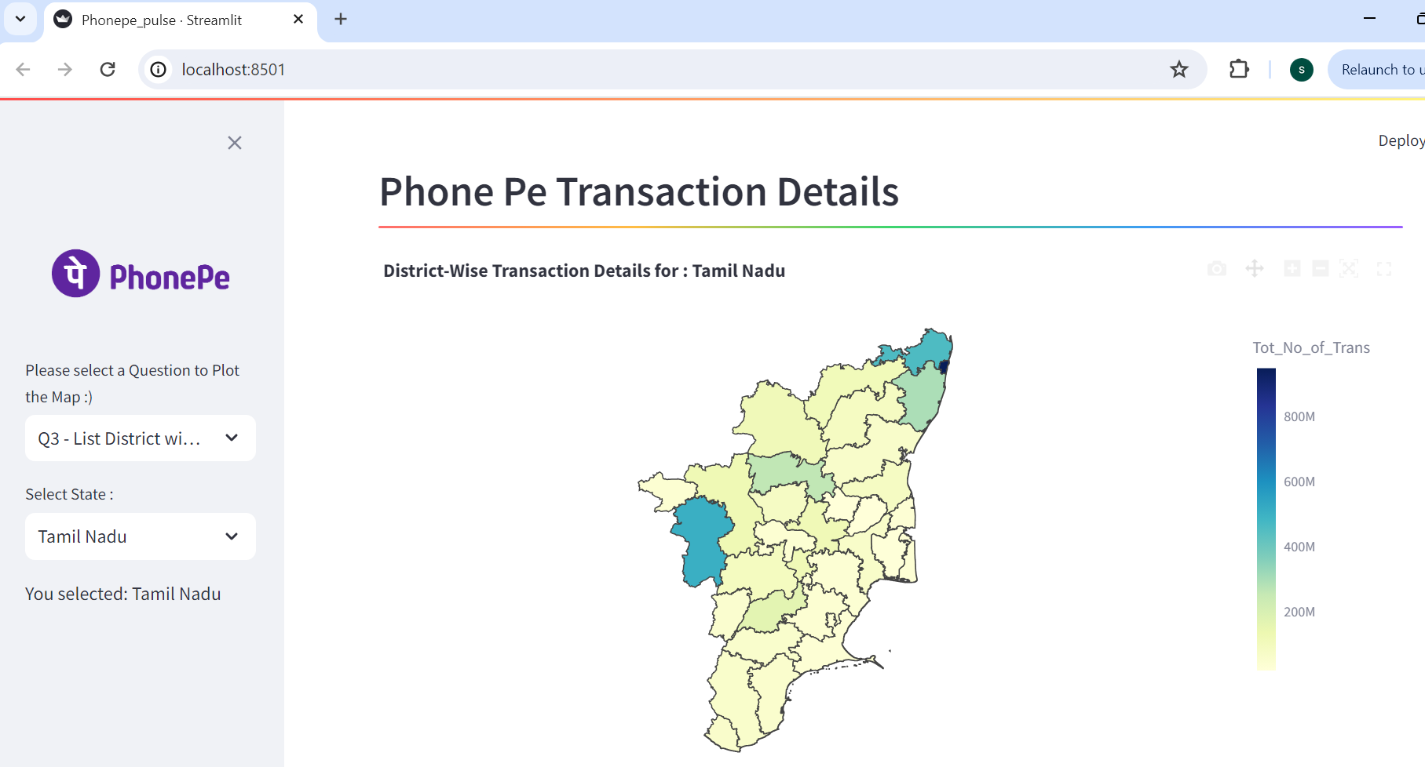

**Selection 4 – Top 10 District Users all over INDIA**

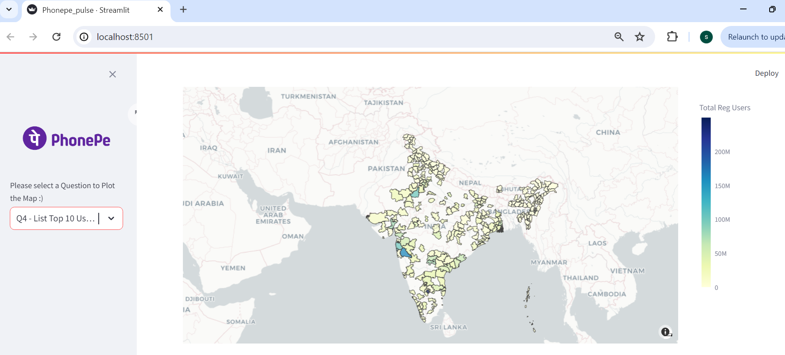

**Selection 4 – Sub-Selection - Top 10 District Users in each State**

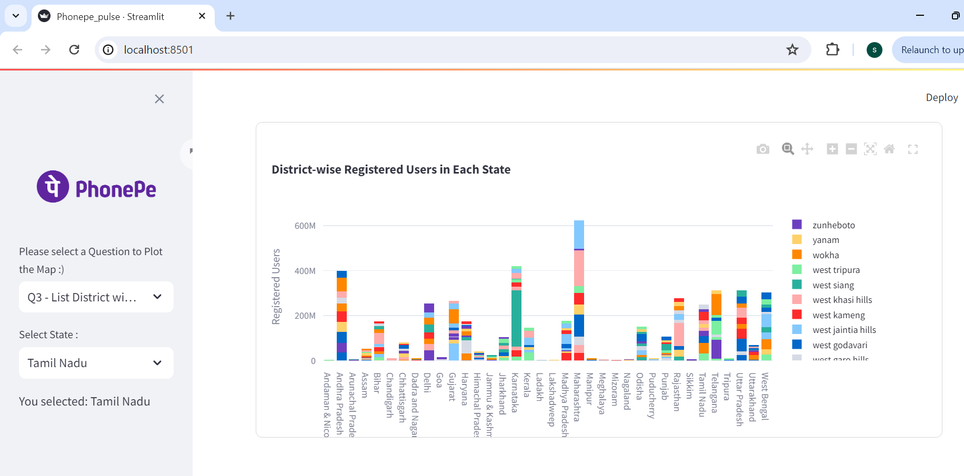

**Selection 4 – Sub-Selection - Top 10 Pin Code Users in each State**

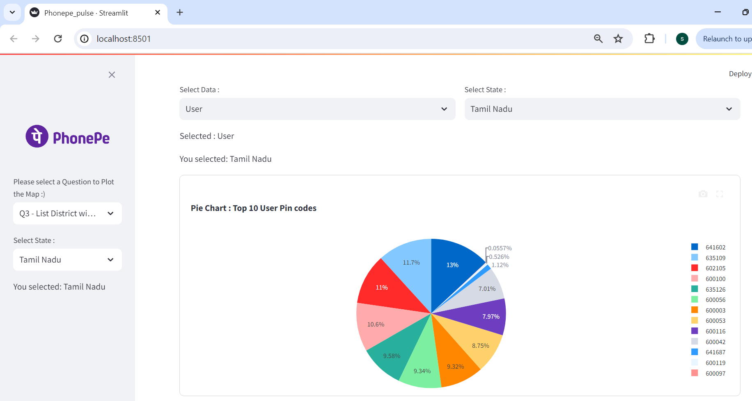

**Selection 5 – Aggregated State Insurance** 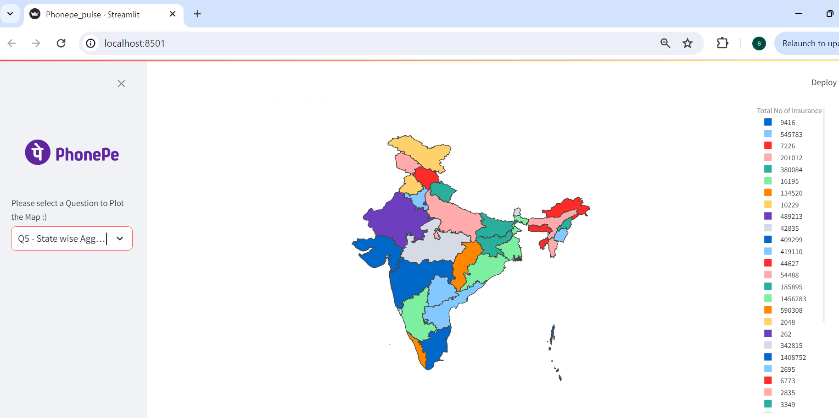

1. **C**[**ode Details**](https://github.com/PhonePe/pulse?tab=readme-ov-file#documentation)

Phone Pe data dump path for each table - code sample

**Aggregated State Transactions Path**

#--------------------------------------------------------------------------#

# Declare the path for data source

#-----------------------------------------------------------------------#

path="C:/Users/Viney Acsa Sam/OneDrive/Desktop/Visual Studio/Phonepe Pulse/pulse/data/aggregated/transaction/country/india/state/"

Agg_state_list=os.listdir(path)

Agg_state_list

**Map State Insurance Path**

#------------------------------------------------------------------------#

# Declare the path for data source

#------------------------------------------------------------------------#

path="C:/Users/Viney Acsa Sam/OneDrive/Desktop/Visual Studio/Phonepe Pulse/pulse/data/map/insurance/hover/country/india/state/"

Map_state_list=os.listdir(path)

Map_state_list

**Database Details –**

The Phone Pe Pulse details are stored in the below table in MYSQL

* SELECT * FROM PHONEPE.AGGR_ST_TRANS;
* SELECT * FROM PHONEPE.AGGR_ST_USERS;
* SELECT * FROM PHONEPE.MAP_ST_INSUR;
* SELECT * FROM PHONEPE.MAP_ST_TRANS;
* SELECT * FROM PHONEPE.TOP_ST_USERS;
* SELECT * FROM PHONEPE.TOP_ST_USERS_AREA;

**5. Features**

1. View the Phone pe data visually

2. Ability to view it State wise, District wise.

3. Store the data in a MYSQL

4. Ability to search and retrieve data from the SQL database using different search options, including joining tables to get channel details.

**6. FAQs**

**7. License**