**Robot Design – Guidance Sript**

We have about 3 minutes for the presentation and 1 minute for mission demo (just 1 or 2 favorite missions).

1. Holly: Introduces team and the way we are organized and covers slide 2
2. Thanu: Talks about contributions by Project Team (first four bullets in slide 3)
3. Shreya: Talks about Outreach activities and one other bullet (last 2 bullets in slide 3)

Holly about 15 to 20 seconds. Thanu and Shreya Each takes less than or about 15 seconds.

1. Adrienne: Talks (like show and tell) about Robot Base and Attachments along with some demo of one or two attachments –Slides 4 and 5 🡪 55 seconds
2. Michael: Talks about software design: programming conventions. Slide 6 🡪 15 to 20 seconds
3. Riya: Talks about MyBlocks and MissionPrograms and Missions. Slides 7 and 8 🡪 1 minute
4. Michael: Talks about Navigational Mathematics (if we decide to do them). slides 9 and 10 🡪 1 minute. Later, if needed we can assign bullet 5 to Riya or Thanu. Let us decide based on this later.

**Sripts (this is for guidance):**

**Holly (slide 2):**

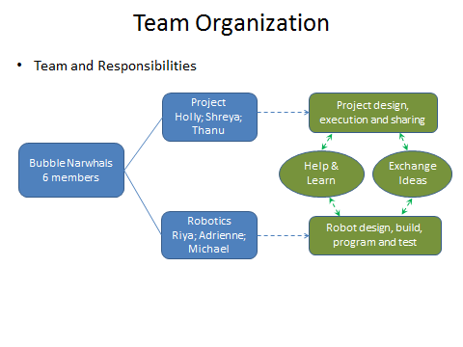

Good Morning Judges. My name is Holly. This is our first FLL experience. We have 6 members. We organized ourselves into two sub teams. One for project and another for Robotics. Our project team members are myself, Shreya and Thanu. Robotics team members are Riya, Adrienne and Michael. {note team members raise their hands and say their names}.

Project team is mostly responsible for project design, execution and sharing. Robo team is mostly responsible for robo design, build, program and test. ALL team members from both teams communicate frequently, help each other out, learn from each other and exchange ideas often.

**Thanu (slide 3 – first four bullets)**

I would like to talk about contributions made by project team to help robo team. We helped in building many mission models and setting up the field. We provided inputs on what missions to solve and learned about the missions and our robot from them. We exchanged ideas and tracked progress of robot design through weekly team meetings.

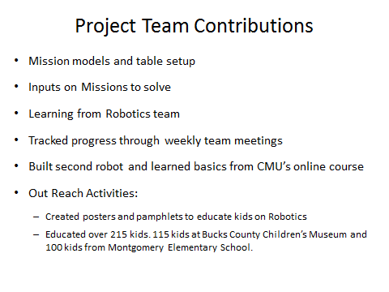

**Shreya (slide 3 – remaining bullets from above slide)**

The project team also built a second robot to do simple activities and learned from Carnegie Mellon University’s online courses. Another main contribution was to organize outreach activities. Project team created posters and pamphlets to educate kids on Robotics. We educated over 215 kids. We educated 115 kids from Bucks County Children’s Museum and 100 kids from Montgomery Elementary School.

**Adrienne (slides 4 and 5) this is more like show and tell.**

This is our robot Tim. Tim can do 9 missions for a maximum score of 205 points.

The robot base is square shaped with 6.6” length and breadth.

The base is largely symmetric in terms of geometry and weight distribution.

The base is also short with a height of 5.6”. It has a low center of gravity and the center of gravity is between the wheels (at the center). This gives a good stability to the robot.

The base is flexible enough to take many kinds of attachments through these holes.

The base is protected by bumpers in all sides. This provides stability, clears path of the robot and covers color sensors so that they can detect the colors better by avoiding the ambient light reflections.

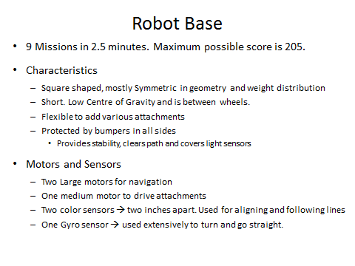

The base has two large motors for navigation and one medium motor to drive attachments. Two color sensors are here and about 2 inches apart. These are used for aligning and following the lines in the field. There is one Gyro sensor which is used extensively for turning to specified angle as well as to travel straight.

Attachments (again show and tell style):

Our attachments are designed to quickly attach to base either using no pins or using one or two pins. We have seven attachments and each of them does a specific set of missions. Some attchments transmits motion using medium motors, gears and rubber bands (show water drop attachment, the gears and rubber bands). Some are used to hold, push and grab (show Pipe removal attachment and explain the function of that red locking part).

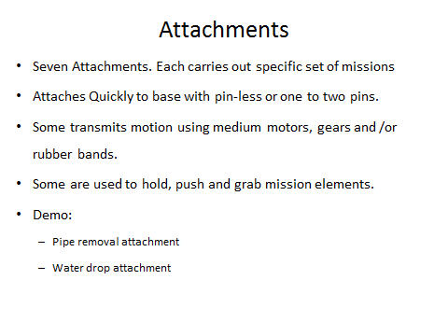

**Michael (or Riya if Math works for Micahel): (this could be show and tell as well)**

We will now talk about software design. We follow naming conventions and versions to manage the programs easily. MyBlocks start with “MB_” and mission programs start with “P_”. Program comments explain its purpose and logics used.

The programs and its versions are organized into the shown folder structure. Under FLL folder we have folders for Development and Final. Each of them have Backup folders. Programs are developed and tested in Development folder and fully tested versions go to Final folder. Incremental versions are created to manage code changes.

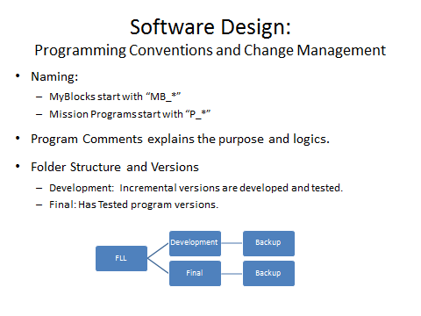

**Riya (combination of talking points and show and tell):**

MyBlocks are used extensively for repeated functions. Some of the main MyBlocks are:

1. Move Straight for specified distance or inches. This has two versions. One uses Gyro for accuracy) and other does not use Gyro to help in speed.
2. Turn to specified degrees using Gyro sensor. Here logics take care of correcting for overshoot errors.
3. Align to Black or White lines using TWO color sensors
4. Follow the line using ONE color sensor. The line following algorithm is most complex of all and uses mathematical formulas to seek the lines quickly and then start following the border between black and white lines.

Moving on to Mission Programs, each one of the mission program performs a set of missions using MyBlocks and mission specific codes.

We have tested the following nine missions extensively: Fountain, Filter, Flow, Pump Addition, Rain Cloud, Tripod, Pipe Removal, Water Well, and Sludge. We tested few more missions but could not accommodate them within 2.5 minutes limit. We hope to achieve 205 points maximum.

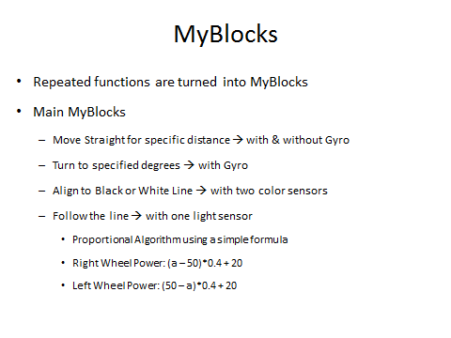

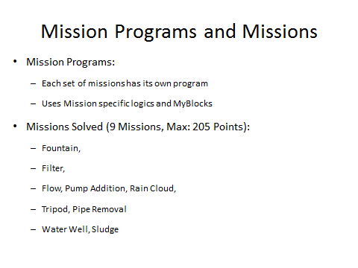

**Michael (on Navigational Mathematics)**

I want to present what we consider as a very innovative solution. I applied advanced algebra that I learned in school to derive equations and mathematical solutions to precisely control the turns using Tank Move blocks. This was implemented in Excel and then the results were incorporated into missions. Filter mission was solved using the results.

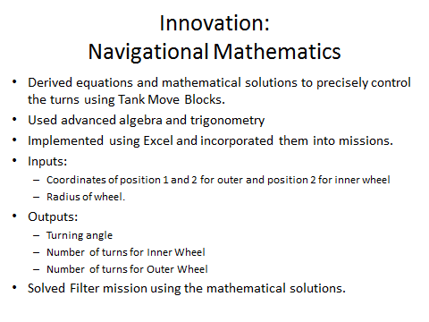

(Now go to the diagram)

[First state the purpose] Let us say the robot has to move from position 1 to position 2 in the field. It has to make a turn. Objective is to find the number of rotations the left and right wheel has to make to go to position 2.

We take the coordinates of the outer and/or inner wheels of first and second positions and derive formula to find out the resulting turning angle Theta. This then helps to find the arc lengths for inner wheel and outer wheels which are then used as inputs to Tank Move Blocks.

[Just show the paper in your hand and tell them] The derivation is bit lengthy and complex. In short, we find equations of line ADE and then using equal distance properties, we derive the equation of line ABC. The slopes from these line equations are then used to find turning angle Theta and then subsequently the arc lengths needed for inner and outer wheels.

The results go directly into Tank Move Blocks for solving missions.

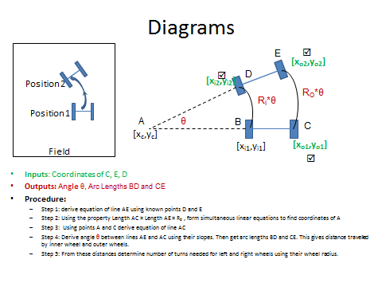

Final: Holly says this concludes our presentation and we can demonstrate our favorite mission Pipe Removal.