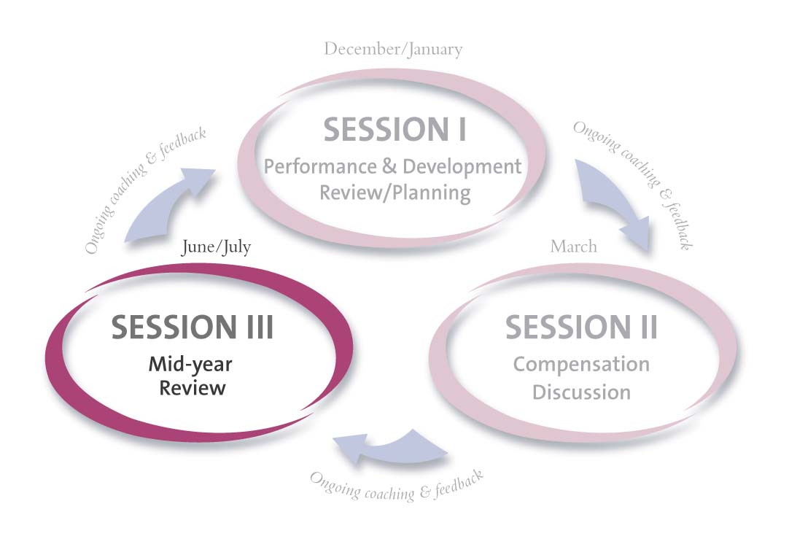
Session III


Mid-year Performance & Development Review

Colleague Name: |  | Colleague #: |  | Period Covered:
Position: |  | Business Group: |  | Business Unit/ Department:
Manager: |  | Session III Discussion Date:

Instructions:

Colleague | Manager
Preparation
- Draft* a Performance & Development Plan Mid-year Review by completing the following sections of the Session III, form:  - Performance Objectives: List your current Performance Objectives.  - Accomplishments/Progress To Date: List your Accomplishments/Progress for each objective.  - Development Objectives: List your Development Objectives.  - Colleague: On-The-Job Behaviors/Progress/Examples: List specific examples, development progress, and on-the-job behaviors linked to your development objectives.  *Add supporting documentation, as necessary.  - Give your draft Session III form to your manager.  - Schedule a one-on-one Session III meeting date & time with your manager. | - Using the colleague’s draft, complete the following sections of the Session III, form:  - Manager Comments on Accomplishments/Progress To Date: Add comments from your perspective on the colleague’s Mid-year performance related to each objective  - Manager Mid-year Review of Performance vs. Objectives: Check a rating to indicate the colleague’s Mid-year performance on each objective.  - Manager: Observations/Other Feedback on Behaviors: List specific observations, examples, and feedback on the colleague’s demonstration of Leader Behaviors, technical skills, and job-related skills.  - Assign a Mid-year Performance “directional” rating (U, BE, AE, EE, EX) by placing an X along the continuum  - Assign a Mid-year Development “directional” rating (U, BE, AE, EE, EX) by placing an X along the continuum.  - Make a copy for the colleague for the discussion.  Note: There is no Overall Rating given at the Mid-year Review.
Session III Discussion
- Discuss each section of the Session III, Mid-year Review form.

Finalization of Documents
- Using the Manager’s Session III form as the final document, you are responsible for incorporating agreed upon discussion specifics.  - Once you have written in specifics and finalized the document: 1) add your Colleague Summary Comments, 2) sign the form, 3) attach your original draft Session III form to the manager’s (final) Session III form, if necessary and 4) submit it to your manager. |  | - Review the final Session III form, add Manager Summary Comments, sign, and give to colleague prior to submission for next level manager’s signature and comments.  - Once colleague has seen your Manager Summary Comments, submit final Session III form to next level manager for approval, signature and comments.  - Once you receive signed form back from next level manager, retain a copy, give a copy to the colleague and send the original to Human Resources.
Session III: Mid-year Performance & Development Review Period Covered: ___________

Colleague: |  | Position: |  | Manager: |  | Review Date:

Performance Plan Mid-year Review (includes business objectives)
Performance Objectives |  | Accomplishments/Progress To Date |  |  |  |  | Manager Review of Performance vs. Objectives |  |  |  | Manager Comments on Accomplishments/Results
 |  |  |  |  |  |  | □ U □ BE □ AE □ EE □ EX
 |  |  |  |  |  |  | □ U □ BE □ AE □ EE □ EX
 |  |  |  |  |  |  | □ U □ BE □ AE □ EE □ EX
Note changes to Performance Plan below: |  |  |  |  |  |  | □ U □ BE □ AE □ EE □ EX
Mid-year Directional Performance Rating
 | U |  | BE | AE |  | EE |  |  | EX
Development Plan Mid-year Review (includes Leader Behaviors, technical skills, & job-related skills)
Development Objectives |  | Colleague: On-The-Job Behavior/Progress/Examples |  |  |  |  |  | Manager: Observations/Feedback on Behaviors
Note changes to Development Plan below:
Mid-year Directional Development Rating
 | U |  | BE | AE |  | EE |  |  | EX
Colleague Summary Comments |  | Manager Summary Comments |  |  |  |  |  | Next Level Manager Comments
Mid-year Review Rating Scale
- Exceptional = Colleague achieved key performance and development objectives and far exceeded job requirements. Colleague consistently went beyond the parameters of the job, displayed highest levels of performance, and made exceptional contributions to the organization relative to others.
- EE= Exceeds Expectations - Colleague achieved key performance and development objectives and often exceeded job requirements. Colleague regularly displayed high performance across a variety of assignments and frequently achieved more than required relative to others.
- AE= At Expectations - Colleague achieved key performance and development objectives and occasionally exceeded job requirements. Colleague displayed solid performance relative to others.
- BE= Below Expectations - Colleague partially met performance and development objectives. Colleague displayed inconsistent performance relative to others and did not fully meet job requirements. Close supervision and counseling required. Improvement is needed.
- U= Unsatisfactory - Colleague did not meet all or most performance and development objectives or did not, by a substantial margin, meet one or more fundamental job requirements relative to others. Close supervision and counseling required. Immediate and sustained improvement required.
Signatures (1) Obtain signatures. (2) Manager(s) and colleague keep a copy of the form. (3) Send original to Human Resources.
Colleague Signature: |  |  |  |  | Date:
Manager Signature: |  |  |  |  | Date:
Next Level Manager Signature: |  |  |  |  | Date:

