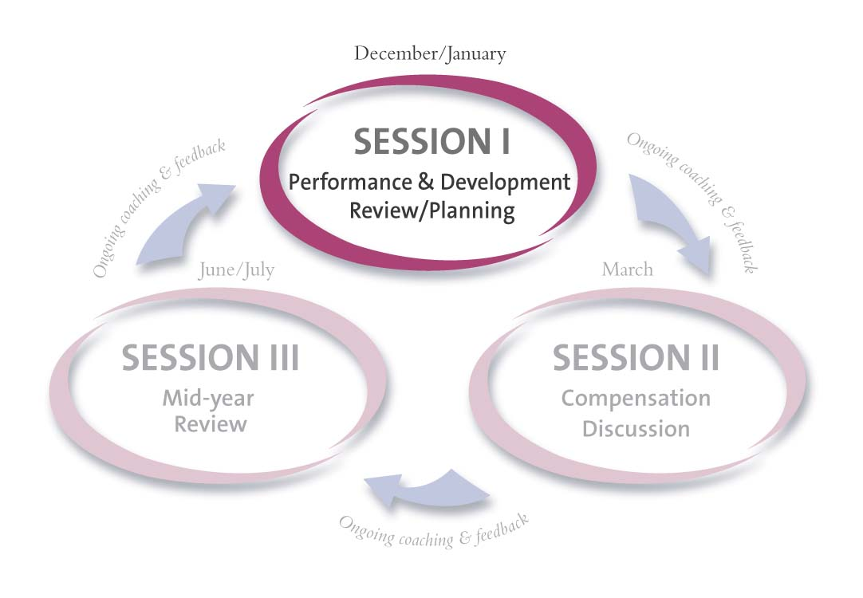
Session I


Part A: Performance & Development Review
Part B: Performance & Development Planning

Colleague Name: | Senthil Murugan | Colleague #: | 131269 | Period Covered: | Jun-2008 to Dec-2008
Position: | Manager | Business Group: | Global Business Analytics | Business Unit/ Department:
Manager: | Shirley Wang | Session I Discussion Date:

Instructions:

Colleague | Manager

Preparation
- Draft* the following Performance & Development Plan Review sections of the Session I, Part A form:  - Performance Objectives: List your Performance Objectives for the year being reviewed.  - Accomplishments/Results: List your Accomplishments/Results for each objective.  - Development Objectives: List your Development Objectives for the year being reviewed.  - Colleague: On-The-Job Behaviors/Progress/Examples: List specific examples, development progress, and on-the-job behaviors linked to your development objectives.  2. Draft the following sections of the Session I, Part B form:  - Performance Plan: List your performance objectives for the new year including milestones, expected target completion dates and manager support needed.  - Development Plan: List your strengths and skills/experiences required to achieve your performance plan. List your development objectives including technical skills, job-related skills, and Leader Behaviors to be developed.  *Add supporting documentation, as necessary.  Give your draft Session I forms to your manager prior to your meeting.  Schedule a one-on-one Session I meeting date and time with your manager. | - Using the colleague’s draft Session I, Part A form, complete the following sections of the Session I, Part A form:  - Manager Comments on Accomplishments/Results: Add comments from your perspective on colleague’s performance related to each objective.  - Manager Review of Performance vs. Objectives: Check a rating to indicate how the colleague performed on each objective.  - Manager: Observations/Other Feedback on Behaviors: List specific observations, examples, and feedback on the colleague’s demonstration of Leader Behaviors and technical/job-related skills.  - Assign a Performance Rating (U, BE, AE, EE, EX) by placing an X along the continuum above the rating.  - Assign a Development Rating (U, BE, AE, EE, EX) by placing an X along the continuum above the rating.  - Assign an Overall Rating (U, BE, AE, EE, EX) by placing an X along the continuum above the rating.  - Make a copy for the colleague for the discussion.

Session I Discussion
- Discuss each section of the Session I, Part A, Performance & Development Review form.
- Discuss and agree upon all sections of the Session I, Part B, Performance Plan: New Performance Objectives, Milestones, Target Completion Dates and Manager Assistance or Support Needed.
- Discuss and agree upon all sections of the Session I, Part B, Development Plan: New Development Objectives, Strengths, Technical/Job-Related Skills and Leader Behaviors to Develop – and specific on-the-job actions, target dates and assistance needed.

Finalization of Documents
- Using the manager’s Session I forms as the final document, you are responsible for incorporating agreed upon discussion specifics.  - Once you have written in specifics and finalized the document: 1) list specific examples under How could my Manager better support me in the accomplishment of my objectives? 2) add your Colleague Summary Comments, 3) sign the form, 4) attach original draft Session I form to the manager’s (final) Session I form, if necessary and 5) submit it to your manager. |  | - Review the final Session I form, add Manager Summary Comments including strengths and development opportunities, sign, and give to colleague prior to submission for next level manager’s signature and comments.  - Once colleague has seen your Manager Summary Comments, submit final Session I forms to next level manager for approval, signature and comments.  - Once you receive signed form back from next level manager, retain a copy, give a copy to the colleague and send the original to Human Resources.
Session I, Part A: Performance & Development Review Period Covered _________

Colleague: | Senthil Murugan | Position: | Manager | Manager: | Shirley Wang | Review Date:

Performance Plan Review (includes business objectives)
Performance Objectives |  | Accomplishments/Results |  |  |  | Manager Review of Performance vs. Objectives |  |  |  |  | Manager Comments on Accomplishments/Results
Initiative: Operational Efficiency (Do More with What We Have)
(1) Continue to build and expand Promotional Assessment capability  - Analyzed promotional response for a major brand  - Measured the impact of Voucher on Proventil HFA Rx to determine the voucher strategy in the situation where CFC will be going away. |  | - Model was designed to account for the confounding effects of detailing and sampling efforts to accurately measure the Voucher effect on Rx.  - Analysis showed that vouchers did have a high positive impact on the physician’s Proventil HFA NRx.  - Tried several different model structures and chose the final model with response estimates of expected direction and magnitude  - This analysis aided in rolling out next wave of vouchers with more confidence. |  |  |  | □ U □ BE □ AE □ EE □ EX
(2) Strengthen In-House Call Plan capability and increase efficiency  - Develop Call Plans for major PCP Field Forces using SP’s traditional approach for CPC2 – 2008.  - Developed call plans for Cambridge field forces by considering new pediatric indications for Asmanex  - Executed both Pre and Post RTT call plan development for all primary care field forces  - Implemented Q4 2008 call plan for Women’s Health Care and Specialty Field Force.  - Roll out the new Customer Centric Selling Model  - Supported the implementation of CCSM for PCP field forces for Q4-2008 and CPC1-2009  - Developed Post-RTT processes for CCSM |  | - For Cambridge field forces, up weighted potential PED and PED-Like MD’s . This resulted in increased reach to PED / PED-Like physicians by the field forces.  - Met the tight deadline to rollout CPC2-2008 call plans for PCP field forces  - Conducted several what-if scenario’s and diagnostics during the call plan development process. This aided in choosing optimal business rules for developing the call plans.  - Worked with IT to develop and test SAS interfaces. This would help to reduce IT file processing time in the future.  - For the Q4 2008 Women’s Health Care call plan, implemented complex business rules in a dynamic business environment to incorporate relevant Implanon and Depo users while down weighting brand generic dominants. This enabled the field to reach important Nuvaring targets while accommodating Implanon targets as well.  - For the Specialty field force Q4-2008 call plan, considered both retail and non-retail targets for Virology and Oncology. This resulted in balanced representative work load in terms of both call frequency for retail targets and FTE’s for non-retail targets.  - Produced call plan diagnostic reports for PCP products, WHC products and Specialty field force products. This helped brand teams to understand the reach and frequency of their products.  - Call plans were completed under the constraints of limited resources and a sharp learning curve  - Prepared input data and did QA for the new CCSM in Q4-08 and CPC1-2009. This helped to reduce errors during the implementation of CCSM in the field.  - Learned underlying principles of CCSM in the short timeframe and helped in the faster adaptation of the new Q4-08 call plan by answering several field questions.  - Helped in the pre process of Javelin inputs, IT post processing and generation of call plan diagnostics within the tight deadline.  - Helped the team to answer several questions from the field during RTT. This would help the field to gain better understanding of the CCSM approach.  - Helped to develop post RTT processes for field forces like Flex, WHC, Schering-Plough and Key-Kenilworth. These processes would help to reduce the post processing times in the future. |  |  |  | □ U □ BE □ AE □ EE □ EX
 |  |  |  |  |  | □ U □ BE □ AE □ EE □ EX
 |  |  |  |  |  | □ U □ BE □ AE □ EE □ EX
Performance Rating
 | U |  | BE | AE | EE |  |  |  | EX
Development Plan Review (includes Leader Behaviors, technical skills, & job-related skills)

Development Objectives |  | Colleague: On-The-Job Behavior/Progress/Examples |  |  |  |  | Manager: Observations/Feedback on Behaviors
Learned to modify and use existing SAS Macros and processes for Call Planning
Learned to use Javelin tool to develop call plan for H1-2009
Coached and trained new members of the team on the call plan processes, Javelin related processes and to answer questions from the field during RTT
Development Rating
 | U |  | BE | AE | EE |  |  |  | EX
Colleague: How could my Manager better support me in the accomplishment of my objectives?
Colleague Summary Comments |  | Manager Summary Comments  (Strengths and Development Opportunities) |  |  |  |  |  | Next Level Manager Comments
- Learned a lot about call plans during the past year
- Derive satisfaction by contributing to our team’s work that has a solid business impact.

Rating Scale
EX= Exceptional - Colleague achieved key performance and development objectives and far exceeded job requirements. Colleague consistently went beyond the parameters of the job, displayed highest levels of performance, and made exceptional contributions to the organization relative to others.
EE= Exceeds Expectations - Colleague achieved key performance and development objectives and often exceeded job requirements. Colleague regularly displayed high performance across a variety of assignments and frequently achieved more than required relative to others.
AE= At Expectations - Colleague achieved key performance and development objectives and occasionally exceeded job requirements. Colleague displayed solid performance relative to others.
BE= Below Expectations - Colleague partially met performance and development objectives. Colleague displayed inconsistent performance relative to others and did not fully meet job requirements. Close supervision and counseling required. Improvement is needed.
U= Unsatisfactory - Colleague did not meet all or most performance and development objectives or did not, by a substantial margin, meet one or more fundamental job requirements relative to others. Close supervision and counseling required. Immediate and sustained improvement required.
Overall Rating
 | U |  | BE | AE | EE |  |  |  | EX

Session I, Part B: Performance & Development Planning Period Covered _________

Colleague: | Senthil Murugan | Position: | Manager | Manager: | Shirley Wang | Review Date:

Performance Plan (includes business objectives)
Performance Objectives | Milestones |  | Target Completion Dates | Manager Assistance or Support Needed
Development Plan (includes Leader Behaviors, technical skills, & job-related skills)
Strengths |  | Skill Development Required
What skills do you consider to be your areas of strength? |  | What additional skills/experiences will be required to achieve your plan?
Development Objectives | Specific Actions |  | Target Completion Dates | Manager Assistance or Support Needed
Signatures (1) Obtain signatures. (2) Manager(s) and colleague keep a copy of the form. (3) Send original to Human Resources.
Colleague Signature: |  |  | Date:
Manager Signature: |  |  | Date:
Next Level Manager Signature: |  |  | Date:

