- LPD vs. IMS Data Analysis:

Problem Statement:
Compare the physician deciles obtained from Longitudinal Prescription Data (LPD) and the IMS projected Rx data. Objective is to quantify the differences in deciles obtained using different data sources.

Short Description:
Dendrite was using the deciles from IMS for various markets to find the target physicians for some of the journal subscription programs. The business case was to replace the IMS data with Dendrite’s own LPD data and save cost. This project was commissioned to study such feasibility by quantifying the differences in deciles obtained using un-projected LPD and projected IMS TRx data.

Methodology:
Cholesterol / Lipid market was used as an example market. NDC codes for drugs in the market were obtained from IMS and the same NDC’s were used to extract the physician’s 24 month TRx from LPD.
The LPD TRx volume data was used to obtain the volume deciles. An iterative process was used to obtain the volume deciles in such a way that each decile had between 9.9% to 10.1% of total Market TRx. The standard error was much lower than that of IMS deciles (this data was provided by IMS as part of the normal delivery). 76% of IMS Physicians were matched to LPD database using physician’s addresses and partially available ME numbers.
Following comparisons were made:
- IMS deciles (2 years) vs. LPD Deciles (2 years) – Same time period was used.
- LPD 1-12 month deciles vs. LPD 13-24 month deciles – This is done to have an idea on the expected error year over year.
- LPD 1-24 month deciles vs. LPD 1-12 month decile - This is done to have an idea on the expected error between various periods used in the measurement.

Results:
- We have a better distribution of market TRx in each deciles (LPD range: 9.98% to 10.02% = 0.04%) than IMS (IMS range: 8.03% to 10.42% = 2.39%). These numbers also validates our deciling algorithm.
- LPD overall mean TRx = 170. IMS overall mean TRx = 344. The ratio is 170/344 = 49.4%, which is about the same as our coverage.
Comparison between LPD TOT and IMS Deciles:
- Prescribers in lower deciles match better.
- Percentage of prescribers in decile 10 of both the data sources is higher than that of lower deciles.
- The match percentage is concentrated around the diagonals, suggesting that most prescribers could be more or less approximately captured with in the same or adjacent deciles by using LPD data source.
- Deciles between 9 and 3 are more sensitive to any change in data.
- 46% of IMS D10 is in LPD D10. 68% of LPD D10 is in IMS D10.
- Similarly, 24% to 38% of LPD D9 to D7 is in IMS D9 to D7.
Comparison between LPD TOT and Y1 or Y2 deciles:
The objective here is to observe the differences in deciles by doubling the time-period of the analysis.
- Both the highest (D10) and lowest (D1) have higher match rate.
- Deciles between 9 and 3 are more sensitive to data variations and percentage match varies between 60% and 78%.

Comparison between Y1 and Y2 deciles:
As time passes, prescribers may change their prescription patterns and our databases may undergo variations in capture rate. This comparison analyzes the effect of such differences in year over year deciles.
- Again, highest and lowest deciles show higher match whereas D9 to D3 shows variation between 42% and 62%.

Outcome:
A decision was made by management internally to go with the LPD database because of huge cost saving and encouraged by the fact in italics above.

- Forecasting – Allergan

Problem Statement:
Objective was to determine the expected sales of a marketing program for the next year.

Short Description:
Dendrite ran a marketing program for Allergan. The marketing team was tasked to contact the targeted physicians and sell Botox to them directly at a discounted price. The program ran for one year (2003) with around 400-targeted physicians. The marketing team wanted to forecast the potential sales for the next year and present the results to Allergan for subsequent renewal of the project.

Methodology:
The sales from all physicians were aggregated for each month of the year and two types of growth models, one linear regression and one exponential, were built using Excel. Exponential model was built as the sales were increasing a lot towards the end of year 2003. The model used here were most simplistic in nature and the data was very limited to predict for one year of sales.

Results:
The linear model had R-SQ of 0.84 and exponential model had an R-SQ of 0.75. The projected sales were 2.5 times that of 2003 using the linear model. Forecast results from exponential model were too high and looked impractical.
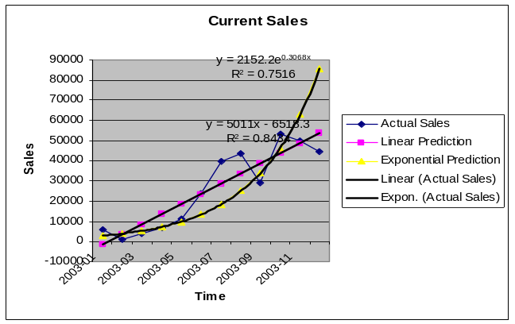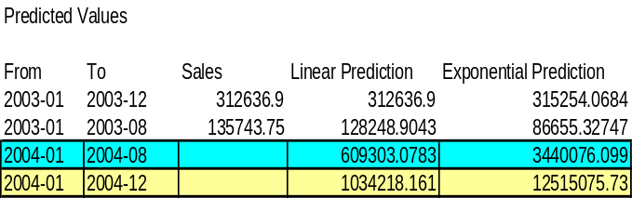

Outcome:
Allergan did not extend the contract for reasons unrelated to the above results. We were not able to measure the growth in the subsequent year.

- Project Cost Estimation Tool

Problem Statement:
Dendrite wanted to build a tool that would estimate the approximate cost of a new LPD related project.

Short Description:
After few years of LPD operations, Dendrite executed several projects ranging from small markets to large markets. Using the cost of completed projects, Dendrite wanted to determine the approximate cost of future project in a very quick manner to minimize the cost involved with estimation.

Methodology and Results:
Based on the data about completed projects, a classification of key factors of different projects was first established. The type of projects was classified into one or more of following studies: Source of Business, Switches, Concomitance, Persistence, ROI, Rx / Patients Tracking etc. The delivery methods were classified as weekly, monthly, or one-time. The size of the markets being studied was classified into Small, Medium, and Large. Several other classifications were made but the one mentioned above turned out to be significant. All of these classifications were determined by carefully looking through the project proposals and by consulting the respective project managers.
All the classified variables were marked as flag variables and were regressed against project cost as the dependent variable. A step-wise approach was used to build the regression model. The final model had an R-SQ of 0.89. Not all parameter estimates were significant due to limited degrees of freedom. We tried other modeling techniques like NN, C5.0 and Associative Rule Mining, but regression model gave the best estimate based on the cross validation.
The final regression model was used for predicting the cost of a new project. A VB tool was built using the final model that let the users can input the parameters of a new project, specify margin and get the estimated cost. Alternatively, cost could be specified to get the proper margin. The GUI is shown below.

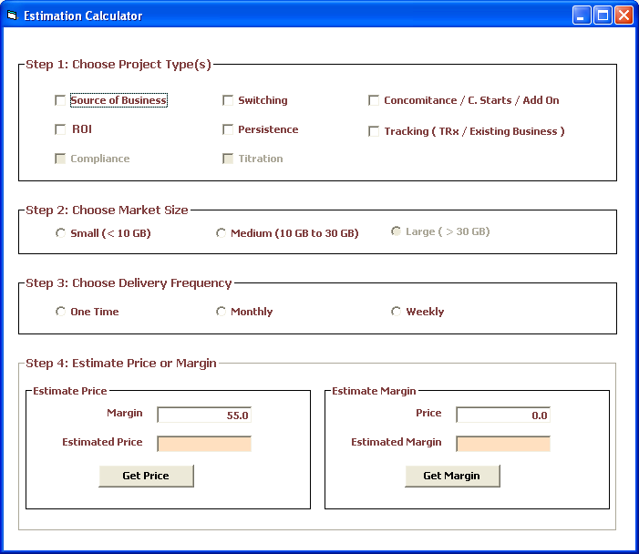
The model-based approach was too quick to estimate. It reduced the cost estimation time from 2 to 3 days to less than an hour. However, it did not fit well for custom projects that were hard to classify.

Outcome:
The tool was used for verification purpose only as the managers preferred to use estimation based on their experience using Excel and other project management tools. There were management advantages in the Excel based approach in terms of resource availability and allocation. Nevertheless, for established projects, the value estimated by the tool was within a margin of 5% to 10% of the value computed manually by managers.

- Web Mining

Problem Statement:
Objective is to build a bot that can mine the pre-specified websites for information about the doctors, parse them, grab the relevant information, and store the data into our DB.

Short Description:
Prescriber details like specialties, titles and their addresses are critical to execute most of the targeted sales and marketing plans. A wealth of information is already available on the web. The software developed here is configured to visit the pre-specified web sites, get relevant information from there, and store it in an organized manner. This data can then be fed into other existing processes for cleaning and merging with SFA related applications. The data can be used to execute the targeted sales and marketing programs as well.

Methodology:
This project has three broad components. 1) A bot goes into configured websites and queries for physician details. 2) A flexible parser parses the relevant data (based on configuration) from these web sites 3) A merge process merges physician data from different sources and stores them into organized tables in our data base. The code was written primarily in Java 1.2. HTTPClient package was used to communicate to the configured websites and download the contents. A flexible parser, named Pattern Matching Parser, which can parse HTML or Text or XML or any other ASCII formats, was developed. The basic idea behind the parser is to specify some expected tags from the web pages between which the required contents could be found. This type of parser allows the software to grab as much or as little of required information. It uses regular expression packages behind it. This is very similar to web parsing capabilities of current Excel tools (such options were not available in Excel when this tool was developed), but the configuration is done in the database.

Results:

Outcome:
The project was abandoned after 7 or 8 months as it proved to be too costly to develop, much of the time went on researching the best parsing methods. However, there is a similar tool at Dendrite that has been working successfully for sometime.

- Financial Applications

Problem Statement:
Objective was to maintain the complex financial software and report client transactions of SEGA, the securities clearing agency of Zurich stock exchange at Switzerland.

Short Description:
This project is more than 20 years old with around 150 to 400 total team members at a given point in time. The software runs in IBM 360 mainframe systems. Primary languages and databases are COBOL, JCL, REXX, CICS, and DB2. Main modules that were maintained were Clearing, Banking, Reporting, and Auditing. I have worked for around 1.5 years on this project mostly in Banking and Clearing. Banking module maintains the accounts of various SEGA customers that include individuals, brokers, and institutions. The Clearing module was tasked with matching securities transactions between different parties. System efficiency was very important to have maximum throughput. Reporting included statuses on daily reconciliations, account status, matched transactions etc. There were weekly, monthly and yearly reports.

Methodology:

Results:

Outcome:
A very successful project, which was TCS’s bloodline and was used as a base for many of the future projects and expansions.

- Sample Management and Sample Allocations

Problem Statement:
Roche Lab and Abbott’s home office web based software to track samples distributed to the representatives of various sales territories. In addition to home office, Business Unit Managers, District Managers, and Sales Representatives have various access levels to the system.

Short Description:
The tool tracks sales reps sample requests, sample shipment, package tracking, sample disbursements and reconciliation at the territory level. District managers can view the activities of their reps and territories with consolidated reports on overall activities. Business unit managers can track the activities of their districts and territories. Home office has the complete control and responsibilities for approving and shipping and tracking the reps sample requests. They can allocate the samples for various territories as well. In addition, the tool assists in sample auditing through reconciliation functionalities.

Methodology:
Sample Management software exists both as a stand-alone application and as a web tool. I was involved in the development of the web tool. This software had four tiers. 1) Client side GUI 2) Web Server 3) Business Object (DCOM) Server and 4) Database Server
IIS Web Server, running on Windows platform, was used in the server side. ASP and VBScript was used for server side scripting. Most of the business rules were written in C++ and were exposed as Business Objects through DCOM server. ASP pages communicated to database Server through these COM objects. HTML and Java Script were used to control the GUI at the client side. In order to use the bandwidth optimally, Microsoft Remote Scripting was used to update some of the data grids at the client side.

Results:

Outcome:
Roche cancelled the project due to internal budget cuts. Abbott uses the tool currently. There were multiple other clients based on the initial success of the tool.

- HR Facilities Management System - Pfizer

Problem Statement:
Pfizer’s Head Quarters was planning to streamline the HR requests related to new hire or location management of their employees through an intranet system. This customized web based tool was developed for this purpose.

Short Description:
It is a queue based system that captures the request from an employee and displays it in a queue with appropriate requests and the statuses. Functionalities included are adding a new hire, relocating an employee or a team, removing an employee from database and the relevant office clean up requests etc. The HR department personnel has to verify personnel information, allocate an office space, setup e-mail and network requests to relevant departments, provide furniture, telecom services, PC equipments and any other special interest items. The queue, accessible to HR persons, shows the status of each of the sub functionalities for a given request. Once job is complete, HR personnel update the status and after completion of entire request, e-mails are sent to the employee who put in the request. Communications to other departments like e-mail and network services are sent automatically through e-mails or relevant forms filled automatically. The responses from those departments are also tracked.

Methodology:
HTML and JavaScript were used in the client side. ASP and VB Script were used in the web server side, Communications to database servers were through ADO. The database used was SQL Server. Access DB was also used to generate queries. SQL Server PLSQL routines were also developed. CDO (Communications Data Objects) were used to communicate with mail server and generate automated e-mails.

Results:
GUI Main Screen Shots:
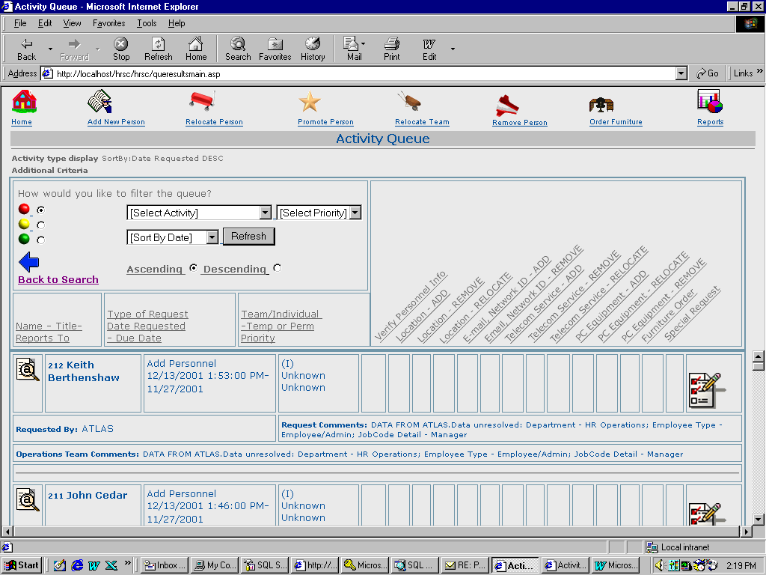
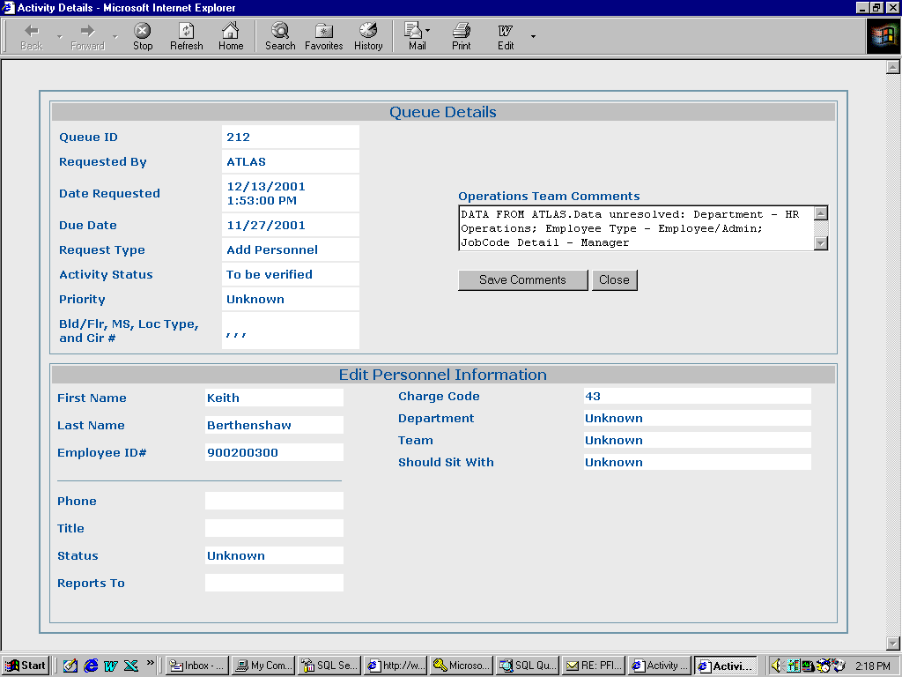

Outcome:
This tool was a good organization tool that eliminated redundant activities and efficiently improved the facilities management functionalities. The respective department at Pfizer for few years used this.

- ROI on Call and Sample Frequency – Pfizer - Relpax

Problem Statement:
To understand the impact of change of levels in detailing and sampling to the physician prescribing Relpax.

Short Description:
Relpax is an anti-migraine drug from Pfizer with sales of around 250 million dollars per year. Dendrite explored the loss of market share if the details or sampling levels are dropped significantly. The idea is to have an idea on ROI by reaching those doctors frequently through non-personal programs.

Methodology:
NBS Shares (around 20%) of Relpax were obtained for 16 months (Feb-05 to May-06). Level of calls and samples were categorized into High, Medium, and Low after analyzing their distributions. Physicians were divided into three groups based on the market volume. Comparison of change in NBS Shares of two groups of physicians, the first group with high level of detail or sampling activity during both Feb – Apr 2005 and Feb – Apr 2006 for all 16 months and the second with high detailing activities in 05 but low promotional activities in 06, were made to find out the influence of continuing the promotional activities during 06.

A simple comparison of these groups was followed by Analysis of Co-Variance (ANCOVA). In the ANCOVA, comparison of Relpax NBS within HL and HH groups were made separately by using Market NBS as a covariate. MNBS was used as covariate to account for the market potential of each physician being considered. The F stat was significant at alpha = 5%. The difference in adjusted Product NBS per physician were tested using multiple comparison (LSD) method (a more conservative one), which turned out to be significant in both HH and HL cases. The mean differences were multiplied by number of physicians to get the expected difference in Product NBS due to increased or decreased level of sampling in 2006.

Results:
Effects of Calls:
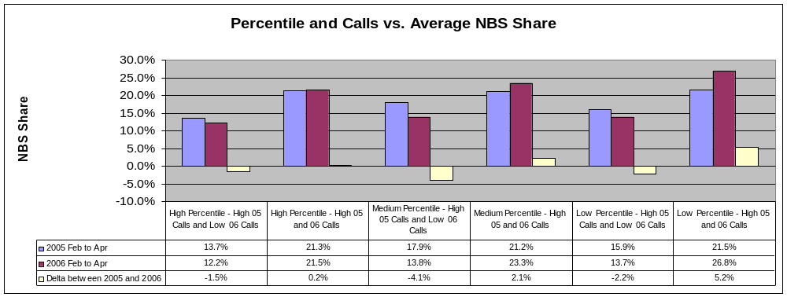
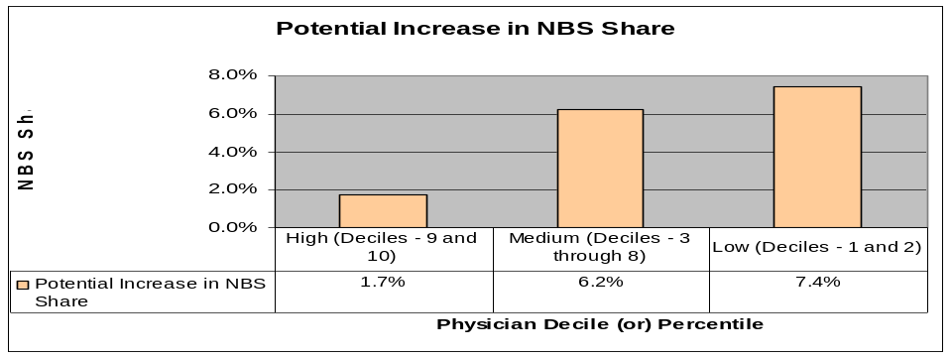

Effects of Samples:
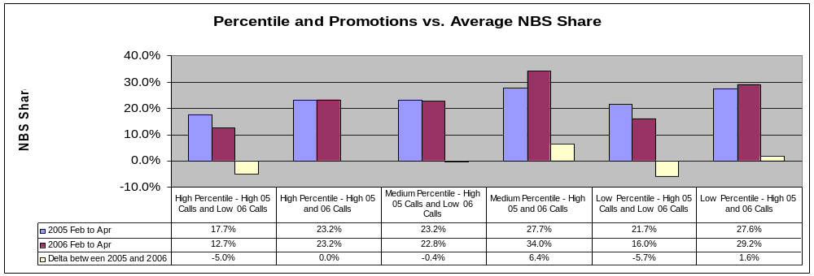
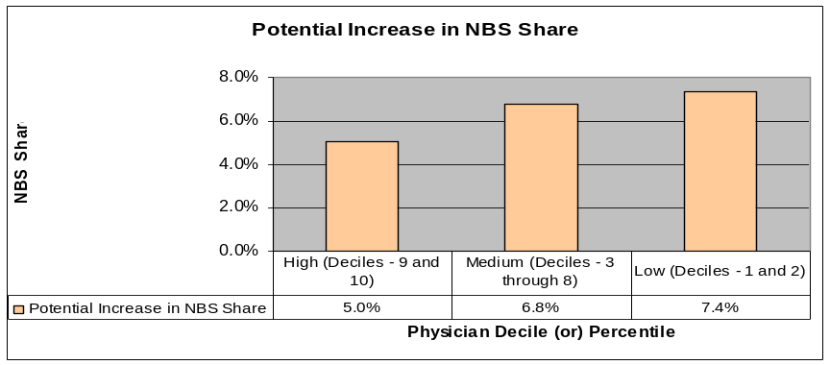

ANCOVA – High-Low Group:
High Calls in Feb to Apr 2005 and Low Calls in Feb to Apr 2006 | 95% Confidence Interval
 | Low | High | Mean
Change in Relpax NBS Volume | -285 | -100 | -193
% Change in Relpax NBS Volume | -32.1% | -11.3% | -21.7%

ANCOVA – High-High Group:
High Calls in Feb to Apr 2005 and Feb to Apr 2006 | 95% Confidence Interval
High Calls in Feb to Apr 2005 and Feb to Apr 2006 | Low | High | Mean
Change in Relpax NBS Volume | 137 | 648 | 392
% Change in Relpax NBS Volume | 1.6% | 7.5% | 4.6%

Based on the above results, we see a significant drop in revenue by dropping the calls and samples. The revenue increase is not too great by continuous sampling, but continuous promotion does seem to avoid the fall in revenue caused by not maintaining the level of promotion.
We controlled seasonality, physician persistence (or Rx Volume), competitor effects (NBS Share / or Market NBS as Covariate) and Promotional activities to some extent through different groupings. Even though ANCOVA tends to control more variables, the noise involved because of low volume of Product or Market NBS per physician, might trend to exaggerate the results.

Outcome:
Based on the above results Dendrite was able to convince Pfizer to run some non-personal promotional programs to reach out to physicians that were not called or detailed during early 2006.

- Optimal Sample Allocation – Pfizer - Lipitor

Problem Statement:
A mini-project to determine optimal sampling levels for Lipitor, to understand the impact of different budget allocations.

Short Description:
Background:
- Dendrite Pfizer team raised issue of large $ volume of unused Lipitor samples in 2005
- Data & Analytics analysis was requested
- Framing the issue:
  - Is there an over-sampling issue?
  - Can it be analyzed at the group practice level?
    - MDs sampled, but samples managed by Groups
  - How much can sample allocation improve?

Analysis Conducted:
- Data sources:
  - Dendrite LPD for Cholesterol Reducer market (10 mths)
    - TRxs, NBS, NPS
  - Pfizer Call and Sample data
  - Group Practice file
    - available for 3 MSAs: Boston, Phoenix, Raleigh
- Analysis steps:
  - Assess over-sampling (within group practices)
  - Segment MDs in top groups by TRx and NBS volume
  - Build promo response functions by MD segment
  - Aggregate response functions to group practice level
  - Allocate samples to group practices (optimal algorithm)
  - Compare pre- vs. post- optimal allocations

Methodology and Results:
Building Promotional Response Functions – Boston MSA

- Data was aggregated at the group level. Then the groups with no calls were discarded.
- The remaining groups (66) were divided into 4 segments. Total Market NBS and Calls for 10 months were used as the differentiator.

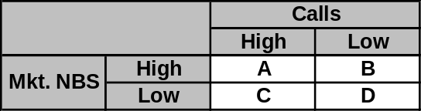

- Promotional Models
  - Lipitor NBS for a given group and a given month is used as the dependent variable.
  - The independent variables were: Lagged Lipitor NBS, Calls, Samples/Call, Samples/(Lipitor NBS)
  - The best model was selected based on model R-Sq and the significance of parameter coefficients.
  - Except for Segment B, all other final models had significant parameter coefficients (at 90% level)
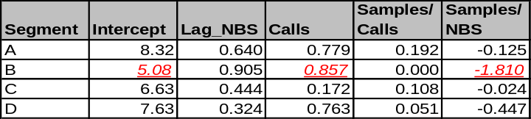

  - The model corresponding to a group practice was determined by using the model of its corresponding segment and holding constant the Calls and NBS at the group’s average monthly calls and NBS.

Optimal Sample Allocation:
- There is a wide variation between current and optimal samples at group practice level.
- Improvement in total NBS for various cases are shown below

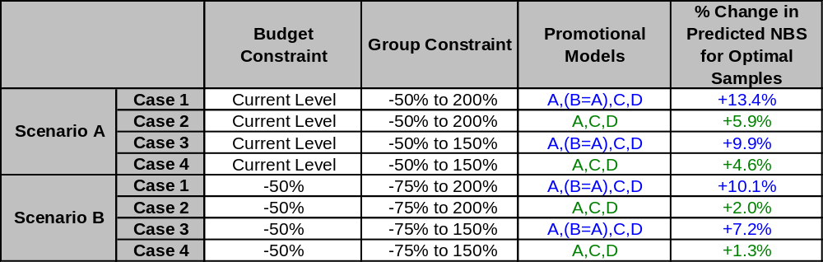

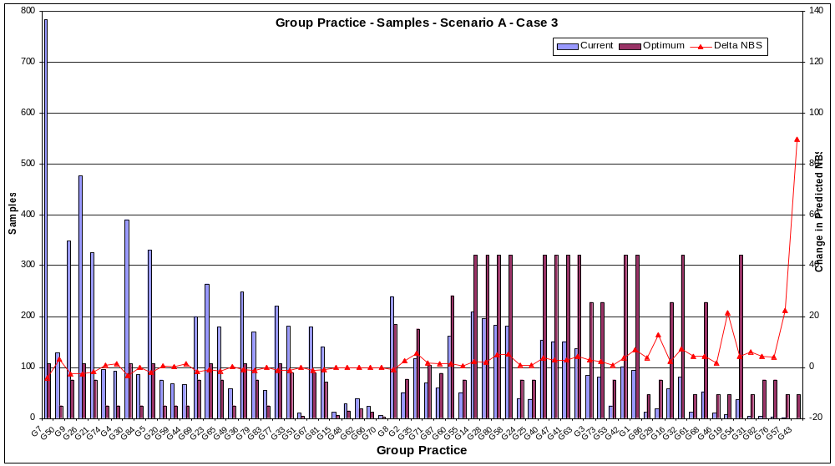

Outcome:
Objective was to show cause Dendrite’s capabilities and retain the overall contract from Pfizer. However, the SFA contract was not extended as other vendors seemingly provided more value for the dollars spent by Pfizer.

- Pharmacy Linking

Problem Statement:
In order to track the patients who switch pharmacies, Dendrite wanted to identify the patients from the encrypted data from a given pharmacy and match them against the data from other pharmacies. This will enable Dendrite to produce a better longitudinal data metrics.

Short Description:
Dendrite was getting Rx data from different pharmacies, each with their own unique encrypted patient id (to satisfy HIPPA regulations). An estimated 30% to 50% of patients switch pharmacies in a year. This was estimated by comparing the epidemiology data with the observed NPS rates in the database. When a patient switches from one pharmacy to another pharmacy, assuming both pharmacies are captured, it is important to track the patients across different pharmacies to get a more accurate longitudinal behavior (NPS / Switch / Add-On etc). HIPPA regulations prevents Dendrite to identify the patients.
This prototype proposes and demonstrates an encryption engine, to be hosted at data vendors, that encrypts various patient demographics and passes the data to the match engine hosted at Dendrite. In essence, we are matching the encrypted patient data across pharmacies and link all the pharmacy specific patient id’s and creates a common patient id.

Methodology:
The engine has two parts, a Client Scrambler and Match Engine. A protocol of patient’s data elements and their format is first agreed upon. For example,
- Pharmacy Id
- Internal Patient Id
- Name (First, Last, Middle Initial)
- Address (Addr1, Addr2, City, State, Zip)
- Phone (Home, Mobile, Office)
- Date of Birth, Age, Gender, SSN
- All the above details are expected in a particular order and format.

The Client Scrambler, installed at pharmacies that provide the data, is a java program that takes each (or a combination) of data elements and applies MD5 encryption algorithm to encrypt the data (it uses private and public keys specified internally in SOAP package). The encrypted data is transmitted to Dendrite and a Java based matcher matches the scrambled fields using pre-configured rules (i.e., 40% weight to SSN + 20% weight to Names etc). Once a match threshold is reached the records are considered to be from same patient and a common patient id is generated and are linked to these pharmacy specific patient id.

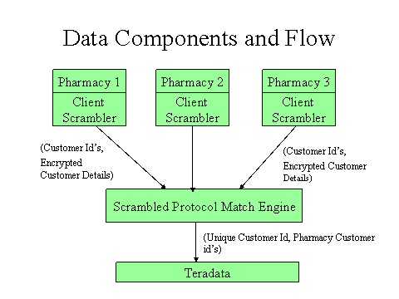
Match Process:
- Rule based match engine.
- The order of comparison, rule weights and a threshold for matching are specified in configuration tables.
- Generates unique id’s for unique customers and outputs a map of corresponding pharmacy customer id’s.

Apache’s SOAP objects were used for MD5 encryptions. An XML data format was used in the prototype.

Results:
A prototype was developed and demonstrated the implementation of Client Scrambler and the Scrambled Data Matcher to the upper management. Further improvements in match algorithms (like Name and Address Standardizations) were suggested.

Outcome:
As the upper management found that it is going to be hard to renegotiate with each pharmacy to come up with the format and the implementation of Client Scrambler at the pharmacies, they did not pursue further with pharmacy linking. In addition, they were considering to replace the data source by cooperating with Verispan. However, the upper management did appreciate and acknowledge the leadership and the development of such solutions.

- Projection Methods (simulations)

Problem Statement:
To come up with an appropriate methodology to project the Rx data.

Short Description:
This study initially presents few projection methodologies to predict the actual scripts generated by a specific geographic area. These geographies may be either of zip 5, zip 3, State, MSA or Nation. Then setting up a simulated environment does the validation of these concepts. Various results obtained and observations made using this simulated environment are discussed. It also presents a hierarchical model for matching up various numbers at different aggregated geometries. Finally, this study discusses about the current data issues and some suggested resolutions and some ideas on a slightly different approach for projection and the directions for further research.
The finding of this study select an appropriate projection methodology and estimates the projection errors of various aggregation levels at different geometries (Zip5, Zip3, MSA, State and National). Java, Access DB were used for simulation. NCPDP data were got from Oracle and Teradata. Clementine and Excel were used to study the patterns in simulated data.
Two primary methods of projections were considered a) Ratio projection (uses ratio of ALL Rx count to Known pharmacy Rx count to project) and b) Count projection (uses ratio of ALL Pharmacy count to Known pharmacy count to project). Both the methods need total (i.e., from both known and unknown pharmacies) yearly Rx count for different Therapy Areas at the Zip5 level.

Methodology:
Study by Simulation:
Since we do not have required real data to study the performance of the above-mentioned methodologies, it was decided to simulate the pharmacy data as real as possible and study the algorithm performances. This way we have enough flexibility to test the limits of the algorithms for various assumptions about the pharmacies and scripts generated from them.
A Fractal that could represent any particular geometry and any pharmacy distribution was constructed. Products or Therapy areas are called as an “entity” to be generic. For each pharmacy, these entity values were generated according to various model assumptions. Some of the pharmacies in the fractals were assumed to be known based on various assumptions on their distributions. A fractal can represent only one entity at a particular time. Known script count for a Fractal is the aggregate of the entity values of the KNOWN pharmacies at a given time. Projection methodologies are used to use this count to predict the aggregate of entity values of ALL pharmacies. These are then compared with the actual aggregated entity values of ALL pharmacies to determine the Prediction errors.
Following paragraph summarizes configurations and possibilities.

A Fractal,
- Represents any geography with pharmacies at different locations generating an entity value (i.e., script counts of underlying measures like a product or a Therapy Area) for each month.
- Many fractals can be combined to form a broad geographic area, or a Fractal itself could be designed to represent a broad geographic area.
- For any defined geographic area of a fractal (say a State), pharmacy locations are determined based on the geocodes of the zips contained in the geography.
- Number of pharmacies and the pharmacy sizes in each zip of a fractal is nearly proportional to 70% of zip population and 30% of zip income. The distribution of pharmacy sizes for a given zip is assumed to be normal and is scaled to zip values (i.e., 70% population and 30% income).
- Number of Pharmacies, Time period used (usually 24 months), The maximum and minimum aggregated entity values across this time could be configured. This gives as the ability to vary them to limits and study the performance of the projection methodologies.
- The distribution of entity value across time and geometry could be controlled using following model components.
  - Trend – Entity value linearly increases or decreases across time. This increase or decrease could be controlled using a linear slope between –1 (decreases) and +1 (increases). This is characterized by a linear function across time.
  - Cyclic – This represents the cyclic variation across time. This fluctuation would repeat after a given time period. Example would be the seasonal variation of an Allergy season across a year. This is characterized by a sinusoidal function across time.
  - Seasonal – This represents the cyclic variation across geography. This might represent the variation across geography due to population density and temperatures. The product of sinusoidal function characterizes this across latitude and longitudes respectively.
  - Random – A pure random variation.
- All the above model components are normalized between –1 and +1 and are combined according to their weights and the pharmacy sizes to determine the entity value of a given pharmacy at a given time. Each pharmacy value is generated in such a way that the aggregated entity value of a fractal falls within the max and min entity value that is specified in the fractal configuration.
- Pharmacies are assumed to be KNOWN based on the following methods
  - Random – A specified percentage of ALL pharmacies are randomly assigned as KNOWN.
  - Category Based – Pharmacies are deciled into 10 different segments according to the their sizes and a specified percentage of specific set of categories are considered to be known. This helps to simulate a situation where we capture scripts from a big chain store and do not capture from small independent pharmacy in the given area.
- In essence we have control over following parameters for configurations
  - Number of Pharmacies.
  - Variation of Entity values across time.
  - Distribution of Entity values.
  - Distribution of KNOWN pharmacies.

Parameters used in the study.
A specific geography (whole US) was considered as a fractal. This allows a wider range in geographic variation, population variation and hence pharmacy sizes and number of pharmacies in a given area. Around 42000 different model configurations were considered. These combinations were derived from following base configurations.
- Number of Pharmacies (11) –
70000, 20000, 5000, 2500, 1000, 500, 250, 100, 50, 25, 10.

- Entity Value Range (21) –
Max Entity Value per Pharmacy per month (7) – 3500, 1000, 500, 200, 50, 25, 10
Min by Max Ratios (for each of the above configuration) – 0.8, 0.6 and 0.4. This represents a max of 10%, 20%, 35% change over mean.

Totally there are 7*3 = 21 possible configurations.

- Entity Value distribution (Model Components) (13) –
13 different models based on model components were used for the study. Here are their configurations:

model_component_id | use_random | use_seasonal | use_cyclic | use_trend | rand_wt | seasonal_wt | cyclic_wt | trend_wt
M_R | Yes | No | No | No | 1 | 0 | 0 | 0
M_S_R_1 | Yes | Yes | No | No | 0.75 | 0.25 | 0 | 0
M_S_R_2 | Yes | Yes | No | No | 0.25 | 0.75 | 0 | 0
M_C_R_1 | Yes | No | Yes | No | 0.75 | 0 | 0.25 | 0
M_C_R_2 | Yes | No | Yes | No | 0.25 | 0 | 0.75 | 0
M_ALL_1 | Yes | Yes | Yes | Yes | 0.3 | 0.2 | 0.2 | 0.3
M_ALL_2 | Yes | Yes | Yes | Yes | 0.4 | 0.2 | 0.2 | 0.2
M_ALL_3 | Yes | Yes | Yes | Yes | 0.3 | 0.2 | 0.2 | 0.3
M_ALL_4 | Yes | Yes | Yes | Yes | 0.4 | 0.2 | 0.2 | 0.2
M_ALL_5 | Yes | Yes | Yes | Yes | 0.3 | 0.2 | 0.2 | 0.3
M_ALL_6 | Yes | Yes | Yes | Yes | 0.4 | 0.2 | 0.2 | 0.2
M_ALL_7 | Yes | Yes | Yes | Yes | 0.3 | 0.2 | 0.2 | 0.3
M_ALL_8 | Yes | Yes | Yes | Yes | 0.4 | 0.2 | 0.2 | 0.2

- Known Pharmacy Distribution (14) –

known_pharm_id | use_random_generator | use_category_generator | Percentage of KNOWN pharmacies | category_id
K_R_1 | Yes | No | 10
K_R_2 | Yes | No | 20
K_R_3.5 | Yes | No | 35
K_R_5 | Yes | No | 50
K_R_7.5 | Yes | No | 75
K_C_L_6 | No | Yes | 0 | CLOW [Deciles: 2,3,4; Ratio:0.6]
K_C_L_8 | No | Yes | 0 | CLOW [Deciles: 2,3,4; Ratio:0.8]
K_C_L_10 | No | Yes | 0 | CLOW [Deciles: 2,3,4; Ratio:1.0]
K_C_M_6 | No | Yes | 0 | CMED [Deciles: 5,6,7; Ratio:0.6]
K_C_M_8 | No | Yes | 0 | CMED [Deciles: 5,6,7; Ratio:0.8]
K_C_M_10 | No | Yes | 0 | CMED [Deciles: 5,6,7; Ratio:1.0]
K_C_H_6 | No | Yes | 0 | CHIGH [Deciles: 8,9,10; Ratio:0.6]
K_C_H_8 | No | Yes | 0 | CHIGH [Deciles: 8,9,10; Ratio:0.8]
K_C_H_10 | No | Yes | 0 | CHIGH [Deciles: 8,9,10; Ratio:1.0]

The combination of these entire components amount to 11*21*13*14 = 42042 models. These models potentially represents small geographies like zip5’s to entire US and the entity value range represents the variation from as less as 10 scripts to 400 million scripts with up to 35% variation across mean. This also represents wide variation in entity value distribution and the known pharmacy distribution.
Each fractal contains data for 24 months. For any prediction, 12 months data were used to obtain the ratios and the next 12 months were used for prediction purposes. Errors across the later 12 months for each projection model were studied.
Numbers of outputs were obtained to study the projection method behavior. Primary among them are listed below.
- Ratio Ra – Ratio of Known to All pharmacy script count averaged across time.
- Ratio Rc - Ratio of number of Known to number of All pharmacies.
- Ratio Re – Ratio of AVG scripts per Known Pharmacy to AVG scripts per Pharmacy when all pharmacies are considered. This has been averaged across time.
- A Chi-Sq value based on pharmacy distribution.
- Mean error (as % across actual value) in Rp projection.
- Error Range (as % across actual value) in Rp projection.
- Mean error (as % across actual value) in Cp projection.
- Error Range (as % across actual value) in Cp projection.
- Above error were each categorized into 0-2%, 2-5%, 5-10%, 10-15%, 15-20%, 20-30%, 30-50%, 50% and above.

Results:
The results obtained from simulation were mined for definitive patterns using some of the visualization and mining algorithms. Effects of each configurable parameter on the various projection methodologies are studied. Then a correlation analysis between the input and output parameters were studied. Finally, the results were classified using C5.0 classification trees and the high confidence and support rules were extracted.
Also, from the NCPDP files that we have access to; following could be observed about the number of pharmacies.
Geographic Area | Minimum number of pharmacies | Maximum number of pharmacies | Comments
Zip 5 | 1 | 52 | Most Zips have <10 pharmacies.
Zip 3 | 1 | 647 | Most are in 100 – 300 range.
MSA | 16 | 2343 | Most have <500 pharmacies
STATE | 22 (second minimum is 100) | 6259 | More on 1000 – 2000 range.
Total number of pharmacies across the country is around 70000.
Following could be implied from the above:
- The Ratio Projection method almost always predicts better than Count projection method.
- The Ratio Projection method is very less sensitive to the nature of the distribution of the known pharmacy and the distribution of the entity values over time when total number of pharmacies is fairly large. This is an extremely important practical observation, as in some cases the known pharmacy distribution is random and also the number of known pharmacies are not too many.
- The Ratio Projection method is highly sensitive to the number of pharmacies in the geographic area. Pharmacies over 250 in a geographic area almost always produce an error less than 2%. Any geographic area with over 50 pharmacies almost always produces an error less than 15% (most cases are in 2% to 10% range) of actual value. And any geographic area with over 25 pharmacies mostly produces an error less than 20% (most cases are in 5% to 15% range) of actual value. This suggests that a projection at ZIP3 geographic area level whose number of pharmacies are between 100 and 200 pharmacies in many cases would result in a prediction error of less than 5% of actual value. While projection at ZIP5 level, where many of them have around 10 pharmacies might reflect an error of 20% of actual value. Some ZIP5’s with more than 25 pharmacies might be considered as its own geographic area for projection.
- Ratio Projection method is also moderately sensitive to amount of variation in scripts over time, particularly when number of pharmacies are less. So, if we observe that the variation in known scripts across time for a given ZIP5 is less than 20%, the prediction error would be less than 10%.
- Count Projection method is very sensitive to the distribution of the known pharmacies. If the distribution of known pharmacy and all the pharmacies are very similar (i.e., ratio Re is very close to 1.0), then we can use this method for projection. This method does not need any extra data per se, but in order to ensure the distribution of known pharmacies, we require same data that we need for Ratio projection method.
- Count projection method is also moderately sensitive to number of pharmacies, thus limiting the use of this method when number of pharmacies in a given area is less, say 50 or 100.
- Count projection method is less sensitive to entity value ranges and distributions.
- Error due to Count projection methods does not seem to correlate well with the Chi-Sq value by goodness of fit test that was discussed in one of my earlier paper, thus effectively invalidating the theories on Chi-Sq value less than 14.98 as suggested in my paper. I do not understand why this happens, but the reality is that the Chi-Sq values are not that useful when compared to the ratio of population to sample averages.
- As the distribution of known pharmacies seems to be fairly same as that of population and known pharmacies at the national level, this method with few modifications may be used to project at the national level with immediate effect.

A supporting Hierarchical model for balance of scripts across geometries.
A definite hierarchy in geometry exists with in a broad geometric area. For example, ZIP5’s could be aggregated to ZIP3 or a county or a state and states or ZIP3 could be aggregated to represent a nation. In the above mentioned projection methodologies, we observed that by using different geometries we may end up with different projected numbers. For example, in order to get the projected value for the State we could use the pharmacies in state to get more accurate value. However, when Zip based projection for these states are aggregated together at the state level, the earlier projected value may not match.
Following paragraphs presents a model for matching these numbers and also to better control the accuracies of smaller geometries within a broad area. The results obtained from the simulation exercise could be used to set the constraints for this model.
Let us consider following hierarchy,

Here,
N, N1, N2, N3,n1,n2,….,n9 →Number of KNOWN scripts in the respective geometry.
R,R1,R2,R3,r1,r2,….,r9 → Projection ratio’s for the corresponding geometries that are to be estimated.
R’,R1’,R2’,R3’,r1’,r2’,….,r9’ → Predicted projection ratio’s based on the corresponding geometries.
Qimin, qimin, Qimax, qimax → Minimum and Maximum possible projected values for the geometry ‘i’, i = 1 to 9. These values could be inferred from above derived rules or results based on the parameters of the given geometry.

Following constraints should be satisfied,
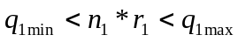
:
:
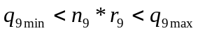
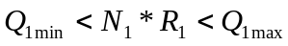
:
:

N*R
N1*R1
N2*R2
N3*R3
n1*r1
n2*r2
n3*r3
n5*r5
n4*r4
n9*r9
n8*r8
n7*r7
n6*r6

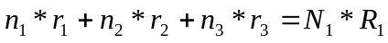
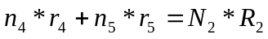
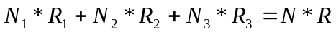

Following is the objective function to be minimized.
We are seeking r1,r2…,R1,R2…,R here. This objective function tries to minimize the difference between the computed r’ and the r.

The above quadratic function could be made linear by applying Taylor series for each of the square terms and after liberalizing it, we could solve this set of equations using Simplex method.

Data Issues And Suggested Resolutions.
From above discussions it is very clear that we need additional data to do projection at zip level or on a State level. For the Nation, we might get away with count projection method (that does not need any additional data) for now.

Ideally, we need,
“Total Prescription Volume of ALL pharmacies for each product (at least therapy area) for a given month (or minimally the previous year) at the pharmacy level.”

To my knowledge, Mark Rose and/or Louis Wei already expressed this requirement to upper management. Mark has also expressed some of the approaches to get this data. Following paragraphs reiterates those ideas and I have expressed some other additional ways to get hold of these data.
- NDC Health and Advanced PCS seem to have access to the Rx volumes at pharmacy level for all of our unknown pharmacies. The data fees, to my knowledge, seem to be 200K+. We might consider getting data from them.
- SK&A Information Services Inc., (www.skainfo.com, www.skainfo-direct.com/index1.cfm) has a database for “Pharmacies” which can provide the required data for us (i.e., Prescription volume per month per pharmacy). These data are collected through survey. Mark seems to have done research on this and feels that the data cost is somewhat cheap.
- Another possibility is to obtain the sales data from wholesalers and retailers and then internally converting them approximately to Rx volume per pharmacy. IMS does do this to obtain relevant data. Probably we can approach IMS for this data.
- Another practical and interesting approach is to get the TRx counts provided by IMS for each product of client’s interest from our clients themselves. We need Rx count of each physician (or ZIP level) aggregated for the previous year. We can use this data to calibrate our projection model to do the projection for this year. Our clients will be having access to this data and may be willing to give one time data feed. Other advantage is that we can use this ratio to project at physician level directly. Also it might work out cheaper for both Dendrite and our Client.
- Another interesting approach is to randomly choose some physicians and we request them to record all the prescriptions that are sent out from their office. We might set up a small website to do so or we might even derive from their own journals. Once we have this data, we can look to the captured scripts for these doctors in our DB, and the ratio of scripts dispensed by the doctor’s office to the scripts captured in our DB might directly give the ratio we are looking for a specified area at a given time. Additionally physician level projection could be done using these regionalized ratios. IMS exactly does this for their projection model. More information on this model is presented in the following section.

Physician Survey based projection.
This section discusses about a slightly different method for obtaining the necessary projection ratio. This is something similar to an experimental design. We first choose some number of targeted doctors that are randomly distributed across geographies and those who write at least some prescriptions in the therapy area of our interest.
Then they are requested to participate in our script collection program (either through our secured web site or according to their preferred media) and once they participate their office records all the prescriptions that are sent out from their offices. The ratio of projection for a particular physician who participates in the program, say event physicians, is,

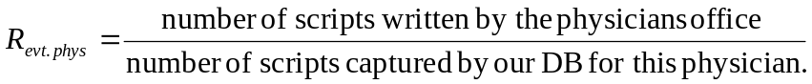
We can use this ratio to project Rx counts for other doctors in the vicinity. A distance-based approach as outlined below could also be used,
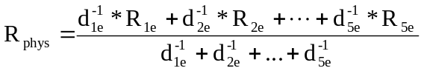
In the above approach, initially 5 most near by event doctors are chosen and according to how close they are to this physician, a weighted average is used to predict the ratio. Closer the event physician greater would be their ratio contribution to the physician of interest (hence the inverse functions).
IMS seems to use a similar approach for their projection.
Another interesting cheap approach might be to use the IMS’s projected Rx’s directly for each physician (or a randomly selected) as the actually generated script counts and use it tune our projection ratio. This way, we will be more close to IMS’s projected numbers and might be easier to convince the industry as the underlying methodologies are almost similar.

Outcome:
Due to the complexity of the study, it was very difficult to communicate the complete results. Due to the cost involved in the extra data that were required, the recommendations were not implemented. Dendrite started exploring whether to continue with the data business, so cost involved to implement the projection system were factored heavily into their analysis.

- Thought Leader Influence Network – GSK (Avandia), Lilly (Diabetic Peripheral Neuropathy), Ortho McNeil (Obesity)

Problem Statement:
Objective is to identify and characterize the relationships between thought leaders who influence the practitioners.

Short Description, Methodology and Results:
This project is surveys based approach (primary research) to identify the thought leaders in the practice area specified by the client and understand their network to drive future promotional planning efforts.
GSK (Avandia):
Type 2 diabetes is the most common diabetes which is characterized by insulin resistance and relative insulin deficiency. Avandia treats Type 2 diabetes. The Avandia brand team wanted to study the adoption characteristics of client-targeted physicians and understand the influence network between them. A simple questionnaire, asking doctors whether when they adopt to new products (First to adopt / Adopts when they hear some positive local experiences/ Adopts when proven safe, along with nominations for thought leaders or influencers at national, regional and local areas were sent out to targeted doctors ($25 to $100 gifts for the responses). A 13% response (980 doctors) was obtained. From the response, a graph of networks were built at national, regional and local levels and based on the nominations made and received, influence scores like social capital measure and influence potentials were obtained. Top 25 physicians with highest scores for influence potential were chosen as thought leaders and the average adoption characteristics of physicians who nominated the leaders were scored (1 – Late adopter, 4 – Early adopter). Further details about the top influencers were obtained from web and a concise presentation was developed.
To obtain the social capital measure, all the nominations by and to a physician were counted and standardized using z-scores. Primary, secondary, and tertiary connections were given different weights and total number of people in the network was included in the measure. The influence potential was obtained by counting and standardizing the number of nominations received. Based on the size of the network (number of nodes of the closed graph), a influence network score was also obtained. All these metrics are used to rank the physicians to identify top networks and thought leaders.
Finally, the networks were presented both as graphs, and as connected graphs using map-point along with map-point based reports. Details about top national thought leaders, local and regional influencers were presented as word document.

Lilly (Diabetic Peripheral Neuropathy):
The measurement of influence scores and identification of national, social and local thought leaders were done similar to above.
Objective:
- To identify the Thought Leader Influence Networks that determine Diabetic Peripheral Neuropathy (the peripheral nerve damage of diabetes) treatment acceptance and utilization
- To enable Ruboxistaurin to expand it’s educational efforts into newly identified physician networks on a national, regional and local basis
- To identify marketing tactics for taking advantage of Influencer Mapping
Target Demographics:
- Specialties - Neurologists
- Audience Targets - 2,000
- Response Rate - 12%
Survey Questions:
- National or Regional Thought Leaders
Please list physicians or researchers in the field of diabetic peripheral neuropathy treatment that you regard as leaders in the field. This may be based on journal articles, authorship of studies or presentations at meetings or seminars. You may not know these physicians personally but place them in high regard as experts in treating patients with this condition.
- Local Technical Resources
Please list local physicians that you may consult with regarding advanced treatments or technical innovations in the field of diabetic peripheral neuropathy. These may be physicians in your specialty or affiliated specialties that treat co-morbid complications of diabetes.
- Local Social Influencers
Please list those local physicians whose expertise that you trust and regularly communicate with regarding the treatment of diabetic peripheral neuropathy. These are peers that you might have informal discussions with during social interactions…for instance at dinner meetings, journal meetings or by telephone.

Tactical applications of influencer mappings:
- Direct Marketing Approaches
  - Physician targeting for market preparation
  - Speaker’s Bureau recruitment and training
  - Recruitment of influencers for CME events/seating chart assignments
  - CME Conference Symposia planning and recruitment
  - Advisory Boards/Focus Groups planning and recruitment
  - Clinical trial participation and recruitment
- Indirect Approaches
  - Direct Mail
  - Physician-Physician interactive dialogue
  - Sampling Programs for Primary Influencers

Project Benefits:
- Provided newly identified influencers on a national, regional and local social level
- Provided an in-depth analysis to assist Lilly in effectively developing, implementing and “fine-tuning” its planning around influencer marketing initiatives
- Providing the opportunity to increase reach and penetration with newly discovered influencers
- Providing the opportunity to increase targeting effectiveness for interactions with the identified physicians

Ortho McNeil (Obesity):
This project is very similar to GSK (Avandia) in terms of survey questions and measurement of network structures. Primary aim was to understand the thought leaders in the Obesity area, so as to plan various activities for Topomax.

Outcome:
Clients used the results in their marketing activities. Dendrite got repeat clients due to the success of this program.

- Measuring the Impact of Marketing Programs – Sanofi-Aventis

Problem Statement:
Sanofi-Aventis wanted to measure the impacts of non-personal marketing programs like Medical dialogs, e-details (from two vendors) and sampling programs for Allegra-D and Nasacort (both Allergy Drugs).

Short Description:
Allegra-D:
- Approximately 10,000 High Prescribing non-called on physicians for Allegra-D were selected (out of 33,000) to receive 3 waves of direct mail which includes a BRC to receive samples
- Sample fulfillment - from Dendrite’s Totowa facility and Sanofi-Aventis’ Customer Service Group (Aug 06 to Oct 06)

Nasacort-AQ:
- Approximately 25,000 Gold, Silver, and Bronze physicians (called on and non-called on) for Nasacort were selected to receive a combination of educational offerings through multiple channels
- Channels comprised:
  - eDetailing (Allscripts and Lathian)
  - Tele-detailing discussion (Dendrite’s Medical Dialogue)
  - Sampling (from Dendrite’s Totowa facility and Sanofi-Aventis customer service)
- Physicians were recruited for either eDetailing or Med dialogue + samples offered

Measurement of impact of these promotional programs on product NBS shares and NRx shares were made to understand and plan the budget required for these programs in the next fiscal year (2007).

Methodology:
Allegra-D:
- A matched control group was developed retrospectively
  - Matched to 23,000 non-sampled group
  - Using pre-period (Feb 06-Jul 06) market Rx volume quintile
- Measurement tool: Dendrite’s LPD (Verispan’s Vector One – unprojected Rxs)
- Metrics:
  - New Brand Starts share (look back period of 12 months)
  - New Rx share
  - Share is used to account for seasonal fluctuations in volume and Rx capture
- Market definition:
  - Allegra-D, Clarinex-D, Zyrtec-D
- 3,582 responded thru Oct (36%)
- Sample frequency is evaluated as receiving 1, 2, 3, 4, and 5+ samples
- A comparison of NBS (and NRx) Shares between aggregated 6 months of pre-period script counts of the physicians in the respective sampling groups and corresponding 3 months of post-period script counts are made.
- Incremental TRx = Incremental NBS share compared to control x Aggregated Mkt NBS (Post 3 mos) x 2 (projection factor) x Refill Rate
- Incremental TRx per MD = Incremental TRx / Number of physicians in the sampling group. Incremental TRx is used to compare or measure the incremental revenue due to the programs.
- An attempt of paired t-test (post – pre) for each doctor was performed to observe the statistical significance, but got a negative impact (i.e., different from the results obtained as above), probably due to the noise introduced to shares by the small count of NBS and NRx volumes. An ANOVA to conduct multiple comparisons also resulted in negative impact. The results from statistical tests were ignored as we felt that the aggregated results reflects the results better than the individual physician level measurement (again due to noise introduced by the low script counts).

Nasacort-AQ:
- Physicians were recruited for either eDetailing or Med dialogue + samples offered
- A 10% hold-out random sample was selected prospectively as a control group Measurement tool: Dendrite’s LPD (Verispan’s Vector One – unprojected Rxs)
- Metrics:
  - New Brand Starts share (look back period of 12 months)
  - New Rx share
  - Share is used to account for seasonal fluctuations in volume and Rx capture
- Pre-period covered 6 months prior to promotion; Post-period is ongoing (Aug-Oct)
- Market definition:
  - Nasacort AQ, Beconase AQ, Flonase+generic, Nasarel, Nasonex, Rhinocort Aqua
- Only single channels had large enough numbers of MDs to analyze
- Because of low numbers of physicians PER MONTH, analyses were pooled across initial exposure month

Results:

Allegra-D:
Physicians receiving samples up to 4 times, have generated the highest increase in NBS share (and NRX Share) versus the pre-promotion period

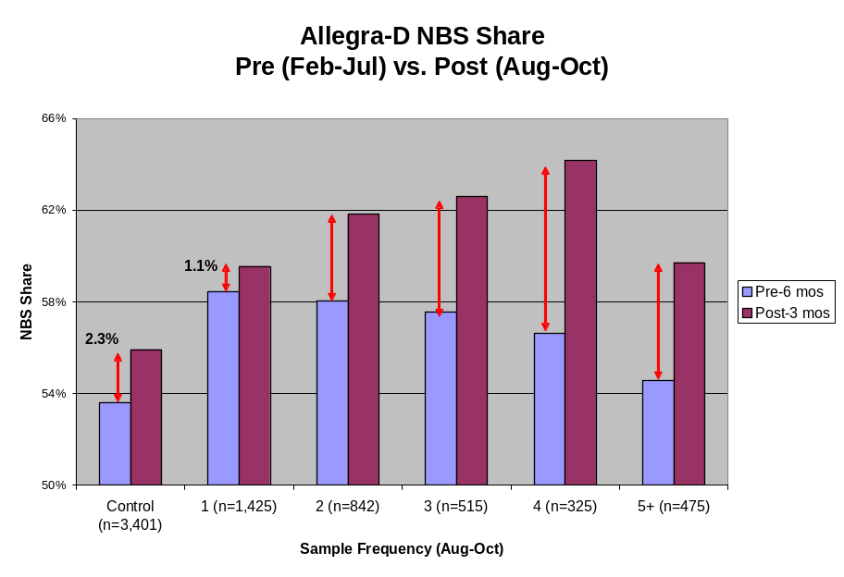
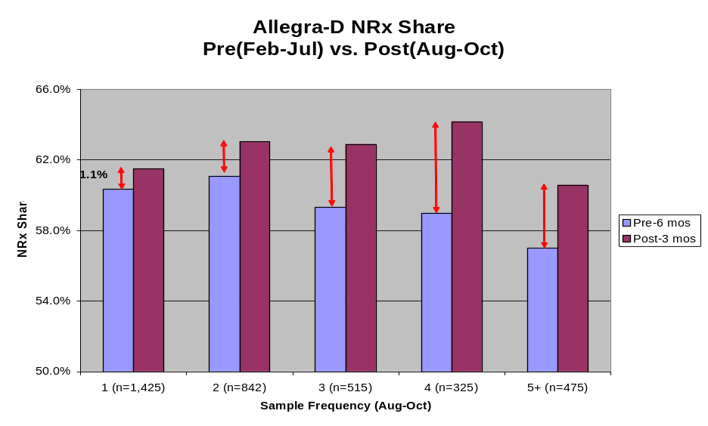

Nasacort-AQ:
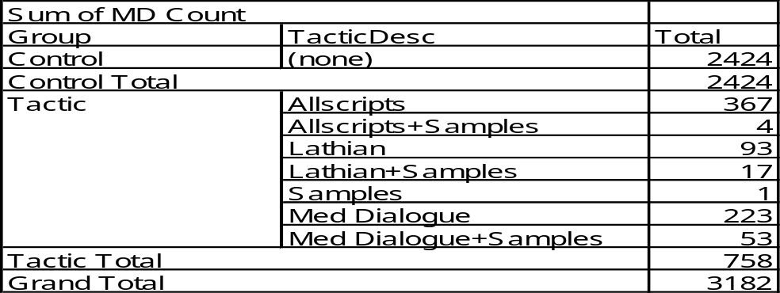
Only single channels (All Scripts, Lathian and Medical Dialog) had reasonable physician count to measure. While all channels are showing NBS share increases in the post-promotion period versus control, Lathian & Medical Dialogue are the highest
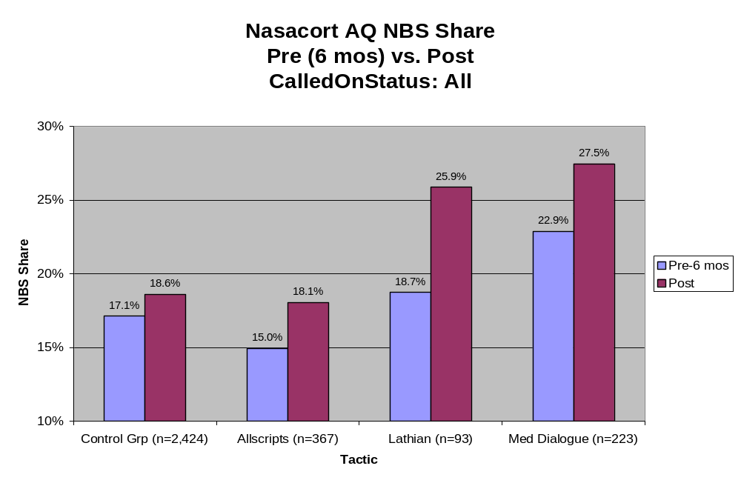
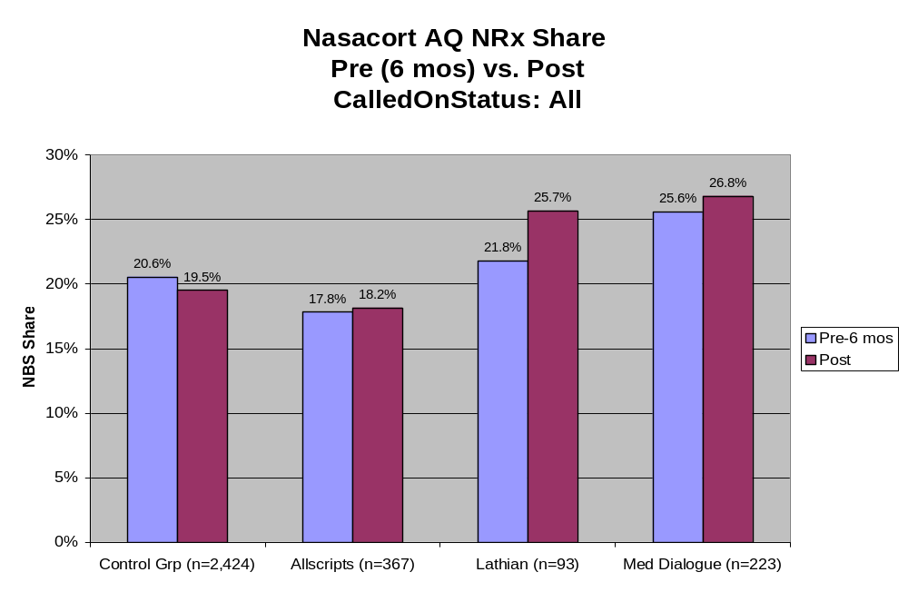
The greatest NBS share gain has been generated by Lathian called on MDs followed by Med Dialogue & Lathian non-called on in the post period
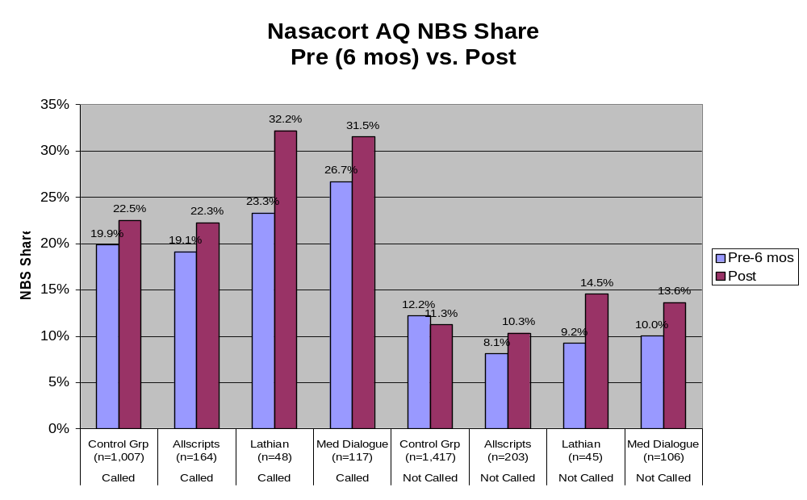
Outcome:
The results from this analysis showed positive impacts of some of the programs and the clients agreed to extend the contract for the next fiscal year with almost similar budgets allocated as in 2006 for each of these programs.

- Quadratic Optimization (Wolfe’s method)

Problem Statement:
A quadratic optimization algorithm to optimize the promotional resources using promotional response model (linear regression models with quadratic terms) was required to imbed it into the promotional response tool.

Short Description:
This research project is a deep dive into the development of quadratic optimization through Wolfe's optimization algorithm. Could not succeed due to difficulties in programming the algorithm (primarily convergence issues for larger problems).
Wolfe’s optimization algorithm was chosen as it gives an truly optimal solution to the convex quadratic objective functions with linear constraints (this was the requirement for PRT tool) with minimal execution time.

Methodology:
If the quadratic objective function is convex (i.e., the matrix representing the quadratic terms is positive definite (eigen values >= 0) or second derivative is >= 0), then Wolfe has proved that the quadratic problem could be represented in linear form along with some variable exclusion rules. Thus, the problem could be solved by a small variation (regarding variable exclusion rules) in Simplex algorithm, a popular method to solve linear optimization problem. For more information on the algorithm refer to “Methods of Mathematical Economics – Linear and non-linear programming, fixed-point theorems” by Joel N. Franklin (pp 177 to 189)

Notes on convex and concave functions:

A function is convex on an interval if for any two points and in and any where ,
If has a second derivative in , then a necessary and sufficient condition for it to be convex on that interval is that the second derivative for all in . If negative of a function is convex, then it is concave function.
Results and Outcome:
Implementation of the Wolfe’s optimization algorithm was not successful. This is because of the failure in implementing the conversion of quadratic to linear problem with variable elimination constraints and some improper convergence problems.

- Return on Investment - Abbott

Problem Statement:
A software and data analysis tool to compute and report ROI for multiple products and multiple channels of promotions across various segments.

Short Description:
Abbott’s analytics division wanted to build a tool to measure the ROI of various promotional programs. Programs (Event Types) typically analyzed for ROI are:
- CET (Clinical Evaluation Teleconferences) – 5 to 15 physicians and a moderator conducted via a conference call. Clinical experiences are shared on the chosen topic by Abbott. 300 to 1000 such events are aggregated to calculate overall ROI. ROI for such programs are complicated by program frequency and duration (i.e., some physicians participate in several events during the programs duration).
- STS (Speaker Teleconference Session) – Similar to CEO, but moderated by a speaker that is an opinion leader.
- LEP (Local Event Programs) – Events with 10 to 30 physicians, the representative, and a speaker. Speaker delivers a presentation during dinner, followed by a social or entertainment type program. Such programs are aggregated to calculate overall ROI for entire season.
- Roundtables – Events with 3 to 8 physicians and a representative. The representative facilitates the product discussion.
- Direct Mail – Low cost mails with multiple waves to same physician. ROI for this program are complicated by program executions: some may receive all waves but others may receive selective waves.
- Journal Subscriptions – Low cost annual subscriptions to targeted physicians on either a weekly or monthly basis that may include 1) supplements with clinical data supporting Abbott product imagery and/or journal ads. ROI are complicated by the frequency in which the audience receives the promotion (no single event date).
- Extending Reach Programs – Programs to target physicians that historically may not have been targets. In this type of promotion, the cost is related to the detail and sample itself. ROIs for this type of promotion are complicated by the control group algorithm that may find difficulty in identifying other physicians that may have received little/none detailing in the pre period while receiving detailing and sampling in the post-period and the nature of the representatives routing schedule in which the program’s roll-out is staggered over several weeks.
- Message Programs – Programs to target select audiences for an experimental message. In this type of promotion, cost is proportional to promotion materials. ROI is complex to measure due to representatives routing schedule spanning several weeks.
- Sampling Programs – Programs to target select audiences to stimulate trial usage via the use of patient compliance packs or other simple configurations. ROI’s are complicated due to routing schedules and the “lost” prescriptions that may have been substituted by the samples themselves.
- Premium Programs – Programs to either mail or personally deliver low cost premiums.
- eDetailing Programs – Programs targeted to difficult to see physicians using the internet to convey a message. ROI’s are complicated by the control group algorithm that may find difficulty in identifying other physicians with low detailing in pre-period and some detailing in post period.
Some control group physician constraints are:
- If a physician participates in a program, he / she cannot be eligible for a control group match for the next 12 months.
- A control group physician can only be used for a maximum of 2 times for a given event for a single time period and another 2 times for a future period for the same program.

ROI’s for each program is expected at different segment (loyalty segments and deciles) levels and the geographic (territories, MSAs) levels along with the overall program ROI.

Methodology:
The procedure to set-up and measure event ROIs are described below in order.
1. Program Setup:
All relevant details of the event types, products being promoted and the actual events and their attendees have to be uploaded into the system before starting the computations. Data about physician universe and their prescriptions for 24 months along with products and market definitions and sales territory alignment along with representative details are uploaded to the tool through batch processes. The batch process also computes the covariance matrices for each product and specialty group combinations. The specialty group for each product usually have multiple specialties in each group. The specialty to specialty group mappings are determined by analyzing products total prescriptions in each specialty for the past 24 months. Specialties with similar counts are grouped into one. Usually there are three to four groups per product.
1.1. Event Type Setup:
All above mentioned event types are entered into the system along with their discount rates and degradation functions. Degradation functions supported are linear, quadratic, and exponential and extrapolate from last available data month to usually nine months from the event date.
1.2. Products Setup:
Includes details on product being promoted and its corresponding market name. Product unit price, average units per Rx, distribution margin (i.e., profit margin) and spill over factor (mostly 1, but some products that are prescribed for other indications than the primary indication may have a higher spill over factors like 1.2)
1.3. Event Setup:
An actual event is given a name and is associated with one of the already defined event type and the product being promoted. Details like event duration, event cost and event start time are also specified.
1.4. Event Attendees Setup:
For each event, attendees are either uploaded from text file (if their ids are known) or selected through the tool by searching the physician universe. The search criteria includes physician ids (ims_id, me_number), last name, first name, specialty, zip and state. Any combination of search criteria could be specified to get a list of valid physicians. The right event physician has to be then chosen from this list.

2. Control Group Matching:
This module attempts to get the best control physician for each event attendee. For each event physician, first a pool of physicians with same specialty and first two digits of zip code are obtained. A distance metric between the event physician and each of the control physician is computed. Then the event physician is mapped to four control physicians, one from each of the following geographies - Zip2, Zip3, Zip4, Zip5 based on the minimum distance and other exclusion criteria between the event and control physician. If the minimum distance is above the user-specified threshold then it is considered that control physicians could not be identified. The parameters used for matching are (users can select a sub-set as well):
Pre-period:
- Product volume (NRx and TRx)
- Market volume (NRx and TRx)
- Call Activity (samples and details)
Post-period:
- Call Activity (samples and details)
Exclusion Criteria:
- Exclude control physicians who have participated in same program (for the same product) within 12 months (or any other user specified months) prior to the event (OR)
- Exclude control physicians who have participated in programs of same event type (for the same product) within 12 months (or any other user specified months) prior to the event (OR)
- Exclude control physicians who have participated in any event (for the same product) within 12 months (or any other user specified months) prior to the event
Other Constraints:
- A control group physician can only be used for a maximum of 2 times for a given event for a single time period and another 2 times for a future period for the same program.
Weights are specified for each of the pre-period and post-period variables. Details about distance computation metric is given below.

Distance Metric:
The usual choice of distance metric is the Euclidean distance ( [Xe-Xc]^{T}[Xe-Xc]). Euclidean distance assumes all variables have equal variance and are uncorrelated. A Generalized Distance Metric (Mahalanobis D²) does not make any such assumptions. Gneralized distance explicitly takes into consideration both differences in the variances in the variables, as well as the intercorrelations among the variables.
Initially we chose Mahalanobis D² as the distance metric and we introduced weights into the metric, but the graph of Rx trends between Event and Control physicians matched using this metric did not satisfy the clients as they appeared wider. A “weighted standardized Euclidean distance”, that does take variable variances (i.e., standardizes the variables) into account but not the correlation between the variables was finally used as the distance metric. Below, we start with Mahalanobis distance and the computation procedure, and then we mention the changes to covariance matrix that leads to weighted standardized Euclidean distance metric.

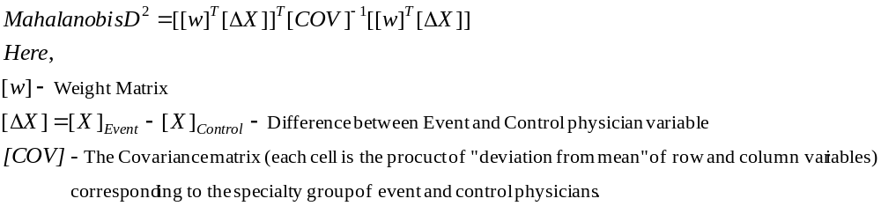
The inverse of matrix is computed using Eigen values and Eigen vectors (for more stability and multiple uses of Eigen Decomposition). i.e., [COV]⁻¹ = [P][D]⁻¹[P]⁻¹ where, [P] – all Eigen vectors, [D] – diagonal matrix with all Eigen values in the diagonal.
By making all elements, but the diagonals, of covariance matrix as zero, we get the variances arranged as diagonal matrix and when the inverse of this matrix is multiplied with difference in variable vector (Delta X above), then it is equivalent to dividing the variable values by their standard deviation and is very similar to Z transformation for standardization. We used such modifications to covariance matrices to get the “weighted standardized Euclidean distance” (WSD²).
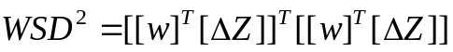

Among the four control group physicians for each event attendee, the user specifies whether which control group physician if the user prefers based on the distance and geographic proximity preferred by the user. By default Zip2 physician is recommended.

3. Computation of ROI
ROI for an event is computed as follows:
- First the user specifies the metric NRx or TRx to use for computation. If it is NRx, average TRx per NRx ratio is used to convert TRx equivalent of NRx.
- Then the degradation function of the corresponding event type is applied to extrapolate any missing data (NRx or TRx) in the post period. The value degrades to pre-period average value at the end of the analysis period (say, 9 months from event date)
- Next, Product TRx, Market TRx for the control group and the event group are aggregated for each time point. These are then aggregated to pre-period and analysis period levels.
- 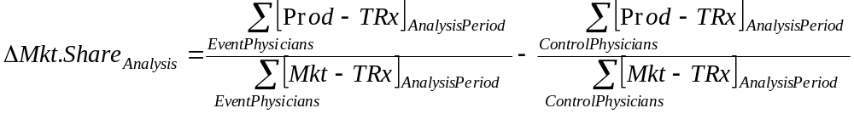
- 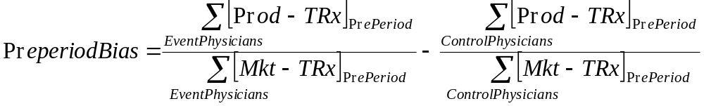

This Event ROI could be further broken down based on event physicians loyalty segments, decile ratings and specialty. The computations are carried out similar to above procedure for each of these groups.

Results and Outcome:
The above tool was used to measure ROI’s of multiple programs of Abbott. The code was transferred to Abbott as per initial agreement and they are using it internally for the past five years.

- Return on Investment - CellTech

Problem Statement:
CellTech conducted a Coupon Program for 13 months with around 9400 physicians. This project measures ROI from this program.

Short Description / Methodolgy / Results:
The ROI tool described above was used to measure the ROI. There were 13 cohorts (one for each month) and each of them were measured separately. ROI was broken down according to number of further redemptions. Few physicians who received the coupons multiple times were dropped due to poor control group matching. The impact of coupon program was significant, the benefit to cost ratio varied from 0.95 to 14 times.

Outcome:
CellTech used the positive results to allocate the budget for the further coupon programs.

- Promotional Response Tool – Abbott

Problem Statement:
Physician segmentation (volume and sensitivity segments) for different markets and products, promotional models for client products and resource optimization using the models and the user specified what-if scenarios are carried out. A software and data analysis tool to report on the market, product, territory, segment, promotional model statistics and most importantly the resource optimization for the user specified what-if scenarios is developed.

Short Description and Methodology:
General Overview:
The Promotional Response Tool (PRT) enables the managers and analysts to determine the optimal level of sampling, detailing and ultimately, the optimal number of representatives needed to maximize the profitability of each product. The tool allows managers and analysts to create what-if scenarios to answer questions concerning the use of resources between products to maximize profitability.
The modeling methodology begins with a 10 X 5 segmentation of physicians according to the Abbott-specified decile (10 groups) and the SAI-determined sensitivity to detailing (5 groups). A model is developed within each of the 50 groups that provides information concerning how each group responds to changes in details, samples, and other variables. These models are then used as the basis for optimization algorithms that apply user input, constraints, and assumptions that will provide feedback, such as where and by how much productivity can be increased by reallocating resources across the 50 physician segments. Response curves for each group are available to enable the user to better understand how each group responds to details and samples.

Markets, Products and Data elements:
Promotional Models were built for Tricor (Cholestrol Market), Biaxin (Anti-Infective), Omnicef, Flomax, Mobic and Micardis. Among these products, Tricor and Biaxin were widely studied and used. There are four sources of data for the PRT. Xponent provides 24 months of Rx data at the Physician and NDC level. Abbott’s SFA system provides activity data (sampling and detailing) by physician and product. Abbott provides alignment data in the form of a zip-to-terr file, which supplies zip codes assigned to each territory. Abbott also provides the organization structure for the drilldowns and execution plans. Meta data about the products and markets are entered manually.

Physician Segments:
Decile Groups:
Grouping physicians as a function of their prescription volume is a common practice in the healthcare industry. The number of scripts prescribed in a given market were divided into ten groups, or deciles, of equal prescription volume. As the decile number decreases from highest (10) to lowest (01), the group sizes increases since the physicians prescribe less. As an example, in the cholesterol market, there are 14.7 K high decile (8 to 10) physicians, 31.5 K medium decile (4 to 7) and 49.4 K low decile (1 to 3) physicians.
Sensitivity Levels:
A further grouping of physicians on the basis of their sensitivity to call activity were carried out. We modeled total prescriptions (TRx) as a function of call activity (details and samples) for all professionals in the sample. Within each volume decile, we then grouped the physicians into quintiles (5 groups) based on the metric (Optimal TRx – Intercept) from each physician model. For example, highly sensitive physicians will respond to increases in call activity with increases in TRx volume, and will respond to decreases in call activity with decreases in TRx volume. However, insensitive professionals will maintain their prescription volume regardless of changes in call activity. An ANOVA analysis was conducted to verify if the sensitivity groups as defined here were sensitive as per the definition. One issue was that many of the R-SQ of physician level models was very low (0.05 to 0.2) and the model F was not significant.

Promotional Models:
A detailed promotional model for each of the 50 segments for a given product was then developed. TRx and NRx were used as dependent variable. The model included linear and quadratic terms for Details and Samples (so that the point of diminishing return could be observed), Rx lag terms (to capture physician persistence), Competitor Rx terms, Trend, Specialty group and Seasonality effects as dependent variables. A reduced model for each segment was then derived for each segment by keeping all dependent variables, except the detail and sample terms, at the segment means. This reduced model was then used for the optimization purposes. Models will be updated 2-3 times per year.

Optimal Sample and Detail Allocation:
First the product and the corresponding model is identified for determining either optimal call or optimal samples. The objective function is the sum of all the reduced models corresponding to 50 segments with one variable (i.e., call or sample) to be optimized for each segment. There are two types of constraints, global and local constraints. The global constraint is the total number of calls or samples that are allowed nationally. This is expressed as a range between a minimum level and a maximum level. A percentage value based on previous year calls or samples at the national levels are usually specified (i.e., 80% to 120% of last year allocation). An absolute value can also be specified. The local constraints are specific to each segment and again specifies the minimum and maximum allowable limits within a segment as percentage of previous year segment mean calls or samples (per doctor per month).
We used a simplex method for solving linear optimization problem. The quadratic objective function of each segment was converted to an approximate linear function around the previous year segment mean using Taylor’s series approximations. Thus the overall objective function is linear with 50 variables (calls or samples per segment) to be optimized. There are 2 global constraints and 100 local constraints resulting in 102 linear constraints. The Simplex method was coded in Java using the ideas presented in Numerical Analysis book by “four authors” as they are usually referred to. Taylor series approximation was straightforward to implement.

Tool Architecture:
Segmentation and Modeling were done using SAS and the physician segment and the model terms and statistics were uploaded to the tools data base using the scripts. There are primarily four layers. Presentation layer is comprised of the applications the end user sees. These are dynamically generated HTML and DHTML pages displayed with MS IE5 Internet browser. These pages are produced by the Web server tier and are downloaded to the client’s browser via HTTP. The Web server layer is a combination of scripts and scriptlets that generate these HTML and DHTML pages. Java Servlets were the primary tool used in the web server (Tomcat engine) layer.
The application server layer (all Java codes) is comprised of core business objects and algorithms that servlets interacts with. The database server/ data access layer is essentially the database (Oracle 8.1.6). The application uses the Abbott’s LAN as a communication backbone.

Tool Functionalities:
Most of the data elements (RX, activity, alignment, orgstructure, products, markets, physician demographics and their product segments) are loaded through SQL load scripts (sqlloader). The model details (terms and stats) are loaded manually or through scripts. The tool allows the user to a) View model statistics b) Obtain Optimal call or sample allocation c) View model response curves d) View Alignment Quality Index e) Geographic drill down and f) generate Execution plans. The optimization module is the most important part of the tool.

View Model Statistics:
After selecting a model, the statistics for that model are displayed, such as the number of variables in the model, the number of detail variables, and the number of sample variables. The Min, Max, Mean, and Median values are given for segment size and the R-Squared terms, which are fit statistics that aid the user in determining the model’s validity. The most productive segments are displayed, showing optimal versus actual total scripts per physician per month. The difference is multiplied by the product’s average unit cost to provide a dollarized gap. Total gap dollars is calculated by multiplying the dollarized gap by 12, providing an annualized figure. The number of physicians included in the segment is shown, as is the segment’s percent to total physicians. Current versus optimal details per year and the percent of current details to total is displayed. Current versus optimal samples per year and the percent of current samples to total is displayed as well. In addition, information for the least productive segments is listed.

View Model Response Curves:
Response curves are available for viewing to enable the user to better understand how each group responds to details and samples.

Optimal Call or Sample Allocation:
Once a model has been created and loaded by SAI, it is ready for optimization by a PRT user. Global and local constraints are entered to narrow down results. Local constraints can be entered for individual segments, multiple segments or all segments.
The first step in the optimization process is to select the variable on which to optimize, whether it is primary details, co-primary details, samples, or sales force. Next, global and local constraints are entered, indicating the desired percentage in increase or decrease in the current level of activity selected. A default percent of increase and/or decrease is entered for all segments and percentages can then be entered for individual segments, if desired. Optimization is performed real-time and the results are displayed, in table format, showing the number of prescribers, current level of activity selected, the optimal level, and the difference. Current and optimal total scripts and their difference are displayed as well. This level of optimization is iterative and constraints can be saved for use later. Once the user is satisfied with the constraints that have been entered, their status can be changed to approved, indicating that the constraints are ready for use in defining call plans.

View Alignment Quality Index:
The Alignment Quality Index (AQI) is defined as the percentage of territories that lie outside + or – 20% of the optimal level of details. The AQI is displayed as a histogram showing the number of territories that lie within the 20%, the number of territories that are less than 20%, and the number of territories that are above 20%.
The user selects a product, model, sales force, and optimization (primary or co-primary details) for which the AQI is to be graphed. The user enters the number of days in territory per year (optimally, 200) and the calls per day (optimal, 8.5), giving a optimal number of details per year (1700). The percentage is also entered. A graph is created which plots all territories in comparison tooptimal number of details. A Territory watch list may also be requested, which details the actual territories that lie outside + or – 20% of the optimal level of details. This list could be used to identify which territories could be expanded (+20%) or collapsed (-20%).

Geographic Drill-Down:
After a model has been optimized, the user may wish to view geographic data in more detail. After selecting a product and model, the activity (samples or details) and sales force must be designated. The minimum and maximum values per prescriber and a step size are entered and the time period is selected. Results are displayed at the national level with drill downs to franchise, area, region, district and finally, territory. Statistics, similar to the model summary statistics scree, are displayed, as is the information that was entered to create the drill down.

Results:
Screen shots from a later prototype (not the one delivered to Abbott) are shown here.
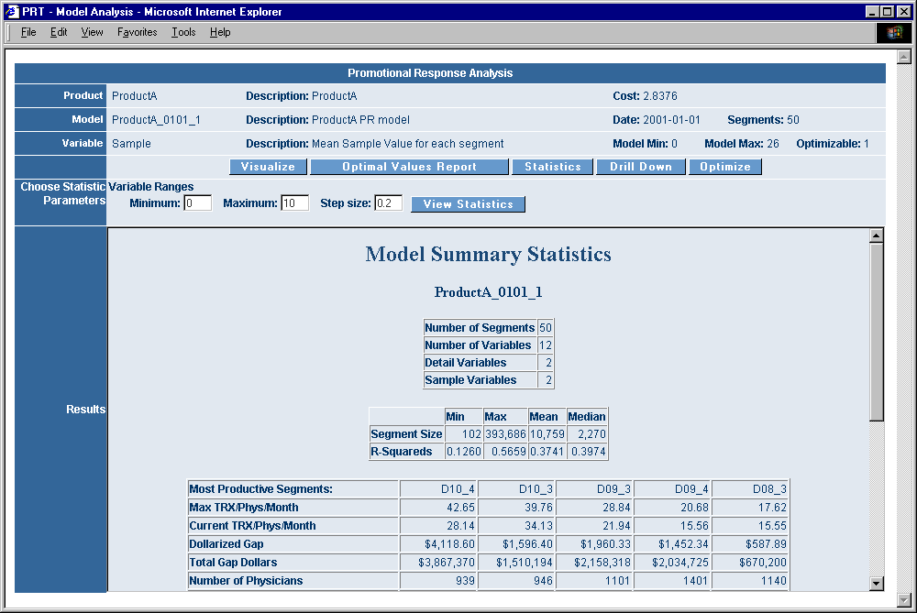
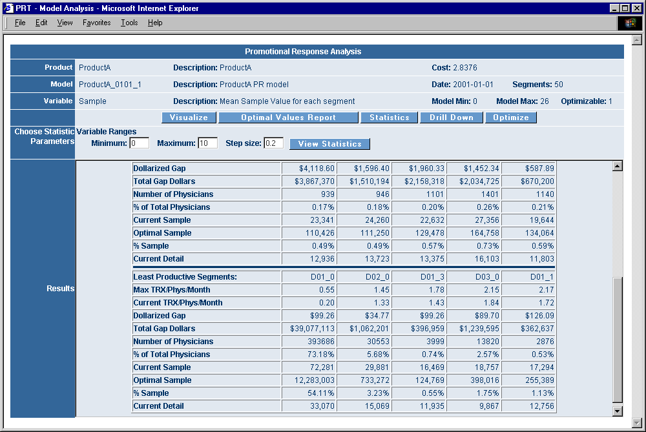
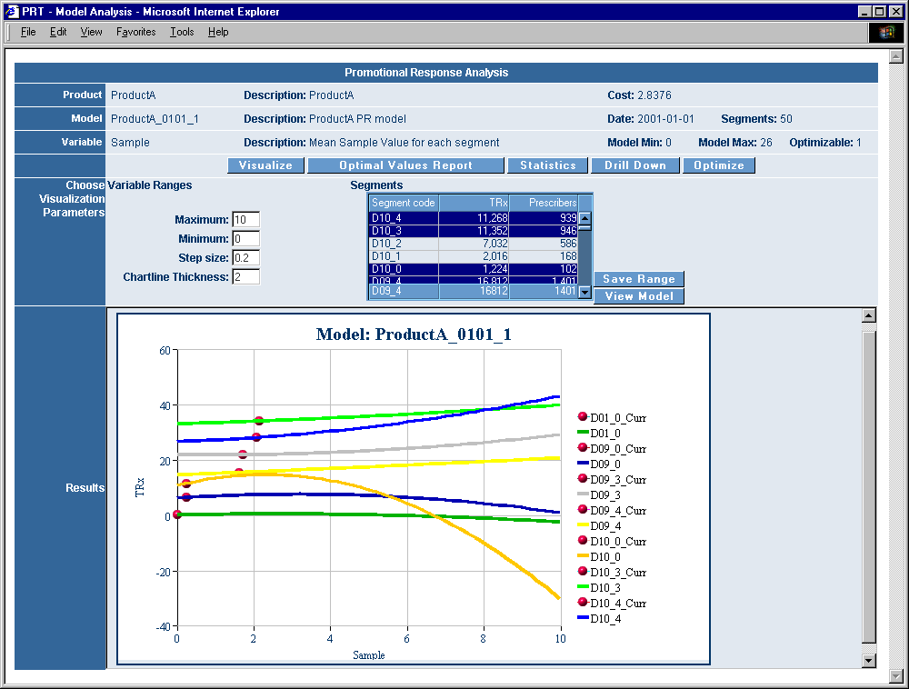
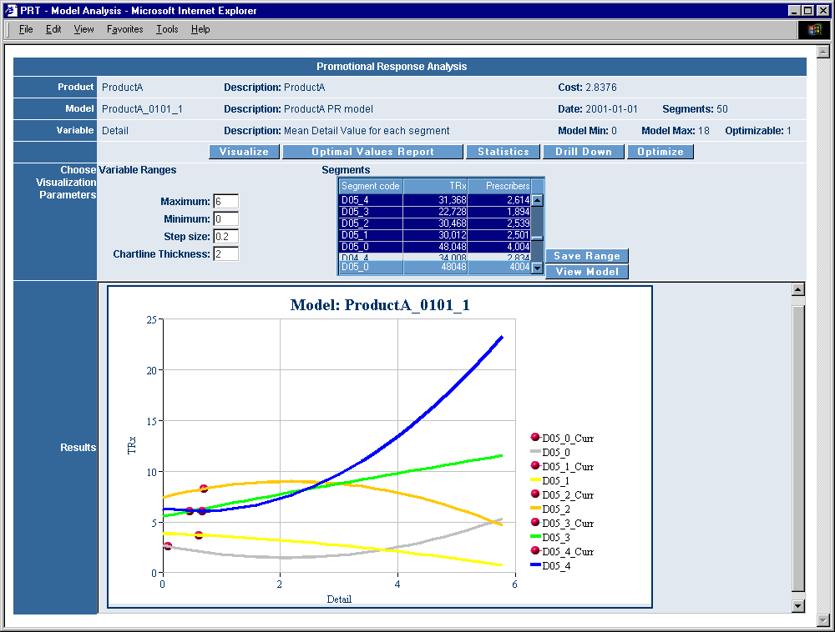

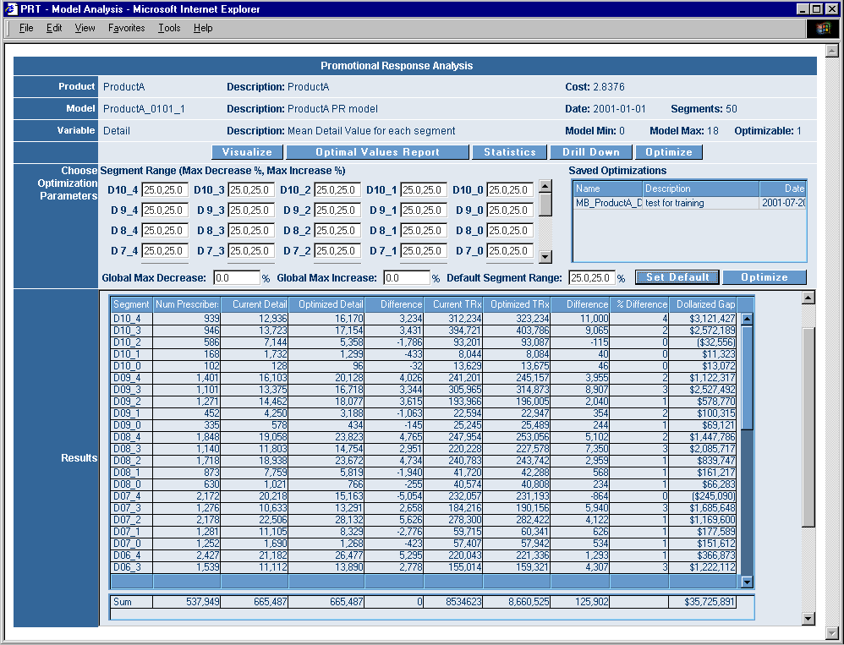

Outcome:
The tool was subsequently not used by Abbott, primarily due to the implementation issues after optimization. However, the ideas developed were key to sell a similar consulting work to other clients, primarily LifeScan. The theories learnt here also helped to appreciate the need and build other optimization algorithms like Genetic Algorithms.

- Promotional Response Model – Pfizer, Japan
Problem Statement:
This project addresses techniques for analyzing Japanese pharmaceutical sales data to predict physician sales sensitivity and to choose target physicians.

Short Description:
The Japanese rules do not allow the capture of prescription data at the doctor level, which makes it hard to predict the sensitivity of the doctors to the promotions of the pharmaceutical companies. The Rx data are captured at the institute level. Given these difficulties, this project attempts to quantify the physician’s contribution to the institute’s sales and builds an approximate approach to choose target physicians.
A JForce (SFA) database instance of Pfizer-Japan was loaded, and data for the analysis of physician's sensitivity to the sales of a drug called Norvask were extracted. Norvask is a calcium channel blocker that treats hypertension and angina. It had an approximate 2.5 Billion dollars in revenue during 2005. Results obtained for the sensitivity of calls (or details) to the sales were not significant. Attempts were therefore made to analyze the sensitivity of physician demographic attributes to institute sales. Based on the initial study, a physician's department, title, medical society, and specialty were identified as being sensitive predictors of sales. Physician's age, medical school and sex were not found to be predictive.
Data were randomly split into 75% for training and 25% for validation. Both regression and neural network models were built on the training data and validated for accuracy using the validation data set. The stepwise regression model performed slightly better than the neural network model. In addition, because of the important mathematical properties of the linear models that enable us to distribute institute sales to the physician level, the regression model was chosen as the model of choice for the analysis. A methodology is proposed on how to distribute institute sales to the physician level, and to predict physician sensitivity (i.e., target value) to sales.
A targeting tool that predicts the most sensitive physicians for a given set of search criteria was built. The search criteria are a set of institutes or a set of physicians or a medical representative. Various other interesting combinations (like, targets at city level) could also be built, but were not done because of time limitations.

Methodology:
Available Data:
The data for the current analysis are derived from a Pfizer Japan JForce database. In the Japanese Market, physician level sales data is not available, however institute level sales data are. Pharmacy sales are distributed approximately to the nearby institutes. The association of physicians to the hospitals is also available. The total institute sales of Norvask between Feb/2002 and Mar/2003 (13 months) are used in the analysis. Following data elements are available:
Doctor: ID, Specialty, Medical Society, Age, Sex, Medical School, Call Activities.
Institute: ID, Number of Beds, Number of Doctors, Address, TRx for various drugs.
Derived through Doctor-Institute Alignment: Doctor’s department, title, drug control member status
The institute sales data is available on the daily basis.

Initial Data Analysis and Segmentation:
Initially a naïve study was conducted to see the correlation of calls on the institution sales. The correlation between total weekly calls and weekly sales from the institute universe was 0.44. As the results of the call sensitivity analysis were not encouraging, it was decided to see how the demographic properties of physicians affect the sales. These attributes include specialty, medical society, department, title, age, sex, and medical school. Since we do not have physician level sales data, a direct mapping between these demographic properties with the sales is impossible. The following methodology was thus adopted,
- Enumerate the possible values that each attribute can take by analyzing the universe.
- Count the number of doctors in each of these categories.
- For each attribute value pair that is considered (say, specialty = orthopedics), a correlation between number of doctors that belong to this category in each institute and the sales of the institute is computed.
- The assumption here is that if a given category were very sensitive to sales, then as we increase the number of doctors in that category then the sales would also be more.
- The correlations are sorted in descending order for each value of the attribute and segmented according to the correlation values.
Among all the variables considered above, department and title seems to show higher correlation, and school shows much lower correlation. There is a considerable amount of missing data in this data set. The following list shows the important attributes, sorted by the variance in sales captured by each attribute (i.e., R-Square).
- Department (38%)
- Medical Society (35%)
- Title (35%)
- Specialty (29%)
- Age (26%)
- Medical School (26%)
- Sex (13%)
In the following analysis, all of the above attribute values are used as independent variables and then models are built on them to predict the institute sales.

Modeling Institute Sales:
The independent variables for the models are the number of doctors in each attribute value combination within an institute (for example, number of doctors in orthopedic specialty in the institute, number of doctors in hematology society in the institute etc.) and the dependent variable is institute sales. There were around 52000 institutes and 550 such independent variables, thus making the problem size to be huge. In order to simplify this, the number of independent variables was reduced to 36 by considering the number of doctors in each segmented group. The data was randomly split into 75% for training and 25% for validation. Training data were used for constructing the models and the validation data were used for the validation of the model. The validation accuracy could be considered as a better estimate of model accuracy when this model is applied to unseen data. In addition, differences in training and validation accuracy help to determine if the obtained model is not over-fit. The training set had around 35300 records and the validation set had around 12000 records.

Multiple Regression Model:
Data were modeled using a stepwise multiple regression model (i.e., a regression model that removes the unnecessary independent variables from the model) with linear terms. The 36 variables generated above were strongly correlated and any attempt to build a regression model using these variables may have a large confidence intervals. So principal components (i.e., factors) were generated and all of them were used as independent variables for modeling. By including all the factors, all the variance in the data with original input variables would be captured and represented in the analysis. The model structure looks as below,

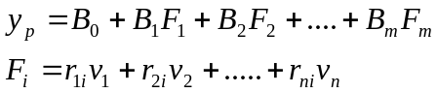 -- Eqn. 1
Where,
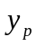 - Predicted institute sales.; 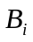 - Regression coefficients.
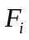 - ‘i’th factor or principal component.
- Independent variables like number of doctors in a particular segmented group.
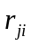 - Factor-Variable correlation coefficient. A value between 0 and 1 that represents the contribution of ‘j’th variable to the ‘i’th factor.
- Total number of independent variables. ; - Total number of input factors.
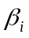 - Standardized representation of B coefficients.
A stepwise regression model (i.e., a regression model that removes the unnecessary independent variables from the model) was built using the factors.

Properties of linear model.
The above-mentioned linear model has an excellent interpretive capability. Some of these properties are listed below
- coefficients represents the ‘i’th factor’s contribution to sales.
- 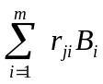 represents the ‘j’th variable’s contribution to sales.
- coefficients represents the ‘i’th factor’s importance to sales.
- 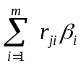 represents the ‘j’th variable’s importance to sales.
- It provides an excellent way to derive each physician’s contribution to institute sales.

Training and Validation Accuracy.
The R-value for the validation set is 0.56. This is comparable to the training set R-value of 0.6, and hence the obtained model is not over-fitting. The obtained R-value of 0.6 does not represent a highly accurate model but a rather approximate model. 36% of variance in the sales could be attributed by the demographic attributes considered in the model.

Neural Network Model.
A neural network model for the training data (with factors) was built and its accuracy was compared with validation data. Network configurations and their accuracy are listed below.
Input Layer : 33 neurons
Hidden Layer #1 : 10 neurons
Output Layer : 1 neuron
NN method : Quick (i.e., Feed Forward Network), with 50% training data, sensitivity analysis and prevent overtraining option.
This particular model removes the unnecessary variables from the model. The training accuracy, as shown by the neural network tool that was used, is 98%. But the analysis of residuals gives the R-Value as 0.56 for training set and 0.52 for validation set.

Comparison of Models.
The linear model is slightly more accurate than the neural network model. In addition, the linear model has properties that would allow for a mathematically valid sales allocation at the doctor level and are made use of in the following sections. Because of these advantages, the linear model is chosen as the model of choice for the current analysis.

Distribution of institute sales to doctor level.
We have thus for obtained the predicted sales of an institute by indirectly using the number of doctors in a particular segment group within an institute. Using the linear model we have obtained B coefficients,  coefficients and ’s for each factor-variable combination. Using these B, and’s, it is possible to predict the sales contribution of each doctor in the institute. It is also possible to find out how important a particular doctor is for targeting purposes.
For identifying target doctors for a promotion from a given set of doctors, we have to sort the doctors by their target values in descending order and choose the best targets from the top of the sorted list.

Sales contribution of physicians.
The sales contribution of each physician in an institute is computed as,

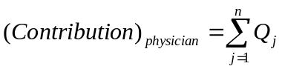 -- Eqn. 2.
Here,
n – Total number of variables; m - total number of factors; - Regression coefficient of ‘i’th factor.
IF a physician belongs to attribute-variable category of ‘j’ THEN 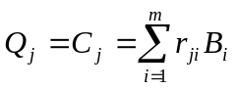
ELSE 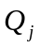=0

Sales Allocation to each physician.
For calculating sales allocation, the noise predicted by the constant coefficient 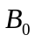 is distributed equally among all doctors of an institute, and this average noise is added to the sales contribution of the physician whose allocation is to be computed. Sales allocation for each physician in an institute is computed as,

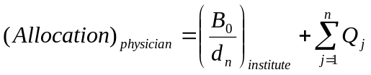 -- Eqn. 3.
Where,
- Constant coefficient of the linear model; 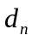 - Total number of doctors in the particular institute, to which this particular physician belongs.

Targeting value of each physician.
Targeting value quantifies the importance of a physician with respect to the institute sales. Targeting value of each physician in an institute is computed as

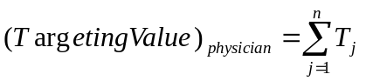 -- Eqn. 4.
Here,
- Standardized regression coefficient of ‘i’th factor.
IF a physician belongs to attribute-variable category of ‘j’ THEN 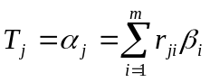
ELSE 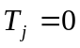
It is easily proved that the total allocation to physicians is equal to the institute’s predicted sales. We can also observe that, if constant (i.e., noise captured by the model), is taken out from the predicted institute sales, then, institute sales without noise is equal to physicians total contribution.
All the important results obtained by the models were loaded to the JForce database from which all the data required for modeling were derived.

Targeting tool.
A simple web based visualization tool that displays the model results in a way that might be useful for the users was built. ASP, JavaScript and HTML were the programming languages used. Data is extracted from a JForce database stored in Oracle database using ODBC and ADO. Java, SQLNavigator, Excel, and Access database were extensively used for data manipulation. Clementine was primarily used for building analytical models and for some data manipulations.
This targeting tool covers following functionality:
- Reports importance of each demographic attribute value pair with respect to product sales in the market. The attributes include Specialty, Medical Society, Department, Title, Age, Sex and Medical School.
- Sorts out best physicians for promotional targeting. The search criteria for getting the physician pool for targeting can be any one of the following,
- Set of institutes.
- Set of physicians.
- One or more medical representatives.

Results:
Target physicians within the pool of selected institutions are shown below. Selections could be made within a pool of physicians and representative levels as well.

Importance of specialty is shown below. The tool also displays other parameter like medical society, department, title, age, medical school, and sex.
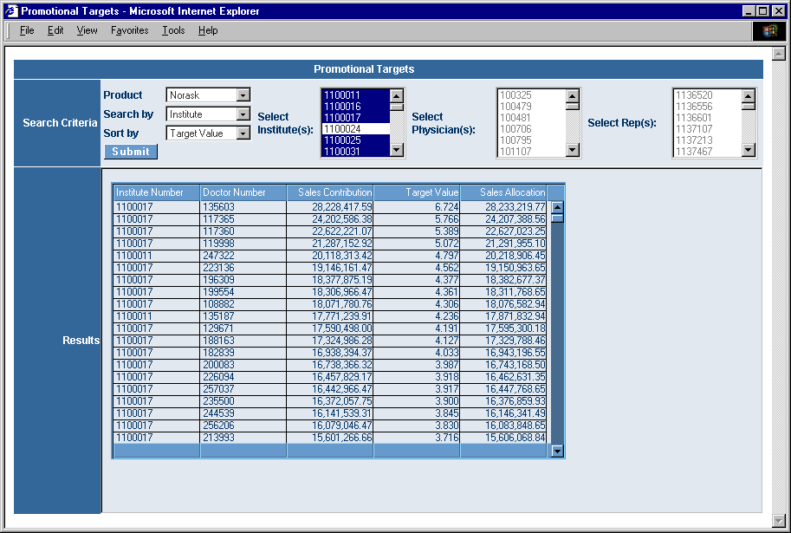
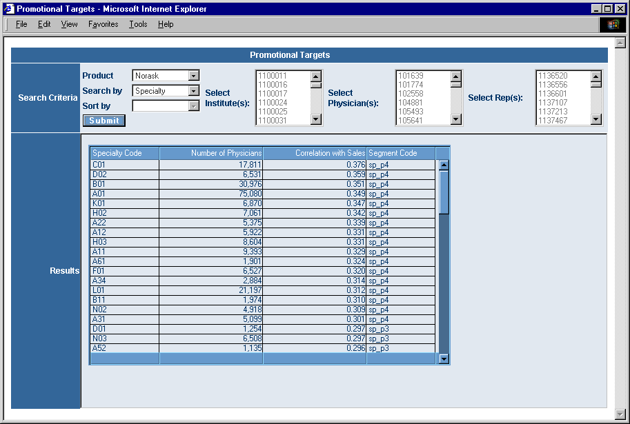
Outcome:
This analysis was key to gain confidence with the clients and provided opportunities for custom analysis. Results from this analysis were not used in the field.

- Forecasting – Allergan

Problem Statement:

Short Description:

Methodology:

Results:

Outcome:

- LPD Analysis and Reporting - GSK - HIV(Epzicom, Truvada, Lexiva), ED(Levitra), Obesity(Xenical - Bayer)

Problem Statement:
Extract and compute various LPD metrics and provide the trend and other summary reports as requested by client to support their decision-making.

Short Description:
HIV (Epzicom,Truvada and Lexiva):
Epzicom was launched recently and GSK wanted to compare its performance with Truvada (competitor drug) and to understand the switching behavior. Similar analysis is carried out for Lexiva as well.

Description of Services/Deliverables:
Report the number of patients taking either Epzicom or Truvada, and from each population, determine the number of patients who are truly new to therapy, or have switched from another regimen. For those who have switched, report the regimens used over the 12 months prior to the switch. For those truly new to therapy, provide a count and percentage that went to each regimen. This information will be delivered as one time report to GSK.

Key Analytic Focus:
- Determine the number of patients taking any HIV therapy. For each product, specify:
  - True New Patient Counts of all patients initiating any of the NNRTIs, NRTIs, and PIs. Also include % share for both therapies for these initiators (naive to therapy).
  - Continuing Rx for any of the NNRTIs, NRTIs, and PIs.
- For patients taking either Epzicom or Truvada, determine the:
  - Switches from other ART therapies (NNRTI, NRTI, and PI meds)
  - Of those consumers who have switched, identify the treatment regimens used over the 12 months prior to the switch

Project notes:
- Concomitance will be defined as two products prescribed twice within 60 days.
- Study period: rolling 24 months (starting October 2002 – September 2004)
- NNRTI meds are: Rescriptor, Sustiva, Viramune
- NRTI meds are: Combivir, Emtriva, Epivir, Epivir HBV, Epzicom, Hivid, Retrovir, Trizivir, Truvada, Videx, Videx EC, Viread, Zerit, Ziagen
- PI meds are: Agenerase, Crixivan, Fortovase, Invirase, Kaletra, Lexiva, Norvir, Reyataz, Viracept
- Market size – Approx. 21 million transactions.

ED – Levitra:
GSK conducted a voucher program for the ED drug Levitra. GSK had Rx data for the vouchers that were redeemed by patients (around 4400). The client wanted to understand the overall usage of the drug by these patients (i.e., continuation rate and refills) and their physicians. We took the redeemed voucher Rx data from GSK and using the field like date filled, Rx Number, Pharmacy NCPDP number, Prescribing Physician names, Quantity dispensed etc., to identify those voucher scripts from Dendrite LPD. There was around 30% match. Very few matches required manual resolution. Parameters like TRx for a given period, refill gap, payment type, co-pay etc., were then computed for these patients, and were aggregated to their corresponding physicians.

Obesity – Xenical (Bayer):
Xenical is a product from Bayer but marketed by GSK. This report was delivered to GSK. Primarily, GSK wanted to segment the physicians into equal Market NPS volume deciles for targeting purposes. GSK provided a list of physician universe that they were planning to target. Data for obesity market (products defined by client – Xenical, Phentermine, Meridia, Bontril etc.,) was derived from LPD data base and based on the gap analysis (i.e., distribution of average gap days between two consecutive Rx for a given patient (days supply excluded)), the rule for identifying an NBS script was specified. Deciling were done based on market NPS volume of all doctors in the LPD universe who had at least one NPS in the study period. An iterative deciling procedure was later developed so that each decile has almost equal volume. In this procedure, first we sort and divide the physicians according to equal volume. Then we look at the physicians in the border between two deciles and if the NPS volume is same for these borderline physicians then they are classified under one of these decile according to the maximum number of physicians with same NPS in each of the two deciles that were considered. This procedure classifies physicians with same NPS into the same decile and maintains the accuracy as much as possible as well. The results section shows gap distribution, match rate and final decile statistics.

Methodology:
Metrics Defined:
NBS – New Brand Start:
Defined as the first occurrence of a product within a specified look-back period (usually 180 days) for a given patient. This can be further classified into New Patient Start (NPS), or Switch and/or concomitant start (CS).

NPS – New Patient Start:
A brand start event for a patient and product that occurs when a patient is first treated with a product or several products from within the Therapy Area since data collection began for the patient.
That is, the patient is naïve to the therapy.

Switch:
A brand start event that occurs when a prescriber switches a patient from one therapy (of one or more products) to one or more products without a gap in time. An NBS script is classified as a switch event if there are no more occurrences of previous products within the defined look-forward (usually 60 days) period. A switch occurs from “Switch From” product(s) to a “Switch To” product.

CS - Concomitant Starts:
A brand start event with multiple products being prescribed simultaneously (i.e., concomitantly). A NBS script is defined to be concomitant if the fill date is within the defined fill-lapse minimum days (usually, 6 days). This event may or may not be a switch.

Usually the look-back periods are computed by analyzing the distribution of gap-days or the client defines them. Client chooses look forward period. A conservative look forward period is say a 1-year period. Fill lapse minimum days are mostly considered to be 6 days. Following are the configurations used for this project:
HIV (Epzicom, Truvada and Lexiva) → Look Back: 180 ; Look Forward: 0 (??)
Obesity – Xenical (Bayer) → Look Back: 180; Look Forward: 60

Results:
HIV (Epzicom, Truvada and Lexiva):
NPS / Continuation Trends:
Study Period: November 2002 to October 2004
 | New Patient Starts |  |  |  | Continuing Scripts
Week Start Date | Volume |  | Market Share (%) |  | Volume
Week Start Date | Epzicom | Truvada | Epzicom | Truvada | Epzicom | Truvada
30-Jul-2004 | 0 | 0 | 0.0 | 0.0 | 0 | 0
6-Aug-2004 | 0 | 23 | 0.0 | 0.6 | 0 | 3
13-Aug-2004 | 0 | 53 | 0.0 | 1.4 | 0 | 16
……. | …. | …. | … | … | … | …
15-Oct-2004 | 67 | 184 | 1.9 | 5.3 | 307 | 826
22-Oct-2004 | 80 | 209 | 2.4 | 6.2 | 422 | 870
29-Oct-2004 | 25 | 38 | 3.0 | 4.5 | 115 | 252
Grand Total | 686 | 1638 | 0.2 | 0.4 | 1594 | 4375

Study Period: November 2002 to October 2004
 | Lexiva - New Patient Starts |  | Lexiva - Continuing Scripts
Week Start Date | Volume | Market Share (%) | Volume
31-Oct-2003 | 0 | 0.0% | 0
7-Nov-2003 | 11 | 0.3% | 4
14-Nov-2003 | 24 | 0.6% | 9
…… | ……. | …….. | ……
15-Oct-2004 | 67 | 1.9% | 988
22-Oct-2004 | 63 | 1.9% | 976
29-Oct-2004 | 15 | 1.8% | 232
Grand Total | 2536 | 0.6% | 30542

Previously Used Products:
Study Period: November 2002 to October 2004 | Switched To
Study Period: November 2002 to October 2004 | Number of Patients |  |  | Share of Patients
Previously Used Products (12 Months) | Epzicom | Truvada | Total | Epzicom | Truvada | Total
Epivir, Sustiva, Ziagen | 51 | 3 | 54 | 6.5% | 0.1% | 1.3%
Trizivir | 32 | 27 | 59 | 4.1% | 0.8% | 1.4%
Epivir, Viramune, Ziagen | 24 | 1 | 25 | 3.1% | 0.0% | 0.6%
Trizivir, Viread | 18 | 22 | 40 | 2.3% | 0.7% | 1.0%

ED – Levitra:

Patient Count
 | Matching - Cash | Matching - Third Party | Matching - Govt. | Matching - Null
Voucher - Cash | 4 | 31 | 3 | 0
Voucher - Third Party | 96 | 176 | 3 | 0
Voucher - Govt. | 0 | 0 | 0 | 0
Voucher - Null | 0 | 0 | 0 | 29

Obesity – Xenical (Bayer):
Gap Distribution (x – Gap Days; y – Patient count) and Match count:
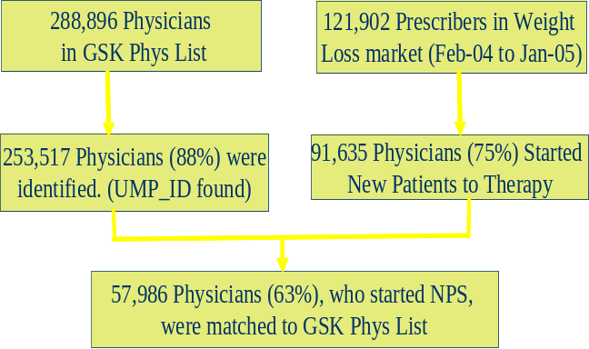
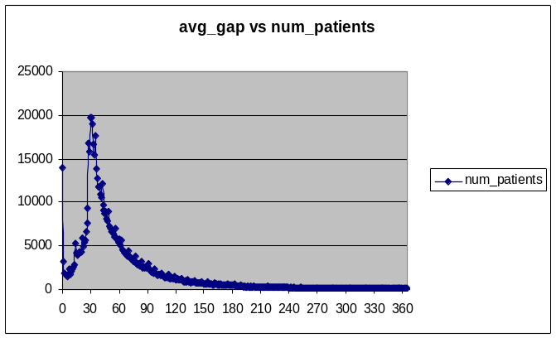

Decile Statistics:
DECILE | Number of  Physicians in the  decile | Number of Physicians  in GSK list | Minimum  NPS | Maximum  NPS | Total Market  NPS volume | Percentage of Total  Market NPS volume | Mean NPS
10 | 43 | 24 | 451 | 13902 | 45425 | 10 | 1056
9 | 327 | 197 | 74 | 449 | 45384 | 10 | 139
8 | 976 | 664 | 33 | 73 | 44552 | 9.8 | 46
7 | 1956 | 1,416 | 19 | 32 | 46832 | 10.3 | 24
6 | 2723 | 2,028 | 13 | 18 | 41037 | 9 | 15
5 | 5779 | 4,299 | 8 | 12 | 55367 | 12.2 | 10
4 | 5193 | 3,810 | 6 | 7 | 33409 | 7.4 | 6
3 | 9838 | 6,918 | 4 | 5 | 43407 | 9.6 | 4
2 | 25153 | 16,688 | 2 | 3 | 59376 | 13.1 | 2
1 | 39647 | 21,956 | 1 | 1 | 39647 | 8.7 | 1
Total | 91635 | 58,000 | 611 | 14,502 | 454,436

Outcome:
All reports were delivered on time to GSK. Client’s action items from these reports are unknown.

- LPD Analysis and Reporting - FDA and Bayer - ED Market

Problem Statement:
The goal of this effort is to extract and analyze the data to understand the current utilization (prescribing, dispensing, and longitudinal patient use) of vardenafil and other PDE-5 inhibitor therapies in the US. This, possibly complimented by data from other medical claims data in the US (e.g., UHC) as well as surveys of prescribers and possibly pharmacies will support the development of a dynamic prevention-focused education and risk minimization action (RiskMAP) plan that addresses the current regulatory topics being addressed by Bayer-GSK and the FDA in 2004-5. This analysis will also compliment the previous analysis of the first PDE-5 Inhibitor, sildenafil, to understand the evolution of ED therapy in the US.

Short Description:
Bayer-GSK obtained final approval for marketing vardenafil (Levitra), a novel selective phosphodiesterase type 5 (PDE 5) inhibitor drug with indications that include erectile dysfunction, on August 19, 2003. As with similar drugs such as sildenafil (Viagra) and tadalafil (Cialis), it has the capability of interacting with other vasodilating drugs, notably nitrates and alpha blocking drugs, to result in serious adverse effects due to excess vasodilatation that results in lowered blood pressure. At present, there is no reason to believe that vardenafil has any different profile than other PDE-5 inhibitors.
Since vardenafil has entered the market with a contraindication for use of concomitant alpha-blockers, there has been regulatory interest in the degree to which this contraindication is noted by prescribers, in addition to understanding the overall use of vardenafil and analogous drugs as was done in the first descriptive study of sildenafil.
Based upon their understanding of the regulatory expectations and what is known about use of therapies for erectile dysfunction, Bayer-GSK would like to utilize the findings of these analyses to provide a basis for a survey of:
- Physicians who are concomitantly prescribing vardenafil and alpha blockers to determine the reasons for their prescribing, by specialty, and
- Pharmacists, to anonymously determine if their drug interaction software captures the interactions related to vardenafil and other ED therapies, particularly with regard to alpha blockers and nitrates as well as possibly other cardiovascular drugs, antibiotics and antiretroviral drugs, since it has been shown that the computer programs for these interaction warnings vary considerably (Hazlet et al, 2001)¹.
- Develop an education program to target prescribers of both drugs to assure appropriate understanding of contraindications and appropriate use

Methodology:
Study Period
- Sildenafil – February 2003 (180 days from August 19,2003) to September 2004
- Tadalafil – August 19,2003 – September 30,2004
- Vardenafil - August 19,2003 – September 30,2004
- Prehistory will be 6 months 180 days February 2003

Concept Definitions
- Number of days: RX fill date = 1 Day
- Person-time exposure = Number of days supply in study period + 10 days (if last days supply ends prior to end of study).
- Persistence of therapy measures
- Continuous therapy – Sequential Rx’s with a gap of
- 45 days for Sildenafil, 44 days for Vardenafil, 39 days for Tadalafil (~Avg. gap days between sequential Rx)
- 10 days for other drugs
- Total prescription time
- Total time of a continuous therapy from the first fill date to last date covered by days supply + 10 days
- Proportion of exposure days
- Person –time exposure/calendar days
- Concomitance = Overlap of Rx dates according to Rx fill date + days supply + 10 days (At end of therapy) for drugs other than ED. For ED drugs: Rx fill date + days supply + (Avg. Gap + 2* Gap SD)

Markets – Groups (other than above three) are defined as
- Alpha blockers
- Nitrates
- Other Cardiovascular -- Antihypertensive (AE inhibitors, angiotensin Receptor Blockers (ARBs), calcium channel blockers (CCBs), beta blockers, diuretics, and combination therapies thereof)
- Antidiabetic agents (Oral,insulin syringes)
- Selected 3A4 inhibitors-azole antifungals, macrolides, for example
- Azole antifungals
- Macrolides
- nefazodone
- Protease inhibitors

Exposure Cohort
Three cohorts were defined and studied separately.
First, the cohort of vardenafil-exposed will be formed from all those with a vardenafil prescription and six months prior history. Then it will be defined by the first prescription after the start date of the cohort study (August 19, 2003) and then defined by prior PDE-5 Inhibitor therapy in the six months prior to this first prescription: (a) none; or, (b) sildenafil. This cohort will subsequently be described as (a) vardenafil only users; (b) switchers to other PDE-5 Inhibitor therapy, sildenafil, tadalafil or both, and the proportion of each will be tabulated.
Second, the cohort of tadalafil users will be selected to include all those who received a prescription for tadalafil and not vardenafil (since these will be analyzed in the vardenafil cohort), and classified by prior PDE-5 Inhibitor therapy in the six months prior to their first prescription: (a) none; or (b) sildenafil; Similar to vardenafil, we will define tadalafil-only users and switchers.
Third, the sildenafil cohort will be those who do not have prescriptions in the study time period (February 2003 (180 days) to August 31, 2004) for either of the other PDE-5 Inhibitors and will likewise be described as to therapy in the prior six months as (a) none or (b) prior sildenafil. As this is a cohort of exclusion, data on switching will not be described.

Reports:
For each of the cohort, several tables were generated. Following are some of the data generated for Vardenafil cohort. Tadalafil and sildenafil also has similar data.
- Total Number of Individuals receiving at least One Prescription for Vardenafil. Results are broken out by Gender, Age, and Region Demographics.
- Overall Use Patterns of Vardenafil Prescriptions broken down by gender.
- Number of Vardenafil Prescriptions per Patient.
- Number of Patients with Continuous Exposure to Vardenafil.
- Average number of days between Vardenafil Prescriptions
- Payment Type for Vardenafil Prescriptions by Demographic Group and Gender
- Overall Use of Vardenafil by Region (Northeast, Midwest, South & West ), Number of Patients Receiving at least One Vardenafil Prescription in Study Year in Each Region. Results are broken down by gender.
- Number and percentage of Unique Physicians by Specialty Prescribing Vardenafil by Region (Northeast, Midwest, South & West)
- Specialty Percentage within Region of Unique Physicians Prescribing Vardenafil by Region
- Number of Vardenafil Prescriptions by Physician’s Specialty by Region
- Overall Summary of Occurrence of Concomitant Cardiovascular / Antidiabetic Therapy with Vardenafil Prescriptions. Results are broken down by gender.
- Concomitant Therapy of Patients Receiving Vardenafil During Selected Time Period
- Number of Overlapping Vardenafil and Nitrate Prescriptions, Vardenafil and Alpha Blocker Prescriptions, Vardenafil and Protease Inhibitor Prescriptions, Vardenafil and Macrolide Prescriptions, Vardenafil and Azole Prescriptions, Vardenafil and Nefazodone Prescriptions.
- Number of Same Day Vardenafil and Nitrate Prescriptions, Vardenafil and Alpha Blocker Prescriptions, Vardenafil and Protease Inhibitor Prescriptions, Vardenafil and Macrolide Prescriptions, Vardenafil and Azole Prescriptions, Vardenafil and Nefazodone Prescriptions.
- Prescribers' Specialty of Overlapping Vardenafil and Nitrate Prescriptions, Vardenafil and Alpha Blocker Prescriptions, Vardenafil and Protease Inhibitor Prescriptions, Vardenafil and Macrolide Prescriptions, Vardenafil and Azole Prescriptions, Vardenafil and Nefazodone Prescriptions.
- Prescribers' Specialty of Same Day Vardenafil and Nitrate Prescriptions, Vardenafil and Alpha Blocker Prescriptions, Vardenafil and Protease Inhibitor Prescriptions, Vardenafil and Macrolide Prescriptions, Vardenafil and Azole Prescriptions, Vardenafil and Nefazodone Prescriptions.
- Patients with Cardiovascular Therapy Prior to First Vardenafil Prescription
- Patients with Cardiovascular Therapy Started Post First Vardenafil Prescription
- Patients with Cardiovascular Therapy Started Post Last Vardenafil Prescription
- Switching between various ED drugs and their dosages.

Results:
Patient and Rx Counts.
Filters:
- Avoid all patients who don’t have any Rx activity 6 months prior to Index date (first use of the cohort drug) and
- Patients with ANY Rx that is dispensed between index date and study end date (Aug/31/2004) should have at least one Rx in the following 90 days. Since we have data until Nov/04, it is possible to check this condition even for the scripts that are near the study end period (say Aug/30/2004). This rule might eliminate sporadic users and the patients who switch pharmacies.
Results:
- Sildenafil Cohort – 594,778 patients, 8,115,953 Rx
- Vardenafil Cohort – 129,653 patients, 1,867,107 Rx
- Tadalafil Cohort – 141,116 patients, 1,376,834 Rx

Gap Computation.
Vardenafil:
- Avg Qty Dispensed: 6.74; SD of Qty Dispensed: 3.96
- Avg Days Per Pill: 8.3 (rounded to 8 days); SD of days per pill: 8.75 (rounded to 9 days)
Tadalafil:
- Avg Qty Dispensed: 6.78; SD of Qty Dispensed: 4
- Avg Days Per Pill: 7.14 (rounded to 7 days); SD of days per pill: 6.63 (rounded to 7 days)
Sildenafil:
- Avg Qty Dispensed: 6.5; SD of Qty Dispensed: 4.95
- Avg Days Per Pill: 8.02 (rounded to 8 days); SD of days per pill: 8.37 (rounded to 8 days)

Some Key Reports(from Vardenafil Cohort):
  - Average Gap Days
Age Group |  | # of Patients | # of Refills |  | Average # of Days between 2 Prescriptons | SD (days)
0 - 19 |  | 119 | 446 |  | 42.69 | 36.89
20 - 29 |  | 335 | 1379 |  | 34.84 | 35.16
30 - 39 |  | 2515 | 10496 |  | 36.17 | 34.65
40 - 49 |  | 11188 | 46213 |  | 39.72 | 36.27
50 - 59 |  | 22144 | 86949 |  | 44.55 | 39.71
60 - 69 |  | 16470 | 61462 |  | 48.88 | 41.77
70 - 79 |  | 6696 | 23560 |  | 52.43 | 44.8
80+ |  | 1093 | 3600 |  | 54.5 | 47.94
Unknown |  | 3806 | 14316 |  | 44.56 | 40.89
Total |  | 64366 | 248421

  - Overlapping Scripts
Total Prescriptions |  |  |  |  | Concomitant Therapy Overlapped with Vardenafil Prescription
Age Group |  | None | With Any |  | Nitrates | Alpha Blockers | Anti-Hypertensives | Anti-Diabetic | Azoles | Macrolides | Protease Inhibitors | Nefazodone
0-19 |  | 62% | 38% |  | 5.62% | 8.18% | 117% | 67% | 6.47% | 15.50% | 0.17% | 0.00%
20-29 |  | 73% | 27% |  | 0.61% | 3.11% | 49% | 28% | 3.49% | 5.38% | 1.11% | 0.55%
30-39 |  | 66% | 34% |  | 0.34% | 2.14% | 55% | 32% | 4.06% | 5.16% | 6.23% | 0.64%
40-49 |  | 54% | 46% |  | 0.69% | 2.74% | 88% | 44% | 3.45% | 4.59% | 5.58% | 0.74%
50-59 |  | 44% | 56% |  | 1.22% | 6.70% | 128% | 58% | 2.96% | 3.97% | 1.76% | 0.67%
60-69 |  | 36% | 64% |  | 1.87% | 14.76% | 158% | 61% | 3.04% | 3.78% | 0.32% | 0.55%
70-79 |  | 35% | 65% |  | 4.37% | 23.20% | 161% | 51% | 4.21% | 4.86% | 0.08% | 0.33%
80+ |  | 34% | 66% |  | 3.46% | 29.79% | 157% | 31% | 3.48% | 4.28% | 0.00% | 0.26%
Unknown |  | 40% | 60% |  | 17.72% | 24.40% | 190% | 91% | 17.39% | 14.69% | 4.65% | 1.28%
Totals |  | 43% | 57% |  | 2.62% | 10.98% | 133% | 56% | 4.13% | 4.85% | 2.23% | 0.64%

  - Specialty Interaction for Overalap – Alpha Bocker Example
 |  | Specialty of Alpha Blocker Prescriber
Specialty of Vardenafil Prescriber |  | Primary Care | Internal Medicine | Cardiology | Urology | Endocrinology | Other | Unknown |  | Total
Primary Care |  | 3% | 0.13% | 0.03% | 0.49% | 0.00% | 0.05% | 0.1% |  | 23%
Internal Medicine |  | 0.11% | 3% | 0.04% | 0.64% | 0.01% | 0.09% | 0.2% |  | 28%
Cardiology |  | 0.02% | 0.06% | 0.14% | 0.10% | 0.00% | 0.02% | 0.0% |  | 2%
Urology |  | 0.36% | 0.57% | 0.08% | 2.26% | 0.01% | 0.09% | 0.2% |  | 23%
Endocrinology |  | 0.02% | 0.03% | 0.00% | 0.04% | 0.05% | 0.01% | 0.0% |  | 1%
Other |  | 0.06% | 0.16% | 0.01% | 0.15% | 0.01% | 0.42% | 0.1% |  | 6%
Unknown |  | 0.12% | 0.18% | 0.01% | 0.20% | 0.00% | 0.04% | 2.1% |  | 17%
Total |  | 22% | 28% | 2% | 25.23% | 0.51% | 4.7% | 18% |  | 100%

  - Switch from Vardenafil to other ED drugs (including dosage):
First Switch | Vardenafil  2.5mg | Vardenafil  5mg | Vardenafil  10mg | Vardenafil  20mg
Tadalafil
5mg | 1 | 10 | 46 | 24
10mg | 15 | 97 | 1771 | 926
20mg | 12 | 70 | 2997 | 4866
Sildenafil
25mg | 5 | 16 | 64 | 19
50mg | 37 | 166 | 3519 | 1180
100mg | 47 | 325 | 8086 | 9077

Outcome:
FDA, in conjunction with Bayer, used the report to understand the drug overlaps and designed surveys to target physician and pharmacists. Developed educational programs to physicians and pharmacists. This was a high revenue project as it was later repeated for three different times.

- LPD Analysis and Reporting - Schering Plough Periodic Repoorts

Problem Statement:
Periodically report various LPD metrics for products and market categories in Allergy and Hyperlipidemia markets. One-time adhoc reports were also delivered. The Objective of these reports is to understand breaking market trends and dynamics using longitudinal prescription data.

Short Description:
This project is a periodic reporting of various LPD metrics for products in Allergy and Hyperlipidemia markets. The reports were mostly trends of various metrics delivered monthly and quarterly. For some point in time, the reports were delivered weekly. Schering also often requested special adhoc reports.

Types of Reports:
Allergy Market (Delivered Quarterly):
- View the Source of New Business or New Brand Starts (NBS) by therapeutic class.
- Focus on the following therapeutic classes for further detail:
    - Nasal Inhaled Steroids (NIS)
    - Non-Sedating Antihistamines (NSA)
- Examine the Source of Business for Nasonex, Clarinex, and their market competitors by providing details on the following categories:
    - New
    - Brand Restart
    - Switch
    - Add-on
    - Continuing Rx
- Analyze the Switching metrics for the major products within the NIS classes.

Hyperlipidemia Market (Delivered Monthly):
- Monthly and Weekly trends of shares of New Patient Starts (NPS) for main Hyperlipidemia (Cholesterol) products.
- Monthly Net Switch Trends for each of the main product.
SAS Reports:
- These are reports of NPS, Switch, Titration of Hyperlipidemia products at the physician level. NPS and Switch Rx data are extracted through KPM processes defined by Analytika. Only the target physicians identified by Schering are analyzed and reported. SAS process merely merges and groups the data for target physicians. Time starts from January 2003 and reports until the current month.

Products Reported:
Allergy Market (Delivered Quarterly):
- Overall 24 month trends of NBS volumes and Shares for the drug categories Plain Tab Antihistamines, Nasal Antihistamines, Nasal Inhaled Steroids, and Other Antihistamines.
Nasal Inhaled Steroids (NIS):
- Comparison of source of business (New, Switch, Add-On, Brand Restarts, and Continuing Rx) for two one-year periods for Flonase, Nasacort, Nasonex, and Rhinocort. Unique patient counts are reported for each metric and year.
- Twenty-four month trends of NBS volumes and Shares for Flonase, Nasacort, Nasonex, Rhinocort, Fluticasone, and Other NIS products.
- Twenty-four months trends of volumes and shares of individual new brand start events (New, Switch, Add-On, Brand Restart) for products: Flonase, Nasacort, Nasonex, Rhinocort, and Fluticasone.
- Nasonex Add-On broken out by product family. The product families include Allegra, Fexofenadine, Singulair, Astelin, Clarinex, Zyrtec and other combination drugs.
- Nasonex concomitancy trend with other products broken down by quarters.
- Twenty-four months trends of Net Number of Switches (= Number of Switch To events – Number of Switch From events) for all the NIS products.
- Twenty-four months trends for Number of Switches From a product, Number of Switches to a product and the net activities for a product (all in one chart). One graph for each of the NIS products.
- Twenty-four months trends of Share of switches TO a reported product from other brands. Each of the main NIS products mentioned above is reported.
- Twenty-four months trends of Share of switches FROM a reported product to other brands. Each of the main NIS products mentioned above is reported.

Total Defined Antihistamines (TDA):
TDA includes three sub categories: Decongestant Antihistamines (DA – AllegraD, ClarinexD, and ZyrtecD), Plain Tab Antihistamines (PTA – Allegra Tab/Cap, Clarinex Tab/Cap, Zyrtec Tab, and Fexofenadine), Liquid Antihistamines (LA – Clarinex Syrup, Zyrtec Syrup).
Reports for each of these sub categories were very similar to NIS reports listed above except that the products correspond to their respective sub categories. Add-On report was done only for Clarinex Tab (product by Schering). Concomitancy reports are produced for Clarinex-Tab, Clarinex-D, and Clarinex-Syrup.

Hyperlipidemia Market (Delivered Monthly):
- Monthly (13 months) and Weekly (12 weeks) shares of New Patient Starts (NPS) for main Hyperlipidemia (Cholesterol) products. Main cholesterol products are Vytorin (Schering), Crestor, Lipitor, Simvastatin, Zocor, Pravastatin, Pravachol, and Zetia.
- Monthly (13 months) Net Switch Trends for Vytorin, Crestor, Lipitor, Simvastatin, Pravastatin, and Zetia.

Methodology:
LPD Metrics:
Allergy Market:
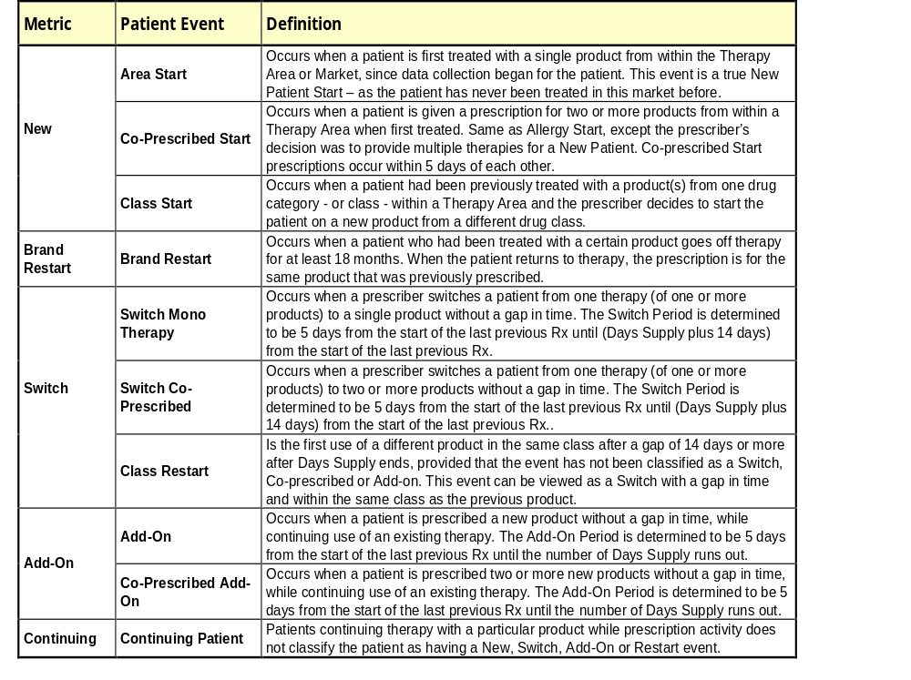
Hyperlipidemia Market:
New Patient Start Events (NPS) defined as a brand start event for a patient and product that occurs when a patient is first treated with a product or several products from within the Therapy Area since data collection began for the patient. It is similar to the events defined as “New” in the Allergy Market.

Net Switch = Switch To – Switch From
Switch To = Switch Mono-therapy, Switch Co-Prescribed, Class Restarts Events, Category starts
Switch From = Switch Mono-therapy

Production process for Allergy reports:
The latest production process is explained. LPD data is loaded initially to Oracle system at Analytika. Transactions corresponding to the defined allergy markets are then extracted and loaded to Teradata by Totowa group. SMIQ studies (Source of Business, Switch, and Add-On) are then generated using this data and QVA files (QlikTech App) are then generated. These QVA files serves as input for generating the slides mentioned above. First according to the bookmarked product definitions various data tables in CSV format is downloaded from QVA files. Several VBA processes written as Access DB modules then reads these data and according to the defined configurations transforms data and produces excel reports (using already defined excel templates) that contains charts shown in the final power-point slides. The data from these excel reports are manually pasted into each of the Microsoft Chart object defined in each slide. The whole process takes about a week. My processes (from QVA files to Excel reports) take about 6 hours to complete.

Production process for Hyperlipidemia reports:
LPD data is loaded initially to Oracle system at Analytika. Transactions corresponding to the defined hyperlipidemia market is then extracted and loaded to Teradata by Totowa group. Special processes, that are similar to SMIQ processes, extract the various brand start events and are stored in event interval tables. Another process (written by me) extracts the NPS and Switch data from these events table in a generic way (i.e., reported products, time periods and data formats are configured separately) and generates one tab limited data file corresponding to each individual reports. Excel templates are set up to read these data files and produce the final charts. These charts are then manually pasted to PowerPoint and annotated.

Results:
Allergy Market Example Slides:
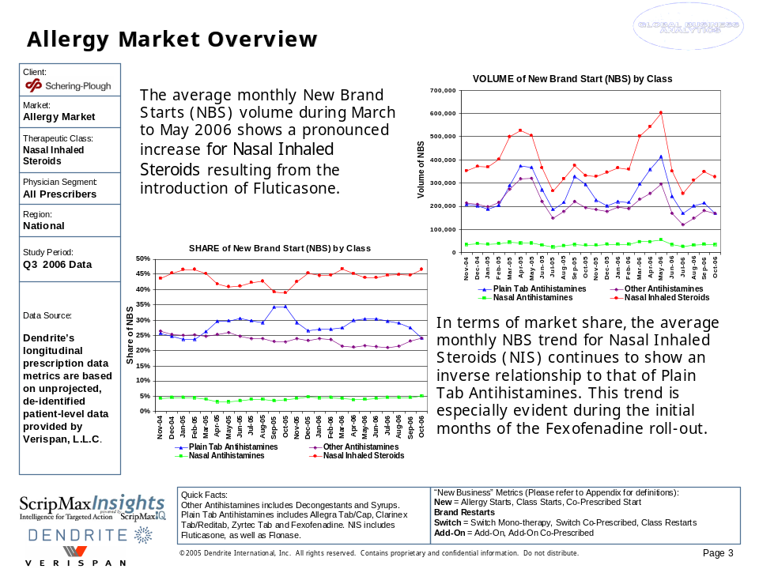
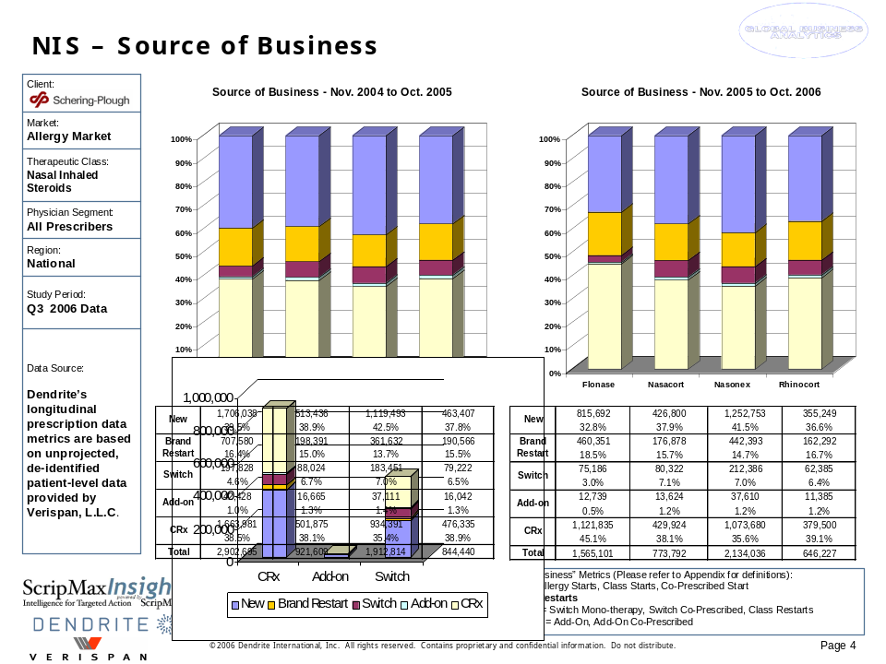
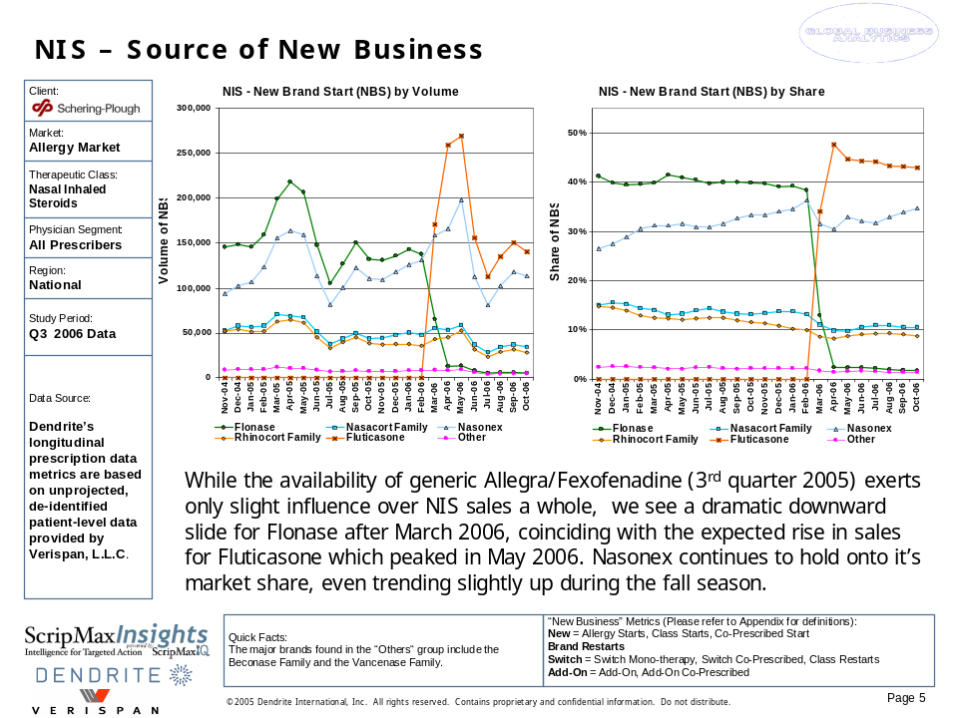
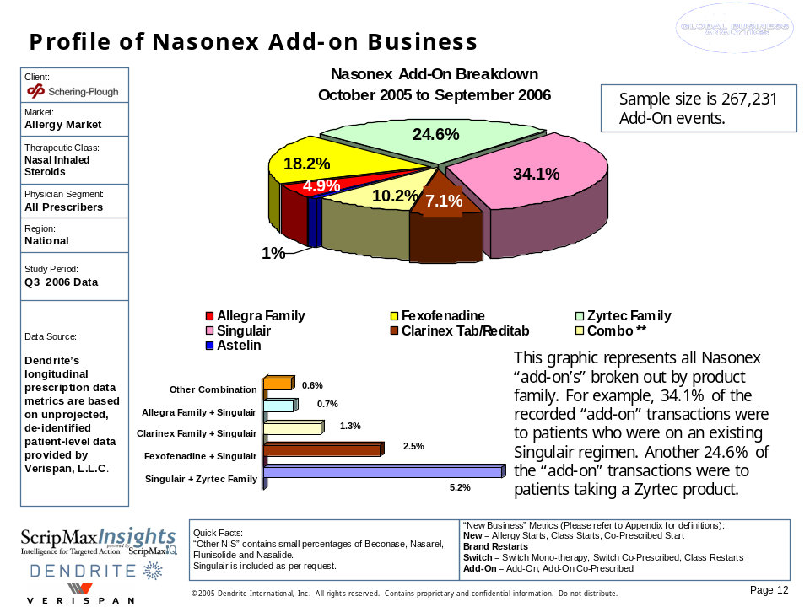
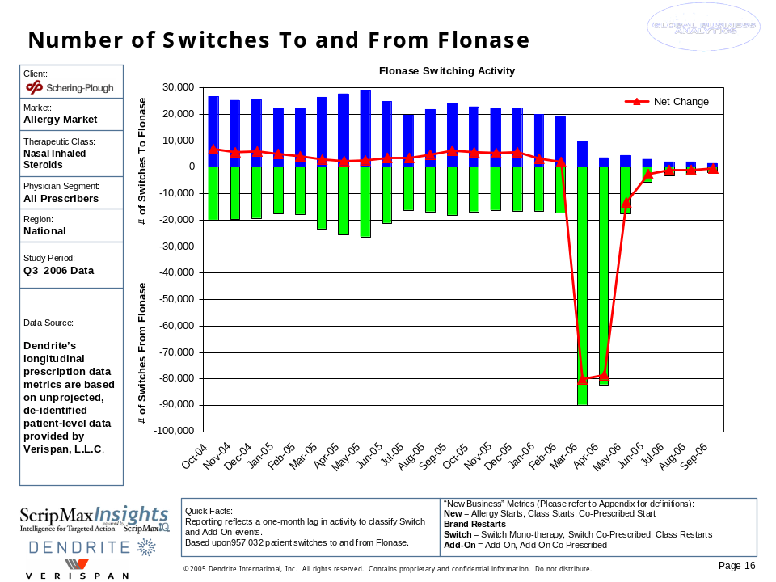
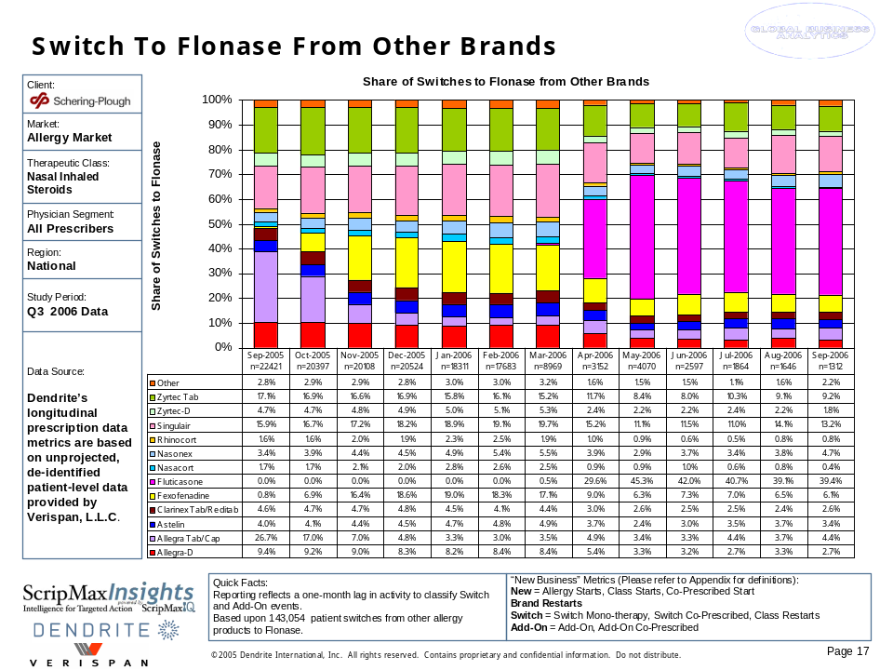

Hyperlipidemia Market Example Slides:
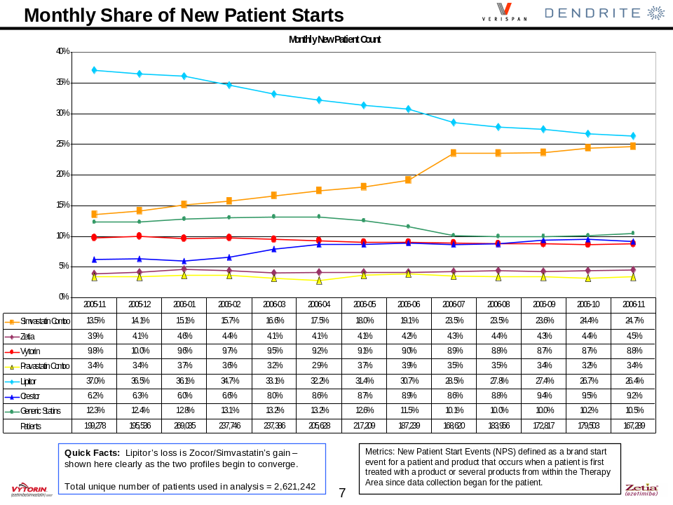
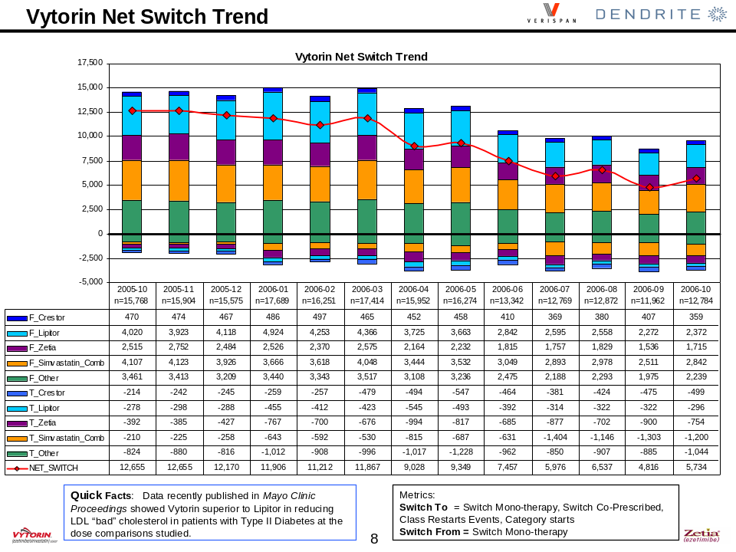

Outcome:
This was a high revenue project executed for around two and a half years. These reports were used by brand teams to understand the product trends and act upon it appropriately.

- Optimal Sample Allocation - LifeScan

Problem Statement:
Determine optimal levels for samples to maximize market share of One Touch Ultra test strips.

Short Description:
We conducted an Intelligent Allocations analysis for LifeScan to analyze how a prescriber responds to changes to details, samples and other variables. With client's input, we identified the variables and market dynamics that affect the analysis. Dendrite integrated the data provided by LifeScan with LPD and WebForce databases, identified prescriber segments, analyzed the prescriber’s promotional sensitivity at the segment level and provided the optimal allocations for each territory.
The project followed the following sequence of operations:
- Data Integration
- Segmentation
- Promotional Response Models
- Optimization of Sample Kits – Various Scenarios
- Conclusion/Observations

Methodology and Results:
Data Integration:
Various data elements were derived from LPD database, WebForce Database and from LifeScan. LifeScan provided Physician Targets, TRx, Market Definition, Zip-Territory Structure, Managed Care Info etc. Following LPD-metrics were derived from LPD database: New Brand Starts (NBS), New Patient Starts (NPS), Switches, Concomitant Starts, and Payment Types. Sales Force automation DB (Cornet / WebForce) provided calls and sampling activities. The TRx, LPD Metrics, and Call/Sampling activities were available at monthly level for each target physician. The TRx count provided by LifeScan was expressed in terms of basic scripts.
Following strips were defined to be in the market being analyzed: One Touch Ultra (OTU), Comfort curve, Compact, Microfill, Therasense, BD, and Other strips (as defined by client). The study period was between August-2003 to July-2005 (24 Months). The call activities were available for 29 months (from March-2003).
- IMS Number was used as the key physician identifier
- Physician Specialties à PCP and Endocrinologists. Physicians who were not in ENDO were classified as PCP.
- Number of Target Physicians – 30,476
- 91% of Target Physicians have LPD metrics.
- There were three Areas with 258 Territories defined for sales force.
- 90% of target physicians have at least one detail.
- 58% of target physicians were sampled.
- Calls and Samples were weighted
LPD Metrics Definition:
- New Brand Starts (NBS)
  - Scripts from patients who are truly new to the brand. A look back period of minimum of 270 days is used. NBS is further classified into:
    - New Patient Starts (NPS)
    - Switches
    - Concomitant Starts (CS)
- Switches
  - Scripts that are identified as switch from one product to another. A look forward period of 90 days is used to verify the switches.
- New Patient Starts (NPS)
  - Patients those are new to the therapy. These scripts correspond to the patients with no prior history (within the defined market) in the database.
- Concomitant Starts (CS)
  - NBS patients starting more than one product at the same time. If two NBS scripts are filled within 6 days of each other then they are classified as concomitant starts.
- Unit of measure is the number of scripts corresponding to a given physician, product and month.
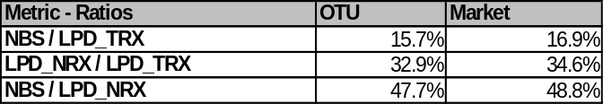

LPD Metrics – Key Observations:
- New Brand Starts (NBS) is comprised of:
  - 82% of New Patient Starts (NPS) (i.e., major share of NBS)
  - 15% of Switches
  - 5% of Concomitant Starts (CS)
- Correlations:
  - OTU NBS vs. OTU NPS à 0.95 (very strong correlation)
  - OTU NBS vs. OTU Switches à 0.5 (medium)
  - OTU NBS vs. OTU TRx à 0.5 (medium)
- Since the majority of the information about brand starts are captured by NBS metric alone, we omitted NPS, Switches and CS from further analysis.
- Metrics used for further analysis: OTU NBS, OTU TRX, Market NBS, and Market TRx.

Weighted Calls and Samples:
- Advantages of Weighting Calls and Samples
  - Distributes the effects of calls and samples over a period of time
  - Provides more variation in data at the physician level to achieve better physician level models
  - Related reference:
    - Natalie Mizik and Robert Jacobson, “Are Physicians “Easy Marks”? Quantifying the effects of Detailing and Sampling on New Prescriptions” Management Science, vol 50. No. 12, December 2004, pp.1704-1715
- Calls and Samples are assumed to be effective for about 6 months, where the effects are assumed to fall exponentially (an exponent of 0.5 is assumed) over this period of time
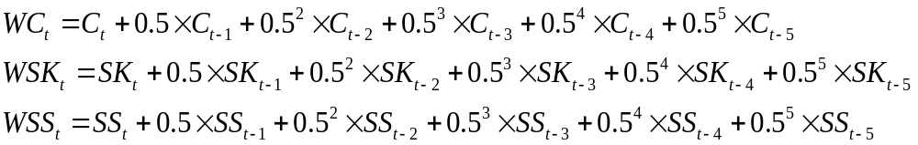

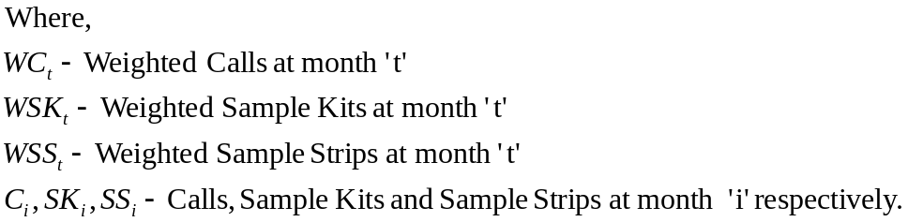

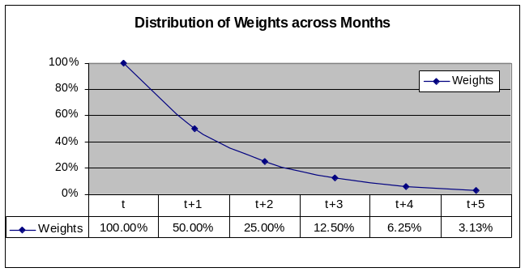
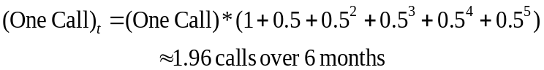

- That is, One actual call (or sample) is equivalent to 1.96 weighted call (or sample).

Segmentation:
Types of Segments:
Physicians were segments in two dimensions: Volume Segments and Sensitivity Segments. Volume segments (5 groups) identify physicians who are likely to generate more scripts. Sensitivity segments (3 groups per volume segment) identify the sensitivity of physicians to calls and samples. Thus, there are a total of 5 X 3 = 15 physician segments. Physicians with non-measurable sensitivity (due to lack of calls or samples data) were dropped from further analysis

Adjusted Score and Methodology for obtaining Volume Segments:
For the volume segments, importance of OTU TRX should be high so that we can reduce the risk of pushing the high OTU TRx doctors to the lower decile groups. We have to identify the doctors who start more new business at the market and to some extent at the product level also. Following metrics and weights were chosen to reflect the above requirements
  - 40% One Touch Ultra TRx
  - 30% Market NBS
  - 20% One Touch Ultra NBS
  - 10% Market TRx
Each metric was normalized (Z-Score) using the formula:
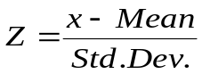

Outliers, mainly high positive Z’s, were truncated. Weighted Score was obtained as,
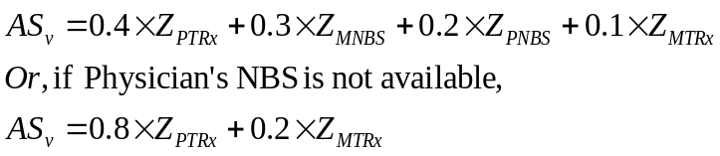

As a first step to obtain the volume segments, quintiles based on OTU TRx were obtained and the number of physicians for each group was determined. As the second step, the physicians were sorted in the descending order of adjusted score for volume segments (ASv). Then the physicians were divided into 5 groups using the number of physicians per group obtained initially in the first step. The highest volume segment was named V5 and the lowest volume segment was named V1. Some key statistics for volume segments are shown below. Data was aggregated for the 24 months of the study period.

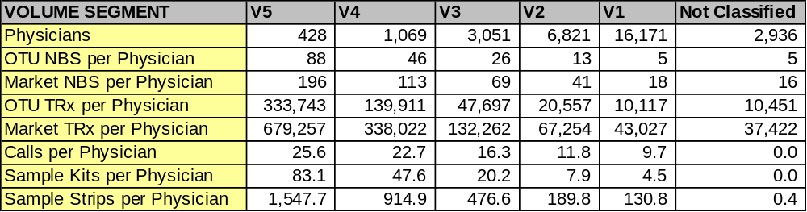

Adjusted Score and Methodology for obtaining Sensitivity Segments:
Sensitivity segments are designed to reflect the promotional sensitivity of the physicians. We need only the OTU related information as functions of calls and samples. As any New Brand Starts are likely to continue filling Rx’s for a while, giving higher weight to the OTU NBS would identify the physicians with high potential to generate new business. A 60% OTU NBS and 40% OTU TRX is a good combination as relatively high OTU TRX ensures that we are not dropping the importance of physicians with large number of prescriptions.
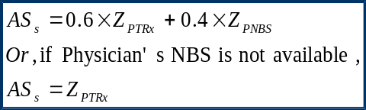
OTU TRx and OTU NBS were normalized and the outliers were truncated. Weighted Score was obtained as,

The adjusted score was again normalized and transformed to have same mean and standard deviation as that of OTU TRx distribution. That is, the final adjusted score is represented in the same unit and scale as that of OTU TRx.
To obtain the sensitivity segments, first regression models with linear and quadratic terms were derived for each physician. In this model, Adjusted score (ASs) was used as dependent variable and the independent variables were, Weighted Calls, Weighted Sample Kits, Weighted Sample Strips, Competitor TRx, and Lagged TRx.
Then, for each physician, the calls and samples were varied over a valid range and the optimum response within this range was measured using the model obtained for the corresponding physician. Within each volume segment, physicians were sorted in descending order using the optimal response value. Then the physicians were divided into three groups (S5, S4 and S3). Each group has equal number of physicians. Segment S5 is relatively more sensitive than S3. Due to sparse calls and sample frequency data, these segments are approximate indicators of sensitivity of the physicians’ behaviors.
Some of the key statistics for each of the 15 segments is shown below:

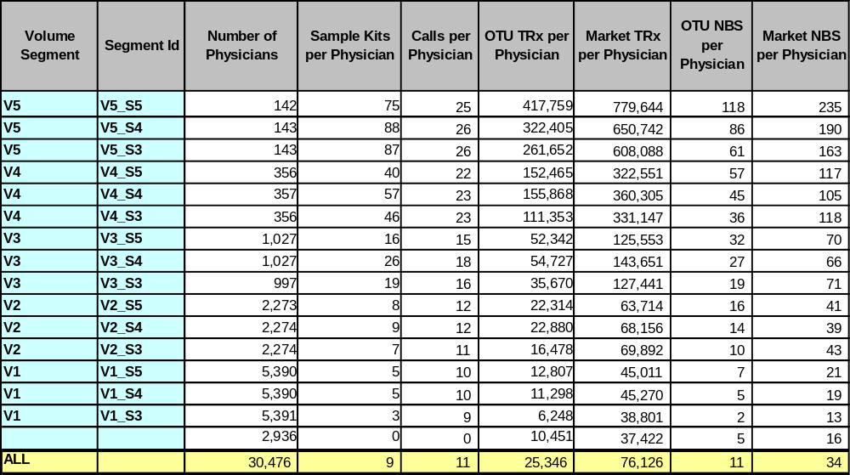

Promotional Response Models:
Promotional models were built for each segment. Monthly physician data within each segment were used for modeling. OTU TRx was used as dependent variable. Many independent variables were considered initially. Attempts were made to get the best possible segment level promotional models by eliminating variables that were not relevant to the models. Segment level reduced models, with only the sample kit terms, were derived as the final models

Variables Considered:

Variables | Description
C | Weighted Calls (details). Calls are weighted exponentially for 6 months with the exponent as 0.5. Weights assigned from t(n) to t(n-5) are [1, 0.5, 0.25, 0.125, 0.0625, 0.03125)
C_PER_TRX | Weighted Calls Per Product TRx.
LAG_P_TRX | Lagged Product TRx. Accounts for the physician's Rx history.
COMP_TRX | Competitor TRx. Computed as Market TRx - Product TRx.
P_TRX | Product TRx. Dependent Variable.
C_C | Square of Weighted Calls.
SK | Weighted Sample Kits. Weights are same as that of calls.
SK_PER_TRX | Weighted Sample Kits per Product TRx.
LAG_P_NBS | Lagged Product New Brand Starts. Accounts for NBS history.
SK_SK | Square of Weighted Sample Kits.
C_SK | Cross product of C and SK
SS | Weighted Sample Strips. Weights are assumed same as that of Calls.
SK_PER_NBS | Weighted Sample Kits per Product New Brand Start.
SK_PER_C | SK per unit C.
TREND_VAL | Indicator of Product Trend. Varies from 1 to 24 according to the data month.
SPEC_GRP | Specialty Group. 0 - PCP; 1 - ENDO
MC_IDX | Managed Care Index. Physicians managed care index is assumed to be same as that of their territory. Managed Care Index is a standardized score proportional to the Rx volume through insurance companies by territory.

Variable Elimination Criteria:

Following were considered while eliminating the variables:
  - Model F and R-Sq should be maximized.
  - All the parameter estimates must be very significant. Most parameters are highly significant. Very few fall between 5% to 1% significance level.
  - As far as possible, attempts were made to retain the basic SK variables like, SK, SK_SK and SK_PER_TRX.
  - Parameter estimates with questionable values (or directions) were removed. These parameter estimates might have been due to multicollinearity.
  - PRESS statistics were checked to contain the influence of outliers.
  - Variance Inflation Factors and Eigen Values were checked to be within limits so as to reduce multicollinearity as much as possible.
  - In order to retain SK related variables, in few cases, slight multicollinearity was accepted among these variables. For optimization purposes, multicollinearity among related variables may not hurt the model performance.
Model Parameters:
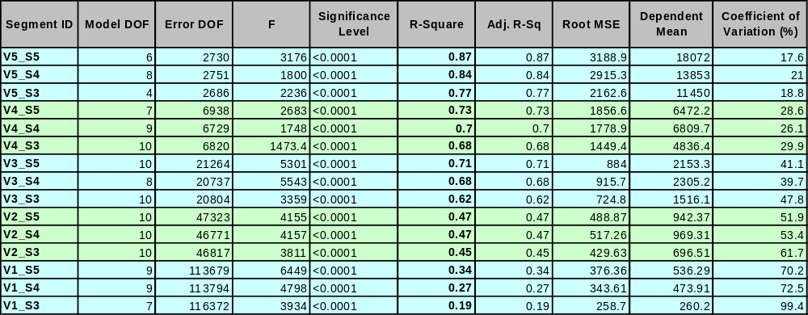

All the models are highly significant (alpha < 0.0001). R-Squares vary from 0.19 (Low Volume Segments) to 0.87 (High Volume Segments). High volume segments have high R-Square, mainly because of large contribution (Type II SS) of persistence and inertia related terms (lagged variables). In general, an R-Square of 0.4 or above is considered to be good for such models. Details about model parameters are listed below.
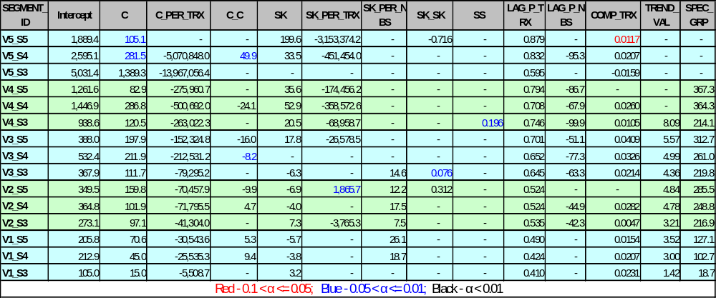

Most of the parameter estimates were significant at 1% level. Exceptions are noted. Segments V5_S3 and V3_S4 do not have “Sample Kits” related terms. These two segments could not be used for optimal sample allocation. In general, parameters with alpha <= 5% are considered to be significant

Reduced Models:
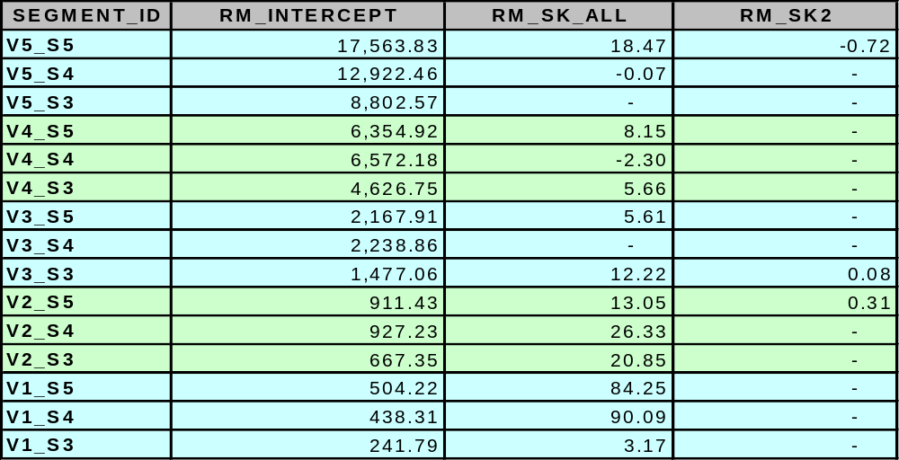

All the parameters, except SK, are held constant at their mean level. Reduced models for each segment are obtained by substituting parameter means (except SK) to the full model. These are the final segment level models (13 out of 15) that will be used for segment level optimization. Lower volume segments are more sensitive to samples and have a smaller measurable range in sample kits. Following graphs shows the reduced models for volume segments V5 and V4.

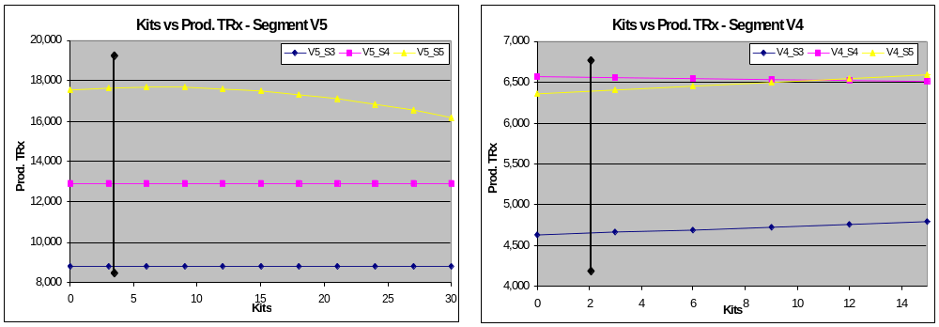

- Segment V5_S5 shows a slight increase in OTU TRx when sample kits are increased up to 6 per physician per month. Beyond 6 kits, the TRx decreases
- Segment V5_S4 and V4_S4 are not too sensitive to samples
- Segment V5_S3 is not measurable due to the lack of sample related terms in the model
- Segment V4_S5 and V4_S3 shows some positive sensitivity
- Both V1_S5 and V1_S4 has almost equal positive sensitivity
- V1_S3 is not too sensitive. Its R-Sq. is low, due to minimal call activities
Overall, the low volume segments are more sensitive than high volume segments. However, their measurement range is small. Care should be taken to constrain the allocations accordingly.

Optimal Sample Kit Allocation:
Overall Approach:
Reduced models are combined together to form the objective function. Various allocation scenarios are constructed in the form of constraints. Constraints are considered at the following levels:
  - Segment Level
  - Area Level
  - Territory Level
A heuristic divide and conquer approach is used to determine allocation at various levels. First, get optimal allocation at segment level (13 segments). Then, distribute these allocation to area level (3 Areas) according to number physicians in each segment in each area. Finally, distribute allocation at area level to their corresponding territories according to number of physician’s on each segment.

Scenarios Considered:
The constraints are set based on current level of sampling projected to reflect the availability of 750K samples for HCP physicians.
- CASE 1
  - Segment: + or – 50%
  - Area: + or – 50%
  - Territory: +100% to -50%
- CASE 2 (Restrictive Constraints)
  - Segment: + or – 20%
  - Area: + or – 20%
  - Territory: +100% to -50%
- CASE 3 (Relaxed Constraints)
  - Segment: + or – 100%
  - Area: + or – 100%
  - Territory: +100% to -100%
An example that shows the computation procedures for segment level constraints is shown below.
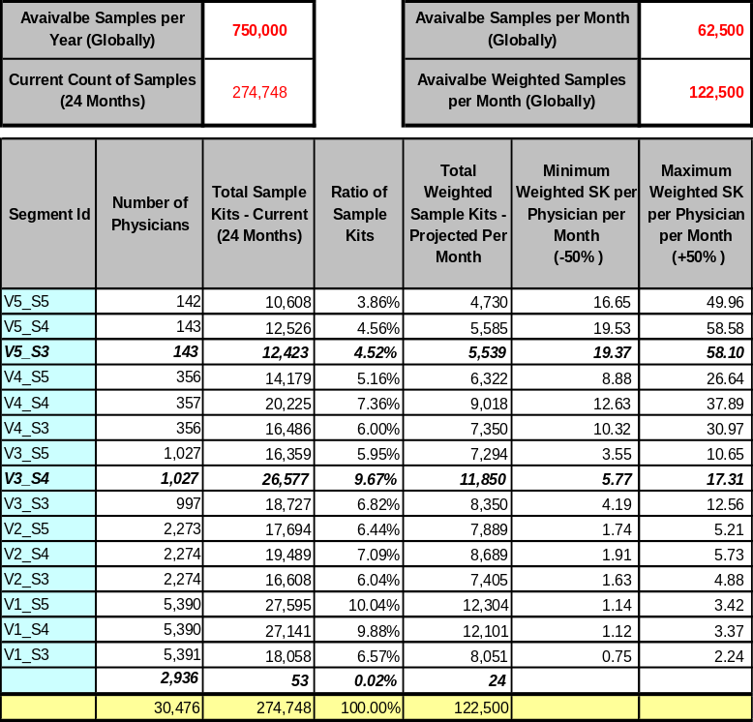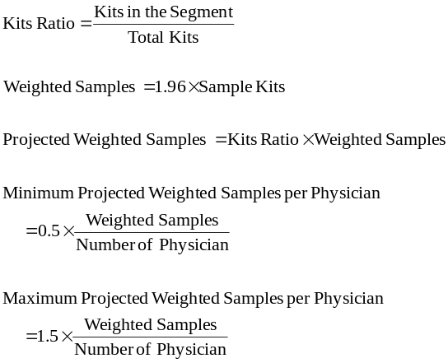

Segment Level Allocation – Problem Setup:
Objective Function is the sum of the reduced models of each measurable segment. The local constraints keep the allocations within the minimum and maximum weighted sample kits of the segment. There are 13 X 2 = 26 local constraints. The global constraint states that sum of all the allocated samples must be equal to the globally available kits.
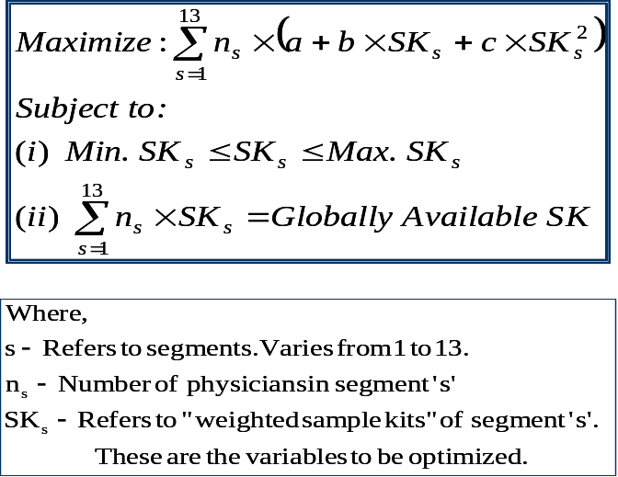

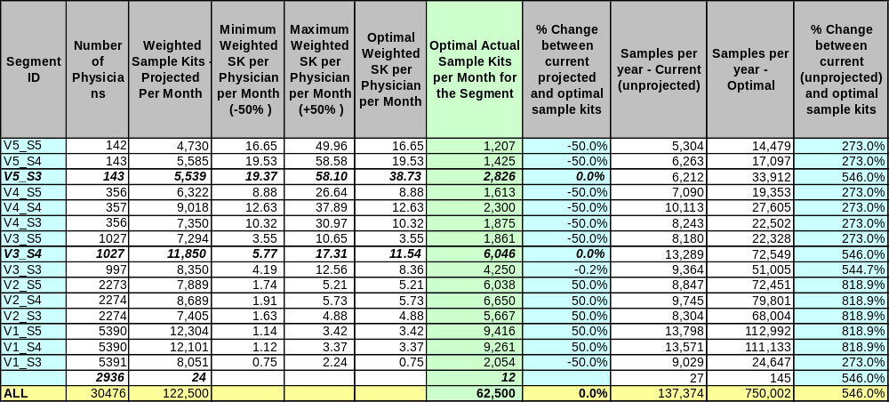

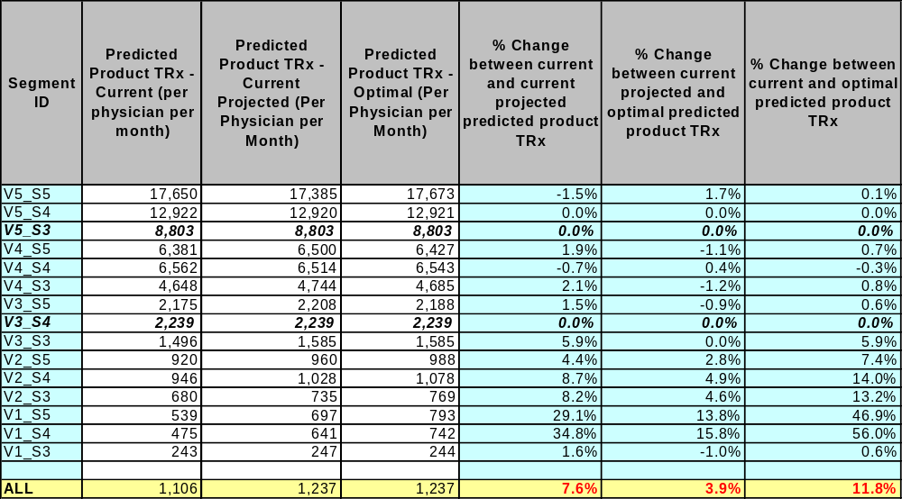

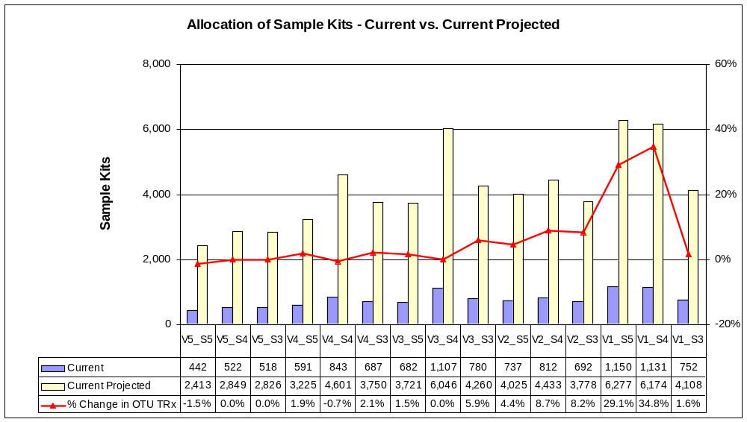

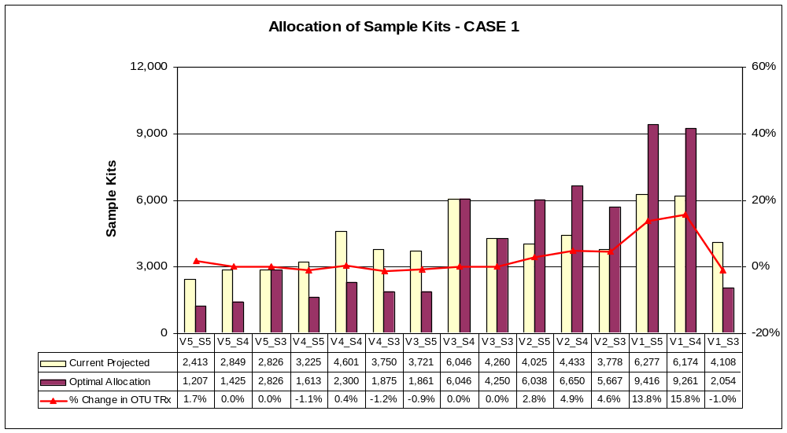

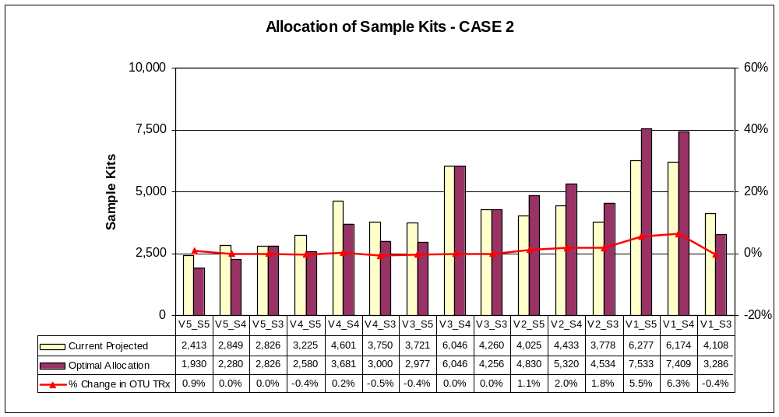

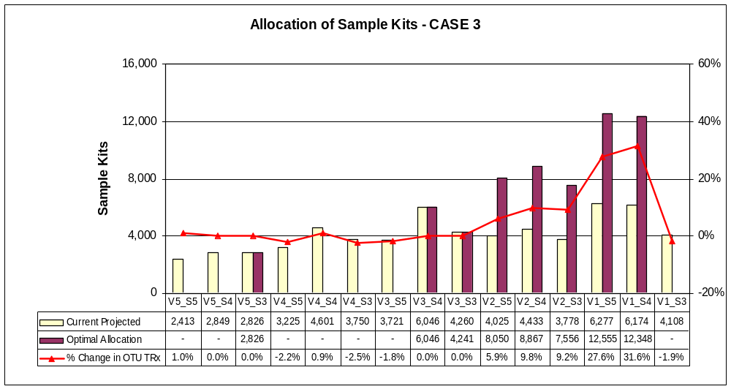

Segment Level Observations:
  - A slight increase in samples from the current level is enough for segment V5_S5. Current projected and both Case 1 and Case 2 results in over sampling for this segment
  - Optimal allocation favors lower volume segment
  - A large increase in estimated OTU TRx could be seen in the lower volume segments
  - Current projected allocation results in 7.6% estimated increase in OTU TRx
  - An improvement of 3.9%, 1.6%, and 7.6% over the current projected allocation could be observed from Case 1, 2, and 3 respectively
  - Compared to current allocation, cases 1, 2 and 3 results in an estimated increase in OTU TRx of 11.8%, 9.3% and 15.9% respectively

Area Level Sample Allocation:
Samples are distributed according to the number of physicians in each segment with in a given area. Such distribution is considered as ideal allocation. An optimization problem is setup to adjust the ideal allocation to fall within the area level constraints. Squared distance between ideal and final allocation is minimized, subject to the local and global constraints. An example, along with the Area level problem setup, is shown below:

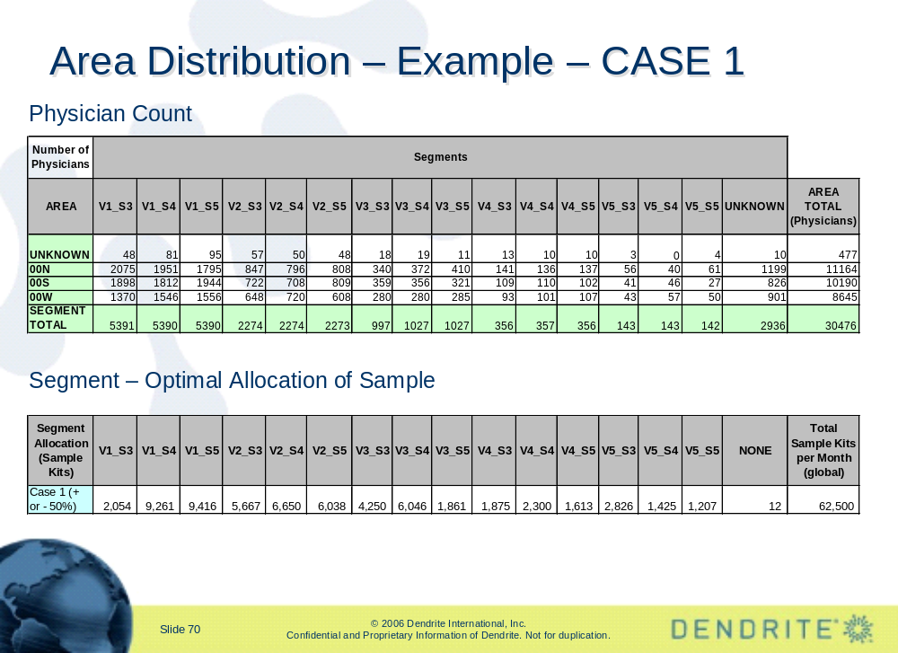

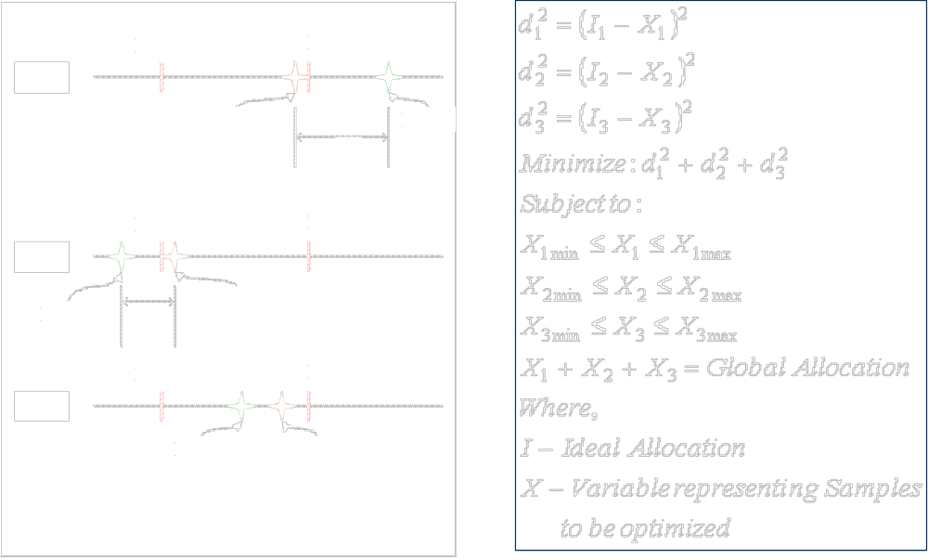

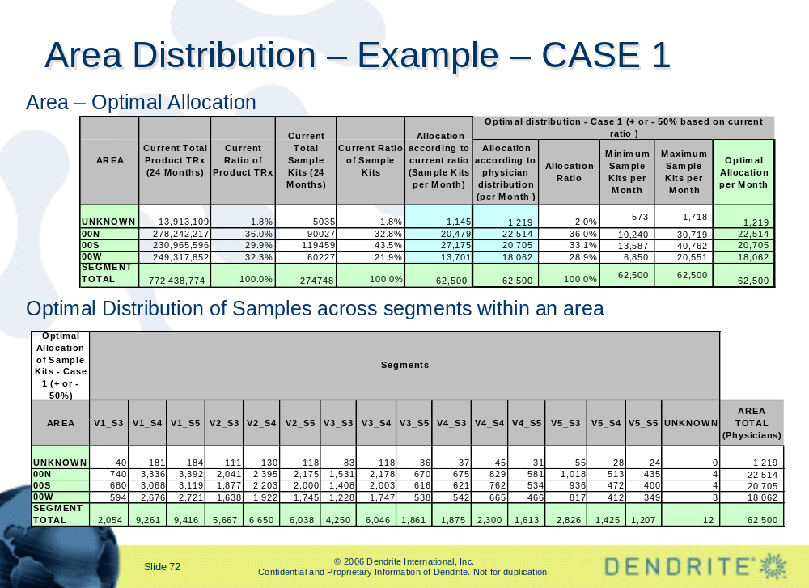

Area Level Allocation – Observations:
- All the cases allocates similar amounts of samples to areas
- Compared to current projected, cases suggests a decrease in allocation in south
- Compared to current projected, cases suggests a increase in allocation in west

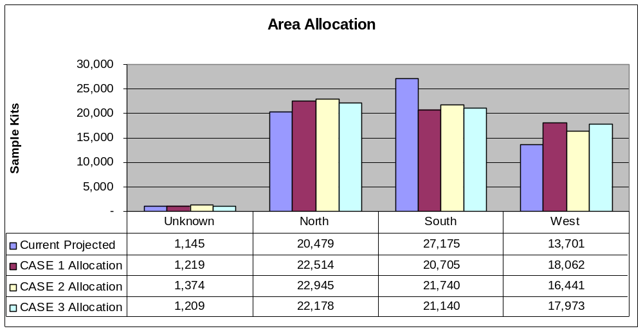

Territory Level Sample Allocation:
Each Area has around 60 to 100 territories. Separate optimization for each Area is carried out. The approach and the problem set up is similar to the area level allocation. Global constraint states that the sum of all Territory allocation should be same as optimally allocated samples at their Area level. Salient observations are listed below.

- Optimal allocations at the most under allocated 10 territories are double the current projected level.
- Optimal allocations at the most over allocated 10 territories are reduced to half of the current projected level.
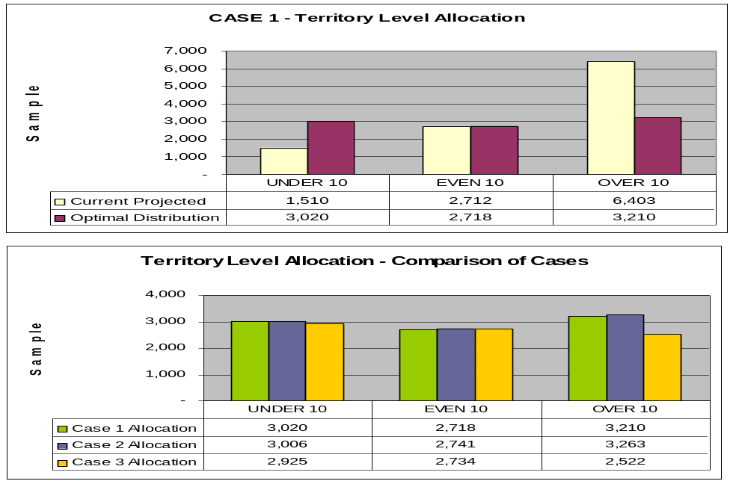
- Allocation for Even 10 territories are not changed

Current projected level of allocation changes a lot for top and bottom territories. However, all the cases allocate more or less the same number of samples for the territories being analyzed.

Summarized Results / Conclusions:
- By increasing the budget to 750,000 samples, the OTU TRx is projected to increase by 7.6%.
- Optimizing the sample allocations by segmenting based on promotional sensitivities will increase test strip volumes by 3.9%, 1.6%, and 7.6% over the current projected allocation could be observed from Case 1, 2, and 3 respectively.
- Compared to current allocation, cases 1, 2 and 3 results in an estimated increase in OTU TRx of 11.8%, 9.3% and 15.9% respectively.
- Segment V5_S5
  - Current projected and both Case 1 and Case 2 results in over sampling for this segment.
  - Slightly increasing the samples from the current levels will maximize OTU TRx.
- Lower volume segments – the largest increase in estimated OTU TRx could be seen in the lower volume segments.
- All the cases allocate similar amounts of samples to areas.
- Compared to current projected, cases suggest a decrease in allocation in south.
- Compared to current projected, cases suggest a increase in allocation in west.
- Current projected levels of allocation changes a lot for top and bottom territories.
- However, all the cases allocate more or less the same number of samples for the territories being analyzed.

Follow-up Analysis – Physician Level Allocation:
As a follow-up analysis, LifeScan requested us to further divide the V5 segment physicians into granular buckets of around 40 physicians in each bucket. This bucket is based on the amount of optimal samples that are required for each physician.
The Product NBS and Market NBS were not projected in our database. Based on our 50% coverage, we used a projection factor of 2 to obtain "Projected Product NBS and Market NBS". The projected product NBS and Market NBS were used for this analysis.
The aim of this study is to divide the V5_S5 and V5_S4 physicians into a sub group of 40 each, based on the required optimal sampling level. Physicians in segment V5_S3 were not used in the study as its promotional response model do not have "Sample Kit" related terms. There were a total of 281 physicians in segments V5_S5 and V5_S4. Seven Sampling Segments (with approximately 40 physicians each) were derived.
We first obtained the reduced models for each physician based on the overall model of their respective "volume and sensitivity" segments. Then we set the following constraints for each physician:
Minimum Samples Per Month = Maximum of (25% of Mrket NBS, 50% of Product NBS).
Maximum Samples Per Month = 150% of Market NBS. If M_NBS is zero (ie., those that were not matched to LPD DB), then we assume the projected current sample kits as their maximum.
We chose 150% of Market NBS as maximum constraint in order to account for variations in NBS projection factor (i.e., thrice the raw NBS).
The Global constraints are set so as that the allocated samples do not exceed the samples available (based on projected historic trend) in the segments V5_S5 and V5_S4 respectively. Global constraints are required so that the optimal values are not computed to be either the allowed minimum or the maximum, and the available sample kits are optimally shared. The objective is to maximize the total product TRx (i.e., all the equations are added).
After obtaining the optimal samples for each physician, the physicians are sorted based on the optimal values and are divided into equal groups of 40. The low value segment (SAMP_SEG_1) has 41 physicians. SAMP_SEG_7 requires highest amount of samples, while SAMP_SEG_1 requires lowest amount of samples. Some statistics at the segment level is shown below.

SEGMENTS | Physician Count | Mean Optimal Sample Kits Per Month Per Physician | Std. Dev. in Optimal Sample Kits per Month per Physician | Mean Product NBS per Physician Per Month | Std. Dev. in Product NBS per Physician Per Month | Mean Market NBS per Physician Per Month | Std. Dev. in Market NBS per Physician Per Month
SAMP_SEG_1 | 41 | 4.6 | 1.9 | 6.3 | 4.1 | 13.9 | 9.1
SAMP_SEG_2 | 40 | 8.9 | 1.2 | 7.5 | 4.5 | 20.2 | 13.5
SAMP_SEG_3 | 40 | 13.4 | 1.7 | 5.7 | 2.9 | 9.7 | 3.2
SAMP_SEG_4 | 40 | 19.0 | 1.5 | 7.7 | 2.7 | 13.9 | 4.6
SAMP_SEG_5 | 40 | 23.1 | 1.2 | 8.4 | 2.4 | 15.7 | 2.9
SAMP_SEG_6 | 40 | 28.4 | 2.3 | 9.6 | 3.3 | 19.6 | 4.3
SAMP_SEG_7 | 40 | 42.8 | 10.5 | 14.0 | 9.0 | 30.9 | 11.0

Physicians who belong to each of these segments along with their address and territory details were provided to the client.
During phase-II requirements discussion, we suggested using “Growth” Segments instead of “Sensitivity” Segments we used in the segmentation. The Growth here is defined based on the difference in NBS volume between Year 2 and Year 1 for each physician.

Outcome:
This project work and the results were well received by LifeScan. Some of the response models were integrated with their promotional response model portfolio. LifeScan planned to start a small pilot based on the final segments (follow-up analysis) we provided. Same analysis was being planned for the most recent period as Phase-II analysis, with an emphasis on optimal sample and call allocation.

- Forecasting – Allergan

Problem Statement:

Short Description:

Methodology:

Results:

Outcome:

- Forecasting – Allergan

Problem Statement:

Short Description:

Methodology:

Results:

Outcome:

- Forecasting – Allergan

Problem Statement:

Short Description:

Methodology:

Results:

Outcome:

