- Sales Force Design and Implementation - Odyssey

Problem Statement:
In anticipation of product launch activities for Senctura, a new competitor in the overactive bladder (OAB) market, Odyssey Pharmaceuticals, Inc. (Odyssey) approached Dendrite with a request to redefine their field sales force to optimize the location of sales representatives, target high-volume and behaviorally crucial physicians, maximize call frequency to these targets, provide optimal territory alignment, and integrate the data with SFA (WebForce) system.

Short Description:
Odyssey augmented existing field sales personnel by partnering with Indevus to create a joint sales team numbering just over 520 employees. This team was divided into two sales groups: a Base sales force consisting of 406 sales representatives and 34 District Managers, and a Specialty sales force composed of 75 sales representatives and 7 District Managers, yielding a ratio of approximately twelve to one between sales representatives and managers. The Base sales force contained roughly equal numbers of Odyssey and Indevus personnel, while the Specialty sales force was made up of Indevus resources alone. The sales call plan projected each sales representative to target between 150 to 200 physicians with eight to twenty-four calls per physician per year, depending on the importance of the target practitioners. Assuming 220 field days per year, the plan assigned to each sales representative approximately seven or eight calls per day.
To realize this sales force vision, Odyssey engaged Dendrite to execute five strategic objectives:
- Provide foundation knowledge of central OAB sales hubs for each sales representative and manager. This information ultimately optimized physician coverage calculations, while early identification of potential sales centers facilitated the initiation of the hiring process.
- Pinpoint key physicians in the OAB market.
- Segment key physician targets and design a call plan that assigns approximately eight calls per day on targeted OAB practitioners per a schedule that weighs the relative importance of each target’s prescribing habits, early adoption potential, and other relevant behaviors.
- Design a sales force structure featuring highly compact territory modules offering equivalent call schedules to sales representatives within each territory.
- Communicate results obtained in this project to Dendrite’s SFA team for incorporation into Odyssey’s WebForce™ application.

Methodology and Results:
Market Definition and Key Data Elements:
The OAB market is composed of eight major products:
- Detrol LA – Cap
- Ditropan XL – Tab
- Detrol – Tab
- Oxybutynin CL – Tab
- Oxytrol – Patch
- Ditropan – Tab and Syrup
- Flavoxate HCL – Tab
Prescriber behavior for these products was tracked over a twenty-four-month period beginning January 2002 through December 2003. New prescription counts (NRx) and total prescription counts (TRx) for each month were provided by IMS, as were corresponding prescriber demographics including address, city, state, zip code and primary specialty. Additional information relating zip codes details to their corresponding important cities and Metropolitan Statistical Areas (MSAs) was obtained from Dendrite’s internal database. Other data elements used for targeting are explained in the corresponding section.

Identification of Sales Territory Centers:
Early identification of urban areas with high OAB prescription volume allowed intelligent assignment of field sales personnel prior to creation of the envisioned optimized sales force structure and enabled recruitment efforts to begin at once. Optimally sized sales centers (territories) that offered the most effective prescriber coverage were identified for each sales representative and district manager using the prescription volume aggregated by zip code.

Methodology:
To locate sales center sites, an approximate territory design was derived using a proprietary modified K-Means Clustering technique. The goal of K-Means Clustering is to divide objects into K clusters such that some metric relative to the centers of the clusters is minimized. Various metrics that can be minimized include maximum distance to its center for any object, sum of the average distance to the centers over all clusters, sum of the variance over all clusters, and total distance between all objects and their centroids. The metric used to minimize and the choice of a distance measure will determine the shape of the optimum clusters.
Application of this algorithm produced a territory design wherein each sector contributed approximately equal prescription volume and was as compact as possible. The centers of the obtained territories were recommended as potential principal cities where sales representatives and/or managers could be located. The following sections detail the procedures used to identify sales centers.

Targeting:
Deciling of prescribers in the OAB market was applied based on individual total market TRx aggregated over the past twenty-four months. Physicians in each decile contributed ten percent of the total market TRx.

Base Sales Force Territories:
For the construction of 406 Base Sales Force territories, physicians from Decile 10 through Decile 3 were identified as potential targets, representing eighty percent of all prescriptions. Decile ranges for these target physicians were computed using approximately 150 to 175 targets within every territory, per Odyssey’s guidelines for preferred number of prescribers assigned to each sales representative. For Base Sales Force territories, this translated to 406*175 = 71,050 physicians. Deciles 10 through 3, representing eighty percent of total market activity, tallied somewhat more than 73,550 physicians. This slight surplus of prescribers was intentional, designed to offset anticipated attrition during later stages of the targeting process.
Territory analysis was carried out at the state level. The percent of prescription volume contributed by each state to the national total was scaled between 0 and 406 to obtain an approximate number of territories per state. In some cases, states were combined to ensure a balance in total prescription volume covered by each sales representative. All territories followed a naming convention. For example, “ODY_NJ_3” represents the third territory created for New Jersey. States that yielded a low number of total prescriptions, such as Alaska and Puerto Rico, were not considered in the analysis.
Central locations are computed in terms of geocodes (latitudes and longitudes) and are listed in terms of zip code, nearest cities, county, state, and MSA code.

Top 10 States:
State | Total Market TRx (past 24 months, deciles 3 through 10) | Number of Prescribers (In deciles 3 through 10) | Number of Reps allocated | Market TRx per Rep | % deviation from mean Market TRx (mean = 41843) | Prescribers per Rep
CA | 1284326 | 5859 | 31 | 41429.87097 | -0.987331291 | 189
TX | 1051690 | 4540 | 25 | 42067.6 | 0.536768396 | 181.6
FL | 990039 | 4298 | 24 | 41251.625 | -1.413318835 | 179.0833333
PA | 961173 | 4105 | 23 | 41790.13043 | -0.126352234 | 178.4782609
NY | 945803 | 3907 | 23 | 41121.86957 | -1.723419532 | 169.8695652
MI | 934099 | 3692 | 22 | 42459.04545 | 1.472278409 | 167.8181818
OH | 814632 | 3570 | 19 | 42875.36842 | 2.467242839 | 187.8947368
IL | 703081 | 2947 | 17 | 41357.70588 | -1.159797619 | 173.3529412
NC | 529807 | 2354 | 13 | 40754.38462 | -2.60166667 | 181.0769231

Base Territory Centers in Alabama:
Territory Id | Territory Center - Zip Code | Territory Center - Nearest City | Territory Center - County | Territory Center - State | Territory - Total Market Trx | Territory - Number Of Prescribers | Territory - Number of Zips | Other Cities / Areas
ODY_AL_0 | 35206 | BIRMINGHAM | JEFFERSON | AL | 40265 | 177 | 36 | East and Nort East of Birmingham
ODY_AL_1 | 36606 | MOBILE | MOBILE | AL | 39652 | 170 | 20 | Prichard, West and South West of Mobile
ODY_AL_2 | 35456 | DUNCANVILLE | TUSCALOOSA | AL | 39876 | 170 | 32 | North Port, Tuscaloosa, South West of Birmingham
ODY_AL_3 | 35962 | CROSSVILLE | DE KALB | AL | 40520 | 155 | 22 | Gadsden, South East of Huntsville
ODY_AL_4 | 35541 | ARLEY | WINSTON | AL | 40168 | 173 | 22 | Double Springs, Halleyville
ODY_AL_5 | 35010 | ALEXANDER CITY | TALLAPOOSA | AL | 39324 | 203 | 40 | North Montgomery, East of Auburn
ODY_AL_6 | 36420 | ANDALUSIA | COVINGTON | AL | 38620 | 172 | 40 | West of Enterprise
ODY_AL_7 | 35643 | HILLSBORO | LAWRENCE | AL | 40551 | 166 | 20 | North west of Huntsville, Decatur, Florence

Base Sales Force Districts:
Base Sales Force districts were constructed by combining the base territories. Districts were obtained by minimizing the same kind of metrics used in territory formulation.

Map of Base Sales Force Districts (Flags) and Territory Centers (Circles):
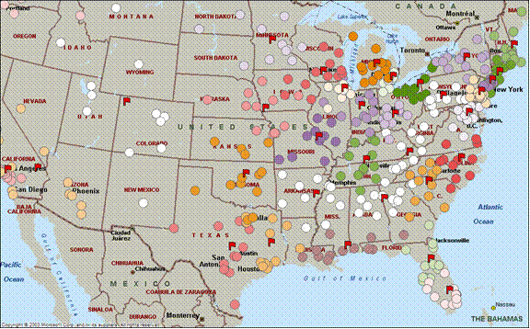

Specialty Sales Force Territories:
For the construction of Specialty Sales Force territories, only physicians from Decile 10 through Decile 7 were identified as potential targets, covering forty percent of total prescriptions. The total targeted physicians in this analysis numbered 14,715. Considering approximately 175 doctors per territory for each of 75 specialty territories, 175 * 75 = 13,125 physicians were expected targets. As with the base territories, a higher number of targets (for example, 14,715) were initially considered to anticipate the attrition at later stages. Seventy-five Specialty Sales Force territories were constructed by combining zip codes. A modified algorithm was used to identify sales centers containing highest prescription activity in the territory that also minimized travel between other areas within the territory.
The TerrAlign Group, a consulting company specializing in field force deployment issues, conducted a similar analysis using their own algorithms and provided a number of updates to the proposed centers. Few deviations from Dendrite’s suggested sales centers exist in these files. This early identification of sales centers identified possible territory structure and set expectations for later stages of specialty territory construction.

Specialty Territory Centers – Example Stats:
Specialty Territory Id | Specialty Territory Center - Zip Code | Specialty Territory Center - Nearest City | Specialty Territory Center - State | Specialty Territory - Total Market Trx | Specialty Territory - Number Of Prescribers | Specialty Territory - Number of Zips Covered
ODY_ZL_SPEC_TERR_0 | 98104 | SEATTLE | WA | 110563 | 211 | 80
ODY_ZL_SPEC_TERR_1 | 32134 | FORT MC COY | FL | 106801 | 198 | 68
ODY_ZL_SPEC_TERR_10 | 95360 | NEWMAN | CA | 122889 | 187 | 65
ODY_ZL_SPEC_TERR_11 | 14211 | BUFFALO | NY | 114091 | 132 | 50
ODY_ZL_SPEC_TERR_12 | 48140 | IDA | MI | 116592 | 165 | 44
ODY_ZL_SPEC_TERR_13 | 15120 | HOMESTEAD | PA | 114781 | 199 | 72
ODY_ZL_SPEC_TERR_14 | 65686 | KIMBERLING CITY | MO | 115136 | 210 | 58

Map of Specialty Sales Force Territory Centers:

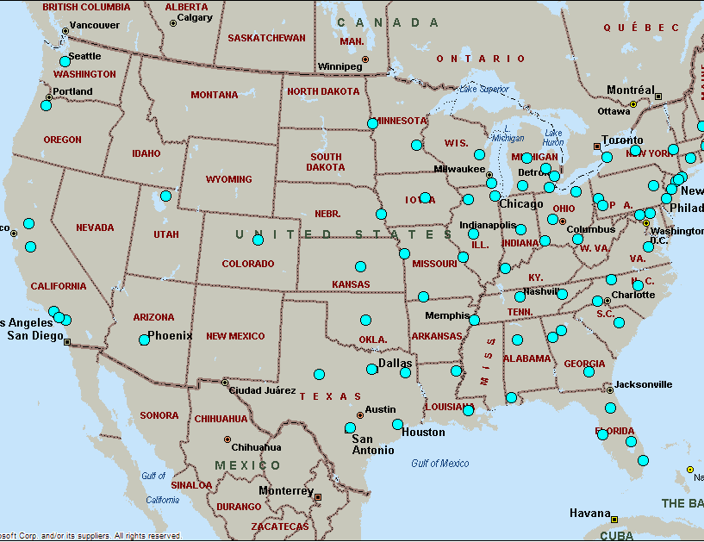

Specialty Sales Force Districts:
Specialty Sales Force districts were constructed by combining the specialty territories, using base territories as primary units. As there were only seven Specialty Sales Force districts to be designed, it was decided to do this manually or wait until the final field session.

Details About the Clustering Algorithm to Obtain Optimal Territory Centers:
A modified form of K-Means clustering algorithm was used to obtain the territory centers. Each territory is considered as a cluster and the zip codes are considered as “Sales Correspondence Units (SCU)”. The problem is to assign SCU’s to different clusters in such a way that a) The total Market TRx in each cluster is more or less same and b) the clusters (territories) are as compact as possible so that the driving distances between various SCU’s with in a given cluster is minimized.
The general K-Means clustering algorithm works as follows:
- Number of clusters is set as equal to the number of territories that are desired.
- Each zip code, considered as a SCU, is initialized with the corresponding latitudes and longitudes of zip centers and the total market TRx generated by the doctors in that zip code during the study period. Initially none of the SCU’s is assigned to any clusters.
- Initialize cluster centers by randomly choosing a SCU from the available SCU’s.
- Assign the remaining unassigned SCU’s to one of the cluster (say, Cluster 0).
- Update the cluster center. The cluster center is computed as “centroid” of a mass. Cluster center is characterized by center latitude and center longitude. This centroid is the mean latitude and mean longitude of all SCU’s that belong to this cluster. That is,
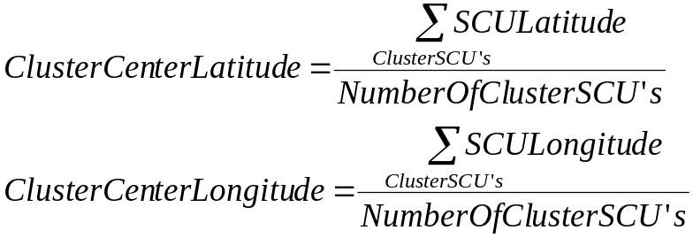
This centroid measure helps to locate the cluster center close to where many zip codes are densely located (as they add more weight to the means). This is a desiarable property for territory centers as, ideally a sales rep would like to be located close to many of his sales targets. In order to further refine this metric so that the sales representatives are close to many high potential targets, a weight proportional to the zip codes market TRx is used. That is,
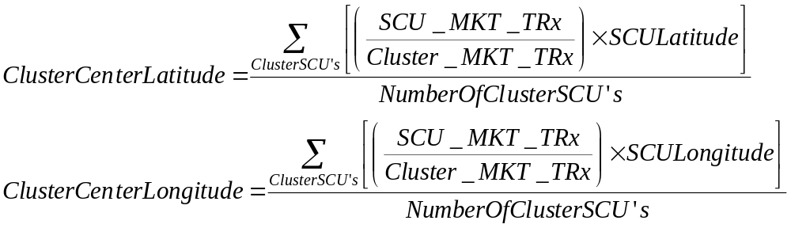
The above metric was used for specialty sales territories. For base sales territories, the centers were more or less same irrespective of the centeroid metric used.
- Then, as the next iteration, reassign SCU’s to the cluster that minimizes the scoring function. More details about the scoring function are detailed in the section below. Usually, Euclidean distance is used for K-Means algorithm. Keeping our objectives of both minimizing the Market TRx as well as territory compactness, we devised a proprietary scoring function that quantifies the objectives as a single metric.
- Once such assignment is done, update all cluster centers.
- Repeatedly process each SCU until no more new cluster assignments are possible. This ensures a locally optimal (the local here depends on initial cluster assignments) territory (cluster) to zip (SCU) assignments. The final cluster centers are then recommended as territory centers where Odyssey can begin their recruitment process.

Scoring Function:
The scoring function that was minimized has two components: a) measure of cluster compactness and b) the standard deviation in Cluster Market TRx between the clusters.
The distance between the SCU being considered for assignment and the cluster center of the potential cluster is used to determine cluster compactness. That is,
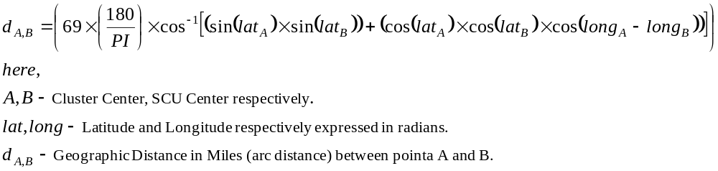
Geographical distance can be calculated by:
- cos C = (sin latA * sin latB) + (cos latA * cos latB * cos (lngA - lngB))
- where C is the arc distance between A and B.
- inverse cosine of the above eqn gives C in degrees
- multiply by 69 to get C in miles

The standard deviation in Cluster Market TRx is computed as:
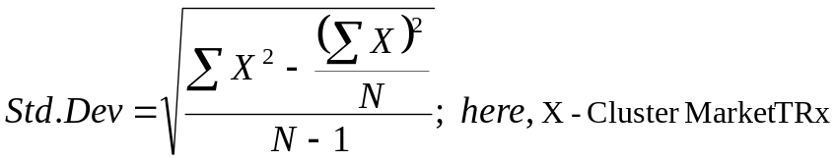

In order to minimize the computation time in computing the standard deviation during iterations where an SCU is assigned from a Source Cluster to Target Cluster, a simple not so computing intensive formulae was derived. That is,
Let x1, x2,..xs,..,xt,..xn be initial population with initial variance varI.
Let the new population be x1, x2,..xs-delta,..,xt+delta,..xn
Then the new variance varF is given by,
VarF = VarI + (2*delta [delta - (xs - xt)]) / (n -1).
Here, “delta” refers to the Market TRx of an SCU being transferred from source cluster to target cluster and “xs”, “xt” are the Market TRx of source and destination clusters respectively. “n” is the total number of clusters.
After obtaining these two metrics, they are scaled to lie between specific ranges. These ranges are determined by trial and error (by looking at the compactness of territories) and were fixed at 0 to 100 for geographic distances and 0 to 10 for Market TRx. These scalings are nothing but a way to assign weights to different metrics that are used to come up with scoring function.
The Scoring Function is the sum of “Scaled Geographic Distance” and the “Scaled Market TRx”.

Physician Targets:
In order to identity key target prescribers, numerous practitioner-level measures were considered; among them, total OAB prescriptions written, inclination for early adoption of new products, strong persistence behavior, and high initiation characteristics. These measures were drawn from various data sources and assigned different weighting factors to derive a standardized physician score. This score, expressed in the same units as that of the OAB market TRx, was called the “Adjusted Market TRx”. The magnitude of this score determined the importance of physicians for targeting.

Data Description:
Market Prescriptions:
Total OAB Market Prescription data was obtained from IMS.

Adoption Ranks:
Odyssey provided the adoption rank and volume rank for each physician in the OAB market from an adoption study commissioned from IMS Health, Inc. IMS Health performed the OAB market adoption study using approximately three years of prescription data for three new OAB products that were launched during that period. Each physician was assigned a ranking between 1 (late adopter) and 6 (early adopter). The study results presented adoption details for 144,890 physicians. Dendrite’s earlier targeting exercise resulted in extraction of 73,550 targets for Base Sales Force territories, including approximately fourteen thousand targets for Specialty Sales Force territories. By using the physicians’ ME number to link the two data sets, it was possible to match and extract adoption ranks for 57,100 physicians out of the original 73,550 target practitioners.

Longitudinal Prescription Data (LPD):
Dendrite’s Data and Analytics division provided Longitudinal Prescription Data (LPD) measurements for three prescribing events: New Patient Starts, Number of Days Supply, and Number of Patients. The three LPD measures were obtained for each target physician at the product level over a twelve-month period. Of the 73,550 original target practitioners, 62,052 physicians could be matched by ME number to prescriber data in the LPD database.
The physician addresses were scrubbed so that P.O. Box addresses and physicians’ home addresses could be replaced by valid office locations.

Physician Scoring (Adjusted Market TRx)
The following numeric measures were obtained for each physician from various data sources and used to obtain a standardized physician score, called the “Adjusted Market TRx”.
- Prescriber OAB market TRx aggregated over the past twenty-four months
- Prescriber Adoption Rank
- Number of new patient starts per prescriber over the past twelve months
- Total number of days supply prescribed during the past twelve months
- Total number of patients treated over the past twelve months.
The last three measurements, which are LPD prescribing events, were used to calculate the initiation and persistence characteristics of each physician. The total number of days supply per patient indicates the average number of days a patient is expected to use any particular drug as prescribed by the physician, thus indicating the physician’s persistence for a particular drug. Mathematically, persistence in this case is defined as follows:
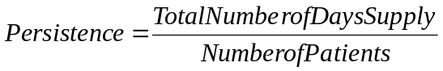
For any physician, the number of new patient starts when compared to the average new patient starts of the physician universe indicates how much more (or less) initiative that physician takes to start a new patient on a dosing formulation. Mathematically, the Initiation Index in this case is defined as follows:
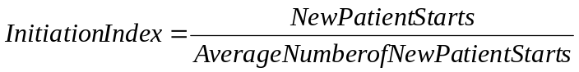
Weighting factors varied for Base Sales Force and Specialty Sales Force prescribers to obtain the Adjusted Market TRx scores. These weights are listed next.
Base Sales Force Territory:
- Total Market Prescriptions: 70%
- Initiation: 10%
- Persistence: 10%
- Adoption: 10%
Specialty Territory:
- Total Market Prescriptions: 60%
- Initiation: 15%
- Persistence: 10%
- Adoption: 15%
Initially, all these measurements were standardized by obtaining their z-scores. Appropriate weights were applied to each calculation for each physician and then those weighted calculations were summed to obtain the combined physician score. To account for missing data, not all physicians received the same weighting factor. The following formulae were used, depending on the data availability.
- None of the four parameters were missing (54,429 physicians):
- Base Sales Force:
- Specialty Sales Force:
- Adoption Rank missing (7,623 physicians):
- Base Sales Force:
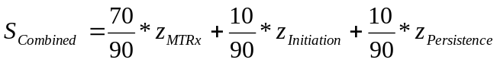
- Specialty Sales Force:
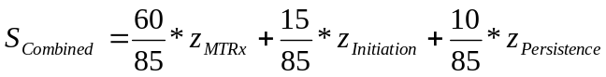
- Persistence and Initiation missing (2671 physicians):
- Base Sales Force:
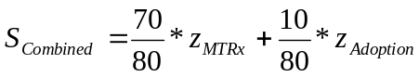
- Specialty Sales Force:
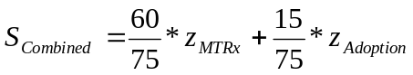
- Adoption, Persistence, and Initiation missing (8,829 physicians):
- Base Sales Force:
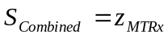
- Specialty Sales Force:
This score was then standardized again, and the following formula was used to express the obtained value in the same units as “Total Market Prescriptions”. This final score was called the “Adjusted Market TRx”, because it was expressed in the same units as Market TRx.
The “Adjusted Market TRx” was used for segmentation calculation and call plan construction.

Segmentation and Call Plans
Data Description:
Adjusted Market TRx, as computed for both the Base Sales Force and the Specialty Sales Force, were used to segment the physicians. To construct call plans, the following Odyssey guidelines were followed:
Base Sales Force:
- Field days per year: 218 to 220
- Calls per day: 7 to 8
- Number of Reps: 406
Specialty Sales Force:
- Field days per year: 218 to 220
- Calls per day: 7 to 8
- Number of Reps: 75
General:
- Calls per physician per year: Ranges from 24 to 8 according to the importance of the physician.

Segmentation:
Practitioners were segmented into three groups for each sales force. The three groups were named as follows, according to the importance of the physicians in each group.
- H = High
- M = Medium
- L = Low
Practitioners were segmented in such a way that the sum of Adjusted Market TRx for each segment is the same, and each segment covers approximately thirty-three percent of the Total Adjusted Market TRx. The number of practitioners in each segment for the Base Sales Force and the Specialty Sales Force is listed next:
Base Sales Force:
- H – 8,274 Physicians
- M – 22,386 Physicians
- L – 42,892 Physicians
Specialty Sales Force:
- H – 2,198 Physicians
- M – 4,469 Physicians
- L – 8,048 Physicians

Call Plan:
As noted previously, targeted physicians for the Specialty Sales Force were Base Sales Force targets as well. A grid of the number of physicians who existed in each segment of both sales forces was constructed to determine the optimal number of calls that would satisfy both the workload and coverage for each sales representative. By allocating twelve, ten, and eight calls per year per physician for H, M, and L segments of the Base Sales Force and Specialty Sales Force respectively, it was determined that the number of calls per targeted physician falls within the range of twenty-four to eight calls per year, as required.
Greater details can be found in the following table.

 |  | Specialty Sales Force |  |  |  | Number of Doctors in Base Sales Force | Calls per Doctor in Base Sales Force | Total Calls per Segment in Base Sales Force
 |  | High | Medium | Low | 0 | Number of Doctors in Base Sales Force | Calls per Doctor in Base Sales Force | Total Calls per Segment in Base Sales Force
Base Sales Force | High | 2,198 | 4,465 | 1,602 | 9 | 8,274 | 12 | 99,288
Base Sales Force | Medium | 0 | 4 | 6,436 | 15,946 | 22,386 | 10 | 223,860
Base Sales Force | Low | 0 | 0 | 10 | 42,882 | 42,892 | 8 | 343,136
Base Sales Force | 0 | 0 | 0 | 0 | 0 | 0 | 0 | 0
Number of Doctors in Specialty Sales Force |  | 2,198 | 4,469 | 8,048 | 58837 |  |  | 666,284
Calls per doc in Specialty Sales Force |  | 12 | 10 | 8 | 0
Total Calls per Segment in Specialty Sales Force |  | 26,376 | 44,690 | 64,384 | 0 | 135,450

 | Field Days per Year | Calls per Day | Reps | Calls per Year | Calls per Year per Rep | Workload Ratio
Specialty Sales Force | 220 | 8 | 75 | 132,000 | 1,760 | 1.026
Base Sales Force | 220 | 8 | 406 | 714,560 | 1,760 | 0.932

The number of calls made by each sales force was compared to workload specifications. The following observations confirm that these conditions were met.
For the Base Sales Force with 406 sales representatives:
- By allocating 220 field days per year with eight calls per day, it was shown that 93% of a sales representative’s workload efforts would satisfy full coverage requirements.
- By allocating 218 field days per year with seven calls per day, each sales representative would fulfill full coverage requirements by expending a little more than the assigned workload effort (107%).
For the Specialty Sales Force with 75 reps:
- By allocating 220 field days per year with eight calls per day, each sales representative would need to extend slightly over the assigned workload effort to realize the full coverage (102%).
- By allocating 218 field days per year with seven calls per day, a sales representative can obtain full coverage by increasing effort to 117% of the assigned workload.
These call plans were used to create optimal territories for each sales force.

Territory Alignment Design:
Territories were designed to be highly compact and to offer equivalent call schedules to sales representatives within each territory. That is, the drive time within each territory and the difference in total calls across territories were both minimized. TerrAlign carried out this optimization and conducted the final field session wherein district managers were able to make minor adjustments to the alignment according to individual business needs. After the final field session, all territory alignments were considered final.

Data Description:
The following data elements were required as input for optimal territory design:
- Prescriber demographics, including ME number, last name, first name, middle name, address, city, state, and zip code.
- Target details of each practitioner, such as total number of calls per year and physician segmentation, for both Base and Specialty sales forces.
- The current Odyssey employee roster.
- Details of the initially computed sales centers where reps were being hired, including initial territory names, center cities, zip codes, and nearby cities.
Also provided were targeting elements, such as MTRx (Market TRx), as well as the computed Adjusted Market TRx, persistence indicators, decile distributions, adoption characteristics, initiation indices, new patient starts, number of patients, and number of days supply, even though this information was optional and intended for use only if statistics were required at the field level for each territory.

Territory Naming Convention:
There are four alignment levels in the sales force hierarchy: Nation, Region, District, and Territory.
On the national level, there are two national managers, one each from Odyssey and Indevus. Odyssey’s national manager owns the eight-digit ID “A0000000”, and the Indevus national manager owns ID “B0000000”. These national managers have control over their corresponding sales regions across the U.S.
All Odyssey Base Sales Force territories follow the naming convention “AAddtttt", where “dd” refers to a corresponding district, and “tttt” has a numeric value of “0001” and greater.
Indevus has two regions. The first Indevus region is part of the Base Sales Force and includes 17 districts and 206 territories that are owned by Indevus. All Indevus Base Sales Force territories follow the naming convention “BAddtttt”, where “dd” refers to a corresponding district, and “tttt” has a numeric value of “0001” and greater. A second Indevus region includes the entire Specialty Sales Force. The Specialty Sales Force includes seven districts (“CAdd0000”) and seventy-five territories (“CAddnnnn”).

Methodology:
All data mentioned previously in data description section was presented to TerrAlign to facilitate territory construction for both the Base Sales Force and the Specialty Sales Force. Territories were designed to be as compact as possible and to accommodate similar call schedules across all territories.
TerrAlign used mapping software to display information such as territory name, number of doctors per territory, number of calls per territory, percentage deviation of calls from the mean, territory center, and name of the initially identified nearest sales center (where hiring was recommended) alongside the geographical view of the territory.

Field Sessions and Final Alignment:
When territory construction was completed, district managers from Odyssey and Indevus were invited to review the new alignments and to modify them according to individual business needs. A field session was organized by TerrAlign wherein eight district managers from Odyssey and one Indevus manager participated. Eight computer systems were set up with mapping software that allowed managers to reposition zip codes within territories. Managers were given almost equal numbers of exclusive districts with which they were familiar and, with the help of TerrAlign consultants, they adjusted the territories to fit the business needs of their districts. Zip codes that crossed assigned district boundaries were negotiated among the managers to obtain consensus on the territory structure.
As territories were modified, the mapping software dynamically displayed corresponding changes in percentage deviation from mean calls and thus helped the managers make intelligent business decisions in the right direction, resulting in an optimal mix of workload and district needs. Some of the business needs mentioned include minimal bridge crossings and consideration of sales representatives’ current locations. After the final territory configurations were obtained, additional information such as territory assignments and selection of territory headquarter cities were collected from the district managers.

Results:
All data that was used, transformed, and computed during the previous three stages was merged into a single data source and will be used to produce reports and inputs to the SFA system.

<<< INCLUDE RESULTS FROM REFERENCE 5.1, 5.2 and 5.5 >>>
Final Base Territory Alignment – Example Statistics:
Territory | HQ City | Annual Calls | Annual Calls (%Avg) | Tgt Docs Market TRx | Total Docs
AA010007 | Gresham, OR | 1,716 | 104.6% | 38,303 | 193
AA010008 | Bremerton, WA | 1,720 | 104.8% | 39,611 | 190
AA010103 | Eugene, OR | 1,606 | 97.9% | 39,064 | 177
AA010111 | Seattle/Bellevue, WA | 1,790 | 109.1% | 41,625 | 201
AA010116 | Vancouver/Portland, OR | 1,692 | 103.1% | 40,902 | 191
AA010121 | Corvallis, OR | 1,540 | 93.8% | 36,286 | 173

Map of Final Base Districts (TerrAlign):
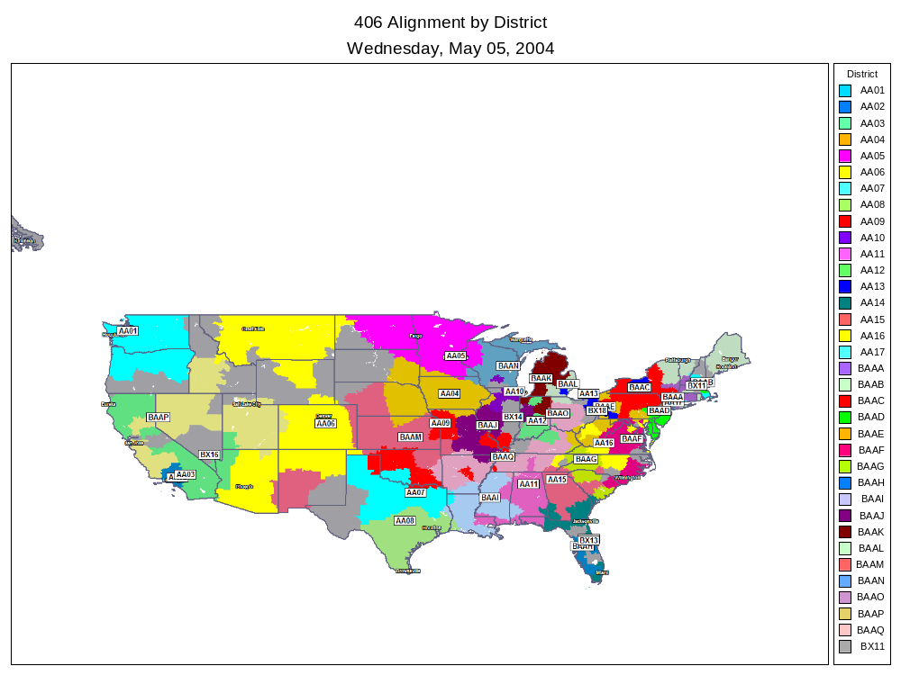

Map of Final Specialty Territories (TerrAlign) – Examples of two NE districts:

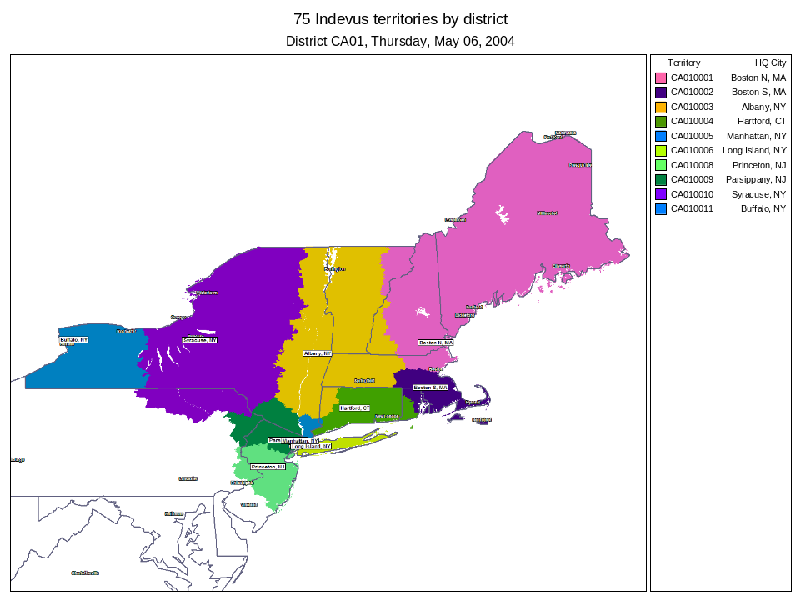
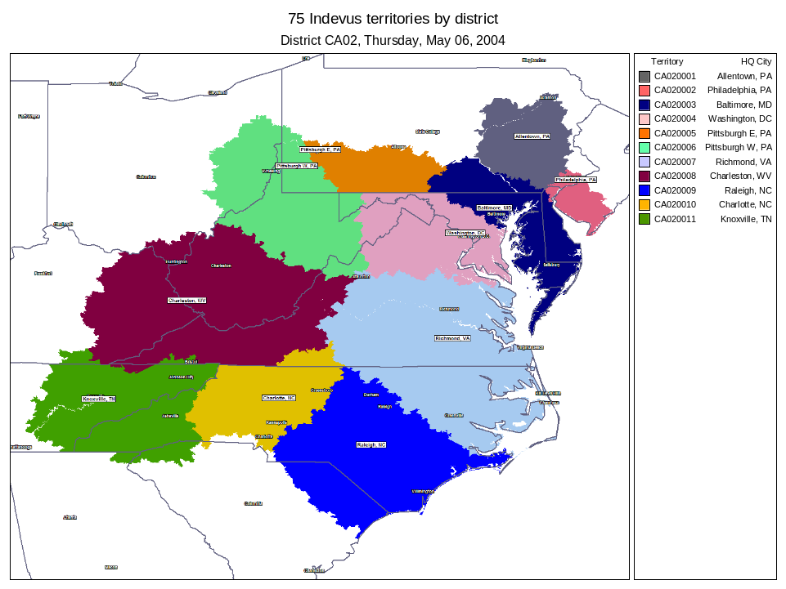

The following data elements were provided to Dendrite’s SFA team for incorporation into Odyssey’s WebForce™ application.
- Alignment - information relating to the design of the sales force hierarchy (Territories, Districts, Regions, and National).
- Postal Areas - zip code information.
- Postal Area Alignment – zip-to-territory relationships
- Prescriber - prescriber profile demographics
- Address - prescriber addressing information
- Affiliations – links prescribers to their addressing information
- Telephone - prescriber telephone numbers
- State License - prescriber state licensing detail
- Customer Rating – physician scores at the sales representative level and call plan goals.
Odyssey provided the following employee and product information for inclusion:
- Team, Employee, Employee Address, Employee Telephone, Product, Product Category, Product Alignment, and Territory Assignment

Outcome:
This project was implemented at Odyssey and was used by their sales forces. This project resulted in additional marketing solutions projects to Dendrite.

- Optimization through Genetic Algorithms

Problem Statement:
This research project is an attempt to develop a robust non-linear constrained optimization routine. Genetic Algorithm with carefully chosen operators was implemented.

Short Description:
While working on the Promotion Response Models for Abbott, we realized the need for a robust non-linear optimization routine that could handle a vast array of constraint specifications (linear, non-linear or rule based). The search for an appropriate solution led to the implementation of Genetic Algorithms with necessary operators.
Genetic algorithm with straight forward operators for reproduction, crossover and mutation and with extensions like fitness scaling, multiparameter mapped fixed-point coding for chromosomes, and stochastic ranking for handling constraints has been developed using Java and validated for three hard optimization problems and a feed-forward Neural Network model of objective function. The results were compared with the published results of different other types of genetic algorithms and iterated hill climbing methods. The results show reasonably good global convergence.
Most textbook nonlinear optimization methods fall under the broad category of hill climbing schemes. Hill climbing begins by choosing a point in solution space, then determines the local steepest uphill direction, moves a certain distance in that direction, reevaluates the local uphill direction, and so on until a location in solution space is arrived at where all surrounding directions are down hill. Hill climbing methods work great if the objective function has only one maxima or minima (i.e., unimodal functions). However, in real world, most problems are not unimodal and global optimization is not guaranteed. In order to handle global optimization problem iterated hill climbing methods are used (whose solution largely depends on the type of problem and no of iterations). In this method, hill climbing methods are executed many times by choosing many different random starting points and the most optimal solution among all the local maximums is considered the global maxima. As one is faced with optimization problems of increasing parameter space dimensionality (i.e., multi variable) and/or situations where the global maximum spans only a tiny fraction of parameter space, iterated hill climbing can add up to lot of work. Most hill climbing methods do as well in terms of numerical accuracy and computational time. However, global convergence depends heavily on suitable starting guess.
Genetic algorithms are search algorithms based on the mechanics of natural selection and natural genetics. They combine survival of the fittest among string structures with a structured yet randomized information exchange to form a search algorithm with some of the innovative flair of human search. The central theme of research on genetic algorithms has been robustness, the balance between efficiency and efficacy necessary for survival in many different environments. Genetic algorithms are different from more normal optimization and search procedures in four ways:
- GAs work with a coding of the parameter set, not the parameters themselves.
- GAs search from a population of points, not a single point.
- GAs use objective function information, not derivatives, or other auxiliary knowledge.
- GAs use probabilistic transition rules, not deterministic rules.
GAs perform relatively well in global convergence and to a greater degree in accuracy of the results. However, they do involve more computation time.

Advantages of GA:
- They are robust. It treats continuous, discontinuous, linear, or nonlinear functions equally. All it needs is, given a set of trial points (or input parameters), an output of the objective function value for those points should be computable. This leads to an interesting possibility of handling objective functions predicted (or trained) by neural networks or any other kind of curve fitting techniques. Even the constraints can be of any form.
- Representing various objective functions in the computer code (NOT coding of genes in chromosome) is relatively simple.
- Based on the parametric study, it looks like as the problem size grows, computing time increases linearly. Some more parametric studies are required to confirm this. However, it is fairly certain that it increases by a polynomial order not greater than 2. This is advantageous when we go on to franchise level optimization where so many parameters are involved.
Disadvantages of GA:
- Relatively time consuming mainly because of more number of function evaluations.
- Selection of proper coding for chromosome.
- It does not always converge to global maxima (still it outperforms many other hill climbing methods for wide range of problems).
Convergence can be increased by using advanced operators (niching, variable mutation etc...). Some of the chromosome codings like multiparameter mapped fixed-point coding (the one used in this work) and the real codings perform better for wide range of problems.

Currently Developed Genetic Algorithm:
It uses Reproduction based on roulette wheel selection procedure, one point crossover, and constant probability mutation genetic operators. It uses Fitness Scaling to distribute the population more efficiently and encourages healthy competition between offsprings. It also uses multiparameter mapped fixed-point coding for chromosome coding. Stochastic ranking is used to handle constraints.
CGA (Constrained Genetic Algorithms) can be used for solving single objective, constrained nonlinear (or linear) optimization problems. Performance studies for CGA are carried out using 3 test problems which are considered to be hard optimization problems. Results show that CGA performs relatively good when compared to simplex method (one of the hill climbing methods), iterated simplex method (one of the iterated hill climbing methods), and 3 different kinds of genetic algorithms which are reported in the reference [ref: 2].

References:
- D.E. Goldberg, Genetic algorithms in search, optimization, and machine learning. (Addison-Wesley, Reading, 1989).
- P.Charbonneau, "An Introduction to Genetic Algorithms For Numerical Optimization", Proceedings of the 1998 Mini-Workshop on Numerical Methods in Astrophysics.
- K. Deb, "An Efficient Constraint Handling Method for Genetic Algorithms". Computer methods in Applied Mechanics and Engg. Vol 186(2-4), 2000, pp 311-338.
- C. A. Coello Coello, "A Survey of Constraint Handling Techniques used with Evolutionary Algorithms". http://citeseer.nj.nec.com/202945.html.
- T.P.Runarsson and X.Yao, "Stochastic Ranking For Constrained Evolutionary Optimization," IEEE Transactions on Evolutionary Computation, 4(3):284-294, September 2000.
- The linear ranking formula is obtained from http://www.geatbx.com/docu/algindex-02.html#P240_14879

Robust Resource Allocation Framework:
GA solves wide range of types of optimization functions and constraints. However, mathematical representation of the given optimization problem is not intuitive for a user who does not have much experience with optimization. We developed an intuitive and flexible framework to solve wide range of resource optimization problems. The allocation problems that are of practical interest and could be solved by this framework are:
- Allocating the total marketing budget across various channels of promotion.
- Sales force product mix.
- Sales force size and structure.
The proposed solution framework has two components with seamless interface between them. These components are:
- A flexible model representation using tree and a list.
- A robust solution procedure using Genetic Algorithms (GA).
The details about the implementation and applications are listed in the Methodology and Results sections respectively.

Methodology:

Overall Process:
The algorithm starts by initializing all the global variables. Most important global variables are length of dependent variables (or parameters), chromosome length, crossover probability (0.85), mutation probability (<0.1. Prefereed around 0.03 or 0.2*(1/population size)), individuals in a populations, number of generations, probability of objective comparison (0.45, used in handling constraints) etc.,
Each parameter to be optimized is represented as a string of fixed length binary values. A binary value is termed as allele. Each parameter has a defined range and the length of the bit string that represents the parameter determines the accuracy. All the parameter bit strings are joined together in a specific order and the resultant string is called a “Chromosome”. Any individual is considered to have a specific chromosome, in other words, an individual represents a possible solution to the optimization problem at hand. The value of the independent variable or the objective function for the string specified by the individual’s chromosome (i.e., set of specific values for the dependent variables or a point in the solution space) is equal to or proportional to the fitness value of the individual.
Having defined an individual, the algorithms sole purpose is to find an individual whose fitness value is maximum through the mechanics similar to the one used by the nature. First several individuals are initialized and a particular number of such individuals (as specified in the configuration) are considered part of the same population. First, the algorithm picks two individuals at random, but the probability of being picked up is proportional to the fitness value of the individuals and cross over information from each individual to produce two offsprings. A mutation of alleles (i.e., 1 turns to 0 and 0 turns to 1) is carried out for each of the offspring but with a low probability as defined by probability of mutation. Both the location of cross over and mutation are determined at random. These two offsprings is part of the new generation of population. The process is repeated until a new generation of population with specified number of individuals is formed. Then for each individual in the new generation, fitness values are recomputed. In an elitist model, the individual with the highest fitness value is preserved and always passed onto further generations. In addition, the fittest individual is always stored separately as the optimal solution. The fittest individual is re-evaluated after a new generation is formed and their fitness values evaluated. The generation of new population (i.e., evolution) is repeated for a set number of evolutions (say, between 2000 and 5000) and after the end of all evolutions, the fittest individual that was tracked all along is considered as the winner or in other words the optimal solution. For multi-modal problems with almost same solutions, several fittest individuals are tracked. This procedure results in a better fit individuals in each evolution as fittest individuals survive and reproduce much higher than the unfit individuals.
The process for computation of the fitness values requires a special mention here. First, the chromosome being evaluated is split into their component parameters and using a linear scaling algorithm, the real value of each of the parameter is obtained. Then these real parameter values are passed on to objective function and the constraints evaluators. The objective function then evaluates the value of the independent variable and returns the value as the fitness value. The constraints function evaluates if the parameter values satisfies all the constraints. If not the constraint deviations are squared and added together and a stochastic procedure is applied to choose the right individual during the reproduction process.
A mathematical analysis, schemata and formata theories, explain the order of convergence during each evolution. The convergence heavily depends on the proper selection of parameter encoding and the genetic operators (selection, crossover, and mutation). The operators we chose to implement are explained in the below sections and are specific to solving continuous or dis-continuous functions. These operators fail miserably for combinatorial optimization problems like bin packing, as the natures of operators differ. In essence, the operators should be able to improve the fitness of later generations. It is proved (ref.1) that the chosen parameters results in cubic convergence for continuous optimzable functions.

Parameter Encoding:
A well studied simple binary coding is used to code the parameters. In this coding we concatenate a string of 0’s and 1’s. Each parameter string is then combined together to form the chromosome. For example, each parameter has 4 characters and there are three parameters to form the chromosome string below.
Position | 12 | 11 | 10 | 9 | 8 | 7 | 6 | 5 | 4 | 3 | 2 | 1
Coding | 1 | 0 | 0 | 1 | 1 | 1 | 0 | 0 | 0 | 1 | 0 | 1
 | Parameter 1 (= 9) |  |  |  | Parameter 2 (= 12) |  |  |  | Parameter 3 (= 5)
 | Chromosome

To decode the chromosome values, parameters are first split and derived as individual parameter strings and then the parameter value is obtained as:
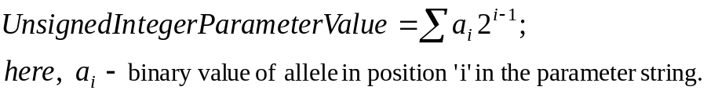

In order to solve the continuous function with real parameter values, the decoded unsigned integer value of the parameter, with value ranging between [0,2^{m}] (m – number of characters in a parameter string), is mapped backed to a specific interval [U_{min},U_{max}]. That is,
The above coding schema in the example is called a Multiparameter, Mapped, Fixed-Point Coding. This coding is useful for wide variety of problems, particularly the problems with continuous or dis-continuous objective function and constraints.
Choice of coding schema is critical to solve the type of problem at hand. This is more of an art and understanding schemata theory. There are two basic principles for choosing a GA coding:
Principle of Building Blocks:
The user should select a coding so that short, low-order schemata are relevant to the underlying problem and relatively unrelated to schemata over other fixed positions.
Principle of Minimal Alphabets:
The user should select the smallest alphabet that permits a natural expression of the problem.

In the binary coding case, the hunt for important similarities is made possible by the small cardinality of the alphabet. It is also shown that the binary alphabet offers the maximum number of schemata per bit of any information of any coding. Since these similarities are the essence of our search, when we design a code, we should maximize the number of them available for the GA to exploit.

Evaluating Fitness of Individuals in a Population:
The problem outlined here is thriving to maximize (or minimize) the objective function while satisfying all the constraints. Thus, it is inevitable to check if constraints are satisfied in addition to evaluating the value of objective function. One way to do this is to follow the penalty function approach, where the deviations from the constraints are added to the objective function with a penalty parameter attached to the constraints. Since this penalty function is problem dependent, we implemented a non-parametric stochastic solution offered by reference [ref. 5].
The first step is to compute the Stochastic Constrained Rank of an individual within the population. This is a sorting technique very similar to bubble sort, but the value being compared between two individuals are always the objective function value when the constraints are satisfied for the individuals. But if one or both the individual’s constraints are not satisfied then the algorithm chooses to compare the objective function with the probability specified in configuration for objective function comparison (usually 0.45). Otherwise, it compares the penalty value that is proportional to the deviation in constraints. Specifically, the penalty value of an individual is computed as:
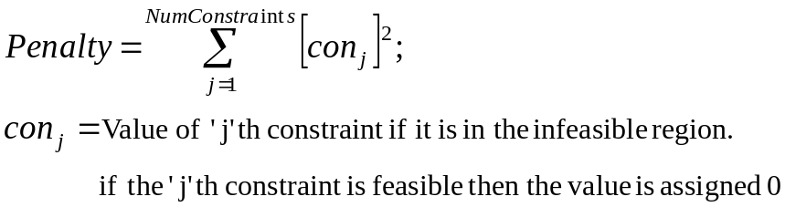
The main advantage here is that it is a non-parametric approach and hence problem independent and more generic way of treating the constrained optimization. Detailed bubble sort algorithm is given in [ref. 5]. At the end of this sorting, most fit individuals are at the top of the array and the least fit are in the bottom of the array. The array index here is termed as “Stochastic Constrained Rank” and are used as the input to fitness function evaluation.
These ranks are then linearly scaled between a value of zero and SP (i.e., selective pressure that is configured, usually 3). This linear scaling of ranked values is obtained from [ref.6.]. As we increase the selective pressure, the probability for the individual being selected for reproduction increases. This linearly scaled value is the fitness value of the individual and is obtained using simple formulae:
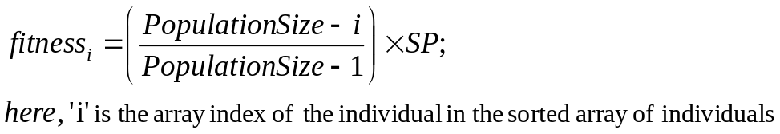
In other words, most fit individual has the value of SP and the least fit individual has the value zero. The reason for doing such scaling to decouple the dependence of objective function or penalty value of a given problem from the evaluation of fitness value of an individual, so that the algorithm can be used for wide variety of optimization problems and are independent of underlying functional forms of the problem. Such scaling helps prevent the early domination of extraordinary individuals, while it later on encourages a healthy competition among near equals.

Genetic Operators:
Reproduction (or Select):
Reproduction selects two fit individuals for obtaining the siblings. This operation stochastically selects two individuals from a population using fitness values of individuals as the driver through roulette wheel algorithm (stochastic sampling with replacement). That is, most fit individuals have higher chances of being picked up for reproduction. This is a linear search through a roulette wheel with slots weighted in proportion to individual fitness values. The algorithm is as follows
  - Select a random number between 0 and 1 and multiply it by sum of fitness values of all the individuals in the population.
  - Then go through the sorted array of individuals and stop at the point where the above random fitness value exceeds the running sum of individual’s fitness values. The last individual that caused the loop to break is selected for reproduction.
  - The above procedure is repeated twice to get two individuals for reproduction (called parents).
An example from [ref. 6] is given below:
Table shows the selection probability for 11 individuals, linear ranking and selective pressure of 2 together with the fitness value. Individual 1 is the most fit individual and occupies the largest interval, whereas individual 10 as the second least fit individual has the smallest interval on the line (see figure ). Individual 11, the least fit interval, has a fitness value of 0 and get no chance for reproduction.
Table 3-2: Selection probability and fitness value
Number of individual | 1 | 2 | 3 | 4 | 5 | 6 | 7 | 8 | 9 | 10 | 11
fitness value | 2.0 | 1.8 | 1.6 | 1.4 | 1.2 | 1.0 | 0.8 | 0.6 | 0.4 | 0.2 | 0.0
selection probability | 0.18 | 0.16 | 0.15 | 0.13 | 0.11 | 0.09 | 0.07 | 0.06 | 0.03 | 0.02 | 0.0
For selecting the mating population the appropriate number of uniformly distributed random numbers (uniform distributed between 0.0 and 1.0) is independently generated.
sample of 6 random numbers:
0.81, 0.32, 0.96, 0.01, 0.65, 0.42.
Figure shows the selection process of the individuals for the example in table together with the above sample trials.
Fig. 3-3: Roulette-wheel selection
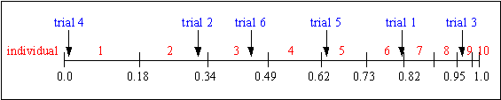
After selection the mating population consists of the individuals:
1, 2, 3, 5, 6, 9.
The roulette-wheel selection algorithm provides a zero bias but does not guarantee minimum spread.
Crossover:
Crossover helps to carry over the important features of the parents to their children. In this one point crossover operation first determination is made whether to execute the crossover operation. The crossover operation is determined to be executed with a crossover probability (0.85) specified in the configuration. Once the decision is made to carryout crossover, a cross over point is randomly picked. The crossover point is nothing but the location of a particular allele in the chromosome.
Then parent 1 is split into two parts at the cross over point. Parent 2 is also split into two parts at the same crossover location. Child 1 is formed by combining part 1 of parent 1 and part 2 of parent 2. Child 2 is formed by combining part 2 of parent 1 and part 1 of parent 2. These two children are then used in the mutation process.
An example from [ref.6] is given below:
Consider the following two individuals with 11 binary variables each:
individual 1 0 1 1 1 0 0 1 1 0 1 0
individual 2 1 0 1 0 1 1 0 0 1 0 1
The chosen crossover position is:
crossover position 5
After crossover the new individuals are created:
offspring 1 0 1 1 1 0| 1 0 0 1 0 1
offspring 2 1 0 1 0 1| 0 1 1 0 1 0
Fig. 4-6: Single-point crossover
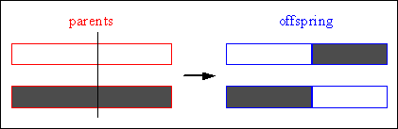
Mutation:
Mutation helps to maintain diversity. In this mutation operation first determination is made whether to execute the mutation operation for each children. The mutation operation is determined to be executed with a mutation probability (<0.05) specified in the configuration. Once the decision is made to carryout mutation, a mutation point is randomly picked. The mutation point is nothing but the location of a particular allele in the chromosome. Then a binary NOT operation is carried out for the selected allele. The chromosome is now considered to be mutated. The process is repeated individually for each child.
Individual before and after binary mutation
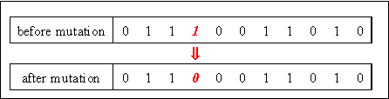
After carrying out all these three genetic operations, the children are inserted into new generation of population. In the elitist model, the fit individual parent is reintroduced to the new generation as well.

Robust Resource Allocation Framework:
Model Representation:
The model is represented as a combination of a tree and a list. The tree structure represents the hierarchy involved in the problem. The list contains different types of events. Each tree node is constrained by minimum and maximum values. Top-Level constraints can be specified for each event type in the list. Leaf nodes are the independent variables to be optimized and are associated with one of the event types in the list. Cost associated with parent nodes are the sum of the costs of its children. Objective functions can be associated either with leaf nodes or to the event types in the list.
The solution procedure used is the same GA that is described in the earlier sections. The objective function and constraints modules are modified to take the model representation mentioned above and convert them to the appropriate mathematical form for evaluation by rest of the algorithm.
The current implementation supports the following function types: Linear Polynomial, Quadratic Polynomial, S-Curve (Lodish), and a Histogram (i.e., IF THEN ELSE types of rules). Model parameters generated through historic ROI data (i.e., promotional response models) be given as input. In the absence of such promotional models, the implemented functions allow a field expert to estimate model parameters.

Results:
Initially, the algorithm was tested using 3 hard optimization problems (non-linear functions) as given in [ref. 1]. The results were compared to the various other methods given in the reference. A relatively very good convergence to global solution was demonstrated. Then, to demonstrate robustness, a feed-forward neural network model was used as objective function. The GA performed well on optimizing this Neural Network model as well.
The Neural Network model was built using the data points obtained for a quadratic polynomial whose optimal solution is know prior. The GA converged very well to the solution using this NN model as well. The NN model was built and used using the java objects available from “jahuwaldt.tools.NeuralNets” package available freely over the internet.
Later, the problem was tested using various other functions, particularly the Lodish models, and a generic framework for treating different kinds of business problems were developed, tested and implemented. These generic frameworks were presented at PMSA 2005 conference as well. This GA algorithm was used for resource allocation project for BMS.
One of the main disadvantages is that GA could not handle more than 20 or 30 parameters in the realistic computational time. Convergence became an issue for larger optimization problems as well (mainly because of limited number of iterations).

Robust Resource Allocation Framework:
The framework was tested with a hypothetical problem with known optimal solution. The solution converged to the optimal solution.

Applications – Channel Optimization:
The objective is to maximize sales by allocating budgets optimally for different promotional programs of various districts. The problem structure is shown in the following figure:

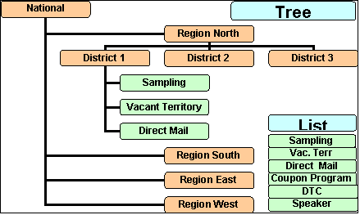

An estimated 9% increase in sales is observed with a ROI of 9.8 : 1 when global budget is increased by 10%. An estimated 3% increase in sales is observed by redistributing the current global budget.

Applications – Sales Force Product Mix:
Objective is to allocate optimal number of reps for primary, secondary, or tertiary products for each sales force. An estimated 3.5% increase in sales with global budget at current level could be observed. The following figure shows the problem representation:
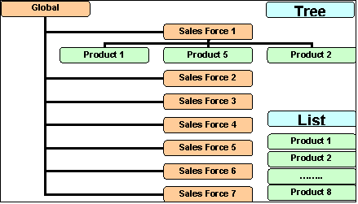

Outcome:
The Genetic Algorithms developed initially as a research project to integrate the algorithm to promotional response tool (PRT) for Abbott, was not integrated because of the huge computational time and resources required for handling large number of optimization variables. However, its robustness was useful and implemented for resource optimization for BMS (explained elsewhere). The development of generic framework was presented at PMSA 2005 conference (poster session).

- Optimal Sales Territory Alignment (Zip to Terr)

Problem Statement:
This research project is an attempt to develop a sales territory alignment (Zip to Territory) in such a way that the representative loads are balanced between the territories and the territories provide equal opportunities.

Short Description:

Methodology:

Results:

Outcome:

