19. Sales Force Resource Allocation – BMS
Problem Statement:
This software tool facilitates the representative allocation for various sales forces and products and customer specialties across all countries where BMS operates. Specifically, an optimization module optimizes representative allocation across sales forces and products.

Short Description:
BMS has one or more sales forces in each country that promotes multiple products within the designated country. This tool facilitates allocation of representatives for these sales forces and products. Representative allocations are primarily done across three dimensions: Sales Forces, Products, and Customer Specialties. Cost to promote a product, sale of each product, sales force budget are some of other inputs to decide right number of representatives.
To obtain optimal allocation, a Lodish kind of sales expectation model for different number of representative equivalents is used to optimize the rep equivalent across sales forces and products. Constraints across sales teams and products are taken into consideration. Some of the inputs shought from each sales team and loaded into the tool are:
Part 1: Sales Force Call Capacity
• For each Sales Team, determine the average number of working days in the field calling on customers. This can be done by subtracting the number of holidays/average vacation days, weekends and days off territory attending training classes or meetings from 365.
• Average Calls/Day - On average, how many calls are made in a sales day.
• Average Details/Call - On average, how many products are detailed during a call.
• Average Calls/Rep/Year - Working Days/Territory multiplied by Average Calls/Day.
Part 2: Sales Force Costs:
• Number or Representatives for each of the years being analyzed.

All numbers should be in the x000 format. Use average numbers where appropriate

• Annual Costs/RE should be for a fully load sales representative including:
* Yearly Salary
* Bonus or Commission
* Vehicle/Transportation
* Administrative Supplies (not to include promotional supplies)
* Appropriate Percentage of Field Management Costs
* Appropriate Yearly Training Cost if required by government
• Hiring Costs should include all costs associated with hiring and training a new representative. This is supplemental cost and should not include any costs that are already included in Annual Costs.
• Termination Costs should include the total costs to terminate a representative either voluntary through resignation or by firing. This is supplemental cost and should not include any costs that are already included in Annual Costs or Hiring Costs.
• Annual Turnover Rate is the annual percentage of the sales force which turns over through termination’s, resignations and promotions in a year for each of the Sales Forces.
Form 2: Product Information Sheet
Complete the necessary information for each in-line and future product being included in this analysis.
• Product Name - Local Market Brand Name
• IMS Therapeutic Class - IMS Market Class Identification Number
• Launch Date - Original Launch or Anticipated Date of Product Launch
• Budgeted Sales
• Actual/Expected Sales
• Number or Representative Equivalents (RE’s)
• IMS Therapeutic Market Total Sales - Market Potential Sales 12 month MAT (x000)
• IMS Market Growth. Percent of anticipated annual growth for this product. Current IMS Therapeutic class growth can be used here if appropriate.
• IMS Product Market Share
• Advertising and Promotional Spend (A&P). This may include Journal Ads., Direct Mail, Market Research, Symposia, Opinion Leader Programs, Congresses, and Clinical Trails) . (x000)
• Field Support Spend. This should include Literature (Sales Aids), Samples and Marketing Gimmicks (e.g. pens, cups, etc.) (x000).
• Cost of Goods (% as percentage)

Competitive Analysis
Complete for each product being included in this analysis plus the top 5 competitors
• IMS Market Share 3 Month Average Market Share
• IMS Market Share 12 Month MAT
• IMS Market Share 12 Month MAT Last Year
• Number of RE’s allocated to selling this product in current year
Form 3: Allocation of Products to Sales Force – By Product Position
We will be using the following information during our meeting
Percent Change in Sales/Representative - % Change in Representative Selling Productivity for this product when compared to current Sales/Representative.
Carry Over- Decline in Sales each year as a percentage after product promotion has been discontinued
Complete the Product Promotional Matrix using the example on the page and then list the allocation of products to sales teams by product postion. A grid should be completed for each team. If the team is currently promoting more than 5 products, use a second grid for that team. If more than three teams exist, use multiple pages.
Or – this information can be completed by RE’s – Form 3A
Form 3A: Allocation of Product to Sales Force By Representative Equivalents
Complete this form to show allocation of products to sales teams. A grid should be completed for each team. If the team is currently promoting more than 5 products, use a second grid for that team. If more than three teams exist, use multiple pages. Actual or projected Rep Equivalents (RE’s) should be entered on the grid.
Form 4: Customer Universe
Complete the necessary information for each specialty that Sales Force resources are to be applied towards.
• BMS Called on Universe: The BMS called on universe should be divided for each specialty by very high, high, medium and low value physicians.
• Total Country Universe: This is the size of the total country physician universe for each specialty.
Form 5: Percent of Product Sales by Specialty
For current year sales, list the percent of sales for each product that was generated out of each specialty. List the products and specialties and for each product enter percentage sales from each specialty. Each product row should total 100%.

Some screen shots of the tool is shown in the results section. I was involved in modifying the GA to the specifications required for resource optimization.

Methodology:
The software tool was developed by another team using C# and SQL Server. The optimization part was developed by me in Java, which was converted to C# for implementation. Other modeling and optimization related details are given below.
Basics of Lodish model for developing Call Plans:
Following article proposed a popular methodology for obtaining call plans:

Leonard M. Lodish, “An interactive salesman’s call planning system”, Management Science, vol.18, No. 4., Application Series, Part 2, Dec 1971, pp. p25 – p40.

Here, product sales is related to the promotional resources by a “S” type curve whose parameters are solely determined by the expected minimum sales, expected maximum sales, current estimate of sales and current estimate of promotional resources. Experts in the field give the expectations.

Lodish Model:
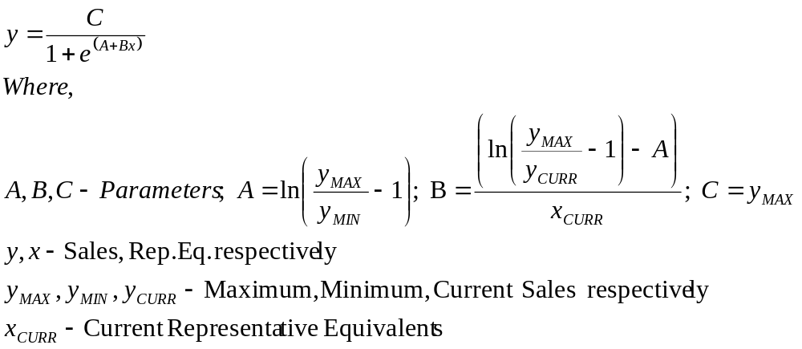
The idea is to treat dependent variable y as sales and the independent variable x as representative equivalents (or any other promotional variable). Based on experts estimations of possible range of sales and current sales corresponding to current representative equivalents, parameter A, B and C are computed. This non-linear ”S” type curve is then used similar to promotional response model to obtain optimal representative equivalents.

Computing product contribution:
BMS uses “Product Contribution” to allocate the representative equivalents. Product Contribution is computed as detailed below.
 |  | Sales Force Team |  |  | Product Total
 |  | Team A | Team B | …. | Product Total
Product | Abilify | 12 RE | 15 RE | … | …
Product | Avapro | 20 RE | 5 RE | … | …
Product | Incover | 0 RE | 10 RE | … | …
Team Total |  | … | … | … | …

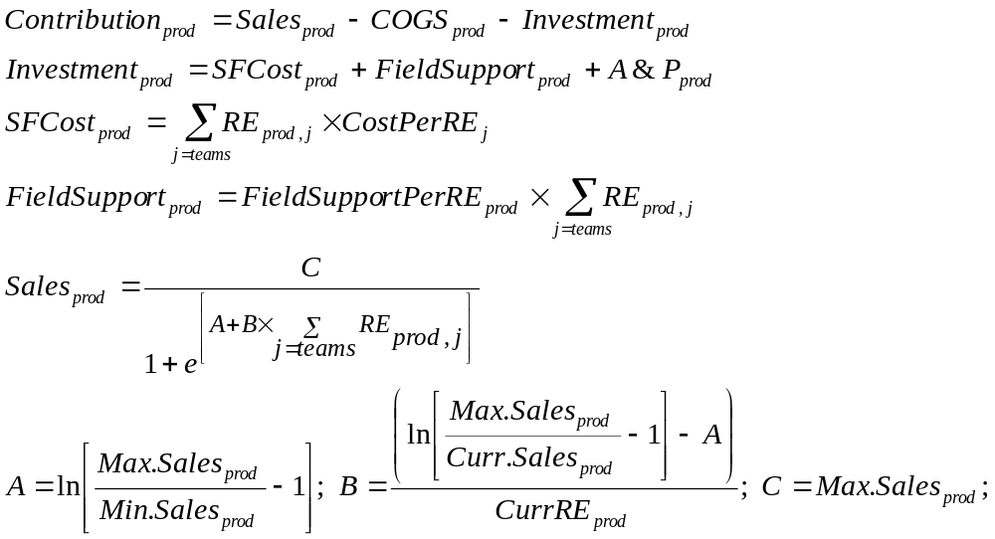
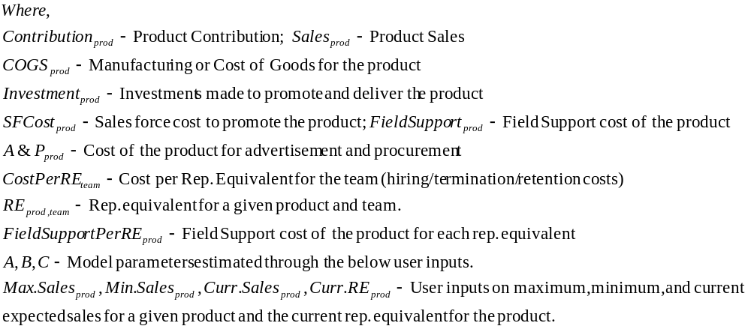
Obtaining optimal allocation of representative equivalents:
Objective function is obtained by summing up all product contributions that are being promoted in a given country by various sales teams in that country. Constraints are minimum and maximum allowable variation in current representative equivalents. These constraints are expressed for each product, each sales team and overall global resources for the given country.
We use Genetic Algorithms (GA) to solve this non-linear objective function. The parameters being optimized are rep. equivalents for a given product and a given team. A maximum in total contribution is aimed at, after satisfying all the constraints mentioned above. An appropriate parameter encoding was used in GA to minimize the execution time and to achieve desired accuracy.
The GA code was initially developed and implemented in Java, which was then converted to C# and integrated with the sales force allocation tool.

Results:

