CHART – Original Variables

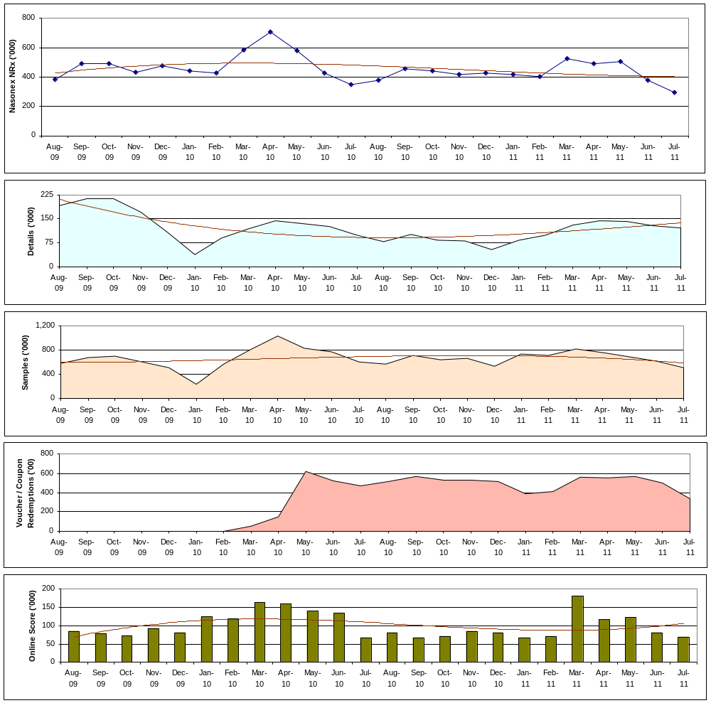

CHART – Nasonex NRx vs. TV GRPs (SUM)
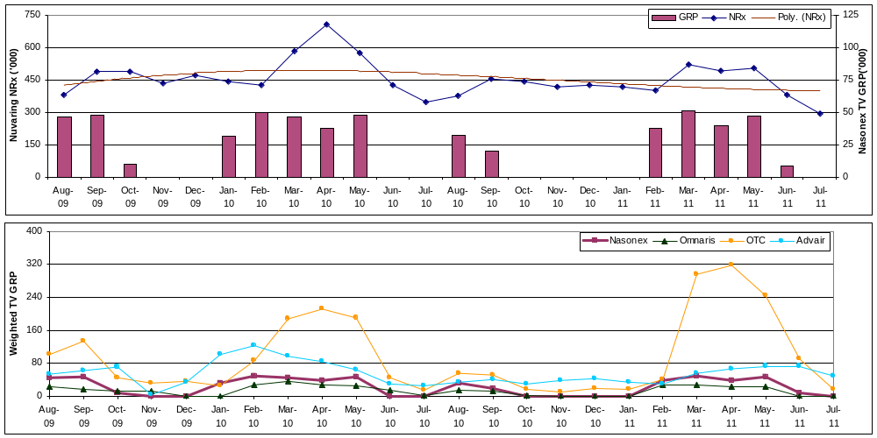

CHART Standardized Vars (Means across DMA):
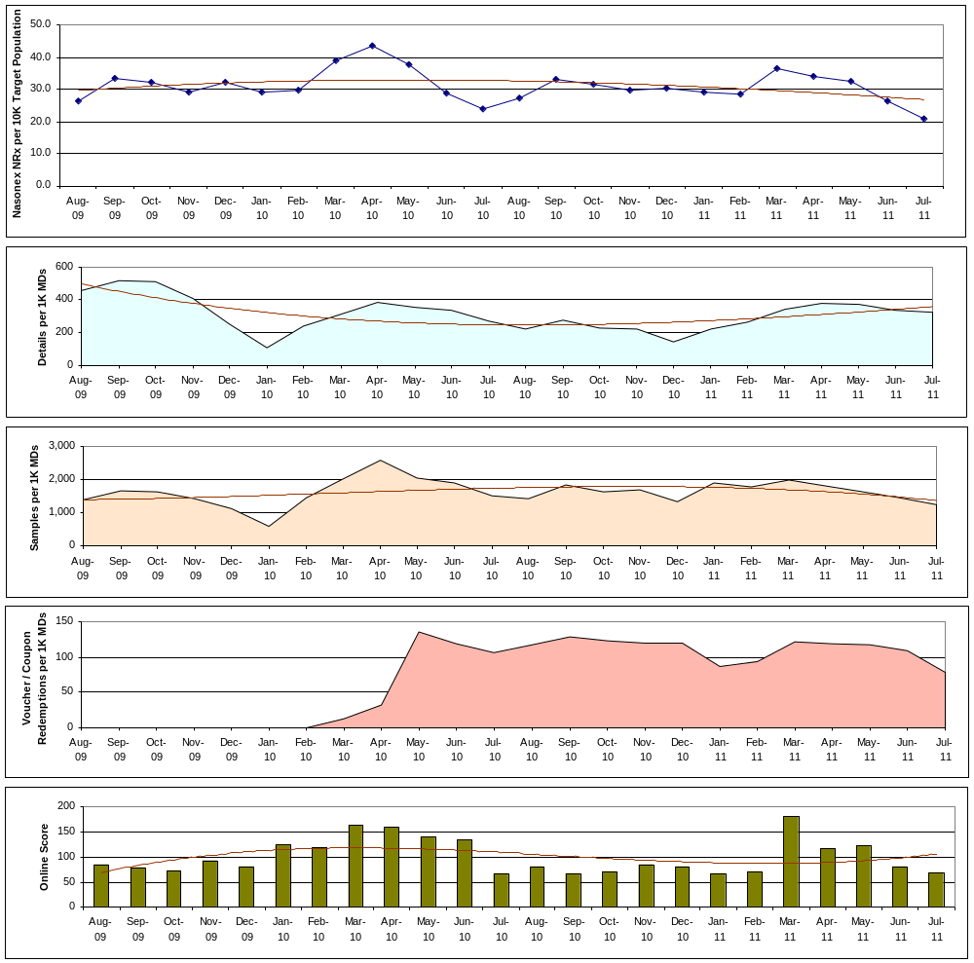

Chart Standardized Vars (Means across DMAs)
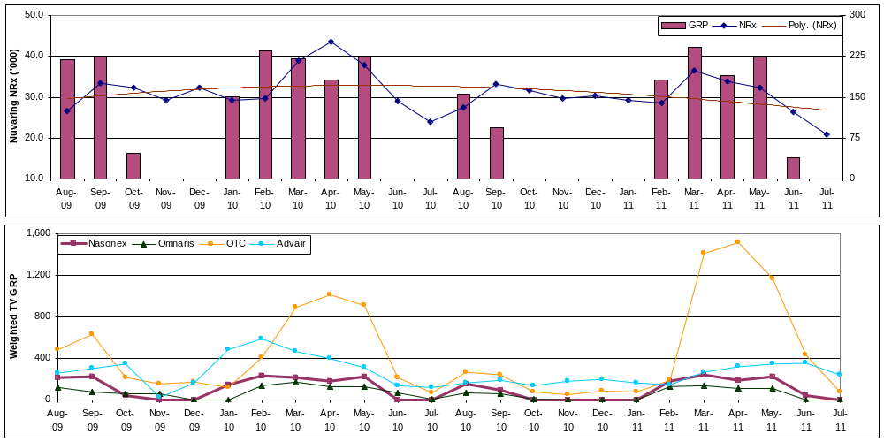

CHART Std. Vars - ADSTOCKS:
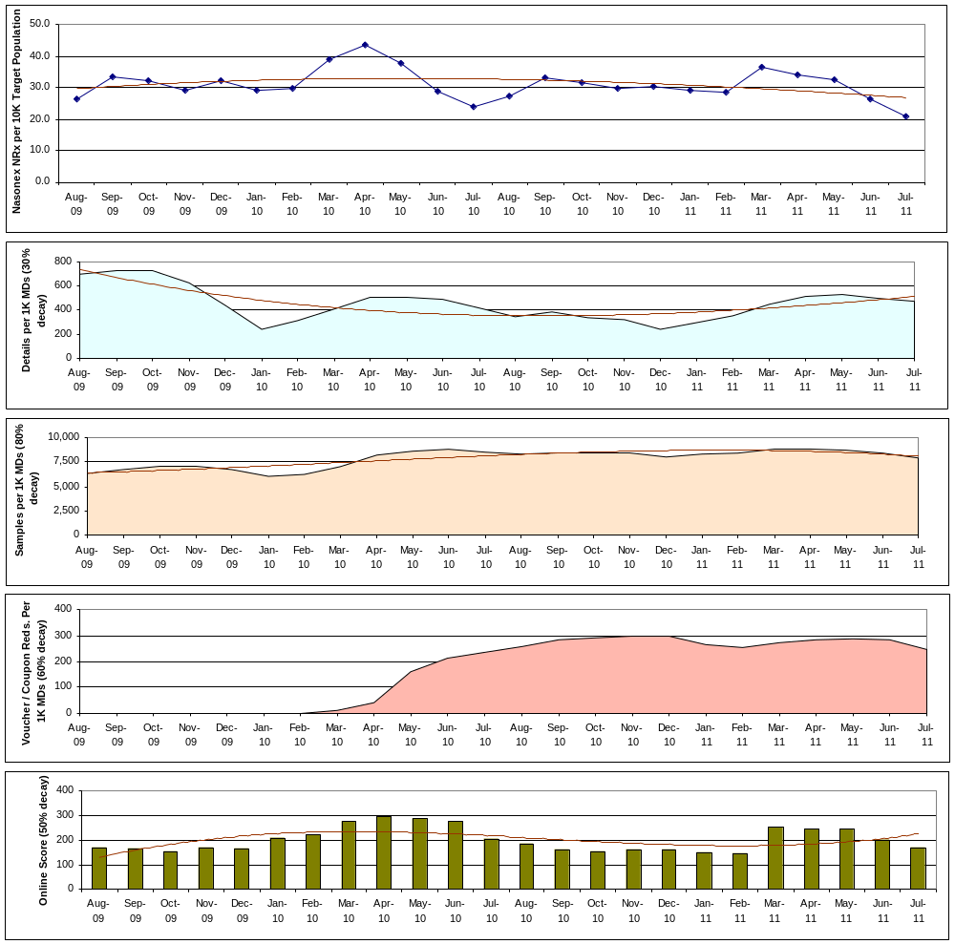

CHART Std. Vars - GRP ADSTOCKS:

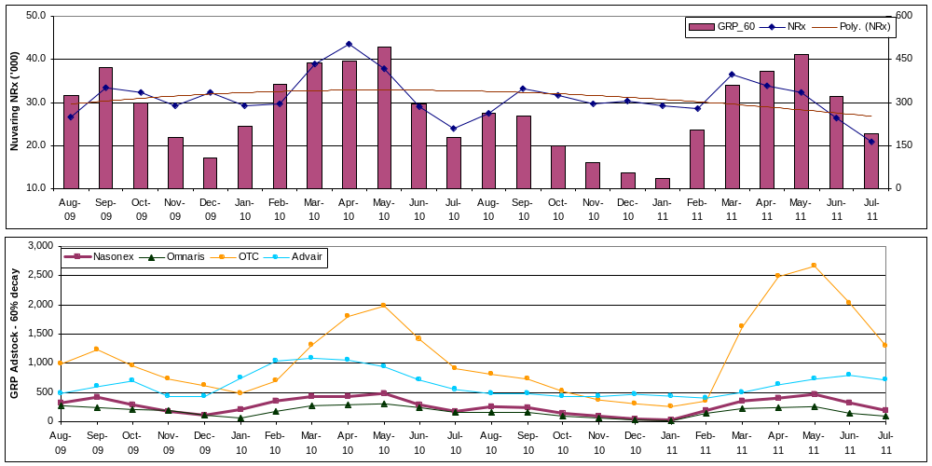

CHART – Rx (Total):
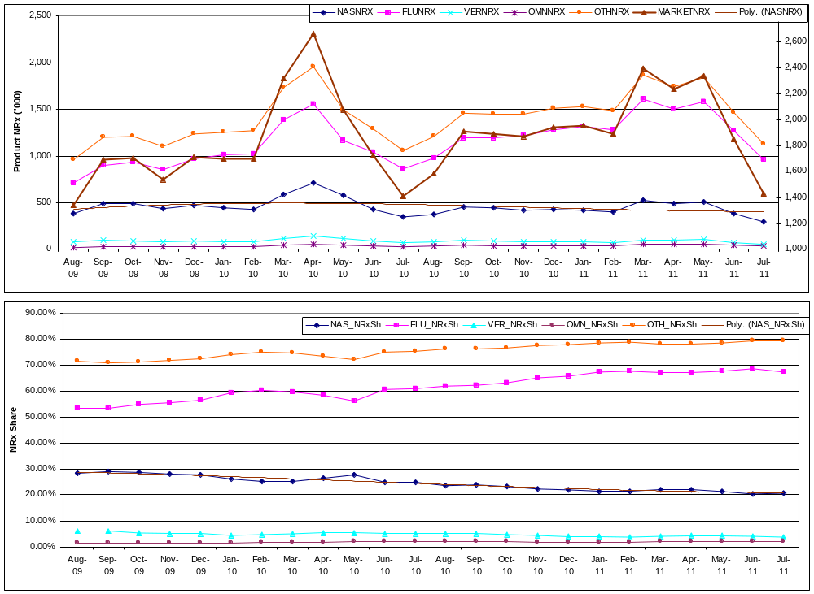

CHART – Rx per 10K Target Population (Mean per DMA):
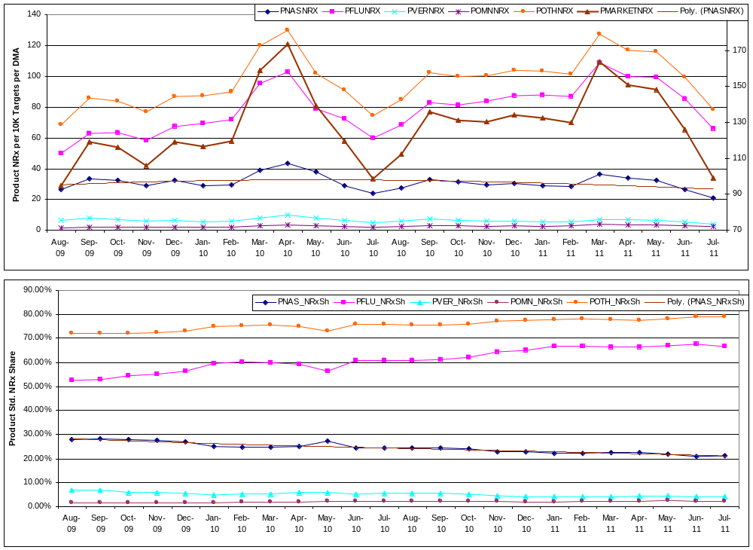

CHART – NAS GRP – Share of Voice. [Total GRP = NAS GRP + OMN GRP + OTC GRP]
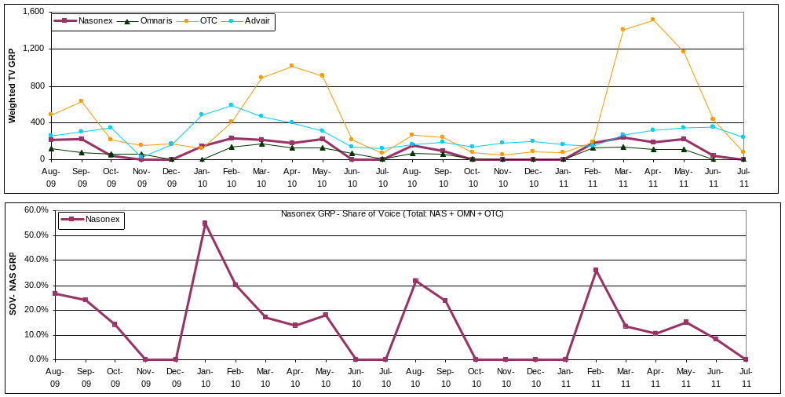

Adstocks SOV: 60% decay rate.
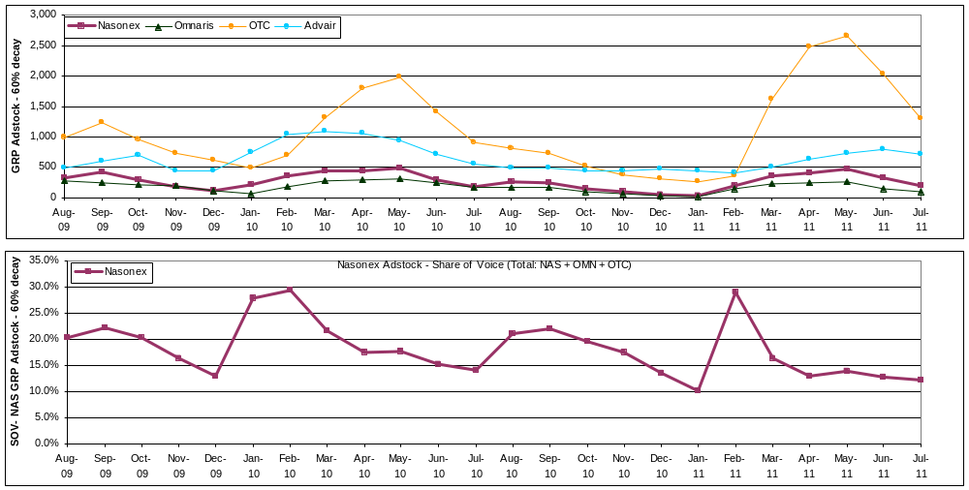

CHART of NAS GRP / NAS ADSTOCKs and NAS GRP SOV / NAS ADSTOCK SOV

