Distributions
Sum(NASNRX)
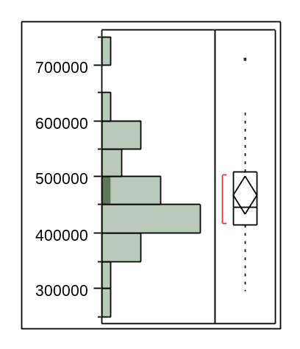

Quantiles
100.0% | maximum | 707825
99.5% |  | 707825
97.5% |  | 707825
90.0% |  | 586189
75.0% | quartile | 508879
50.0% | median | 444915
25.0% | quartile | 413818
10.0% |  | 372022
2.5% |  | 295267
0.5% |  | 295267
0.0% | minimum | 295267

Moments
Mean | 467458.55
Std Dev | 90059.119
Std Err Mean | 16442.47
Upper 95% Mean | 501087.18
Lower 95% Mean | 433829.92
N | 30
Sum(MKTNRX)
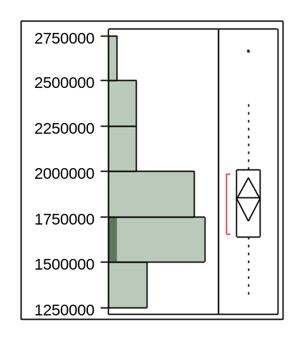

Quantiles
100.0% | maximum | 2666049
99.5% |  | 2666049
97.5% |  | 2666049
90.0% |  | 2339057
75.0% | quartile | 2010062
50.0% | median | 1860270
25.0% | quartile | 1638104
10.0% |  | 1411152
2.5% |  | 1310643
0.5% |  | 1310643
0.0% | minimum | 1310643

Moments
Mean | 1848326.5
Std Dev | 325959.22
Std Err Mean | 59511.739
Upper 95% Mean | 1970041.7
Lower 95% Mean | 1726611.4
N | 30
Sum(DET)
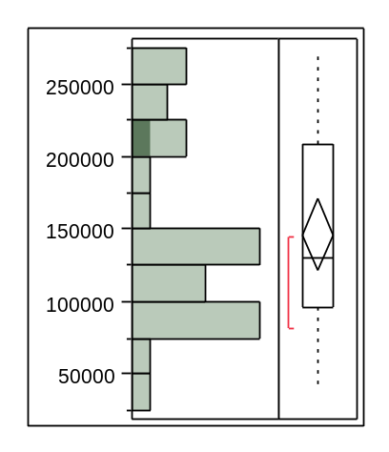

Quantiles
100.0% | maximum | 271535
99.5% |  | 271535
97.5% |  | 271535
90.0% |  | 253643
75.0% | quartile | 208525
50.0% | median | 129948
25.0% | quartile | 96387.3
10.0% |  | 79474
2.5% |  | 39247
0.5% |  | 39247
0.0% | minimum | 39247

Moments
Mean | 146108.17
Std Dev | 65854.211
Std Err Mean | 12023.279
Upper 95% Mean | 170698.53
Lower 95% Mean | 121517.8
N | 30
Sum(SAM)
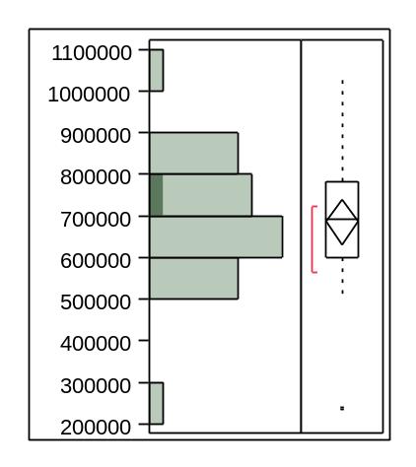

Quantiles
100.0% | maximum | 1032991
99.5% |  | 1032991
97.5% |  | 1032991
90.0% |  | 888314
75.0% | quartile | 783086
50.0% | median | 691706
25.0% | quartile | 598099
10.0% |  | 514932
2.5% |  | 232923
0.5% |  | 232923
0.0% | minimum | 232923

Moments
Mean | 685187.83
Std Dev | 149881.16
Std Err Mean | 27364.431
Upper 95% Mean | 741154.38
Lower 95% Mean | 629221.29
N | 30
Mean(mc_nrp)
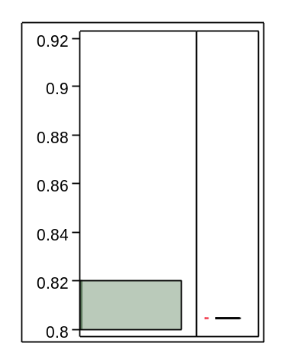

Quantiles
100.0% | maximum | 0.80459
99.5% |  | 0.80459
97.5% |  | 0.80459
90.0% |  | 0.80459
75.0% | quartile | 0.80459
50.0% | median | 0.80459
25.0% | quartile | 0.80459
10.0% |  | 0.80459
2.5% |  | 0.80459
0.5% |  | 0.80459
0.0% | minimum | 0.80459

Moments
Mean | 0.8045854
Std Dev | 0
Std Err Mean | 0
Upper 95% Mean | 0.8045854
Lower 95% Mean | 0.8045854
N | 30
Sum(vcr)
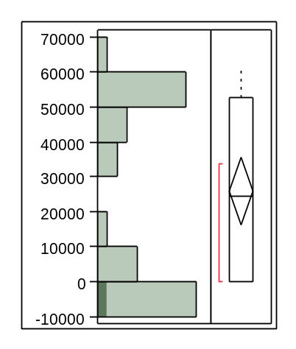

Quantiles
100.0% | maximum | 61877
99.5% |  | 61877
97.5% |  | 61877
90.0% |  | 56407
75.0% | quartile | 52659.5
50.0% | median | 24425
25.0% | quartile | -4.5
10.0% |  | -39
2.5% |  | -92
0.5% |  | -92
0.0% | minimum | -92

Moments
Mean | 25978
Std Dev | 25764.812
Std Err Mean | 4703.9897
Upper 95% Mean | 35598.739
Lower 95% Mean | 16357.261
N | 30
Sum(FLUNRX)
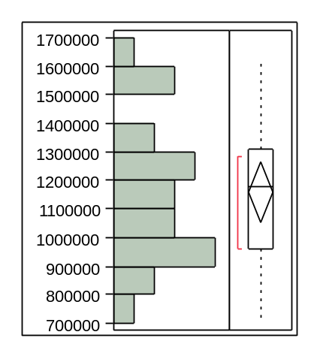

Quantiles
100.0% | maximum | 1606890
99.5% |  | 1606890
97.5% |  | 1606890
90.0% |  | 1571086
75.0% | quartile | 1307428
50.0% | median | 1178449
25.0% | quartile | 962162
10.0% |  | 857317
2.5% |  | 712630
0.5% |  | 712630
0.0% | minimum | 712630

Moments
Mean | 1158333.8
Std Dev | 250188.42
Std Err Mean | 51069.498
Upper 95% Mean | 1263979.1
Lower 95% Mean | 1052688.5
N | 24
Sum(VERNRX)
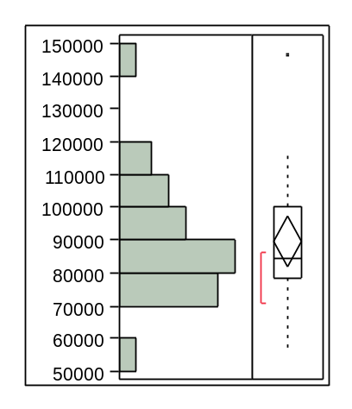

Quantiles
100.0% | maximum | 146138
99.5% |  | 146138
97.5% |  | 146138
90.0% |  | 114767
75.0% | quartile | 100209
50.0% | median | 84326.9
25.0% | quartile | 78537.1
10.0% |  | 72109.1
2.5% |  | 56323.2
0.5% |  | 56323.2
0.0% | minimum | 56323.2

Moments
Mean | 89521.353
Std Dev | 18312.182
Std Err Mean | 3737.9585
Upper 95% Mean | 97253.909
Lower 95% Mean | 81788.796
N | 24
Sum(OMNNRX)
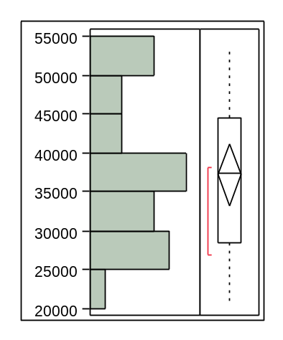

Quantiles
100.0% | maximum | 53450.3
99.5% |  | 53450.3
97.5% |  | 53450.3
90.0% |  | 51706.8
75.0% | quartile | 44576.2
50.0% | median | 37469.3
25.0% | quartile | 28499.2
10.0% |  | 26201.8
2.5% |  | 20927
0.5% |  | 20927
0.0% | minimum | 20927

Moments
Mean | 37177.327
Std Dev | 9265.8816
Std Err Mean | 1891.3902
Upper 95% Mean | 41089.966
Lower 95% Mean | 33264.689
N | 24

