**PRODUCT SALES ANALYSIS**

TEAM MEMBER

SENTHILKUMAR M

Phase 3: Coding part

**Introduction:**

A sales analysis is the process of analyzing the sales revenue generated from a business within a period of time. It looks at various factors such as consumer demographics, products sold, time of sale, region and many more.



**DATASET:**

* Order Id: The id of the order.
* Product: The type of the product bought.
* Quantity Ordered: How many of the product was ordered.
* Price Each: The price of a single item.
* Order Date: When the product was ordered including the year,month, day, hours and minutes
* Purchase Adrress: Where to deliver the order.

**PRODUCT SALES ANALYSIS:**

Product analysis involves examining product features,

costs, availability, quality, appearance and other aspects.

Product analysis is conducted by potential buyers, by

product managers attempting to understand competitors

and by third party reviewers.

import numpy as np

import pandas as pd

import os

for dirname, _, filenames **in** os.walk('/kaggle/input'):

for filename **in** filenames:

print(os.path.join(dirname, filename))

**INPUT :**

import pandas as pd

import numpy as np

import seaborn as sns

import matplotlib.pyplot as plt

pd.options.display.max_columns=50

sns.set(style="darkgrid")

**IMPORTING DATA:**

df=pd.read_csv("/kaggle/input/product-sales-data/statsfinal.csv")

df.head(5)

**OUTPUT:**

|  | Unnamed: 0 | Date | Q-P1 | Q-P2 | Q-P3 | Q-P4 | S-P1 | S-P2 | S-P3 | S-P4 |
| --- | --- | --- | --- | --- | --- | --- | --- | --- | --- | --- |
| 0 | 0 | 13-06-2010 | 5422 | 3725 | 576 | 907 | 17187.74 | 23616.50 | 3121.92 | 6466.91 |
| 1 | 1 | 14-06-2010 | 7047 | 779 | 3578 | 1574 | 22338.99 | 4938.86 | 19392.76 | 11222.62 |
| 2 | 2 | 15-06-2010 | 1572 | 2082 | 595 | 1145 | 4983.24 | 13199.88 | 3224.90 | 8163.85 |
| 3 | 3 | 16-06-2010 | 5657 | 2399 | 3140 | 1672 | 17932.69 | 15209.66 | 17018.80 | 11921.36 |
| 4 | 4 | 17-06-2010 | 3668 | 3207 | 2184 | 708 | 11627.56 | 20332.38 | 11837.28 | 5048.04 |

**INPUT :**

*# Create a figure and axis*

def month_plot():

fig, ax = plt.subplots()

*# Plot the sales data for each product by month*

data_reduced.groupby('Month')[['Q-P1', 'Q-P2', 'Q-P3', 'Q-P4']].sum().plot(ax=ax)

*# Set the x-axis limits to only show up to December*

ax.set_xlim(left=0, right=13)

*# Set the axis labels and title*

ax.set_xlabel('Month')

ax.set_ylabel('Total unit sales')

ax.set_title('Trend in sales of all four products by month')

*# Show the plot*

plt.show()

month_plot()

**OUTPUT:**

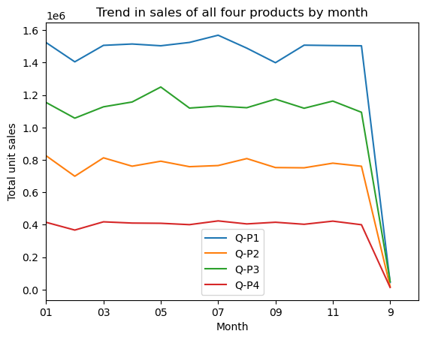

**INPUT :**

plot_bar_chart(_31_months, ['Q-P1', 'Q-P2', 'Q-P3', 'Q-P4'], 'Average Units', 'each Month, for 31st', 'mean')

**OUTPUT:**

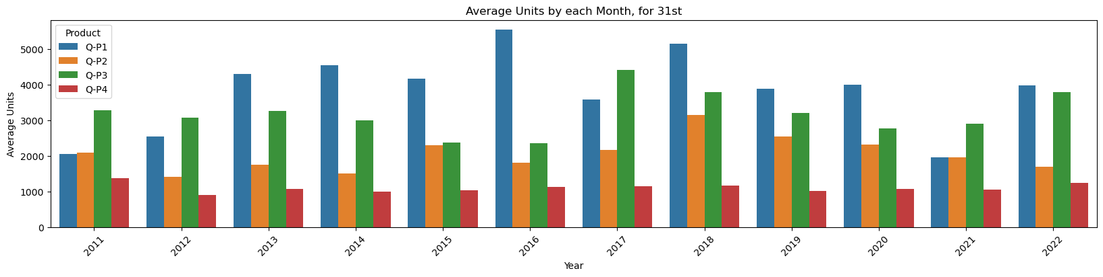

**INPUT :**

Plot_ bar_ chart (_31_months, ['S-P1', 'S-P2', 'S-P3', 'S-P4'], 'Average Revenue', 'each Month, for 31st', c 'mean')

**OUTPUT :**

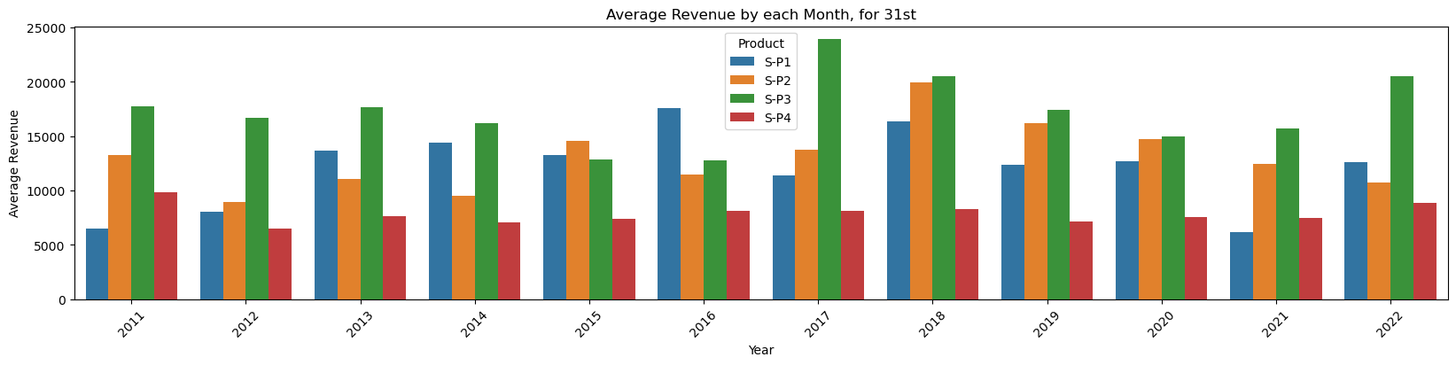

**DATASET :**

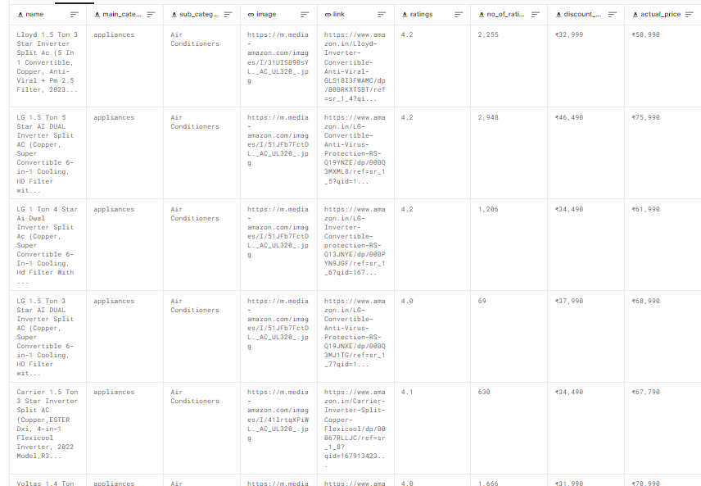

7*1267