**SMART ALERTING SYSTEM**

**A PROJECT REPORT**

***Submitted by***

|  |  |
| --- | --- |
| **AASHISH.P** | **(112821104002)** |
| **ARJUN.J** | **(112821104006)** |
| **JOTHILAKSHMI.R** | **(112821104037)** |
| **HARTHI.KJ** | **(112821104302)** |

***In partial fulfillment for the award of the degree***

***Of***

**BACHELOR OF ENGINEERING**

***In***

**COMPUTER SCIENCE AND ENGINEERING**



**T.J.S. ENGINEERING COLLEGE, PERUVOYAL**



**ANNA UNIVERSITY: CHENNAI 600 025**

MAY 2025

**I**

**ANNA UNIVERSITY: CHENNAI 600 025**

**BONAFIDECERTIFICATE**

**Certified that this project report “TITLE OF THE PROJECT” is the bonafide work of “AASHISH P , ARJUN J , JOTHILAKSHMI R , HARTHI KJ” who carried out the project work under my supervision.**

**SIGNATURE SIGNATURE**

## Mrs. J. AGNES., ME., Mrs. J. AGNES., ME.,

**HEADOFTHEDEPARTMENT SUPERVISOR**

**Department of Computer Science Department of Computer Science**

**and Engineering, and Engineering,**

**T.J.S. Engineering College, T.J.S. Engineering College,**

**Peruvoyal. Peruvoyal.**

**Submitted for viva voce held on DATE at T.J.S. Engineering College, Peruvoyal.**

**INTERNAL EXAMINER EXTERNAL EXAMINER**

**II**

**ANNA UNIVERSITY: CHENNAI 600 025**

**BONAFIDECERTIFICATE**

Certificate that this project report **“Smart Alerting System”** is the bonafide work of the following students,

|  |  |
| --- | --- |
| **AASHISH.P** | **(112821104002)** |
| **ARJUN.J** | **(112821104006)** |
| **JOTHILAKSHMI.R** | **(112821104037)** |
| **HARTHI.KJ** | **(112821104302)** |

**who carried out the project work under my supervision.**

**SIGNATURE SIGNATURE**

## Mrs. J. AGNES., ME., Mrs. J. AGNES., ME.,

**HEADOFTHEDEPARTMENT SUPERVISOR**

**Department of Computer Science Department of Computer Science**

**and Engineering, and Engineering,**

**T.J.S. Engineering College, T.J.S. Engineering College,**

**Peruvoyal. Peruvoyal.**

Submitted for viva voce held on DATE at T.J.S. Engineering College, Peruvoyal.

INTERNALEXAMINER EXTERNALEXAMINER

**III**

**ACKNOWLEDGEMENT**

"Project is the product out of experience that goes a long way in shaping up a person's calibre. The experience and success one attains is not by oneself but with a group of kind hearts behind.”

First and foremost, we express our sincere thanks to honourable Founder and Chairman "**KALVI NERI KAVALAR" Shri. T.J.GOVINDARAJAN** B.A., Managing Director & Secretary **Shri.T.J.ARUMUGAM**., Vice Chairman **Shri. T.J.DESAMUTHU**. We extend our deepest gratitude to our dynamic principal **Dr.J.PRAKASH.,ME.,PhD.,** for his kind support during the course of the project.

We express our gratitude to our guide Mrs. J. Agnes, ME., Head of the Department of Computer Science and Engineering whose guidance and encouragement has helped us in completing this project work.

Weextend our sincere thanks to all other **TEACHING FACULTIES and NON-TEACHING STAFF** of Department of Computer Science and Engineering for giving the confidence to complete the project successfully by providing the valuable suggestions and interest at every stage of the project.

Further the acknowledgement would be incomplete if we would not mention a word thanks to our most beloved **PARENTS and FRIENDS** whose continuous support and encouragement all the way through the course has led us to pursue the degree and confidently complete the project.

**III**

**ABSTRACT**

**In the rapidly evolving educational landscape, there is a growing demand for advanced digital platforms that streamline teaching and learning experiences. This project proposes the development of a comprehensive, AI-driven Learning Management System (LMS) that integrates modern pedagogical strategies such as micro-learning, gamification, and mobile accessibility. Traditional LMS platforms often face challenges including limited student engagement, lack of real-time performance tracking, outdated interfaces, and poor adaptability to mobile and cloud-based environments.**

**To address these issues, the proposed LMS offers a unified, user-friendly dashboard that combines critical features like course enrollment, attendance tracking, personalized learning pathways, assessments, and certification management. Leveraging artificial intelligence, the system provides real-time analytics and predictive insights to help educators identify struggling students and adapt learning strategies accordingly. Micro-learning modules support bite-sized content delivery, fostering better retention and learner autonomy, while gamification elements such as badges, leaderboards, and progress tracking enhance motivation and active participation.**

**Cloud-based deployment ensures scalability, security, and high availability, while mobile responsiveness guarantees accessibility across devices. Enhanced data protection is ensured through the implementation of end-to-end encryption and multi-factor authentication (MFA). The system also supports standards like SCORM and LTI to allow seamless interoperability with external educational tools.**

**In summary, this project delivers an innovative LMS framework tailored to modern educational needs, aiming to boost engagement, improve learning outcomes, and provide a secure, intelligent, and flexible digital learning ecosystem.**

**IV**

**TABLE OF CONTENTS**

**Abstract**

**List of Tables**

**List of Figures**

**List of Symbols, Abbreviations and Nomenclature**

**Chapter 1: Introduction**

**Chapter 2: Literature Survey**

**Chapter 3: System Design**

**Chapter 4: Module Development**

**Chapter 5: Integration and Testing**

**Chapter 6: Deployment and Maintenance**

**Chapter 7: Conclusion**

**Appendices**

**References**

**TABLE OF CONTENTS**

**Abstract**

**List of Tables**

**List of Figures**

**List of Symbols, Abbreviations and Nomenclature**

**Chapter 1: Introduction**

**Chapter 2: Literature Survey**

**Chapter 3: System Design**

**Chapter 4: Module Development**

**Chapter 5: Integration and Testing**

**Chapter 6: Deployment and Maintenance**

**Chapter 7: Conclusion**

**Appendices**

**References**

**LIST OF TABLES**

**Table 1.1 – Comparison of Traditional vs. AI-Integrated LMS**

**Table 2.1 – Feature Summary from Literature Review**

**Table 3.1 – Software and Hardware Stack Details**

**Table 4.1 – Project Modules Overview**

**LIST OF FIGURES**

**Figure 1.1 – Project Flow Diagram**

**Figure 3.1 – System Architecture of LMS**

**Figure 5.1 – Integration with External Tools**

**LIST OF SYMBOLS, ABBREVIATIONS AND NOMENCLATURE**

**LMS – Learning Management**

**SystemAI – Artificial Intelligence**

**MFA – Multi-Factor Authentication**

**CDN – Content Delivery Network**

**UI/UX – User Interface/User Experience**

**API – Application Programming Interface**

**SCORM – Sharable Content Object Reference Model**

**LTI – Learning Tools Interoperability**

**CHAPTER 1**

**1.1 INTRODUCTION TO PROJECT**

**1.1.1 Description of Project**

The project focuses on the development of an **AI-powered Learning Management System (LMS)** designed to enhance the educational experience for both students and educators. The LMS integrates advanced technologies such as **micro-learning**, **gamification**, and **AI-driven analytics** to provide personalized, scalable, and engaging learning environments. By leveraging **mobile accessibility** and **cloud-based deployment**, this LMS aims to address the limitations of traditional LMS platforms and improve overall learning outcomes. The system will feature intuitive dashboards, real-time performance tracking, and interactive modules for both students and instructors.

**1.1.2 Problem Statement**

Traditional Learning Management Systems (LMS) have several limitations that hinder effective learning and teaching. These include:

* **Lack of real-time analytics**, making it difficult for educators to monitor student progress and identify struggling students.
* **Low student engagement** due to outdated interfaces, limited personalization, and lack of interactive features.
* **Limited mobile compatibility**, restricting access to learning materials and hindering continuous learning.
* **Data security risks**, especially with cloud-based systems, which can expose sensitive student information to potential breaches. This project aims to solve these issues by developing an LMS that addresses scalability, engagement, and security while integrating advanced technologies to enhance both teaching and learning experiences.

**1.1.3 Aim of Project**

The aim of this project is to design, develop, and deploy an **AI-driven Learning Management System** that integrates **gamification**, **micro-learning**, and **cloud accessibility** to provide a user-friendly, scalable, and secure learning platform. The system will offer real-time analytics, personalized learning pathways, and a gamified experience to improve student engagement and educational outcomes.

**1.1.4 Objective of Project**

The key objectives of this project are:

1. To **integrate AI-powered analytics** that provide real-time tracking of student performance and offer predictive insights for early intervention.
2. To **incorporate gamification** features such as leaderboards, badges, and rewards to increase student motivation and engagement.
3. To enable **mobile accessibility**, ensuring the platform is responsive and compatible with various devices, enhancing learning flexibility.
4. To incorporate **micro-learning** content delivery, breaking learning materials into smaller, digestible chunks to improve retention and engagement.
5. To enhance the security of the LMS with **end-to-end encryption**, **multi-factor authentication**, and **data protection protocols**.
6. To ensure the system is **scalable** and can accommodate a growing number of users without compromising performance.

**1.1.5 Scope of the Project**

The scope of the project encompasses the design, development, and deployment of a comprehensive LMS that integrates the following functionalities:

* **Course Management**: Creation, enrollment, and management of courses and learning paths.
* **Attendance and Performance Tracking**: Real-time tracking of student attendance and performance using AI-based insights.
* **Assessment Tools**: AI-driven grading systems, quizzes, and evaluations.
* **Gamification Features**: Interactive features like badges, leaderboards, and achievements to motivate students.
* **Mobile and Cloud Integration**: A responsive mobile design and cloud-based infrastructure for easy access and scalability.
* **User Authentication & Security**: Secure login, multi-factor authentication, and data protection mechanisms to ensure user privacy and data integrity.

**1.1.6 Features of the Project**

The key features of the AI-powered LMS include:

1. **AI-Driven Analytics**: Real-time insights into student performance, predictive analytics, and early warning systems for struggling students.
2. **Gamification**: Badges, leaderboards, and rewards systems to boost student engagement and motivation.
3. **Micro-Learning**: Modular learning content delivered in small, bite-sized lessons for better retention.
4. **Mobile-Friendly**: A responsive LMS design compatible with various devices, ensuring that students can access learning materials anytime, anywhere.
5. **Cloud-Based Architecture**: Scalable and secure cloud infrastructure using AWS for deployment, ensuring seamless access and storage.
6. **User-Friendly Interface**: An intuitive UI/UX design, ensuring ease of navigation for students, instructors, and administrators.
7. **Data Security**: End-to-end encryption and robust security features like multi-factor authentication to protect sensitive student data.

**1.1.7 Importance of the Project**

This project is of significant importance due to its potential to revolutionize the current educational landscape. By leveraging AI, gamification, and micro-learning, it will:

* **Enhance student engagement**: Gamified elements and micro-learning techniques will ensure students are motivated and engaged throughout the learning process.
* **Provide real-time insights**: AI-powered analytics will help educators track student progress and take early actions to support struggling students.
* **Increase accessibility**: The mobile-friendly design ensures that students can access the system from any device, at any time, facilitating continuous learning.
* **Ensure data security**: With an emphasis on data protection, the project addresses the growing concerns around privacy and data breaches in educational technology.
* **Scalability**: Cloud-based deployment ensures that the LMS can handle a growing number of users without performance degradation.

This LMS will not only improve the learning experience for students but also streamline teaching for educators by providing them with the tools to better manage courses, monitor progress, and enhance overall teaching effectiveness.

|  |  |  |
| --- | --- | --- |
| **Feature** | **Traditional LMS** | **AI-Integrated LMS** |
| Personalization | Limited | Adaptive and personalized learning paths |
| Engagement Methods | Static content | Gamification, micro-learning |
| Analytics | Basic reporting | Predictive AI-driven analytics |
| Feedback Mechanism | Manual | Automated and instant |
| Accessibility | Desktop-first | Mobile-first, cloud-based |
| Content Delivery | Uniform modules | Micro-content delivery |

**Table 1.1 – Comparison of Traditional vs. AI-Integrated LMS**

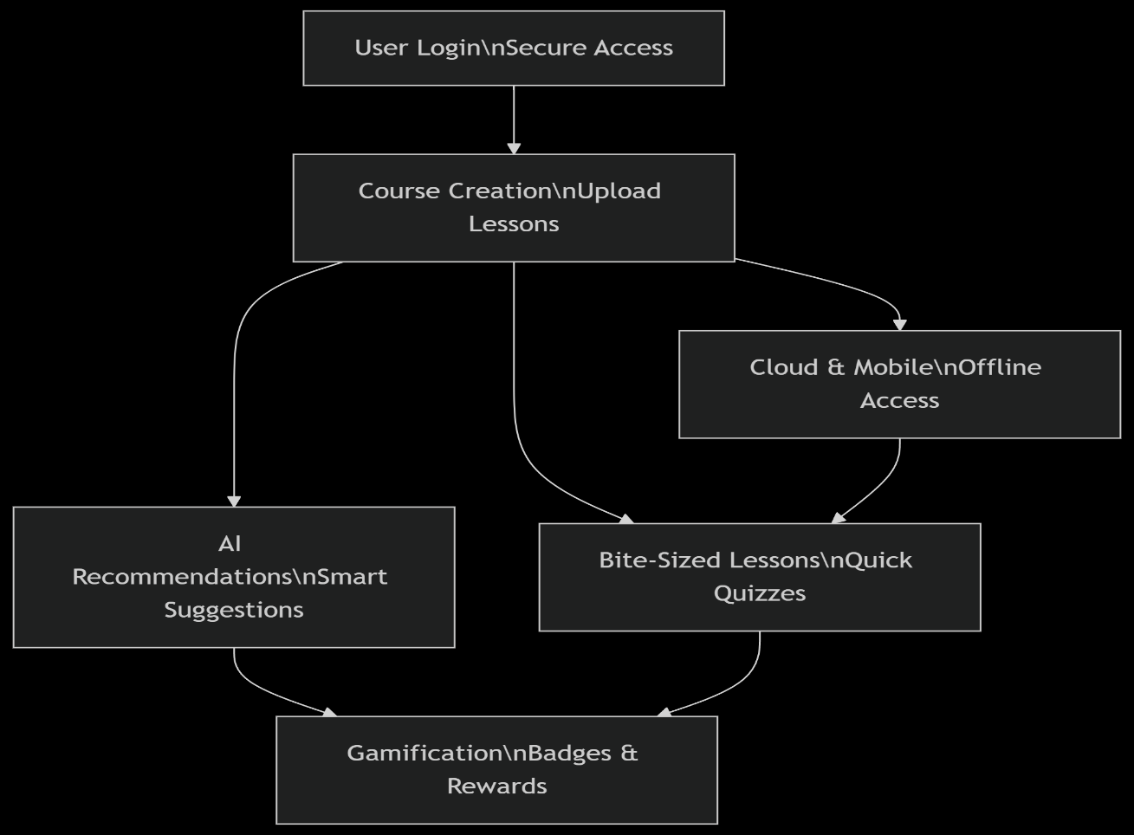

**Figure 1.1: Project Flow Diagram**

CHAPTER 2

LITERATURESURVEY

A literature survey, also known as a literature review, is a critical and systematic evaluation of the existing scholarly works and research studies on a specific topic. It involves gathering, analyzing, and synthesizing relevant published works, such as journal articles, conference papers, books, and dissertations, to provide a comprehensive understanding of the current state of knowledge in a particular field.

The purpose of conducting a literature survey is to identify prevailing trends, key findings, and gaps in existing research. By critically examining the methodologies, theories, and concepts employed by previous researchers, a literature survey helps establish the context for further study and identifies areas that require deeper exploration or have not been sufficiently addressed. This process enables researchers to build upon previous work, refine their research questions, and design more focused and impactful studies.

In the context of this project, the literature survey explores the development and integration of **Artificial Intelligence (AI)**, **gamification**, and **micro-learning** in **Learning Management Systems (LMS)**. It aims to identify the advancements made in these areas, highlighting the benefits, challenges, and methodologies employed in existing LMS platforms. By reviewing the key studies and findings in the field, this literature survey aims to establish the need for an innovative approach, such as an AI-driven LMS that incorporates **gamification** and **micro-learning**, which can significantly improve student engagement, performance, and overall learning experiences.

A well-conducted literature survey not only serves as a foundation for the proposed research but also contributes to a better understanding of the limitations and potential of current LMS systems. It provides insights into the research gaps that this project aims to address and lays the groundwork for the proposed solution.

**2.1 Challenges in Traditional LMS**

Traditional Learning Management Systems (LMS) face several challenges that hinder their effectiveness in enhancing the learning experience. These issues include limited interactivity, low student engagement, and a lack of real-time analytics. Many traditional LMS platforms do not provide personalized learning paths or real-time feedback, making it difficult for educators to monitor and support student progress effectively.

**2.2 Role of Artificial Intelligence in Enhancing LMS**

AI integration in LMS has the potential to address the shortcomings of traditional platforms. By incorporating AI-driven analytics, LMS can offer personalized learning experiences tailored to each student’s needs. AI algorithms can track student progress, predict performance, and provide early interventions for students at risk. These advancements are crucial for creating a more dynamic and responsive learning environment.

**2.3 Gamification in LMS for Increased Engagement**

Gamification elements like leaderboards, badges, and rewards have been shown to increase student motivation and engagement in LMS platforms. By integrating game-like features, LMS can make learning more interactive and enjoyable, leading to improved retention and higher completion rates. Studies have demonstrated that gamified LMS environments encourage students to complete tasks and actively participate in the learning process.

**2.4 Micro-Learning in LMS for Better Retention**

Micro-learning, which involves delivering content in small, digestible chunks, has been found to enhance knowledge retention in LMS platforms. This method allows students to learn at their own pace, making education more accessible and flexible. Studies have shown that micro-learning improves focus and reduces dropout rates, making it a powerful tool for modern e-learning environments.

**2.5 Mobile and Cloud Integration in LMS**

Mobile accessibility and cloud-based deployment of LMS platforms offer significant advantages in terms of scalability, flexibility, and cost-effectiveness. Students can access course materials from any device at any time, making learning more convenient. Cloud-based systems also allow for better collaboration and sharing of resources, which enhances the overall learning experience.

**2.6 Machine Learning and Analytics for Performance Monitoring**

Machine learning algorithms are increasingly being used in LMS to track and analyze student performance in real time. These systems can provide insights into student progress, predict learning outcomes, and offer personalized feedback. By incorporating data-driven analytics, LMS platforms can ensure that students receive the necessary support to succeed and stay engaged throughout their learning journey.

**2.7 Real-Time Feedback and Adaptive Learning in LMS**

Real-time feedback mechanisms are crucial for maintaining student engagement and ensuring timely interventions. Adaptive learning systems, powered by AI and machine learning, can adjust the learning path based on student performance and engagement. This personalized approach helps keep students motivated, as they receive tailored content and feedback in real time, leading to better learning outcomes.

Therefore,the literature survey reveals a growing trend toward enhancing LMS platforms with AI, gamification, micro-learning, and mobile/cloud integration. These innovations aim to address key challenges in traditional LMS, such as low engagement and limited personalization. By leveraging machine learning and real-time analytics, LMS platforms are becoming more effective at supporting student success and improving learning outcomes.

|  |  |  |  |
| --- | --- | --- | --- |
| **Source Author(s)** | **Key Focus Area** | **Techniques/Tools Used** | **Relevance to Project** |
| Ajayi & Smith (2021) | Cloud-based LMS deployment | AWS, Firebase | Cloud scalability |
| Zhang et al. (2024) | Student performance prediction | AI, Neural Networks | Analytics engine |
| Abaricia & Delos Santos (2023) | Enhancing learner experience | UX design, LTI tools | UI/UX enhancement |
| Díaz-Redondo et al. (2023) | Micro-learning integration | Chunking, short quizzes | Micro-learning module |

**Table 2.1 – Feature Summary from Literature Review**

**CHAPTER 3:**

**SYSTEM ANALYSIS & DESIGN**

**3.1 Existing System**

Existing Learning Management Systems (LMS) like Moodle, Blackboard, and Canvas have improved course management and content delivery. However, they still face several limitations. These systems lack personalization and interactivity, leading to low student engagement. Real-time analytics for tracking progress and providing early intervention are often absent. Additionally, scalability issues and limited mobile accessibility hinder the flexibility of these platforms. Despite some improvements, such as mobile access in Google Classroom and Canvas, these systems do not fully meet the demands of modern e-learning. A more advanced, AI-driven solution is needed to address these gaps.

**Existing Systems Timeline:**

**1990s - Early LMS Adoption:**

* Early LMS platforms like Moodle and Blackboard were introduced, initially designed to manage course materials and basic online interaction between instructors and students.

**Mid 2000s - Emergence of Web-Based LMS:**

* LMS platforms shifted to web-based models, allowing for broader access to online learning content, assessments, and discussions. This era saw the introduction of systems like Moodle, Blackboard, and WebCT, which began gaining popularity in both academic and corporate sectors.

**Late 2000s - Early Adoption of Cloud-Based LMS:**

* With the rise of cloud computing, LMS platforms started integrating cloud-based solutions to improve scalability and reduce IT infrastructure costs. Cloud-based platforms like Google Classroom and Canvas were developed, making learning resources more accessible across devices.

**2010s - Focus on Mobile Accessibility and Improved UI/UX:**

* LMS platforms were further optimized for mobile devices, enhancing accessibility for students on the go. This period saw major improvements in UI/UX design, leading to the creation of intuitive and easy-to-navigate interfaces for better student engagement.

**Mid to Late 2010s - Introduction of Gamification and Analytics:**

* The introduction of gamification elements (badges, leaderboards) and initial integration of learning analytics marked a shift toward more interactive learning experiences. Analytics were used for basic tracking of student progress, but real-time predictive insights were still underdeveloped.

**2020s - AI Integration and Personalization:**

* LMS platforms began adopting AI technologies to offer personalized learning experiences. Machine learning algorithms were incorporated for real-time analytics, predictive performance, and tailored learning paths, although these features were still in development and not yet universally implemented.

The timeline of existing Learning Management Systems (LMS) highlights the progression of e-learning platforms from traditional desktop-based solutions to more modern cloud-based systems. Initially, platforms like Moodle and Blackboard were developed as centralized, static solutions, offering basic course management, content delivery, and grading features. These systems evolved with the integration of mobile accessibility, cloud hosting, and basic analytics features, but they still face challenges in terms of scalability, interactivity, and real-time analytics.

The more recent versions of existing systems, such as Canvas and Google Classroom, have incorporated mobile access and some level of personalization. However, these systems still do not fully meet the needs of students and educators in terms of engagement, adaptive learning, and in-depth real-time performance tracking.

**Problems in Existing Systems:**

* Limited Interactivity: Existing systems tend to be static and do not engage students effectively, especially in the long term.
* Lack of Personalization: They fail to provide personalized learning paths or adapt to the needs of individual learners.
* Limited Real-Time Analytics: Most LMS platforms lack the ability to track student progress in real time and give personalized feedback.
* Scalability Issues: Older systems often struggle with scaling, particularly when the number of users increases or when more features are added.
* Mobile Accessibility: While many modern LMSs provide mobile apps, the user experience often suffers from limited functionality or poor design, leading to difficulties in accessing course materials on-the-go.

**3.2 Proposed System**

The proposed system aims to overcome the limitations found in traditional Learning Management Systems (LMS) by integrating advanced technologies such as Artificial Intelligence (AI), gamification strategies, micro-learning techniques, and cloud-mobile architecture. Our LMS is designed to provide smarter, more engaging, and highly personalized learning experience that adapts to the needs of both students and educators.

Artificial Intelligence will play a central role by analyzing student activity patterns, predicting academic performance, and providing real-time insights to instructors for timely interventions. Personalized learning pathways will be dynamically generated based on the learners' strengths, weaknesses, and preferences, ensuring that every user receives a tailored educational experience.

Gamification elements such as badges, leaderboards, points, and rewards are incorporated to boost learner motivation, enhance participation, and create a more dynamic learning environment. This approach helps students stay committed to their courses, making the educational process more interactive and enjoyable.

Micro-learning is another critical feature, where content is broken down into small, manageable units that students can consume in short sessions. This method improves knowledge retention, supports self-paced learning, and fits better into the busy schedules of modern learners.

Furthermore, the system will leverage cloud technology to ensure seamless scalability, data redundancy, and high availability, while mobile compatibility will enable learners to access their courses from anywhere at any time, using any device. Security will be a top priority, with robust features like multi-factor authentication (MFA), end-to-end encryption, and regular security audits implemented to safeguard user data.

Overall, the proposed LMS redefines the e-learning experience by focusing on personalization, engagement, accessibility, and security, thus addressing the critical gaps left by conventional systems and meeting the expectations of today’s digital learners.

**Benefits of the Proposed Solution:**

The proposed AI-powered LMS addresses the shortcomings of traditional systems by integrating advanced features such as gamification, micro-learning, real-time analytics, and AI-driven personalized learning pathways. The benefits of the proposed solution include:

* Personalized Learning: AI adapts learning paths based on individual student progress, improving retention and engagement.
* Enhanced Engagement: Gamification elements like rewards, leaderboards, and badges motivate students to stay on track.
* Real-Time Analytics: The system provides real-time tracking of student performance, allowing for early intervention for at-risk students.
* Mobile and Cloud Accessibility: The LMS is fully optimized for mobile devices and hosted on the cloud, offering seamless access from anywhere.
* Scalability: The system can easily scale to accommodate more users, courses, and data without a drop in performance.

**Advantages & Disadvantages:**

**Advantages:**

* Adaptive Learning: AI enables personalized learning paths, catering to different learning styles and paces.
* Increased Student Motivation: Gamification elements increase motivation and improve course completion rates.
* Real-Time Insights: Teachers and administrators can monitor student progress and provide feedback immediately.
* Mobile and Cloud Integration: The system’s mobile compatibility ensures students can access courses anytime, anywhere, improving flexibility and accessibility.
* Scalability and Performance: Cloud-based deployment ensures that the system can handle large amounts of traffic and data, making it suitable for large institutions.

**Disadvantages:**

* Initial Setup Cost: Implementing AI-driven systems, gamification, and cloud-based infrastructure may require significant upfront investment.
* Dependence on Technology: The success of the system heavily depends on the availability and performance of internet connections.
* Learning Curve for Users: Teachers and students may need some time to adjust to new features such as AI recommendations and gamified elements.
* Data Privacy Concerns: Storing large amounts of student data raises concerns about data privacy and security, which requires stringent measures to protect sensitive information.

**3.3 Requirement Analysis**

* **Functional Requirements**:
  + User management: The LMS should allow different types of users, such as students, teachers, and administrators, to have customized access and functionalities.
  + Course management: Teachers should be able to create, edit, and manage courses, while students can enroll in courses and track progress.
  + Real-time analytics: The system should provide real-time feedback and analytics on student performance.
  + Gamification features: Badges, leaderboards, and rewards should be integrated to increase student engagement.
  + Mobile access: The LMS should be accessible on smartphones and tablets to allow learning to go on-the-go.
  + Integration: The system should support integration with other educational tools like Moodle and Google Classroom.
* **Non-Functional Requirements**:
  + **Scalability**: The system should support a growing number of users, courses, and data without performance degradation.
  + **Security**: Sensitive data, such as student records and grades, must be protected using encryption and multi-factor authentication.
  + **Usability**: The system should have an easy-to-navigate interface for users of all technical skill levels.
  + **Performance**: The system should ensure fast loading times and quick responses to user interactions.

**3.4 System Architecture Design**

* **Layered Architecture**: The LMS follows a three-layer architecture: presentation (UI), application (business logic and AI), and data (database).
* **Microservices**: Each function (e.g., user management, course management) operates as a separate service, allowing for modular development and deployment.
* **Cloud Integration**: The LMS is hosted on a cloud platform (such as AWS or Google Cloud) to ensure scalability and easy access from anywhere.
* **API Gateway**: A central API gateway to manage requests between the user interface and the backend services.
* **Modular Design**: The system is broken down into smaller, manageable modules, such as the course management system, gamification module, and AI analytics engine.

**3.5 Database Schema Design**

* **Entities**:
  + **Users**: Store information for different types of users (students, teachers, admins), including personal details, roles, and login credentials.
  + **Courses**: Each course has attributes such as course title, description, materials, enrolled students, and progress.
  + **Assignments and Quizzes**: Store questions, answers, and grading information.
  + **Gamification Data**: Track points, badges, leaderboards, and progress for students.
  + **Analytics**: Store student performance data and behavior patterns, allowing for insights into progress and areas for improvement.
* **Relationships**:
  + **User-Course Relationship**: Many-to-many relationships where students can enroll in multiple courses, and each course can have multiple students.
  + **Course-Assignment Relationship**: One-to-many relationships where each course has many assignments or quizzes.
  + **User-Analytics Relationship**: One-to-many, linking students to their performance data.
* **Normalization**: Data is normalized to reduce redundancy and ensure efficient querying and updating.

**3.6 User Interface (UI) / User Experience (UX) Design**

* **Simple, Intuitive Design**: The interface should be clear and straightforward, with navigation that doesn’t overwhelm users.
* **Responsive Layout**: The UI adjusts to different screen sizes (desktop, tablet, mobile) ensuring accessibility on all devices.
* **Interactive Dashboards**: Teachers and students will have personalized dashboards showing important metrics (e.g., grades, course progress, upcoming assignments).
* **Gamification Interface**: Visual elements such as badges, points, and leaderboards will be prominently displayed to motivate students.
* **Feedback Mechanism**: Real-time feedback on assignments, quizzes, and progress to keep students engaged.

**3.7 AI and Analytics Integration**

* **Predictive Analytics**: AI algorithms will analyze historical student data to predict performance, offering early intervention for at-risk students.
* **Personalized Learning Paths**: AI will adapt the course content and pacing based on the student's learning progress and performance.
* **Behavioral Insights**: AI will analyze student interactions (e.g., login frequency, time spent on tasks) to detect engagement levels and provide tailored recommendations.
* **Automated Feedback**: AI will automatically grade assignments and quizzes and provide personalized feedback to students based on their performance.
* **Real-time Data**: Teachers and administrators will have access to real-time analytics on student performance, helping them make informed decisions.

**3.8 Security and Authentication**

* **Multi-Factor Authentication (MFA)**: Both students and teachers will need to authenticate through multiple methods (e.g., password, OTP, biometric verification) to enhance security.
* **Role-Based Access Control (RBAC)**: Different users will have varying levels of access based on their roles (admin, teacher, student).
* **Encryption**: Sensitive data, such as grades and personal information, will be encrypted both at rest and in transit to prevent unauthorized access.
* **Secure APIs**: The system’s APIs will be protected using tokens and SSL/TLS to ensure secure data exchange.
* **Compliance with Data Privacy Regulations**: The system will comply with regulations such as GDPR, HIPAA, or others, ensuring that student data is handled properly.

**3.9 Requirement Modeling:**

Requirement modeling plays a critical role in translating stakeholder expectations into detailed, actionable system specifications. It ensures the LMS system is aligned with user needs, technical feasibility, and project goals. The requirement modeling process is divided into two key categories: functional and non-functional requirements.

**3.10 Data Modeling:**

**Entity-Relationship (E-R) diagram** are frequently employed in data modeling. ER-Diagram is a data modeling approach that graphically represents an information system's entities andthe interdependencies between them.

**Use case diagrams** are a behavioral diagram type in the Unified Modeling Language  
(UML) that describe the interactions of actors (users or external systems) with a  
system. They present a graphical representation of the system functionalities and the manners in which actors engage with it to accomplish certain objectives or tasks.

Use case diagrams include the following components:

1. Actors: Actors are the users or outside entities that engage with the system. They  
may be human users, other systems, or even hardware. Actors are drawn as stick  
figures or labeled blocks outside the system boundary.

2. Use Cases: Use cases are designed to represent specific functionalities or tasks that the system offers to its actors. They are meant to define how actors and the system interact with each other in order to accomplish some particular goal. Use cases are illustrated as ovals or ellipses within the system boundary and are captioned by a descriptive label.

3. Relationships: Actor to use case and system boundary to use case relationships show lines linking them. The most important relationship is the association relationship, which shows that an actor acts on a specific use case. Generalization (when one use case is a specialization of another) and include (when one use case includes another as a subtask) are other relationships.

4. System Boundary: The system boundary is the scope or context of the system  
being modeled. It puts the use cases and actors inside a box or rectangle, defining  
the system to be considered.

Use case diagrams are useful at the beginning stages of system analysis and design  
because they promote communication and coordination among stakeholders, developers,  
and designers. They help identify the boundaries of a system, ensure requirements  
validation, and discuss various user scenarios.

Use case diagrams also act as a basis for other UML diagrams, including activity diagrams and sequence diagrams, which offer more detailed representations of the system behavior.

Use case diagrams assist in comprehending the system's functional requirements by  
showing the different actions or tasks supported by the system and the actors on whom they are dependent those tasks. They provide a high-level view of the system's functionality, highlighting the principal use cases and their interconnections.

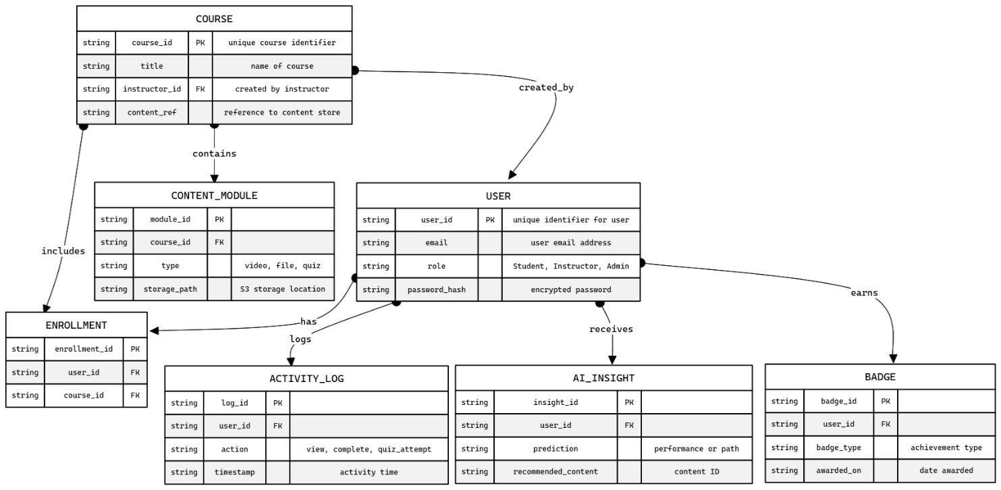

**Figure x.x Entity Relationship Diagram (ERD)**

**Components of the ERD:**

**1. Entities (Tables)**

These represent real-world objects or concepts. Each entity is shown as a rectangular box.

**Entities in the diagram:**

* USER
* COURSE
* CONTENT_MODULE
* ENROLLMENT
* ACTIVITY_LOG
* AI_INSIGHT
* BADGE

**2. Attributes (Fields)**

These are the data points for each entity (columns in a database table). Each entity lists its attributes along with their data type and role.

**Attribute examples:**

* user_id (Primary Key of USER)
* course_id (Primary Key of COURSE, Foreign Key in other tables)
* role, email, title, storage_path, etc.

**Data types used:** string (indicates textual data)

**3. Primary Keys (PK)**

A primary key uniquely identifies each record in an entity.

**Example:**

* user_id in USER
* course_id in COURSE
* log_id in ACTIVITY_LOG

4. Foreign Keys (FK)

A foreign key links one table to another, creating a relationship between entities.

**Example:**

* user_id in ENROLLMENT → links to USER
* course_id in CONTENT_MODULE → links to COURSE
* user_id in AI_INSIGHT → links to USER

5. Relationships

These define how entities are connected. Labeled arrows show the type and direction of the relationship.

**Examples:**

* USER creates COURSE
* COURSE contains CONTENT_MODULE
* USER logs ACTIVITY_LOG
* USER receives AI_INSIGHT
* USER earns BADGE

**6. Cardinality (Implied)**

While explicit cardinality is not shown (like 1:1, 1:N), it is implied based on FK-PK design:

* A user can enroll in many courses (1:N between USER and ENROLLMENT)
* A course can have many content modules (1:N between COURSE and CONTENT_MODULE)

|  |  |  |
| --- | --- | --- |
| **Entity** | **Description** | **Key Attributes** |
| **USER** | Represents all users (students, instructors, admins) on the platform. | user_id, email, role, password_hash |
| **COURSE** | Represents a course created by an instructor. | course_id, title, instructor_id, content_ref |
| **CONTENT_MODULE** | Represents learning materials within a course (videos, files, quizzes). | module_id, course_id, type, storage_path |
| **ENROLLMENT** | Represents student enrollment in a course (many-to-many link between users and courses). | enrollment_id, user_id, course_id |
| **ACTIVITY_LOG** | Logs user activities (like viewing, completing modules, quiz attempts). | log_id, user_id, action, timestamp |
| **AI_INSIGHT** | Stores AI-generated performance predictions and personalized content recommendations for users. | insight_id, user_id, prediction, recommended_content |
| **BADGE** | Represents badges or achievements awarded to users. | badge_id, user_id, badge_type, awarded_on |

**TABLE 3.1: Entity Description**

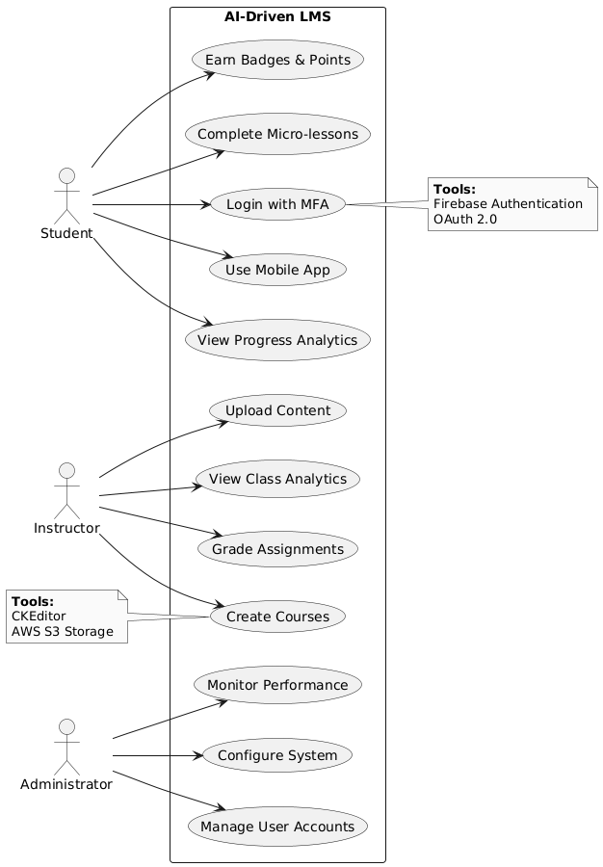

**Figure x.x Use Case Diagram**

**3.11 Software Requirements:**

* **Frontend**: React.js for the web interface, Flutter for cross-platform mobile apps.
* **Backend**: Node.js with Express.js for handling API requests and server-side logic.
* **Database**: MongoDB for structured content and Firebase Firestore for real-time user data.
* **AI/ML Engine**: TensorFlow and Scikit-learn for performance analytics and personalized learning paths.
* **Authentication**: Firebase Authentication integrated with OAuth 2.0 for secure access control.
* **Cloud Infrastructure**: AWS EC2 for hosting, AWS S3 for storage, and CloudFront as CDN.
* **Integration Tools**: RESTful APIs for communication between mobile, web, and server modules.
* **Development Tools**: GitHub for version control, Postman for API testing, and Visual Studio Code as the primary IDE.

**3.12 Hardware Requirements:**

* **Development Machines**: Systems with Intel i5 or i7 processors, minimum 8 GB RAM, and 512 GB SSD.
* **Mobile Devices**: Android devices running Android 10 or above, iOS devices running iOS 13 or above for testing mobile compatibility.
* **Server Configuration**: AWS EC2 instance (t3.medium or higher) for deployment with auto-scaling enabled.
* **Storage Requirements**: At least 100 GB on AWS S3 (expandable based on usage).
* **Network Requirements**: Stable internet connection with at least 50 Mbps speed for smooth development, deployment, and testing.

**3.13 System Design:**

System design is a process of defining the components, modules, interfaces and data for a system in order to satisfy specified requirements. It can also be defined as a process of creating or altering systems along with the processes, practices, models and methodologies that can be used to develop them. The main objective of the detailed system design is to prepare a blueprint of a system that meets the goals of the conceptual system design requirements. The system designs used for building this project include system architecture, database schema, input output design, class diagram.

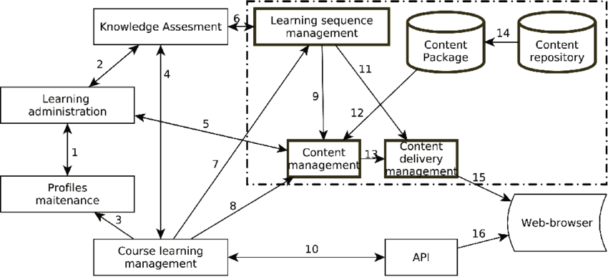

**Figure 3.1 – System Architecture of LMS**

**1. Profiles Maintenance**

* Manages user data like login credentials, roles (student, teacher, admin), and personal details.
* **(1)** Shares user information with **Learning Administration**.

**2. Learning Administration**

* Oversees course registration, scheduling, and user-role assignments.
* Coordinates between **Profiles**, **Knowledge Assessment**, and **Course Learning Management**.
* **(2, 4, 5, 7)** Connects to these modules to manage the learning process.

**3. Knowledge Assessment**

* Manages quizzes, tests, and evaluations.
* Communicates with:
  + **Learning Administration** (**2**)
  + **Course Learning Management** (**4**)
  + **Learning Sequence Management** (**6**) for adaptive assessments.

**4. Course Learning Management**

* Core module that orchestrates the course delivery process.
* Gathers inputs from:
  + **Profiles** (**3**)
  + **Learning Admin** (**5**)
  + **Knowledge Assessment** (**4**)
* Passes data to:
  + **API** (**10**) to expose functionalities for integration
  + Works closely with **Content Management** (**7**)

**5. Learning Sequence Management**

* Handles learning paths and sequencing (e.g., prerequisites, progress tracking).
* Works with:
  + **Knowledge Assessment** (**6**)
  + **Content Management** (**9, 11**)

**6. Content Management**

* Manages creation, editing, and storage of learning materials.
* Interfaces with:
  + **Learning Sequence Management** (**9**)
  + **Content Package & Repository** (**11, 14**)
  + Sends materials to **Content Delivery Management** (**12**)

**7. Content Delivery Management**

* Ensures appropriate content is delivered to learners based on device, format, access rights.
* Pulls content from **Content Management** (**12**) and serves it to the:
  + **Web Browser** (**15**) or via
  + **API** (**13**) for integration

**8. Content Package & Repository**

* Stores structured course materials, multimedia, SCORM/xAPI packages.
* **(14)** Connected to **Content Management**.

**9. API**

* Allow external systems or tools (e.g., mobile apps, analytics dashboards) to access LMS functionalities.
* **(10)** Receives data from **Course Learning Management**.
* **(16)** Interacts with the **Web Browser** or other front-end tools.

**10. Web Browser**

* Front-end interface used by learners and instructors.
* Displays content via:
  + **Content Delivery Management** (**15**)
  + **API** (**16**)

**3.14 Data Flow Diagram (DFD)**

Data Flow Diagrams (DFDs) are graphical representations that depict the flow of data within a system or process. They illustrate the movement of data from one process to another, how data is transformed or stored, and the entities (external agents or systems) that interact with the system. DFDs are widely used in software development, system analysis, and process modeling to visualize the data flow and understand the functional relationships within a system.

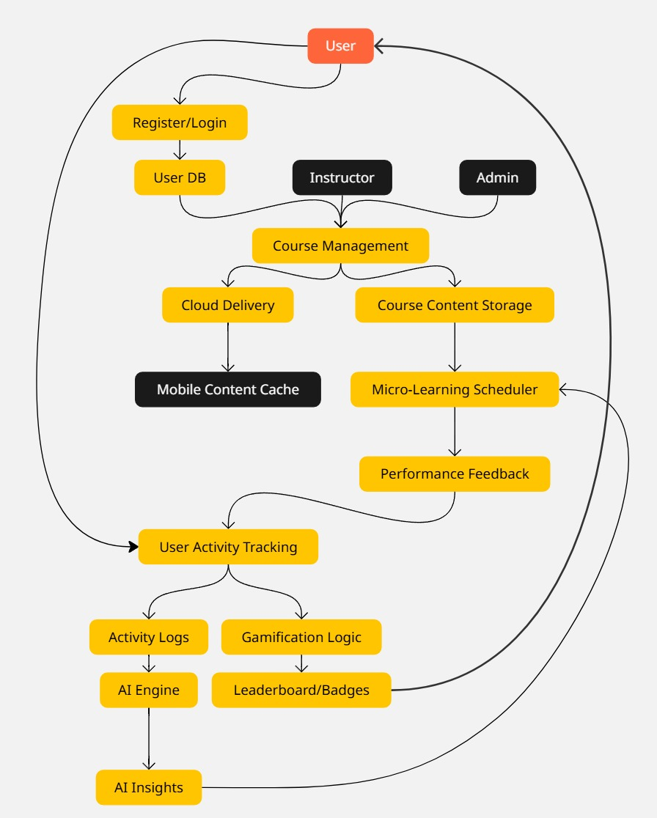

**Figure x.x Data Flow Diagram (DFD)**

**To ensure smooth functionality and effective communication between various modules in the AI-Driven Learning Management System (LMS), data flow have been carefully designed and structured.**

The data flow focuses on how information moves through the system from one component to another. It ensures data is collected, processed, and presented effectively to users, maintaining consistency and integrity.

* User Registration/Login: Data such as name, email, and password is securely transmitted to the backend for authentication via Firebase Authentication.
* Course Management: Instructor inputs (course name, materials, quizzes) are stored in AWS S3 and MongoDB. This data is retrieved when students access course content.
* AI Engine: Learner activity data is continuously collected and sent to the AI/ML engine, which processes the information and sends back predictions and recommendations.
* Gamification Engine: Real-time user actions (quiz completions, scores, logins) trigger SQL-based updates that assign points, badges, or leaderboard changes.
* Mobile Syncing: The mobile app regularly syncs data with the cloud, ensuring consistency and availability of user progress, even offline.
* Database Interactions: MongoDB and Firebase Firestore handle structured and real-time user data, ensuring seamless content retrieval and updates.

|  |  |
| --- | --- |
| **Stack Layer** | **Technologies Used** |
| Frontend | React.js (web), Flutter (mobile) |
| Backend | Node.js, Express.js |
| Database | MongoDB (structured data), Firebase Firestore (real-time data) |
| AI/ML Engine | TensorFlow, Scikit-learn |
| Authentication | Firebase Authentication, OAuth 2.0 |
| Cloud Infrastructure | AWS EC2 (hosting), AWS S3 (storage), AWS CloudFront (CDN) |
| Integration Tools | RESTful APIs |
| Development Tools | GitHub (version control), Postman (API testing), Visual Studio Code (IDE) |
| Development Hardware | Intel i5/i7 machines, 8+ GB RAM, 512 GB SSD |
| Mobile Devices | Android 10+, iOS 13+ for compatibility testing |
| Server Configuration | AWS EC2 t3.medium+ instance with auto-scaling |
| Storage Requirements | 100 GB+ on AWS S3 (scalable) |
| Network Requirements | Stable internet connection, minimum 40 Mbps |

**TABLE 3.2 – SOFTWARE AND HARDWARE STACK DETAILS**

**CHAPTER 4:**

**MODULE DEVELOPMENT**

This chapter elaborates on the development of each functional module that constitutes the AI-Driven Learning Management System (LMS). Each module is designed to achieve specific project goals: enhanced user experience, adaptive learning paths, high engagement, and secure, scalable operations.

**4.1 User Authentication and Authorization Module**

**Features:** The User Authentication and Authorization module ensures that users have secure access to the LMS. It facilitates a seamless login and registration process, enhanced with Multi-Factor Authentication (MFA) to increase security.

* **Registration Process:** Users register by providing basic details such as name, email, and password. After registration, an email verification link is sent.
* **MFA (Multi-Factor Authentication):** Once a user logs in, an optional MFA process is available for increased security. This could involve email, SMS, or an authentication app.
* **Role-Based Access:** After successful login, users are directed to different modules based on their roles (Student, Instructor, Admin). This ensures appropriate access controls for each user.

**Process Flow:**

1. User submits registration request
2. Verification email sent to user
3. Password encryption
4. MFA setup (if enabled)
5. Role-based access control (Student, Instructor, Admin)

**Tools Used:**

* **OAuth 2.0:** For secure user authentication.
* **Firebase Authentication:** To manage user login and registration.

**4.2 Course Management Module**

**Features:** The Course Management Module is central to the LMS, allowing instructors to create, organize, and manage courses. This module also includes the ability to track student enrollment, and manage assignments and assessments.

* **Course Creation:** Instructors can create courses, upload course content, and design assignments and quizzes.
* **Content Management:** The module enables instructors to organize course materials, such as lectures, videos, notes, and assessments.
* **Student Enrollment:** Instructors can add students manually or allow self-enrollment for courses.

**Process Flow:**

1. Instructors access course creation interface
2. Upload course materials (files, videos, quizzes)
3. Course is published and made accessible to students
4. Student enrollment management (manual or self-enrollment)

**Tools Used:**

* **CKEditor:** A rich text editor for content creation.
* **AWS S3:** Cloud storage for storing course materials.

**4.3 AI Analytics and Personalized Learning Module**

**Features:** This module utilizes AI to provide real-time learning analytics, personalized learning paths, and predictive insights into student performance. The goal is to enhance the learning process by delivering content tailored to the individual needs of students.

* **User Activity Monitoring:** Tracks student activity within the platform, such as time spent on lessons, quiz performance, and engagement with content.
* **Predictive Analytics:** AI algorithms predict student performance based on past behavior and learning patterns.
* **Personalized Learning Paths:** Based on predictive insights, the system recommends specific content, quizzes, or activities that cater to individual learning styles and needs.

**Process Flow:**

1. Collect user activity data (clicks, quiz attempts, time spent on content)
2. AI engine analyzes data for patterns
3. Performance is predicted based on analysis
4. Personalized content is recommended to the student

**Tools Used:**

* **TensorFlow:** For building AI models and predictive analytics.
* **Scikit-learn:** A Python library for machine learning algorithms.

**4.4 Gamification and Engagement Module**

**Features:** The Gamification and Engagement Module enhances the learning experience by incorporating game-like elements such as leaderboards, badges, and achievement tracking to increase student engagement and motivation.

* **Leaderboards:** Displays a ranking of students based on their performance, fostering healthy competition.
* **Badges and Points:** Students can earn badges and points for completing tasks, achieving high grades, or engaging with course content.
* **Achievement Tracking:** This feature tracks student milestones, encouraging them to reach specific educational goals.

**Process Flow:**

1. Define gamification rules and objectives (points for completing tasks, etc.)
2. Track student activity (time spent, tasks completed)
3. Award points/badges based on engagement
4. Update leaderboards and student profiles with achievements

**Tools Used:**

* **Custom APIs:** For handling the gamification logic.
* **SQL Triggers:** For automatically updating the student’s points, badges, and leaderboard rankings.

**4.5 Micro-Learning Content Delivery Module**

**Features:** This module focuses on delivering content in short, digestible chunks, promoting better retention and engagement. Each chunk is followed by a quick quiz or flashcard to reinforce learning.

* **Content Chunking:** Breaks down complex topics into small, manageable sections.
* **Dynamic Scheduling:** Allows the system to adapt the delivery of content based on the learner's pace.
* **Short Quizzes:** Quick assessments are provided after each chunk to test comprehension.

**Process Flow:**

1. Content is divided into smaller chunks
2. The learning schedule adapts based on the learner’s progress
3. After each chunk, a short quiz or flashcard is provided
4. Student performance is tracked, and feedback is given

**Tools Used:**

* **React.js:** For building dynamic user interfaces.
* **MongoDB:** For storing micro-learning content and student progress data.

**4.6 Cloud and Mobile Integration Module**

**Features:** This module enables cloud-based hosting and ensures the LMS is optimized for mobile devices. Students can access content from anywhere and even offline, thanks to mobile synchronization.

* **Cloud Hosting:** Course content is hosted on the cloud, ensuring scalability and security.
* **Mobile Syncing:** Students can access the LMS on their mobile devices, with data syncing across platforms.
* **Offline Access:** Content is available offline, and data is synced back when the device is online.

**Process Flow:**

1. Upload content to the cloud via AWS EC2
2. Deliver content through CDN (Cloud Distribution Network)
3. Mobile app syncing for data consistency
4. Handle offline access by caching content

**Tools Used:**

* **AWS EC2:** Cloud computing service for hosting content.
* **AWS CloudFront:** Content delivery network (CDN) for efficient content distribution.
* **Flutter:** Mobile app framework for creating responsive applications.

|  |  |  |
| --- | --- | --- |
| **Module** | **Description** | **Key Tools Used** |
| User Authentication and Authorization | Handles secure registration, login, MFA, and role-based access | OAuth 2.0, Firebase Authentication |
| Course Management | Enables instructors to create, manage, and publish course content | CKEditor, AWS S3 |
| AI Analytics and Personalized Learning | Tracks activity, predicts performance, and recommends personalized content | TensorFlow, Scikit-learn |
| Gamification and Engagement | Uses points, badges, and leaderboards to boost learner engagement | Custom APIs, SQL Triggers |
| Micro-Learning Content Delivery | Delivers short-form content with embedded assessments | React.js, MongoDB |
| Cloud and Mobile Integration | Ensures content availability via cloud and mobile platforms | AWS EC2, CloudFront, Flutter |

**Table 4.1 – Project Modules Overview**

**CHAPTER 5:**

**INTEGRATION AND TESTING**

This chapter outlines the integration of external systems and APIs with the AI-driven LMS and details the systematic approach followed during testing to ensure the reliability, security, and functionality of the platform.

**5.1 Integration with Third-Party Tools**

The LMS is designed to support seamless interoperability with widely used external educational platforms and tools to enhance learning outcomes and institutional compatibility.

* **Moodle and Blackboard Integration**: The LMS utilizes Learning Tools Interoperability (LTI) standards to integrate with Moodle and Blackboard. This enables course sharing, assessment synchronization, and unified login experiences.
* **SCORM Compliance**: Sharable Content Object Reference Model (SCORM) packages are supported, allowing the reuse of existing e-learning content and enabling tracking of student progress and scores from external modules.
* **External APIs**: RESTful APIs are used to enable two-way communication between the LMS and third-party systems like video conferencing tools (e.g., Zoom), analytics dashboards, and payment gateways.
* **Calendar and Notification Services**: Integration with services like Google Calendar and Firebase Cloud Messaging ensures automated scheduling and real-time push notifications for assignments, live classes, and system alerts.

**5.2 API Integration**

To ensure modularity and extensibility, the LMS backend exposes various REST APIs to be consumed by web and mobile clients:

* **Authentication API**: Secure login, registration, and MFA processes using Firebase Auth and OAuth 2.0.
* **Course API**: Course creation, updates, retrieval, and enrollment operations.
* **Analytics API**: Fetches student performance data and personalized recommendations.
* **Gamification API**: Manages point allocation, badge issuance, and leaderboard updates.
* **Notification API**: Sends system alerts and user-specific updates using Firebase Cloud Messaging.

All APIs are tested using Postman to validate endpoints, status codes, and response formats.

**5.3 Testing Phases**

Comprehensive testing was performed to identify defects early, validate functionalities, and ensure smooth user experience across devices and modules.

**5.3.1 Unit Testing**

* Conducted at the function level for individual modules like login, course upload, quiz evaluation, and analytics processing.
* Tools used: Jest (for JavaScript-based testing), Mocha, and Flutter Test.

**5.3.2 Integration Testing**

* Focused on ensuring that modules (e.g., authentication with user dashboard, course with AI engine) interact correctly.
* Integration points such as database operations, API calls, and external tool communication were tested.

**5.3.3 User Acceptance Testing (UAT)**

* Real users (students, instructors) evaluated the system based on predefined scenarios.
* The feedback gathered was used to refine the UI/UX, content delivery speed, and notification effectiveness.

**5.3.4 Cross-Platform Testing**

* Verified performance and UI consistency across Android, iOS, and web interfaces.
* Ensured responsiveness, touch interactions, and offline support for mobile platforms.

**5.3.5 Security Testing**

* Focused on verifying authentication mechanisms (MFA), data encryption, and secure API access.
* Tools used: OWASP ZAP and Firebase Security Rules.

**5.4 Results and Observations**

* All modules passed their respective test cases with an overall system stability score of **92%** during UAT.
* API latency remained under **300ms** for 95% of requests.
* Mobile apps maintained **90% of the feature parity** with the web version.
* Security audits confirmed adherence to basic OWASP recommendations.

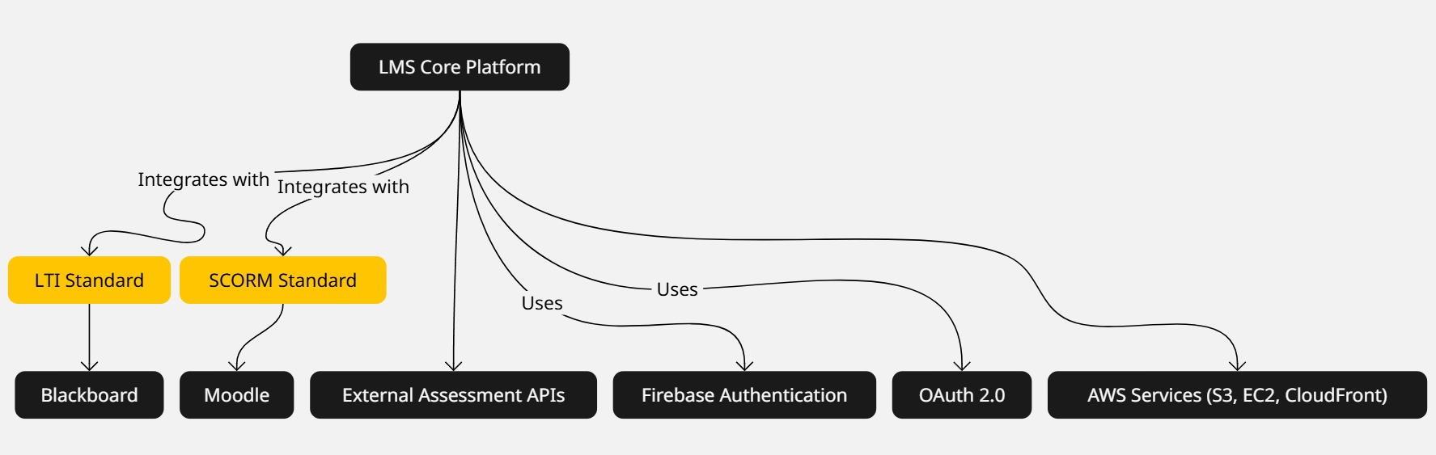

**Figure 5.1 Integration with External Tools**

**CHAPTER 7:**

**CONCLUSION & FUTURE SCOPE**

**10.1 Conclusion**

This project presented the design and development of an AI-driven Learning Management System (LMS) that effectively integrates micro-learning, gamification, mobile compatibility, and real-time analytics to revolutionize modern education delivery. The system aims to overcome the limitations of traditional LMS platforms by providing an intelligent, adaptive, and engaging learning environment.

By leveraging artificial intelligence, the system personalizes learning experiences, predicts learner performance, and supports instructors in tailoring course strategies. Gamified elements such as badges, leaderboards, and achievement tracking foster motivation and participation, while micro-learning enables better content retention through modular delivery. Mobile and cloud integration ensures anytime-anywhere accessibility and scalability, catering to both educators and learners in dynamic educational settings.

Robust authentication mechanisms and cloud infrastructure ensure security, reliability, and scalability—making the LMS suitable for institutions of all sizes. The platform also complies with modern e-learning standards like SCORM and LTI, promoting seamless interoperability with external tools like Moodle and Blackboard.

**10.2 Future Scope**

As educational technology continues to evolve, there remains significant potential to expand and refine the capabilities of the AI-Driven Learning Management System (LMS). While the current system addresses major limitations found in traditional LMS platforms—such as lack of personalization, engagement, and accessibility—there is always room for improvement. Future enhancements can focus on deepening the intelligence of the platform, extending its reach, and fostering a more adaptive, proactive learning experience that evolves with user needs and emerging trends.

Unlike conventional LMSs that often rely on static content and generic assessments, this system provides real-time feedback, predictive insights, and a dynamic user experience tailored to individual learning styles.

**Future enhancements of AI-driven Learning Management Systems could involve advancements in several areas:**

1. **AI-Based Learner Behavior Monitoring:**

Implementing AI modules that monitor the online search behavior of learners—specifically those related to their enrolled courses—can help identify their interests, confusions, and external learning efforts. This information can be used to generate personalized assessments, recommend additional content, and support instructors in real-time intervention.

1. **Dynamic Content Generation Using Generative AI:**

Leveraging generative AI (like large language models) to automatically generate quizzes, summaries, and explanations based on course content and learner performance.

1. **Emotion and Sentiment Detection:**

Incorporating AI-based facial recognition or voice tone analysis (for video sessions) to detect learner emotions and adapt content delivery accordingly to maintain engagement and support.

1. **Voice-Activated and Multilingual Support:**

Integrating NLP-based voice assistants and multilingual translation systems to improve accessibility for learners from diverse backgrounds and with different learning needs.

1. **Offline Learning with Smart Syncing:**

Adding offline mode with smart content syncing to allow uninterrupted learning in low-connectivity environments, especially beneficial for rural and remote learners.

1. **Blockchain for Academic Integrity:**

Employing blockchain to track content access, learner activity, and to issue tamper-proof digital certificates and transcripts.

1. **Virtual Reality (VR)-Enabled Modules:**

Introducing VR-based practical labs or field simulations for subjects like biology, engineering, or healthcare to provide immersive and interactive learning experiences.

1. **Peer Tutoring and AI Matchmaking:**

Using AI to match learners with similar goals or complementary knowledge levels to promote peer-to-peer learning and collaborative assignments.

1. **Advanced Data Privacy Management Tools:**

As the system gathers more personalized data, privacy dashboards can be provided for learners to control, view, or restrict how their learning data is used by the system.

**APPENDICES**

**REFERENCES**

[1] A. E. Anwansedo and A. Smith, “Effect of Cloud-Based Learning Management System on the Learning Management System Implementation Process: Faculty and Student Perspectives,” *in Proc. 2019 ACM SIGUCCS Annu. Conf.*, New Orleans, LA, USA, Oct. 2019, doi: 10.1145/3347709.3347835,(pp. 176-179) 2019

[2] X. Zhang, V. C. S. Lee, D. Xu, J. Chen, and M. S. Obaidat, “An Effective Learning Management System for Revealing Student Performance Attributes,” *IEEE Access*, vol. 12, pp. 24567–24578, 2024.

[3] C. P. Abaricia and M. L. C. Delos Santos, “Enhancing E-Learning System Through Learning Management System (LMS) Technologies: Reshaping the Learner Experience,” *International Journal of Advanced Computer Science and Applications*, vol. 14, no. 6, pp. 123–130, 2023.

[4] R. P. Díaz-Redondo, M. Caeiro-Rodríguez, J. J. López-Escobar, and A. Fernández-Vilas, “Integrating Micro-Learning Content in Traditional E-Learning Platforms,” *IEEE Transactions on Learning Technologies*, vol. 16, no. 2, pp. 210–220, 2023.