Tableau

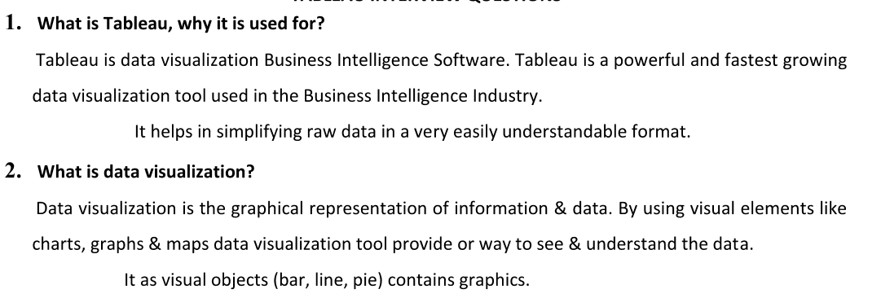

enabling data-driven decision-making

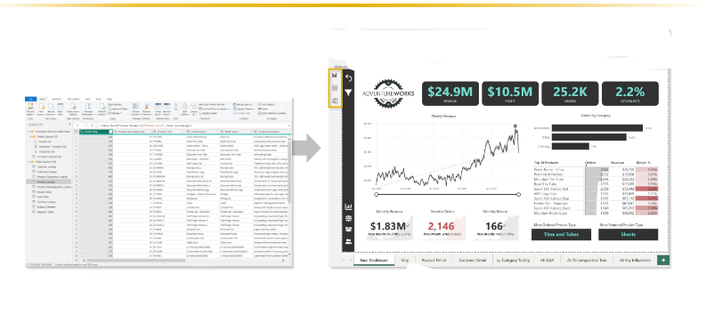

Downloading Tableau

Tableau Desktop - Professional version

Option - 1

Tableau public download link

<https://www.tableau.com/products/public/download>

Option 2

Tableau Desktop download link for windows users

<https://www.tableau.com/products/desktop/download>

1. Tableau Desktop download after 20 and try to experience the feature which missed in public version

How to connect data source in Tableau

1. Explain this with Tableau data source connectivity page

TYPES OF CONNECTIONS

-LIVE

\*IT S A REAL TIME UPDATES

-EXTRACT

\*IT S SNAPSHAT OF COPY OF DATA

\* SCHEDULE REFRESH