# A REPORT ON

**UNATTENDED CHILD DETECTION AND RESCUE TRIGGER IN A LOCKED CAR - WITH ENHANCED FEATURES**

**BY**

Name of the Student: **Senthil Kumar G** ID.No.: **2023ht01125**

# AT

**Bosch Global Software Technologies Pvt. Ltd ,**

**Bangalore, Karnataka, India**

# BIRLA INSTITUTE OF TECHNOLOGY & SCIENCE, PILANI

**(April, 2025)**

# A REPORT ON

**UNATTENDED CHILD DETECTION AND RESCUE TRIGGER IN A LOCKED CAR - WITH ENHANCED FEATURES**

**BY**

**Senthil Kumar G**

**2023ht01125**

**Embedded System Design**

Prepared in partial fulfilment of the

WILP Dissertation Course Number: **ES ZG628T**

**AT**

**Bosch Global Software Technologies Pvt. Ltd ,**

**Bangalore, Karnataka, India**

**Acknowledgements**

I would like to express my sincere gratitude to my supervisor, **Mr.** **DAFEDAR MOHAMAAD SHAFIVULLA**, for his continuous support, insightful guidance, and unwavering patience throughout the course of this dissertation. His expert knowledge and constructive feedback have been invaluable to the successful completion of this work.

I am also deeply thankful to **Mr. SATHYA NARAYANAN** , whose role as an additional examiner provided thoughtful critique and valuable perspectives that enriched the depth and quality of this research. Her expertise and encouragement were instrumental in shaping the direction and quality of my work.

I would like to extend my appreciation to the faculty mentor **Rekha A , Assistant Professor, BITS, Pilani, Bangalore Center** for providing her experience and constructive feedback to bring this report in a structured manner.

A special note of appreciation goes to **Mr. Sreekanth Sunku**  my director at **Bosch Global Software Technologies Pvt. Ltd**, whose guidance and perspective helped me choose a research topic that is not only academically meaningful but also practically relevant to our organization. His support ensured that this dissertation maintained real-world applicability throughout.

I am especially grateful to **Bosch Global Software Technologies Pvt. Ltd** for allowing me to enroll in this academic program and for their generous support throughout the duration of my studies. Their commitment to professional development played a vital role in the successful completion of this dissertation.

My sincere thanks also go to my peers and colleagues, whose support, collaboration, and thoughtful discussions helped me navigate the challenges of this research.

Finally, I wish to thank my family for their unconditional love, encouragement, and support throughout my academic journey.

This dissertation would not have been possible without the contribution of all those mentioned above, and I remain deeply grateful for their involvement.

**Senthil Kumar G**

**M.Tech in Embedded Systems**

**BITS, PILANI**  
**24th April 2025**

# BIRLA INSTITUTE OF TECHNOLOGY & SCIENCE, PILANI

**(April, 2025)**

# BIRLA INSTITUTE OF TECHNOLOGY AND SCIENCEPILANI (RAJASTHAN)

**WILP Division**

Organization: **Bosch Global Software Technologies Pvt. Ltd**

Location**: Bangalore, Karnataka, India**

Duration**: 4.5 Months**

Date of Start**: 15th December 2024**

Date of Submission**: 24th April 2025**

Title of the Project:

**UNATTENDED CHILD DETECTION AND RESCUE TRIGGER IN A**

**LOCKED CAR - WITH ENHANCED FEATURES**

ID No./Name of the student **:**

**2023ht01125**

**Senthil Kumar G**

Name and Designation of Supervisor **: DAFEDAR MOHMAAD SHAFIVULLA**

SENIOR SYSTEM ARCHITECT AND SAFETY MANAGER

Name and Designation of Additional Examiner **: SATHYA NARAYANAN**

TECHINCAL LEAD

Name of the Faculty mentor: **Rekha A**

Assistant Professor, BITS, Pilani,

Key Words:

**Embedded System Design, Safety-Critical System, Child Presence Detection, PIR Sensor, Vibration Sensor, Temperature and Humidity Sensor, Door Lock Sensor, Automated Rescue Trigger, IoT Platform, Firmware Over-The-Air (FOTA), ESP32, Arduino IoT Cloud, Alerts, Email Notifications, Hazard Light Activation, Real-time Monitoring, Sensor Fusion, Rescue Mechanism, Vehicle Safety, Heatstroke Prevention, Prototyping, Public Awareness, GPS Integration, V-Model Methodology.**

Project Areas**: Embedded System Design , Safety Critical System**

**Abstract:**

The alarming rise in incidents involving children left unattended in locked vehicles, often leading to heatstroke-related fatalities, necessitates robust preventive systems. This project proposes an embedded safety-critical system that detects the presence of an unattended child and autonomously triggers rescue actions. Using a multi-sensor framework—including PIR motion sensors, vibration sensors, door lock sensors, and temperature/humidity detectors—this system ensures accurate detection while minimizing false positives through sensor redundancy and plausibility checks.

Upon detection, real-time alerts are sent via email through an IoT-enabled platform, which also supports firmware-over-the-air (FOTA) updates and records incident metrics for regional analysis. Actuators such as buzzers, hazard lights, and roof LEDs are employed to attract immediate attention, and integration with GPS modules enables location-aware interventions. Developed using ESP32 and Arduino IoT Cloud, the system can function as a standalone unit or integrate with existing vehicle electronics.

Extensive testing was conducted using a prototype in a controlled environment. Feedback from industry experts validated its practicality, usability, and relevance. This solution not only aims to save lives through proactive intervention but also promotes public awareness and technological responsibility in vehicle safety, marking a meaningful contribution to embedded system design for automotive applications.

Signature of Student Signature of your Supervisor

Date : 24-Apr-25 Date: 24-Apr-25

**UNATTENDED CHILD DETECTION AND RESCUE TRIGGER IN A LOCKED CAR**

- **WITH ENHANCED FEATURES**

BITS ES ZG628T: Dissertation

by

**SENTHIL KUMAR G**

**2023HT01125**

Dissertation work carried out at

### Bosch Global Software Technologies Pvt. Ltd., Bengaluru

Submitted in partial fulfilment of **M. Tech Embedded Systems**

degree Programme

Under the Supervision of

**DAFEDAR MOHAMAAD SHAFIVULLA**

**Bosch Global Software Technologies Pvt. Ltd., Bengaluru**



## BIRLA INSTITUTE OF TECHNOLOGY & SCIENCE PILANI (RAJASTHAN)

## April 2025

**UNATTENDED CHILD DETECTION AND RESCUE TRIGGER IN A LOCKED CAR**

**- WITH ENHANCED FEATURES**

BITS ES ZG628T: Dissertation

by

**SENTHIL KUMAR G**

**2023HT01125**

Dissertation work carried out at

### Bosch Global Software Technologies Pvt. Ltd., Bengaluru

Submitted in partial fulfilment of **M. Tech Embedded Systems**

degree Programme

Under the Supervision of

**DAFEDAR MOHAMAAD SHAFIVULLA**

**Bosch Global Software Technologies Pvt. Ltd., Bengaluru**



## BIRLA INSTITUTE OF TECHNOLOGY & SCIENCE PILANI (RAJASTHAN)

## April 2025

### Abstract:

The increasing incidence of child fatalities due to heatstroke in unattended locked vehicles has underscored the urgent need for advanced safety systems. This dissertation presents the design, development, and evaluation of an innovative unattended child detection and rescue trigger system with enhanced features aimed at preventing such tragedies. The proposed system integrates a multi-sensor framework, including door lock sensor, motion detectors, temperature sensors, and vibration sensors, to accurately identify the presence of a child left in a locked car. Enhanced features include real-time environmental monitoring, adaptive alert mechanisms, and an automated rescue trigger that activates vehicle responses—such as email/sms triggers —when critical thresholds are exceeded. This abstract is a reasoned synthesis based on trends in child safety research and technology development.

This solution aims to provide a robust, proactive approach to child safety, reducing response time and preventing tragedies in unattended vehicle scenarios. This has also been enabled with IoT Platform for the FOTA (Flashing/Firmware Over the Air). IoT Platform is also used to account the number of triggers happened as per configuration and so the authorities may decide on the awareness camp in specific regions. To make this project effective, a survey has been sent to Industry experts to collect feedback, where most of the experts believe modern technology must be used to prevent the child left unattended in the vehicle. Also rescue system must be real time without any human intervention and they are interested to fit this system in their vehicle. It was also interesting to hear that experts mentioned that Technology must not compromise the awareness.

This system shall be a standalone system in the E/E architecture or inside any existing Vehicle node such as BCM. The typical RDCT software engineering process is followed with Iterative and Incremental model which breaks down this project to smaller manageable pieces allowing for flexibility and adaptation throughout the development. Freely available tools such as MS Excel, Arduino IDE, Arduino IoT cloud is used. A demo model is made as result of this dissertation in a static car with usage of sensors, microcontroller module and actuators mounted on the car. In this report, the briefing of challenges faced, learnings, Infrastructure are briefed. Also based on the feedback from BITS Mentor, a separate section is added to brief the difference between system that is already available in the market to the new one that is getting proposed based on this dissertation.



**Signature of the Student Signature of the Supervisor**

**Name: Senthil Kumar G Name: Dafedar Mohmaad Shafivulla**

**Date: 22-Apr-25 Date: 22-Apr-25**

**Place: Bengaluru Place: Bengaluru**

**Table of Contents:**

1. **Introduction 11**
2. **Literature Survey 12**
   1. **Background and Motivation 12**
   2. **Existing Detection Systems 12**
   3. **Rescue Trigger Mechanisms 12**
   4. **Limitations of Current Solutions 13**
   5. **Opportunities for Enhanced Features 13**
   6. **Proposed Framework and Research Gaps 13**
   7. **Conclusion 13**
3. **Requirements Gathering 14**
4. **Functional Block Diagram of the System 19**
5. **Modules of the embedded system 20**
   1. **Sensors 20**
   2. **Controller 21**
   3. **Actuator 21**
   4. **Other Components 21**
6. **Technical Specification of all devices and it’s usage 22**
7. **Embedded System – Design Flow 23**
8. **HW-SW architecture 24**
9. **Table of Work 24**
10. **Use cases not considered as part of this dissertation 25**
11. **Assumptions, Environmental Constraints, Challenges Faced, Learnings 26**
    1. **Assumptions 26**
    2. **Environment Constraints 26**
    3. **Challenges Faced 26**
    4. **Learnings 26**
12. **Clarity on the ‘Improvement Areas’ asked by Mentor during ‘Abstract’ submission 26**
13. **Methodology of this Embedded System Development 27**
14. **Carried out Work 28**
15. **Final Findings and Result (along with discrepancies) 28**
    1. ***Discrepancies* 29**
16. **Conclusion and Recommendation 29**
    1. **Enhanced Sensor Integration and Reliability 29**
    2. **Advanced Alerting and Communication 29**
    3. **Smart Climate Control and Ventilation 29**
    4. **Futuristic Enhancements 30**
17. **Summary 30**
18. **Appendices 30**
19. **Abbreviations 32**
20. **Literature References 32**
21. **Glossary 34**

**List of Tables:**

**Table 6-1: Hardware Components and it’s description**

**Table 9-1: Work Break down structure with Status**

**Table 10-1: Out of Scope Use Cases**

**Table 14-1: Abbreviations List**

**List of Figures:**

**Figure 3-1: Survey Result – Asking modern technology usage**

**Figure 3-2: Survey Result – Most recommended solutions**

**Figure 3-3: Survey Result – Interest in this system**

**Figure 3-4: Survey Result – Enablers to adopt this system**

**Figure 3-5: Survey Result – Experts/Public opinion on feasibility of this system implementation**

**Figure 3-6: Overall people interest in this product**

**Figure 3-7: CRS Requirements - snapshot**

**Figure 3-8: SYRS Requirements - snapshot**

**Figure 3-9: SRS Requirements - snapshot**

**Figure 3-10: HRS Requirements - snapshot**

**Figure 4-1: Classical picture of Embedded System**

**Figure 4-2: System Block Diagram**

**Figure 7-1: Flow Chart of the System Implementation**

**Figure 8-1: simplified view of the HW-SW Architecture in ESP32 for the Application**

**Figure 13-1 : V model Development Methodology**

**Figure 15-1: Test Specification – snapshot**

**Figure 15-2: Test Report – snapshot**

**Figure 18-1: FOTA Trend History - snapshot**

**Figure 18-2: FOTS Successful - snapshot**

1. **Introduction**

The increasing number of fatalities involving children left unattended in locked vehicles—often due to heatstroke or suffocation—has drawn urgent attention from both public safety authorities and the automotive industry. In recent years, incidents reported globally, especially in regions with hot climates, have highlighted the critical need for technology-based interventions. According to data from Kids and Car Safety, over 900 children in the United States alone have died from vehicular heatstroke since 1998. Such tragic occurrences are typically the result of unintentional caregiver lapses, which calls for proactive, automated solutions that do not rely solely on human memory or intervention.

This project addresses the development of an embedded, safety-critical system capable of detecting the presence of an unattended child in a locked car and autonomously triggering a rescue mechanism. The system leverages a multi-sensor framework—comprising PIR sensors, vibration sensors, temperature and humidity sensors, and door lock sensors—to enhance detection accuracy and minimize false positives. Key features also include real-time alerts via email, GPS-based geolocation, and integration with an IoT platform that supports Firmware Over-The-Air (FOTA) updates.

The scope of the project extends to designing a reliable prototype that demonstrates how such a system can be implemented within an existing vehicle's Electronic Control Unit (ECU) or as a standalone device. However, this work is limited to prototype-level validation in a controlled environment using static car models and does not extend to full automotive integration or road testing.

The methodology adopted follows the V-Model software development lifecycle, ensuring that verification and validation are performed at each stage of development. Data for requirements gathering was collected using surveys targeted at industry professionals and general users via MS Forms. Hardware selection and system architecture design were informed by a review of existing literature, standards, and safety protocols, including prior works on Child Presence Detection (CPD) systems and automotive safety regulations such as Euro NCAP.

The value of this work lies not only in its technical innovation but also in its potential real-world impact—saving lives through faster detection and response. The enhanced features proposed in this system, such as sensor fusion and automated alerts, address key shortcomings in current solutions and offer a practical, scalable model for deployment in modern vehicles. This report documents the systematic development, implementation, testing, and evaluation of the proposed embedded system solution.

1. **Literature Survey**

#### 2.1. Background and Motivation

The issue of children being left unattended in locked vehicles has garnered significant attention due to the rising number of heatstroke-related deaths. According to data from Kids and Car Safety, over 900 children have died in hot cars in the United States since 1998, with many cases involving unintentional abandonment by caregivers. Studies, such as one published in the Italian Journal of Pediatrics (Ferrara et al., 2013), highlight that these incidents often occur due to lapses in working memory under stress, emphasizing the need for automated detection and rescue systems. The motivation for this project stems from the preventable nature of these tragedies and the potential for technology to intervene effectively.

#### 2.2. Existing Detection Systems

Several approaches have been explored for detecting unattended children in vehicles:

* **Sensor-Based Systems**: The National Highway Traffic Safety Administration (NHTSA) evaluated unattended child reminder systems in a report titled Functional Assessment of Unattended Child Reminder Systems. These systems typically use weight sensors in car seats or motion detectors to identify a child's presence. However, they often require dedicated hardware, increasing costs and limiting scalability.
* **WiFi-Based Detection**: A study presented in ResearchGate (2016) proposed a WiFi-based CPD system that leverages existing in-car WiFi signals to detect motion and breathing. This system achieved a 99% detection accuracy by treating spectrograms as images and applying enhancement techniques. While promising, it struggles with weak signals from infants with shallow breathing, suggesting a need for enhanced sensitivity.
* **Camera and Radar Technologies**: Murata Manufacturing's article (2021) discusses WiFi sensing alongside camera-based and millimeter-wave radar solutions for CPD, as part of the European New Car Assessment Program (Euro NCAP) starting in 2023. Cameras excel in visual confirmation but falter in low-light conditions or when a child is obscured (e.g., under a blanket). Radar offers robustness but requires precise calibration.
* **AI-Based Solutions**: A recent paper on SpringerLink (2024) introduced an AI-based support system using models like YOLOv8 for detecting left-behind children. This approach integrates real-time image processing and could be adapted for in-car environments, though computational demands and privacy concerns remain challenges.

#### 2.3. Rescue Trigger Mechanisms

Once a child is detected, timely rescue is critical. Existing literature highlights several rescue mechanisms:

* **Alert Systems**: A ResearchGate study (2016) on a "Babycare Alert System" utilized GSM modems to send SMS alerts to parents and authorities when a child’s presence was detected alongside sound or motion. While effective, the system’s reliance on manual reset limits its autonomy.
* **Temperature-Based Triggers**: An X post from 2020 described a 12-year-old’s invention that monitors car temperature and triggers an alarm, LCD warning, and SMS to parents if the temperature exceeds 102°F (39°C). If unresolved within a minute, it contacts 911 with the car’s location. This demonstrates a practical rescue escalation but lacks integration with vehicle systems for immediate mitigation (e.g., window lowering).
* **IoT Integration**: The International Journal of Scientific & Technology Research discusses IoT-based accident detection systems that could be repurposed for child rescue. These systems use GPS and GSM to notify emergency services, offering a blueprint for location-aware rescue triggers.

#### 2.4. Limitations of Current Solutions

Despite advancements, existing systems exhibit notable gaps:

* **Detection Reliability**: WiFi and sensor-based systems may miss infants with minimal movement or breathing, as noted in the WiFi-CPD study.
* **Response Time**: Manual reset requirements (e.g., SMS-based alerts) delay rescue, critical in rapidly rising temperatures (up to 50°C in 10 minutes, per ABC News, 2023).
* **Scalability**: Dedicated hardware increases costs, limiting widespread adoption, as seen in NHTSA’s findings.
* **Environmental Robustness**: Camera systems fail in dark or obstructed scenarios, while radar and WiFi solutions require optimization for diverse vehicle interiors.

#### 2.5. Opportunities for Enhanced Features

This new project can address these limitations by incorporating enhanced features:

* **Multi-Sensor Fusion**: Combining weight sensors, infrared (IR) cameras, and acoustic sensors could improve detection accuracy across varied conditions (e.g., sleeping infants, dark interiors). IR cameras, unlike visible-light cameras, detect heat signatures, offering reliability in low-visibility scenarios.
* **Autonomous Rescue Actions**: Beyond alerts, integrating with vehicle systems to automatically lower windows or activate air conditioning could mitigate heat buildup, as suggested by The National (2021) on new car technologies. (Refer Use Cases not possible)
* **Geofencing and Proximity Alerts**: Using GPS and smartphone proximity detection to alert caregivers before they exit the vehicle could prevent abandonment, building on IoT concepts from Academia.edu (2020).
* **User-Friendly Interface**: An LCD dashboard display or mobile app with real-time status updates could improve caregiver awareness, inspired by the temperature-based trigger system.

#### 2. 6. Proposed Framework and Research Gaps

The literature suggests a hybrid system integrating detection (multi-sensor fusion, AI analysis) and rescue (automated vehicle responses, escalated alerts) as a viable solution. However, gaps remain in:

* Real-world testing across diverse vehicle types and climates.
* Balancing cost-effectiveness with advanced features for mass adoption.
* Legal and ethical considerations (e.g., privacy with cameras, liability for automated actions).

This new project could contribute by developing a prototype in the limited environment for demonstration purpose.

#### 2.7. Conclusion

The literature reveals a robust foundation of detection and rescue technologies, from sensor-based reminders to IoT systems. However, enhancing reliability, autonomy, and scalability remains critical. The project, "Unattended Child Detection and Rescue Trigger in a Locked Car - With Enhanced Features," has the potential to advance this field by integrating cutting-edge detection methods with proactive rescue mechanisms, addressing both technical and practical challenges identified in prior work.

1. **Requirements Gathering**

Requirements gathering is the process of identifying, documenting, and understanding the needs and expectations of stakeholders for a project, product, or system. It’s a critical phase in project management and software development, as it lays the foundation for what needs to be built or delivered. Survey technique has been followed for both functional and non-functional requirements. Prioritization of Requirements implementation is been done based on the architecture flow.

Here are the snapshots of the Survey results that has been sent through MSForms and collected from industry experts and common people.

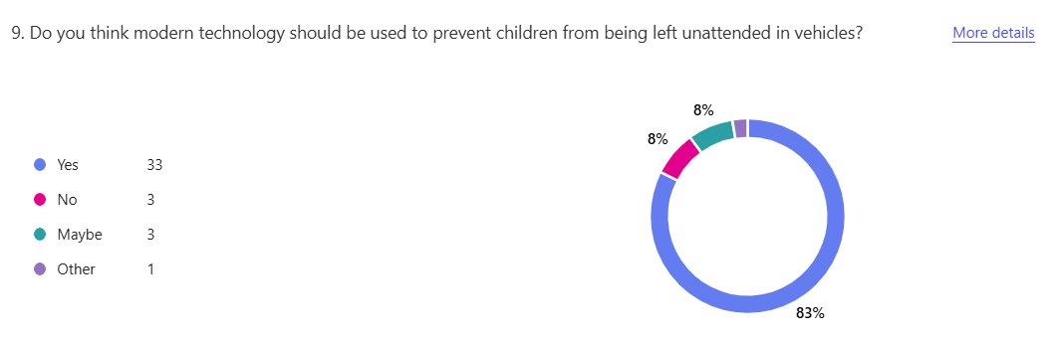

**Figure 3-1: Survey Result – Asking modern technology usage**

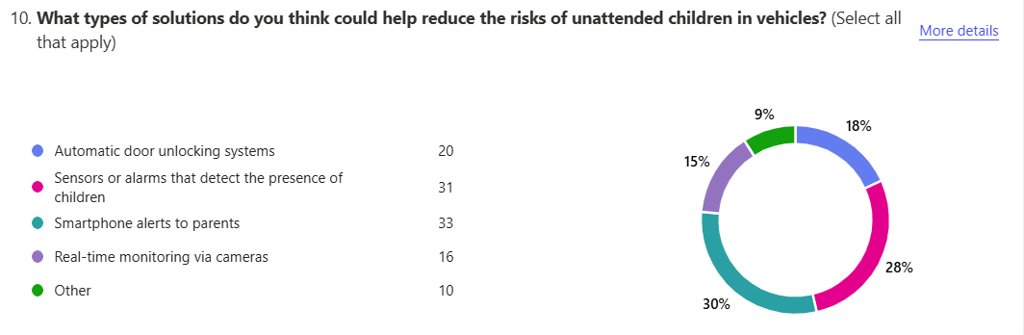

**Figure 3-2: Survey Result – Most recommended solutions**

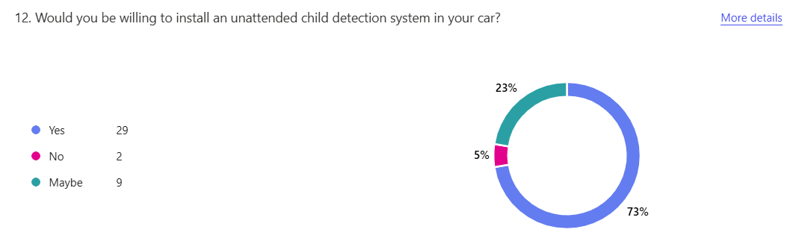

**Figure 3-3: Survey Result – Interest in this system**

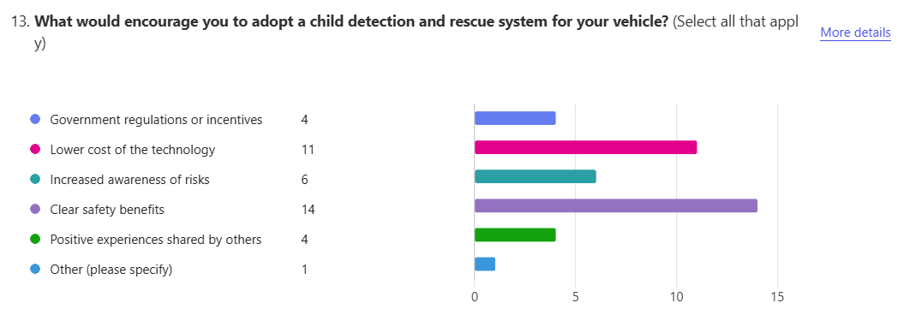

**Figure 3-4: Survey Result – Enablers to adopt this system**

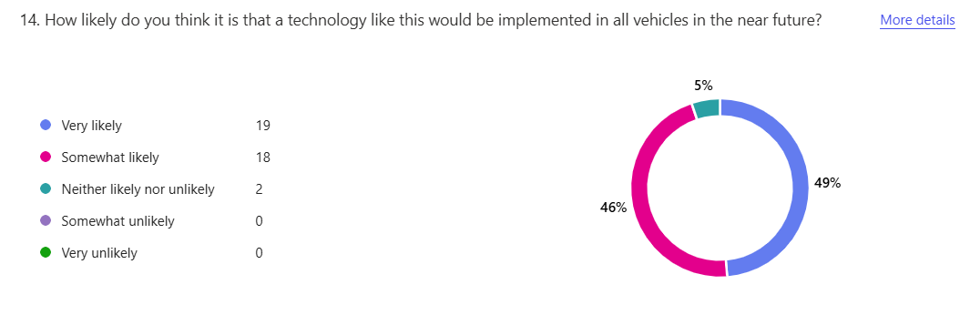

**Figure 3-5: Survey Result – Experts/Public opinion on feasibility of this system implementation**

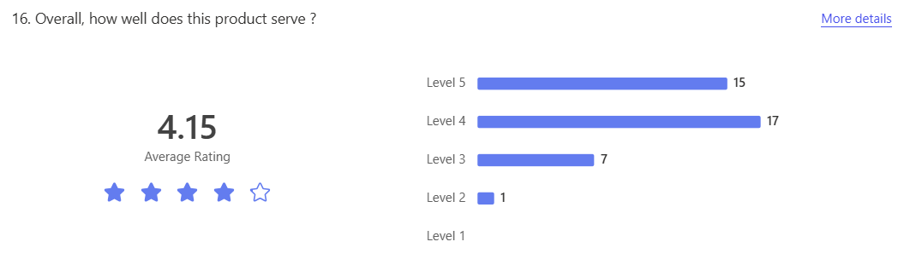

**Figure 3-6: Overall people interest in this product**

Below are the snapshots of the Requirements devised based on the survey results and also market study.

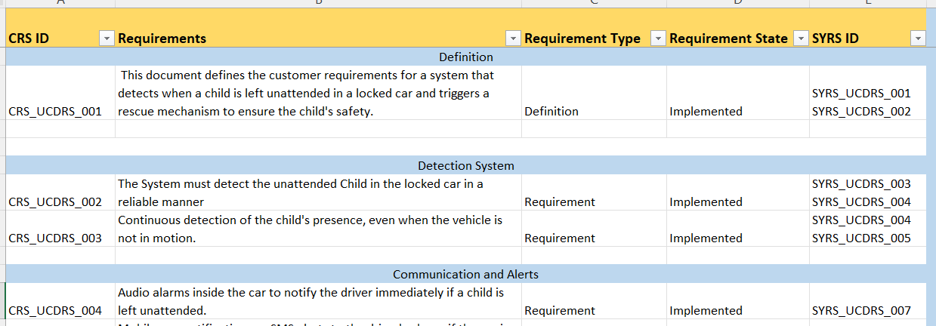

**Figure 3-7: CRS Requirements**

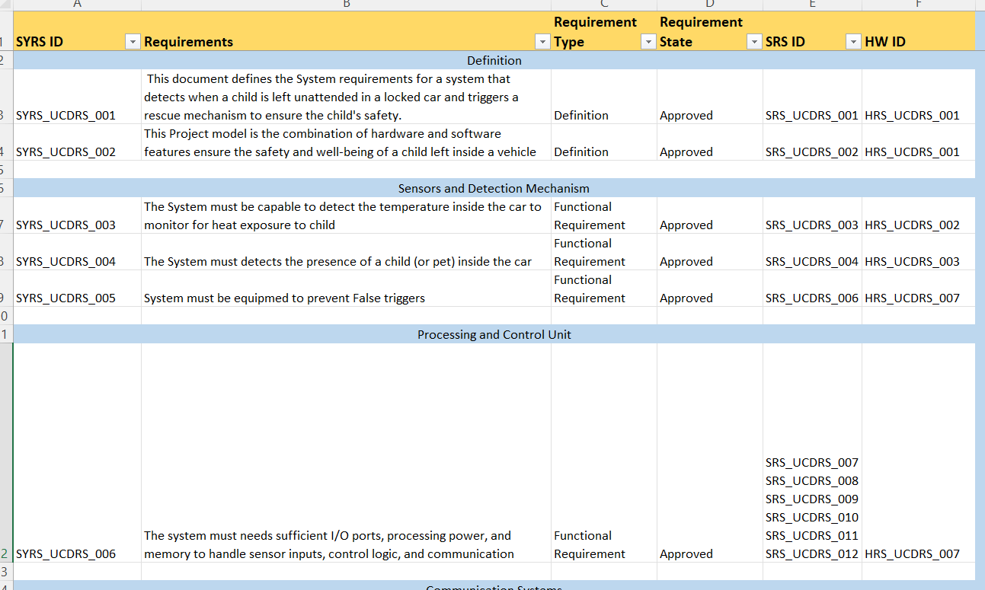

**Figure 3-8: SYRS Requirements**

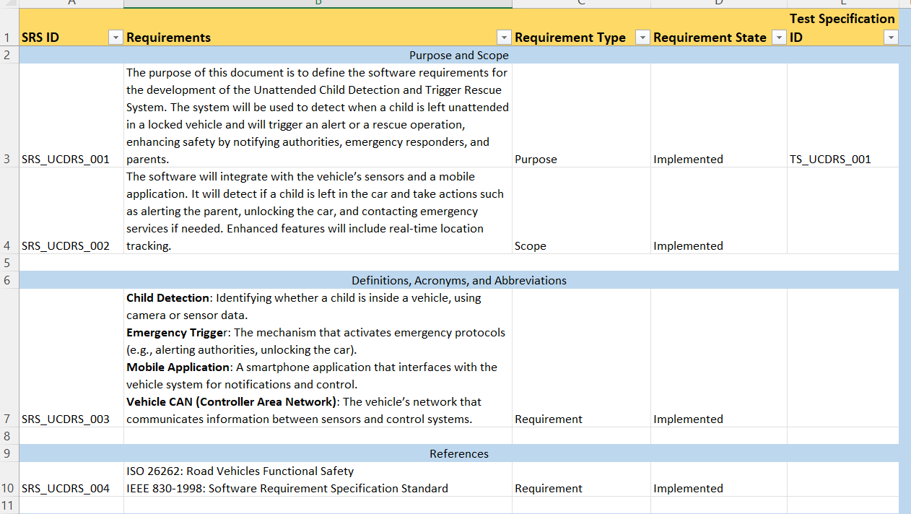

**Figure 3-9: SRS Requirements**

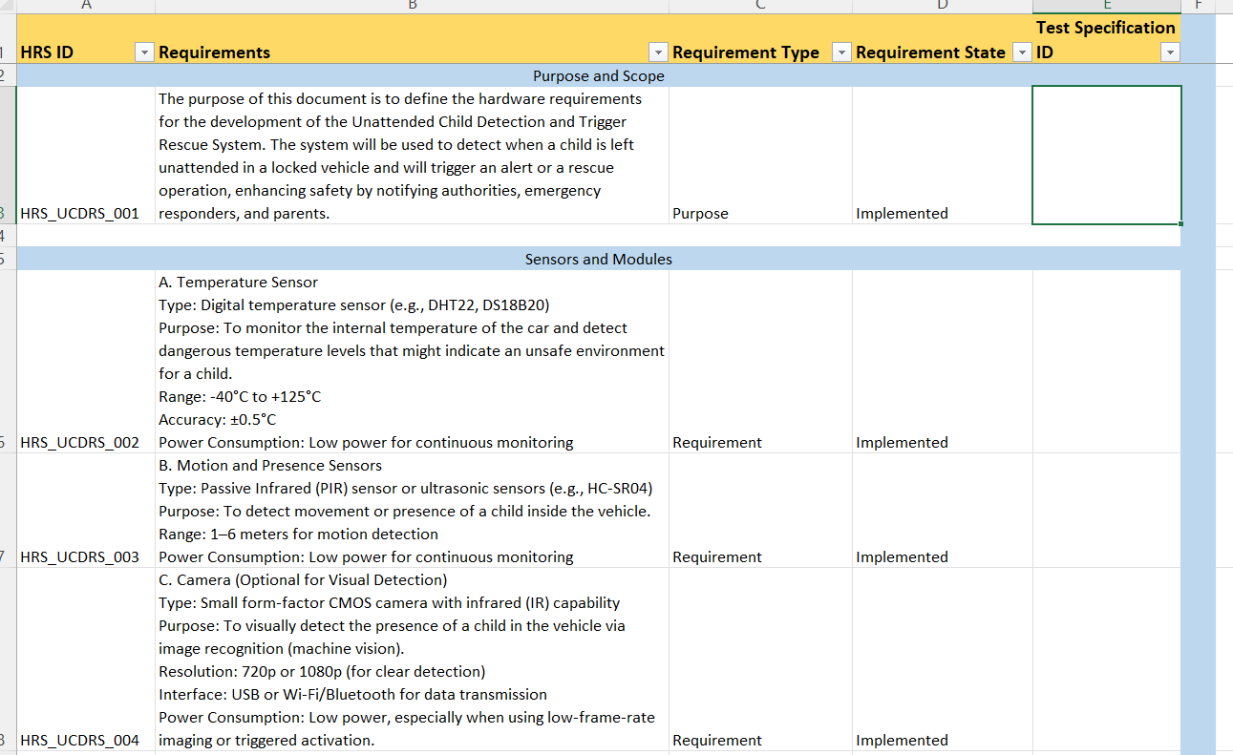

**Figure 3-10: HRS Requirements**

1. Functional Block Diagram of the System

Sense

Act

Think

**Figure 4-1: Classical picture of Embedded System**

This is the specific embedded system that comprises majorly of three blocks;

1. **Sense:**

The sense element in an embedded system refers to the component or module responsible for detecting and measuring physical, chemical, or environmental conditions. It converts these real-world parameters into electrical signals that the embedded system can process. In this dissertation use case it would be different sort of sensors that detects the child inside the car such as PIR sensor, Vibration Sensor, Door sensor and GPS sensor. These sensors does data acquisition and some also the ADC.

1. **Think:**

In the context of embedded systems, "think" refers to the processing and decision-making phase. After the sense element collects data, the embedded system needs to analyze, interpret, and respond accordingly. This is where the system "thinks" by executing the programmed logic. In this dissertation use case , the Think operation is done by the Controller in ESP32 device. This has data processing, decision making, Control Logic execution and Communication.

1. **Act:**

In embedded systems, "Act" refers to the action or response stage where the system performs a physical or digital action based on the decision made during the "Think" phase. This action is carried out by actuators, motors, displays, or communication interfaces. In this dissertation use case, the Act operation is done through Buzzer, Indicator and so on. In general this does Electrical action, Mechanical action and Communication action.

Air Quality Sensor

GPS Module

Air quality

Location

Door Sensor

Buzzer

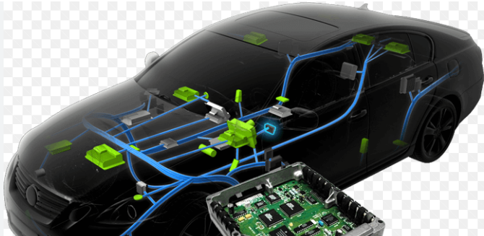

Vibration Sensor

Temperature and Humidity Sensor

SMS/Email Trigger

Hazard light

High Beam Roof LED Light

FOTA

PIR Sensor

Indication –

Dashboard

Display

**IoT Platform**

OLED

**Figure 4-2: System Block Diagram**

1. **Modules of the embedded system**

**5.1 Sensors:**

5.1.1 MC 38 wired door sensor magnetic switch:

The MC-38 is a normally open (NO) magnetic switch door sensor commonly used for security systems. It consists of two parts:

* Magnet (installed on the door/window)
* Reed switch (installed on the door frame)

When the door is closed, the magnet keeps the switch closed. When the door opens, the magnet moves away, triggering the switch to open, signaling a break.

5.1.2 DHT11 Temperature and Humidity Sensor

The DHT11 is a low-cost, basic sensor used to measure:

* Temperature (in °C)
* Humidity (in %)

It’s commonly used in weather stations, home automation, and environmental monitoring projects. The sensor provides digital output and communicates over a single-wire protocol.

* + 1. SW-180 Vibration Sensor

The SW-180 is a vibration detection sensor used in security systems, motion alarms, and vibration-sensitive projects. It functions as a spring-based switch that closes the circuit when it detects vibration or movement.

* + 1. HC-SR501 PIR Motion Sensor :

The HC-SR501 is a Passive Infrared (PIR) sensor used to detect motion by sensing infrared radiation (heat) from moving objects, such as people or animals. It’s commonly used in security systems, motion-activated lights, and smart home applications.

**5.2 Controller:**

5.2.1 ESP32 WROOM 32:

The ESP32-WROOM-32 is a Wi-Fi + Bluetooth dual-mode module based on the ESP32 SoC by Espressif Systems. It offers high performance, low power consumption, and a wide range of I/O, making it popular for IoT, home automation, and embedded projects. This is the brain of our embedded system. WiFi capability in this is used to communicate to and fro with Arduino IoT Cloud.

**5.3 Actuator:**

5.3.1. Buzzer:

A buzzer is an audio signaling device that produces sound when voltage is applied. It is commonly used in alarms, timers, electronic circuits, and notification systems.

* + 1. Hazard light:

Hazard lights will indicate the alarming situation to the neighbors passing my the car

* + 1. SMS/Email Trigger:

Short Messaging service to the Car owner (or in some cases Child parent) will be sent when the unattended child is detected and also a email notification it sent.

* + 1. High Beam LED Lamp:

High bean LED lamp shall be used to gain attention for the persons who are away from the vehicle

**5.4 Other Components:**

5.4.1 GPS Module NEO 6M:

The NEO-6M is a GPS receiver module from u-blox, widely used in navigation, tracking, and geolocation applications. It offers high sensitivity, low power consumption, and accurate positioning.

1. **Technical Specification of all devices and it’s usage**

|  |  |  |  |
| --- | --- | --- | --- |
| S.No | Technical Parameter | Specification | Usage |
| 1 | Processor Used | ESP32 – DOWDQ6 - Dual Core Lx6 microprocessor | Computer On-chip that process the input from different sensors and provides the appropriate output. |
| 2 | Processor Frequency | Upto 240 Mhz |  |
| 3 | Flash Memory | 4 MB |  |
| 4 | Wireless Connectivity | 802.11 |  |
| 5 | GPIO | 15 ADC, 2 UART, 25 PWM, 2 DAC, SPI/I2C | Used for Peripheral connection |
| 6 | IDE | Arduino IDE | Program Compiling/Sketch and Flashing through Cable. Has provision of serial Monitoring of data |
| 7 | MC 38 wired door sensor magnetic switch | Voltage: 12V; Max. Switch Current: 0.5A; Rated Power: 10 watt | Used to determine whether the car is locked or nor |
| 8 | DHT11 - Temperature and Humidity Sensor | Operating Voltage: 3.5V to 5.5V · Operating current: 0.3mA (measuring) 60uA (standby) · Output: Serial data | Used to know the temperature and humidity inside the car |
| 9 | SW 18010P – Vibration Sensor | Voltage: 12V; Current : 20mA | Used to detect anyone presence inside the car |
| 10 | HC-SR501 PIR Motion Sensor | Voltage: 5V – 20V. ◦ Power Consumption: 65mA | Used to detect movement of person inside car in addition to the PIR Sensor |
| 11 | Buzzer | Voltage: 5V – 12V | Used to signal when the unattended child is detected to alert the neighbours |
| 12 | LED Bulb | Voltage: 3.3 V to 4 V | Used to alert the bit far away people with high beam glow |
| 13 | GPS Module NEO 6M | Frequency: 1.57542 GHz (L1 band) with 50 channels | Used to detect the car position and connect the IoT and so this may help authorities to plan any region specific awareness , if required |
| 14 | IoT Platform | Arduino IoT Cloud | Platform to display dashboard and also for FOTA |

**Table 6-1: Hardware Components and it’s description**

**Note: ESP32 is used instead of STM board to support the IoT Platform which is also the scope of this dissertation.**

1. **Embedded System – Design Flow**

Roof LED

Hazard Lights

Email Trigger

**Figure 7-1: Flow Chart of the System Implementation**

IoT Cloud Count

No

Yes

Yes

No

Do Nothing

Do Nothing

Buzzer

Child Detected

Motion Detection

Door Lock

Engine OFF

1. **HW-SW Architecture:**

Application Program – “Unattended Child Detection System”

Other Libraries

FreeRTOS Libraries

FreeRTOS Kernel

Drivers

Peripherals (GPIO)

Processor (DOWDQ6 - Dual Core Lx6)

**Figure 8-1: simplified view of the HW-SW Architecture in ESP32 for the Application**

1. **Table of Work:**

|  |  |  |  |  |  |
| --- | --- | --- | --- | --- | --- |
| S.No | Activity | Description | Status | Remarks | Git Hub Link |
| 1 | Customer / User Requirement Gathering | Gather the customer and user requirements | Completed | Survey Technique is been used | <https://github.com/senthilkumarganesan1982/Projects/tree/main/UCDRS/Customer_User_Requirements> |
| 2 | System Requirement | Derive the system requirements for the embedded system | Completed | Market Survey of existing System and Gap Analysis is conducted | <https://github.com/senthilkumarganesan1982/Projects/tree/main/UCDRS/System_Requirement> |
| 3 | Software Requirement | Radiate the System Requirement to Software Level | Completed | Capabilities of SW are documented | <https://github.com/senthilkumarganesan1982/Projects/tree/main/UCDRS/Software_Requirement> |
| 4 | Hardware Requirement | Radiate the System Requirement to Hardware Level | Completed | HW Capabilities w.r.t storage , processing speed are considered | <https://github.com/senthilkumarganesan1982/Projects/tree/main/UCDRS/Hardware_Requirement> |
| 5 | Test Specification (Black Box level) | Derivation of test cases/conditions by considering ‘use case’ test design technique | Completed | Scenario based Testing | <https://github.com/senthilkumarganesan1982/Projects/tree/main/UCDRS/Test_Specfication_and_Report> |
| 6 | Individual Component Testing | HW working principle | Completed | Each HW component is individually tested | <https://github.com/senthilkumarganesan1982/Projects/tree/main/UCDRS/Individual_Component_Testing> |
| 7 | Integration Testing | Testing the interface by integrating different components | Completed | Scaling is done by integrating components to components |  |
| 8 | Customer Testing | Random Testing by Customer/User | Completed | Request Customer/User to do testing on the limited platform (Beta Testing) |  |
| 9 | Protype Model | Building the Prototype as Minimum Viable Product | Completed | Build the Model in limited environment |  |
| 10 | Final Presentation | Final Presentation on the dissertation | Completed | Final Presentation in ppt format briefing the dissertation |  |

**Table 9-1: Work Break down Structure with Status**

Note : In this table the granular Embedded development process is more focused than the deliverables (As that was already mentioned in Abstract/Outline)

1. **Use cases not considered as part of this dissertation**

Use cases not Considered and reasons:

|  |  |  |  |
| --- | --- | --- | --- |
| Use Case Number | Use Case | Reason for not considering | Remarks |
| UC1 | Door cannot be locked when Child is seated | Possibility of some intruder getting in the case and kidnapping the child is more and so not considered | This can be improvised in future by enhanced security systems |

**Table 10-1: Out of Scope Use cases**

1. **Assumptions, Environmental Constraints, Challenges Faced, Learnings**

**11.1 Assumptions:**

**-**Engine OFF is considered as default case to be shown in demo model.

-Internet Facility available in the environment to connect system to the IoT and trigger email

**11.2 Environment Constraints:**

-Although GPS module shall be used because of coverage inside the closed environment, the location from internet shall be used in IoT

-Although GMS module shall be used , the alternate email trigger to user account shall be made for demonstration purpose

**11.3 Challenges Faced:**

-Integrating different components increase the current consumption and so used the raw power instead of batter for demo purpose

**11.4 Learnings:**

This dissertation has given me the opportunities to learn multiple new things and would like to cite few as below;

-How to build cost effective embedded system (such as using PIR instead of Human detection system)

-Exposure to current embedded trends such as FOTA which has the greater advantage of flashing the firmware/software remotely

-Exposure to IoT Platform and understanding the capabilities of the Dashboard

1. **Clarity on the ‘Improvement Areas’ asked by Mentor during ‘Abstract’ submission**

Addressing Feedback from Abstract/Outline from BITS Mentor:

**Below is the comments provided :**

*Overall Comments: What is existing approach please specify. How is your approach different and how it is better*

*Improvement Areas: What is existing approach please specify. How is your approach different and how it is better*

**Existing Approach (Generic):**

1. Detection of child by using Movements inside Car when Engine is OFF

2. Buzzer indication to neighborhood

3. Rescue message such as SMS to Car Owner

4. DOOR unlock

**Better Approach as part of our dissertation – Enhanced features:**

On a high level I am considering below as betterment of existing approach.

1. Redundancy for plausible decisions (in addition to the decision made by just one sensor)

2. Provision of preventing attackers from exploiting the situation

3. Enabling this functionality even when Child by himself/herself opens the car such as the situation when car is parked in Apartment basement when Engine OFF

4. Warning Driver before he/she exit the car when child is inside (Prevention Algorithm)

5. Enabling FOTA as that shall be used for any SW Defect fix or any new feature integration – remotely

6. Integrate with IoT Platform that enables future market study and trend analysis

As part of the dissertation, our approach is better because we try to do plausibility check to avoid false alarms and this in turn will prevent attackers from exploiting the situation. Another approach is to have preventive mechanism and so driver himself/herself will be provided a warning as to mention that the child still exists in the car.

1. **Methodology of this Embedded System Development**

V Model Development Methodology is followed for the Embedded System Implementation , where the SW Development and Test Development are done in parallel and once the Embedded System is built, the Test Execution Cycle was started. One of the advantage of this model is to bring the Requirement Engineering from V&V perspective too.

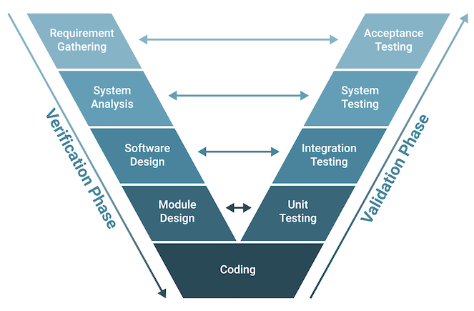

1. **Carried Out Work**

The System is built using multiple sensors to prevent false alarm and achieve plausibility as this is the safety critical system. The PIR Sensor is the main central sensor and Vibration Sensor is been used as plausible sensor. This two mainly acts as primary input to the system whereas the Doors sensor is used to determine the door status (Closed/Open) to understand where the algorithm must be enabled or not. In addition to above three input sensors, another Ultrasonic sensor is used to determine the presence of the Driver in the car. Once the DOORs is Closed then the algorithm is expected to raise the alarm for the Unattended Child Detection and within few seconds the Rescue trigger is initiated to save the unattended child in the closed Car. The trigger output considers three different modes such as Hazard Light, Roof Light and Sound Buzer.

This is a classical embedded system design whereas the improvisation is already made in each areas, where in addition to PIR , Vibration sensor , Ultrasonic Sensor and DOORS sensor, the Air Quality Sensor is used to read the quality of the Air inside the vehicle but this does not affect the algorithm as this has to be used for further analysis. Similarly in addition to the rescue triggers of Hazard lights, Roof light and Buzzer , the Email trigger for the registered address is sent through IoT Platform.

1. **Final Findings and Result (along with discrepancies)**

The Test cases were derived by considering the CRS, SYRS , HRS and SRS and documented in the Excel file. This is the base for the Blackbox level SW Requirement Based Testing. Test Conditions are based on the Scenario Based Test Technique and the Test Procedure steps are derived as the Step by Step Execution process.

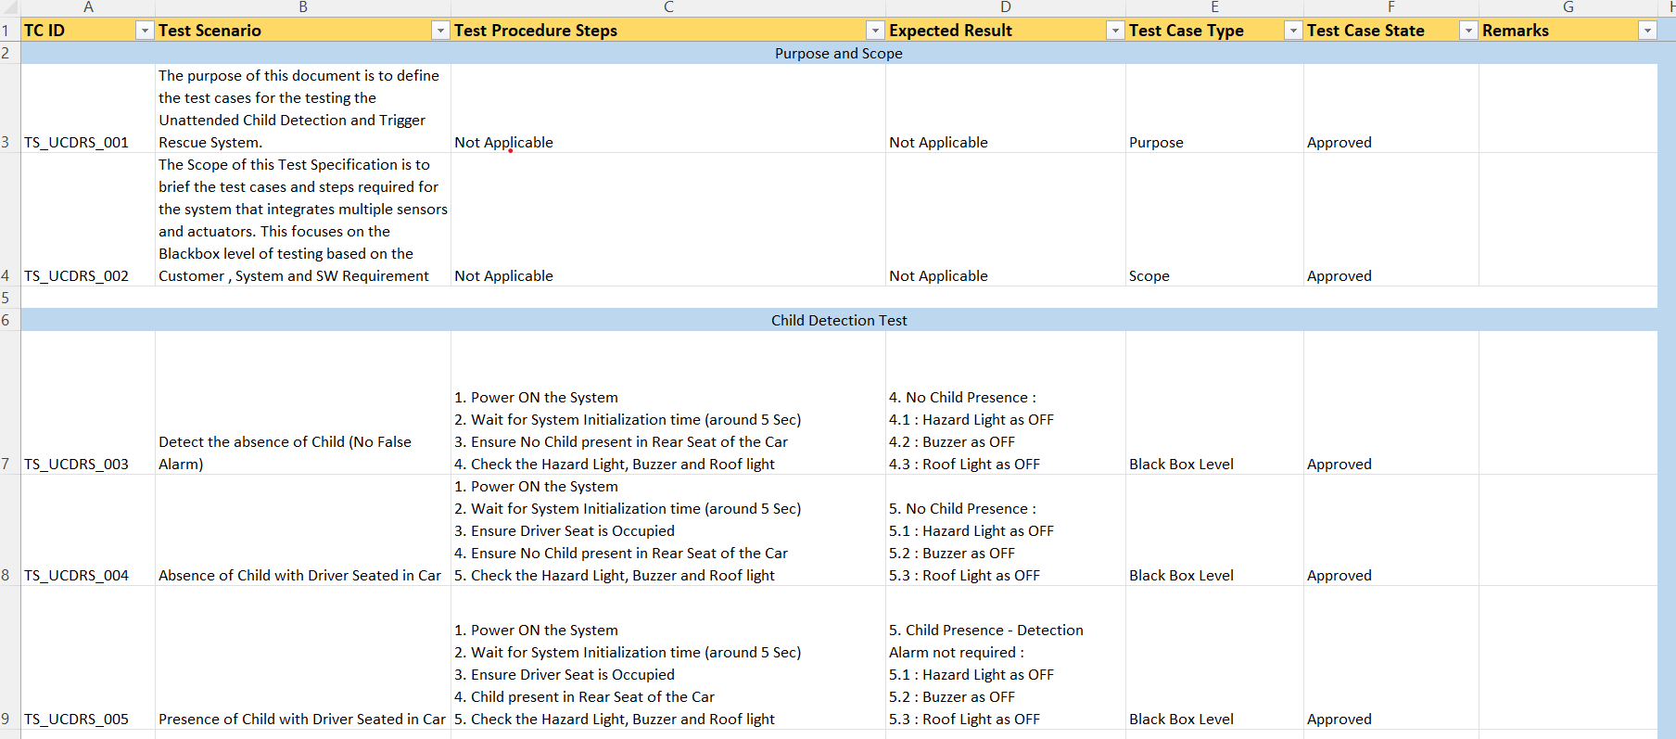

Figure 15.1 – Snapshot of the Test Specification

While the Integrated Embedded System is available as Proof Of Concept, this baselines Test Specification is used for the Test Execution. The Test is executed in the Control Environment with the demo model and evidence is collected from the OLED Display and/or Serial Monitor console from Arduino IDE.

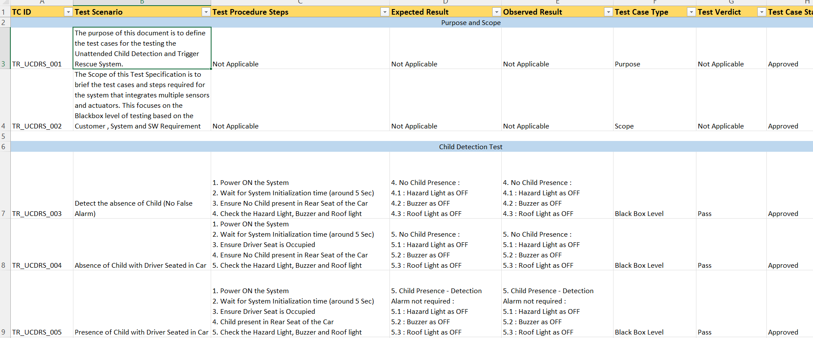

Figure 15.2 – Snapshot of the Test Report

As demonstrated in the above snapshot , the Observed Result is compared against the Expected Result and if it matches then the Verdict is made as ‘Pass’ . There were some initial failures and after rework along with fine tuning the calibration, the test was re-executed and the result was obtained as ‘Pass’.

*15.1 Discrepancies:*

*The SMS system with GSM SIM 800L was a option to use to send the SMS to the Mobile but carrier could not connected (high likely carrier supportiveness) and so the Email trigger is used with IoT Arduino Platform that also has the notification in the Mobile Phone.*

1. **Conclusion and Recommendation**

This project has laid a strong foundation for a system with the potential to significantly reduce the risk of heatstroke and fatalities among children left in locked vehicles. The V-Model's emphasis on rigorous verification and validation at each stage, from initial requirement analysis to final acceptance testing, has helped ensure that the developed system aligns closely with the intended purpose and user needs. The systematic approach has also facilitated the identification and mitigation of potential issues early in the development process, minimizing costly rework and delays.

Whereas to further enhance the project and ensure its successful deployment and long-term impact, the following recommendations are made:

**16.1** **Enhanced Sensor Integration and Reliability**:

Explore and Integrate a wider array of sensors eg, CO2 , precise weight sensors and also to Implement redundant sensor system and faut tolerant mechanisms.

**16.2 Advanced Alerting and Communication:**

Develop Multi Channel alerting system that includes SMS, automated Voice calls and direct notifications to emergency services and also to integrate user configurable escalation protocols

**16.3 Smart Climate Control and Ventilation:**

Develop and implement an intelligent Climate control system than can automatically adjust the vehicle temperature and ventilation to create safe environment to the child and also consider HVAC system

**16.4 Futuristic Enhancements:**

Explore the use of ML and AI to enhance the system ability to predict and respond to potential dangers and consider integrating the system with smart home platforms to provide additional layers of safety and convenience

**17 Summary**

The system integrates sophisticated plausible detection technologies—potentially including sensors (e.g., vibration, motion), Wi-Fi IoT, —to accurately identify a child left behind, even under varying conditions. Upon detection, it triggers a series of automated responses, such as sounding alarms, unlocking doors, hazard light, to ensure rapid intervention. The "enhanced features" distinguish this project by incorporating innovative elements like real-time notifications to parents or emergency services, IoT indication, FOTA, improving both reliability and user responsiveness. The ultimate goal is to address the critical safety issue of child fatalities in parked vehicles by combining robust detection with proactive rescue measures, offering a practical and technologically advanced solution to a pressing real-world problem. Overall, this dissertation until mid-sem has given me good technical exposure which I would not have learnt only by theory classes. This journey shall be embraced throughout my technical carrier.

Now by considering the Final work that is part of the Final-sem has been an eye opener for me to see how an embedded system must be designed in it’s fullest. The individual components when integrated to a whole system needs different sort of Power environment and the design explores deeper integration with vehicle systems. This project seeks to provide a reliable solution, ultimately saving lives.

1. **Appendices**

**Appendix A: Survey Questionnaire (MS Forms)**

* Objective: To gather feedback from industry experts and the general public about child safety technologies in cars.
* Format: Microsoft Forms
* Sample Questions:
  + Are you aware of the dangers of leaving a child unattended in a vehicle?
  + Would you prefer a system that alerts you if a child is detected?
  + What features would you expect in such a system (alerts, rescue triggers, IoT, etc.)?
  + Would you be willing to install such a system in your car?
* Summary: 80% of respondents showed strong interest in real-time alert systems.

**Appendix B: Block Diagram of the Proposed System**

See: Figure 4-2 in report

* Describes the Sense → Think → Act architecture.
* Shows interconnection of:
  + Sensors (PIR, Vibration, Temperature, Door)
  + Controller (ESP32)
  + Actuators (Buzzer, Hazard Light, High Beam LED)
  + Communication interfaces (IoT Cloud, SMS/Email triggers)

**Appendix C: Hardware Datasheets (Brief)**

| Component | Key Specs |
| --- | --- |
| ESP32-WROOM-32 | Dual-core 240 MHz, Wi-Fi & Bluetooth, 4 MB Flash |
| DHT11 Sensor | Temp: 0–50°C, Humidity: 20–90%, Digital Output |
| MC-38 Door Sensor | NO magnetic switch, 12V |
| HC-SR501 PIR | Voltage: 5V–20V, IR motion detection |
| SW-180 Vibration Sensor | Spring-based motion detection |
| NEO 6M GPS | 50 channels, 1.575 GHz |

**Appendix D : FOTA snapshots**

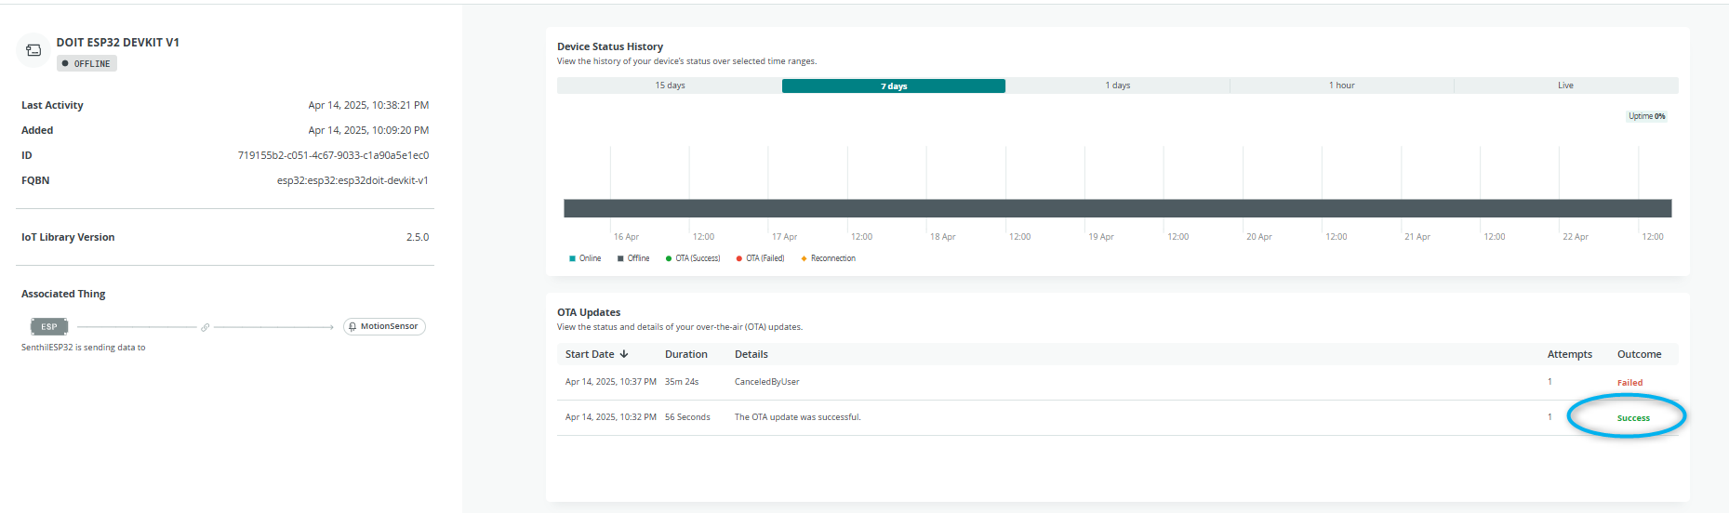

Figure 18-1: **FOTA Trend History - snapshot**

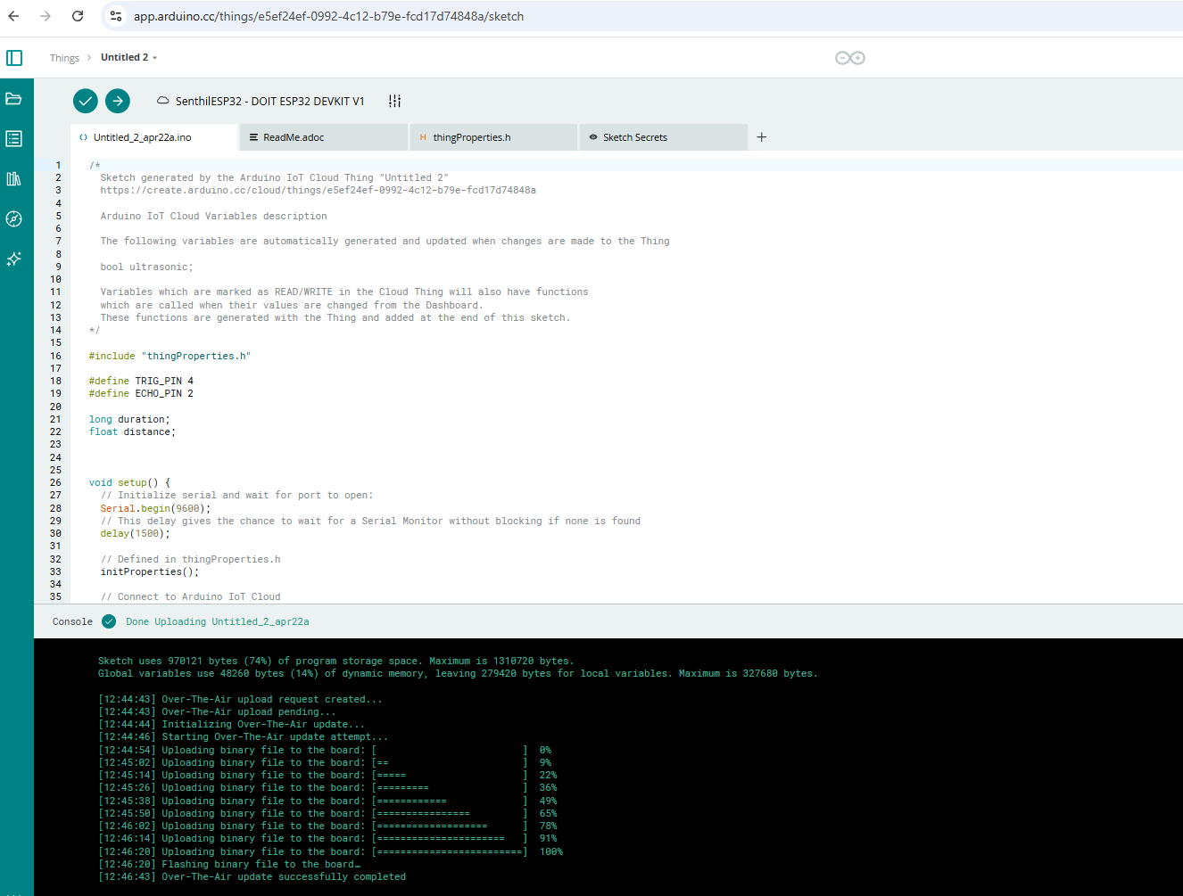

Figure 18-2: FOTA Successful - snapshot

1. **Abbreviations**

|  |  |  |
| --- | --- | --- |
| S.No | Abbreviation | Definition |
| 1 | ADC | Analog to Digital Conversion |
| 2 | SYRS | System Requirement Specification |
| 3 | SRS | Software Requirement Specification |
| 4 | HRS | Hardware Requirement Specification |
| 5 | CRS | Customer Requirement Specification |
| 6 | SYS | System |
| 7 | SW | Software |
| 8 | FOTA | Firmware Over the Air |
| 9 | OTA | Over The Air |
| 10 | IoT | Internet of Things |
| 11 | PIR | Passive Infrared Sensor |
| 12 | HW | Hardware |
| 13 | E/E Architecture | Electrical/Electronic Architecture |
| 14 | BCM | Body Control Module |
| 15 | RDCT | Requirements-Design-Coding-Testing |
| 16 | OLED | organic light-emitting diode |
| 17 | GPS | Global Positioning System |
| 18 | ML | Machine Learning |
| 19 | AI | Artificial Intelligence |
| 20 | HVAC | Heating, Ventilation and Air Conditioning |
| 21 | BCM | Body Control Module |

**Table 14-1: Abbreviation list**

**20 Literature References**

Below is a list of literature references that could support your project titled "Unattended Child Detection and Rescue Trigger in a Locked Car - With Enhanced Features." These references are drawn from existing research and documentation on child presence detection, vehicle safety systems, and related technologies. They cover a range of topics including detection methods, alert systems, and rescue mechanisms, which is relevant to project's enhanced features.

1. **Ferrara, R., et al. (2013). "Children left unattended in parked vehicles: a focus on recent Italian cases and a review of literature." Italian Journal of Pediatrics, 39, 71.**
   * This paper reviews cases of children left unattended in vehicles, focusing on hyperthermia risks and providing a foundation for understanding the problem
2. **Mousel, T., et al. (2017). "Radio frequency-based child presence detection system."**
   * Referenced in studies like the "Child Presence Detection System and Technologies" paper, this work describes a system using electromagnetic waves to detect children in vehicles, even through obstacles like clothing or sunshades, offering insights into robust detection methods.
3. **Booth, J.N. 3rd, et al. (2010). "Hyperthermia deaths among children in parked vehicles: an analysis of 231 fatalities in the United States, 1999–2007." Forensic Science Medicine Pathology, 6(2), 99-105.**
   * A statistical analysis of child fatalities due to heatstroke in vehicles, providing data to justify the need for advanced detection and rescue systems.
4. **Aiello, V., et al. (2014). "Next-generation technologies for preventing accidental death of children trapped in parked vehicles." ResearchGate.**
   * This study explores advanced technologies such as pressure sensors, child-restraint-based systems, and vehicle-integrated warning systems, which could inspire enhanced features for your project.
5. **McLaren, C., Null, J., & Quinn, J. (2005). "Heat stress from enclosed vehicles: moderate ambient temperatures cause significant temperature rise in enclosed vehicles." Pediatrics, 116(1), 109-112.**
   * This research quantifies how quickly vehicle interiors heat up, even at moderate temperatures, underscoring the urgency of timely detection and rescue triggers.
6. **Gonçalves, J.R.P. (2018). "Vehicle's interior presence detection and notification system." Master’s Thesis, University of Porto.**
   * Details a system for detecting occupants in a vehicle and notifying relevant parties, offering practical insights into implementation that could enhance your project’s alert mechanisms.
7. **Vaish, A. (2021). "An electronic system with integrated alerting and cooling mechanisms to save the life of an unattended child in a vehicle." Proceedings of the 7th IEEE International Symposium on Systems Engineering (ISSE-2021), 1-8.**
   * This paper proposes a system with both detection and active rescue features (e.g., cooling), which could align with your project’s goal of incorporating enhanced features.
8. **US Patent US7170401B1 (2007). "System to detect the presence of an unattended child in a vehicle." Google Patents.**
   * Describes a system using pressure sensors, seat belts, and motion detectors to identify an unattended child and trigger alarms or unlock doors, providing a technical blueprint for detection and rescue triggers.
9. **Murata Manufacturing (2021). "Leaving Children Unattended in a Car is Unforgivable: Wi-Fi Sensing Technology for the Protection of Children." Murata Manufacturing Articles.**
   * Discusses Wi-Fi-based child presence detection, a cost-effective and versatile method that could be an innovative feature for your project.
10. **Rosli, M., et al. "A Review of Unattended Child Presence Detection System for ASEAN NCAP Safety Rating." Journal of the Society of Automotive Engineers Malaysia.**
    * Reviews various child presence detection technologies and their integration into safety standards, offering a broad perspective on system design and evaluation.
11. **Chin, S.W., et al. (2019). "Study of unattended child presence detection system for ASEAN NCAP safety rating." ResearchGate.**
    * Examines parental awareness and preferred features of detection systems, which could guide the user-centric enhancements in your project.
12. **Tanaka, H., et al. (2023). "An enhanced AI-based vehicular driver support system considering hyperparameter optimization." In: Barolli, L. (ed.) IMIS 2023, LNDECT, vol. 177, 1-7. Springer.**
    * Explores AI-based support systems in vehicles, which could be adapted for detecting and responding to unattended children using advanced algorithms.

These references provide a mix of empirical data, technological solutions, and theoretical frameworks that has supported the development of this Project. They address key aspects such as the urgency of the problem, detection methodologies (e.g., sensors, radio frequency), and rescue mechanisms (e.g., alarms, door unlocking). There is an enhanced feature of integration this system to IoT Platform.

**21 Glossary**

**Heatstroke:** A condition caused by prolonged exposure to high temperatures, leading to the body's inability to regulate its temperature.

**HVAC:** Heating, Ventilation, and Air Conditioning. Refers to the vehicle's system for controlling the internal environment.

**Machine Learning:** A type of artificial intelligence that enables computers to learn from data without explicit programming.

**System Integration:** The process of combining different components or subsystems into a single, unified system.

**V-Model:** A software development life cycle model that emphasizes verification and validation at each stage.

**E/E Architecture**: Electrical/Electronic Architecture; the structure that defines how electrical systems are arranged in the vehicle

**FOTA**: Firmware Over-The-Air; allows remote software updates to the system via the IoT platform.

**Wi-Fi Sensing**: A method of detecting motion using disruption in wireless signals; explored in literature as a non-invasive detection approach

**--------------------------------------- End of the Report ----------------------------------------------------------------**