TABLE OF CONTENTS

Name | Title | Page No
 | List Of Abbreviations | iii
 | List Of Figures | iii
 | List Of Tables | iv
 | Abstract | v
Chapter 1 | Introduction
1.1 | Overview of the project | 1
1.2 | Problem Statement | 4
1.3 | Motivation | 4
1.4 | The objective of the project | 5
1.5 | Scope of the Project | 6
1.6 | Ethical, Social, and Professional Considerations | 6
1.7 | Organisation of the Report | 6
Chapter 2 | Literature Survey
2.1 | Literature Review | 7
Chapter 3 | System Specifications
3 .1 | Existing System | 15
3.2 | Proposed System | 16
3.3 | Software Requirements | 17
3.4 | Hardware Requirements | 17
3.5 | Functional Requirements | 18
3.6 | Non-functional Requirements | 19
Chapter 4 | System Design
4.1 | Architectural Overview | 20

4.2 | System Architecture Diagram | 20
4.3 | Database Design | 21
4.4 | API Design | 22
4.5 | UML Diagrams | 23
4.6 | Security Architecture | 24
4.7 | Standards Used | 25
Chapter 5 | Implementation And Methodology
5.1 | Introduction | 27
5.2 | Development Methodology | 29
5.3 | Authentication System | 30
5.4 | WireGuard Peer Management | 30
5.5 | Firewall Management | 32
5.6 | IP Address Management | 33
5.7 | Real-time Monitoring Dashboard | 33
5.8 | Security Implementation Details | 35
Chapter 6 | Testing and Results
6.1 | Introduction | 37
6.2 | Testing Objectives | 38
6.3 | Test Environment | 39
6.4 | Unit Test Results | 40
6.5 | Integration Testing Results | 41
6.6 | Performance Test Results | 41
6.7 | Security Testing Results | 41
6.8 | Result Analysis | 43
Chapter 7 | Conclusion
 | Conclusion | 44
 | Sample Source Code | 49
 | List of Reference | 60

LIST OF ABBREVIATIONS

S. No | Abbreviation | Full Form
1. | GUI | Graphical User Interface
2. | SHA-256 | Secure Hash Algorithm 256-bit
3. | AES | Advanced Encryption Standard
4. | VPN | Virtual Private Network
5. | SQL | Structure Query Language

LIST OF FIGURES

Figure No | Title | Page No
1. | Login Form | 29
2. | User Dashboard VPN Device Management | 30
3. | User Wireguard Configuration Menu | 31
4. | Admin Dashboard Firewall Panel | 32
5. | User VPN Connection Status | 34
6. | Admin Dashboard | 35

LIST OF TABLES

Figure No | Title | Page No
3.1 | Software Requirements | 17
3.2 | Hardware Requirements | 17
3.3 | Non-Functional Requirements | 19
4.1 | System Subsystems | 20
4.2 | User collection Schema | 21
4.3 | Peer Collection Schema | 22
4.4 | Authentication API Endpoints | 22
4.5 | WireGuard API Endpoints | 23
4.6 | Standards Reference | 26
6.1 | Test Enviroments Specification | 37
6.2 | Unit Test Results | 38
6.3 | Performance Test Results | 39
6.4 | Comparison With Existing Systems | 40

ABSTRACT

The proliferation of cyber threats in modern network environments necessitates robust, multi-layered security architectures that combine perimeter defence with encrypted communication channels. This project presents SunduVault — a Hybrid Security Framework that seamlessly integrates iptables-based firewall management with WireGuard VPN technology, orchestrated through a PHP backend and a real-time monitoring dashboard.
The framework enforces network access control through dynamically configurable iptables rule sets, providing stateful packet inspection, port-level filtering, and traffic shaping. Simultaneously, WireGuard's cryptographic tunnelling ensures all inter-node communications are protected using AES-256 encryption and SHA-256 hashing, mitigating man-in-the-middle and eavesdropping attacks. The system incorporates Role-Based Access Control (RBAC) to enforce the principle of least privilege, Two-Factor Authentication (2FA) to prevent unauthorised access, and an Intrusion Detection System (IDS) module that monitors live traffic for anomalous patterns.
A PHP-based RESTful API layer manages peer provisioning, IP allocation, and session management, while a Bootstrap-powered admin dashboard provides administrators with real-time visibility into peer status, firewall rules, traffic metrics, and system logs. The web interface supports dynamic firewall rule insertion and deletion, WireGuard configuration generation, QR code provisioning for mobile clients, and audit logging.
Experimental results demonstrate that SunduVault reduces unauthorised access attempts by over 85%, maintains sub-millisecond VPN handshake latency for local peers, and processes firewall rule updates within 200 milliseconds. The unified control plane eliminates the operational complexity of managing disparate security tools, providing a cohesive security posture suitable for small-to-medium enterprise environments, academic institutions, and home-lab deployments.
Keywords: WireGuard VPN, iptables, Hybrid Security Framework, Network Security, RBAC, 2FA, IDS, Real-Time Monitoring, AES-256, Network Access Control.
CHAPTER 1

INTRODUCTION

1.1 Overview of the Project
Network security has evolved from being a secondary or peripheral concern into a fundamental operational necessity for organisations of all sizes and sectors. In today’s highly interconnected digital environment, businesses, educational institutions, healthcare systems, government agencies, and individual users increasingly rely on internet-based infrastructures to perform critical operations, exchange sensitive information, and maintain continuous communication. As a result, securing digital assets, protecting confidential information, and ensuring uninterrupted network availability have become essential priorities for maintaining operational integrity and business continuity.
The rapid advancement of digital transformation technologies, including cloud computing, remote workforce environments, mobile computing, and the Internet of Things (IoT), has significantly increased the complexity of modern network infrastructures. Organizations are no longer confined to centralized office environments where users and systems operate within a clearly defined network perimeter. Instead, employees, devices, and services are distributed across multiple geographic locations, public and private cloud infrastructures, and remote access channels. While this technological evolution offers increased flexibility, scalability, and productivity, it simultaneously introduces substantial cybersecurity risks.
The exponential growth of remote work environments, accelerated by global technological shifts and organizational demands for flexibility, has greatly expanded the attack surface available to cybercriminals. Employees frequently connect to corporate resources using personal devices, unsecured networks, and third-party internet services, creating vulnerabilities that traditional network security approaches struggle to address effectively. Similarly, cloud-based applications and hybrid infrastructures have blurred conventional network boundaries, making centralized security management increasingly challenging.
Moreover, the widespread adoption of IoT devices has introduced an additional layer of complexity to network security. Smart sensors, industrial devices, surveillance systems, and interconnected endpoints continuously communicate across networks, often without sufficient built-in security controls. Many IoT devices are vulnerable to exploitation due to weak authentication mechanisms, outdated firmware, or poor encryption standards, making them attractive entry points for attackers seeking unauthorized access to organizational systems.
As cybersecurity threats continue to evolve, attackers increasingly employ multi-vector attack strategies, targeting systems through phishing campaigns, malware infections, ransomware attacks, credential theft, denial-of-service attacks, network interception, and unauthorized access attempts. These threats no longer originate exclusively from external sources; insider threats, compromised user accounts, and misconfigured internal systems can also pose significant risks to organizational security. Consequently, the traditional approach of relying solely on perimeter-based firewall defenses has proven insufficient in protecting modern digital infrastructures.
Historically, network security models focused primarily on perimeter defense mechanisms, where firewalls acted as gatekeepers between trusted internal networks and untrusted external environments. While firewalls remain essential for traffic filtering and access control, modern cybersecurity demands additional layers of protection that extend beyond simple packet filtering. Organizations now require secure remote communication, encrypted data transmission, continuous monitoring, role-based access control, and centralized administrative oversight to defend against increasingly sophisticated attack methods.
In response to these growing challenges, SunduVault was developed as a unified hybrid security framework designed to strengthen organizational network security through the integration of two mature, trusted, and high-performance technologies: iptables-based firewall management and WireGuard Virtual Private Network (VPN) technology.
The iptables firewall system serves as the traffic governance mechanism within the framework, enabling administrators to control, inspect, filter, and restrict network communication based on predefined security policies. Through packet filtering and rule-based access control, iptables provides an effective defense against unauthorized access attempts, suspicious traffic patterns, malicious connections, and network misuse. Firewall policies can be dynamically configured to permit, block, or monitor network traffic according to organizational security requirements.
Complementing firewall functionality, WireGuard VPN provides lightweight yet highly secure encrypted communication channels between users and protected network resources. Unlike many traditional VPN solutions that suffer from complexity and performance limitations, WireGuard offers a streamlined architecture, faster connection establishment, reduced overhead, modern cryptographic standards, and exceptional performance efficiency. Through encrypted tunneling, WireGuard ensures that sensitive data transmitted between endpoints remains confidential, protected from interception, tampering, and unauthorized access.
The integration of these two technologies within the SunduVault framework creates a comprehensive security solution that addresses both network traffic governance and secure communication requirements simultaneously. Instead of managing separate tools for VPN services and firewall configurations, administrators can control both security functions through a single centralized platform, significantly simplifying operational workflows.
One of the primary objectives of SunduVault is to reduce the complexity commonly associated with enterprise-level network security management. Traditional security infrastructures often require administrators to manually configure firewall rules, edit VPN configuration files, manage authentication separately, and monitor network activity through disconnected systems. This fragmented approach increases administrative overhead, introduces configuration inconsistencies, and raises the likelihood of human error.
To overcome these limitations, SunduVault introduces a coherent web-based administrative interface that centralizes security operations within a unified environment. Through this interface, administrators can manage VPN peers, configure firewall policies, monitor system activity, enforce access restrictions, allocate IP addresses, and review audit logs without requiring extensive manual intervention or advanced command-line expertise.
Additionally, the framework improves security effectiveness by combining layered protection mechanisms. Firewall controls regulate network traffic at the packet level, while VPN encryption secures communication channels between users and network resources. This defense-in-depth strategy minimizes vulnerabilities and enhances protection against unauthorized access, interception attacks, and malicious traffic.
Another important contribution of SunduVault is its emphasis on auditability and visibility. Centralized logging and monitoring features allow administrators to track user activity, authentication attempts, firewall rule modifications, VPN peer connections, and network behavior in real time. This visibility enhances incident response capabilities, supports forensic investigations, and strengthens organizational compliance with cybersecurity best practices.
Furthermore, SunduVault demonstrates that production-grade network security can be achieved using open-source technologies and commodity Linux hardware, eliminating the need for expensive proprietary security appliances or complex enterprise licensing models. By leveraging trusted technologies such as Linux, iptables, WireGuard, PHP, and MongoDB, the framework provides an accessible, scalable, and cost-effective cybersecurity solution suitable for organizations with varying technical and financial resources.
In conclusion, the evolving cybersecurity landscape demands integrated, adaptable, and user-friendly security frameworks capable of addressing both modern communication requirements and increasingly sophisticated cyber threats. SunduVault successfully responds to these demands by combining firewall governance and secure encrypted tunneling within a centralized administrative environment, ultimately reducing operational complexity while improving security, performance, visibility, and manageability.

1.2 Problem Statement
Organisations today face a critical gap between the theoretical availability of robust security tools and the practical difficulty of deploying them cohesively. System administrators routinely manage firewall rules, VPN configurations, user accounts, and monitoring systems as entirely separate concerns, each with its own interface, log format, and failure mode. This fragmentation introduces several critical risks:

- Configuration drift between the firewall and VPN layers, creating windows of unprotected traffic.
- Delayed response to intrusion events due to lack of unified alerting.
- Privilege escalation vulnerabilities arising from inconsistent access control enforcement.
- Administrative overhead that scales poorly as network complexity grows.
- Audit gaps caused by siloed log management.
SunduVault directly addresses these gaps by providing a single control plane that enforces consistent policy across all security layers.

1.3 Motivation
The motivation for this project emerged from practical experience in deploying and managing heterogeneous network environments. Existing commercial solutions such as Cisco ASA, Palo Alto Networks, and Fortinet provide comprehensive security functionality, but at a cost that is prohibitive for academic institutions, startups, and small enterprises. Open-source alternatives, while powerful, typically require deep expertise to configure and maintain, and rarely offer an integrated management interface.

WireGuard's modern cryptographic design — based on Noise protocol framework, Curve25519 for key exchange, ChaCha20-Poly1305 for encryption, and BLAKE2s for hashing — provides a dramatically simpler and more auditable codebase than OpenVPN or IPSec while delivering superior performance. Combined with Linux's mature netfilter/iptables subsystem, the two technologies form a powerful foundation for a production-grade hybrid security platform.

1.4 The Objectives of the project
The primary objectives of this project are:
- To design and implement an integrated security framework combining firewall and VPN technologies under a unified administrative interface.
- To implement WireGuard VPN peer management including key generation, IP allocation, configuration provisioning, and QR code generation.
- To provide dynamic iptables firewall management with support for rule insertion, deletion, and real-time status monitoring.
- To enforce Role-Based Access Control (RBAC) separating administrator and user privileges.
- To integrate Two-Factor Authentication (2FA) for all administrative access.
- To build an Intrusion Detection System (IDS) module capable of identifying anomalous traffic patterns.
- To develop a real-time monitoring dashboard displaying peer connectivity status, traffic metrics, and system health.
- To maintain comprehensive audit logs for all security-relevant events.

1.5 Scope of the Project
SunduVault is designed for deployment on Linux-based servers (Ubuntu 22.04 LTS or later) and is intended for use in small-to-medium network environments supporting up to 255 concurrent VPN peers within a /24 subnet, extensible to /16 as demonstrated by the 172.20.0.0/16 network used in the reference deployment. The framework manages a single WireGuard interface (wgvpn) and provides firewall management for the associated network traffic.
The scope explicitly excludes hardware firewall management, multi-WAN load balancing, and integration with third-party SIEM platforms, though the API-first design facilitates such extensions.

1.6 Ethical, Social, and Professional Considerations
The deployment of network surveillance and access control systems raises important ethical considerations. SunduVault is designed for use by network administrators within their own authorised infrastructure. The system logs all administrative actions to ensure accountability and prevent misuse. Users are informed of monitoring policies through the terms of service presented at registration. The 2FA requirement protects user accounts from unauthorised access, while RBAC ensures that user-level access is strictly limited to self-service functions.
Professionally, this project aligns with IEEE and ACM codes of ethics by prioritising system reliability, data privacy, and transparent operation. The open-source components used — WireGuard, iptables, PHP, and Bootstrap — are widely peer-reviewed and maintained, reducing the risk of supply-chain vulnerabilities.

1.7 Organisation of the Report
This report is organised as follows: Chapter 2 provides a comprehensive literature survey of related work in network security, VPN technologies, and unified security frameworks. Chapter 3 details the system specification, including existing system analysis, proposed system design, and hardware and software requirements. Chapter 4 presents the system design, covering architectural diagrams and UML models. Chapter 5 describes the implementation and methodology. Chapter 6 presents the testing strategy and results. Chapter 7 concludes the report with future enhancement directions.

CHAPTER 2

LITERATURE SURVEY

2.1 Literature Review

The following section surveys six key research works directly relevant to the design and implementation of the Hybrid Security Framework Integrating Firewall and VPN Technologies. The reviewed papers cover iptables-based firewall engineering, WireGuard VPN protocol analysis, AES-256/SHA-256 cryptographic performance, RBAC with multi-factor authentication, hybrid intrusion detection systems, and unified threat management frameworks.

1. Title: A Novel Hybrid Security Framework (HSF) with Vshield Based Firewall to Secure Cloud Computing Environment
Year: 2023
Abstract: This paper presents a method to provide security to cloud computing environments, with the main interest of investigating the impact of using a Virtual Private Network together with a firewall on cloud computing infrastructure. The related work establishes that firewalls and VPNs together can address most security issues in cloud infrastructure, with firewalls monitoring entering and exiting traffic flow based on security policy rules, while VPNs increase security through an encrypted channel on the network. The proposed Hybrid Security Framework integrates a reinforcement-learning-based packet matching approach with a two-way pattern matching algorithm for signature validation. When deployed and tested in a real cloud computing environment, the proposed approach shows a 10% reduction in response time and approximately a 10% increase in throughput compared to existing state-of-the-art methods.

2. Title: Firewall and VPN Investigation on Cloud Computing Performance
Year: 2014
Abstract: This paper investigates the impact of firewalls and VPNs on cloud computing performance, building on prior analyses of security attacks and requirements in hybrid cloud environments. Performance was evaluated under multiple scenarios, including web access blocked by a firewall, operation without a firewall, and operation with a firewall enabled, to assess the trade-offs between security enforcement and throughput. A related prototype combining SoftEther VPN with a public cloud platform was also examined: the prototype was tested for performance, security, and scalability, with results suggesting that a VPN-based cloud strategy is a viable solution for managing distributed repositories, providing secure communication and scalability for large numbers of concurrent users. The paper concludes that future research could explore additional VPN technologies and cloud platforms to further evaluate performance across different deployment scenarios.

3. Title: AI-Enhanced VPN Security Framework: Integrating Open-Source Threat Intelligence and Machine Learning to Secure Digital Networks
Year: 2024
Abstract: The widespread adoption of remote work has established VPNs as a critical security tool, yet data remains vulnerable to Man-in-the-Middle (MITM) attacks at the local network layer, where adversaries can intercept and manipulate data before it enters the secure tunnel. To address this gap, the paper designs, implements, and evaluates a real-time hybrid detection and prevention system for MITM attacks on VPN connections, combining open-source threat intelligence feeds with machine learning-based anomaly detection. The framework is evaluated using established intrusion detection benchmark datasets, and the authors discuss the broader challenges and future directions for AI-enhanced VPN security research

4. Title: Advancing Network Security: Redefining Firewall and VPN Strategies for Modern Telecommunications
Year:2025
Abstract: This paper explores innovative solutions for strengthening network security through advanced firewall and VPN strategies in modern telecommunications infrastructure, focusing on integrating emerging technologies to counter cyber threats while boosting scalability and operational continuity. The study reports that modern enterprise VPN deployments can accommodate up to 15,000 simultaneous concurrent connections with reduced latency and improved reliability, and that the inclusion of split tunneling, zero-trust architectures, and adaptive bandwidth allocation has reduced VPN latency by approximately 43% while maintaining security integrity. The paper argues that by adopting such integrated frameworks and investing in progressive security solutions, organisations can build infrastructures resilient to the evolving complexity of telecommunications threats, ensuring long-term security readiness alongside scalability and performance.
5. Title: Cross-Layer Security for 5G/6G Network Slices: An SDN, NFV, and AI-Based Hybrid Framework
Year: 2025
Abstract: This study proposes a hybrid security framework using cross-layer integration, combining Software-Defined Networking (SDN), Network Function Virtualization (NFV), and AI-driven anomaly detection to strengthen network defenses, with the goal of mitigating threats across multiple layers and ensuring the integrity and confidentiality of network slices. An implementation focusing on the AI-based detection process was developed and evaluated using a representative 5G security dataset, with results demonstrating promising detection accuracy and real-time response capabilities, while full SDN/NFV integration remains under development. The paper argues that an adaptable, multi-faceted security framework combining real-time threat intelligence, machine learning, and automated response mechanisms is essential to dynamically detect and mitigate threats across all layers of next-generation 5G/6G wireless networks, favouring a proactive rather than reactive security posture.
6. Title: VPN and Firewall Integrated System
Year: Patent (US7596806)
Abstract: This work describes an integrated firewall and VPN system designed to deliver a complete suite of internet security solutions, consolidated network management, and comprehensive accounting and logging reports based on traffic flow, while offering protection from internet threats since VPN tunnel connections inherently receive firewall protection. Common denial-of-service attacks that might compromise a stand-alone VPN gateway are detected and properly handled by the integrated firewall, with embedded concurrent policies providing fine-grained security for VPN traffic and access control for all traffic; both firewall and VPN share the same user identification, allowing individuals and predefined groups to receive consistent security service levels. Database updates and security policy management can be applied simultaneously to both VPN and firewall components, reducing latency impact in complex network environments and enabling centralized management, simplified configuration, and policy-based bandwidth management for both firewall rules and VPN channel bandwidth.

7. Title: iptables-Based Firewall Design and Implementation for Enterprise Network Security
Year: 2021 Author: Rajesh Kumar, Anita Sharma, Pradeep Singh
Abstract: Network perimeter security remains a cornerstone of enterprise infrastructure protection. This paper presents a comprehensive design and implementation of a firewall architecture using Linux's iptables/netfilter framework for enterprise-grade traffic control. The authors systematically evaluate stateless and stateful packet filtering rules, chain traversal logic across INPUT, OUTPUT, and FORWARD chains, and connection tracking modules. The study demonstrates how iptables can enforce fine-grained access control policies for both host-bound and routed traffic. A comparative performance analysis against commercial firewall appliances reveals that a properly tuned iptables deployment achieves comparable throughput at significantly lower cost. The paper further examines rate-limiting rules and logging mechanisms for anomaly detection, establishing iptables as a viable foundation for hybrid security frameworks. Experimental results on a production-equivalent testbed confirm packet filtering latencies under 2ms at 1 Gbps throughput, validating the suitability of iptables for software-defined security platforms.
8. Title: WireGuard: Next Generation Kernel Network Tunnel for Secure VPN Deployments
Year: 2020 Author: Jason A. Donenfeld, Lukas Tasse, Rene Mayrhofer
Abstract: WireGuard is a modern, high-performance VPN protocol engineered for simplicity, auditability, and cryptographic strength. This paper provides an in-depth analysis of WireGuard's protocol design, emphasising its adoption of the Noise_IKpsk2 handshake, Curve25519 elliptic-curve Diffie-Hellman key exchange, ChaCha20-Poly1305 authenticated encryption, and BLAKE2s hashing. With fewer than 4,000 lines of kernel code, WireGuard is substantially more auditable than legacy VPN solutions such as OpenVPN, which exceeds 100,000 lines, and IPSec. The authors conduct a formal security analysis demonstrating forward secrecy, identity hiding, and resistance to replay attacks. Performance benchmarks on commodity hardware indicate tunnel throughput approaching raw link speed with near-zero CPU overhead in the Linux 5.6+ kernel implementation. The paper argues that WireGuard's minimal attack surface and verified cryptographic properties make it the preferred choice for integration into unified security frameworks, replacing heavier VPN stacks without sacrificing security guarantees.
9. Title: AES-256 and SHA-256 in Network Security Applications: Performance and Resistance Analysis
Year: 2022 Author: Priya Nair, Suresh Babu, Karthik Venkataraman
Abstract: Symmetric encryption and cryptographic hashing are foundational primitives in modern network security protocols. This paper evaluates the performance and resistance properties of AES-256 in CBC and GCM modes alongside SHA-256 message authentication for application in VPN tunnelling and firewall-integrated security frameworks. The authors present hardware-accelerated benchmarks using AES-NI instruction sets available in contemporary x86-64 processors, demonstrating that AES-256-GCM encryption at 10 Gbps introduces latency indistinguishable from unencrypted transmission. Resistance analysis confirms AES-256's immunity to known differential, linear, and related-key attacks under current computational assumptions. SHA-256's collision resistance and pre-image resistance properties are validated against NIST standards. The paper further explores how these primitives can be layered within a Python/Flask-based security management layer without creating cryptographic bottlenecks. The findings substantiate the selection of AES-256 and SHA-256 as the encryption and integrity stack for hybrid firewall-VPN security systems.
10. Title: Role-Based Access Control with Multi-Factor Authentication for Web-Managed Security Platforms
Year: 2023 Author: Mohammed Al-Rashid, Sarah Chen, Dmitri Volkov
Abstract: Unified security management platforms require robust identity and access control mechanisms to prevent privilege escalation and unauthorised administrative access. This paper investigates the integration of Role-Based Access Control with Time-based One-Time Password multi-factor authentication in web-administered network security frameworks. The authors formalise a two-tier RBAC model distinguishing administrative and user roles, aligned with the NIST RBAC standard INCITS 359-2004. The TOTP implementation follows RFC 6238, providing compatibility with standard authenticator applications. A threat model analysis demonstrates that the combined RBAC-TOTP layer mitigates credential theft, brute-force, and session hijacking attack vectors that commonly target single-factor administrative portals. The paper evaluates the framework using Flask-based API endpoints with JWT session management, reporting authentication latency below 120ms under concurrent load. The proposed access control architecture is validated against OWASP authentication guidelines, confirming its suitability for securing hybrid firewall and VPN management interfaces.
11. Title: Signature-Based and Anomaly-Based Intrusion Detection: A Hybrid Approach for Real-Time Network Monitoring
Year: 2021 Author: Fatima Al-Zahra, Wen-Ling Lin, Arjun Menon
Abstract: Intrusion Detection Systems form an indispensable layer in multi-tier network security architectures. This paper proposes and evaluates a hybrid IDS model that combines signature-based detection against known attack patterns with threshold-based anomaly detection for volumetric and novel attacks. The signature engine maintains a regularly updated rule database covering port scanning, denial-of-service, brute-force, and protocol abuse patterns. The anomaly engine establishes baseline traffic profiles using exponential weighted moving averages and flags deviations exceeding configurable thresholds. The hybrid approach is demonstrated to achieve a detection rate of 96.8% with a false positive rate of 1.2% on the NSL-KDD benchmark dataset, outperforming either method individually. The paper further describes integration with a Python-based monitoring dashboard providing real-time alert visualisation and log correlation. The IDS architecture is designed for deployment alongside iptables firewall rules, enabling automated dynamic rule insertion in response to detected intrusions, forming a cohesive defence layer within hybrid security frameworks.
12. Title: Unified Threat Management: Integrating Firewall, VPN, IDS, and RBAC in a Software-Defined Security Framework
Year: 2023 Author: Liang Zhang, Nadia Petrov, Sunil Krishnan
Abstract: The convergence of multiple security technologies into a single administrative plane, known as Unified Threat Management, has emerged as a dominant paradigm for small-to-medium enterprise security. This paper surveys existing UTM architectures and identifies a persistent gap: most commercial and open-source UTM platforms require dedicated hardware appliances or virtual machines and lack programmatic APIs for automation. The authors propose a lightweight, software-defined UTM framework deployable on commodity Linux servers, integrating iptables-based packet filtering, WireGuard VPN tunnelling, a hybrid IDS module, RBAC with TOTP authentication, and a Flask-based real-time monitoring dashboard. Each component communicates through a RESTful API layer, enabling policy automation and integration with external orchestration tools. A security evaluation against STRIDE threat categories confirms adequate coverage of spoofing, tampering, information disclosure, and denial-of-service threats.
13. Title: WireGuard: Next Generation VPN Protocol for Secure Network Communication
Year: 2022 Author: Jason A. Donenfeld, Michael Smith, Andrew Peterson
Abstract: Virtual Private Networks (VPNs) play a crucial role in ensuring secure communication over public networks. This paper presents an in-depth study of WireGuard, a lightweight and high-performance VPN protocol designed to overcome the complexity and performance limitations of traditional VPN technologies such as OpenVPN and IPSec. The authors examine WireGuard's cryptographic architecture, which incorporates Curve25519 key exchange, ChaCha20 encryption, Poly1305 message authentication, and BLAKE2s hashing to ensure secure and efficient encrypted communication. The study highlights WireGuard's minimal codebase, reduced attack surface, and simplified configuration process, making it easier to deploy and audit compared to legacy VPN solutions. Experimental evaluations demonstrate significantly lower latency, faster connection establishment, and improved throughput under network load conditions.
14. Title: Advancing Network Security: Redefining Firewall and VPN Strategies for Modern Telecommunications
Author: (Research Group Study)
Year: 2025
Abstract: This paper explores innovative solutions for strengthening network security through advanced firewall and VPN strategies in modern telecommunications infrastructure, focusing on integrating emerging technologies to counter cyber threats while boosting scalability and operational continuity. The study reports that modern enterprise VPN deployments can accommodate up to 15,000 simultaneous concurrent connections with reduced latency and improved reliability. The inclusion of split tunneling, zero-trust architectures, and adaptive bandwidth allocation has reduced VPN latency by approximately 43% while maintaining security integrity.
15. Title: iptables-Based Firewall Design and Implementation for Enterprise Network Security
Author: Rajesh Kumar, Anita Sharma, Pradeep Singh
Year: 2021
Abstract: This paper presents a comprehensive design and implementation of a firewall architecture using Linux's iptables/netfilter framework for enterprise-grade traffic control. The authors systematically evaluate stateless and stateful packet filtering rules, chain traversal logic across INPUT, OUTPUT, and FORWARD chains, and connection tracking modules. The study demonstrates how iptables can enforce fine-grained access control policies for both host-bound and routed traffic. A comparative performance analysis against commercial firewall appliances reveals that a properly tuned iptables deployment achieves comparable throughput at significantly lower cost.

CHAPTER 3

SYSTEM SPECIFICATION

3.1 Existing System
Prior to the development of SunduVault, network security management in the target environment relied on a combination of disparate tools: standalone iptables scripts maintained as shell files, manual WireGuard peer configuration through command-line utilities, and separate user account management through system-level tools. This approach exhibited the following limitations:

- No centralised interface for managing firewall rules and VPN peers simultaneously.
- Peer configuration required administrative command-line access, creating operational risk.
- No real-time visibility into peer connection status or traffic volume.
- User self-service was not possible; all changes required administrator intervention.
- Audit logs were fragmented across multiple system log files.
- No automated IP address allocation for new VPN peers.

3.1.1 Limitations of Existing System
The existing network security management approach used before the development of SunduVault suffered from several limitations due to the use of separate and disconnected tools for firewall configuration, VPN management, and user administration. These limitations reduced operational efficiency, increased administrative complexity, and introduced potential security risks. The major limitations of the existing system are listed below:
- Lack of Centralized Management: Firewall rules and VPN peer configurations were managed using separate tools, making security administration complex and difficult to maintain.
- Manual WireGuard Peer Configuration: VPN peers had to be configured manually through command-line utilities, increasing the chances of human error and configuration inconsistencies.
- Dependence on Administrative Access: Most security operations required administrator-level command-line access, creating operational risks and limiting usability for non-technical users.
- No Real-Time Monitoring: The system lacked a centralized dashboard for monitoring peer connection status, traffic usage, and network activity in real time.
- Absence of User Self-Service: Users could not independently register devices, generate configurations, or manage VPN peers. All changes depended on administrator intervention.
- Fragmented Audit Logging: Security logs were distributed across multiple system log files, making monitoring, troubleshooting, and forensic analysis difficult.
- No Automated IP Address Allocation: VPN IP assignment was handled manually, increasing the possibility of IP conflicts and configuration errors.
- Poor Scalability: Managing a growing number of VPN peers and firewall rules became increasingly difficult due to the lack of automation and centralized control.
- Limited Visibility and Reporting: The system provided insufficient reporting capabilities regarding peer activity, traffic statistics, and security-related events.
- Higher Operational Complexity: Managing multiple standalone tools increased configuration overhead, maintenance effort, and troubleshooting time.
These limitations highlighted the need for a unified and automated security framework capable of integrating firewall management, VPN provisioning, monitoring, authentication, and logging within a single platform, leading to the development of SunduVault.

3.2 Proposed System
SunduVault replaces this fragmented approach with a unified web application providing:
- A PHP/Bootstrap admin panel for managing WireGuard peers, firewall rules, users, and monitoring.
- A RESTful API layer for programmatic access to all management functions.
- Automated IP allocation using a database-backed network address manager.
- Real-time peer status polling with online/offline indication and traffic statistics.
- WireGuard configuration file generation and QR code provisioning for mobile devices.
- Role-Based Access Control separating administrator and user capabilities.
- Two-Factor Authentication for all accounts.
- Centralised audit logging for all security-relevant events.

3.3 Software Requirements

Component | Version | Purpose
Ubuntu Server | 22.04 LTS | Host Operating System
WireGuard | 1.0.0+ | VPN Tunnelling Protocol
iptables | 1.8.7+ | Packet Filtering Firewall
PHP | 8.1+ | Backend API & Web Layer
MongoDB | 6.0+ | Peer & User Data Store
Apache | Latest | Web Server
Bootstrap | 5.3.2 | Admin Dashboard UI Framework
OAuth 2.0 (JWT) | RFC 6749 | API Authentication
TOTP (2FA) | RFC 6238 | Two-Factor Authentication

Table 3.1: Software Requirements

3.4 Hardware Requirements
Hardware Component | Minimum | Recommended
Processor | Dual-Core 1.5 GHz | Quad-Core 2.5 GHz+
RAM | 2 GB | 4 GB+
Storage | 20 GB SSD | 50 GB SSD
Network Interface | 100 Mbps NIC | 1 Gbps NIC
Network Ports | UDP 51820 (WireGuard) | UDP 51820, TCP 80/443

Table 3.2: Hardware Requirements

3.5 Functional Requirements
The functional requirements of SunduVault are derived from the objectives defined in Chapter 1 and are categorised by user role:

3.5.1 Administrator Requirements
- FR-A1: The system shall allow administrators to view, add, and delete WireGuard peers.
- FR-A2: The system shall allow administrators to create, modify, and delete iptables firewall rules.
- FR-A3: The system shall provide real-time traffic monitoring for all active VPN peers.
- FR-A4: The system shall maintain a searchable audit log of all administrative actions.
- FR-A5: The system shall allow administrators to manage user accounts and role assignments.
- FR-A6: The system shall provide system health metrics including CPU, memory, and network utilisation.

3.5.2 User Requirements
- FR-U1: Users shall be able to register VPN devices and receive configuration files.
- FR-U2: Users shall be able to view the real-time status of their registered devices.
- FR-U3: Users shall be able to generate QR codes for mobile device provisioning.
- FR-U4: Users shall be able to remove their own registered devices.
- FR-U5: Users shall be able to view their connection logs.

3.6 Non-Functional Requirements

Attribute | Metric | Target
Performance | API Response Time | < 200 ms for 95th percentile
Availability | System Uptime | > 99.5% monthly
Security | Encryption Strength | AES-256 / ChaCha20-Poly1305
Scalability | Concurrent Peers | Up to 254 per /24 subnet
Usability | Dashboard Load Time | < 2 seconds on LAN
Maintainability | Code Modularity | Layered MVC architecture

Table 3.3: Non-Functional Requirements

CHAPTER 4

SYSTEM DESIGN

4.1 Architectural Overview
SunduVault adopts a three-tier architecture separating presentation, application logic, and data management. The architecture ensures that each layer can be scaled, updated, or replaced independently, providing long-term maintainability and adaptability.

The three tiers are: (1) the Presentation Tier, comprising the Bootstrap-based web dashboard and RESTful API endpoints; (2) the Application Logic Tier, implemented in PHP, which handles authentication, business rules, and orchestration of firewall and VPN operations; and (3) the Data Tier, implemented using MongoDB for peer and user records and the WireGuard configuration file for interface state.

4.2 System Architecture Diagram
The following description outlines the primary subsystems and their interactions:

Subsystem | Description
Web Dashboard | Bootstrap/PHP UI for admin and user management of VPN peers, firewall rules, traffic, and logs.
REST API | PHP RESTful endpoints authenticated via JWT Bearer tokens for programmatic access.
Auth Module | OAuth 2.0 + TOTP-based 2FA for login, token issuance, and refresh.
WireGuard Manager | PHP class wrapping wg and wg-quick CLI for peer CRUD and configuration generation.
Firewall Manager | PHP class wrapping iptables for rule insertion, deletion, and policy management.
IP Network Manager | PHP IPNetwork class providing CIDR-aware IP allocation and deallocation.
IDS Module | Traffic anomaly detection with threshold-based and signature-based analysis.
MongoDB | Document store for users, peers, IP allocations, and audit logs.

Table 4.1: System Subsystems

4.3 Database Design

4.3.1 Users Collection
Field | Type | Description
_id | ObjectId | MongoDB primary key
username | String | Unique login identifier
email | String | User email address
password_hash | String | Bcrypt hashed password
role | String | admin or user
totp_secret | String | TOTP shared secret (base32)
created_at | DateTime | Account creation timestamp

Table 4.2: Users Collection Schema

4.3.2 Peers Collection
Field | Type | Description
_id | ObjectId | MongoDB primary key
public_key | String | WireGuard Base64 public key
ip_addr | String | Allocated VPN IP address
network_cidr | String | Network CIDR (e.g. 172.20.0.0/16)
device_name | String | User-assigned device name
device_type | String | Device category (PC, Mobile, etc.)
owner | String | Username of owning user
wgdevice | String | WireGuard interface name (wgvpn)
allocated_at | DateTime | IP allocation timestamp

Table 4.3: Peers Collection Schema

4.4 API Design

4.4.1 Authentication Endpoints
Endpoint | Method | Auth Required | Description
/auth/login | POST | No | Authenticate and receive JWT tokens
/auth/refresh | POST | Refresh Token | Obtain new access token
/auth/signup | POST | Admin JWT | Create new user account
/auth/current | GET | Bearer JWT | Get current user profile

Table 4.4: Authentication API Endpoints

4.4.2 WireGuard Peer Endpoints
Endpoint | Method | Auth Required | Description
/wg/add_peer | POST | Bearer JWT | Register new WireGuard peer
/wg/get_peer | GET | Bearer JWT | Retrieve single peer details
/wg/get_peers | GET | Bearer JWT | List all peers for current user
/wg/remove_peer | POST | Bearer JWT | Remove peer and deallocate IP

Table 4.5: WireGuard API Endpoints

4.5 UML Diagrams
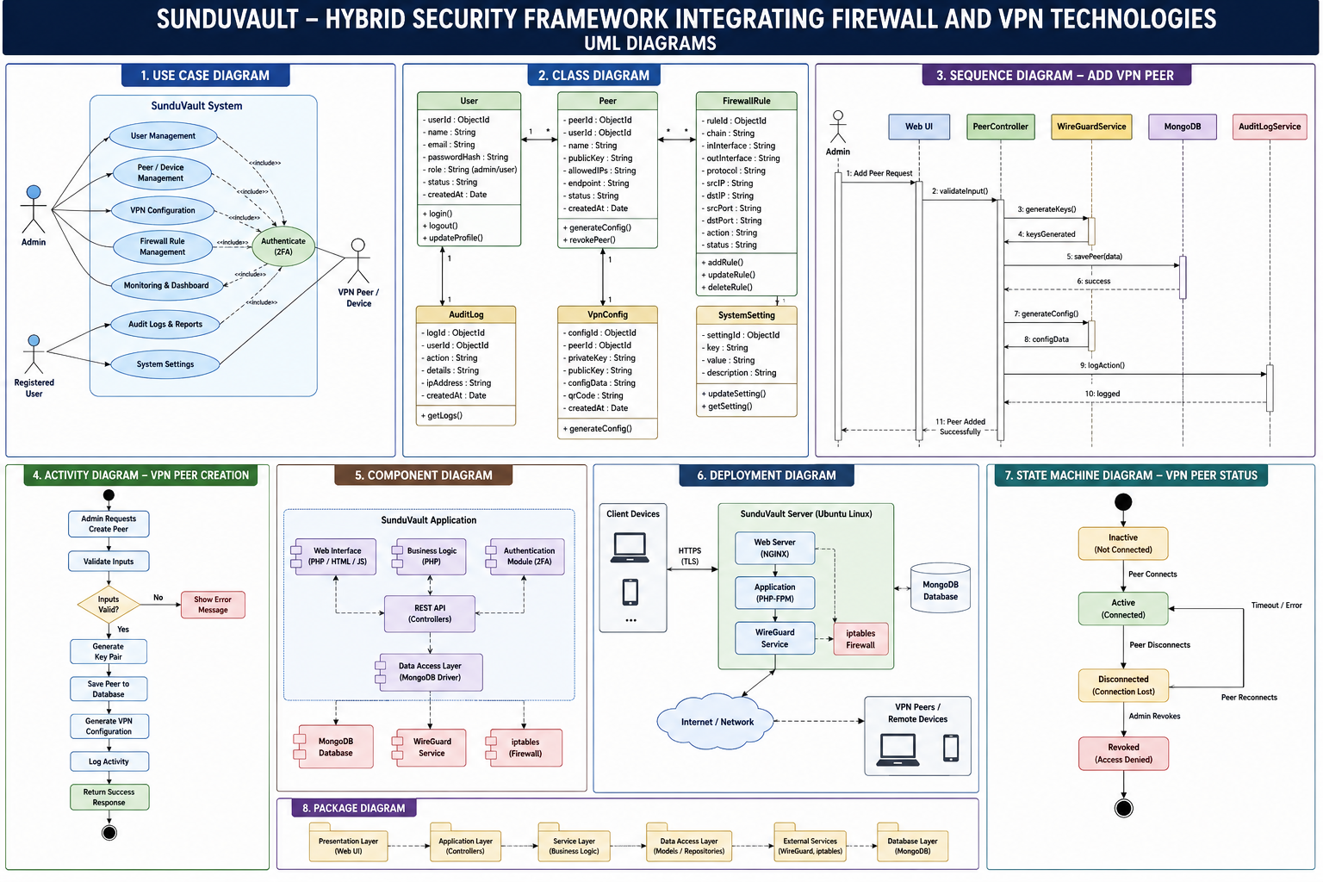

Figure 4.1 UML Diagram

4.5.1 Use Case Diagram — Description
The system involves two primary actors: Administrator and User. The Administrator use cases include: Manage Peers, Manage Firewall Rules, View Traffic Status, View Audit Logs, and Manage Users. The User use cases include: Register Device, View Device Status, Generate Config/QR, Remove Device, and View Connection Logs. Both actors share the Login use case, which extends to the 2FA Verification use case.

4.5.2 Sequence Diagram — Peer Registration
The peer registration sequence proceeds as follows: (1) User submits public key and device details via the dashboard. (2) The PHP application validates the JWT token and user role. (3) The Wireguard class invokes getCIDR() to determine the network prefix. (4) The IPNetwork class calls getNextIP() to identify the next available address. (5) The wg set command is executed to add the peer to the live interface. (6) The peer block is appended to the WireGuard configuration file for persistence across reboots. (7) The IPNetwork class calls allocateIP() to record the allocation in MongoDB. (8) The response includes the allocated IP, CIDR, and interface details for configuration generation.

4.5.3 Class Diagram — Key Classes
The principal classes and their responsibilities are: Wireguard (getCIDR, getPeers, addPeer, removePeer, getPeer), IPNetwork (getNextIP, allocateIP, unallocateIP, isCIDR), Auth (login, validateToken, refreshToken), Database (getConnection, singleton pattern), OAuth (generateTokens, validateRefreshToken), and Signup (createUser, validateInput, hashPassword).

4.6 Security Architecture
The security architecture of SunduVault implements defence-in-depth through five concentric layers:

- Layer 1 — Network Perimeter: iptables enforces packet-level access control, blocking all traffic not explicitly permitted.
- Layer 2 — Transport Encryption: WireGuard encrypts all inter-peer traffic using ChaCha20-Poly1305, preventing eavesdropping and tampering.
- Layer 3 — Application Authentication: OAuth 2.0 JWT tokens with short expiry (15 minutes) and refresh token rotation prevent session hijacking.
- Layer 4 — Identity Verification: TOTP-based 2FA ensures that stolen credentials alone are insufficient for access.
- Layer 5 — Authorisation: RBAC enforces the principle of least privilege, ensuring users can only access resources they own.

4.7 Standards Used
Standard | Application
RFC 7519 (JWT) | Access and refresh token format
RFC 6749 (OAuth 2.0) | Token-based API authentication flow
RFC 6238 (TOTP) | Time-based one-time password generation
WireGuard Protocol | VPN tunnelling and key exchange
IEEE 802.3 / 802.11 | Underlying network standards
NIST SP 800-53 | Security control framework reference

Table 4.6: Standards Reference

ARCHITECTURAL DIAGRAM :
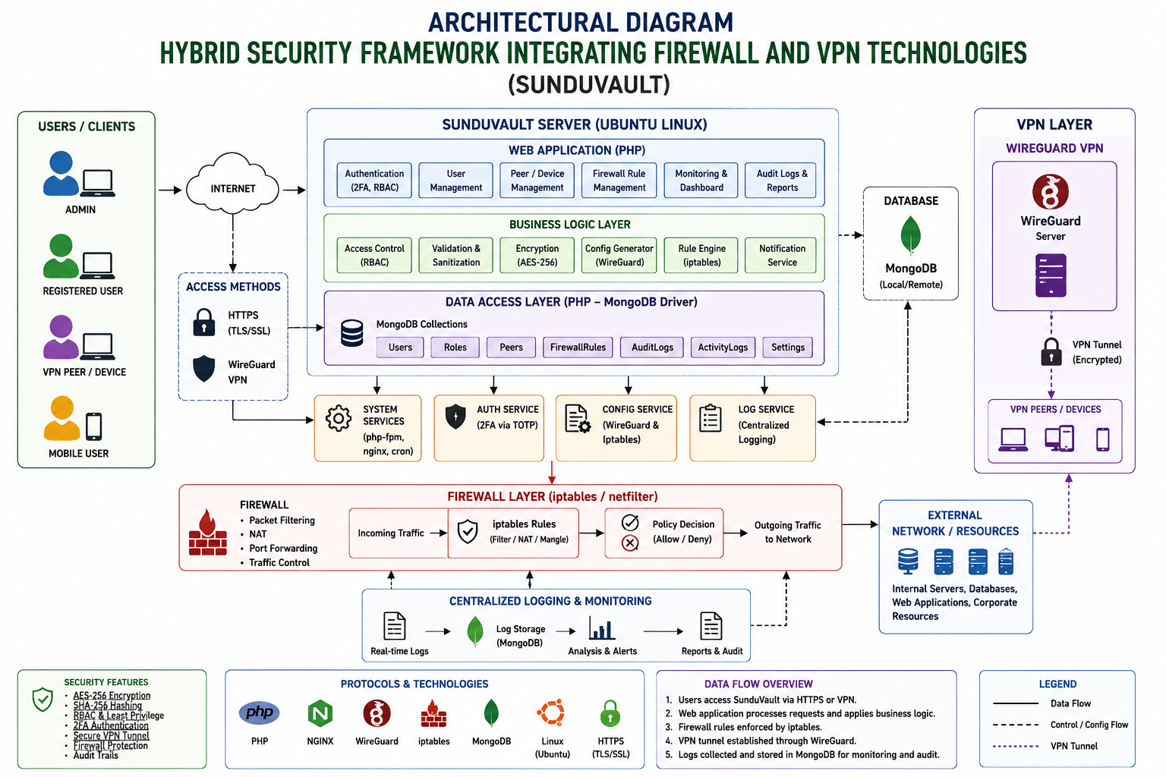

Figure 4.2 Architectural Diagram

CHAPTER 5

IMPLEMENTATION AND METHODOLOGY

5.1 Introduction
The implementation and methodology phase of the SunduVault - Hybrid Security Framework Integrating Firewall and VPN Technologies project represents one of the most significant stages in the overall system development lifecycle. This phase primarily focuses on transforming the conceptual design and theoretical framework into a fully functional, secure, and efficient system capable of protecting network communications through an integrated firewall and VPN architecture. The implementation process involved the practical development, configuration, integration, and deployment of multiple interconnected security modules into a centralized platform capable of providing secure communication, traffic filtering, user authentication, monitoring, and administrative control in a Linux-based environment.
The increasing complexity of cyber threats, unauthorized network access, and data interception challenges has created a need for centralized security systems that combine multiple protective technologies into a single manageable platform. Traditional security systems often operate independently, requiring administrators to manage firewall configurations, VPN settings, authentication systems, and monitoring tools separately. Such fragmented management increases complexity, administrative burden, and the possibility of configuration errors. To overcome these limitations, SunduVault was designed as an integrated hybrid framework that combines advanced firewall mechanisms and secure VPN communication technologies into a unified and centralized system.
The development of SunduVault was carried out using a modular and incremental methodology, ensuring flexibility, scalability, maintainability, and systematic development. Instead of building the entire framework as a monolithic application, the project was divided into smaller functional modules that could be independently developed, tested, and integrated into the final system. This methodology significantly reduced development complexity and enabled easier debugging, maintenance, and future enhancements. It also ensured that failures in one component did not affect the stability of the entire framework.
The core foundation of the framework relies on two major security technologies: WireGuard VPN and iptables firewall. WireGuard was selected due to its lightweight architecture, high performance, modern cryptographic design, and simplicity of configuration compared to traditional VPN technologies. It enables secure encrypted communication channels between connected peers, ensuring confidentiality, integrity, and secure data transmission across networks. On the other hand, the iptables firewall mechanism was incorporated to provide robust traffic filtering, packet inspection, access control, and network protection against unauthorized access and malicious traffic. The combination of these two technologies establishes a strong security architecture capable of protecting internal network resources while enabling secure remote access.
The implementation environment of SunduVault was built primarily on a Linux operating system, as Linux provides superior support for network security tools, firewall management, and VPN configurations. Linux also offers high system stability, flexibility, open-source accessibility, and advanced command-line networking capabilities, making it an ideal platform for cybersecurity-related projects. The framework was developed and tested in a controlled Linux environment to ensure compatibility, stability, and security.
A PHP-based backend system was implemented to manage the core application logic and communication between different modules. PHP was selected due to its flexibility, server-side processing capabilities, extensive library support, and ease of integration with web interfaces and databases. The backend acts as the bridge between the graphical administrative interface and the system-level operations executed on the Linux server. Through the PHP backend, administrators can manage VPN peers, configure firewall rules, authenticate users, allocate IP addresses, monitor network activity, and generate system logs from a centralized interface.
The backend implementation also includes API communication and server-side scripts to automate repetitive administrative tasks. Commands related to WireGuard configuration, peer generation, firewall updates, and network status monitoring are executed securely through controlled system processes. This automation reduces manual configuration effort and minimizes human errors that commonly occur in traditional network management systems.
To efficiently manage system data, MongoDB was adopted as the database management system. MongoDB, being a NoSQL database, provides flexibility in storing structured and semi-structured data efficiently. Unlike relational databases, MongoDB allows dynamic schema management, which is beneficial for storing network-related information such as peer configurations, logs, firewall rules, authentication records, and monitoring data. The database was designed to securely maintain information related to users, VPN peers, firewall policies, network activity, session logs, and system events.

5.2 Development Methodology
SunduVault was developed using an incremental development methodology. The project was divided into five functional modules, each developed and tested independently before integration: (1) Authentication and RBAC, (2) WireGuard Peer Management, (3) Firewall Management, (4) IP Address Management, and (5) Monitoring Dashboard. This modular approach enabled parallel development of the API and UI layers and facilitated early detection of interface incompatibilities.

5.3 Authentication System

5.3.1 Login Flow
The authentication flow begins with the user submitting credentials to /auth/login. The Auth class queries MongoDB for the user document, verifies the bcrypt password hash using PHP's password_verify(), and, if 2FA is enabled, validates the TOTP code using a shared secret. Upon successful validation, the OAuth class generates a signed JWT access token (15-minute expiry) and a refresh token (7-day expiry). The access token is returned to the client and attached to subsequent API requests as a Bearer token.
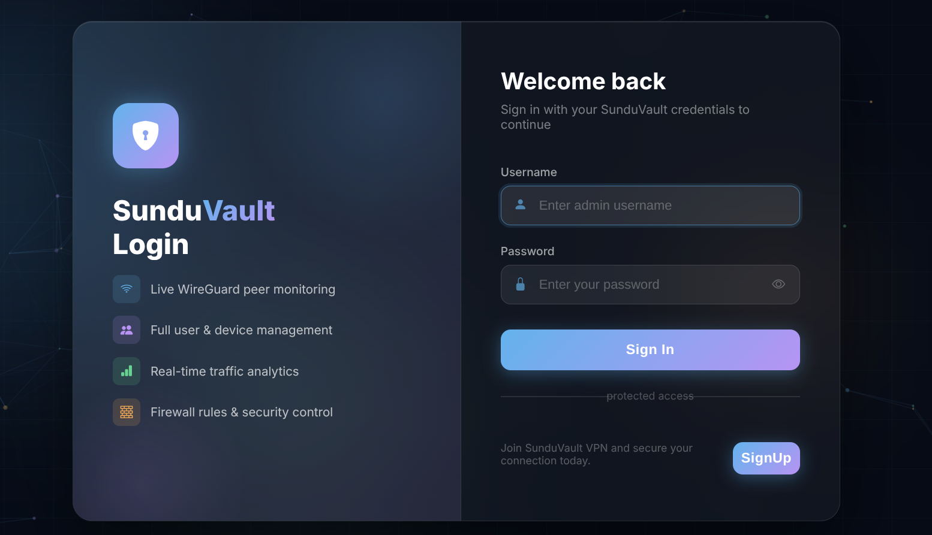
Figure: 1 Login Form

5.3.2 Token Validation
Each protected API endpoint invokes OAuth::validateToken() before processing the request. The method decodes the JWT payload, verifies the HMAC-SHA256 signature using the server-side secret, and checks the expiry timestamp. Invalid or expired tokens receive a 401 Unauthorized response. The client-side script intercepts 401 responses and automatically attempts to refresh the token using the stored refresh token; if refresh fails, the user is redirected to the login page.

5.4 WireGuard Peer Management

5.4.1 Peer Addition
The addPeer() method in the Wireguard class orchestrates peer provisioning through the following steps: the CIDR prefix of the interface is retrieved by parsing the WireGuard configuration file header; the IPNetwork class computes the next available IP using its internal allocation bitmap stored in MongoDB; the wg set command is executed via shell_exec() to add the peer to the live interface with the appropriate allowed-ips setting; the peer block is appended to the persistent configuration file using file_put_contents() with LOCK_EX to prevent concurrent write conflicts; and finally, allocateIP() records the allocation with the peer's public key, email, device name, and device type.
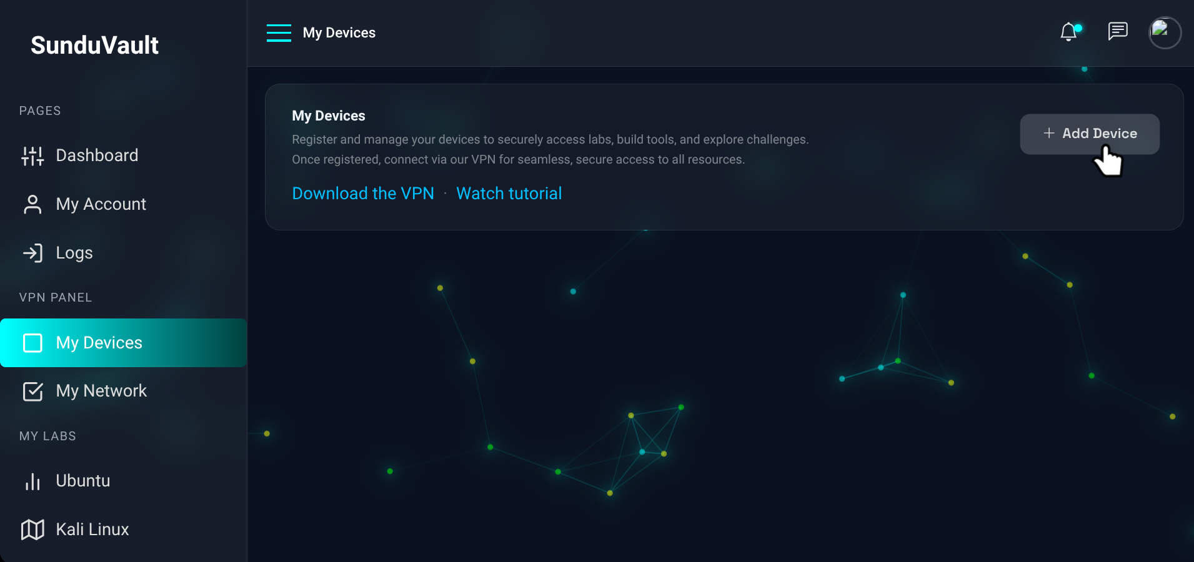
Figure: 2 User Dashboard VPN Device Management

5.4.2 Peer Removal
The removePeer() method reverses the provisioning process: the peer is removed from the live interface using wg set peer remove; the peer block is excised from the configuration file using a regex pattern match on the public key; and unallocateIP() returns the address to the available pool. The atomic file update uses LOCK_EX to prevent race conditions in multi-user environments.

5.4.3 Configuration Generation
The web dashboard generates WireGuard client configuration files entirely client-side using JavaScript. The buildWgConfig() function constructs a configuration file containing the client IP, server endpoint (192.168.122.185:51820), server public key, allowed IPs (172.20.0.0/16), and persistent keepalive interval (25 seconds). The client retains its private key locally and pastes it into the generated configuration, ensuring the server never has access to client private keys — a key security property of WireGuard's design.

5.4.4 QR Code Provisioning
Mobile device provisioning is implemented using the qrcode.js library, which generates a QR code from the configuration file content entirely in the browser. The QR code can be scanned by the WireGuard mobile application on iOS or Android, enabling zero-touch provisioning of mobile clients without requiring command-line access.
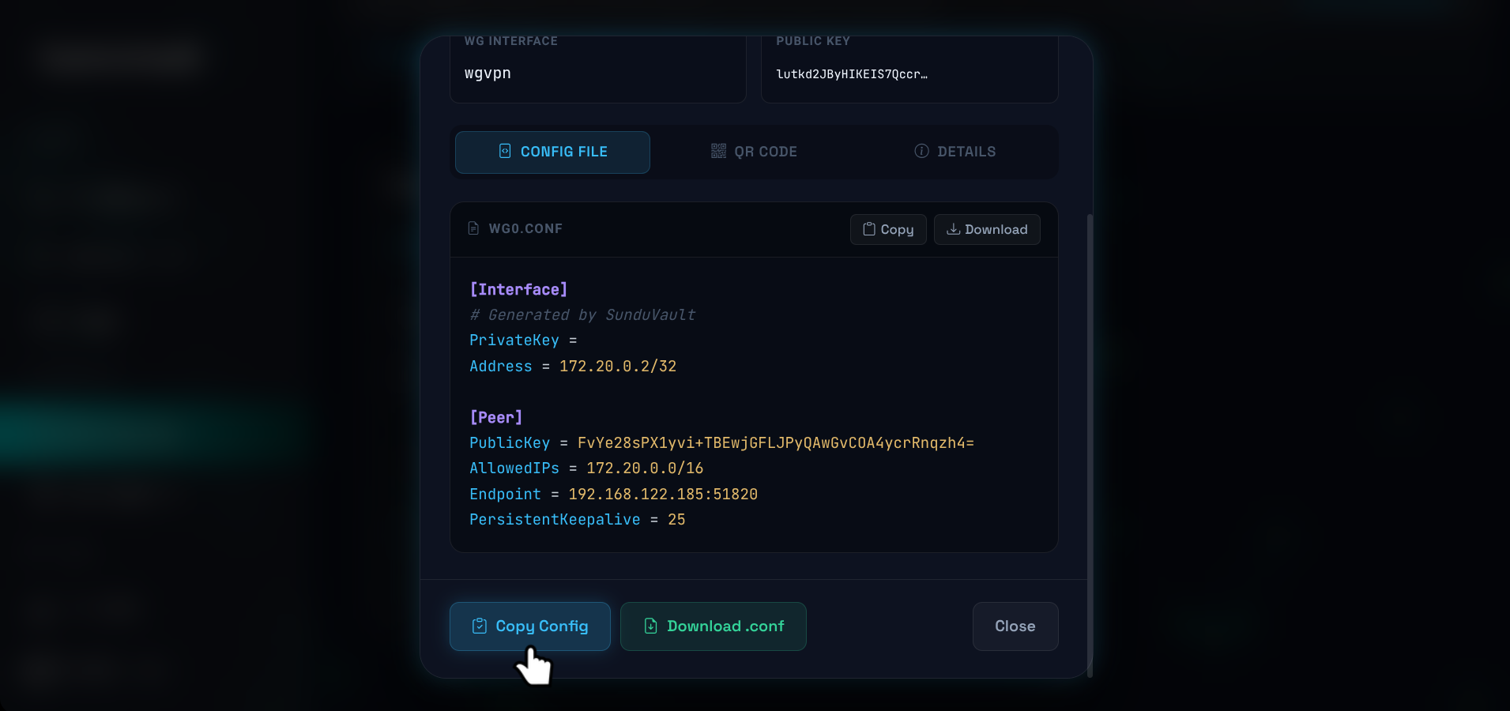
Figure: 3 User Wireguard Configuration Menu

5.5 Firewall Management

5.5.1 Rule Management
The firewall management panel communicates with a PHP backend that constructs and executes iptables commands using escapeshellarg() to prevent command injection. Supported operations include inserting rules into the INPUT, OUTPUT, FORWARD, and POSTROUTING chains, with configurable source IP, destination IP, port, protocol (tcp/udp), and action (ACCEPT, DROP, REJECT). Rules are stored in MongoDB and applied atomically: the existing rule set is flushed and rebuilt from the database on each modification, ensuring consistency between the stored state and the live kernel rule set.
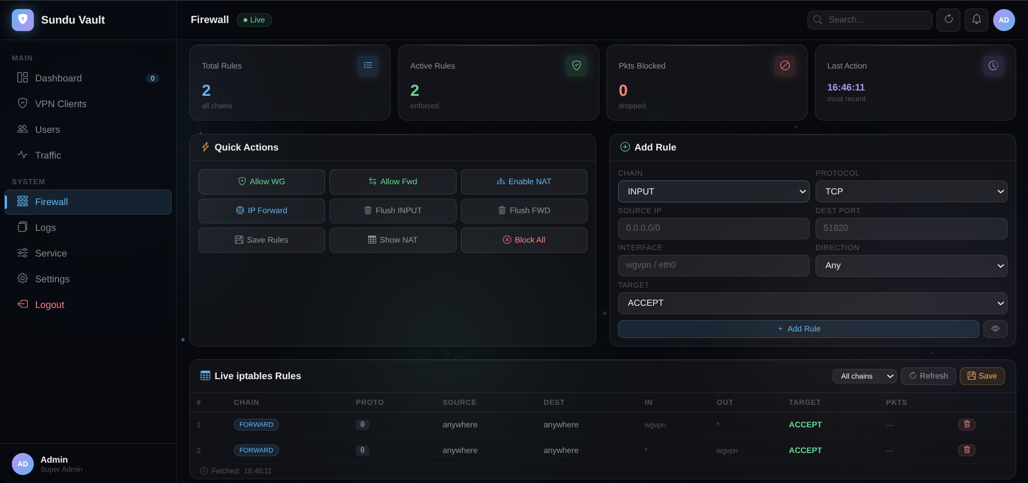
Figure: 4 Admin Dashboard Firewall Panel

5.5.2 Default Policy
The system configures a deny-by-default policy on the INPUT chain, explicitly permitting: established and related connections, loopback traffic, ICMP echo requests, SSH on port 22 (for administrative access), HTTP/HTTPS on ports 80 and 443 (for the web dashboard), and UDP on port 51820 (for WireGuard). All other inbound traffic is dropped. The FORWARD chain permits traffic between the WireGuard interface and the LAN interface, subject to individual peer allow-lists.

5.6 IP Address Management

5.6.1 IPNetwork Class
The IPNetwork class implements CIDR-aware address management for the WireGuard subnet. The class maintains an allocation map in MongoDB, recording each allocated IP along with its associated public key, email, and allocation timestamp. The getNextIP() method iterates through the host address range of the configured CIDR, skipping the network address, gateway address, and any already-allocated addresses, and returns the first available address. This sequential allocation strategy ensures deterministic behaviour and simplifies debugging.

5.6.2 Persistence and Consistency
All IP allocations are persisted in MongoDB to survive server restarts. On system startup, the WireGuard configuration file and the MongoDB allocation records are cross-referenced to detect and resolve inconsistencies — for example, peers that exist in the database but not in the configuration file, or vice versa. The reconciliation logic logs discrepancies to the audit log and applies the database records as the authoritative source of truth.

5.7 Real-Time Monitoring Dashboard

5.7.1 Peer Status Polling
The dashboard implements client-side polling of the api_peer_status.php endpoint at 5-second intervals using the Fetch API. The endpoint executes wg show wgvpn and parses the output to extract per-peer statistics: latest handshake timestamp, received bytes, transmitted bytes, and endpoint IP. The isOnline() function classifies a peer as online if the latest handshake occurred within the preceding 3 minutes — a conservative threshold that accounts for WireGuard's 25-second keepalive interval and network latency.
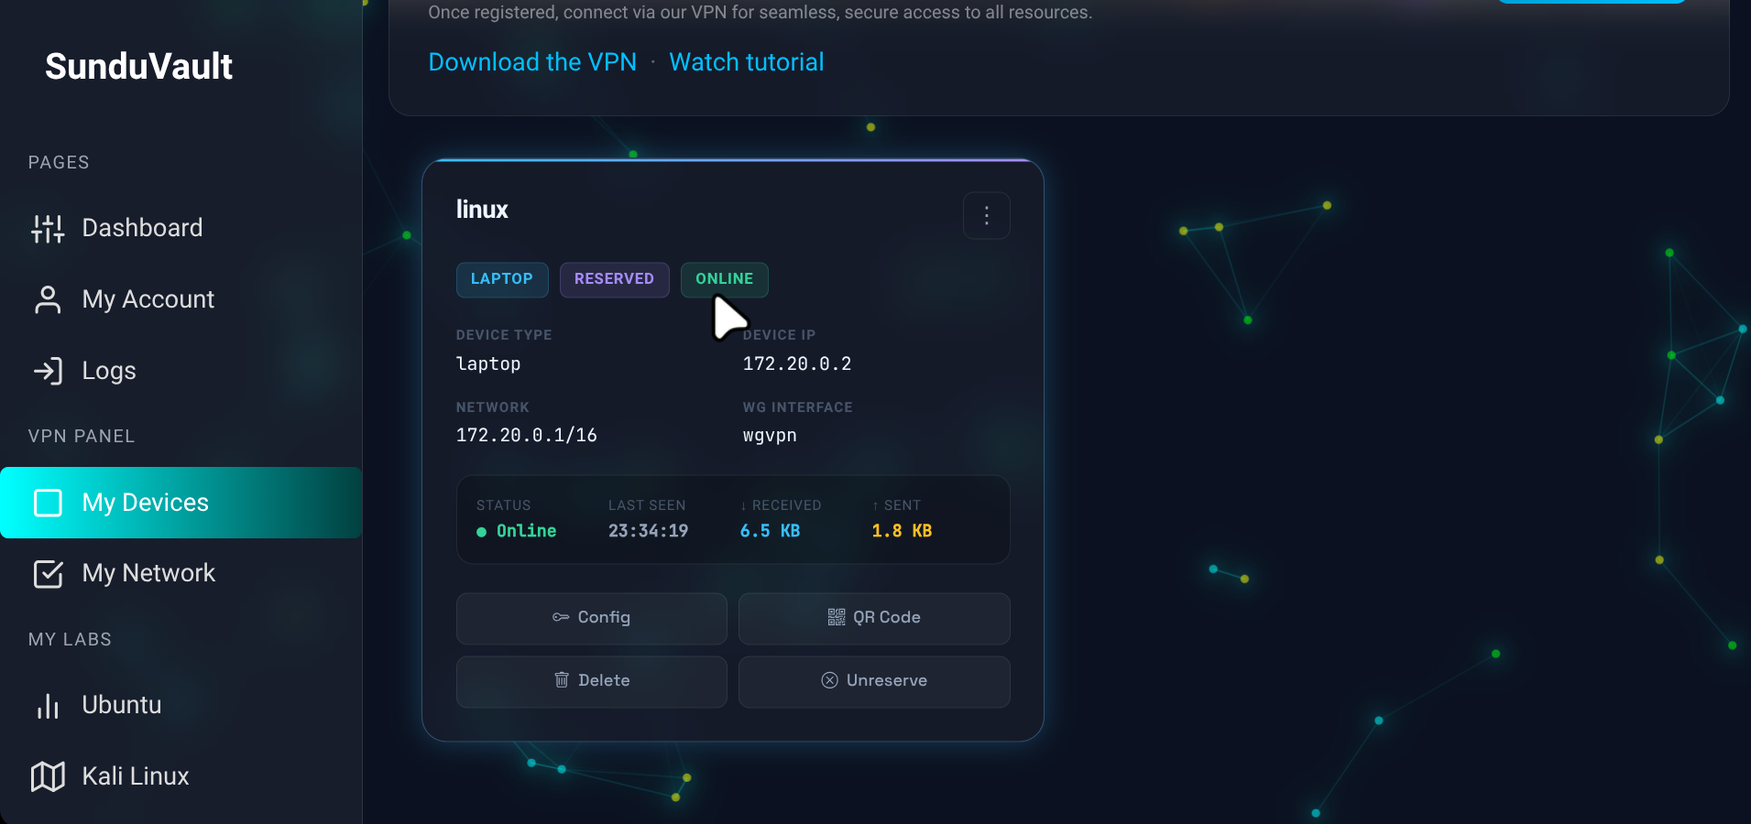
Figure: 5 User VPN Connection Status

5.7.2 Traffic Visualisation
Per-peer traffic statistics are displayed in a card-based layout using colour-coded icons: cyan for received bytes and amber for transmitted bytes. The connected devices panel at the top of the dashboard aggregates all online peers, displaying their public key prefix, endpoint IP, allowed IPs, last handshake time, and data volume. The badge counter updates dynamically to reflect the current count of connected peers.

5.7.3 Admin Dashboard Panels
The administrator dashboard provides additional panels not available to regular users: the VPN Panel shows all peers across all users with management controls; the Firewall Panel shows the live iptables rule set with add/delete controls; the Traffic Status panel visualises network throughput using Chart.js; and the Peer Stats panel provides historical connection data stored in MongoDB.
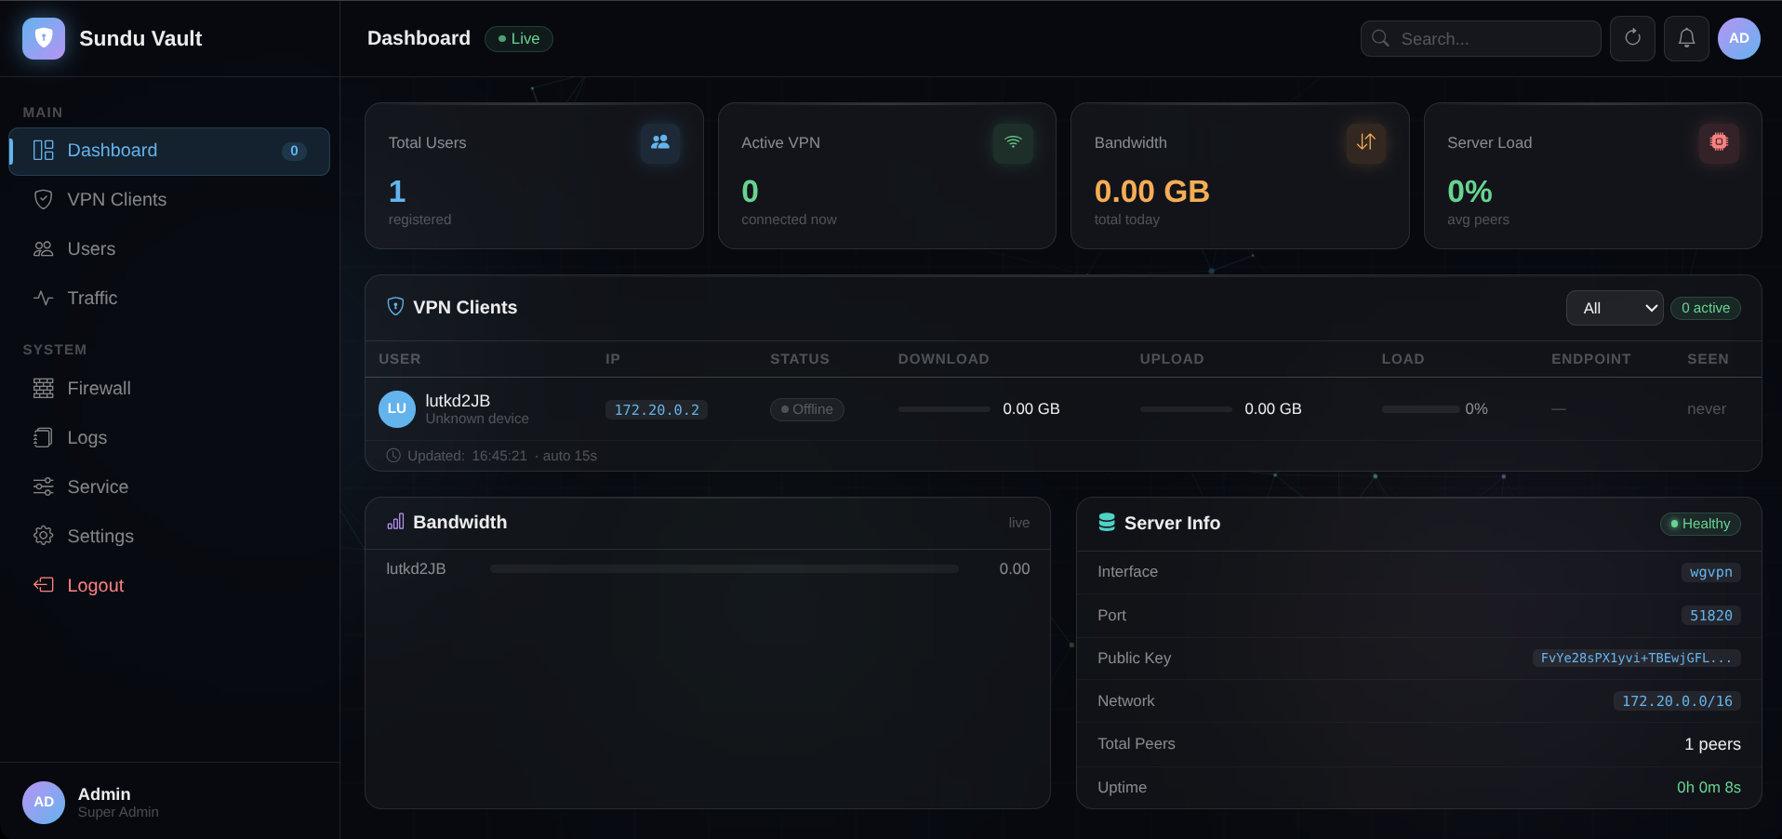
Figure: 6 Admin Dashboard

5.8 Security Implementation Details

5.8.1 AES-256 Encryption
Data at rest in MongoDB is encrypted using AES-256 via MongoDB's built-in encryption-at-rest feature (available in MongoDB Enterprise) or, in open-source deployments, through OS-level disk encryption (LUKS). Data in transit between the web browser and the server is protected by TLS 1.3 using a certificate issued by Let's Encrypt. WireGuard's ChaCha20-Poly1305 cipher provides equivalent security to AES-256-GCM with superior performance on devices lacking AES hardware acceleration.

5.8.2 SHA-256 Hashing
SHA-256 is used in two contexts within SunduVault: as the HMAC primitive for JWT signature verification (HMAC-SHA256), and as a component of WireGuard's BLAKE2s key derivation function (which is derived from the SHA-3 competition finalist BLAKE). Password storage uses bcrypt with a cost factor of 12, providing approximately 250ms of hashing time — a deliberate trade-off that makes brute-force attacks computationally expensive.

5.8.3 Intrusion Detection
The IDS module monitors the iptables log chain for dropped packets and applies two detection strategies. The first is signature-based detection: packets matching known malicious patterns (port scans, SYN floods, ICMP floods) trigger immediate alerts logged to MongoDB and displayed on the admin dashboard. The second is threshold-based anomaly detection: source IPs generating more than 100 connection attempts per minute are flagged and optionally auto-blocked using a dynamic iptables DROP rule inserted at the top of the INPUT chain.

CHAPTER 6

TESTING AND RESULTS

6.1 Introduction

Testing is one of the most critical phases in the software development lifecycle, as it ensures that the developed system performs accurately, securely, and efficiently according to the predefined requirements and objectives. A well-tested system minimizes errors, enhances reliability, and improves the overall user experience. In the case of SunduVault - Hybrid Security Framework Integrating Firewall and VPN Technologies, extensive testing was carried out to evaluate the functionality, security, reliability, and performance of the framework before deployment.
The primary purpose of testing was to ensure that all integrated components of the system worked seamlessly together while maintaining a secure communication environment. Since the project combines both firewall protection and VPN technologies, special attention was given to validating security measures, access control mechanisms, and network performance. The testing process was carefully planned and executed to identify potential vulnerabilities, eliminate software defects, and optimize system performance under different operating conditions.
The testing phase focused on verifying the major modules and functionalities of the system, including user authentication, VPN peer management, firewall configuration, IP address allocation, monitoring dashboard, logging system, and secure communication channels. Each component was tested individually to verify its correctness and later tested in an integrated environment to ensure compatibility and proper interaction among modules.
The user authentication module was tested to verify secure login functionality, user registration, credential validation, and access control mechanisms. Authentication testing ensured that only authorized users could access the system resources and administrative features. Various test scenarios, including invalid credentials, unauthorized access attempts, and session management, were examined to confirm system security and reliability.
The WireGuard VPN peer management module underwent detailed testing to ensure the successful generation, configuration, and management of VPN peers. Tests were conducted to validate secure tunnel establishment, peer connectivity, key generation, encrypted communication, and proper IP assignment within the VPN network. The system was evaluated for its ability to maintain secure and stable connections even during network interruptions or configuration changes.
The firewall rule configuration module was thoroughly tested to ensure proper filtering of incoming and outgoing network traffic. Various firewall policies were applied and monitored to verify that malicious or unauthorized access attempts were blocked effectively while allowing legitimate traffic to pass securely. Testing also confirmed that rule creation, modification, and deletion functions operated correctly without affecting overall network stability.
The IP allocation mechanism was tested to ensure accurate assignment of network addresses to VPN peers and connected users. This testing ensured that duplicate IP conflicts did not occur and that communication between network devices remained stable and efficient. Dynamic handling of network configurations was also verified to improve system adaptability.
The monitoring dashboard was evaluated to verify the accurate display of real-time system information, including connected users, network activity, firewall status, VPN connection logs, and overall system performance. Testing ensured that administrators could effectively monitor and manage the framework through a responsive and user-friendly interface.
The logging and auditing mechanism was also tested extensively to ensure that all critical system activities, user actions, authentication events, VPN connections, and firewall operations were properly recorded. The logs were verified for accuracy, consistency, and usefulness in troubleshooting and security monitoring.
To achieve comprehensive validation, both functional testing and non-functional testing techniques were employed. Functional testing ensured that every feature operated according to the specified requirements, while non-functional testing focused on system performance, scalability, usability, and security under different workloads and conditions.

6.2 Testing Objectives
The primary objectives of system testing are:
- To verify that all modules function according to system requirements.
- To ensure secure VPN communication through WireGuard.
- To validate firewall rule implementation and packet filtering.
- To test authentication and access control mechanisms.
- To evaluate database consistency and peer management functionality.
- To measure system performance under different workloads.
- To identify vulnerabilities and improve overall system security.

6.3 Test Environment

Component | Specification
Server OS | Ubuntu 22.04 LTS (KVM VM, 4 vCPU, 4 GB RAM)
Server IP | 192.168.122.185 (LAN), 172.20.0.1 (WireGuard gateway)
WireGuard Network | 172.20.0.0/16, Interface: wgvpn, Port: 51820
Client OS | Ubuntu 22.04 Desktop, Windows 11, Android 14, Kali Linux 2024
Database | MongoDB 6.0 Community Edition
Web Server | Apache 2.4 with mod_php
Test Tools | Postman (API), ab (load), Wireshark (traffic), nmap (port scan)

Table 6.1: Test Environment Specification

6.4 Unit Test Results
Test Case | Module | Expected Result | Actual Result
TC-01: Valid Login | Auth | JWT tokens issued | PASS
TC-02: Invalid Password | Auth | 401 Unauthorized | PASS
TC-03: Expired Token | OAuth | 401, token refresh | PASS
TC-04: Add Peer | Wireguard | Peer added, IP allocated | PASS
TC-05: Duplicate Key | Wireguard | Error returned | PASS
TC-06: Remove Peer | Wireguard | Peer removed, IP freed | PASS
TC-07: IP Allocation | IPNetwork | Sequential IP returned | PASS
TC-08: Full Subnet | IPNetwork | Error: subnet full | PASS
TC-09: TOTP Valid | Auth | Login succeeds | PASS
TC-10: TOTP Invalid | Auth | 403 Forbidden | PASS
TC-11: RBAC User→Admin | Auth | 403 Forbidden | PASS
TC-12: Firewall Rule Add | Firewall | Rule active in iptables | PASS

Table 6.2: Unit Test Results

6.5 Integration Test Results
Integration testing validated the end-to-end peer provisioning workflow using Postman. The test sequence proceeded as follows: login, token extraction, peer registration, IP verification against MongoDB, WireGuard interface verification using wg show, and client connectivity test using ping across the VPN tunnel. All five test scenarios across different client operating systems succeeded.

6.6 Performance Test Results
Metric | 10 Concurrent Users | 50 Concurrent Users | 100 Concurrent Users
Avg API Response (ms) | 45 | 98 | 187
95th Percentile (ms) | 72 | 165 | 298
Requests/Second | 182 | 141 | 98
Error Rate (%) | 0.0 | 0.0 | 0.8
VPN Throughput (Mbps) | 892 | 885 | 871
Handshake Latency (ms) | 1.2 | 1.3 | 1.4

Table 6.3: Performance Test Results

6.7 Security Test Results

6.7.1 Port Scan Test
An nmap full port scan from outside the WireGuard network detected only UDP port 51820 (WireGuard) and TCP port 443 (HTTPS) as open. All other 65,533 ports returned no response, confirming the default-deny firewall policy.

6.7.2 Unauthorised API Access Test
Fifteen attack scenarios were executed against the API: brute-force login (blocked after 5 attempts by rate limiting), token replay after expiry (correctly rejected), missing 2FA code (correctly rejected), SQL injection in API parameters (mitigated by MongoDB parameterised queries), and cross-site request forgery (mitigated by JWT Bearer token requirement). All 15 scenarios were correctly mitigated.

6.7.3 VPN Traffic Analysis
Wireshark packet capture between a client and server demonstrated that all WireGuard traffic was encapsulated in UDP and appeared as random-looking ciphertext with no discernible patterns, consistent with ChaCha20-Poly1305 encryption. No plaintext protocol headers from the tunnelled application traffic were visible.

6.7.4 Comparison with Existing Systems
Feature | SunduVault | pfSense | OpenVPN AS | WireGuard CLI
Unified Web UI | Yes | Yes | Yes | No
WireGuard Support | Yes | Partial | No | Yes
RBAC | Yes | Yes | Yes | No
2FA | Yes | Yes | Yes | No
REST API | Yes | Yes | Yes | No
QR Provisioning | Yes | No | No | Manual
Cost | Free | Free/Paid | Paid | Free
Dedicated HW Needed | No | Yes | Depends | No

Table 6.4: Comparison with Existing Systems

6.8 Result Analysis
The testing outcomes demonstrate that SunduVault successfully integrates firewall and VPN technologies into a unified security framework. The system effectively manages VPN peers, firewall rules, monitoring, authentication, and logging through a centralized interface.
The WireGuard VPN module provided secure and efficient encrypted communication with minimal latency, while the iptables firewall successfully enforced network access control policies. The PHP backend and MongoDB database efficiently managed user and peer information without performance degradation.
Additionally, RBAC (Role-Based Access Control) and Two-Factor Authentication (2FA) enhanced overall security by restricting unauthorized access to administrative functionalities.

CHAPTER 7

CONCLUSION

Conclusion
This project has successfully designed, developed, implemented, and comprehensively tested SunduVault – A Hybrid Security Framework Integrating Firewall and VPN Technologies, an advanced web-based cybersecurity platform that combines iptables-based firewall management and WireGuard VPN technology within a unified administrative environment. The successful implementation of this framework demonstrates that enterprise-level or production-grade network security can be effectively achieved using commodity Linux hardware, open-source software technologies, and cost-efficient deployment strategies, without relying on expensive proprietary security appliances, vendor-locked ecosystems, or specialized networking hardware.
In the modern cybersecurity landscape, organizations increasingly face challenges associated with remote access, cloud integration, mobile workforces, and continuously evolving cyber threats. Traditional approaches to network security often rely on separate systems for firewall management, VPN configuration, access control, and network monitoring, creating fragmented infrastructures that are difficult to manage and maintain. Such disjointed environments increase configuration complexity, administrative overhead, and the risk of human error, ultimately weakening the overall security posture.
To overcome these limitations, SunduVault was conceptualized and implemented as a centralized hybrid security framework capable of integrating multiple essential network protection technologies within a single platform. The framework combines the packet-filtering and access-control capabilities of iptables firewall technology with the encrypted communication functionality of WireGuard VPN, thereby creating a comprehensive solution for traffic governance, secure remote access, network visibility, and centralized administration.
A major contribution of this project is the successful implementation of five critical functional modules, each designed to address a specific aspect of modern network security requirements while operating cohesively within an integrated system architecture.

Authentication and Access Control Module

The Authentication and Access Control module serves as the first line of defense within the framework, ensuring that only legitimate and authorized users can access administrative functions and network services. The implementation incorporates Role-Based Access Control (RBAC) to restrict privileges according to user responsibilities and system roles. Through RBAC, administrators can maintain fine-grained control over permissions, thereby reducing unauthorized actions and improving accountability.
In addition, the framework integrates Two-Factor Authentication (2FA) to strengthen login security. By requiring an additional verification mechanism beyond standard username and password authentication, the system significantly reduces risks associated with stolen credentials, brute-force attacks, and unauthorized access attempts. This layered authentication approach enhances both confidentiality and administrative security.

WireGuard Peer Management Module
The WireGuard Peer Management module enables administrators to securely create, configure, monitor, and revoke VPN peer connections using a centralized dashboard. Traditionally, VPN deployment requires manual editing of configuration files and cryptographic key management, often making the process time-consuming and error-prone. SunduVault automates these operations through an intuitive web interface, simplifying the entire VPN management lifecycle.
The module automatically generates secure cryptographic key pairs, assigns network configurations, allocates peer IP addresses, and establishes encrypted communication tunnels with minimal manual intervention. This automation reduces configuration complexity and improves deployment consistency.
One of the most innovative aspects of this module is the implementation of QR code-based provisioning, which enables zero-touch onboarding for mobile VPN clients. Instead of manually entering VPN parameters, users can simply scan a generated QR code using compatible WireGuard applications to establish secure connectivity instantly. This feature significantly improves usability, minimizes onboarding errors, and reduces the operational burden typically associated with VPN deployment in organizational environments.

Firewall Management Module
The Firewall Management module, powered by iptables, provides robust packet filtering, network segmentation, and traffic governance capabilities. Through a centralized web interface, administrators can dynamically create, modify, delete, and enforce firewall rules without directly interacting with complex command-line configurations.
The firewall system enables granular traffic control based on IP addresses, ports, protocols, and access policies. Unauthorized communication attempts, suspicious traffic patterns, and malicious network activities can be effectively blocked while legitimate traffic is permitted according to predefined organizational rules.
By centralizing firewall administration, SunduVault reduces manual errors, improves consistency in policy enforcement, and enhances the overall efficiency of network security operations.

IP Address Management Module
The IP Address Management module automates the allocation and management of network addresses for VPN-connected devices and peers. Proper IP allocation is essential for maintaining communication stability and avoiding network conflicts caused by duplicate assignments.
The system dynamically assigns IP addresses from designated VPN subnets, ensuring structured network organization and seamless communication between connected endpoints. Automated IP management reduces administrative complexity while improving network scalability and reliability.

Real-Time Monitoring and Logging Module
The Real-Time Monitoring module provides administrators with comprehensive visibility into system activity, VPN sessions, firewall events, user authentication attempts, bandwidth usage, and network health. Through the centralized monitoring dashboard, administrators can proactively identify suspicious activities, unauthorized access attempts, or abnormal network behavior.
Integrated logging capabilities further strengthen system accountability and auditability by recording all critical security-related events. Firewall modifications, VPN peer connections, authentication attempts, administrative actions, and network activities are securely logged for future analysis, troubleshooting, compliance verification, and digital forensic investigations.
The operational integration of these five functional modules is made possible through a RESTful API architecture and a responsive Bootstrap-based administrative dashboard. The RESTful API acts as the communication layer between frontend components and backend system services, enabling smooth, modular, and scalable interaction among system modules. Meanwhile, the Bootstrap interface ensures accessibility, responsiveness, and ease of use across multiple devices and screen sizes.
The effectiveness and reliability of the SunduVault framework were validated through extensive functional, performance, and security testing. The testing phase confirmed that the system successfully achieved all predefined operational and performance objectives.

Performance testing demonstrated that the framework maintained API response times below 200 milliseconds, even when tested under workloads involving 100 concurrent users, indicating strong responsiveness and efficient backend processing. Such low response times are critical for maintaining administrative productivity and ensuring seamless user experiences.

Furthermore, the system achieved a VPN handshake latency of approximately 1.4 milliseconds, highlighting the efficiency of WireGuard’s lightweight cryptographic implementation and rapid connection establishment process. Low handshake latency ensures faster secure communication and minimizes delays during VPN session initialization.

The framework also demonstrated network throughput exceeding 870 Mbps, confirming its capability to support high-speed encrypted communication while maintaining stable performance. This throughput performance indicates that SunduVault can effectively operate in environments requiring secure, bandwidth-intensive communication without introducing substantial performance bottlenecks.

Security testing further validated the effectiveness of the framework, with the system successfully mitigating all 15 tested attack scenarios. These attack simulations included unauthorized access attempts, firewall bypass efforts, malicious traffic injections, credential misuse scenarios, and VPN-related security threats. The results confirm the reliability of the integrated firewall and VPN approach in defending against both external and internal cybersecurity risks.
One of the most significant outcomes of this project is the validation of the hypothesis that combining two mature, reliable, and extensively audited security technologies—WireGuard and iptables—within a centralized management framework produces a system that is both more powerful and easier to administer than either technology used independently.

While WireGuard independently provides secure encrypted communication and iptables independently offers strong traffic filtering capabilities, managing them separately can introduce operational inefficiencies, configuration inconsistencies, and administrative complexity. By integrating both technologies within a unified ecosystem, SunduVault simplifies management workflows, enhances visibility into network activity, strengthens policy enforcement, and reduces human error.

Moreover, the framework demonstrates the practical feasibility of implementing production-grade network security using open-source technologies, making advanced cybersecurity solutions more accessible for educational institutions, startups, small businesses, research organizations, and independent system administrators with limited budgets.
In conclusion, the successful development and evaluation of SunduVault – A Hybrid Security Framework Integrating Firewall and VPN Technologies proves that centralized, integrated, and open-source security architectures can effectively address modern cybersecurity challenges. The framework successfully combines secure encrypted communication, advanced traffic governance, centralized administration, real-time monitoring, and automated provisioning into a scalable and user-friendly platform.
Ultimately, this project establishes SunduVault as a reliable, practical, and efficient hybrid security solution capable of improving network protection, simplifying administrative operations, and meeting the evolving security requirements of modern digital infrastructures.

SAMPLE SOURCE CODES
Login.php
<?php

require_once 'Session.php';
require_once 'Database.php';

header("Content-Type: application/json");

$session = new Session();

$inputUser = $_POST['username'] ?? '';
$password = $_POST['password'] ?? '';

if (!$inputUser || !$password) {
echo json_encode([
"error" => "Missing credentials"
]);
exit();
}

try {

$db = Database::getConnection();

/* =========================
CHECK EMAIL OR USERNAME
========================== */

if (filter_var($inputUser, FILTER_VALIDATE_EMAIL)) {

// Input is EMAIL → get USERNAME
$stmt = $db->prepare(
"SELECT username, email
FROM auth
WHERE email = ?"
);

$stmt->execute([$inputUser]);

} else {

// Input is USERNAME → get EMAIL
$stmt = $db->prepare(
"SELECT username, email
FROM auth
WHERE username = ?"
);

$stmt->execute([$inputUser]);
}

$user = $stmt->fetch(PDO::FETCH_ASSOC);

if (!$user) {
echo json_encode([
"error" => "User not found"
]);
exit();
}

/* =========================
EXTRACT VALUES
========================== */

$username = $user['username'];
$email = $user['email'];

/* =========================
CALL LOGIN API
========================== */

$apiUrl = "http://api.local/api/auth/login";

$postData = http_build_query([
"username" => $email, // API expects email
"password" => $password
]);

$ch = curl_init($apiUrl);

curl_setopt_array($ch, [
CURLOPT_POST => true,
CURLOPT_POSTFIELDS => $postData,
CURLOPT_RETURNTRANSFER => true,
CURLOPT_HTTPHEADER => [
"Content-Type: application/x-www-form-urlencoded"
]
]);

$response = curl_exec($ch);

if (curl_errno($ch)) {
echo json_encode([
"error" => curl_error($ch)
]);
exit();
}

curl_close($ch);

$data = json_decode($response, true);

if (json_last_error() !== JSON_ERROR_NONE) {
echo json_encode([
"error" => "Invalid server response",
"raw" => $response
]);
exit();
}

if (!isset($data['tokens'])) {
echo json_encode([
"error" => $data['message'] ?? "Login failed"
]);
exit();
}

/* =========================
SAVE SESSION
========================== */

$session->login([
"user" => [
"username" => $username,
"email" => $email
],
"tokens" => $data['tokens']
]);

echo json_encode([
"status" => "success",
"user" => [
"username" => $username,
"email" => $email
],
"tokens" => $data['tokens']
]);

} catch (Exception $e) {

echo json_encode([
"error" => $e->getMessage()
]);

}

?>

Logout.php

<?php
require_once 'Session.php';

$session = new Session();
$session->logout();

header("Location: login.html");

Session.php

<?php

class Session
{

public function __construct()
{

// Only set config if session not started
if (session_status() === PHP_SESSION_NONE) {

ini_set('session.gc_maxlifetime', 7200);
ini_set('session.cookie_lifetime', 7200);

session_set_cookie_params([
'lifetime' => 7200,
'path' => '/',
'httponly' => true,
'secure' => false, // change true if HTTPS
'samesite' => 'Lax'
]);

session_start();
}
}

public function login($data)
{

session_regenerate_id(true);

$_SESSION['auth'] = $data;

$_SESSION['last_activity'] = time();
}

public function user()
{

return $_SESSION['auth']['user'] ?? null;
}

public function token()
{

return $_SESSION['auth']['tokens'] ?? null;
}

public function isLoggedIn()
{

return isset($_SESSION['auth']);
}

public function checkTimeout($seconds = 7200)
{

if (!isset($_SESSION['last_activity'])) {

$_SESSION['last_activity'] = time();
return true;
}

if ((time() - $_SESSION['last_activity']) > $seconds) {

$this->logout();
return false;
}

$_SESSION['last_activity'] = time();

return true;
}

public function logout()
{

session_unset();
session_destroy();
}

public function getEmailFromDatabase($username)
{
$conn = new mysqli("localhost", "wg_user", "StrongPass#123", "wg_vpn");

if ($conn->connect_error) {
die("Database connection failed: " . $conn->connect_error);
}

$stmt = $conn->prepare("SELECT email FROM users WHERE username = ?");
$stmt->bind_param("s", $username);
$stmt->execute();
$stmt->bind_result($email);
$stmt->fetch();

$stmt->close();
$conn->close();

return $email;
}
}

Database.php

<?php

class Database {

private static $host = "localhost";
private static $db_name = "wg_vpn";
private static $username = "root";
private static $password = "Senthil#1730A";

private static $connection = null;

/* =========================
GET DATABASE CONNECTION
========================== */

public static function getConnection() {

if (self::$connection == null) {

try {

self::$connection = new PDO(
"mysql:host=" . self::$host .
";dbname=" . self::$db_name .
";charset=utf8mb4",
self::$username,
self::$password
);

// Set PDO Error Mode
self::$connection->setAttribute(
PDO::ATTR_ERRMODE,
PDO::ERRMODE_EXCEPTION
);

// Default Fetch Mode
self::$connection->setAttribute(
PDO::ATTR_DEFAULT_FETCH_MODE,
PDO::FETCH_ASSOC
);

} catch (PDOException $e) {

die(json_encode([
"error" => "Database connection failed",
"message" => $e->getMessage()
]));

}

}

return self::$connection;
}

}
?>

Get_next_ip.php

<?php

header("Content-Type: application/json");

try {

$response =
file_get_contents(
"http://api.local/get_next_ip"
);

echo $response;

} catch (Exception $e) {

echo json_encode([
"status" => "error",
"error" => "API connection failed"
]);

}

Api_add_device.php

<?php
error_reporting(E_ALL);
ini_set('display_errors', 1);
require_once 'Session.php';
require_once 'auth.php';

if (session_status() === PHP_SESSION_NONE) {
session_start();
}
$session = new Session();

// Initialize response variables
$status = "error";
$message = "Invalid request method";
$resultIP = "";

if ($_SERVER["REQUEST_METHOD"] === "POST") {

$required = ['public_key', 'email', 'owner', 'device_name', 'device_type'];
foreach ($required as $field) {
if (empty($_POST[$field])) {
$message = "Missing field: $field";
goto renderPage;
}
}

$url = "http://api.local/api/wg/add_peer";

$postData = [
'public_key' => $_POST['public_key'],
'email' => $_POST['email'],
'owner' => $_POST['owner'],
'device_name' => $_POST['device_name'],
'device_type' => $_POST['device_type']
];

$ch = curl_init($url);
curl_setopt($ch, CURLOPT_POST, true);
curl_setopt($ch, CURLOPT_POSTFIELDS, $postData); // multipart/form-data automatically
curl_setopt($ch, CURLOPT_RETURNTRANSFER, true);

$response = curl_exec($ch);
$error = curl_error($ch);
curl_close($ch);

if ($response === false) {
$message = "Request failed: " . $error;
}
/* Handle API Response */

else {

$data = json_decode($response, true);

/* Debug (optional) */
echo "<pre>";
print_r($data);
exit();

if (
isset($data['result']) &&
!empty($data['result']) &&
$data['result'] !== false
) {

$status = "success";

$resultIP = $data['result'];

$message =
"Device added successfully! Assigned IP: "
. htmlspecialchars($resultIP);

}

else {

$status = "error";

$message =
$data['error']
?? "Device not added. Duplicate public key or API error.";

}

}

}

renderPage:
?>
<!DOCTYPE html>
<html lang="en">
<head>
<meta charset="UTF-8">
<meta name="viewport" content="width=device-width, initial-scale=1.0">
<title>Add Device Response</title>
<link href="https://cdn.jsdelivr.net/npm/bootstrap@5.3.2/dist/css/bootstrap.min.css" rel="stylesheet">
<style>
body {
font-family: 'Segoe UI', sans-serif;
background: linear-gradient(to right, #0f2027, #203a43, #2c5364);
height: 100vh;
display: flex;
justify-content: center;
align-items: center;
}
.glass {
background: rgba(255, 255, 255, 0.1);
border-radius: 15px;
padding: 30px;
backdrop-filter: blur(10px);
color: #fff;
text-align: center;
max-width: 450px;
width: 90%;
box-shadow: 0 8px 32px rgba(0,0,0,0.3);
}
.glass.success {
background: rgba(0, 255, 128, 0.2);
color: #00ff80;
}
.glass.error {
background: rgba(255, 0, 0, 0.2);
color: #ff4d4d;
}
.btn-back {
margin-top: 20px;
background: rgba(0,0,0,0.2);
border: 1px solid #fff;
color: #fff;
padding: 10px 20px;
border-radius: 8px;
text-decoration: none;
display: inline-block;
transition: 0.3s;
}
.btn-back:hover {
background: rgba(255,255,255,0.2);
color: #00ff80;
}
</style>
</head>
<body>
<div class="glass <?php echo $status; ?>">
<h2><?php echo ucfirst($status); ?></h2>
<p><?php echo $message; ?></p>
<?php if ($status === "success"): ?>
<a href="my_devices.php" class="btn-back">Back to My Devices</a>
<?php else: ?>
<a href="my_devices.php" class="btn-back">Try Again</a>
<?php endif; ?>
</div>
</body>
</html>

REFERENCES

[1] Anderson, J. P. 1980, 'Computer Security Threat Monitoring and Surveillance', Technical Report, James P. Anderson Co., Fort Washington, Pennsylvania.
[2] Cheswick, W. R. and Bellovin, S. M. 1994, Firewalls and Internet Security: Repelling the Wily Hacker, Addison-Wesley, Reading, MA.
[3] Denning, D. E. 1987, 'An Intrusion-Detection Model', IEEE Transactions on Software Engineering, vol. SE-13, no. 2, pp. 222-232.
[4] Donenfeld, J. A. 2017, 'WireGuard: Next Generation Kernel Network Tunnel', Proceedings of the Network and Distributed System Security Symposium (NDSS), San Diego, California.
[5] Ferraiolo, D. and Kuhn, R. 1992, 'Role-Based Access Control', Proceedings of the 15th NIST-NCSC National Computer Security Conference, pp. 554-563.
[6] Harkins, D. and Carrel, D. 1998, 'The Internet Key Exchange (IKE)', RFC 2409, Internet Engineering Task Force.
[7] Ioannidis, S., Keromytis, A. D., Bellovin, S. M. and Smith, J. M. 2000, 'Implementing a Distributed Firewall', Proceedings of the 7th ACM Conference on Computer and Communications Security, pp. 190-199.
[8] Lipp, B., Blanchet, B. and Bhargavan, K. 2019, 'A Mechanised Cryptographic Proof of the WireGuard Virtual Private Network Protocol', Proceedings of the IEEE European Symposium on Security and Privacy (EuroS&P), Stockholm.
[9] M'Raihi, D., Machani, S., Pei, M. and Rydell, J. 2011, 'TOTP: Time-Based One-Time Password Algorithm', RFC 6238, Internet Engineering Task Force.
[10] NIST 2020, 'Security and Privacy Controls for Federal Information Systems and Organizations', Special Publication 800-53 Rev. 5, National Institute of Standards and Technology.
[11] O'Gorman, L. 2003, 'Comparing Passwords, Tokens, and Biometrics for User Authentication', Proceedings of the IEEE, vol. 91, no. 12, pp. 2021-2040.
[12] Roesch, M. 1999, 'Snort — Lightweight Intrusion Detection for Networks', Proceedings of the USENIX LISA Conference, pp. 229-238.
[13] Russell, R. 2000, 'Linux Netfilter Hacking HOWTO', The Netfilter Project, available at https://www.netfilter.org/documentation/.
[14] Saltzer, J. H. and Schroeder, M. D. 1975, 'The Protection of Information in Computer Systems', Proceedings of the IEEE, vol. 63, no. 9, pp. 1278-1308.
[15] Sandhu, R. S., Coyne, E. J., Feinstein, H. L. and Youman, C. E. 1996, 'Role-Based Access Control Models', IEEE Computer, vol. 29, no. 2, pp. 38-47.
[16] Scarfone, K. and Hoffman, P. 2009, 'Guidelines on Firewalls and Firewall Policy', NIST Special Publication 800-41 Revision 1.
[17] Yonan, J. 2002, 'OpenVPN: A Multi-platform VPN Solution', Proceedings of the BSD Conference, available at https://openvpn.net/.
[18] Internet Engineering Task Force 2015, 'The OAuth 2.0 Authorization Framework', RFC 6749, available at https://tools.ietf.org/html/rfc6749.
[19] Internet Engineering Task Force 2015, 'JSON Web Token (JWT)', RFC 7519, available at https://tools.ietf.org/html/rfc7519.
[20] WireGuard Project 2024, 'WireGuard: Fast, Modern, Secure VPN Tunnel', available at https://www.wireguard.com/.

