R.SENTHIL MURUGAN

WEEKLY ASSESMENT TEST
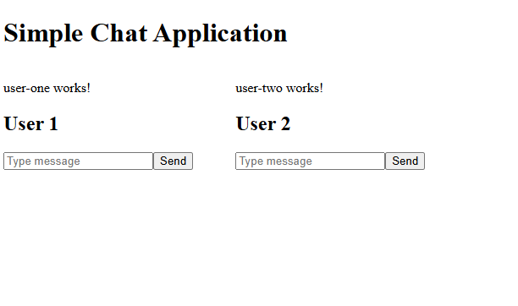

A simple web-based chat interface with two sections: User 1 and User 2.
Each user has a text input field and a “Send” button to submit messages.
Status text (“user-one works!” and “user-two works!”) indicates both sides are functioning.

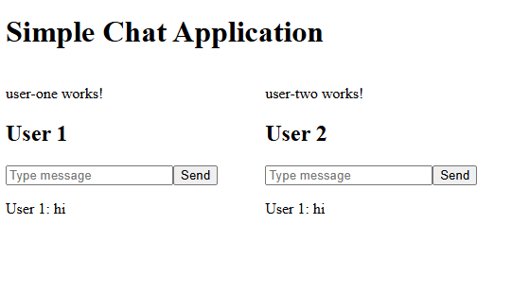
A simple chat app showing two users side by side (User 1 and User 2).
User 1 sends the message “hi,” which appears in both chat sections.
This shows that messages are shared/connected between the two users.

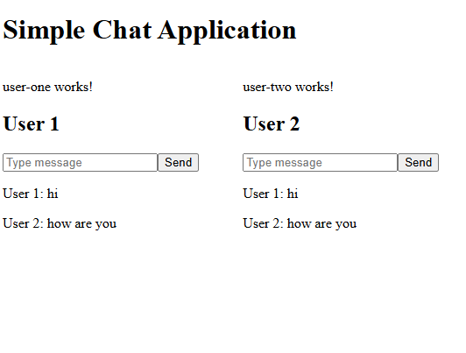

A simple two-user chat application displayed side by side.
User 1 sends “hi,” and User 2 replies “how are you.”
Both messages appear in both chat sections, showing real-time message sharing between users.
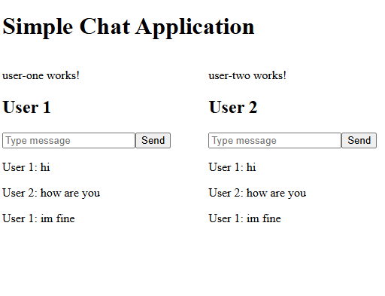
A simple two-user chat interface showing a conversation between User 1 and User 2.
User 1 says “hi,” User 2 replies “how are you,” and User 1 responds “im fine.”
All messages appear on both sides, indicating synchronized real-time communication.

