InventoryIQ AWS Architecture Notes
Current AWS setup, architecture rationale, and interview-ready notes
Project: InventoryIQ - Intelligent Inventory Optimization Platform

1. Current AWS Architecture Summary
This document summarizes the AWS environment configured for InventoryIQ so far. The goal of this AWS setup is to move the project from local CSV files into a cloud-based analytics architecture using Amazon S3 and Amazon Athena.
Local CSV files
-> Amazon S3 Data Lake
-> Amazon Athena External Tables
-> SQL Analytics Queries
-> Dashboard Layer (Tableau / Streamlit later)

2. AWS Resources Configured
Resource | Name / Setting | Purpose | Why It Matters
AWS Region | US East (N. Virginia) / us-east-1 | Keeps S3 and Athena in the same region. | Using one region reduces confusion and avoids cross-region setup issues.
AWS Budget | InventoryIQ Monthly Budget / $5 monthly cost guardrail | Monitors AWS spend while building the project. | Shows cloud cost awareness and safe AWS usage.
S3 Data Lake Bucket | inventoryiq-data-lake-sandeep | Stores the project datasets in S3. | Acts as the main cloud storage layer for the analytics platform.
S3 Athena Results Bucket | inventoryiq-athena-results-sandeep | Stores Athena query outputs and metadata. | Keeps source data separate from temporary query result files.
Athena Database | inventoryiq | Logical database that contains table metadata. | Organizes all InventoryIQ tables under one analytics database.
Athena Tables | 5 external tables | Makes S3 CSV files queryable with SQL. | Athena reads data directly from S3 without importing it into a server.

3. S3 Data Lake Folder Structure
The data lake bucket is organized into zones so the project can scale cleanly as more data pipelines and dashboards are added later.
inventoryiq-data-lake-sandeep/
├── raw/
│ ├── inventory/
│ │ └── inventory_data_cleaning.csv
│ ├── suppliers/
│ │ └── suppliers_data.csv
│ ├── purchase_orders/
│ │ └── purchase_orders.csv
│ ├── sales_orders/
│ │ └── sales_orders.csv
│ └── inventory_transactions/
│ └── inventory_transactions.csv
│
├── processed/
├── athena/
└── exports/
Folder | Current Purpose | Future Purpose
raw/ | Stores original CSV datasets uploaded from the local project. | Will support append-only or scheduled data ingestion in Phase 2.
processed/ | Created as a placeholder for future transformed datasets. | Can store cleaned, aggregated, or Parquet outputs later.
athena/ | Placeholder for Athena-related outputs or saved analytics artifacts. | Can store reusable query exports or Athena outputs if needed.
exports/ | Placeholder for dashboard/report exports. | Can store CSV, Excel, or PDF reports generated by the dashboard later.

4. Key Architecture Decisions and Why We Made Them
Separate S3 data bucket and Athena results bucket: The data lake bucket stores source business data, while the Athena results bucket stores query outputs. This keeps raw data separate from temporary query files and makes the architecture cleaner.
Block Public Access enabled on S3 buckets: The datasets should not be publicly accessible. Keeping public access blocked follows AWS security best practices and prevents accidental data exposure.
ACLs disabled / bucket owner enforced: Modern S3 architectures usually manage access through IAM and bucket policies instead of object-level ACLs.
SSE-S3 encryption enabled: Objects stored in S3 are encrypted at rest using Amazon S3 managed keys. This gives baseline data protection with minimal setup.
Athena instead of PostgreSQL or MySQL: Athena lets the project query files directly from S3 without provisioning a database server. This keeps storage and compute separate, which is a modern data lake pattern.
External tables instead of importing data: Athena external tables store metadata only. The actual data remains in S3. If a CSV is updated later, Athena can query the updated file without a traditional import step.

5. Athena Analytics Layer
The Athena database created for this project is named inventoryiq. It contains external table definitions pointing to the CSV files stored under raw/ in S3.
Athena Table | S3 Location | Source File | Business Role
inventory_data_cleaning | raw/inventory/ | inventory_data_cleaning.csv | Main SKU master and inventory KPI table.
suppliers_data | raw/suppliers/ | suppliers_data.csv | Supplier master data with reliability and risk metrics.
purchase_orders | raw/purchase_orders/ | purchase_orders.csv | Supplier replenishment and procurement activity.
sales_orders | raw/sales_orders/ | sales_orders.csv | Customer demand, order volume, and sales revenue.
inventory_transactions | raw/inventory_transactions/ | inventory_transactions.csv | Operational inventory movement such as restocks, orders, and adjustments.

6. Current Project Status
- AWS account access recovered and console access confirmed.
- AWS cost budget created before provisioning resources.
- S3 data lake bucket created in us-east-1.
- S3 Athena query results bucket created in us-east-1.
- Raw data folder structure created inside the S3 data lake bucket.
- Five validated CSV datasets uploaded into their matching raw folders.
- Athena query result location configured to use the Athena results bucket.
- Athena database inventoryiq created.
- Five Athena external tables created and tested successfully with SELECT queries.

7. What GitHub Can and Cannot Save
Important: GitHub does not save AWS resources themselves. Git only tracks local project files such as Python scripts, SQL files, Markdown notes, screenshots, and documentation. The S3 buckets, Athena database, and Athena tables are saved inside the AWS account, not inside GitHub.
Can Be Committed to GitHub | Cannot Be Committed Directly
SQL DDL files for creating Athena tables | Actual S3 buckets
AWS architecture notes and screenshots | Actual Athena database metadata
README documentation | Actual query result files in S3
Architecture diagrams | AWS budget settings
Python scripts and local CSVs | AWS account configuration

8. Interview Talking Points
- I configured AWS Budgets before provisioning resources because AWS is pay-as-you-go and cloud projects need cost controls from the beginning.
- I used Amazon S3 as the data lake because it provides scalable object storage and is commonly used as the storage layer for cloud analytics systems.
- I organized the data lake into raw, processed, athena, and exports zones so the architecture could support future data transformation and reporting workflows.
- I used Amazon Athena because it lets me query S3 data with SQL without managing a database server.
- I created external tables in Athena so the data remains in S3 while Athena stores only the table metadata.
- I separated the source data bucket from the Athena results bucket to keep raw business data separate from query outputs and temporary metadata.

9. Resume-Worthy Accomplishments So Far
- Designed and configured an AWS-based data lake architecture using Amazon S3 and Amazon Athena for an inventory optimization analytics platform.
- Created a structured S3 data lake with raw, processed, athena, and exports zones to support scalable analytics workflows.
- Configured Athena external tables over five business datasets, enabling serverless SQL querying directly against CSV files stored in S3.
- Implemented cloud cost guardrails using AWS Budgets before provisioning analytics resources.
- Validated cloud table schemas by testing each Athena external table with SQL queries against S3-backed data.

10. Planned Future Enhancement: Incremental Data Refresh
After Phase 1 is complete, the planned Phase 2 enhancement is to add an incremental or scheduled data refresh pipeline. The idea is to simulate new weekly or daily sales orders, purchase orders, and inventory transactions, reprocess the metrics, and refresh dashboard outputs.
EventBridge schedule (future)
-> Lambda or local scheduled Python job (future)
-> New data batch written to S3
-> Athena reads updated S3 data
-> Dashboard KPIs refresh
This should be described as scheduled batch processing or an incremental data refresh pipeline, not true real-time streaming unless a streaming service like Kinesis is added later.

11. Screenshots of the AWS Environment
The following screenshots document the AWS environment configured so far. Account-identifying browser/header areas were cropped where possible, while keeping the important architecture evidence visible.

Screenshot 1
S3 bucket list showing the separate data lake bucket and Athena query results bucket.
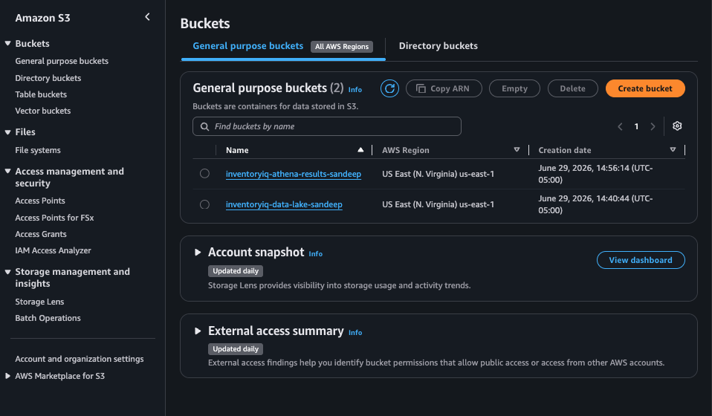

Screenshot 2
S3 data lake root folder structure: athena, exports, processed, raw.
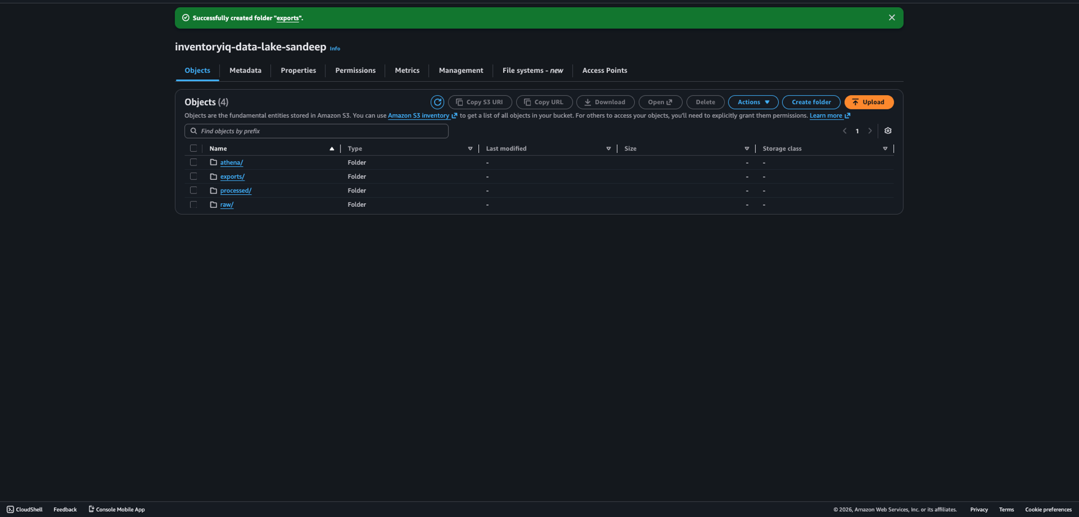

Screenshot 3
S3 raw data zone with one folder per dataset.
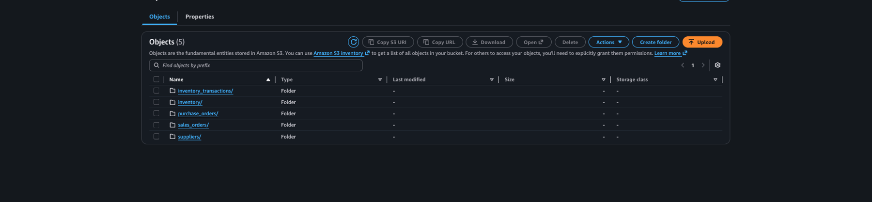

Screenshot 4
Athena query settings showing the configured S3 query result location.
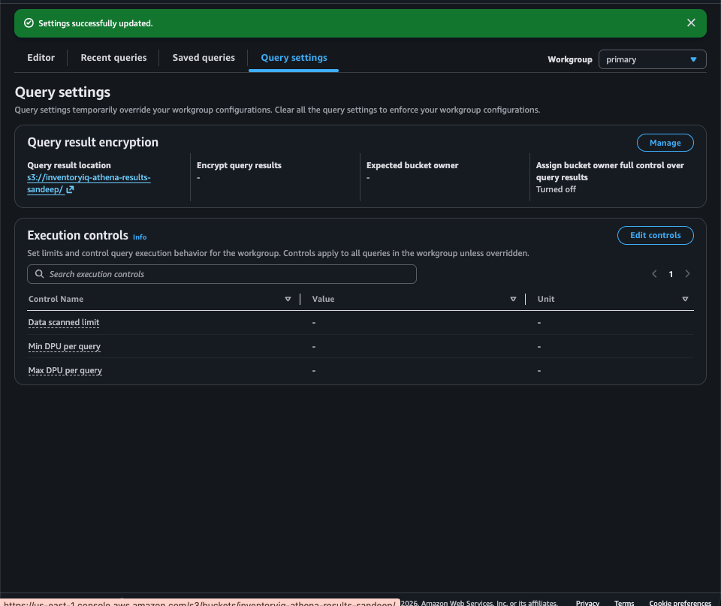

Screenshot 5
Athena successfully querying the inventory external table.
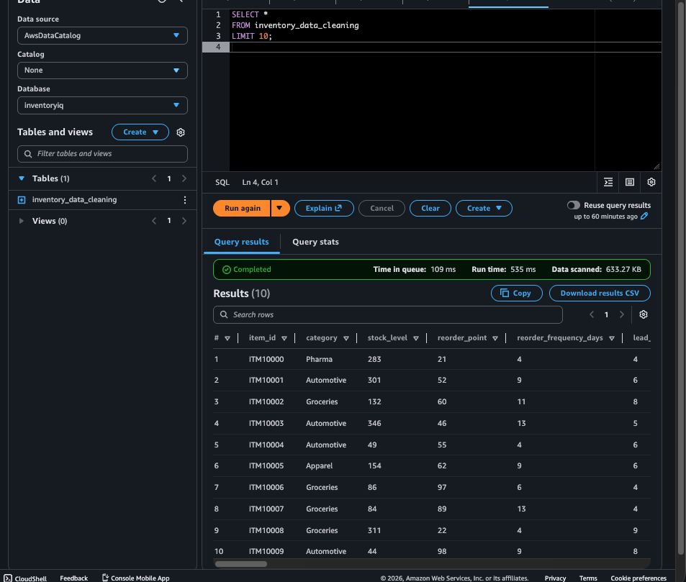

Screenshot 6
Athena database with all five external tables created and queryable.
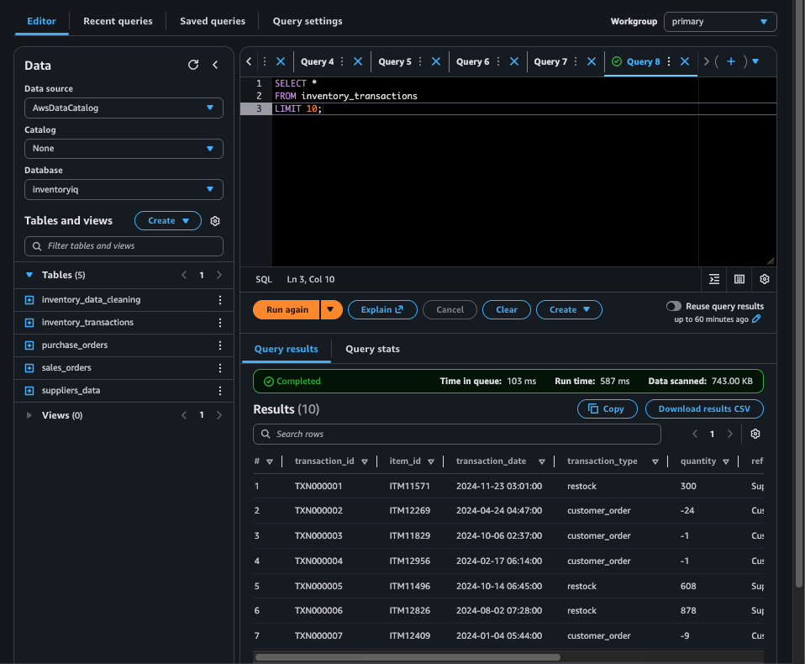

12. Suggested Next Local Commit
After adding this document to the project folder, a good commit message would be:
Add AWS architecture notes
This commit documents the AWS work completed so far, even though the AWS resources themselves live in the AWS account and are not stored in GitHub.

