CoGeNT Tool User's Guide

VERSION 1.0
25 JAN, 2017


Visteon Corporation

Table of Contents

Contents
Table of Contents 2
1 Introduction 2
1.1 Purpose 2
1.2 Files generated for VNIM: 3
1.3 Files generated for NOS: 3
1.4 Acronyms 3
2 COGEN Tool Usage: 3
2.1 Installation: 3
2.2 Directions for usage: 4
2.3 Message Configuration parameter: 6
2.4 Signal Configuration parameters: 7
3 Appendix A: Revision History 8

Introduction

Purpose
This document is provided as a guide to assist a user with learning how to operate the software application known as the CoGeNT tool.
CoGeNT tool is capable of generating the following list of files for VNIM and NOS:

Files generated for VNIM:
- nw_vnim_app_signals_par.c
- nw_vnim_app_signals_par.h
- vnim.msg.resource
- vnim.txrx.resource

Files generated for NOS:
- can_rxrule.cfg
- nw_can_dll.h
- nw_il_msg.h
- nw_il_par.h
- nw_nm_par.h
- nw_il_par.c

Acronyms
VNIM vehicle Network Interface Management
NOS Network Operating System
CFG ConFiGuration
DI Driver Information
EOL End Of Line
Codegen Code generator

CoGeNT Tool Usage:

Installation:
- Click CoGeNT_INSTALLER.exe file to install the tool.
- CoGeNT will be installed in C:\ CoGeNT\

Directions for usage:
- Open CoGeNT.exe from the installation folder. Tools Home page will be appear as below
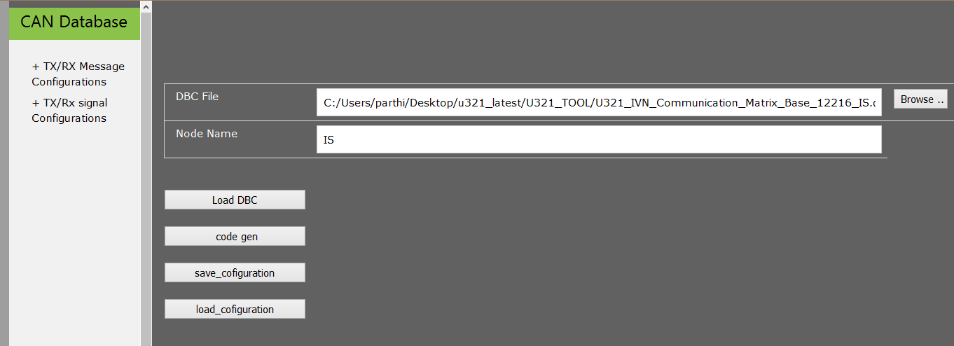


- DBC File : select the can database file by clicking the browse button,
- Node Name : Enter the node as mentioned in the data base file.(It is case sensitive)
- Previously saved configuration file can also be loaded by clicking button.
- Click button for validating whether the node name and the database file are valid.
- If a valid dbc file and node name are entered properly , below window will pop up for confirmation
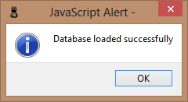

- Click 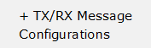 on the left side of the window, to open message configuration window.
- In the message configuration window , you will see both Tx and Rx messages with their configuration settings.(Refer Message parameter section )
- After configuring message parameters , Click button to save the configuration.
- Click 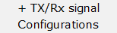 on the left side of the window, to open Signal configuration window. This configuration will be opened only when the message configuration is saved
- In the message configuration window , you will see both Tx and Rx signals with their configuration settings.(Refer Signal configuration section )
- After configuring signal parameters, Click button to save the configuration.
- Click button to generate NOS and VNIM files and the files will be in “CODE_GEN” folder which will be in the folder you have installed the TOOL.
- On successful code generation , below window will appear 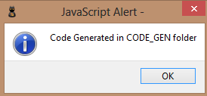

- To save the current configuration, Click button. Enter the name you wish to store the configuration in the below wiondow
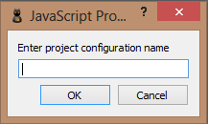

- The configuration will be saved with .cfg extension in the “C:\CoGeNT\Config”

Message Configuration parameter:
- TX MESSAGE
  - Message Properties:
    - Message Name: It shows the name of the transmission message of your node.
    - ID: It shows the identifier of the transmission message of your node.
    - DLC: It shows the data length of the transmission message of your node.
    - Periodicity: It shows the periodicity of the transmission message of your node.
  - Configuration Parameters:
    - Enable/Disable Message: This parameter is used to select whether the message is required. Check the box to enable the message and uncheck the box to disable.
If the message is disabled other configuration parameters will also be disabled and will not be included in code generation.
    - Message Type: This parameter is used to select whether the message is an application/NM/diagnostic message.
      - Select Appl for application messages.
      - Select NM for network management messages.
      - Select Diag for diagnostic messages.

- RX MESSAGE
  - Message Properties:
    - Message Name: It shows the name of the message of your node.
    - ID: It shows the identifier of the message of your node.
    - DLC: It shows the data length of the message of your node.
    - Periodicity: It shows the periodicity of the message of your node
  - Configuration Parameters:
    - Enable/Disable Message: This parameter is used to select whether the message is required. Check the box to enable the message and uncheck the box to disable.
If the message is disabled other configuration parameters will also be disabled and will not be included in code generation.
    - Message Type: This parameter is used to select whether the message is an application/NM/diagnostic message. If the message type is not APPl, the parameters will be disabled.
      - Select Appl for application messages.
      - Select NM for network management messages.
      - Select Diag for diagnostic messages
    - Node Name: This parameter represents the node to which the message belongs. It should be in uppercase. eg:ESC
    - Key Message: This parameter represents the key message of the node. It is used to select the key messages of the node. Check the box to select the key message.
    - Node Absent ID: This represents the DIAG ID TYPE used to notify to diagnostic component for node absent. This will be enabled only if key message option is checked.
    - Message Timeout ID: This represents the DIAG ID TYPE used to notify to diagnostic component for message timeout. This will be enabled only if key message option is unchecked.
    - Message Content DLC ID: This represents the DIAG ID TYPE used to notify to diagnostic component for message content fault.
    - Notification during IGN OFF: It represents whether the application has to be notified to application during IGN Off.
    - OS Message Notification: It represents the message notification delay to application. This feature is included to reduce the load of os messages. Message with periodicity less than 100ms will be shared among 100 an 145ms task.
      - No Delay: Message notification will be done without any delay .Mostly messages with periodicity greater than or equal to 100ms and event messages.
      - 100ms Delay: Message notification will be done after 100ms delay. Message with periodicity less than 100ms
      - 145ms Delay: Message notification will be done after 145ms delay.

Signal Configuration parameters:
- TX Signals:
  - Signal Properties:
    - Signal Name: It shows the name of the signal.
    - Message Name: It shows the name of the message of the signal.
    - Length: It shows the data length of the transmission message of your node.
    - Byte order : It shows the signal order whether Intel or Motorola.
  - Configuration Parameters:
    - Init Value: This is the value used as default value during initialization and during failure cases. Value must be entered in hex format eg: 0x0
    - Signal Debounce: This parameter defines whether de-bounce logic has to be implemented for the signal. A new switch case has to be added for each signal id in Vnim_tx_signal_debounce function .
- Rx Signals:
  - Signal Properties:
    - Signal Name: It shows the name of the signal
    - Message Name: It shows the name of the message of the signal.
    - Length: It shows the data length of the transmission message of your node.
    - Byte order: It shows the signal layout whether Intel or Motorola.
  - Configuration Parameters:
    - Init Value: This parameter is used to select whether the message is

required. Check the box to enable the message and uncheck the box to

disable.
If the message is disabled other configuration parameters will also be disabled and will not be included in code generation.
    - Green Drive enable: If enabled green drive message notification will be done for this signal change.
    - Signal Content Error check: If enabled, a callback function will be called to check the content of the signal, whenever the signal is received . A new switch case has to be added in vnim_validate_signal_content_error function for this signal, as per the signal id generated in VNIM_SIGNAL_FAULT enum type.

    - Signal Content Error DTC ID: This represents the DIAG ID TYPE used to notify to diagnostic component for signal content fault.

Appendix A: Revision History

Revision | Section/Page | Date | Description
1.0 | All | 18/6/2015 | Initial revision.

